**Screenshots**

### Check IAM Permission

### 

***Create an EKS Cluster***

eksctl create cluster --name my-cluster --region us-east-1 --nodegroup-name my-nodes --node-type t3.small --nodes 1 --nodes-min 1 --nodes-max 2

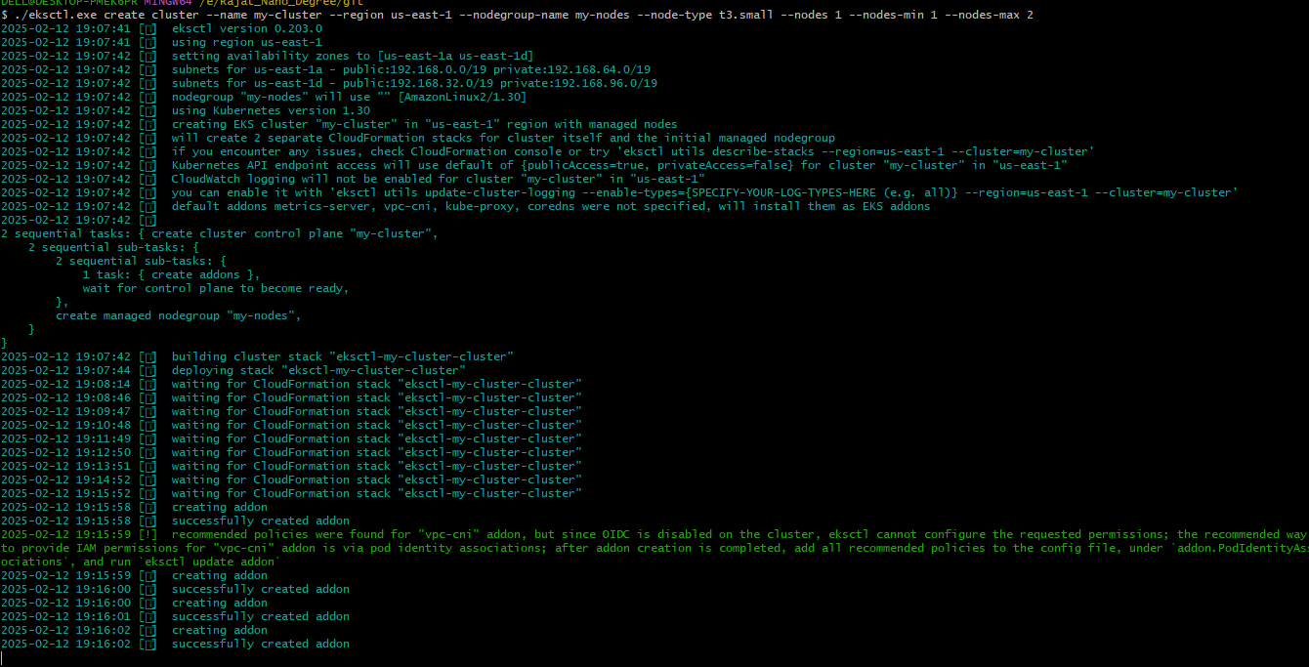

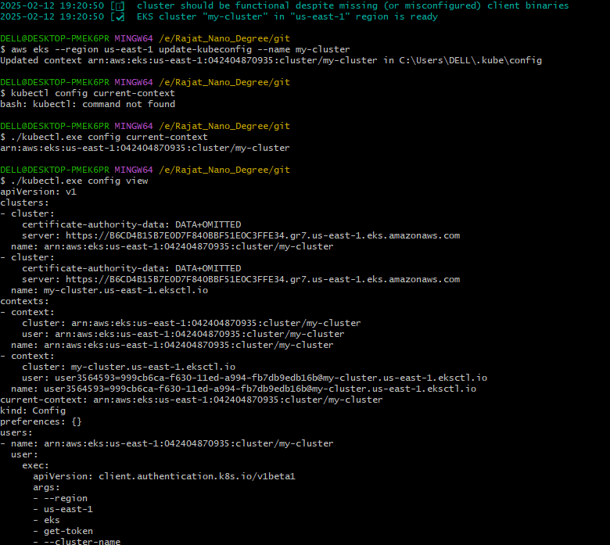

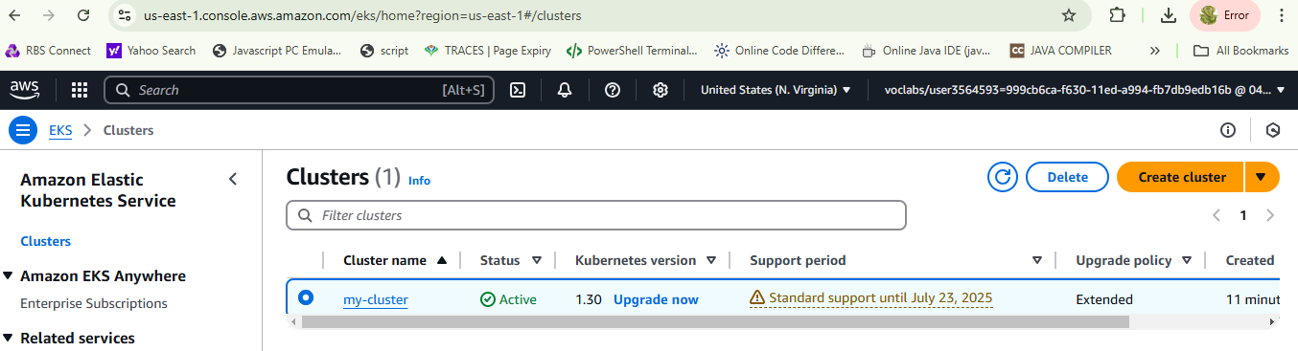

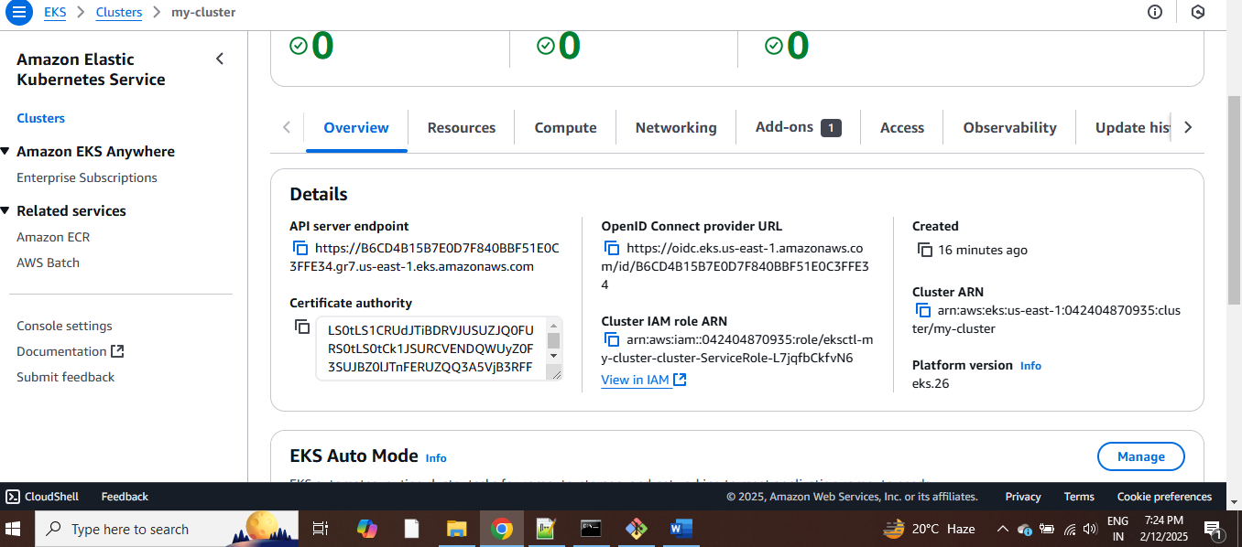

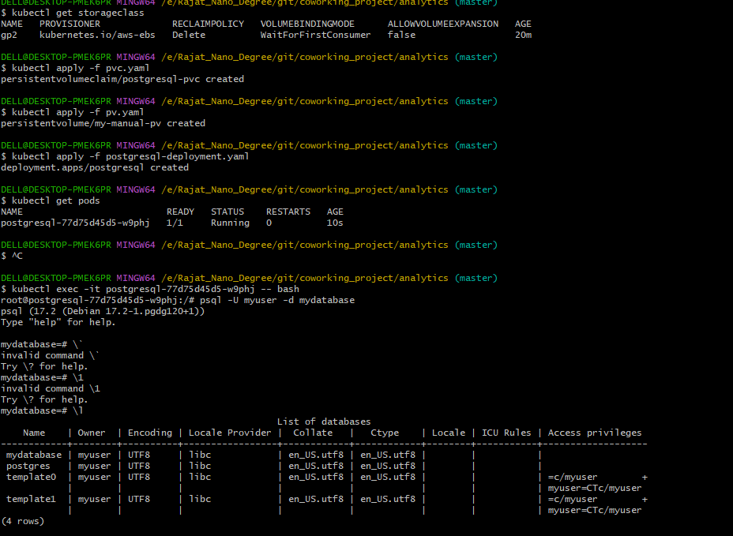

***Checking the tables***

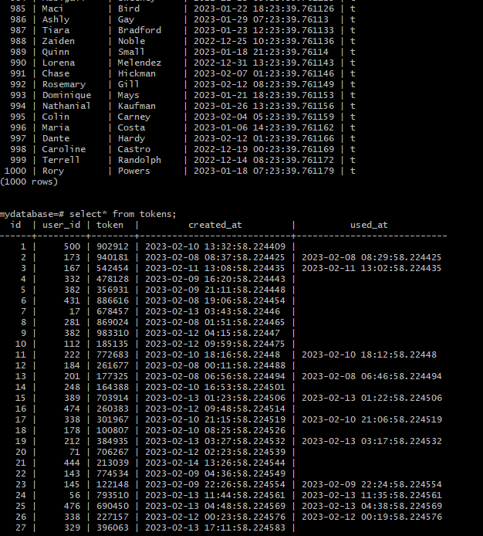

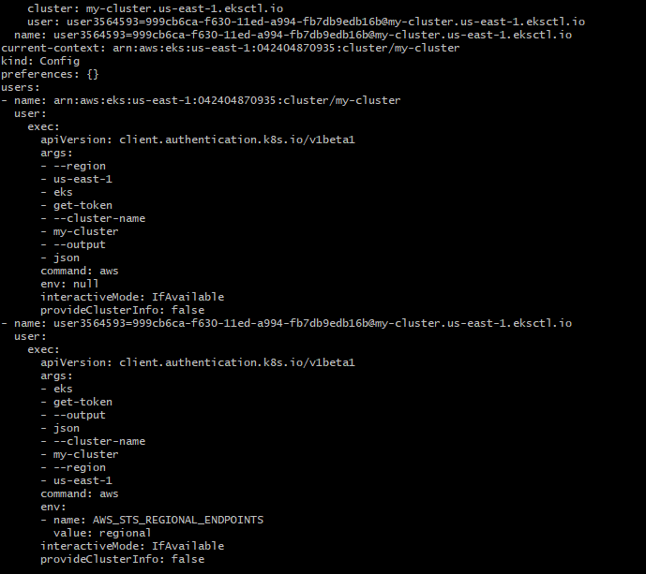

***A). Configure a Database***

**Set up a Postgres database using a Helm Chart**

1. **Set up Bitnami Repo**

helm repo add bitnami https://charts.bitnami.com/bitnami

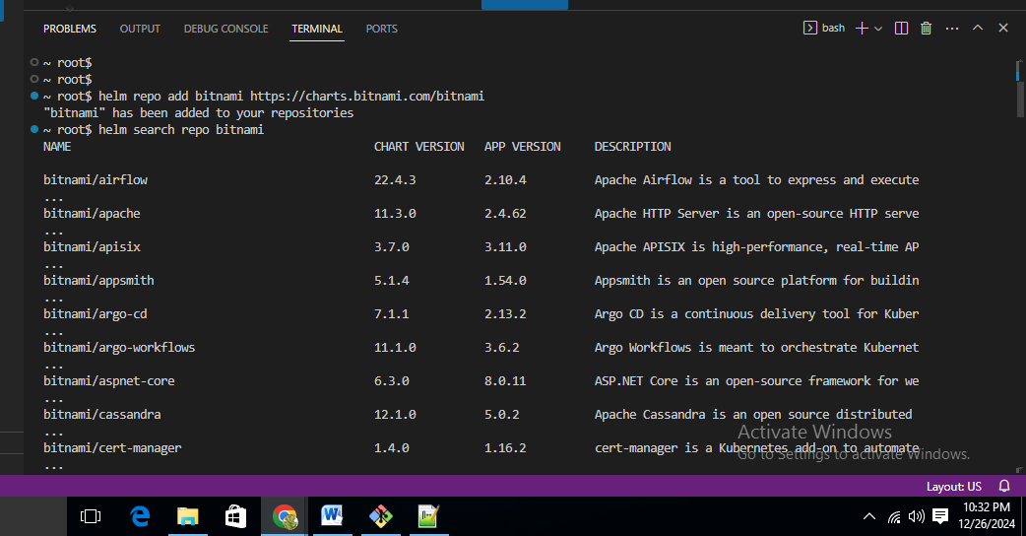

1. **Install PostgreSQL Helm Chart**

helm install my-postgresql bitnami/postgresql

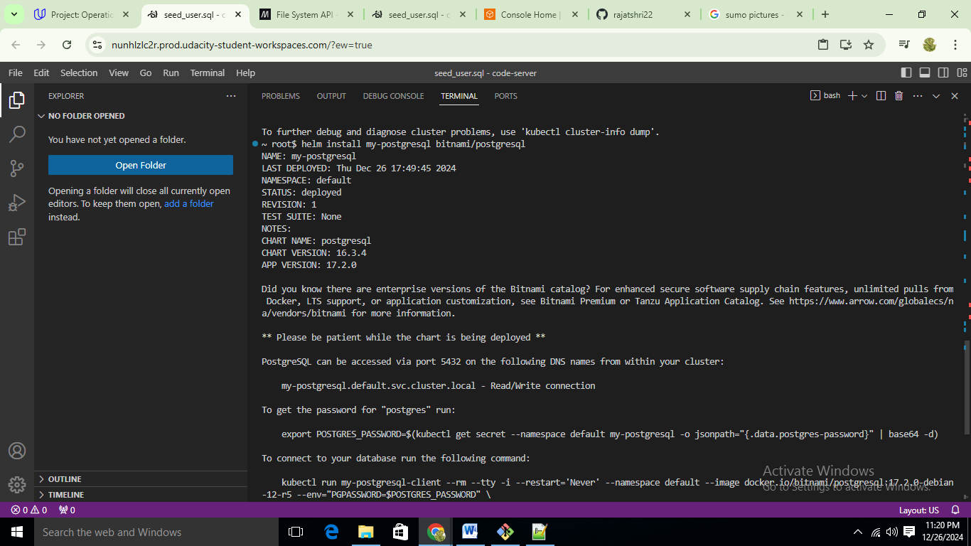

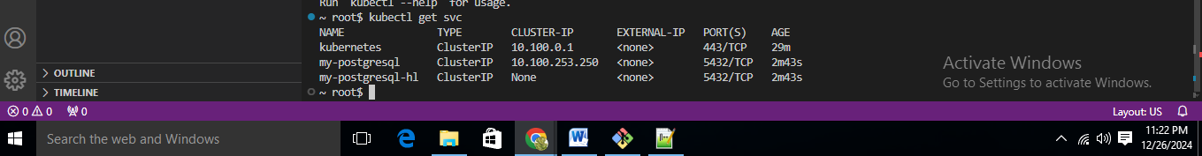

**Password Retrieval**

export POSTGRES_PASSWORD=$(kubectl get secret --namespace default my-postgresql -o jsonpath="{.data.postgres-password}" | base64 --decode)

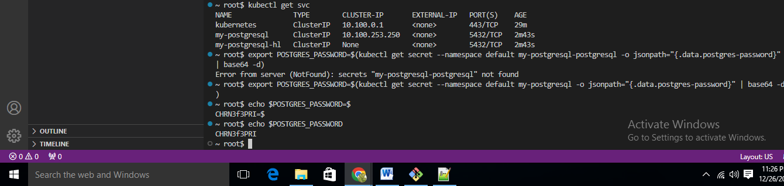

**Get svc/pods output**

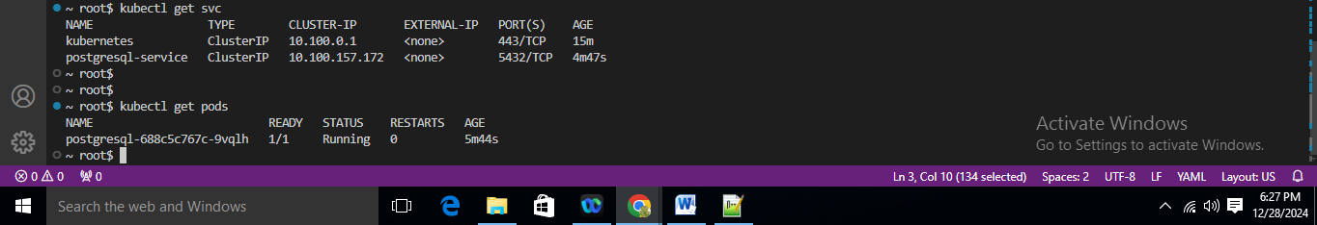

**Screenshot of `kubectl describe svc <DATABASE_SERVICE_NAME>`**

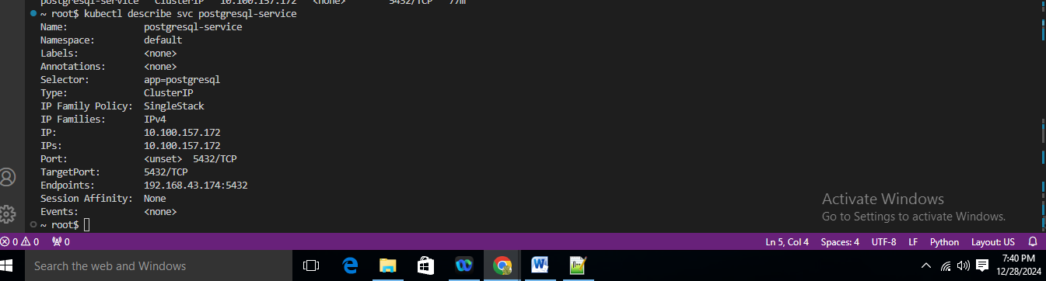

**Screenshot of `kubectl describe deployment <SERVICE_NAME>`**

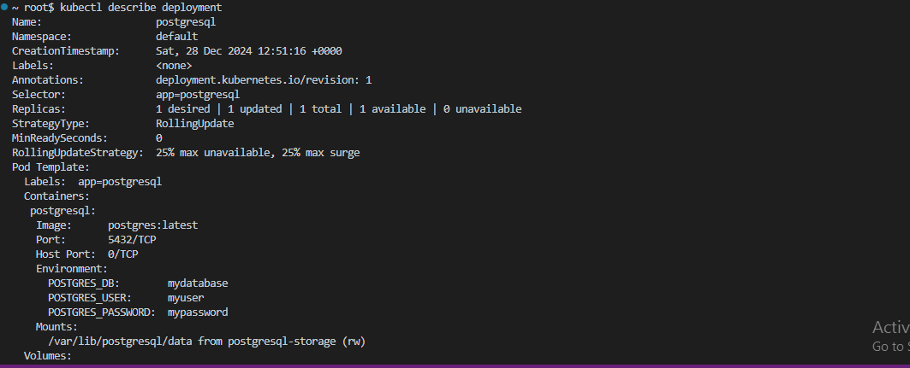

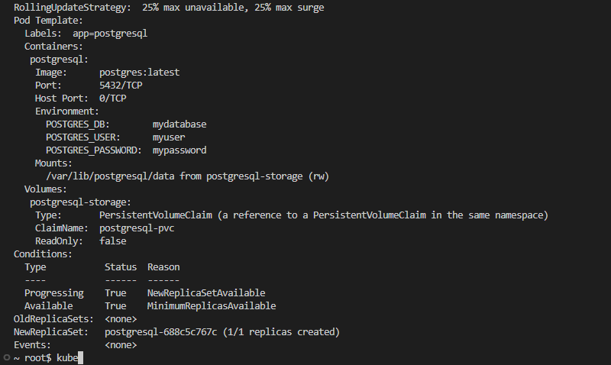

1. **Test Database Connection**

**Connecting Via Port Forwarding**

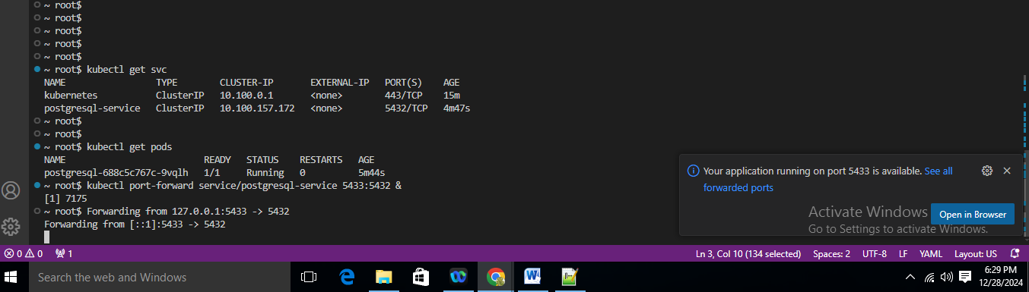

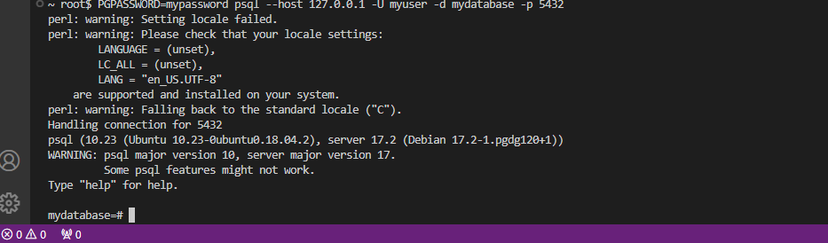

**Connecting Via a Pod**

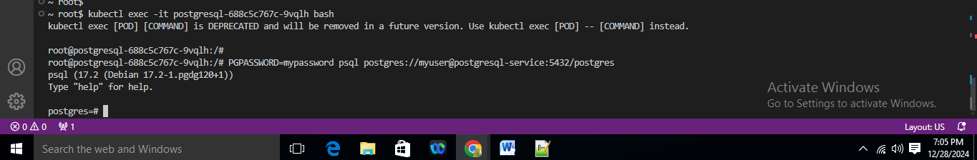

1. **Run Seed Files**

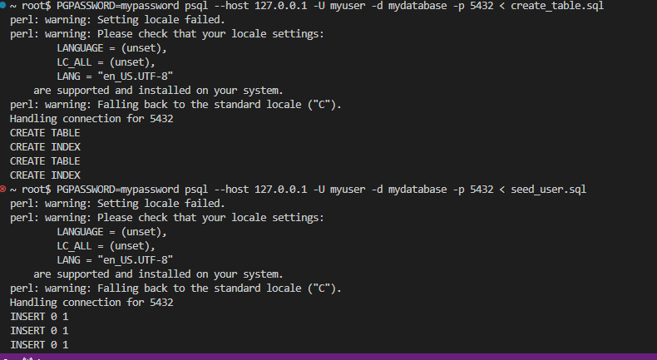

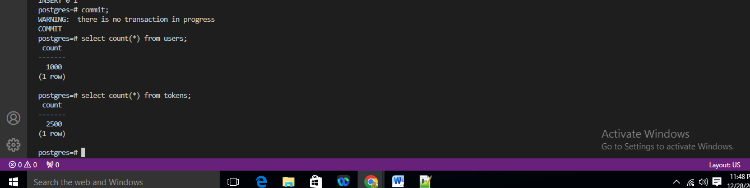

**B) Running the Analytics Application Locally**

1. **Install dependencies**

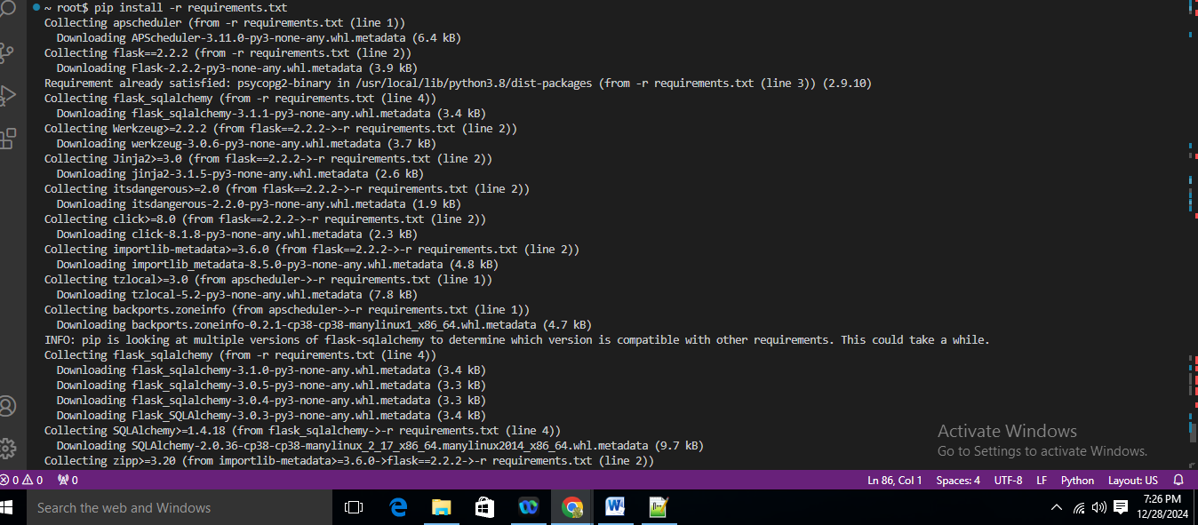

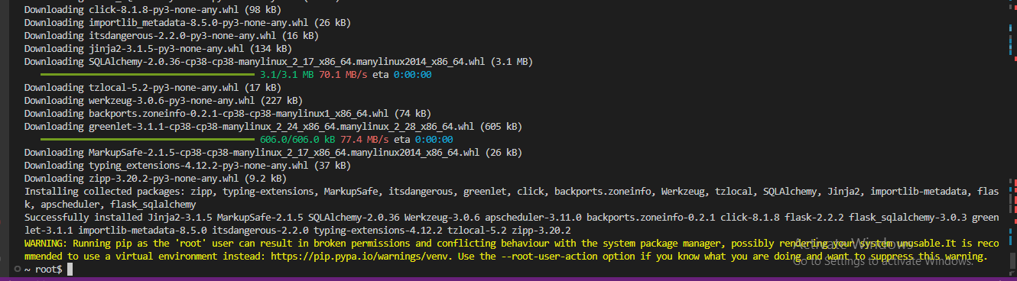

1. **Run the application (see below regarding environment variables)**

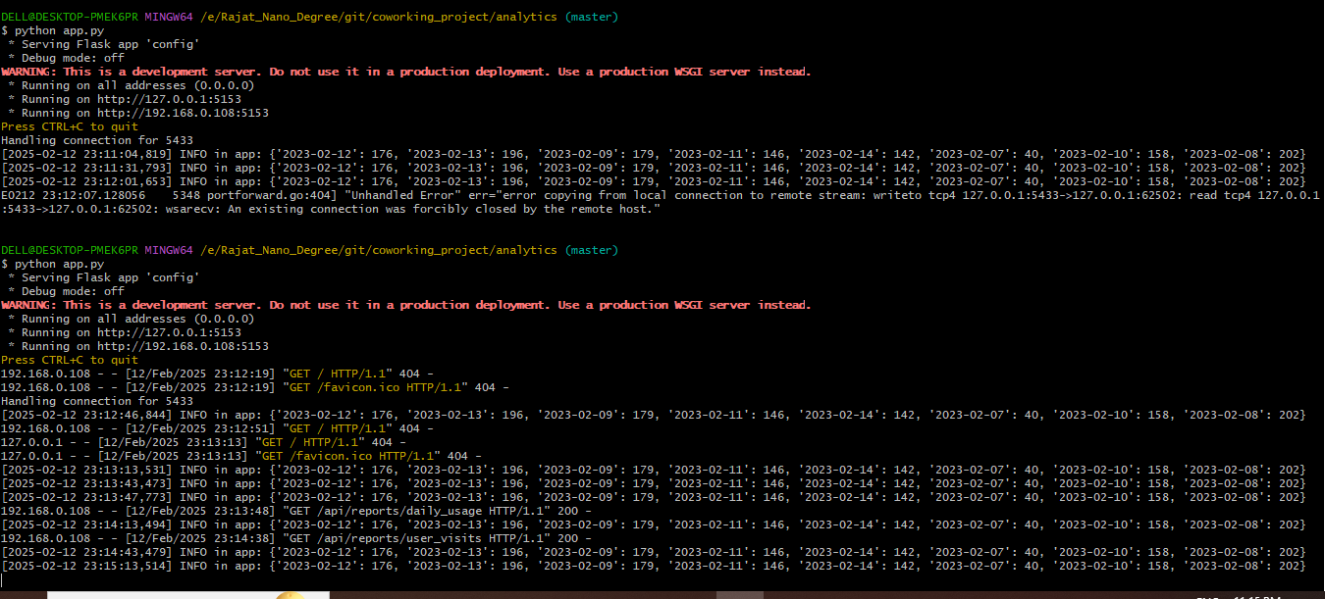

1. **Verifying The Application**

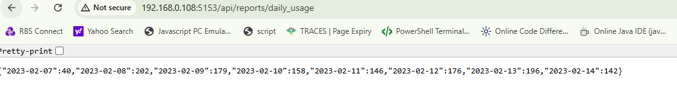

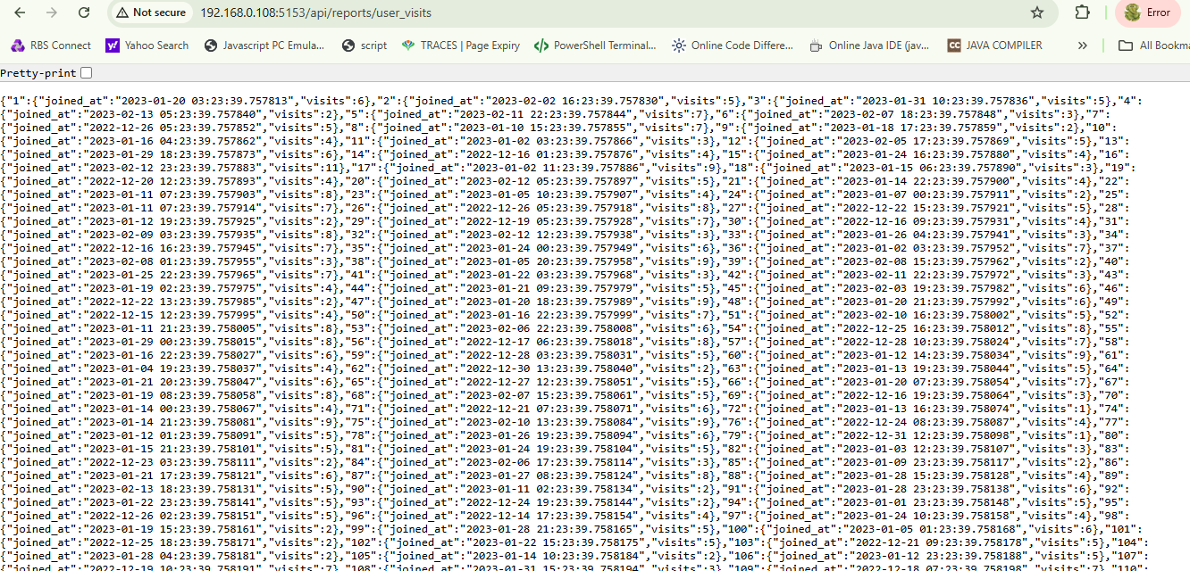

**Deploy the Analytics Application**

**Set up Continuous Integration with CodeBuild**

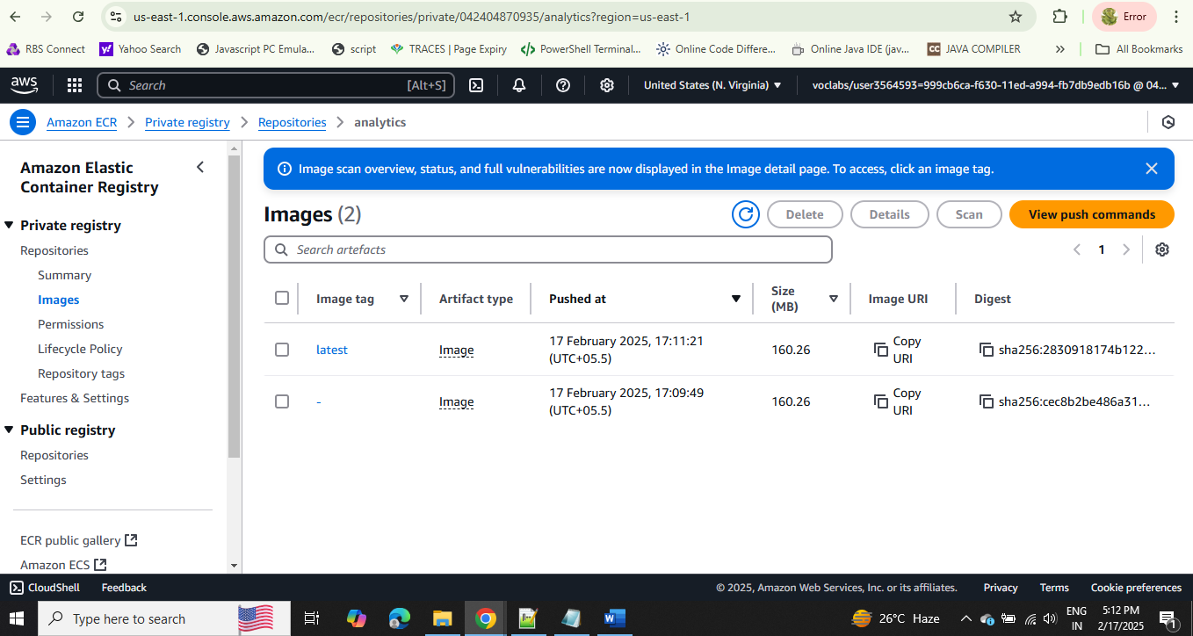

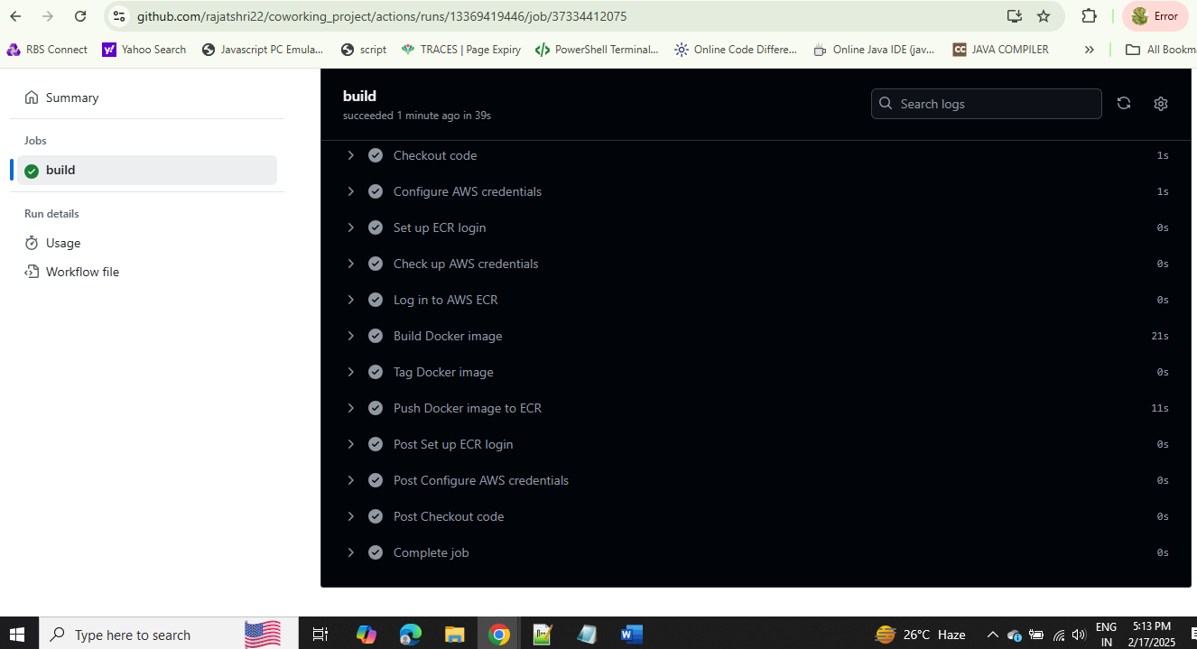

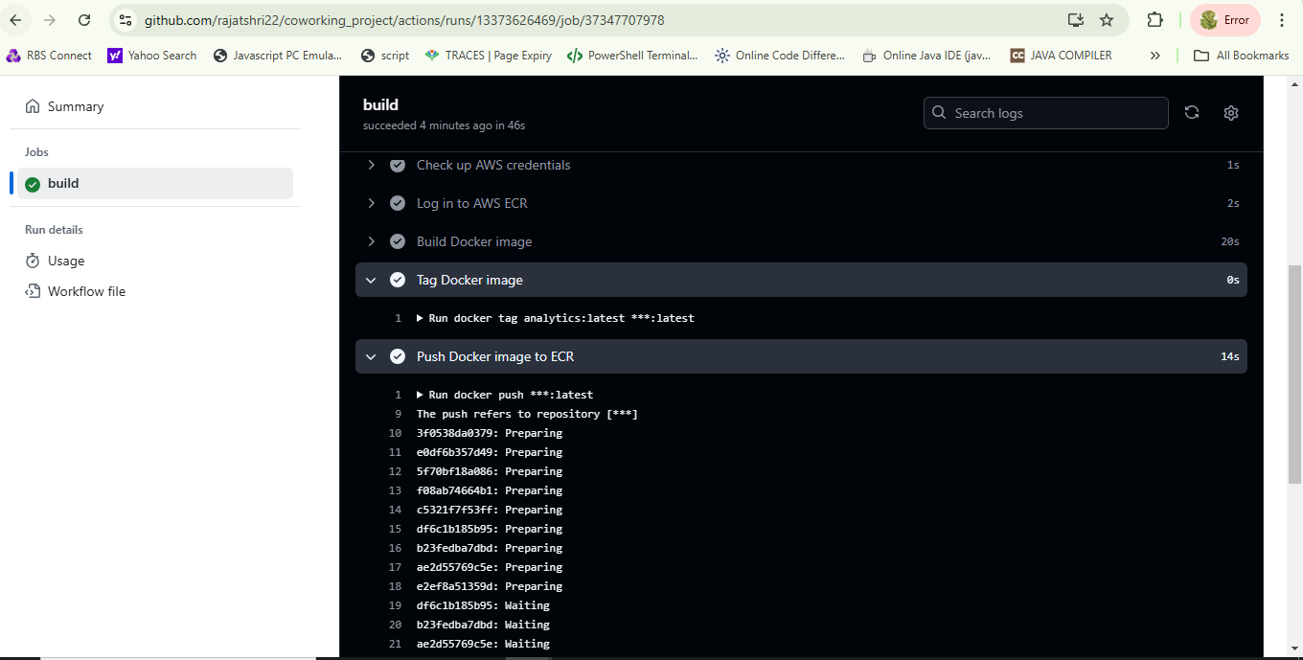

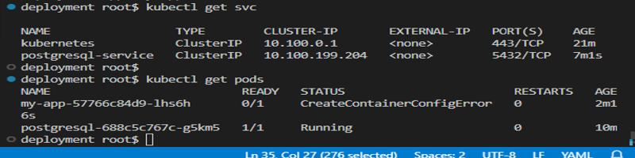

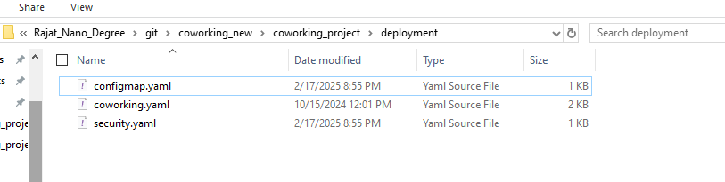

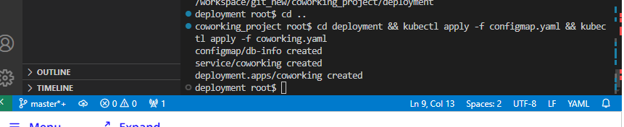

**Verify the Deployment**

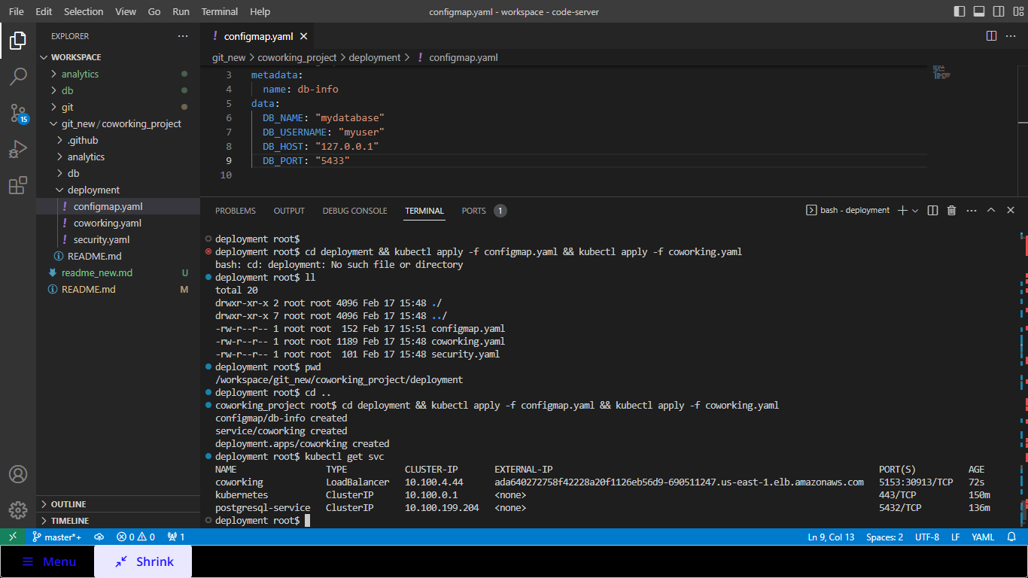

**Setup CloudWatch Logging**

