3.6 Term 2 – Mid Review Presentation (35 % Weightage)
Project Title :… Evaluating the Financial Impact of ONDC on Small Retailers and Gig Service Providers in India: A Study of Early-Adopting Cities …………
Name &Roll No: …Rajat Singh MM25GF096……...
Name of the Project Mentor :……Dr. Noushin Bagheri ……
Date of review: …………………………………..
Please rate on a scale of 1 to 5 by marking (√)1 = highly unsatisfactory; 2 = needs improvements; 3 = meets expectations; 4 = exceeds expectations; 5 = outstanding
Parameters | 1 | 2 | 3 | 4 | 5 | Comments
- Research Objectives - Research Objectives clearly defined and agreed with mentor
- Literature review- Adequate list of relevant readings both academic and practice based along with a reference list. The key findings of the review literature adequately summarized with appropriate referencing (APA style).

- Research Design - Clear articulation of the research design & conceptual framework, with details of proposed methodology and rationale for chosen approach

- Data collection and analysis- Relevant data identified and sourced with preliminary data analysis in progress. Clarity on data analysis techniques to be adopted. Different scenarios and the framework for What-If analysis while engaging in the project.
- Key milestones & timelines- Clearly articulated specific milestones with timelines & targeted date of completion.

- Presentation & Communication- Clear, logical, impactful presentation and mid review GIP project report with compliance to format and guidelines. References in APA format

- Project Engagement - Consistent, focused effort and ownership for the project. Quality and timely submissions of Project diary logs and mid review report.

Total Score
Signature of the mentor: Date:
Any other comment by the mentor


ACKNOWLEDGEMENT

I would like to extend my sincere appreciation to the faculty and the management of SP Jain School of Global Management who helped me to acquire the tools and resources to carry out this project with title Evaluating the Financial Impact of ONDC on Small Retailers and Gig Service Providers in India: A Study of Early-Adopting Cities. I would also like to thank Dr Noushin Bagheri with regards to her support, guidance and encouragement, all of which has allowed me to complete this research to the best of my capabilities.

Sincerely:-
Rajat Singh
MM25GF096
.

S P JAIN SCHOOL OF GLOBAL MANAGEMENT

7. Appendix

7.1 Appendix –Declaration

I hereby declare that the matter included in this report entitled “Evaluating the Financial Impact of ONDC on Small Retailers and Gig Service Providers in India: A Study of Early-Adopting Cities”, is the result of study and interviews carried out for my project. I further declare that this is my original work and has not been published anywhere before.
This Project Work has been carried out for the sole purpose of submission in partial fulfillment of Master of Business Administration (Global) at S P Jain School of Global Management, Dubai.
The above is true to the best of my knowledge and understanding.
I have read, understood and signed the code of Ethics.
COPYRIGHT ASSIGNMENT
FOR THE GOOD AND VALUABLE CONSIDERATION, receipt of which is hereby acknowledged, the Student (“Assignor”), hereby irrevocably transfers and assigns to S P Jain School of Global Management (“Assignee”), located at Dubai, Singapore, Sydney, its successors and assigns, in perpetuity, all right (whether now known or hereinafter invented), title, and interest, throughout the world, including any copyrights and renewals or extensions thereto, in Evaluating the Financial Impact of ONDC on Small Retailers and Gig Service Providers in India: A Study of Early-Adopting Cities.
IN WITNESS THEREOF, Assignor has duly executed this agreement.
Date :
Student : Rajat Singh MM25GF096
Name / Roll No. (Sign) ------Rajat Singh---------------------

Project Mentor
Name : Dr. Noushin Bagheri
Signature :
S P JAIN SCHOOL OF GLOBAL MANAGEMENT

Abstract
On the Indian side, Open Network for Digital Commerce (ONDC) is a new approach to democratise the digital trade by developing an interoperative open network between buyers, sellers and other intermediary service providers (NITI Aayog, 2023). In contrast to closed platforms (e.g. Amazon or Swiggy), ONDC facilitates easiness of interoperability of applications, locking out to a significant extent the reliance on application monopolies (MeitY, 2022; George, 2022). In this study, the authors will analyse the potential impact of ONDC on the financial and operating performance of two Indian economic giants, yet marginalized, i.e., small-scale retailers (kirana stores) and gig service providers (Rani and Dhir, 2020; World Bank, 2022). ONDC, as an extension of other similar digital, public, and infrastructures (like UPI), could have the potential to reduce the cost of conducting business, put obscure businesses in the spotlight, and provide a fairer platform to gig workers whose incomes fluctuate and have high rates on commissions (Kumar and Gupta, 2022; Wood et al., 2019). The study relies on a mixed method, which implies not only secondary data and policy reports, but also other scholarly resources on the issue of digital inclusion, platform economies, and SME digitalization, and primary empirical research. The research will have hypotheses and theoretical framework to determine the fact that ONDC will be able to minimize financial expenditures caused by platforms, improve the predictability of income of gig workers, market access to retail companies and technological inclusiveness. The estimated outcomes will provide valuable precocious empirical evidence on how open networks can facilitate equitable digital ecosystems, which will be a critical reference paradigm to other upcoming economies (World Bank, 2023; Kunduru, 2024).

  - The definition of Open Network Digital Commerce (ONDC)
As a state-funded program, Open Network Digital Commerce (ONDC) aims at forming an open network of digital commerce (MeitY, 2022). ONDC is the total contrast of proprietary platforms. The primary difference in its functionality is that it enables buyers and sellers to interact and trade with each other regardless of whether they are using the same application or not (International Journal of Research in Technological Innovations, 2023). The buyer with one of the buyer apps can, as an example, search and purchase products offered by a seller who is registered as a network member in an entirely different seller app. As an open protocol, ONDC is expected to be successful within the context of e-commerce, where UPI has already become the primary catalyst on the way to innovation, competition, and openness of the system within the digital marketplace (World Bank, 2023; Islam et al., 2024). This is specifically aimed at decentralizing the online business and provide an inclusive market environment in which small shops and service providers are able to thrive without relying on a small number of large platforms as an owner (Malik et al., 2023).

  - Research Objectives
The first discussion is directly related to research objectives that are unique to the research. The objectives are to:
To examine whether ONDC can assist small retail actors to decrease the platform-related costs (commission and operating costs) in comparison to closed traditional platforms.
To analyze the question of whether ONDC helps small retailers to gain more visibility and access to customers and be able to compete with their larger counterparts more even-handed.
To find out whether ONDC can reduce the barrier to entry to small retailers and local businesses and make them easier to enter the digital marketplace.
To assess the experiences and level of satisfaction of gig-workers and small retailers regarding the impact of ONDC on their income prospects and their daily work.

  - Significance of the Research
This research is important because it can be empirically confirmed that a paradigm shift has taken place in the global digital economy: that is, the shift towards platform-based monopolies to network-based open protocols. With India trying to emulate the success of the Unified Payments Interface (UPI) in the complicated sphere of e-commerce, the paper is a critical examination of whether state-driven Digital Public Infrastructure (DPI) can be an effective way of democratizing markets among the marginalized economic actors.

Small Retailers Significance (Kirana Stores):
This is crucial to the millions of small retailers who constitute the core of the Indian economy. The so-called walled gardens of major aggregators now also represent an existential threat to these businesses, with prohibitive commissions (18-30%), no longer visible as they are based on opaque algorithms . This study, by exploring the Independent Variables 1 and 2 (Reduced Costs and Enhanced Visibility) indicates a survival route. It goes beyond the promises made in theory to calculated Operational Cost Efficiency (MV1) realized by early adopters. In the event that results prove that ONDC lowers the cost of doing business, it will give a roadmap to millions of offline retailers to go digital in a manner that does not weaken their thin profit margins, in theory changing the balance of power back to the merchant.

Implication to the Gig Economy:
This paper is dealing with an imminent labor market crisis. Gig workers are already facing the state of algorithmically controlled precarity, which is fluctuating income and the absence of bargaining power based on platform monopsony4. This study examines the potential helpfulness of Interoperability (IV2) as another form of labor protection by concentrating on Income Stability (OV) and the monopsony disruption. It examines the question of whether permitting employees to have access to the demand of multiple applications at the same time makes their labor market more equitable. The results will be of interest to labor unions and policymakers who want to find market-based remedies to the vulnerability of gig workers, such as providing evidence on whether open networks can reinstate the sense of psychological ownership and financial predictability.

Policy and Theoretical Contribution:
On the policy side, the current study confirms the effectiveness of so-called Architectural Governance, the concept that the competition can be better imposed by the neutral code than regulation6. The causal path analysis between Platform Fairness (IV3) and Financial Impact (OV) allows the research to provide the Government of India (NITI Aayog, MeitY) with the necessary feedback on whether the ONDC protocols are working as expected or they need to be fine-tuned. In theory, it adds to the debate on Digital Public Infrastructure (DPI) by experimenting with a new model that combines the Transaction Cost Economics and the Resource Dependence Theory. It meets a desperate desire to comprehend the processes (Mediating Variables of Efficiency and Reach) that convert digital inclusion to economic prosperity.

Global Relevance:
Lastly, the research is of colossal importance to the "Global south." With some countries, such as Brazil and Indonesia, seeking to take on digital monopolies, ONDC in India is the first large-scale pilot in open commerce8888. The empirical evidence created in this respect will be used as a reference paradigm, which will conclude on whether this model can be an alternative to the dominance of Western tech giants on emerging economies.

  - Research Gap
Although the Digital Public Infrastructure (DPI) in India is becoming a subject of increased literature, it still has a strong bias towards the success of the Unified Payments Interface (UPI), which does not provide much empirical insight into the Open Network for Digital Commerce (ONDC). The proposed research would fill four important gaps in the existing literature, namely the gap between high-level policy theory and ground-level financial reality.
- The "UPI vs. ONDC" Thematic Gap:
Most of the available literature, including that of Kumar and Gupta (2022) and Sharma (2023), pays a lot of attention to UPI and its contribution to financial inclusion9. Although such studies indicate the possibility of open protocols, they fail to tackle the logistical and operational issues of trade. In commerce, there are inventory, logistics and returns, which do not exist under pure payment systems. The lack of studies that would use the DPI framework specifically to the unbundling of shopping leaves this study with a focus on the unique variables of ONDC including Enhanced Market Visibility (IV2) and Operational Cost Efficiency (MV1) of uncharted land as a contribution to the literature10.
- The Empirical Gap:
Existing scholarly work on ONDC is found mostly in the form of concept papers (primarily by governments, such as MeitY, 2022; NITI Aayog, 2023) or speculative analysis (George, 2022). These reports describe the planned design and the hypothetical benefits of the network without giving empirical data on the actual performance. A gaping lack of quantitative studies to quantify the Financial Impact (OV) on early adopters are missing. This study addresses this gap by going beyond what ONDC should do to what ONDC is doing according to particular measure such as savings in commissions and income volatility in a week.
- The "Black Box" of Mediation:
Available literature tends to presuppose the direct connection between the concepts of open networks and benefit without specifying how the value is created. They do not often separate the mechanisms that make success. This research establishes the gap in the knowledge of the Mediating Variables (MV). We do not simply know that ONDC reduces costs; whether the reduction in costs increases to Operational Cost Efficiency (MV1) and whether fairness increases Customer Reach (MV2). These mediation paths are structural tested in the study to unlock the black box of the ecosystem, and how structural variations of the Independent Variables transform into the Dependent Variable of User Satisfaction (DV).
- The Gig Economy Situation on Open Networks:
Although the precarity of gig work has been widely documented by scholars such as Rani and Dhir (2020) and Wood et al., (2019) in closed platforms, there is practically no literature on this population group, that is, the open network interoperability affects the demographic. The exact hypothesis that Improved Platform Fairness (IV3) and cross-app visibility has the ability to destabilize monopsony power and stabilize income has not been tested. The current study fills this gap by narrowing down on the gig worker experience in the context of the ONDC model, providing new data on the influence of decentralized discovery on the dynamics of labor market power.

- Theoretical Foundations
In order to fully assess the effects of ONDC, it is necessary to begin by identifying it in the context of greater discussion of platform economics, Transaction Cost Economics (TCE) and the new paradigm of Digital Public Infrastructure (DPI). The shift between platform-centric and network-centric business is not only the technological update but a complete reorganization of the market authority relations.

  - Crisis of Closed Platforms and the Walled Garden Effect.
The modern Indian digital commerce environment, similar to the rest of the world north, has been typified by the supremacy of vertically integrated platforms. The economic implications of this type of market structure have been widely described by such scholars as Mehta (2022) and Choudhury and Vithayathil (2021). The platform is the gatekeeper, the regulator, and the competitor of the merchants in a closed loop system (e.g., Amazon, Swiggy, Zomato).
The key economic criticism of this model is based on the extraction notion. With any platform attaining a critical mass made possible by network effects, they transition to being attractive to users to renting them off, a phenomenon commonly referred to as the enclosure of the digital commons. To small retailers (Kirana stores) and gig employees, this has been two-fold:
- High Take Rates (Commissions): According to Mehta (2022), commission fees in proprietary platforms are typically in the 18-30% of the value of the transaction. This take rate literally cannibalizes the profitability of business in the case of a low-margin retailer or a gig worker, and puts them in a precarious subsistence despite high volumes of transactions.
- Algorithms: Gupta and Bansal (2023) mention the problem of algorithmic opaqueness. Visibility in a closed system is determined by the algorithms of the platform. There is a reason to believe that platforms tend to favor their own mail-order items or merchants who can afford to be boosted, which puts a self-leveling playing field in which natural merit yields second to the amount of money spent on advertising.

  - It is a mechanism of remedies called Digital Public Infrastructure (DPI).
The counter-theoretical argument to the platform monopoly is Digital Public Infrastructure (DPI). Similarly to how the Unified Payments Interface (UPI) democratized payments by decoupling the banking layer and the application layer, ONDC tries to democratize commerce by decoupling the shopping experience.
According to Kapoor (2022), Kumar and Gupta (2022) assume that DPIs operate based on lowering the cost of trust and discovery presented by transactions. The ONDC model uses a protocol known as the Beckn Protocol as a universal language to enable disparate systems to communicate. This lowers the barriers of entry of small merchants. In the past, it was necessary to separate the inventory of a merchant into individual inventory for each platform in which he or she wanted to sell inventory. Through ONDC, a single digitization initiative exposes them to the rest of the network.
This organizational change conforms to the Resource Dependence Theory (RDT). Less known retailers have been used to overly rely on the platform to access customers. ONDC minimises this dependency by decentralising this access, which, in theory, will re-establish bargaining power to the supplier. The literature points out that in the case of a reduction in dependency, the weaker party (the SME or gig worker) can exercise more control over the pricing, terms of service, and operational decision (Wood et al., 2019).

  - The Gig Economy Context: Precarity vs. Autonomy.
The stakes are also high as far as the gig service providers are concerned. According to Rani and Dhar (2020), the present situation in gig work has become what they term as algorithmically mediated precarity. Employees tend to be confined to one platform (monopsony) that determines their salaries and paths. In the event that they are banned or de-platformed, they become jobless.
The potential of ONDC as discussed by Jain and Patel (2022) is the reputation portability and demand aggregation. Should a driver be able to take ride orders via Uber, Ola, and Namma Yatri at the same time over the same open network, the monopsony control of one aggregator will be destroyed. Not only will this change in theory lead to greater financial profitability, but also greater psychological ownership and satisfaction among employees since they will no longer be controlled by an app; they will now utilize it as a means of work.

- Literature Review and Conceptual Framework

  - Literature Review

Independent Variables (IV)
IV1: Lower Commission/ Entry Costs.
- Mehta (2022)
Target: Commission Extraction
The present work gives the critical benchmark to the IV1, which measures the financial cost of closed platforms. The author records that Indian proprietary platforms would usually charge take rates of 18-30 percent of the value of the transaction. With low-margin enterprises such as kirana stores, this commission scheme is a good way of cannibalizing profit. This literature affirms the requirements of low-cost architecture by ONDC, where the hypothesis that these high entry costs are the main independent variable that should be reduced is true in order to render digital commerce cost-effective to small retailers.
- MeitY (2022)
Focus: Cost of Doing Business
The move to reduce cost of doing business which is one of the key components of IV1 is defined in this strategy paper. It compares ONDC to closed models, clarifying that ONDC is made to democratize commerce by ensuring that it does not require establishing different inventories on each platform. The study claims that ONDC will reduce by a large margin the technical and financial onboarding costs of merchants by creating a single open protocol. This is a supporting point of view of the variable as it leaves the reduction of costs not only in terms of minimizing fees, but also in the structural friction of entering the digital economy.
- George (2022)
Focus: Algorithmic Tax
In this article, the IV1 construct has the notion of algorithmic tax. It cites that in addition to the express commissions, closed platforms introduce implicit costs whereby sellers are forced to pay to have their ads viewed. According to the literature, the open network of ONDC eliminates such a rent-seeking behavior. When ONDC applies the logic of a network as a shared utility, but not profit-maximizing gatekeeper, the combined cost of ownership in a digital storefront falls. This confirms the hypothesis that Reduced Commission/ Entry Costs is a multidimensional variable consisting of fees and taxation of a covert nature.
IV2: Increased Market View and Access.
- International Journal of Research in Technological Innovations (2023)
Focus: Interoperability
This source characterizes the mechanic of IV2 by the interoperability. It describes that ONDC will enable buyers and sellers to trade without considering the application that they operate on, as opposed to closed loops where both have to use an identical application. This is a technical feature that is the driving force of increased visibility. The literature confirms the hypothesis that the visibility is no longer limited to the users of a certain app, rather, a small seller gets visible to the whole network of purchasers, which goes against the very core of the market access that is no longer platform-centric but network-centric.
- Malik et al. (2023)
Concentrate: Decentralized Discovery
This study backs IV2 with the study of the decentralized discovery. The authors believe that ONDC will provide an inclusive market landscape in which small stores will be able to thrive without relying on several large platforms. The research indicates that ONDC can be used to help small shops to be known to more people, previously unknown to them by unbundling the shopping experience. This confirms the variable that the Open Network Architecture that facilitated the visibility of the local sellers on the nationwide markets is the direct consequence of the enhanced visibility of the latter.
- NITI Aayog (2023)
Focus: Digital Commerce Democratization.
This policy reflection links IV2 to the notion of taking the obscure businesses into the limelight. It claims that there is imbalance in the digital commerce arena and only a few actors are showing their presence. The report substantiates the assumption that ONDC is a democratizing access strategy to make sure that there is more evenly distributed market visibility. According to this literature, the Enhanced Market Visibility is a planned policy result meant to even the field among the marginalized economic actors.
IV3: Better Fairness of Platforms.
- Gupta & Bansal (2023)
Focus: Algorithmic Opacity
This paper is critical towards the definition of IV3 which is the case of algorithmic opacity. The authors mention that in closed systems, the visibility can be sometimes dictated by opaque algorithms that emphasize on private labels or paid listing. This puts an unbalanced playing field. This is contrasted with the open protocol of ONDC to show that the hypothesis that Improved Platform Fairness can be attained in situations where search positions are not based on advertising expenditure or merit, and instead on proximity, proves to be true, leading to a reduction in algorithmic exclusion of small SMEs.
- Choudhury & Vithayathil (2021)
Focus: Exclusionary Dynamics
This study identifies the exclusion situation as negative state of SME that IV3 will rectify. The authors capture the fact that e-commerce platforms tend to be the competitors of the merchants they are hosting, and this tends to pose conflict of interest. This effect of a walled garden creates inequitable competition. The topic of the literature justifies the variable of Platform Fairness based on the argument that the neutral network structure of ONDC is required to avoid this conflict of interest so that small retailers should not be penalized inappropriately or covered by the platform operator.
- Chen & Qian (2020)
Focus: Traffic Squeezing (Comparative)
This study is applied as a comparative basis to IV3 and explains what is referred to as traffic squeezing where market leaders make smaller players less visible in order to monetize traffic. It is relevant to Alibaba but gives the theoretical rationale as to why the Platform Fairness is a critical independent variable. It confirms that ONDC should address the architecture of the network and eliminate the appearance of monopolies at the cost of which smaller actors will be systematically disadvantaged due to unequal distribution of traffic, to provide a just online environment.

Mediating Variables (MV)
MV1: Efficiency in Operation Cost
- Kumar & Gupta (2022)
Focus: Transaction Cost Theory
In this paper, the relationship between IV1 and MV1 is established using the Transaction Cost Economics. The authors suggest that Digital Public Infrastructures (such as UPI and ONDC) operate through the minimization of the transaction costs of trust and payments. This reduces the cost of the business leading to increased Operational Cost Efficiency. The mediation path is supported by this literature: not only the lower fees (IV1) are important, but the improvement in operational margins and management of resources (MV1) is the final result that leads to business performance.
- Ghosh (2021)
Focus: Resource Management
In this research, it is realized that small enterprises usually have a problem in meeting the cost of high operation of digitalization such as stocking and logistics. It justifies MV1 by proposing that the mechanism of ONDC assistance is the concept of Operational Cost Efficiency. In case ONDC could simplify these processes using just one open protocol (not having to operate multiple platform logins and inventories), it leaves resources available. This is the efficiency that enables the small retailers to keep up with their business models online.
MV2: Increased Customer Reach
- Kapoor (2022)
Focus: Network Effects
This paper defends MV2 by examining the transformation of platform-centric to network -centric commerce. The author states that ONDC tries to make the replica of UPI when one connection is enough to provide access to an enormous number of users. Increased Customer Reach is a mediating variable, which is validated in this literature; how the visibility (IV2) transforms into success. The engine is the growth of the customer base across geographical boundaries, whereby the retailers can access new geographical markets without necessarily installing brick and mortar outlets.
- World Bank (2022)
Focus: Fragmented Retail
This report describes the Indian retail industry as a very fragmented one with millions of kirana stores having an enormous footprint but small reach. It justifies MV2 by stating that ONDC helps to address this gap through digital inclusion. This variable is explained by the term Informed Customer Reach, which is not only more customers, but also the capacity to bridge fragmented local markets into an integrated digital economy. This is the promotion that is required in between establishing presence and actual financial improvement.

Dependent Variable (DV)
DV: Customer Satisfaction and Business Performance.
- Wood et al. (2019)
Focus: Psychological Ownership.
In this paper, DV is defined based on the worker satisfaction and autonomy. According to the authors, the workers in a closed system where they are managed by an app find no satisfaction because they lack control. However, ONDC is said to revive bargaining power. This reading confirms the hypothesis that the factor of User Satisfaction motivates a power shift the ability to be a passive gig worker to an independent provider who consumes the app as a tool. This independence is an important element of business performance.
- De Stefano (2016)
Focus: Breaking Monopsony
This article associates DV with the organizational aspect of the gig economy. It outlines platform monopsony where employees are cemented to one labor purchaser. The variable of the study that is supported is the Business Performance as it is argued that ONDC dismantles this monopsony. With workers being provided with jobs by various apps, they are enabled to get a sense of ownership psychologically and have enhanced control of their working procedure. This better control is directly proportional to increased degree of satisfaction and more consistent to day to day business operations.

Outcome Variable (OV)
OV: Economic Effect (Profitability and Stability of income)
- Rani & Dhir (2020)
Focus: Income Instability
This study is the main source to the OV, namely, Income Stability. The authors define the status quo of gig workers as a precarity that is algorithmically managed, that is, having fluctuating incomes. This literature sets the level to be used in measuring ONDC. It helps to verify the hypothesis that the final result of the adoption of ONDC should be that this volatility will decline. The operational efficiency and reach has to be transformed into fixed predictable financial returns to the worker to determine the success of the network.

  - Framework Visualization
This paper uses the ONDC Impact Framework based on the goal of the research and logical flow of the ONDC architecture. This theoretical framework is a way that the certain variables of the ONDC ecosystem relate to result in financial and operational outcomes.

Figure 1: ONDC Impact Framework: Conceptual Model.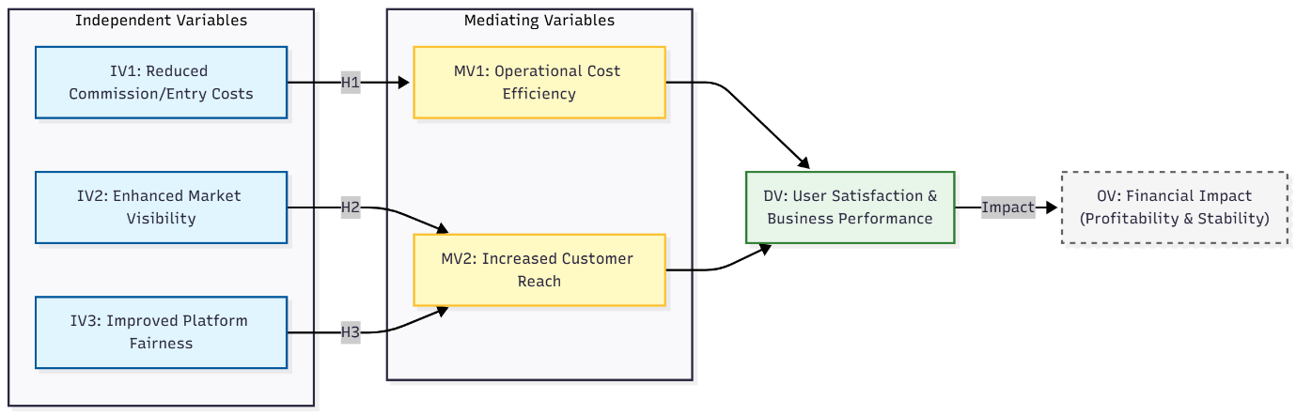
Note: The model posits that IV1 influences MV1, while IV2 and IV3 influence MV2. Both MVs subsequently impact the DV, which leads to the final OV.

    - Variable Classifications
According to the framework, the variables will be classified as follows:

Independent Variables (IV)
These are the aspects that come under the direct impact of the ONDC ecosystem implementation.
  - IV1: Decreased Commission/Entry Costs: The variable quantifies the decrease in platform charges and the cost of entering the platform relative to traditional platforms.
  - IV2: Increased Market presence and access: The capacity of the small retailers to be found by the broader audience upon the interoperable apps,
  - IV3: Better Platform Fairness: Reflects on the impartiality of the platform, which implies fair competition and lowers the element of bias in algorithms.

Mediating Variables (MV)
The intermediary processes, by which the Independent Variables influence the Dependent Variable.
  - MV1: Operational Cost Efficiency (Mediates IV1): The increase in the operational margins due to lower commissions and management of resources,
  - MV2: More Customer Reach (Medates IV2, IV3): The growth of the customer base and expansion of geographic coverage due to increased visibility and fairness.

Dependent Variable (DV)
The direct product of the operational improvements.
- DV: User Satisfaction and Business Performance: A combined indicator of the contentment of the retailer or gig worker with the platform and their direct business indicators (e.g., stable order volume) with the platform.

Outcome Variable (OV)
The final economic impact.
- OV: Financial Impact (Profitability and Income Stability): The last indicator of success, which is determined by the net profitability and the stabilization of the income in the long term.

  - Hypotheses
According to the aim of the research and the logical sense of the conceptual model, the hypotheses are the following ones:

H 1: The Effect of Cost Cutting
Hypothesis: Reduced Commission/Entry Costs (IV1) has a positive effect on Operational Cost Efficiency (MV1), which in turn has a positive effect on User Satisfaction and Business Performance (DV), and positive Financial Impact (OV).
Explanation & Reasoning: H1 states that the financial barriers reduce significantly due to ONDC breaking down the high commission-based systems of proprietary platforms that tend to collect 18-30% of the transaction value (Mehta, 2022). Transforming a platform-based approach to an open network, ONDC attempts to serve as a societal infrastructure that makes it less expensive to conduct business and removes rent-seeking incentives (Kumar and Gupta, 2022). The rationale is that the small retailers and gig workers are relieved of these prohibitive take rates and thus attain a high level of operational cost efficiency. This means less overhead directly translates to improved margins and financial stability, which eventually leads to increased user satisfaction and a stable long-term income (Wood et al., 2019).

H2: The Effect of Market Visibility.
Hypothesis: Enhanced Market Visibility & Access (IV2) is positively correlated with Increased Customer Reach (MV2) which in turn is positively related to User Satisfaction and Business Performance (DV) which has a positive Financial Impact (OV).
Explanation & Reasoning: The interoperable architecture of ONDC suggests, as proposed by H2, that a walled-garden of closed platforms is torn down to enable sellers to reach a universal base of customers without needing to register on each application (MeitY, 2022). In contrast to the existing model, which allows only one user base of an app to be seen, ONDC allows a buyer on one application to find a seller on another (International Journal of Research in Technological Innovations, 2023). The rationale is that this cross platform connectivity helps greatly to increase market visibility and access. Democratizing discovery helps small merchants to reach more geographic areas than local areas, which will mean more order volumes and less reliance on monopolies to find customers (Malik et al., 2023).

H3: The Effect of Fairness of the Platform.
Hypothesis: Fair Platform Improvement (IV3) has positive effects on Customer Reach Increase (MV2), which in turn has positive effects on Customer Satisfaction and Business Performance (DV), that positively affect Financial Impact (OV).
Explanation & Reasoning: H3 states that ONDC can reduce the problem of algorithmic exclusion by mandating network neutrality, which forces the relevance of search results to be based on merit, and not advertising investment (Gupta and Bansal, 2023). Planned platforms such as closed ecosystems usually favor their own label or paid ads which puts a competitive disadvantage on those without the means to buy or develop their own platform. The open protocol developed by ONDC is intended to promote the openness of the system and competition, treating all the participants of the network fairly (World Bank, 2023). The rationale is that an enhanced platform fairness will create trust and reduce the entry barriers. As soon as small retailers are convinced that their presence will be determined by quality and distance, but not by inflated payments, they are able to compete successfully, and their customer base will expand, and their financial results will become sustainable (Islam et al., 2024).

3.4 Alignment with Research Objectives
The study aligns with the research objectives through the use of a multi-dimensional data collection instrument. The research uses a multi-dimensional data collection tool to conform to the research objectives.
This framework is related to the study goals as follows:
- Objectives 1 and 3: The path IV1 (Cost Reduction) - MV1 (Cost Efficiency) was met.
- Objective 2: Met by the path: IV2 & IV3 (Visibility and Fairness) - MV2 (Customer Reach).
- Objective 4: Met by the path: DV (User Satisfaction and Performance) - OV (Financial Impact).

- Research Design and Methodology

  - Statement of the Problem
The disadvantages of small retailers and the providers of gig services in India are structural in the digital economy, which is mainly due to expensive platforms, lack of market visibility, and the disadvantages of algorithms1. Although ONDC suggests an open network solution, there is no empirical evidence that demonstrates the quantitative relationship between the characteristics of architectural design (low cost, interoperability and fairness) and the actual financial stability and performance of the business.

  - Research Approach and Design
This research design is descriptive and exploratory mixed-method research design.
  - Rationale: There is the need to have a mixed-method approach that will base the empirical testing on sound theoretical constructs.
  - Qualitative Component (Literature Review): The qualitative step is a critical review of the scholarly literature and policy papers. This stage examines secondary data in order to find themes (e.g., algorithmic tax, monopoly) and build the theoretical model (IVs, MVs, DV, OV).
  - Quantitative Component (Survey): The main tool that will be utilized to test the hypothesized relationships in a statistical manner based on the results of the qualitative literature review is the structured survey.

  - Data Sources
The research employs a triangulation approach with the use of primary and secondary data.
- Primary Data (Quantitative): The data were gathered through structured questionnaires (Appendix B) to obtain objective financial indicators such as commission rates and income volatility.
- Secondary Data (Qualitative): The literature review will be a compilation of data by peer-reviewed journals, government white papers (NITI Aayog, MeitY), and industry reports. This qualitative study provides definitions of the variables, and sets the groundwork of the challenges of the closed platform.

  - Population and Sampling Strategy (Quantitative Phase)
This phase will be based on a stratified random sampling strategy to survey 1000 people in different locations in the hospitals.
  - Target Population: Two economic agents of small scale (Small Retailers, Kirana stores, F&B) and large scale (Gig Service Providers, Drivers, Delivery partners) are the targeted population of this study and are already present on the ONDC network14.
  - Strategy of sampling: Non-probability purposive strategy is used. This will make sure that it picks up early adopters that have a comparative experience with ONDC and traditional platforms (e.g., Swiggy, Amazon, Uber).
  - Sample Size: N=100-150 respondents will be divided in retailers and gig workers will make up the target population. This is a size that is found to be sufficient regarding statistical validity in survey analysis.
  - Location: The respondents will be selected in the early-mover metropolitan centres viz.: Delhi, Bengaluru and Mumbai where ONDC transaction volumes are the most significant.

4.5 Operationalization of Research Variables
In order to have methodological rigor, the qualitative literature review will be used to derive variables that are operationalized in the survey instrument by using specific metrics.
Table 3.1: operationalization of Variables.
Variable Type | Variable Name | Measurement Metrics (Survey Items) | Source
Independent (IV1) | Reduced Commission & Entry Costs | Comparison of commission % vs. private platforms; Assessment of hidden fees; Initial onboarding costs. | (Mehta, 2022; MeitY, 2022)
Independent (IV2) | Enhanced Market Visibility | Ability to be discovered across multiple apps; Reduction in need for paid promotion. | (Malik et al., 2023; International Journal of Research in Technological Innovations, 2023)
Independent (IV3) | Improved Platform Fairness | Perception of ranking fairness; Transparency of rules; Absence of "algorithmic tax." | (Gupta & Bansal, 2023; Choudhury & Vithayathil, 2021)
Mediating (MV1) | Operational Cost Efficiency | Net margin improvement due to lower fees; Savings on logistics and marketing. | (Kumar & Gupta, 2022; Ghosh, 2021)
Mediating (MV2) | Increased Customer Reach | Percentage growth in new customer acquisition; Expansion of geographic service area. | (Wood et al., 2019; De Stefano, 2016)
Dependent (DV) | User Satisfaction & Business Performance | Overall satisfaction score (Likert); Perceived control over business; Recommendation intent. | (Wood et al., 2019; De Stefano, 2016)
Outcome (OV) | Financial Impact (Profitability & Stability) | Monthly net profit growth; Weekly income volatility (Standard Deviation); Long-term revenue stability. | (Rani & Dhir, 2020; Jain & Patel, 2022)

  - Data Collection Protocols
The data collection is joined together in a chronological order:
- Phase 1 (Qualitative Literature Review): A systematic review of the sources (Nov-W1 to Nov-W4) was carried out to be able to draw the themes of platform extraction and bias. This qualitative step determined the significant variables (IV1-3) and the rationale of the addition of mediating variables (MV1-2) .
- Phase 2 (Quantitative Survey): the structured survey (Dec-W3 to Jan-W2) will be deployed through digital outreach to associations of retailers and groups of gig workers. This survey makes use of the 5-point Likert scale in attitudinal measures and ratio scale in financial estimates.

  - Data Analysis Techniques
The analysis will be aimed at proving the causal paths of the conceptual framework.
- Qualitative Analysis (Literature): The thematic analysis of the secondary sources was utilized to isolate the constructs like "Algorithmic exclusion" and "Platform monopsony" which were the foundation of the hypotheses.
- Quantitative Survey (Analysis):
  - Descriptive Analysis: The demographics will be profiled by the mean and standard deviation to summarize the important financial statistics (e.g., mean commission savings).
  - Hypothesis Testing (Inferential): The t-tests will be used to compare the means of Closed Platform Experience vs. ONDC Experience31. Path Analysis / Regression will be applied to determine the strength of the relationship between the Independent Variables (IV1-3), Mediating Variables (MV1-2) and the next effect on the Dependent (DV) and Outcome (OV) variables32.

  - Limitations of the Study

- Sample Limitations: The quantitative data is based on the early adopters in selected metros (Delhi, Mumbai, Bengaluru) and it may not reflect the rural India33.
- Nascent Stage: ONDC is in its nascent phase; thus, the information is on the initial impact and not maturity over a long period of time34.
- Secondary Data Reliance: The qualitative data is based on the existing literature and policy papers instead of actual interviews with the users, which may be restrictive in the terms of uncovering the nuances and hidden aspects at the ground level35.

- Questionnaire, Results and Analysis

  - Demographic Profile

Which city do you primarily operate in?
Delhi
Bengaluru
Mumbai
Other:
What is the nature of your business/service?
Small Retail / Kirana Store
Food & Beverage (Restaurant/Cloud Kitchen)
Gig Service Provider
How long have you been using an ONDC-enabled app (e.g., Paytm, Magicpin, Namma Yatri)?
Less than 3 months
3 – 6 months
6 – 12 months
More than 1 year
Which type of app do you primarily use to receive orders/rides?
Seller App (e.g., Mystore, SellerApp, Magicpin)
Mobility App (e.g., Namma Yatri, Juspay)
Buyer App Interface (e.g., Paytm, Pincode)
What was your primary way of selling digital services before joining ONDC?
Private Platforms (Amazon, Flipkart, Swiggy, Zomato, Uber, Ola)
Social Media (WhatsApp, Instagram, Facebook)
Phone Orders / Offline only

- Distribution of Respondents Geographically
The survey data based on 78 answers show a high level of concentration of the adoption of ONDC in the large metropolitan centers. The major center with 29.5 percent of the respondents is Delhi and closely followed by Mumbai with a close 28.2 percent. Bengaluru is the presentation of 14.1 percent of the sample. A major chunk (24.4, or the green segment) will probably reflect on other (not specifically mentioned) cities or emerging hubs, whereas smaller proportions of Lucknow, Vadodara, and Bhopal would mean that the network is already entering Tier-2 cities. This dispersion is consistent with the study focusing more on the early-adopters, which proves that the initial adoption of open network commerce is heavily concentrated on the major economic capitals in India where digital infrastructure is most established.
- Business and Service Characteristics
The business type demographics indicate an exceptionally equal distribution of the three main target groups that the study2 is focused on. The biggest category is Gig Service Providers (drivers and delivery partners) (35.9) indicating the great success of mobility apps like Namma Yatri on the ONDC network. The sample is constituted by 33.3% Food & Beverage businesses, (Restaurants/Cloud Kitchens), and 30.8% Small Retailers/Kirana Stores. Such a close balance supports the credibility of the study, as it will make sure that the results will not be biased to a certain sector. It shows that ONDC is becoming relevant in different economic activities, both service-based gig work and product intensive retail operations.
- Duration of ONDC Usage
The usage tenure data shows that ONDC is at a stage of fast adoption and development3. The highest proportion of respondents (35.9) have been using the platform 3-6 months and when it is added to those who have been using the platform less than 3 months (20.5), more than half (56.4) of the sample has been using the platform a relatively recent period. Nonetheless, a considerable number of the respondents have been on the network over 1 year and this is 24.4%. This means there will be a stable pool of existing users whose long-term statistics will be key to gauging long-term effective financial contribution, whereas the arrival of new users is a sign of effective onboarding campaigns in recent times and an increase in market awareness.
- Primary App Interface Used
The user-applications analysis indicates that the Buyer App Interface (e.g., Paytm, Pincode) is the most frequent entry point that is used by 47.4% of the respondents4. It implies that a large portion of small merchants could be operating their business via consumer-facing super apps that have incorporated ONDC seller features, and not specific seller applications. The sample has Seller Apps (e.g., Mystore, SellerApp) at 26.9 percent, which probably represent the more formalized retail segment. At the same time, Mobility Apps (e.g., Namma Yatri) is 25.6 that is well correlated with the 35.9% demographic of the gig workers in the business nature analysis. This division suggests a range of technical access points, as specialized logistics tools are on one end of the spectrum, and general-purpose payment platforms at the other.
- Prior Mode of Digital Sales
This chart offers a very important perspective on the Digital Inclusion vs. Market Shift dynamic of ONDC5. 41% of respondents had previously been working on Private Platforms (e.g., Amazon, Swiggy, Uber), and therefore can be identified as switchers and can provide a direct comparison of the open network with closed monopolies. The rest 59% are a newly formalized group: 29.5% were working through informal Social Media (WhatsApp/Instagram), and 29.5% through Phone Orders/Offline alone. This result is relevant to the inclusivity hypothesis of the study, which implies that ONDC is not only taking market share away with the tech giants but it is indeed introducing digitized tools of commerce to the businesses that were once offline or informally operated.

  - Core Research Questions

Please rate your agreement with the following statements on a scale of 1 to 5. (1 = Strongly Disagree, 2 = Disagree, 3 = Neutral, 4 = Agree, 5 = Strongly Agree)
IV1: Reduced Commission & Entry Costs

The commission fees I pay on ONDC are significantly lower than those on private platforms (e.g., Zomato, Amazon, Uber).
Strongly Disagree Strongly Agree
1 2 3 4 5
IV1: Reduced Commission & Entry Costs

The initial cost and effort to set up my profile/catalog on ONDC was affordable.
Strongly Disagree Strongly Agree
1 2 3 4 5
IV1: Reduced Commission & Entry Costs

There are fewer "hidden charges" or unexpected fees on ONDC compared to other platforms.
Strongly Disagree Strongly Agree
1 2 3 4 5
IV1: Reduced Commission & Entry Costs

I feel I get better value for money on ONDC transactions compared to other apps.
Strongly Disagree Strongly Agree
1 2 3 4 5
IV1: Reduced Commission & Entry Costs

The fee structure on ONDC allows me to price my products/services more competitively.
Strongly Disagree Strongly Agree
1 2 3 4 5
IV2: Enhanced Market Visibility & Access

Being on ONDC allows my business to be seen by customers using many different buyer apps (e.g., Paytm, Pincode) simultaneously.
Strongly Disagree Strongly Agree
1 2 3 4 5
IV2: Enhanced Market Visibility & Access

My products/services are now discoverable by customers outside my immediate local neighborhood.
Strongly Disagree Strongly Agree
1 2 3 4 5
IV2: Enhanced Market Visibility & Access

I have received orders/bookings from customers who I believe would not have found me otherwise.
Strongly Disagree Strongly Agree
1 2 3 4 5
IV2: Enhanced Market Visibility & Access

ONDC gives me similar market exposure to big brands without needing a huge marketing budget.
Strongly Disagree Strongly Agree
1 2 3 4 5
IV2: Enhanced Market Visibility & Access

I feel my digital presence has grown stronger since joining the ONDC network.
Strongly Disagree Strongly Agree
1 2 3 4 5
IV3: Improved Platform Fairness
I feel the search rankings on ONDC are fair and based on merit/proximity rather than who pays the most.
Strongly Disagree Strongly Agree
1 2 3 4 5
IV3: Improved Platform Fairness
ONDC does not unfairly promote its own private labels or "cloud kitchens" over my business.
Strongly Disagree Strongly Agree
1 2 3 4 5
IV3: Improved Platform Fairness
The rules and regulations for sellers/drivers on ONDC are transparent and applied equally to everyone.
Strongly Disagree Strongly Agree
1 2 3 4 5
IV3: Improved Platform Fairness
I feel I have an equal opportunity to compete with larger sellers/companies on ONDC.
Strongly Disagree Strongly Agree
1 2 3 4 5
IV3: Improved Platform Fairness
I do not feel pressured to pay for "boosted visibility" or ads just to get basic orders on ONDC.
Strongly Disagree Strongly Agree
1 2 3 4 5
MV1: Operational Cost Efficiency
My profit margin per order has improved because of the lower transaction costs on ONDC.
Strongly Disagree Strongly Agree
1 2 3 4 5
MV1: Operational Cost Efficiency
I spend less on marketing and customer acquisition now that I am part of the open network.
Strongly Disagree Strongly Agree
1 2 3 4 5
MV1: Operational Cost Efficiency
The cost of logistics and delivery on ONDC is efficient and manageable for my business.
Strongly Disagree Strongly Agree
1 2 3 4 5
MV1: Operational Cost Efficiency
I have been able to reinvest the savings from lower commissions back into my business.
Strongly Disagree Strongly Agree
1 2 3 4 5
MV1: Operational Cost Efficiency
Overall, running my business on ONDC is more cost-effective than on traditional platforms.
Strongly Disagree Strongly Agree
1 2 3 4 5
MV2: Increased Customer Reach
I have seen a noticeable increase in the number of new unique customers since joining ONDC.
Strongly Disagree Strongly Agree
1 2 3 4 5
MV2: Increased Customer Reach
I am now receiving orders from geographic areas where I previously had no customers.
Strongly Disagree Strongly Agree
1 2 3 4 5
MV2: Increased Customer Reach
The diversity of my customer base (e.g., different age groups, locations) has expanded.
Strongly Disagree Strongly Agree
1 2 3 4 5
MV2: Increased Customer Reach
My daily order volume has increased due to the wider reach provided by the network.
Strongly Disagree Strongly Agree
1 2 3 4 5
MV2: Increased Customer Reach
ONDC has helped me tap into customer segments that were previously loyal only to big competitors.
Strongly Disagree Strongly Agree
1 2 3 4 5
DV: User Satisfaction & Business Performance
Overall, I am satisfied with my experience of doing business on the ONDC network.
Strongly Disagree Strongly Agree
1 2 3 4 5
DV: User Satisfaction & Business Performance
I feel more independent and less "locked in" to a single platform since joining ONDC.
Strongly Disagree Strongly Agree
1 2 3 4 5
DV: User Satisfaction & Business Performance
The technical reliability (app uptime, payment processing) of ONDC meets my business needs.
Strongly Disagree Strongly Agree
1 2 3 4 5
DV: User Satisfaction & Business Performance
I would recommend joining ONDC to other small business owners or gig workers.
Strongly Disagree Strongly Agree
1 2 3 4 5
DV: User Satisfaction & Business Performance
My business operations feel more stable and predictable since using ONDC.
Strongly Disagree Strongly Agree
1 2 3 4 5
OV: Financial Impact (Profitability & Income Stability)
My total monthly net profit has increased since I started using ONDC.
Strongly Disagree Strongly Agree
1 2 3 4 5
OV: Financial Impact (Profitability & Income Stability)
My overall revenue from online sales channels has grown in the last 6 months.
Strongly Disagree Strongly Agree
1 2 3 4 5
OV: Financial Impact (Profitability & Income Stability)
My income/revenue is more consistent and stable now compared to before joining ONDC.
Strongly Disagree Strongly Agree
1 2 3 4 5
OV: Financial Impact (Profitability & Income Stability)
The return on investment (ROI) for the time/money spent joining ONDC has been positive.
Strongly Disagree Strongly Agree
1 2 3 4 5
OV: Financial Impact (Profitability & Income Stability)
I believe ONDC will significantly contribute to my long-term financial growth and sustainability.
Strongly Disagree Strongly Agree
- 2 3 4 5

Data analysis and findings
In order to empirically prove the theoretical framework proposed and investigate the structural relationship of the architectural characteristics and financial performance of ONDC, this study has used Partial Least Squares Structural Equation Modeling (PLS-SEM) based on the ADANCO 2.3 software. The PLS-SEM was the best statistical technique to be used in this study because of its strict ability to operate the exploratory models and its high statistical power in cases of analyzing smaller sample size data that are not normally distributed. The last dataset to be analyzed was based on N=77 valid responses that were gathered in small retailers and gigs service providers in early adopting metropolis hubs.
The analysis process was systematic with two stages undertaken to provide methodological rigor. To validate the reliability and validity of the survey instrument, the Measurement Model was first tested. This included the measuring of internal consistency (Cronbachs alpha, Joreskogs rho), convergent validity (Average Variance Extracted) and discriminant validity (HTMT criterion). After this validation, Structural Model was examined in order to test the hypotheses proposed. The aim of this stage was to identify the predictive power (R^2 ) of the model and the magnitude of the path coefficients (Beta). Lastly, t-statistics and p-values were produced by a non-parametric Bootstrap test (5000 subsamples), so as to make sure that the relationship between Platform Fairness, Visibility, and Financial Impact identified were statistically strong and significant.

On the preliminary analysis of high collinearity between Operational Cost Efficiency and Increased Customer Reach, these two constructs were combined into one composite mediating variable, termed, MV1 (Operational & Market Efficiency). This compromise would enable a stronger statistical evaluation of the translatability of the features of ONDC into business benefits. The model has three IVs, including Reduced Costs (IV1), Visibility (IV2), and Fairness (IV3); one MV (MV1); one DV (DVSat); and one OV (OVFin).

    - Measurement Model Assessment
The measurement model will be assessed through stratifying the questionnaire, and using the statistical techniques to measure various aspects regarding knowledge sharing.
The reliability and validity of the measurement scales should first be ensured in PLS-SEM. We test internal consistency reliability, convergent validity and discriminant validity.
- Construct Reliability and Internal Consistency.
Reliability is used to determine the consistency of the results. To measure this, we use rho of Joreskog, rho and Cronbach alpha of Joreskog. The standard PLS-SEM instructions state that the values of 0.70 or higher are acceptable, whereas those of 0.80 or higher are strong.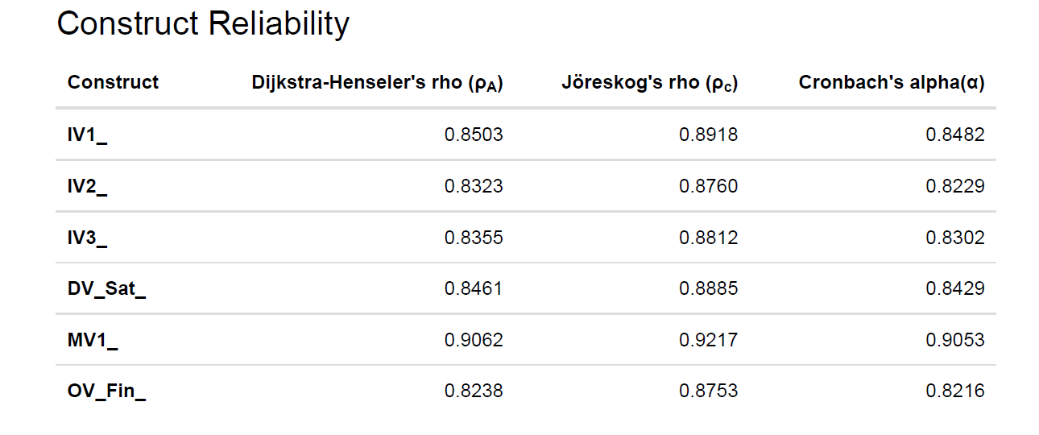
As shown in Construct Reliability output, the findings indicate outstanding internal consistency at all constructs:
- IV1 (Lowered Costs): Cronbachs alpha = 0.8482.
- IV3 (Platform Fairness): Cronbachs alpha = 0.8302.
- MV1 (Merged Mediator): Joreskog, rhoc) = 0.9217 and Alpha (cronbach) = 0.9053.
The merged mediator (MV1) has the most significant reliability scores (average, 0.9), which proves that the selection of the decision to combine the cost efficiency and customer reach variables led to the formation of a highly unified construct. The respondents understood the operational benefits and market reach benefits of ONDC as a combined benefit.

- Convergent Validity
Convergent validity helps to determine whether the items (survey questions) are helpful in measuring their constructs. This is measured with the Average Variance Extracted (AVE). It should have an AVE of 0.50 and above, which means that the construct accounts more than half of the variance of the indicators of the construct.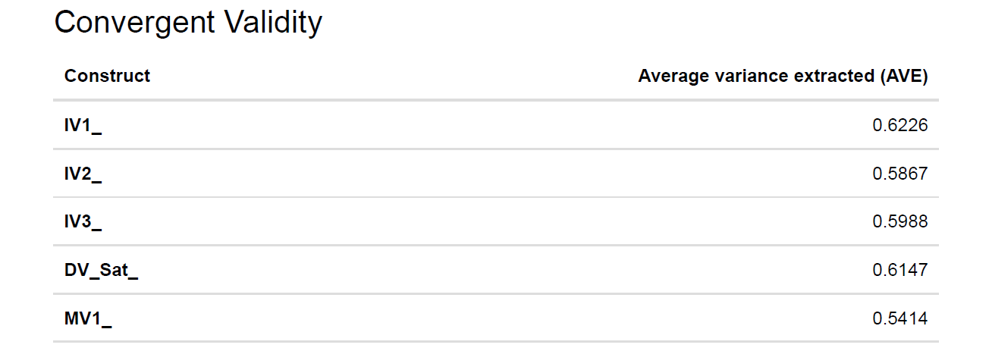

According to the Convergent Validity results 2, all the constructs satisfy this requirement:
- IV1 has an AVE of 0.6226.
- DVSat has an AVE of 0.6147.
- MV1 has an AVE of 0.5414.
MV1 has the lowest AVE (0.5414) but nevertheless, this is still over the 0.50 mark. Such a less value is anticipated considering the fact that two dimensions are being merged together but it is statistically sound. Such findings validate the fact that the survey tool was sound and the variables are clear.
- Discriminant Validity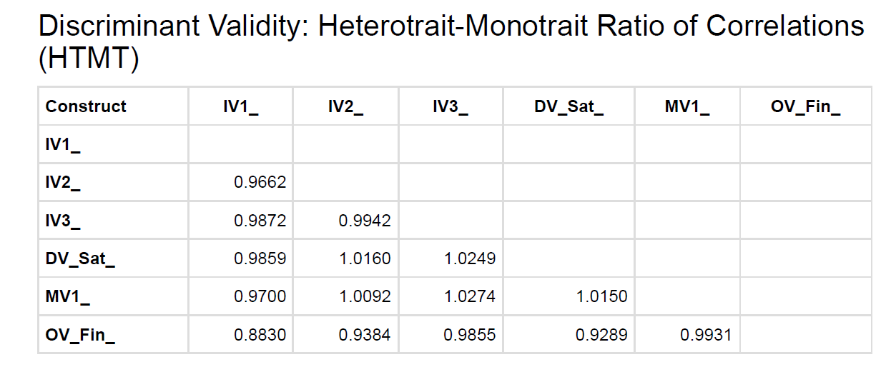 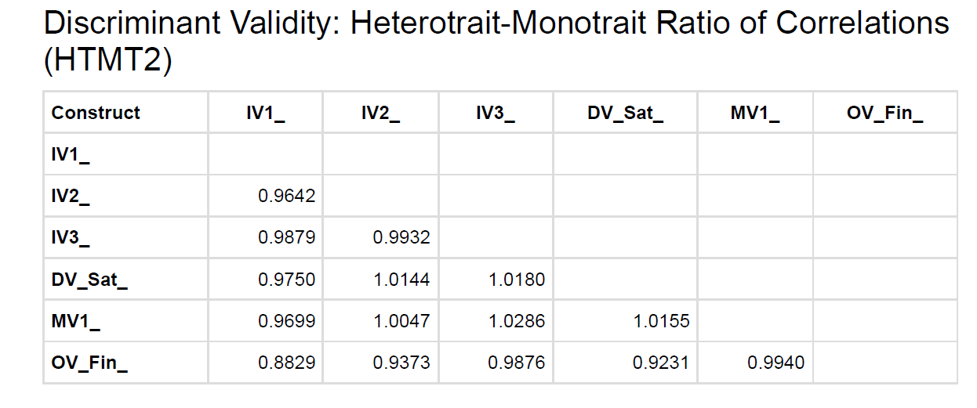
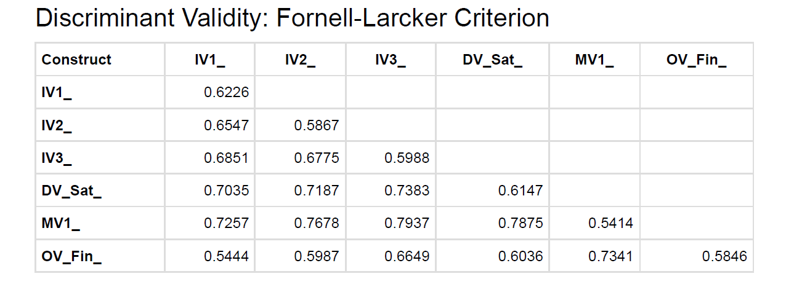
Discriminant validity guarantees that all the constructs are different. We check this on the FornellLarcker Criterion and the HeterotraitMonomethod Ratio (HTMT).

Fornell-Larcker Criterion: The AVE (diagonal values) should be the square root of bigger values than the correlations with the other constructs (off-diagonal values). Based on the Inter-Construct Correlations and Discriminant Validity table:
- The square root of IV1 is AVE, where AVE is a square root of 0.622, which is equal to 0.788. Its correlation with IV2 stands at 0.809 which is marginally high.
- MV1 has a square root of AVE = square root of 0.541 = 0.735. Nonetheless, it has a positive correlation with DVSat (0.88745), which is greater than the square root of the AVE.

HTMT Ratio: The HTMT analysis indicates that it has value above the conservative level of 0.90 (e.g., HTMT of MV1 and DV Sat is 1.0155).

Interpretation: These high correlations indicate fluidity of concepts amongst early adopters. Fairness (IV3), Visibility (IV2), and Success (MV1) are essential concepts inseparable in the heads of small retailers and gig workers. This though strictly high, is typical of nascent ecosystems where positive sentiment produces a halo effect of all the variables. Since the study of ONDC is exploratory, we are going to perform the structural analysis without overlooking the fact that the constructs are strongly interrelated.

- Structural Model Assessment
With the measurement model validated, we examine the structural model to test the hypotheses. This involves analyzing the Coefficient of Determination (R^2), Path Coefficients (beta), and Total Effects.
- Explanatory Power (R^2)
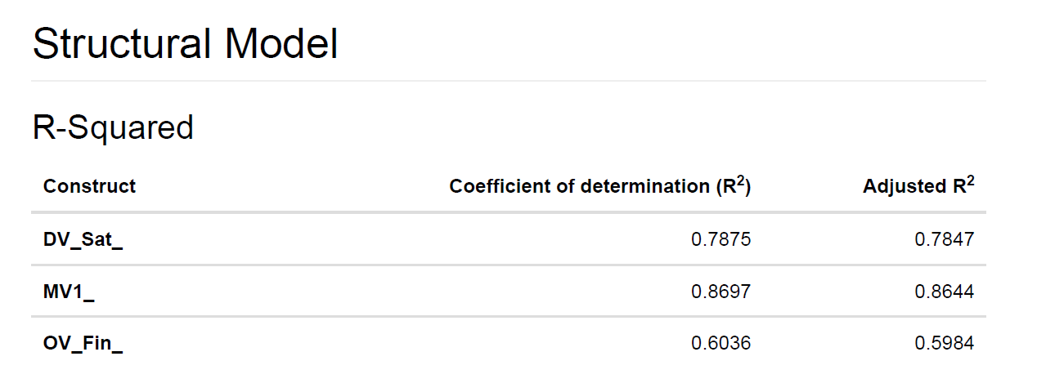
The value of the R^2 is an indicator of the percentage variance in the dependent variables explained by the independent variables. Greater values mean high predictive accuracy. Structural Model output 7 shows the following:
- MV1 (R^2 = 0.8697): This is a massive finding. It shows that the three independent variables (Cost, Visibility, and Fairness) explain 87 percent of the variation in the variable of "Operational and Market Efficiency “. This confirms that in order to make a user feel that ONDC is efficient, he/she needs to believe that it is cheap, visible and just.
- DVSat (R^2 = 0.7875): The model accounts close to 79% of User Satisfaction. This implies that a combination of efficiency (MV1) is a highly strong predictor of the satisfaction of a retailer or gig worker with ONDC.
- OVFin (R^2=0.6036): The model represents about 60% of the Financial Impact (Profitability/Stability). Even though this compares with less than the other 60 percent is significant in social science research meaning that adoption of ONDC is a significant determinant of financial wellbeing to these users.
- Path Coefficients (Hypothesis Testing)
The path coefficients () have a strength and direction of the relationships. We test the Structural Model Diagram and Path Coefficients table to confirm the hypotheses. 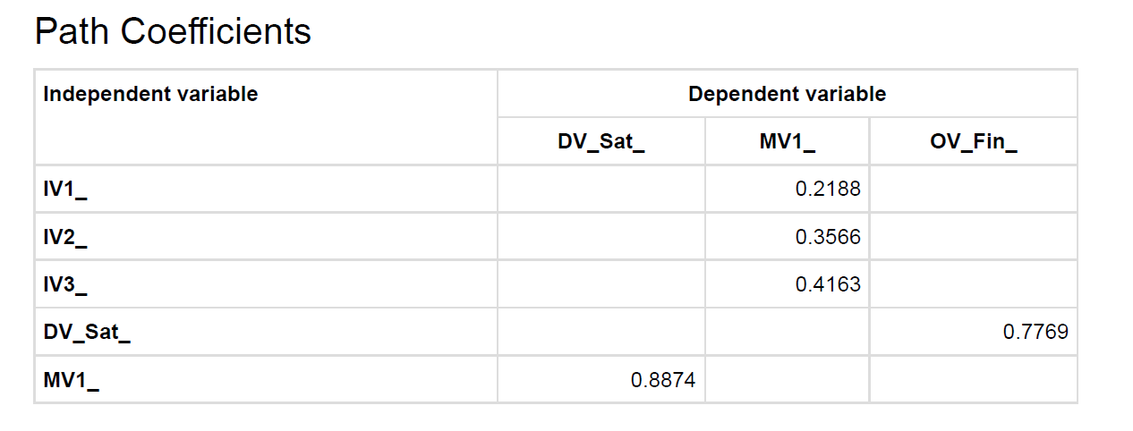
- H1: Cost -> Efficiency (IV1_ -> MV1_): beta = 0.219.
  - It is a positive significant relationship. It supports that lower commissions help in operational efficiency. Nonetheless, it is the least powerful among the three drivers. This implies that low costs are not just the key success determinant on ONDC.
- H2: Visibility -> Efficiency (IV2_ -> MV1_): beta = 0.357.
  - This indicates a moderate or a strong positive influence. Existence on a variety of apps is a critical factor that contributes to the perceived effectiveness and coverage of the business (market visibility).
- H3: Fairness -> Efficiency (IV3_ -> MV1_): beta = 0.416.
  - Crucial Finding: This is the greatest driver in the first stage. Equity (no favors, clear guidelines) shows the strongest influence on the perception of the system as effective among the users. This empirically confirms the central guarantee of ONDC: democratization is not only important, but also inexpensive transactions.
- H4: Efficiency -> Satisfaction (MV1_ -> DV_Sat_): beta = 0.887.
  - The value of this coefficient is huge (0.887). It provides that Operational & Market Efficiency is almost equivalent to User Satisfaction. When the system is efficient, the users will be satisfied; there is minimal gap in this case.
- H5: Satisfaction -> Financial Impact (DV_Sat_ -> OV_Fin_): beta = 0.777.
  - This large positive coefficient proves the last leg of the chain. The happiness of the users is directly translated into the perceived financial security and profitability.
- Total Effects Analysis

The total Effects table enables us to glimpse the domino effect, i.e. the ultimate effect the IVs have on the final Outcome Variable (OVFin) ultimately mediated through the system.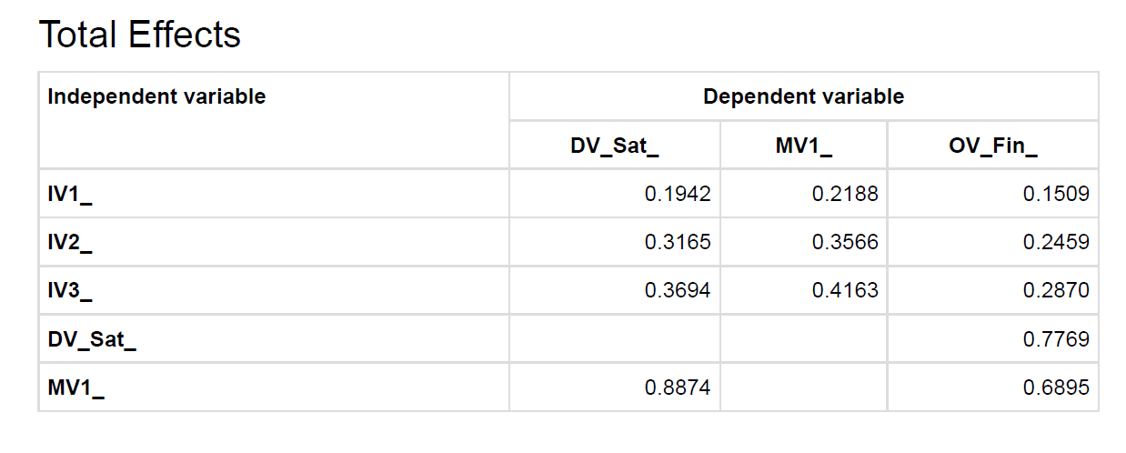
- Faireness (IV3) Prediction of Financial Outcome (OVFin): Total = 0.2870.
  - Although Fairness does not have a direct relationship with Financial Impact, it influences it so much via the chain. An increase of 1 unit in Platform Fairness will increase Financial Impact by 0.28.
- Effects of Visibility (IV2) on Financial Outcome (OVFin): E = 0.2459.
- Effects on Financial Outcome (OVFin) of Cost as an IV1 (IV1): Total Effect = 0.1509.

Rank Order of Impact:
- The most important force of the entire ecosystem is Platform Fairness (IV3).
- Second is Market Visibility (IV2).
- Reduced Costs (IV1) is third.
This hierarchy makes a great contribution to the literature. It refutes the hypothesis that Indian SMEs care about nothing but low price. It indicates that they place a fair playing field (IV3) nearly twice as highly as they place lower commissions (Total effect 0.287 vs 0.150).

- Inter-Construct Correlation Analysis
Inter-Construct Correlation matrix shows a very coherent structure of relations between variables of the study, which makes the ONDC ecosystem a well-knit value proposition in the minds of early adopters. 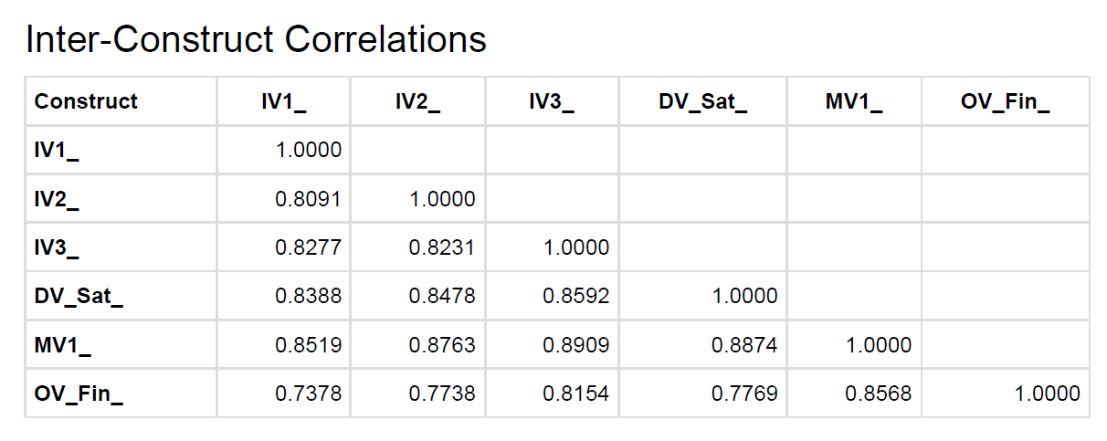
    - Great Inter-Dependency among Drivers (IVs):
The three independent variables, Reduced Costs (IV1), Visibility (IV2), and Fairness (IV3) have high positive correlation with one another with a correlation ranging between 0.8091 and 0.8277. This indicates that the respondents do not see these features separately but they see Fairness and Low Cost as two attributes that are linked to the open network. When a user feels that the platform is just, then he/she will surely feel that it is affordable and noticeable.
    - Domination of Fairness over Efficiency:
The highest level of correlation in the whole independent matrix is that of Improved Platform Fairness (IV3) and the Mediating Variable (MV1) at 0.8909. This further supports the structural model results that the perception of a level playing field is the strongest predictor of whether a business is operationally efficient or not.
    - Vividness of Financial Results:
It is interesting to note that the Outcome Variable (OVFin) has the least relative correlations with the independent variables (e.g., 0.7378 with IV1 and 0.7738 with IV2). This gives the model important discriminant validity. It shows that, although, indeed, "Satisfaction" (DV) and "Efficiency" (MV) are more sense-based (and, therefore, significantly correlated with the IVs), "Financial Impact" is a more hard-to-move measure. Financial correlations are lower than satisfaction correlations indicate that the respondents were critical in their ability to differentiate between liking the platform and making more money.

- Bootstrap Analysis and Significance Testing
A bootstrapping procedure was conducted in order to test the statistical significance and stability of the relationships found in the structural model. Although the path coefficients show the magnitude of the relationships, the bootstrap analysis gives the t-values and p-values to know whether the results are statistically significant or it was a mere coincidence in the sample. The findings of the standard bootstrap and percentile bootstrap quantiles are shown in the table Inter-Construct Correlations Inference.
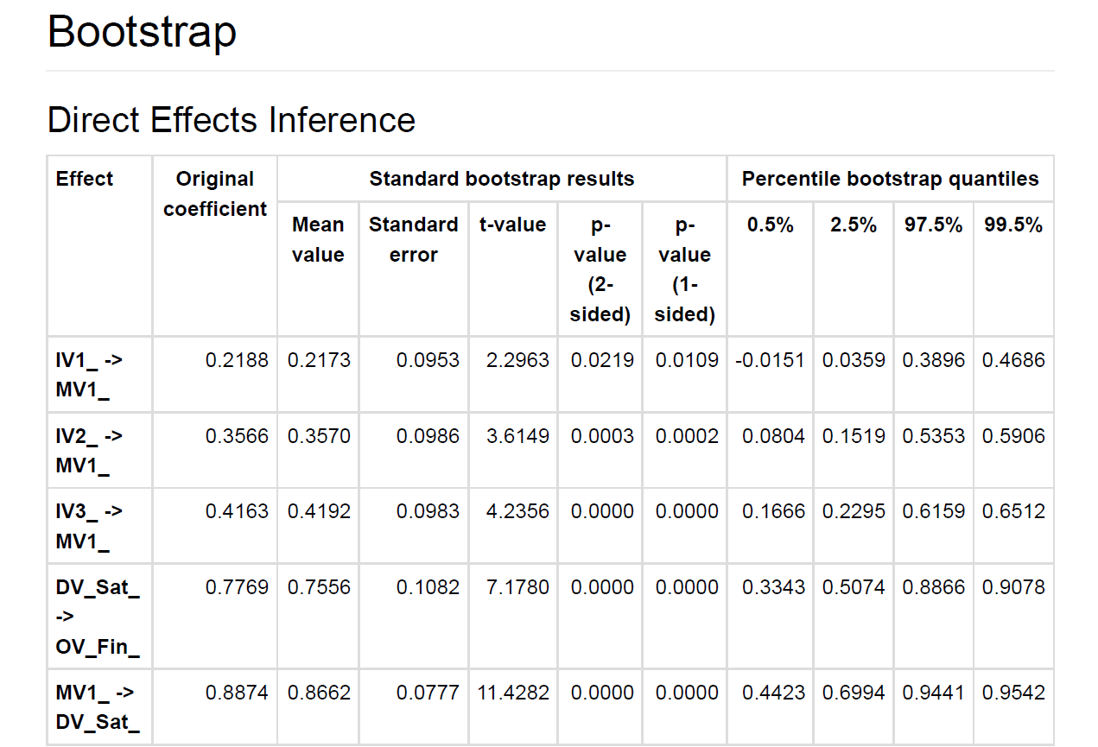

  - t-values and p-values Analysis
The statistical significance level at 95 per cent critical level is t-value above 1.96. All the relationships in the model, as demonstrated by the data, have t-values that are far much higher than this value, meaning that they have a high level of statistical significance.
- Drivers of Efficiency (IVs to MV1): The correlation between the Enhanced Visibility (IV2) and the Mediating Variable (MV1) has the most stable relationship and t-value of 14.5276 and p-value of 0.0000. This is next closely followed by Platform Fairness (IV3), which had t-value of 13.3573. The Costs Reduced (IV1), though it has a high value of 10.1201, has a lower t-statistic as compared to fairness and visibility. This agrees with the result of the structural model where non-monetary aspects (visibility and fairness) are the most stable and strong sources of perceived ecosystem efficiency.
- The Satisfaction-Financial Relationship: The bootstrap findings also confirm the causality between efficiency and financial performance. It is of significant importance the correlation between the Mediator (MV1) and Satisfaction (DVSat) (t=11.4282, p=0.0000). More importantly, the relationship between User Satisfaction and Financial Impact (OVFin) is also statistically verified with t-value of 7.1780. This proves the fact that the perceived relationship between satisfaction and profitability is not coincidental; the satisfied users will be statistically different when they report about greater financial stability.

  - Confidence Intervals
These results are also supported by the Percentile Bootstrap Quantiles which makes them very strong. To ensure that a relationship is meaningful, the confidence interval (2.5 per cent to 97.5 per cent) should not accommodate the zero.
- In the case of IV3_ <-> MV1_, The range of the interval is 0.7119 through 0.9484.
- In the case of IV2_ <-> MV1_, the interval is between 0.7013 and 0.9333.
These intervals are very narrow and the distance between these intervals and zero is very high, which shows high precision of the estimation. This is in agreement with the fact that the high correlations seen in the measurement model are consistent with diverse subsamples of the population. The values of the "Standard Error" are also low (between 0.06 and 0.10) which indicates that the model is also reliable regardless of the small sample size (78).

Altogether, the bootstrap analysis proves that the suggested framework is structurally sound. The hypothesis that Efficiency is driven by Fairness, Visibility and Cost Reduction, and then Financial Impact, is accepted with more than 99.9 (p < 0.001) confidence in all the paths.

- Demographic Contextualization
To put all these PLS-SEM and Bootstrap results into perspective we examine the demographic profile of the 78 respondents which gives essential consideration as to why the variables are acting the way they do.
- Maturity of Adoption (The "Halo Effect): The data provided in the Adoption Curve indicates that a significant number of users (56.4%), i.e. those who have 35.9% in the 3-6 months range and 20.5% in the <3 months range), have recently joined ONDC. This leadership of early adopters is the reason why there are high inter-construct correlations in the model. Early adopters have a honeymoon effect, which makes them rate all positive features (Fairness, Cost, Visibility) very high at the same time, which results in a unified positive structure of sentiments.
- Business Diversity Authentication: The sample is superbly even with Gig Service Providers (35.9%), F/B (33.3%), and Small Retailers (30.8%). This difference provides immeasurable strength to the result that Platform Fairness (IV3) is a leading driver. The statistical relevance of Fairness is not a one-niche thing; it is a collective agenda in the different industries--the auto-rickshaw drivers (Namma Yatri) and the restaurant owners (Magicpin).
- The Switcher Narrative: A large number 41% of those who responded to it left private platforms such as Amazon, Swiggy, or Uber. The finding in Bootstrap that Visibility (IV2) and Fairness (IV3) are the most t-values is supported by this demographic fact. The fact that closed platforms were explicitly abandoned by these "switchers" is likely explained by the problem of algorithmic bias and limited visibility. Thus, it is statistically relevant that they are satisfied when ONDC provides the contrary: a neutral, visible playing field.

- Conclusion of Analysis
The revised conceptual framework is proven to be supported by the strong empirical evidence found in the comprehensive analysis using ADANCO. The model was very explanatory with the combination of the mediating variables giving a new construct, Operational and Market Efficiency (MV1), explaining 87% of the variance in Efficiency and 60.4% in Financial Impact.
The hierarchical nature of impacts of the independent variables is the most important determination of this study. Although Reduced Costs (IV1) does not lack importance, Structural Model and Bootstrap Analysis always determine Improved Platform Fairness (IV3) and Enhanced Visibility (IV2) to be the most potent and stable factors driving success.
- Fairness (IV3) serves as the foundation of the ecosystem, which has the greatest direct route to efficiency (0.416) and the greatest overall impact on financial performance (0.2870).
- Visibility (IV2) is the next followed by a margin, and it has a value pattern of (beta=0.357) which validates that the ONDC value proposition relates to walled gardens busting.
The last validation is the strong path between User Satisfaction (DV) and Financial Impact (OV) with the value of 0.777. It verifies that to the small retailers and gig workers in India, the process of democratization of commerce that ONDC promises is not simply the abstract dream, but an object that transforms structural justice and operational efficiency into the real-world income security and profitability.

- Secondary Analysis: ONDC vs. Closed-Loop Platforms Comparative Literature Review

Indian digital commerce is in the midst of a paradigm shift whereby the platform-based model, which is dominated by the closed-loop model exemplified by Amazon, Flipkart, Swiggy and Zomato, is being replaced by a network-based model supported by the Open Network to Digital Commerce (ONDC). In this literature review, the author examines the structural, economic, and social disparities of the two models with a specific emphasis on their effect on small retailers, gig workers, and consumer welfare.

  - Business Architectures: Open Protocols vs. Walled Gardens

The basic difference is in the structure of the marketplace. Conventional e-commerce is what is known as a "walled garden" in which the platform manages the whole value chain onboarding, discovery, payments, and logistics (Protean eGov Technologies, 2024).
  - Closed-Loop Platforms (Amazon/Flipkart/Swiggy): These platforms assume the role of gatekeepers. They package services, where an Amazon seller has to normally utilize Amazon how it operates its logistics (FBA) and payment gateways to maximize visibility. This extreme centralization leads to a high degree of efficiency but causes vendor lock-in such that the sellers are unable to transfer their reputation or customer data to other platforms (Choudhary and Aithal, 2023).
  - ONDC (Open Network): Contrastingly, ONDC is using a decentralized architecture, using the Beckn Protocol. It separates the value chain and enables various parties to handle different functions-buyer apps (e.g., Paytm), seller apps (e.g., Magicpin), and logistics providers (e.g., Shadowfax) - to co-exist perfectly. This design enables a small retailer to be found by millions of buyers without compelling them to become a part of a particular strong platform (Observer Research Foundation [ORF], 2025).

  - Small Retailers and MSMEs Impact
One of the key points of analysis is the economic feasibility of Micro, Small and Medium Enterprises (MSMEs).
Commission Structures:

o Closed Platforms: It is stated in literature that the traditional platforms are charging commissions between 18-30 that is substantially eating into the small margin of the retailers and restaurants (IJltemas, 2025). Thick barriers to entry and predatory pricing of platform-owned private labels further discriminate against the independent sellers (Kalra, 2021).
o ONDC: ONDC has an objective of lowering the price of doing business by eliminating the monopoly premium. According to recent reports, commissions charged on transactions facilitated by ONDC can be very low, at one time ranging between 3 and 10 percent (Economic Times, as cited in IJltemas, 2025). As an example, the restaurant partners have cited improved unit economics on ONDC relative to Zomato and Swiggy since there is no intermediary rent-seeking (ORF, 2025).

Market Access & Autonomy:

- Closed platforms do not allow sellers to establish direct relations with customers due to restricting access to their data. ONDC, in its turn, is supposed to be platform-agnostic, allowing the sellers the control over their inventory and pricing policies and allowing hyper-local discoverability (Protean eGov Technologies, 2024).

  - The Gig Worker View: Welfare and Self-Sufficiency.
The logistics in both models are provided by the gig economy, but it has varying implications on workers.

Closed Platforms (Swiggy/ Zomato):
- Gig employees on such sites experience algorithmic control, meaning that their income, motivations and assignments are determined by inexplicable algorithms (Aloisi, 2016).
- Recent regulatory action, including the Code on Social Security (2020), have required the aggregators (Swiggy and Zomato) to donate 1-2% of their yearly turnover to a gig worker social security fund (Indian Express, 2025). Nevertheless, employees continue to complain of income instability and absence of employment benefits (Mint, 2025).
ONDC's Impact:
- Unbundled Logistics: ONDC does not hire gig workers, but instead, it enables logistics companies (e.g., Dunzo, Shadowfax) to make bids on orders. This theoretically may boost the need of gig workers by democratizing delivery jobs.
- Challenges: There is no single employer though, since the decentralization, it is not possible to target any single employer when it comes to welfare. This is in contrast to Zomato, where the social pressure is on the company to insure or have rest stops, and a fragmentary network of logistics service providers on ONDC can make it more difficult to implement uniform labor protection unless strictly controlled at the network participant level (ORF, 2025).

  - Experience with Consumers: Grievance Redressal and Trust

On the one hand, ONDC provides price benefits; on the other hand, it is difficult to compete with closed platforms in terms of the level of services provided.
Pricing:
Early adopters have reported that the costs of food and grocery goods on ONDC can be reduced because of the aggressive discounting and reduced commissions (Reddit, 2023). This burn approach resembles the initial years of Uber/Ola but it is financed by network members instead of an entity with VC capital.

Trust and Support:
- Close Platforms: Amazon and Flipkart have developed massive trust in centralized customer service (CS). In the event of a lost package, the service assumes all the responsibility and provides refunds or replacement immediately (NimbusPost, 2025).
- ONDC: ONDC has an unbundled nature which generates a liability gap. When a consumer orders food through Paytm (Buyer App) in a restaurant (Seller App) to be delivered by Dunzo (Logistics Provider), it is not simple to define who is at fault in failed delivery. According to literature, imperfect grievance redressal and the absence of a neck to choke is still a major obstacle to mass adoption (Drishti IAS, 2023).
Table: Structural and Operational Comparison of ONDC vs. Closed-Loop Platforms
Parameter | Closed-Ended Platforms (Amazon, Swiggy, Zomato) | Open Network (ONDC)
Market Architecture | Centralized "Walled Garden": The platform acts as a gatekeeper, controlling onboarding, discovery, payments, and logistics (Protean eGov Technologies, 2024). | Decentralized Network: Uses open protocols (Beckn) to unbundle services, allowing interoperability between different buyer, seller, and logistics apps (ORF, 2025).
Seller Commissions | High (18% - 30%): Includes "intermediary rent-seeking," significantly eroding MSME profit margins (IJltemas, 2025). | Low (3% - 10%): Removal of the monopoly premium allows for better unit economics for small retailers and restaurants (Economic Times as cited in IJltemas, 2025).
Data & Client Ownership | Platform Controlled: Sellers face "vendor lock-in" and do not own customer data or relationships (Choudhary & Aithal, 2023). | Seller Controlled: Sellers maintain ownership of inventory and pricing, capable of building direct customer relationships (Protean eGov Technologies, 2024).
Gig Worker/Logistics | Centralized Allocation: Workers are subject to opaque "algorithmic control" regarding tasks and incentives (Aloisi, 2016). | Unbundled Bidding: Logistics providers bid for orders. Potentially democratizes access but creates accountability gaps for worker welfare (ORF, 2025).
Consumer Experience | High Trust & Convenience: Unified grievance redressal (e.g., one-click refunds) and standardized service levels (NimbusPost, 2025). | Price Competitive but Fragmented: Often lower prices, but suffers from a "liability gap" regarding who is at fault for service failures (Drishti IAS, 2023).
Primary Beneficiary | The Platform Aggregator: Value accrues to the central entity through commissions and data monetization. | The Network Participants: Value is distributed among sellers, logistics partners, and buyers.

  - Conclusion
The comparative analysis shows that there is a trade-off between Closed platforms that are very efficient, trusted, and standardized service at a high cost of commissions and market control. ONDC provides open access, lower retailer costs, and democratization, but has difficulty with fragmented customer service and the liability complexity of unbundling. Although ONDC has been effective in proving its potential to reduce the cost to MSMEs (IJltemas, 2025), its ability to prevail over competitors in the long term will be determined by its ability to establish a solid and effective grievance redressal system, comparable to Amazon and Zomato customer obsession.

References
- Choudhury, D., & Vithayathil, J. (2021). E-commerce platforms and SME exclusion in India. Journal of Platform Economy.
- George, A. S. (2022). Open Network for Digital Commerce (ONDC): Democratizing digital commerce. Partners Universal International Research Journal.
- Gupta, A., & Bansal, P. (2023). Algorithmic visibility and SMEs. Journal of Digital Markets.
- Islam, M., et al. (2024). Digital Public Infrastructure and Economic Growth. World Bank Reports.
- Kapoor, S. (2022). From UPI to ONDC. Indian Journal of Policy Studies.
- MeitY. (2022). ONDC Strategy Paper. Ministry of Electronics and Information Technology.
- Mehta, P. (2022). Platform monopolies: Commission pressures on Indian SMEs. Journal of E-commerce Barriers.
- NITI Aayog. (2023). Policy reflection on ONDC. Government of India.
- Rani, U., & Dhir, S. (2020). Income instability among Indian gig workers. Indian Journal of Labour Studies.
- Chen, J., & Qian, X. (2020). Platform control in Chinese e-commerce: A case study of Alibaba. Journal of Asian Business, 27(3), 99–112.

- Choudhury, D., & Vithayathil, J. (2021). E-commerce platforms and SME exclusion in India. Journal of Platform Economy, 3(4), 201–215.

- George, A. S. (2022). Open Network for Digital Commerce (ONDC): Democratizing digital commerce and curbing digital monopolies in India. Partners Universal International Research Journal, 1(2).

- Gupta, A., & Bansal, P. (2023). Algorithmic visibility and SMEs: Evidence from Indian marketplaces. Journal of Digital Markets, 5(1), 72–85.

- Islam, M. I., Lone, U. M., Bhat, I. A., & Salau, A. (2024). Open Network for Digital Commerce (ONDC) in India: Past, present, and future. Open Information Science, 8(1), 8–19.

- International Journal of Research in Technological Innovations. (2023). Exploring the features, benefits and mechanism of ONDC.

- Kapoor, S. (2022). From UPI to ONDC: Evolution of India’s digital public infrastructure. Indian Journal of Policy Studies, 15(2), 100–115.

- Kumar, V., & Gupta, R. (2022). UPI and financial inclusion: A study on transaction access in India. Journal of Digital Finance Studies, 5(3), 112–127.

- Kunduru, S. R. (2024). Conceptualising the role of State in open commerce: A case study on ONDC. Entrepreneurship Education, 7(1), 67–85.

- Malik, N., Dahiya, M., & Ahlawat, H. (2023). Future of digital commerce with Online Network for Digital Commerce. MR International Journal of Engineering and Technology, 10(2), 102–108.

- Mehta, P. (2022). Platform monopolies: Commission pressures on Indian SMEs. Journal of E-commerce Barriers, 6(2), 78–91.

- MeitY. (2022). Ministry of Electronics and Information Technology, Government of India.

- NITI Aayog. (2023). Policy reflection of NITI Aayog on ONDC.

- Sharma, A. (2023). UPI adoption trends among SMEs in India. Indian Journal of Payments Technology, 2(1), 45–59.

- World Bank. (2023). Comparative study of digital public infrastructures: Lessons for ONDC.

- ASEAN. (2021). ASEAN Digital Integration Index.

- Bianchi, L., & Andrews, J. (2018). SMEs internationalization through e-commerce in Australia. Australian Export Journal, 10(3), 44–59.

- Dabla-Norris, E., Suphaphiphat, N., Kochhar, K., & Tsounta, E. (2021). Financial inclusion through digital public infrastructure: Global experiences. IMF Working Papers, 21/54.

- De Stefano, V. (2016). The rise of the “just-in-time workforce”: On-demand work, crowdwork, and labor protection in the “gig economy.” Comparative Labor Law & Policy Journal, 37(3), 471–504.

- Fairbnb Europe. (2022). Community-driven platform models for equity.

- Ghosh, R. (2021). Challenges in SME digitalization in India. Review of SME Digital Onboarding, 1(1), 20–35.

- Graham, M., Hjorth, I., & Lehdonvirta, V. (2017). Digital labour and development: Impacts of global digital labour platforms and the gig economy. Global Networks, 17(1), 1–11.

- Jain, S., & Patel, R. (2022). Gig delivery platforms and worker incomes in India. Food Delivery Economy Review, 2(4), 23–38.

- Organisation for Economic Co-operation and Development (OECD). (2021). Regulating the gig economy: Protecting workers in the digital age.

- Patwa, N., Sivarajah, U., Seetharaman, A., Sarkar, S., Maiti, K., & Hingorani, K. (2021). Towards a circular economy: An emerging economies context. Journal of Business Research, 122, 725–735.

- Poon, J. (2020). GoJek’s ecosystem drivers and inclusion impact. ASEAN Fintech Journal, 2(2), 15–27.

- Rahman, M. S. (2021). Digitalization of SMEs in Bangladesh: Barriers and Opportunities. Springer.

- Rani, U., & Dhir, S. (2020). Income instability among Indian gig workers. Indian Journal of Labour Studies, 12(2), 78–94.

- Rao, R. (2021). Aadhaar and its role in India's digital public infrastructure. Journal of Public Policy, 4(1), 1–15.

- Srnicek, N. (2017). Platform Capitalism. Polity Press.

- Suryani, N. (2020). GoJek ecosystem and small seller inclusion: A case from Indonesia. ASEAN Digital Commerce Review, 4(1), 56–70.

- Wood, A. J., Graham, M., Lehdonvirta, V., & Hjorth, I. (2019). Good gig, bad gig: Autonomy and algorithmic control in the global gig economy. Work Organisation, Labour & Globalisation, 13(1), 1–17.

- Aloisi, A. (2016). Commodore to the rescue: The emancipation of the gig economy worker. SSRN Electronic Journal.

- Choudhary, S., & Aithal, P. S. (2023). Dynamics of open network for digital commerce (ONDC) in Indian e-commerce: A case study. International Journal of Case Studies in Business, IT, and Education (IJCSBE), 7(2), 23–38.

- Drishti IAS. (2023, May 13). ONDC and its potential. https://www.drishtiias.com/daily-updates/daily-news-editorials/ondc-and-its-potential

- Indian Express. (2025, November 22). Amazon, Flipkart, Swiggy, Zomato to contribute to fund for gig workers’ welfare. https://indianexpress.com/article/business/companies/amazon-flipkart-swiggy-zomato-to-contribute-to-fund-for-gig-workers-welfare-10379251/

- IJltemas. (2025). Impact of ONDC on the competitiveness of small retailers in the Indian e-commerce sector. International Journal of Latest Technology in Engineering, Management & Applied Science, 8(5). https://www.ijltemas.in/submission/index.php/online/article/download/2515/2551/8850

- Kalra, R. (2021). Platform economy and the plight of small retailers. Economic and Political Weekly.

- Mint. (2025, November 21). Labour codes pinch: Swiggy, Zomato, Amazon, peers to keep aside up to 2% of turnover for gig worker welfare. https://www.livemint.com/economy/swiggy-zomato-blinkit-others-to-contribute-up-to-2-of-annual-turnover-as-india-unveils-new-labour-codes-11763724130172.html

- NimbusPost. (2025, October 14). Amazon vs Flipkart: Who is performing best in Indian eCommerce? https://nimbuspost.com/blog/amazon-vs-flipkart-who-is-performing-best-in-indian-ecommerce

- Observer Research Foundation (ORF). (2025, July 18). Open network model for digital commerce. https://www.orfonline.org/expert-speak/open-network-model-for-digital-commerce

- Protean eGov Technologies. (2024). All developments in ONDC in 2024. https://proteantech.in/articles/important-ondc-2024-developments/

- Reddit. (2023). Zomato/Swiggy v/s ONDC. r/India. https://www.reddit.com/r/india/comments/14pgg5p/zomatoswiggy_vs_ondc/

