=======================================

**MILESTONE 1**

CREATE TABLE team_details (sno int, team_name varchar(255) PRIMARY KEY, captain varchar(255),

owner varchar(255), home_ground varchar(255));

CREATE TABLE fixtures (match_number int primary key, home_team varchar(255),

away_team varchar(255), venue varchar(255),team_won varchar(255), team_lost varchar(255));

CREATE TABLE points (team_name varchar(255) primary key, no_of_wins int, no_of_loss int, points int);

=======================================

**MILESTONE 2**

COPY team_details FROM 'C:\Users\Public\team_details_data.csv' DELIMITER ',' CSV HEADER;

select * from team_details;

select count(distinct team_name) from team_details;

=======================================

**MILESTONE 3**

COPY fixtures FROM 'C:\Users\Public\fixtures_data.csv' DELIMITER ',' CSV HEADER;

SELECT * FROM fixtures;

======================================

**MILESTONE 4**

select * from fixtures where home_team = 'RCB' and venue='Bangalore';

=======================================

**MILESTONE 5**

select team_lost from fixtures where venue ='Kolkata';

**MILESTONE 6**

select team_name, count(*) as no_of_wins from team_details join fixtures on team_name = team_won group by team_name having count(*)>8

**MILESTONE 7**

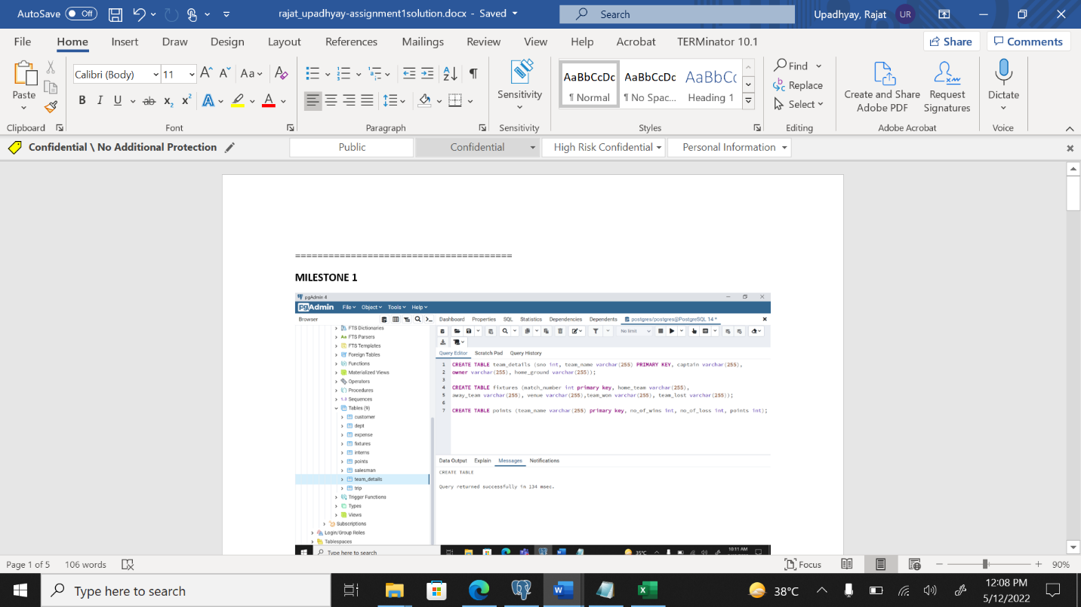

**MILESTON 8**

**MILESTONE 9**

git init

git remote add origin https://github.com/rajatu-deloitte/Assignment1-Solution.git

git status

git add .

git commit -m “added doc file”

git push origin master

**MILESTONE 10**

git branch assignment1

git branch -a

**MILESTONE 11**

git checkout assignment1

git log

git merge master

git push origin assignment1

*made some change in doc file*

Git add .

Git commit -m “files changes”

git push origin assignment1

git checkout master

git merge assignment1

git push origin master