**Solution 1**

CREATE TABLE SALESMAN (SNO INT, S_NAME varchar (30), START_YEAR INT, DEPTNO varchar (10));

CREATE TABLE TRIP (TNO INTEGER, FROM_CITY varchar (20), TO_CITY varchar (20), DEPARTURE_DATE DATE, RETURN DATE, SNO INT);

CREATE TABLE DEPT (DEPTNO varchar (10) PRIMARY KEY, DEPT_NAME varchar(20));

**Solution 2**

INSERT INTO SALESMAN VALUES (1, 'Rajat', 2021, 'FMCG');

INSERT INTO TRIP VALUES (1, 'DELHI', 'MUMBAI', '2022-05-02', '2022-05-09',1);

INSERT INTO DEPT VALUES (1, 'FMCG');

INSERT INTO EXPENSE VALUES (1, 10000, 1);

INSERT INTO SALESMAN VALUES (2, 'Sumit', 2021, 'IT')

INSERT INTO TRIP VALUES (2, 'DELHI', 'MUMBAI', '2022-05-02', '2022-05-09',2);

INSERT INTO DEPT VALUES (2, 'FMCG');

INSERT INTO EXPENSE VALUES (2, 15000, 2);

--

**SOLUTION 3**

SELECT * FROM TRIP INNER JOIN EXPENSE ON TRIP.TNO = EXPENSE.TNO WHERE AMOUNT>10000;

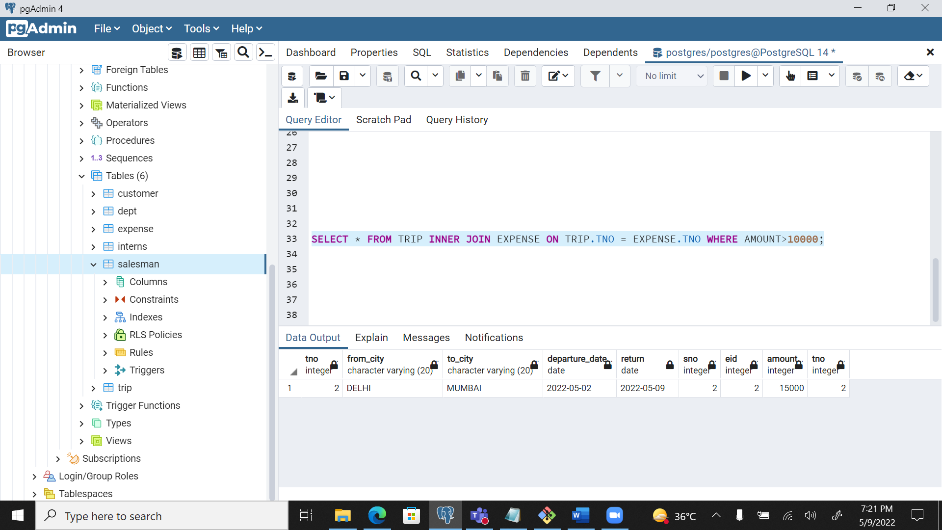

**SOLUTION 4**

SELECT SALESMAN.SNO, S_NAME FROM SALESMAN INNER JOIN TRIP ON SALESMAN.SNO = TRIP.SNO WHERE TO_CITY = 'Calcutta';

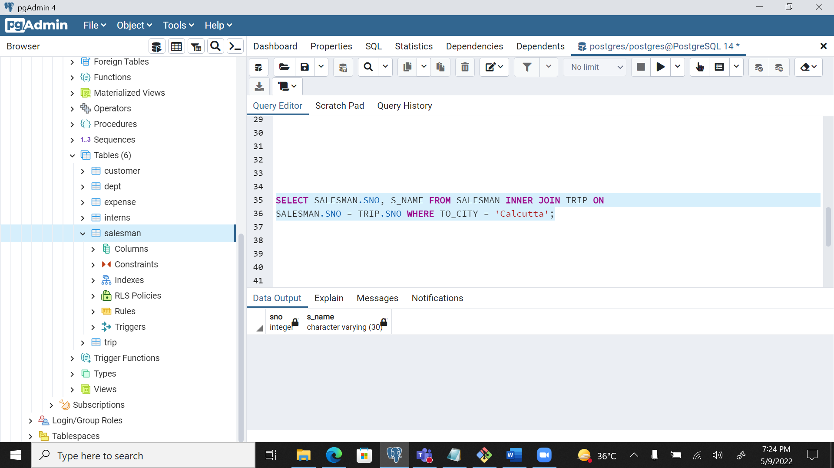

**--**

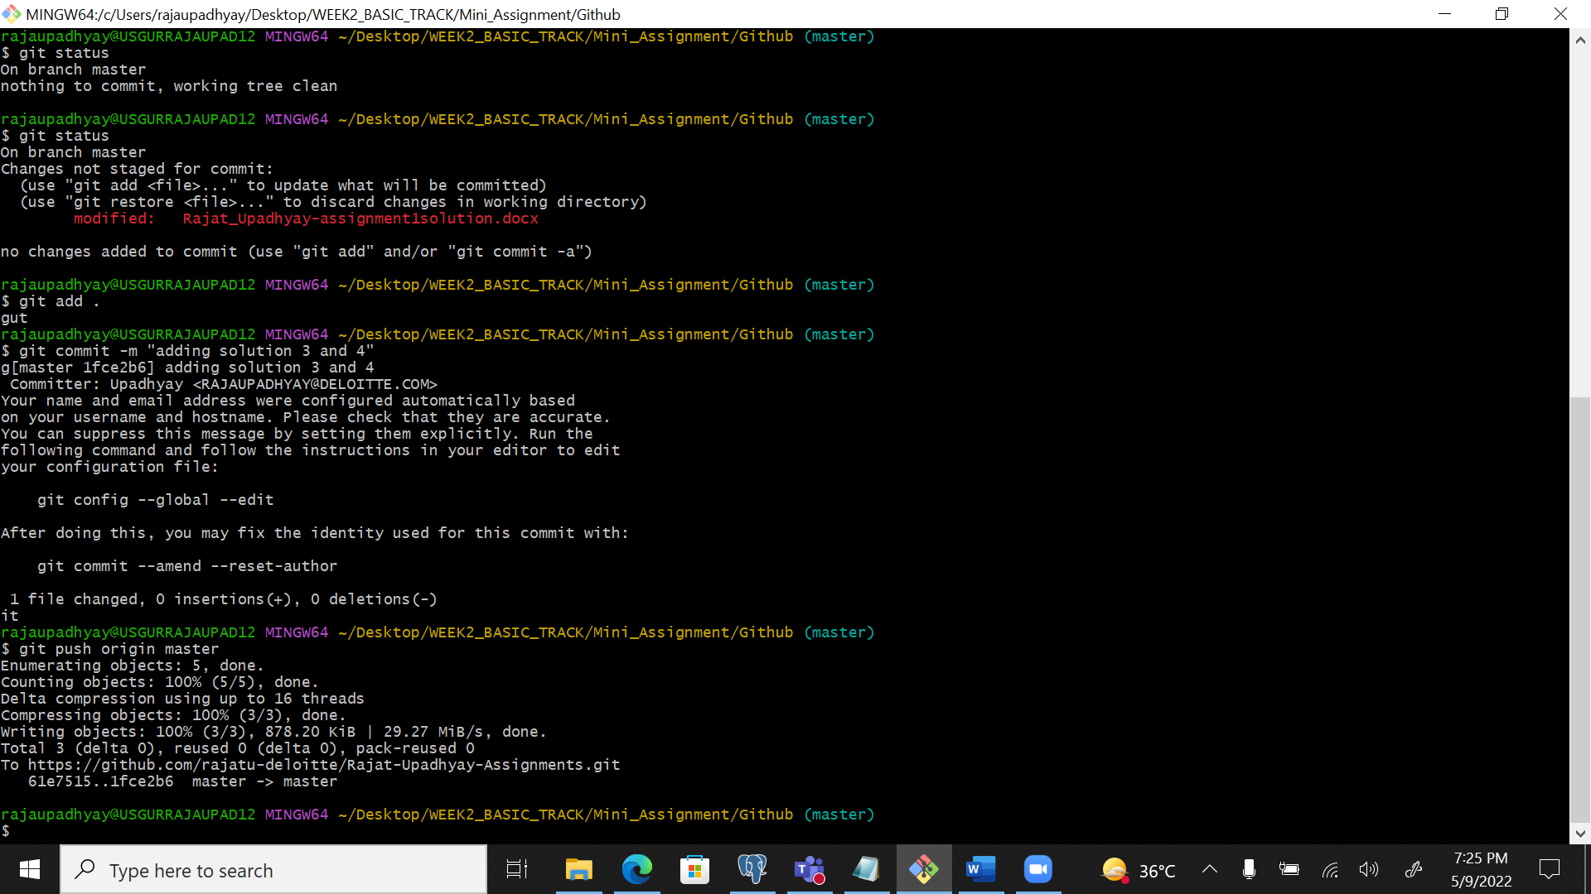

**--**

**SOLUTION 5**

delete from trip where tno = (select tno from expense where amount>15000);

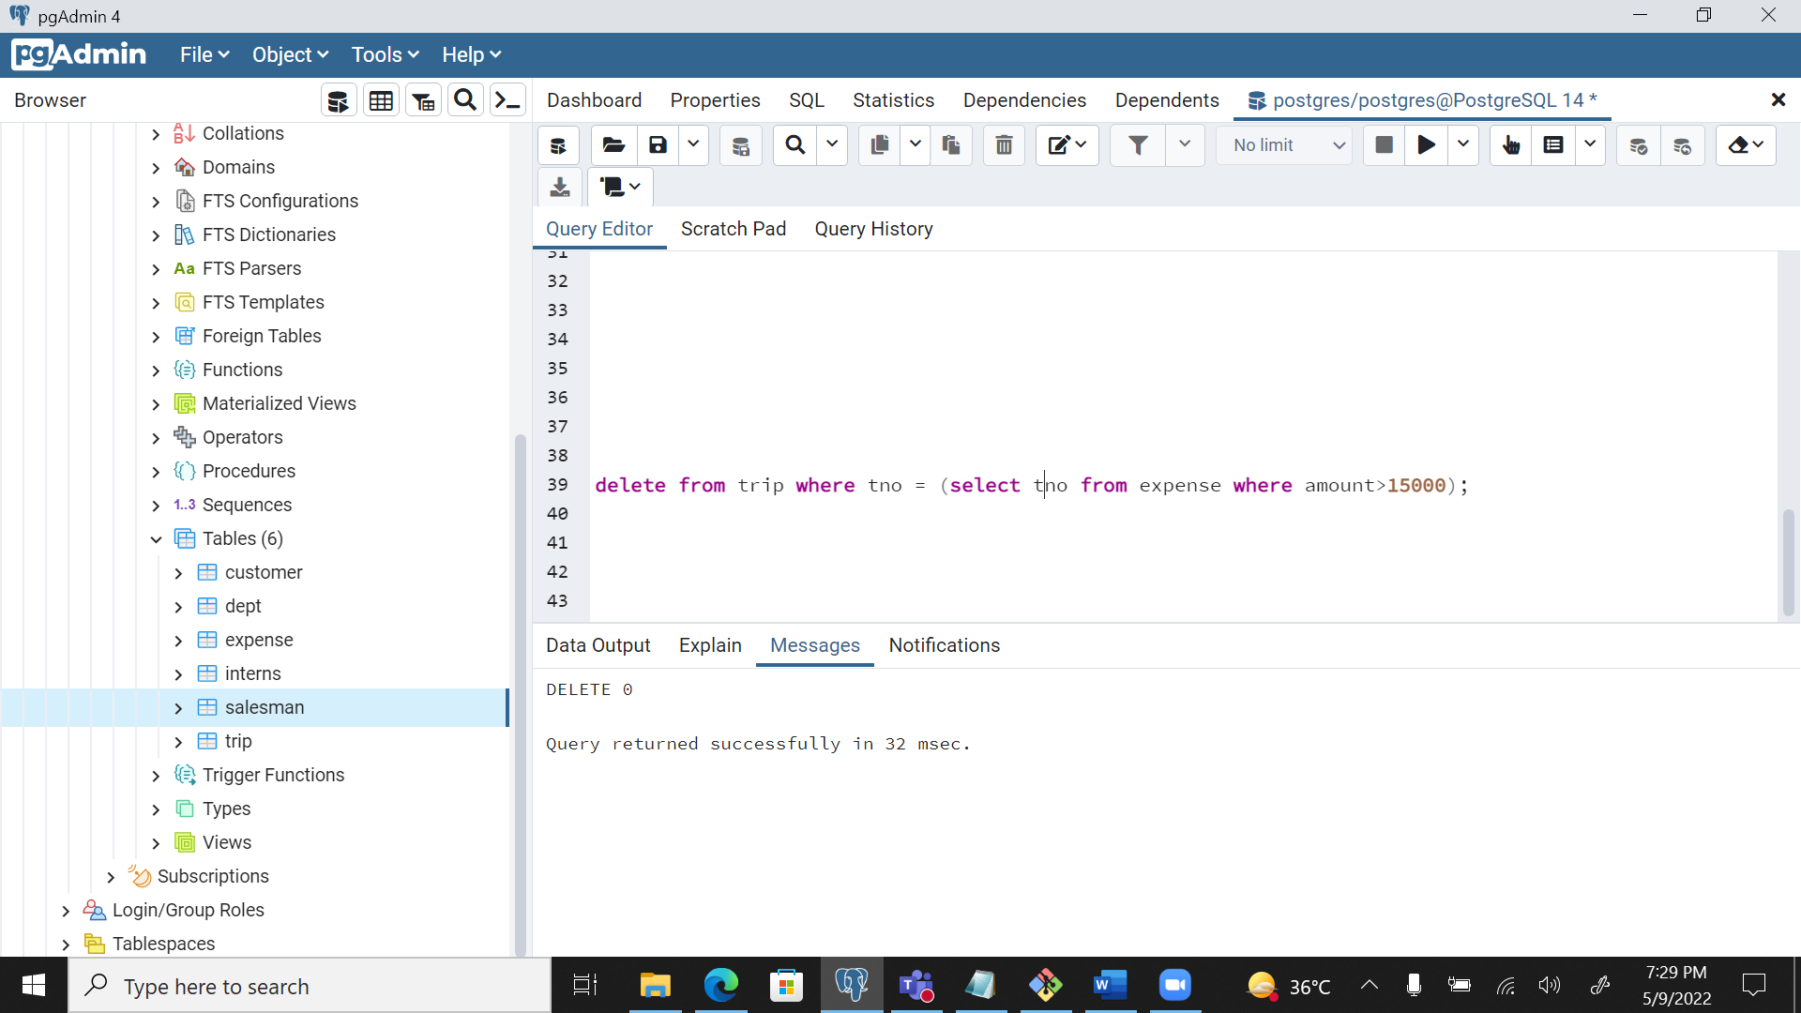

**SOLUTION 6**

ALTER TABLE TRIP ADD COLUMN dno INT;

UPDATE TRIP SET dno=1;

**SOLUTION 7**

**SOLUTION 8**

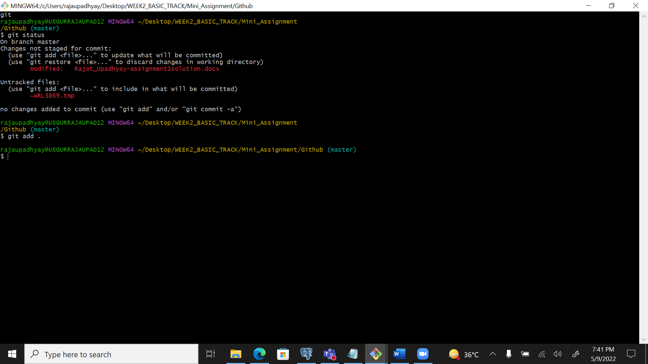

**SOLUTION 9**

**SOLUTION 10**

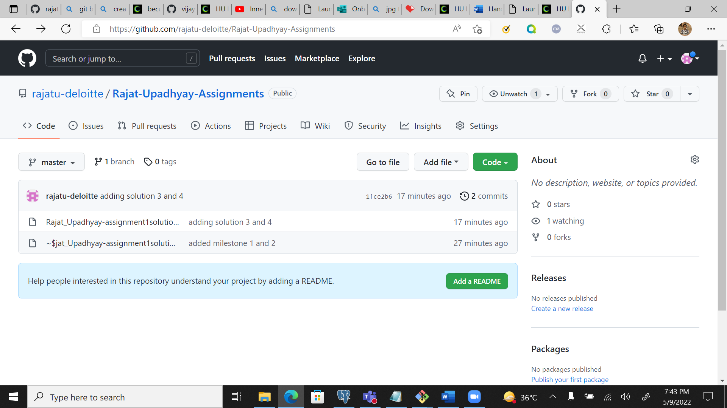

**SOLUTION 11**

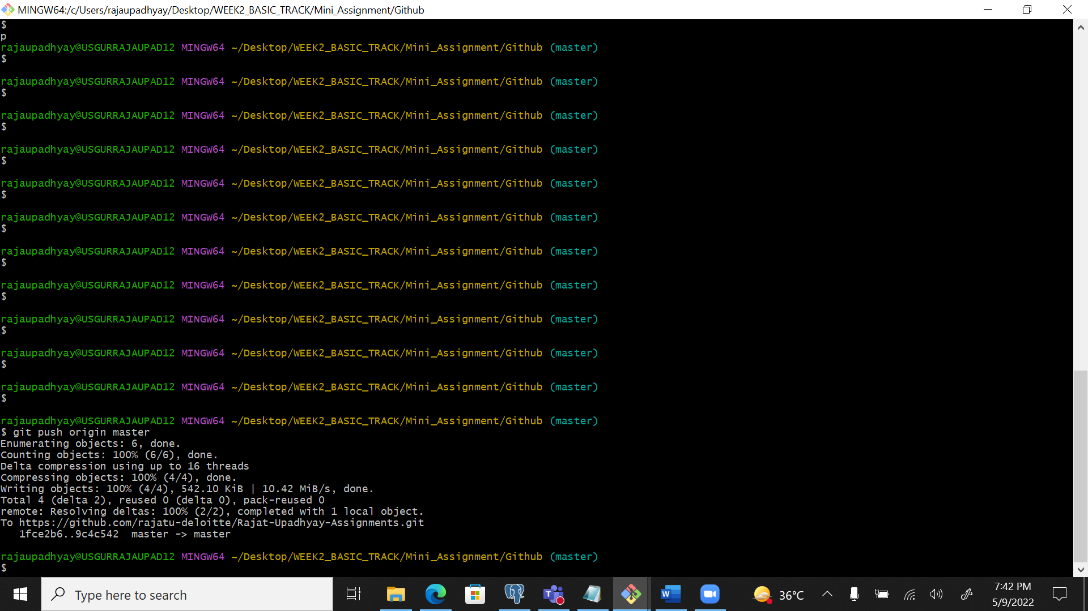

**SOLUTION 12**

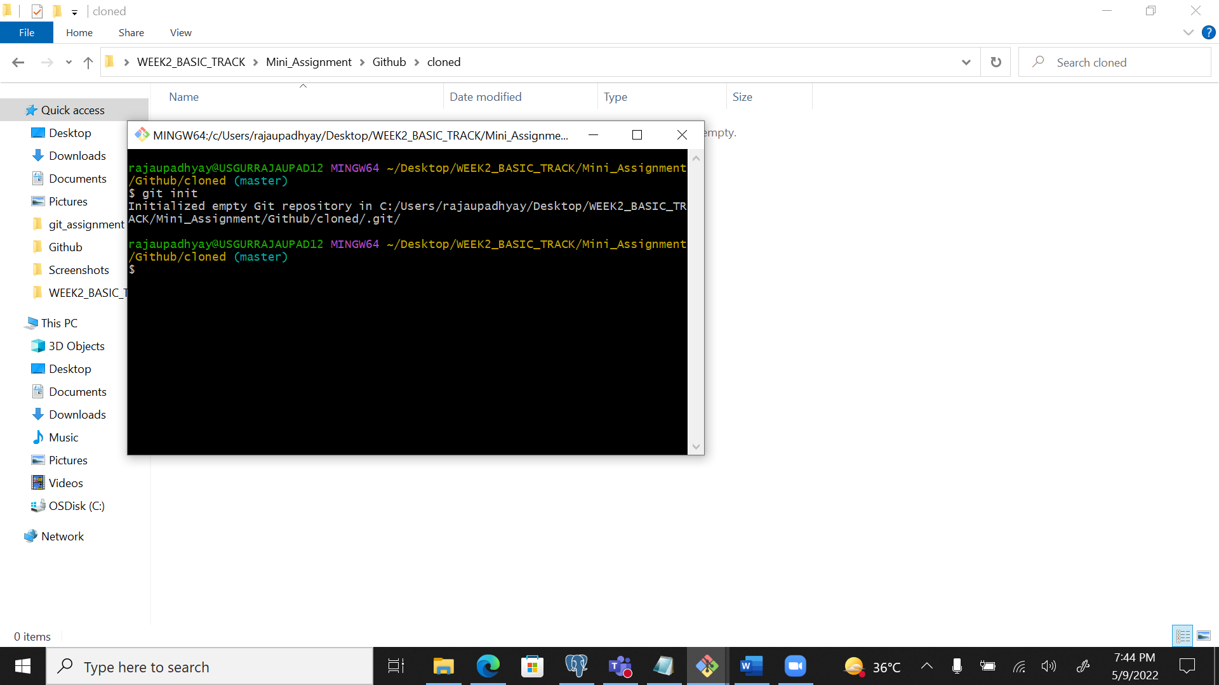

**SOLUTION 13**

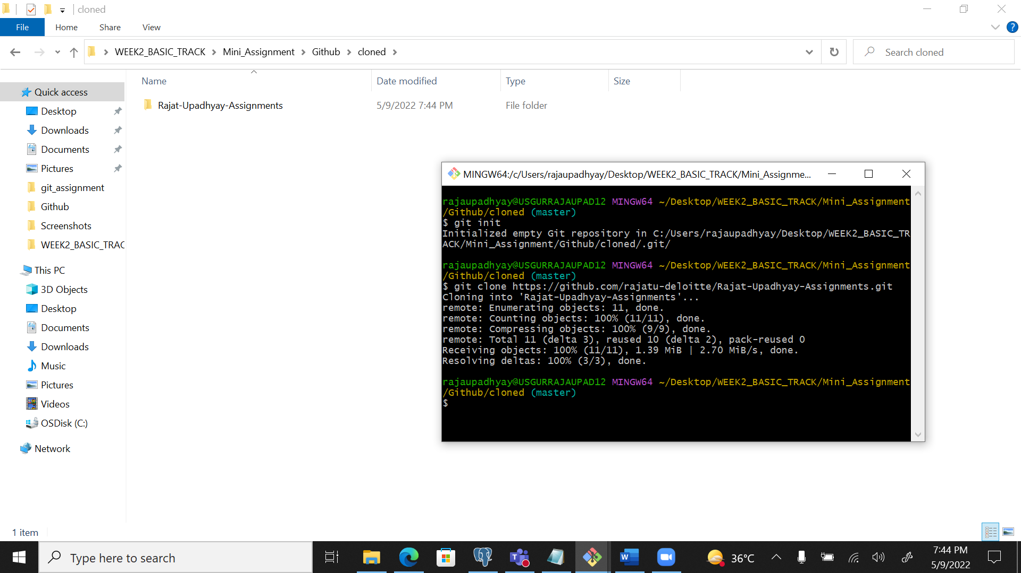

**SOLUTION 14**