**Appendix to Final Project Report**

Here, I describe a variety of test cases that reasonably check various possible shortcomings and attacks that the website may be prone to.

**Email Validation Test Cases** (Invalid email addresses):

* "plainaddress"
* "@no-local-part.com"
* "Outlook Contact <test@example.com>"
* "no-at-symbol"
* "test@.com"
* "test@site."
* "test@.site.com"
* "test@site..com"
* “@.”
* “🥺😍@🟩🟩🟩.™️™️™️”

**SQL Injection Test Cases** (SQL injection attempts):

* "'; DROP TABLE reviews; --"
* "OR '1'='1'"
* "OR ""='"
* "OR x=x"
* "OR 'x'='x"
* "OR 1=1--"x
* "OR 'text'='tEXT'"
* "') OR ('x'='x"
* "'; exec master..xp_cmdshell 'ping 172.10.1.255'--"
* "'; declare @s varchar(8000) select @s = db_name() if (charindex(' ',@s)>0) waitfor delay '0:0:2'--"
* "1; DROP TABLE users"

Here, I demonstrate the outputs of the test cases as run through the Selenium script. The script inputs these test cases from a file and inputs them in the name and email fields. (SQL injection cases were tested in the name field).

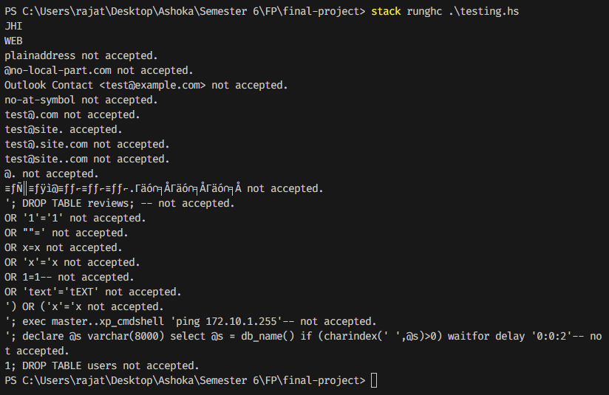

Please note that the “JHI” and “WEB” lines were just debugging print statements I added when the selenium driver wasn’t working properly in the Haskell Stack environment.