### **1. Overview of the Workspace**

* **Workspace Name**: VEOTS_dashboards
* **Objective**: To create analytics Dashboards to present all the required visuals that are required to get meaningful insights from the data that is stored in Data Warehouse (Snowflake).
* **Environment Setup**:
  + **Data Source**: Snowflake
  + **Connection Type**: Import Mode
  + **Dataset Name**: VEOTS_DATASET

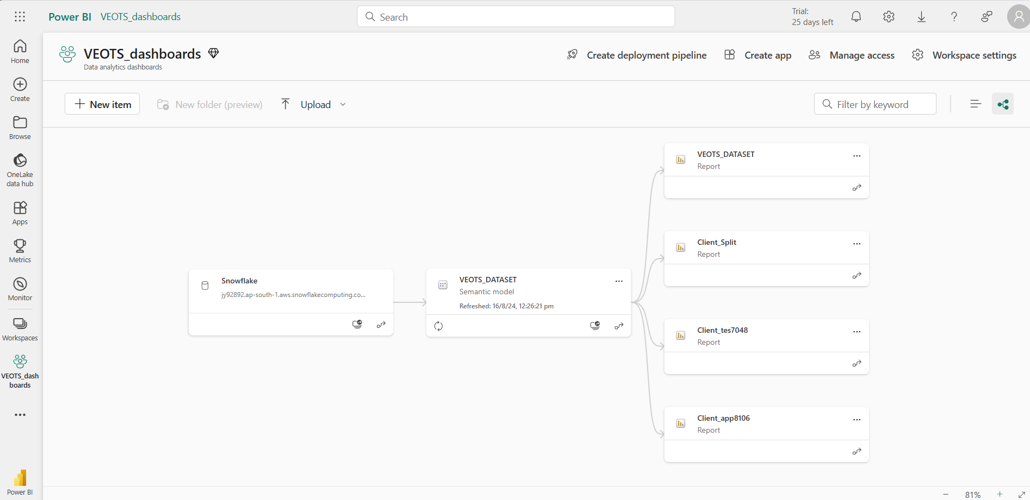This is the power BI workspace we are working in. We have taken data from snowflake and created a Dataset (VEOTS_DATASET) which provides data for all the reports of different clients.

### **2. Dataset Documentation**

* **Dataset Name**: VEOTS_DATASET
* **Connection Details**:
  + **Database**: VEOTS_DB
  + **Views Used**: ANALYTICS_V, COUPONS_V, FAKE_REPORTS_V, FINAL_PRODUCT_QR_V, QR_QUAT_V, QR_TERT_V, QR_SCANS_V
  + **Scheduled Refresh**: Deactivated schedule of daily 10AM refresh.
  + **Relationships**:
    - ANALYICS_V (BATCHES_OID) == QR_SCANS_V (BATCH_OID)
    - ANALYICS_V (BATCHES_OID) == FAKE_REPORTS_V (BATCH_OID)
    - ANALYICS_V (BATCHES_OID) == FINAL_PRODUCT_QR_V (BATCH_OID)
    - ANALYTICS_V (MASTERCLIENTS_OID) == COUPONS_V (MASTERCLEINT_ID)
    - ANALYICS_V (BATCHES_OID) == QR_TERT_V (BATCH_OID)
    - ANALYICS_V (BATCHES_OID) == QR_QUAT_V (BATCH_OID)

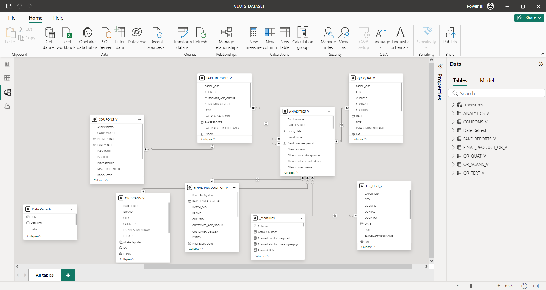

### **3. Reports Overview**

This is the format of the power BI Reports. Different clients have different reports connected to the same dataset, but the format of all the reports is the same. Also, the data in all the reports is the same. The only difference is that we are filtering the data for each client in their respective reports.

#### **Report overview**

* **Purpose**: To represent all the data which is taken from VEOTS Database (MongoDB) into Snowflake in a meaningful way using visuals and KPIs.
* **Pages**:
  + Page 1: QR Codes  
    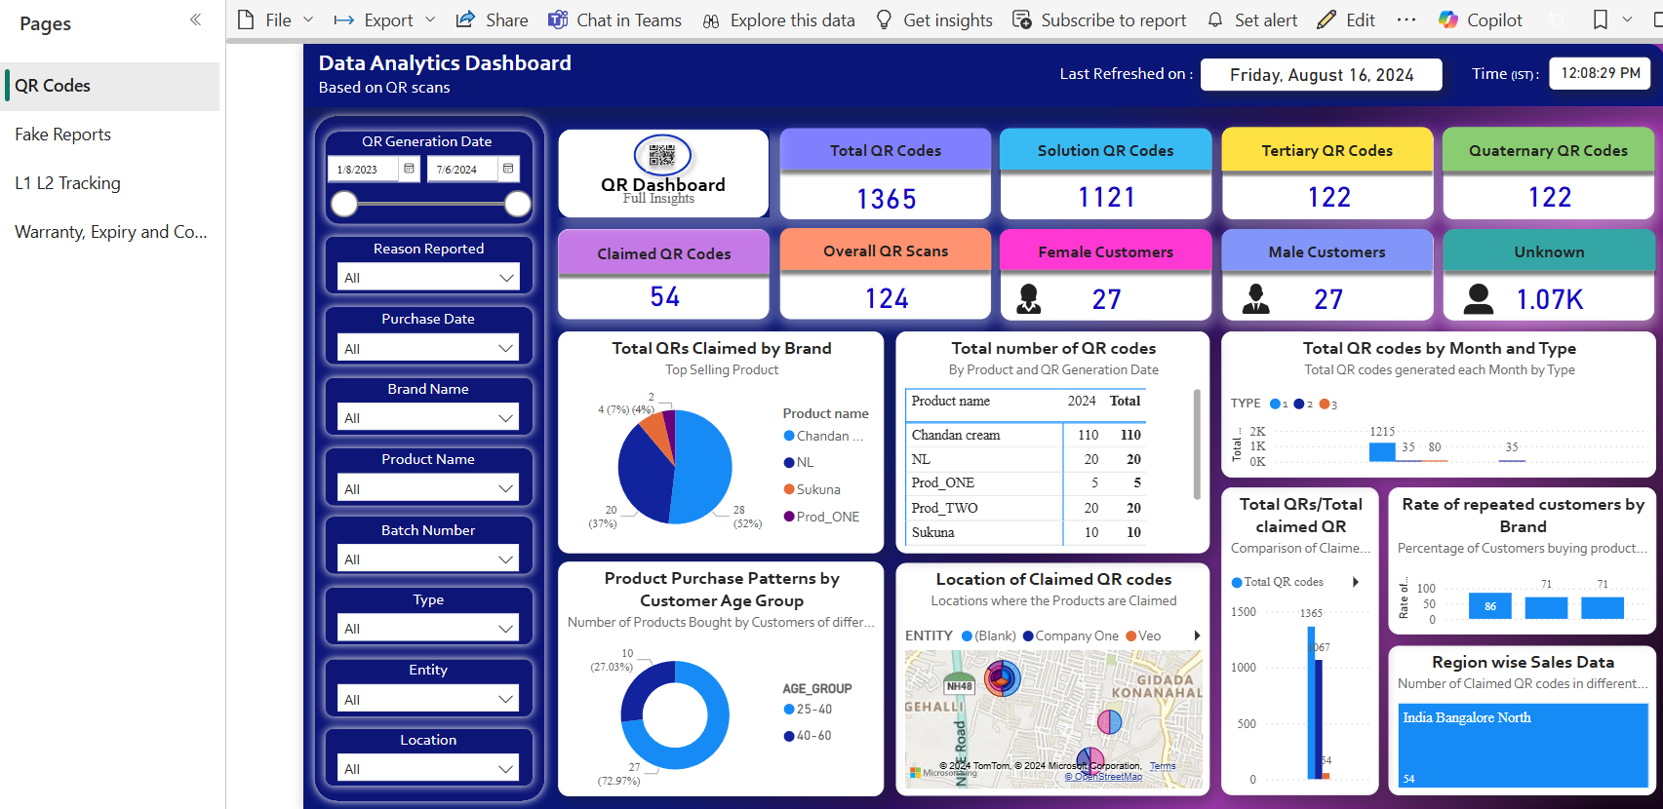This page shows all the KPIs, and visuals related to QR Codes.
  + Page 2: Fake Reports  
    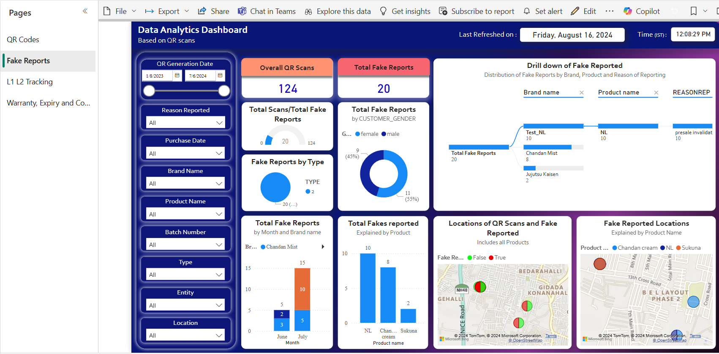These are the insights related to Fake Reports.
  + Page 3: L1, L2 Tracking  
    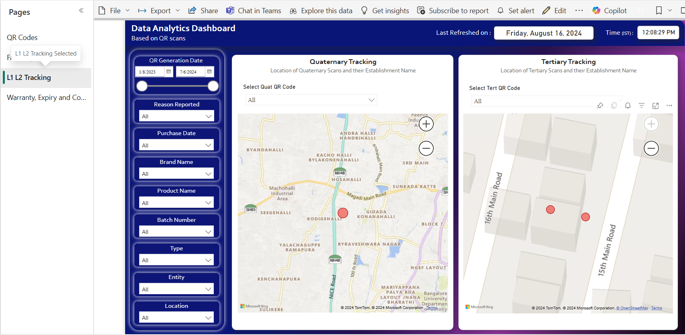These visuals are used to know the tracking of a particular QR Codes. The two maps show where all a particular Tertiary of Quaternary QR Code has got scanned along with the date of scan and Entity name (When you hover on the location).
  + Page 4: Warranty, Expiry and Coupons  
    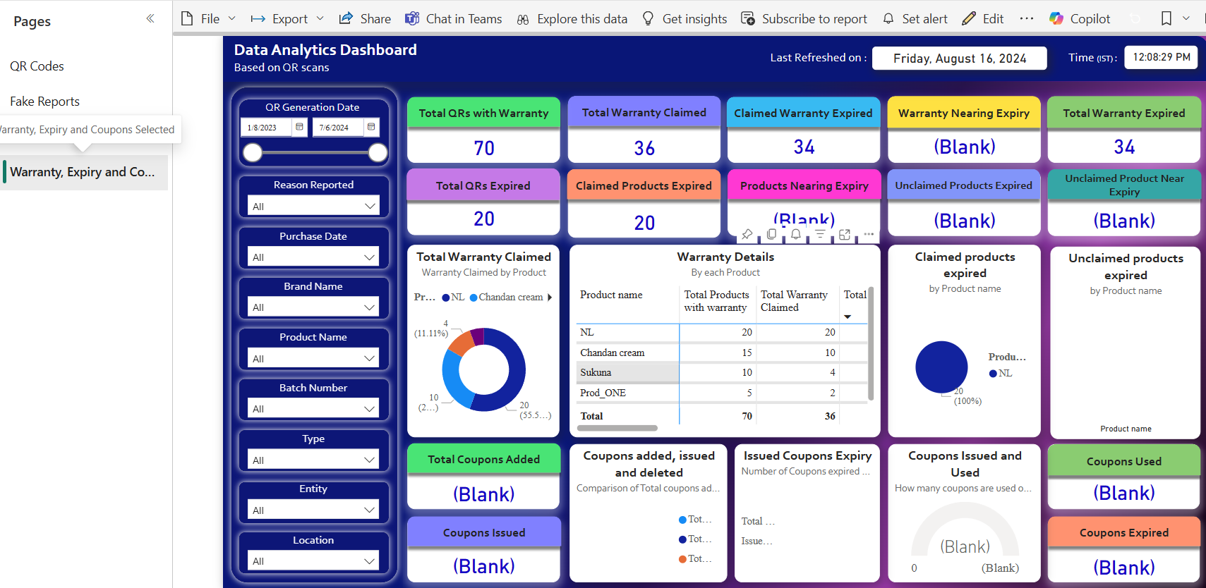This page contains all the visuals related to warranty, expiry and coupons.

### **4. Data Model Documentation**

* **Data Model Diagram**:   
  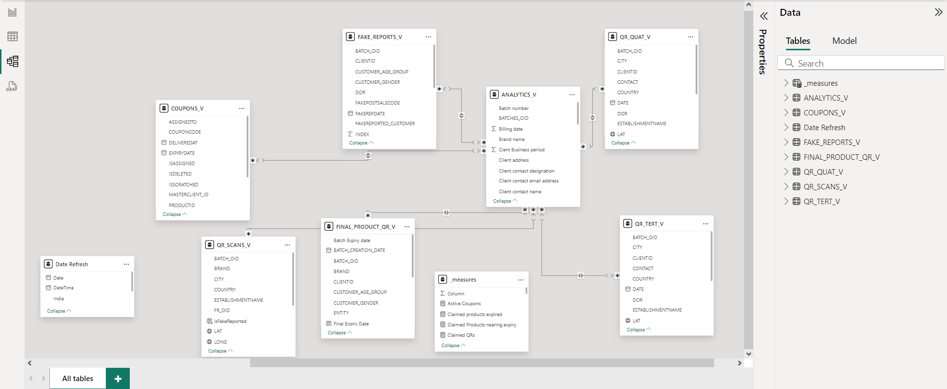
* **Tables**:
  + ANALYTICS_V: Contains all the details of the client and batches.
  + FINAL_PRODUCT_QR_V: Data about QR codes and their types along with expiry dates of the QR codes etc. Data is in the form of count for each Type.
  + QR_SCANS_V: This Table contains only those QR Codes that are scanned at least once.
  + FAKE_REPORTS_V: All the data about the fake reports, their locations, entity Etc.
  + COUPONS_V: Contains data about coupons.
  + QR_TERT_V: Tertiary Tracking QR Codes data.
  + QR_QUAT_V: Quaternary Tracking QR Codes data.
* **Calculated Columns**:
  + **Final Expiry Date:** This measure calculates the final expiry date for products based on the availability of a batch expiry date. If the batch expiry date is "notApplicable", the final expiry date will be blank. If the batch expiry date is "notAvailable", it uses the product expiry date which comes from the product table. Otherwise, it uses the batch expiry date.
  + **OrderOfQuatScan:** This measure ranks the scans of a QR code (qrid) in ascending order based on the scan date. For each qrid, it assigns a rank to each scan, helping to determine the order in which the QR code was scanned.
  + **OrderTertOfScan:** This measure ranks the scans of a QR code (qrid) from the QR_TERT_V table in ascending order based on the scan date. It assigns a sequential rank for each scan, allowing you to determine the order in which each QR code was scanned.
* **Key Measures**: For details on all the measures refer to PowerBi_measures.xlsx

### **5. Snowflake Connection Details**

* **Connection Method**: Import Mode connection.
* **Credentials**:
  + User: GLUE_USER
  + Role: VEOTS_ANALYST