Homework 3

Rajat Vikram Singh

[rajats@andrew.cmu.edu](mailto:rajats@andrew.cmu.edu)

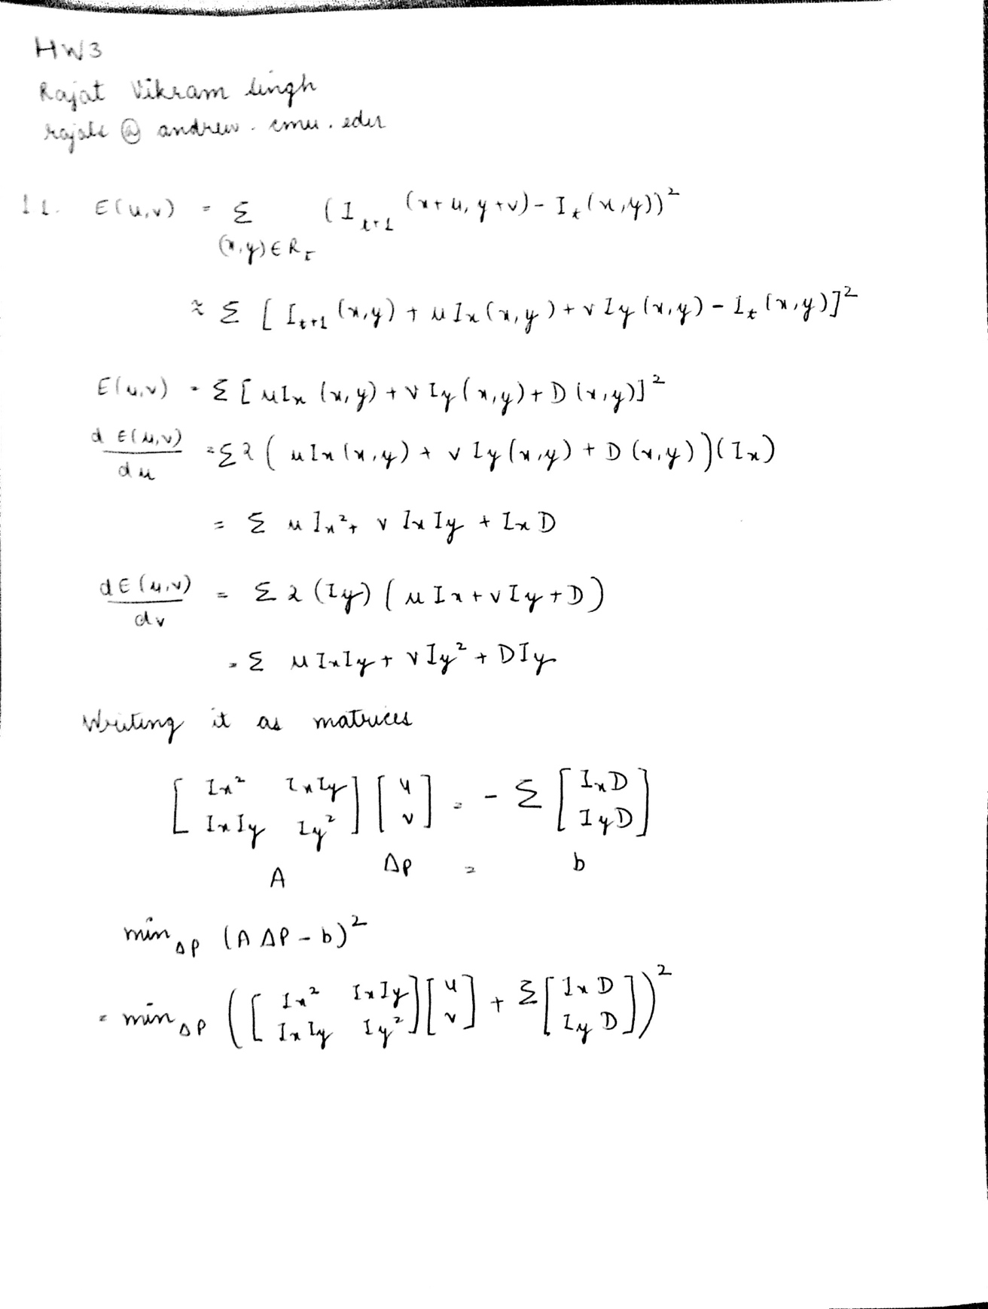

For the equation to be solvable:

Ref: MIT Computer Vision Slides

* + **ATA** should be invertible
  + **ATA** should not be too small due to noise
    - eigenvalues l1 and l2 of **ATA** should not be too small
  + **ATA** should be well-conditioned
    - l1/ l2 should not be too large (l1 = larger eigenvalue)

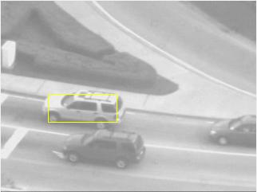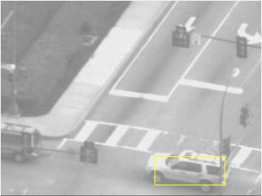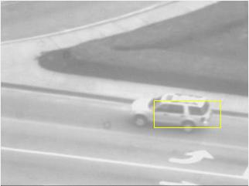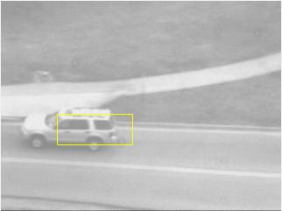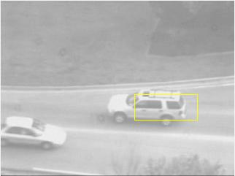

Fig 1: Frames for Lucas Kanade for frames 1, 100, 200, 300, 400

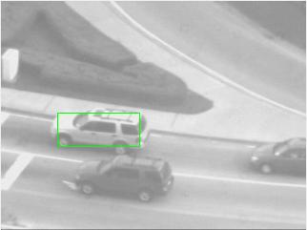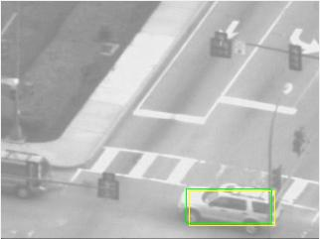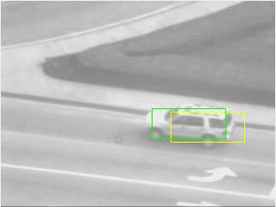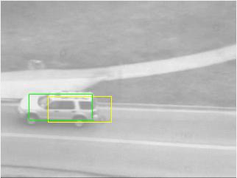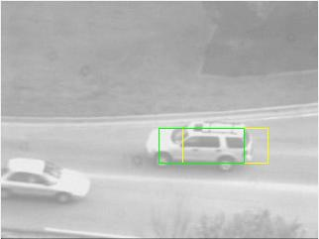

Fig 2: Frames for Lucas Kanade with template correction for frames 1, 100, 200, 300, 400

2.1.

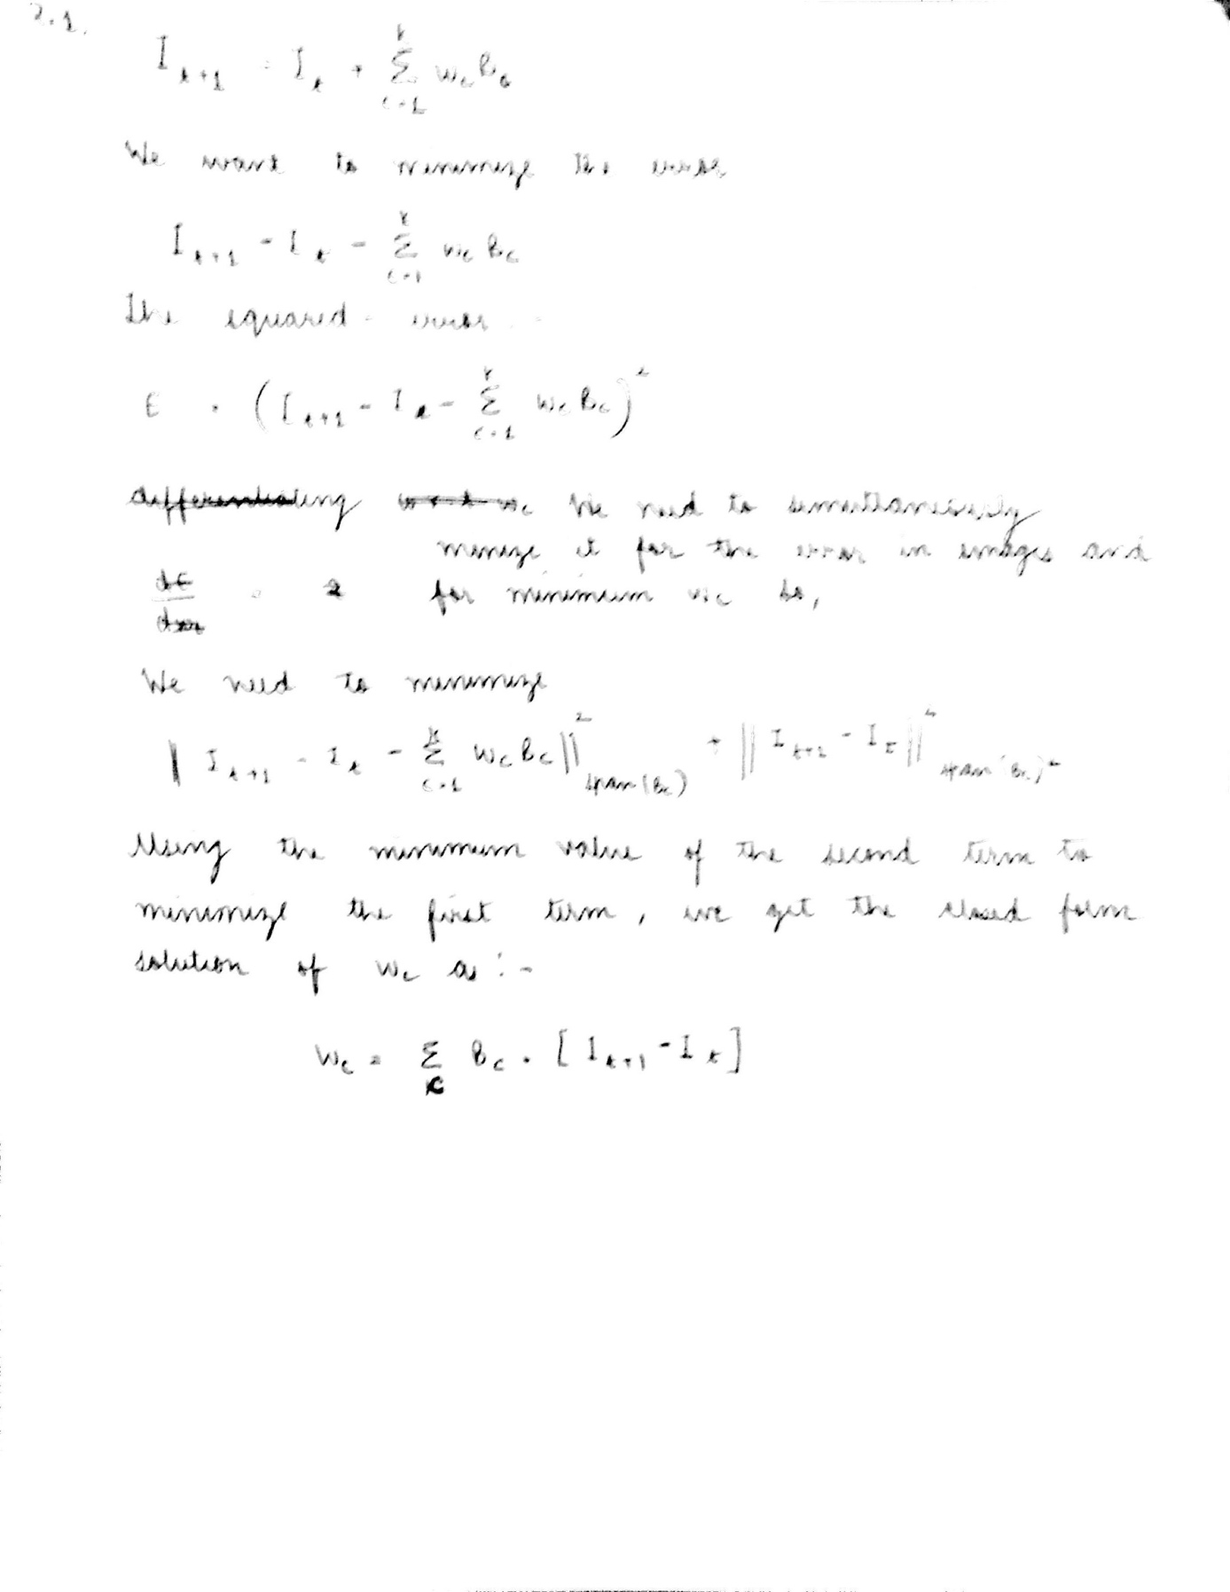

2.3.

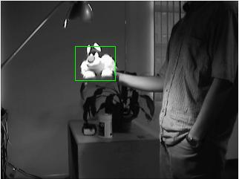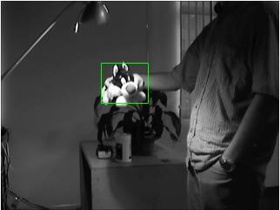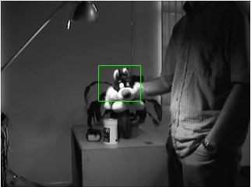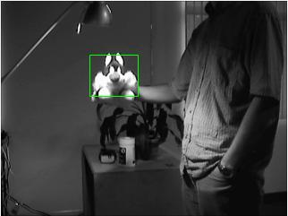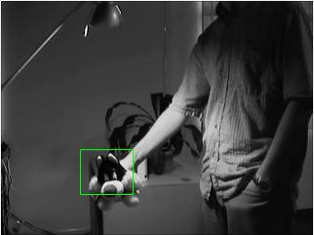

Fig. 3 – Lucas Kanade with Basis Templates at frames - 1, 200, 300, 350, 400

3.3.

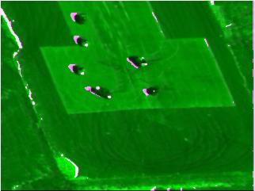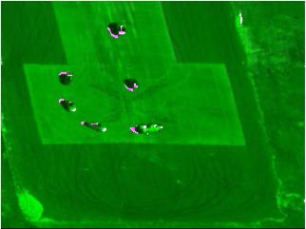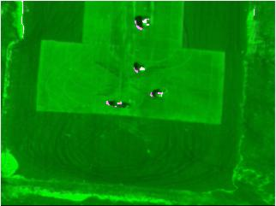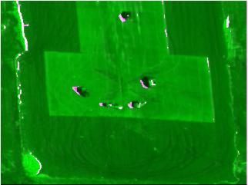

Fig 4 – Background Subtraction with Lucas Kanade Affine Subtraction