Homework 3

Rajat Vikram Singh

[rajats@andrew.cmu.edu](mailto:rajats@andrew.cmu.edu)

Part I

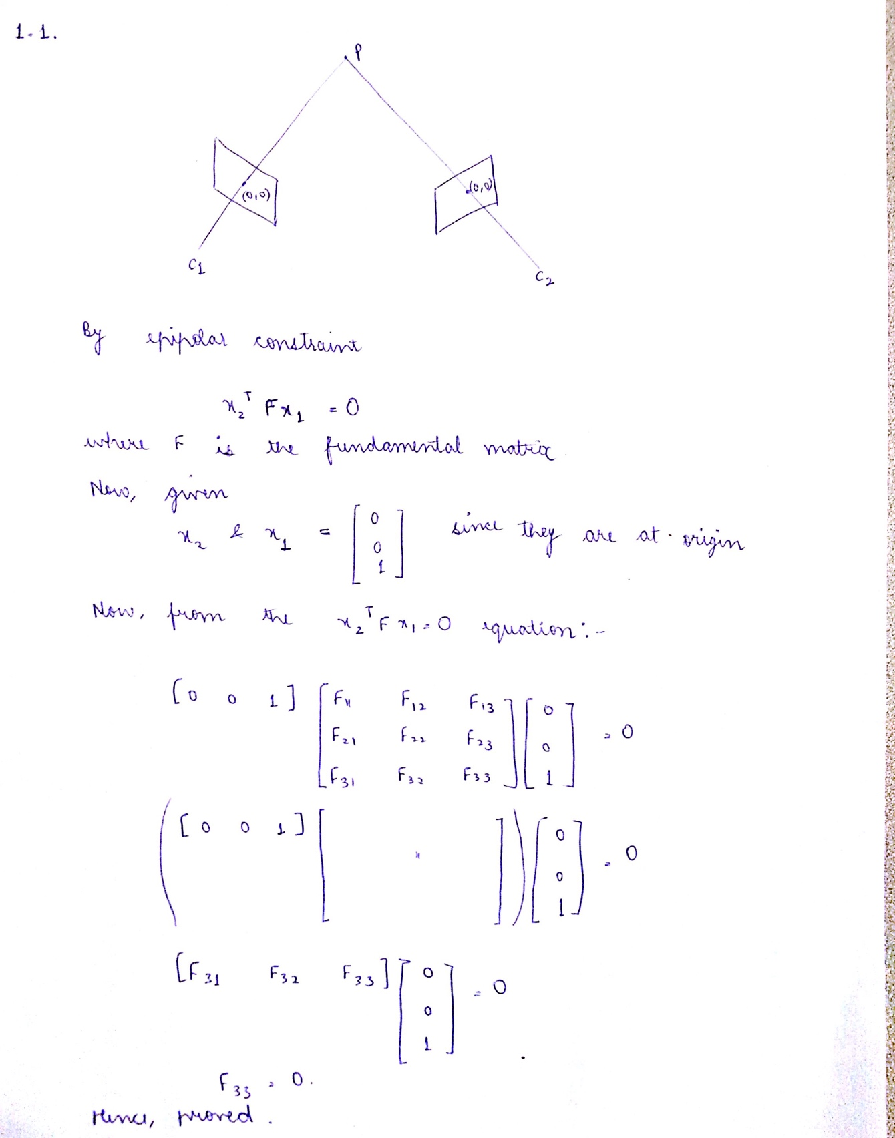

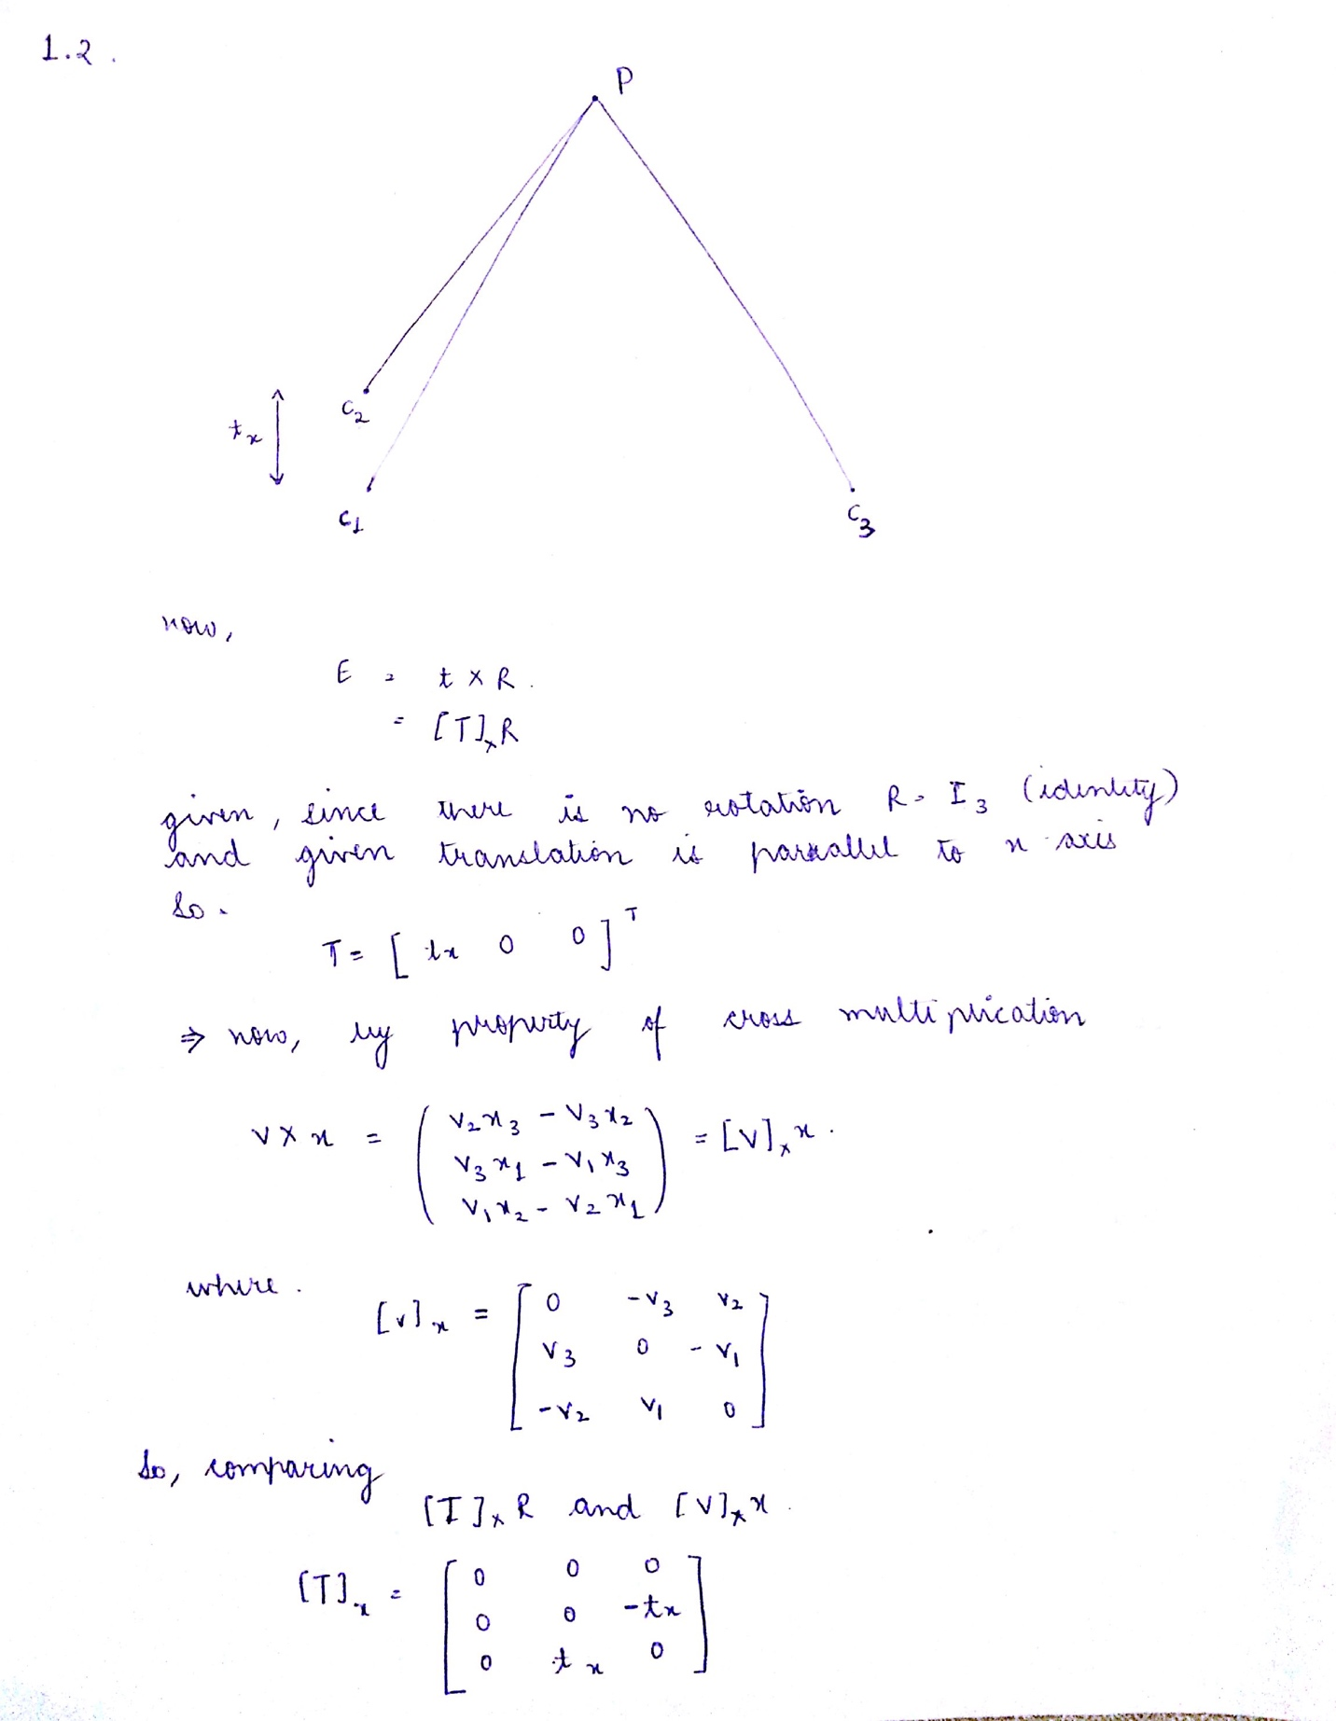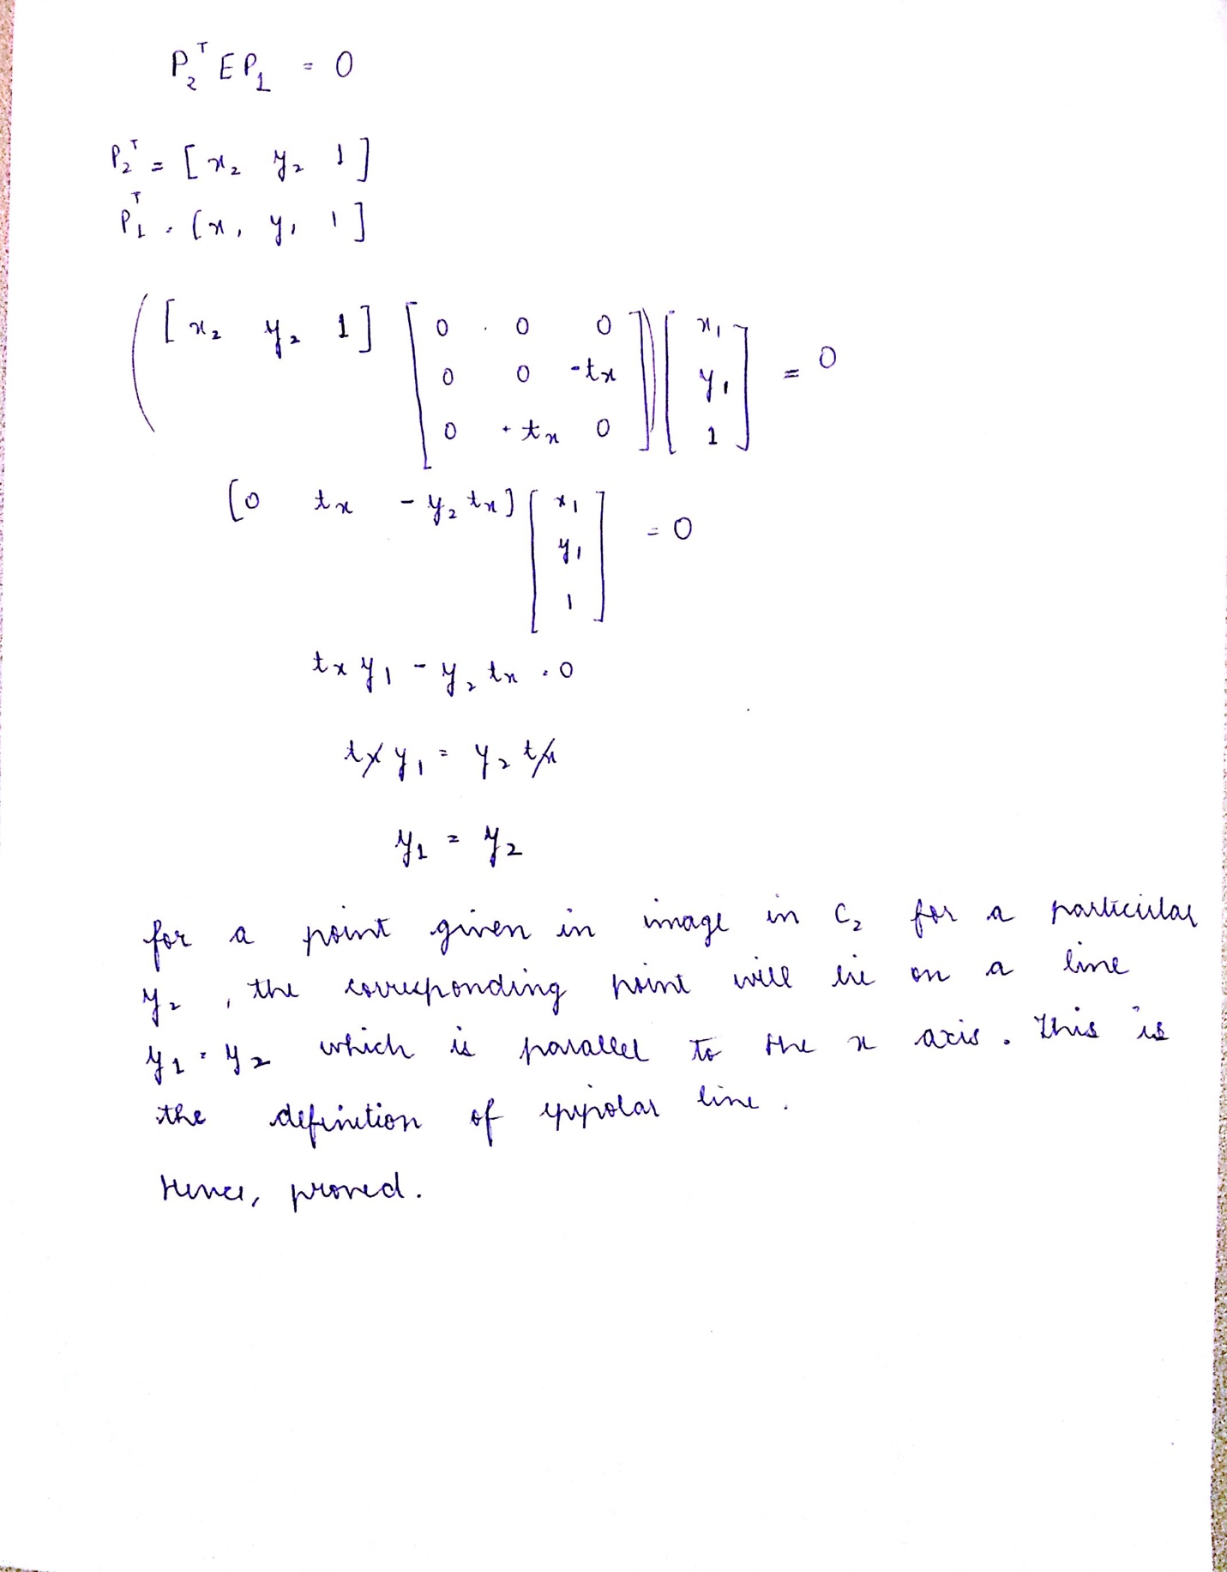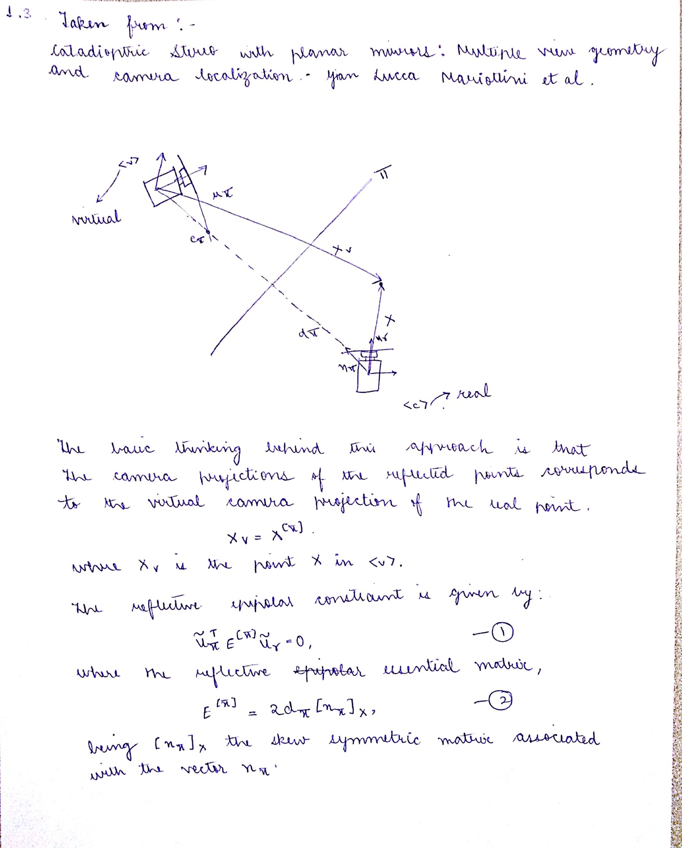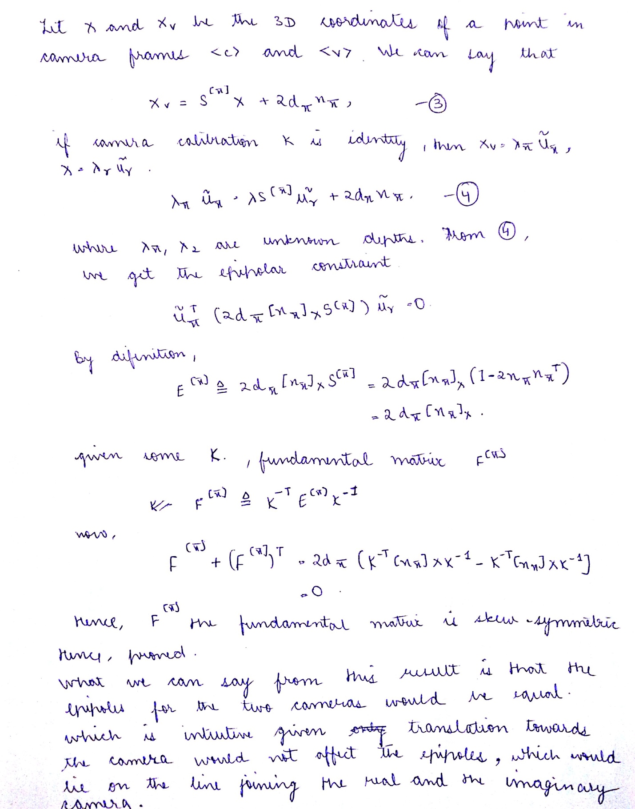

Part II

2.1. The fundamental matrix and the displayEpipolarF output are as follows:

F =

-0.0000 -0.0000 0.0011

-0.0000 0.0000 -0.0000

-0.0011 0.0000 -0.0042

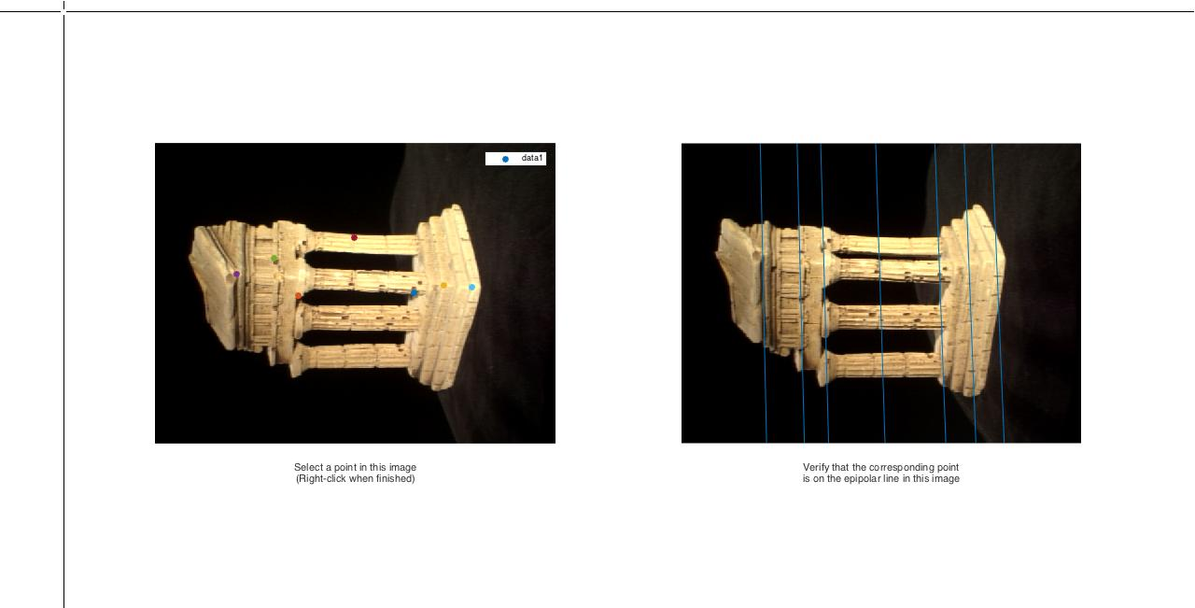

Figure 1: Output of displayEpipolarF

2.2. F is a cell of 3 elements. Only one of them gave good results. The different F are then visualized by displayEpipolarF and the correct one is taken for this approach.

F =

[3x3 double] [3x3 double] [3x3 double]

F{1} =

0.0000 0.0000 -0.0020

-0.0000 -0.0000 0.0005

0.0019 -0.0005 0.0138

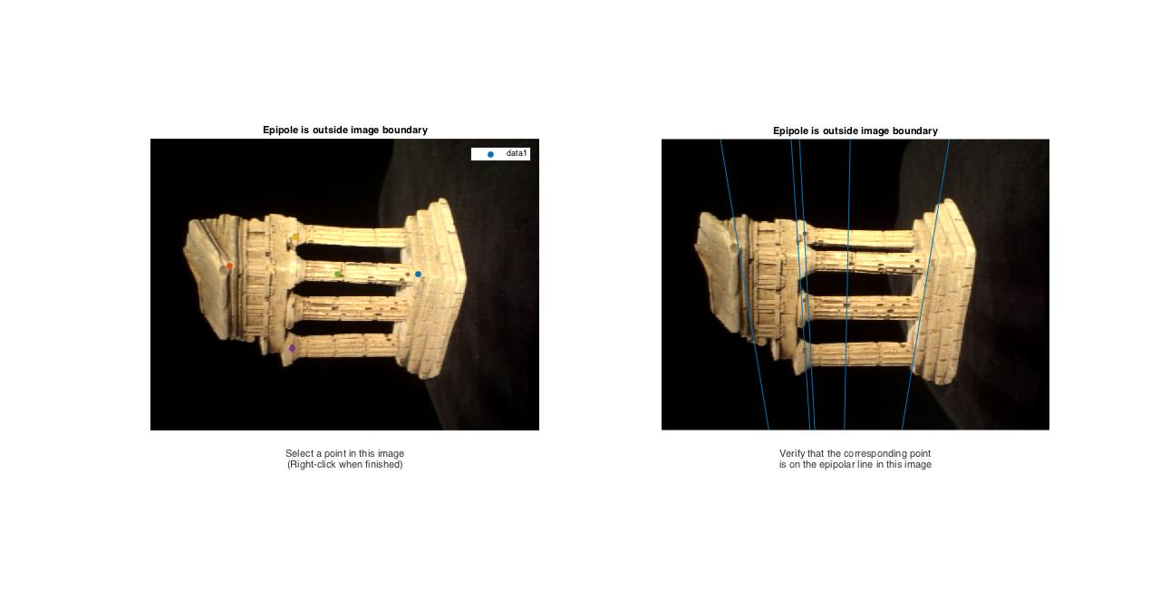

Figure 2: Output of displayEpipolarF

>> F{2}

ans =

0.0000 -0.0000 0.0011

-0.0000 0.0000 0.0000

-0.0011 0.0000 -0.0046

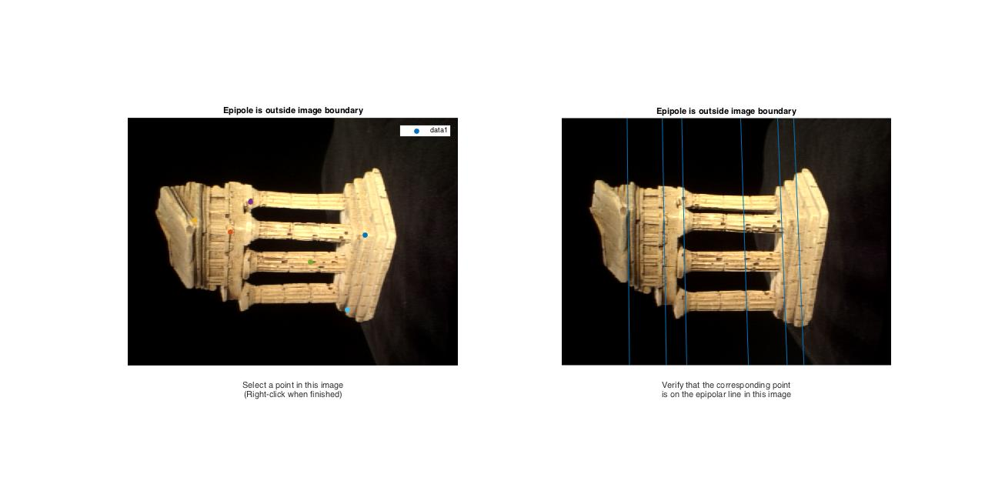

Figure 3: Output of displayEpipolarF

>> F{3}

ans =

-0.0080 0.0264 41.7427

-0.0331 -0.0011 8.0858

-35.8036 -7.4308 -611.4318

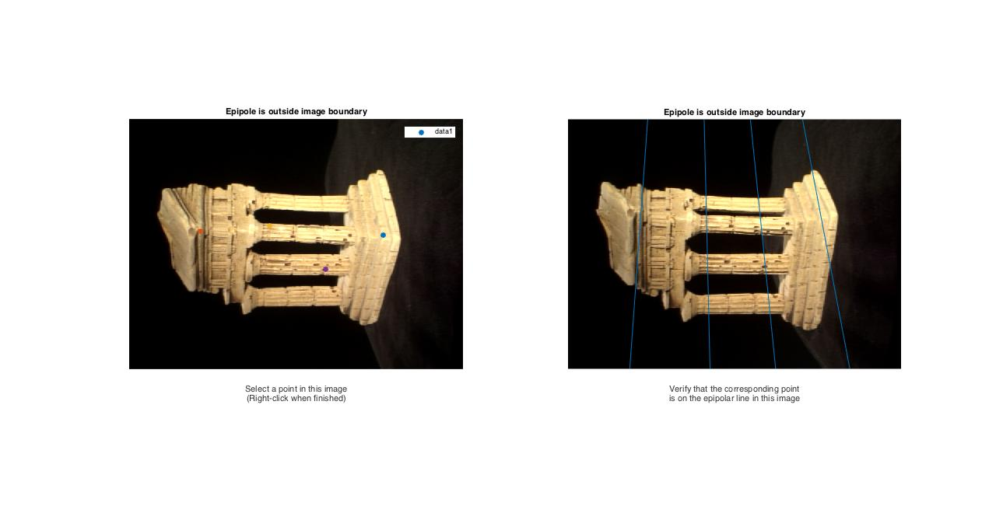

Figure 4: Output of displayEpipolarF

2.3. The essential matrix is as follows:

E =

-0.0030 -0.2862 1.6609

-0.1368 0.0083 -0.0507

-1.6653 -0.0056 -0.0006

2.6. For the epipolar correspondences I have taken a Gaussian window for given more emphasis for the central pixels and then taken two measures which are the Euclidean distance between the two image patches and then the distance between the projected point and the actual point with weights 0.75 and 0.25 respectively. Following are the results from epipolarMatchGUI:

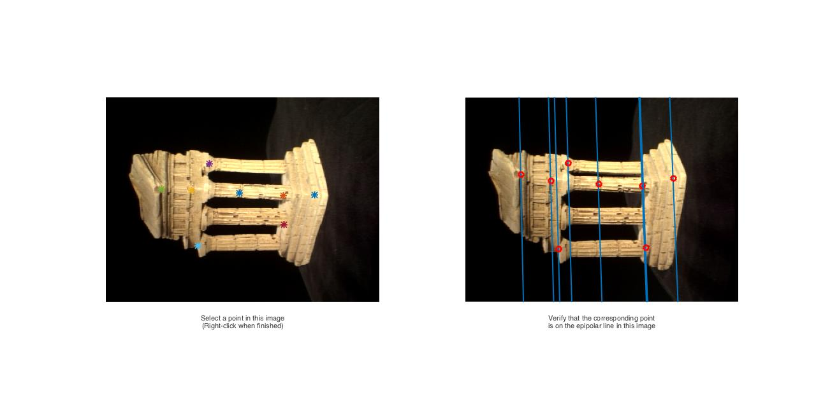

Figure : Output of epipolarMatchGUI

2.7. The 3D scatter plot of the reconstructed 3D points:

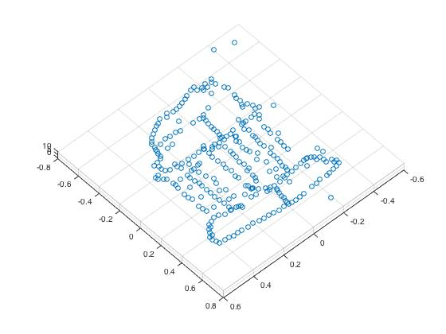

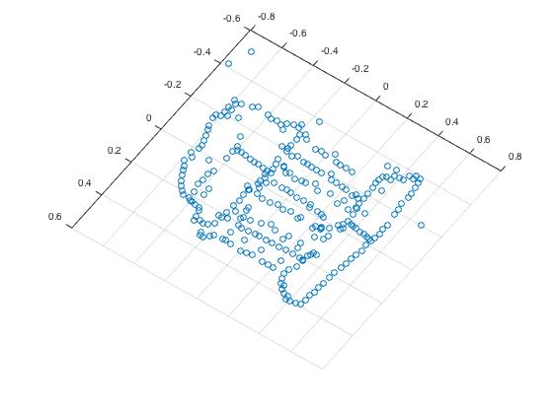

Figure 6, 7: Screengrab of 3D scatter plot