Architecture and Design Decisions
How the system is put together and why
Project: PlacementFlow · Team: Trijal Singh Babbar (23070126137) & Rajat Dwivedi ([23070126100]) · CA-3, AY 2026–27

1. Architecture
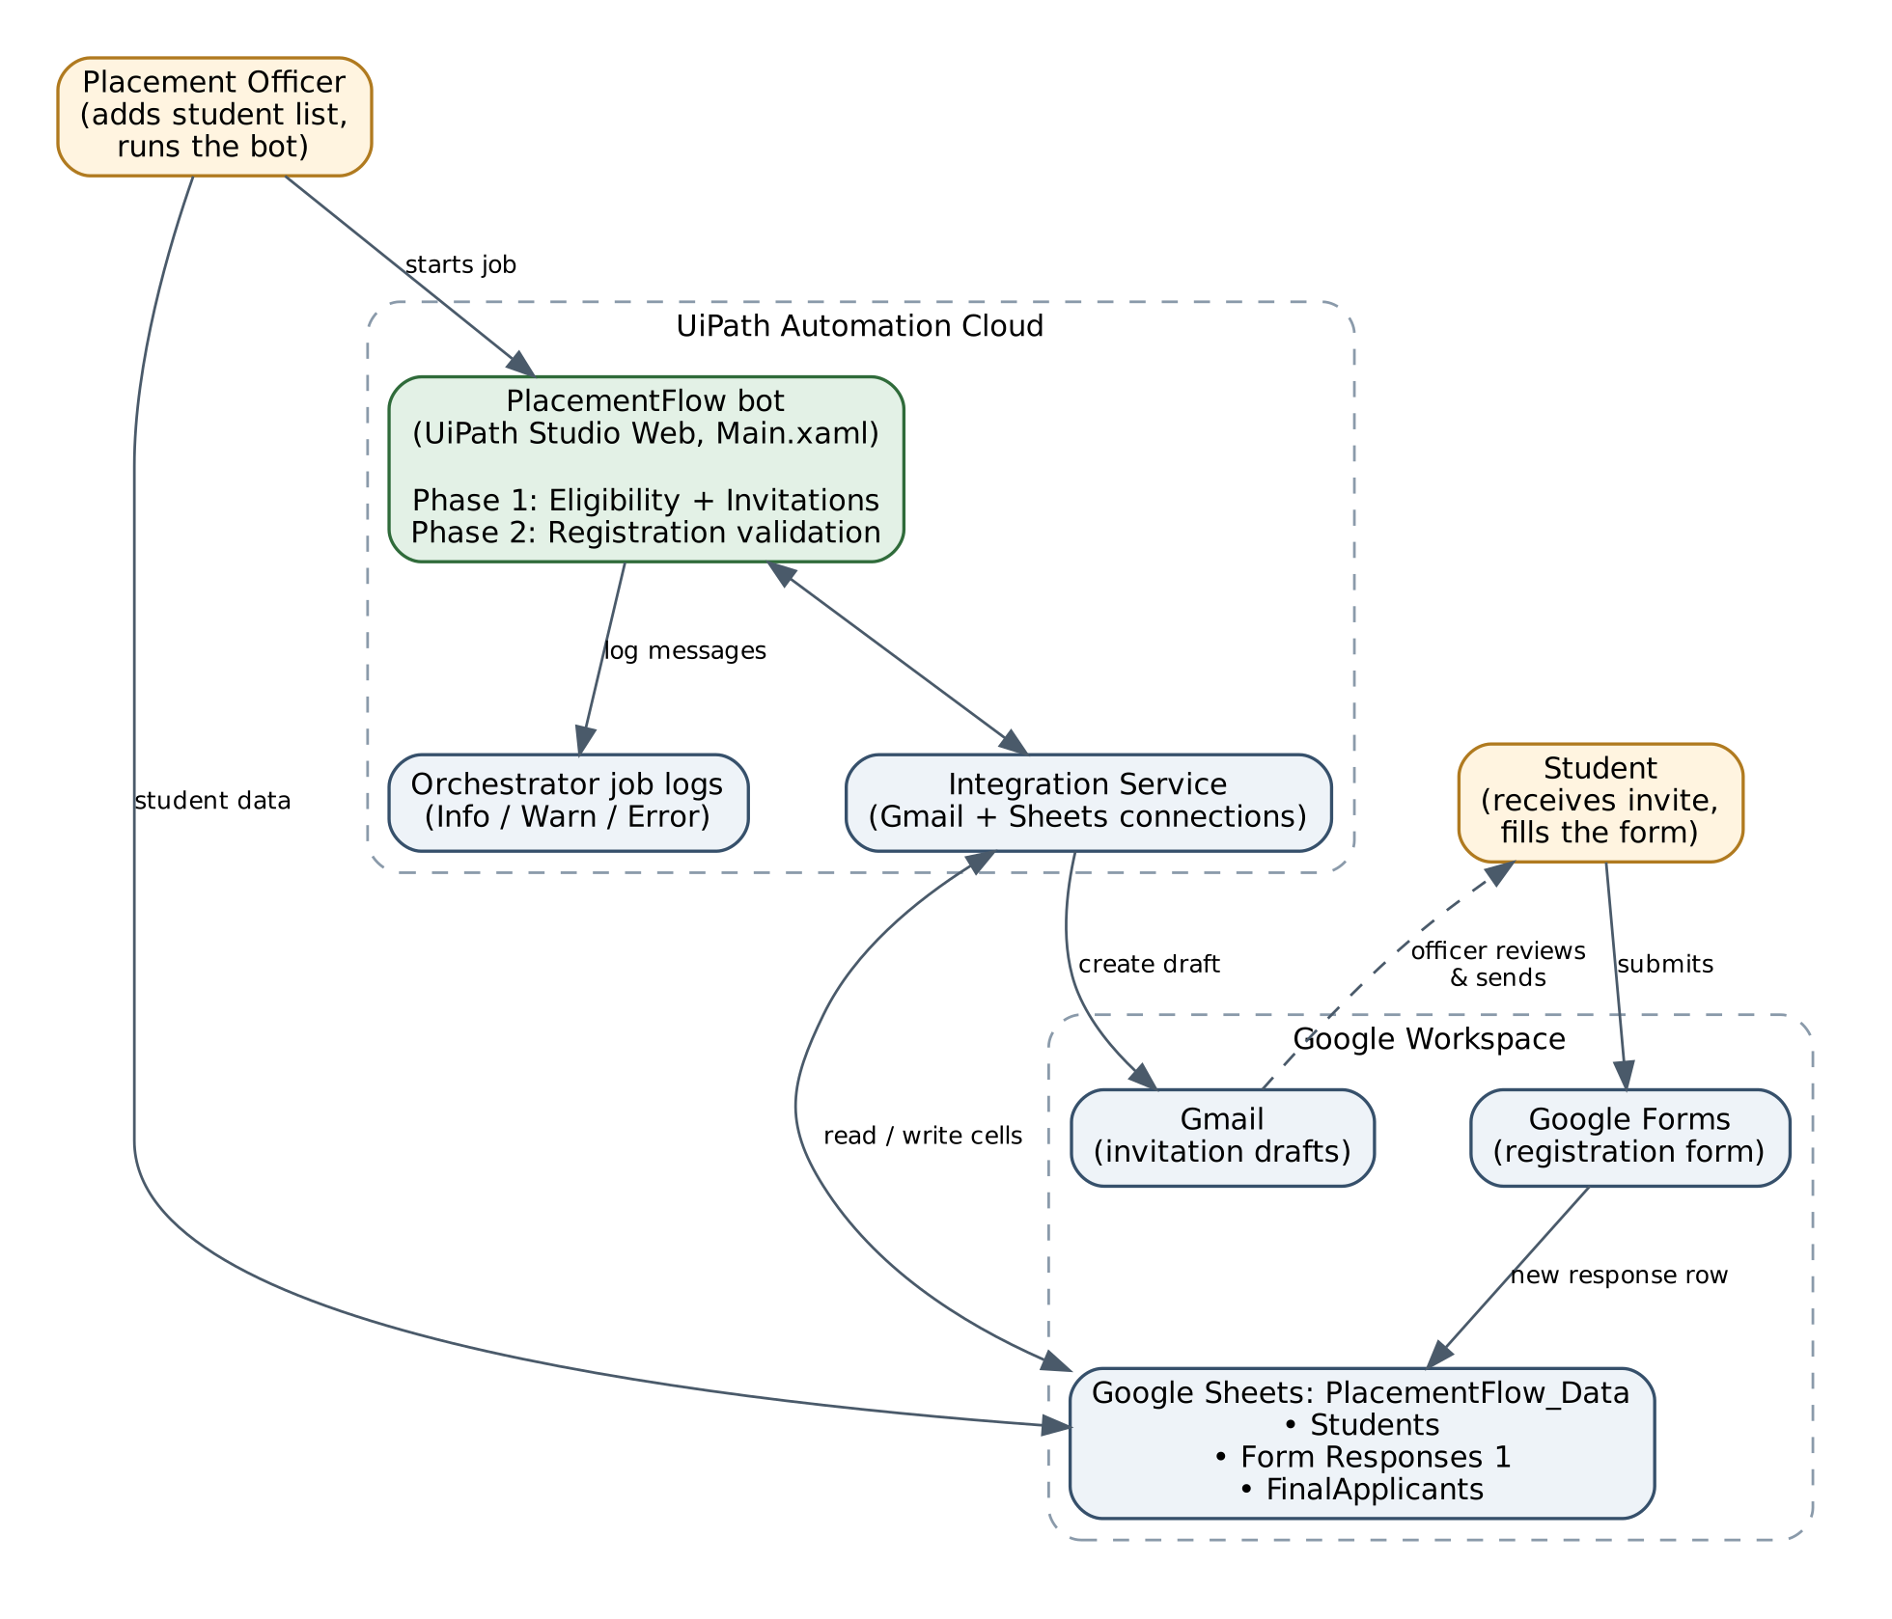
Figure 1: System architecture

2. Data flow, step by step
1. Officer updates the Students tab.
2. Robot reads Students → applies rules → creates Gmail drafts → writes DRAFTED + time.
3. Officer reviews drafts in Gmail and sends them.
4. Students fill the Google Form → responses land in Form Responses 1.
5. Robot reads responses → cross-checks with Students → writes status + time.
6. FinalApplicants formula shows accepted students; Orchestrator holds the log of every run.

3. Design decisions
Decision | Why | Trade-off
Gmail drafts, not direct send | A person checks official emails before they go; prevents mass mistakes | One manual click per email (switch Save as draft to False to auto-send)
DRAFTED + timestamp in the sheet | Makes re-runs safe and gives an audit trail | Sheet must not be re-sorted during a run
Write DRAFTED only after the draft succeeds | Failed rows stay unmarked and are retried next run | Retry happens on the next run, not instantly
Try/Catch per student and per registration | One bad record never stops the run | Slightly more activities in the workflow
Check numbers before the eligibility rule | Blank cells would otherwise crash CDbl/CInt | –
Registration must match an invited student | Stops uninvited or ineligible students reaching the final list | Students must use the invited email
Duplicates judged by earlier rows only | The first submission counts; later ones are flagged | –
FinalApplicants as a sheet formula | Always up to date, zero extra robot work | Depends on the status text being exactly REGISTERED
Integration Service connectors (OAuth) | No passwords in code; easy to switch accounts | Needs a UiPath cloud tenant
SimulateEmailFailure column | Lets us prove error handling live and safely | Test-only column in production data
Single Main.xaml | Simple to follow and present | Future: split into Invite.xaml and Validate.xaml

4. Logging and monitoring
Level | Messages
Info | Processing student · ELIGIBLE · NOT ELIGIBLE · SKIPPED · Registration <PRN>: <status>
Warn | REVIEW: Missing CGPA for student <Name>
Error | INVITATION WORKFLOW ERROR … · REGISTRATION PROCESSING FAILED …

Logs are visible in Orchestrator → Jobs → (job) → Logs and are kept for 30 days (process retention setting). The sheet itself is the business-level record: every invitation and registration carries a status and a time.

5. Future architecture
- Drives configuration tab so rules are data, not code.
- Form-submit trigger or Orchestrator schedule for real-time processing.
- RunLog tab + dashboard; Retry Scope around Gmail/Sheets calls; batch writes for large lists.

