Workflow Explanation
What every activity in Main.xaml does, in plain words
Project: PlacementFlow · Team: Trijal Singh Babbar (23070126137) & Rajat Dwivedi ([23070126100]) · CA-3, AY 2026–27

1. What is in this folder
File | What it is
PlacementFlow.uis.zip | Complete UiPath Studio Web solution export (import this to run the project)
Main.xaml | The workflow itself – every activity, condition and expression
project.json | Project settings: dependencies (GSuite 3.12.10, Integration Service 1.35.0, System 26.10.0, WebAPI 2.5.2), VB expressions, unattended process
entry-points.json | Tells Orchestrator that Main.xaml is the starting point
connection/*.json | Gmail and Google Sheets Integration Service connection definitions (no passwords stored; "Authenticate After Deployment")
process/RPA_Workflow.json | Orchestrator process definition created on publish

To open the project: UiPath Automation Cloud → Studio Web → Import → choose PlacementFlow.uis.zip. Main.xaml and project.json are included separately only so the evaluator can read them without importing.

2. The workflow at a glance
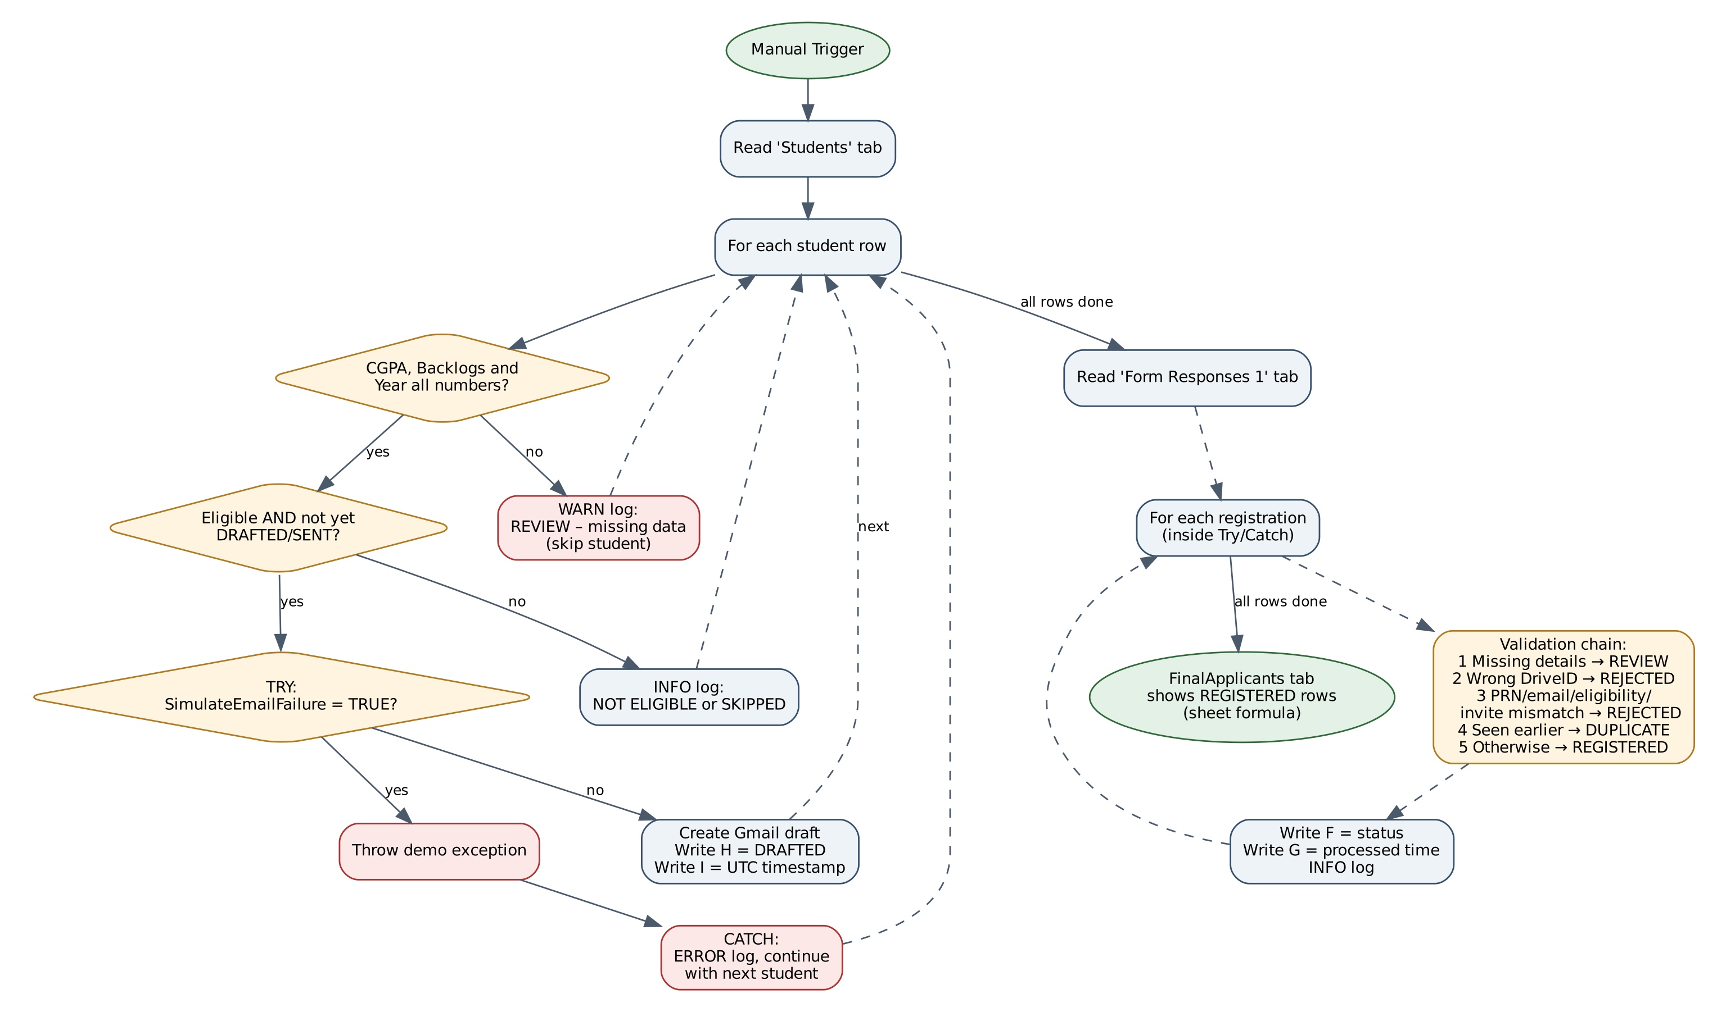
Figure 1: Main.xaml flow
The workflow is a single sequence with two phases. Phase 1 decides who to invite and prepares the emails. Phase 2 checks the people who registered. Both phases use the same Google Sheet, PlacementFlow_Data.

3. Phase 1 – Eligibility and invitations
# | Activity (name in Studio) | What it does | Key setting
1 | Manual Trigger | Starts the robot when someone clicks Run. | –
2 | Read Range | Reads the whole Students tab into a table called readRange. | Sheet: PlacementFlow_Data · Range: Students · Has headers: Yes
3 | For Each Row in Data Table | Repeats the next steps for every student (current student = CurrentRow). | Input: readRange
4 | Log Message | Writes "Processing student: <Name>" to the job log. | Level: Info
5 | If | Is CGPA, Backlogs or GraduationYear not a number (e.g. blank)? | See expression A
5a | Log Message 1 (Then) | Warns "REVIEW: Missing CGPA for student <Name>" and skips the student. Exception 1. | Level: Warn
6 | If 1 (Else) | Does the student meet all four rules and is not already DRAFTED/SENT? | See expression B
6a | Log Message 2 | Logs "ELIGIBLE: <Name>". | Level: Info
6b | Try Catch | Protects the email + sheet updates for this one student. | Catches: System.Exception
6c | If 2 → Throw | Only for testing: if SimulateEmailFailure is TRUE, throw "DEMO ONLY: Simulated Gmail outage…". Exception 2. | –
6d | Send Email | Creates the invitation in Gmail as a draft. | Save as draft: True · HTML body · To: student email
6e | Write Cell | Writes DRAFTED in column H of this student's row. | Cell: "H" & (row index + 2)
6f | Write Cell 1 | Writes the current UTC time in column I. | Format: yyyy-MM-dd HH:mm:ss UTC
6g | Log Message 4 (Catch) | Logs "INVITATION WORKFLOW ERROR: … Student: <Name>" and continues with the next student. | Level: Error
7 | Log Message 3 (Else of If 1) | Logs "SKIPPED: Invitation already processed for <Name>" or "NOT ELIGIBLE: <Name>". | Level: Info

4. Phase 2 – Registration validation
# | Activity (name in Studio) | What it does | Key setting
8 | Read Range 1 | Reads every Google Form response. | Range: 'Form Responses 1'
9 | For Each Row in Data Table 1 | Repeats for every response (current response = RegistrationRow). | –
10 | Try Catch 1 | Protects each registration separately. | Catches: System.Exception
10a | Write Cell 2 | Works out the status with the validation chain (expression C) and writes it in column F. | Cell: "F" & (row index + 2)
10b | Write Cell 3 | Writes the processing time in column G (keeps the old time if already filled). | Cell: "G" & (row index + 2)
10c | Log Message 5 | Logs "Registration <PRN>: <status>". | Level: Info
10d | Log Message 6 (Catch) | Logs "REGISTRATION PROCESSING FAILED: PRN … Check Google Sheets connection and retry". | Level: Error

The FinalApplicants tab is not written by the robot – it is a FILTER formula in the sheet that shows the rows marked REGISTERED, so it is always up to date.

5. Expressions used
A – Missing data check (If):
Not IsNumeric(CurrentRow("CGPA").ToString()) OrElse
Not IsNumeric(CurrentRow("Backlogs").ToString()) OrElse
Not IsNumeric(CurrentRow("GraduationYear").ToString())

B – Eligibility rule (If 1):
CDbl(CurrentRow("CGPA").ToString()) >= 7 AndAlso
CInt(CurrentRow("Backlogs").ToString()) = 0 AndAlso
CInt(CurrentRow("GraduationYear").ToString()) = 2027 AndAlso
New String() {"CSE", "IT", "AIML"}.Contains(CurrentRow("Branch").ToString().Trim().ToUpper()) AndAlso
(Not New String() {"DRAFTED", "SENT"}.Contains(CurrentRow("InvitationStatus").ToString().Trim().ToUpper())
OrElse CurrentRow("SimulateEmailFailure").ToString().Trim().ToUpper() = "TRUE")

In plain words: CGPA at least 7, zero backlogs, graduating in 2027, branch CSE/IT/AIML (spaces and capitals ignored), and not already invited – unless the row is a failure-simulation row, which is always retried.
C – Registration status (Write Cell 2), checked in this order:
1. PRN, Name or Email blank?
-> "REVIEW: Missing registration details"
2. DriveID is not "PF-2027-001"?
-> "REJECTED: Unknown drive"
3. No Students row where PRN matches AND Email matches (any case)
AND InvitationStatus is DRAFTED/SENT AND CGPA is 7-10
AND Backlogs = 0 AND GraduationYear = 2027
AND Branch is CSE / IT / AIML?
-> "REJECTED: Student, email or eligibility mismatch"
4. An EARLIER response has the same PRN + Email + DriveID?
-> "DUPLICATE: Already registered"
5. Otherwise
-> "REGISTERED"

Row number trick: Google Sheets row = position in the table + 2, because the table starts at 0 and row 1 of the sheet is the header.

6. Variables and connections
Name | Type | Purpose
readRange | DataTable | Students tab loaded at the start; also used in Phase 2 to cross-check registrations.
readRange_1 | DataTable | Form Responses 1 tab.
CurrentRow / RegistrationRow | DataRow | The student / response being processed in the loop.
Google Sheets connection | Integration Service | OAuth connection used by Read Range and Write Cell.
Gmail connection | Integration Service | OAuth connection used by Send Email.

