Batch 2023-27
Continuous Assessment – III (CA-3)
Academic Year: 2026–27

Cover Page
Project Title: PlacementFlow – Automated Placement Invitation and Registration Validation using UiPath and Google Workspace
Student Name(s): Trijal Singh Babbar, Rajat Dwivedi
PRN: 23070126137 (Trijal Singh Babbar); 23070126100 (Rajat Dwivedi)
Division: AIML – B3 & B1
Course Name: Robotics process and automation
Faculty Name: Dr. Priya Jhadav
Submission Date: 23/10/26

Project Summary
In each placement season, the placement cell of the college needs to go through the list of the students and select the candidates who are eligible for applying in each company. Currently, this is manually done by opening an Excel sheet, going through each student's CGPA, backlogs, branch, and passing-out year, copying the email addresses of the eligible students, drafting the invitation mail and later comparing the registration forms against the original list. This process is time-consuming, monotonous and error-prone, even a single wrong filter can prevent an eligible student from applying or allow an ineligible student to apply.
PlacementFlow is an automation software that will help the placement cell to perform these tasks for them. This automation is created using UiPath Studio Web and integrates Google Sheets, Gmail, and Google Forms. During the running of the automation, it will first read the list of the students from the Google Sheet, then compare each candidate based on the criteria provided and prepare an individual invitation mail for each candidate in Gmail. It then writes "DRAFTED" and the time into the sheet again, so that no student will be invited twice. In the second part of the loop, it scans all the registrations on the Google Form and checks whether the PRN number is valid, whether the email addresses match, whether this student has been invited, whether the drive id is right and whether this student has registered before. Each of those responses is marked with a unique status like REGISTERED, DUPLICATE or REJECTED and a list of the accepted students is created in another sheet called "FinalApplicants".
The robot can handle errors without stopping the entire run. A student without proper data is not rejected but marked for further investigation and if there is an error sending an email to one particular student, it will be logged and ignored while other emails are being sent. In our experiment the robot successfully drafted invitations, marked missing data, handled a fake Gmail outage, recognized duplicate and invalid registrations and selected Aarav Shah and Arjun Nair as the final applicants.

1. Problem Statement

1.1 Background

Campus placements form one of the most significant activities at an engineering college. For each company which comes for placements, the placement cell announces the set of criteria which include a minimum CGPA, no backlogs, passing out from a particular batch and certain branches of study. Students meeting these criteria alone need to be invited and registered.

1.2 Existing (Manual) Process

1. The placement coordinator first downloads the master student Excel sheet.

2. Manually, the filters are applied based on CGPA, backlogs, graduating year, and branch.

3. Next, they copy the email IDs of the qualified students and draft the invitation email in one go or in small batches.

4. Students submit their details through a Google form.

5. The placement coordinator then opens the responses of the form and verifies each entry on the master Excel sheet to check the validity of the entries in terms of PRN, email ID, qualification, and duplication.

6. Finally, they compile an applicant list to forward to the company.

1.3 Challenges
Problem | What it causes
Repetitive manual checking | Hours of work for every drive; the same checks are repeated for every company.
Human error | An eligible student can be missed, or an ineligible student can be invited.
Duplicate emails | If the process is restarted, students may receive the same invitation twice.
Unverified registrations | Students can register with a wrong email, a wrong drive ID, or without being invited.
Duplicate form submissions | The same student appears twice in the applicant list sent to the company.
Incomplete data | A blank CGPA or backlog cell can silently break a manual filter.
No record of what happened | Nobody can easily tell who was invited, when, and why someone was rejected.

1.4 Motivation

The process steps operate based on fixed criteria and employ pre-existing tools of the college such as Google Sheets, Gmail and Google Forms. This process is thus a perfect candidate for Robotic Process Automation (RPA) which implies that a software robot can follow the same set of criteria each time it is implemented, much faster and always keep a record of the whole process performed by the robot. The idea behind the development of PlacementFlow is to prove that this entire process can be automated at a very low cost.

2. Objectives
The project has the following measurable objectives:
1. Automatic eligibility check – check 100% of the students in the sheet based on the four criteria without any filters.
2. Ready-to-send invitations – compose a Gmail draft containing the drive details and the registration link for each eligible student.
3. No duplicate invitations – mark DRAFTED and the timestamp of each invitation so that running the robot again will not send any duplicate invitation to the student.
4. Registration validation – assign exactly one status (REGISTERED, DUPLICATE, REJECTED or REVIEW) to each of the form responses.
5. Final applicants – display only the approved registrations on the separate Final Applicants sheet.
6. Robustness – deal with at least two types of failures (lack of student data and email failure) without terminating the whole process.
7. Traceability – log each decision (eligibility, ineligibility, skipped, warning and error).3. Scope of the Project

3.1 In Scope

• Extracting details from students' record (PRN, Name, Email, Branch, CGPA, Backlogs, Year of Graduation) from Google Sheet.

• Screening students for eligibility for single placement drive (ID: Drive - PF-2027-001).

• Generating draft invitation emails with the link of registration form in Gmail.

• Returning with invitation status and time back to the sheet.

• Validating registration form entries with status and processing time.

• Listing final applicants in a different sheet 'FinalApplicants'.

• Dealing with missing data and failed emails, with logs in UiPath Orchestrator.3.2 Out of Scope

• Mailing of emails automatically – drafting and sending of emails by a person (this is a conscious safety feature).

• Connection to the college ERP or actual student database – Google Sheet is used in its place.

• Concurrent management of multiple drives with varying rules (refer to future improvements).

3.3 Assumptions

• The student sheet contains only one header and the column names are those which the robot uses (as mentioned in Section 8).

• CGPA is on a 10-point scale and “Backlogs” is the count of backlogs currently active.

• Students enroll themselves using the same email that received the invitation.

• The robot is executed after the invitations are sent out and after the registrations take place (or on some schedule).

• All the test data is dummy data and is mentioned clearly in the email to be so.

4. System Requirements
Category | Requirement
Hardware | Any laptop/desktop with a modern browser and internet connection (the robot itself runs in the UiPath cloud, so no special hardware is needed). Recommended: 4 GB RAM or more.
Operating system | Any OS with Chrome/Edge (Windows, macOS or Linux) – UiPath Studio Web runs in the browser.
Development platform | UiPath Studio Web (Studio version 26.0, cross-platform "Portable" project, VB.NET expressions).
Robot runtime | UiPath Automation Cloud – Orchestrator with a serverless/cloud robot (unattended process).
UiPath packages | UiPath.GSuite.Activities 3.12.10, UiPath.IntegrationService.Activities 1.35.0, UiPath.System.Activities 26.10.0, UiPath.WebAPI.Activities 2.5.2.
Cloud services | Google Sheets, Gmail and Google Forms (Google Workspace account – college account used).
Connectors | UiPath Integration Service connectors: Google Sheets (v1.9.44) and Gmail (v1.24.9), signed in with OAuth.
Accounts | A UiPath Automation Cloud account (free Community plan is enough) and a Google account.

5. System Architecture
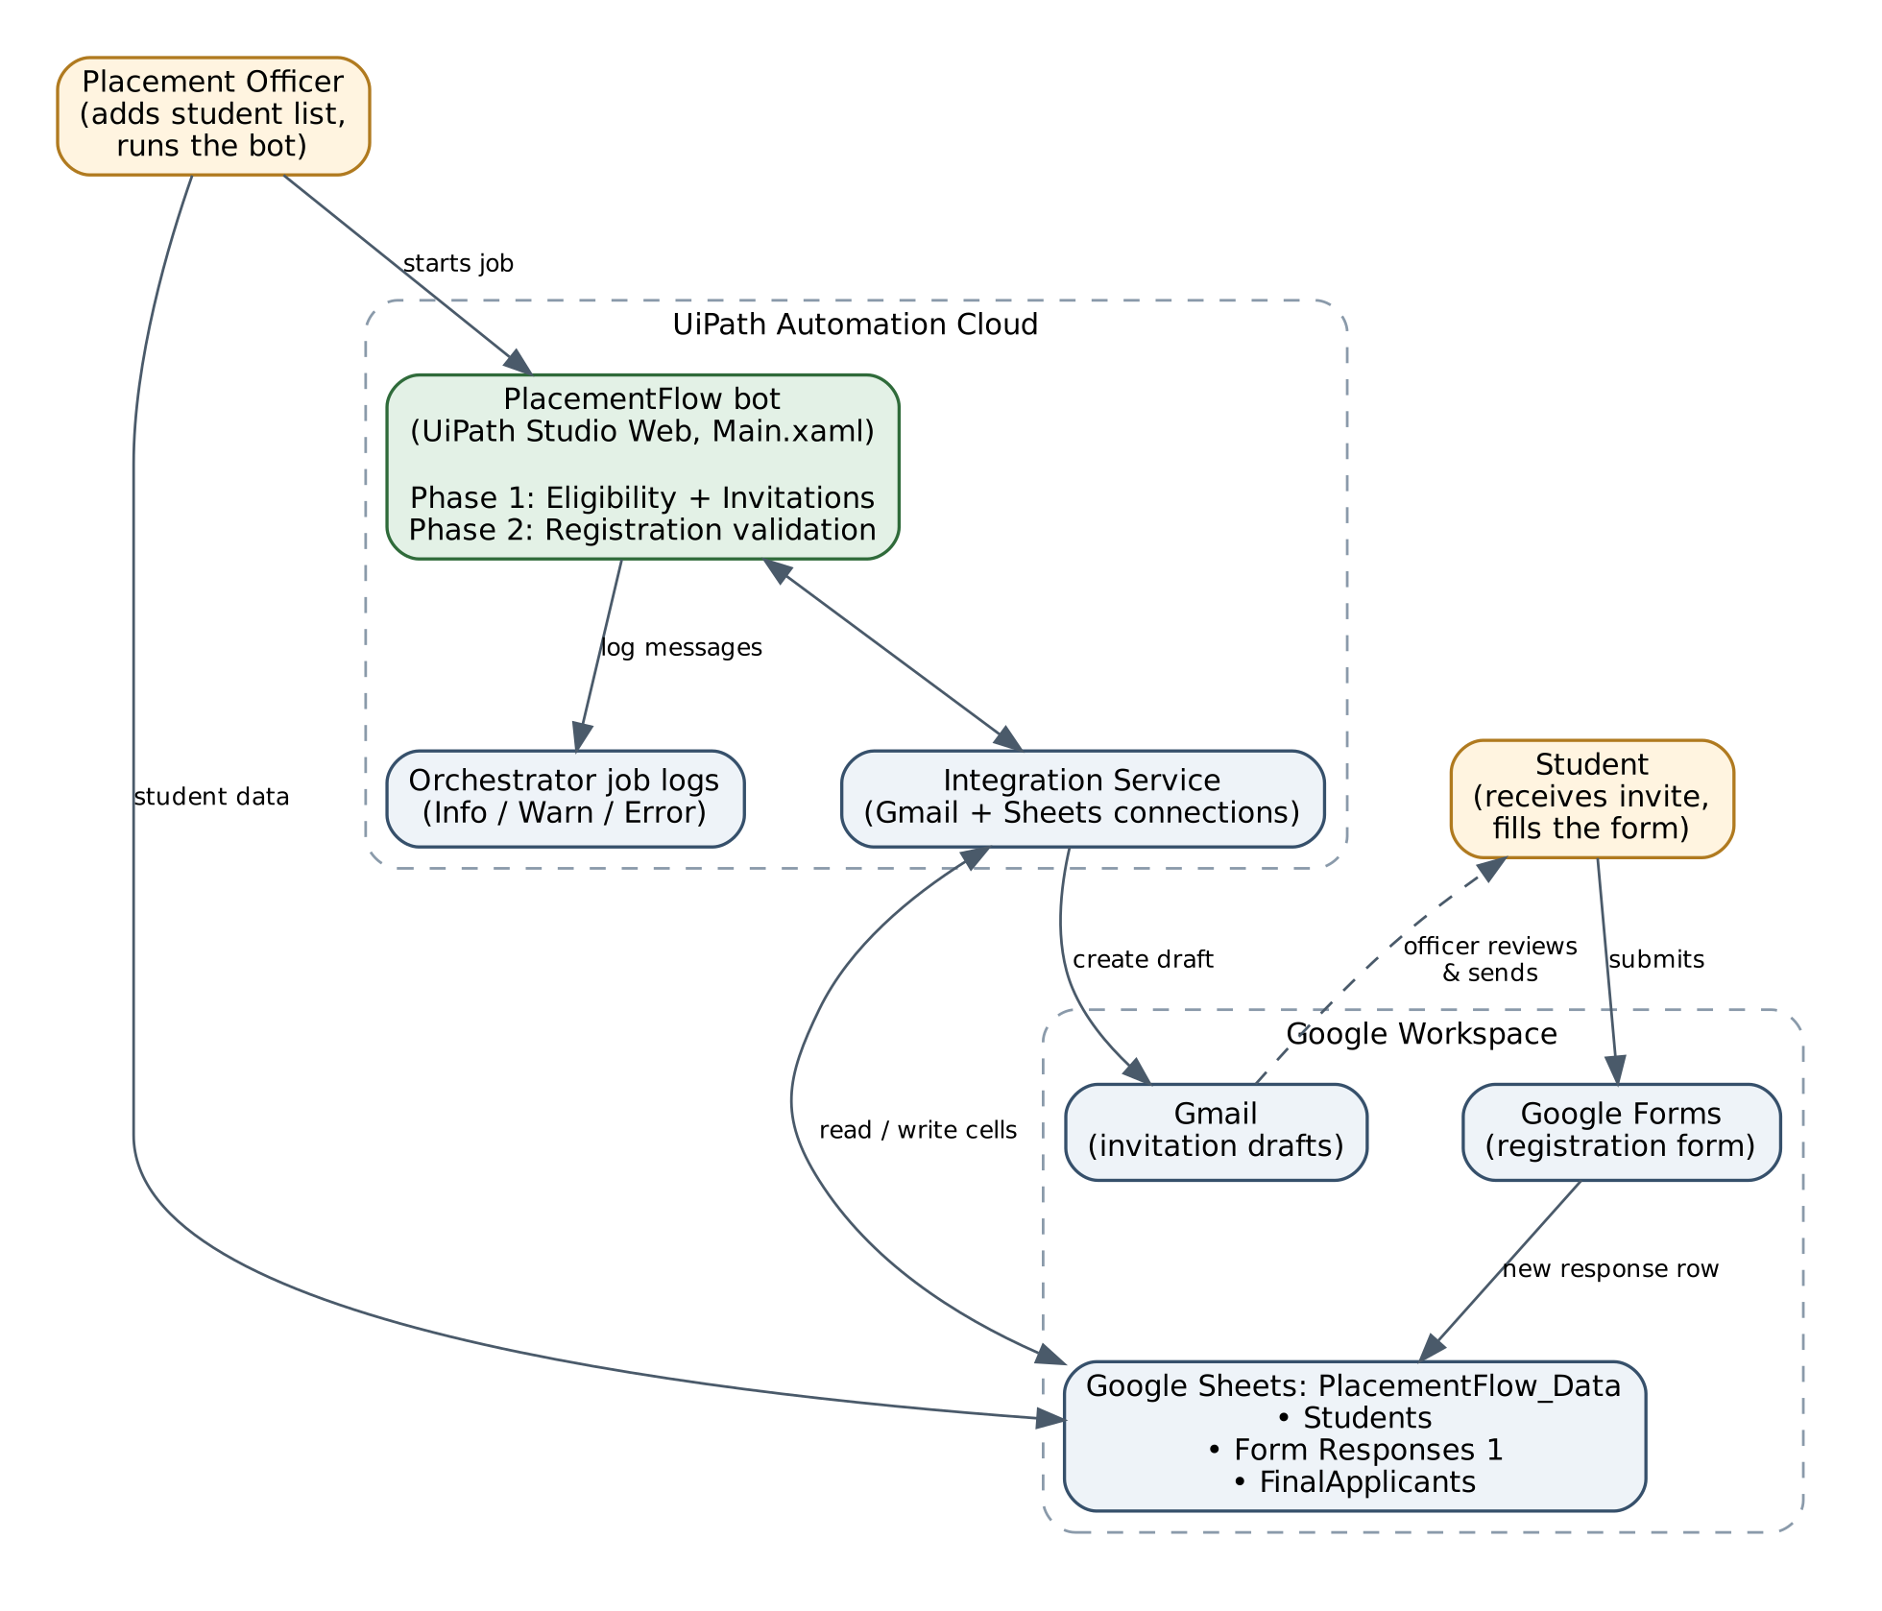

Figure 1: PlacementFlow system architecture

The system has three layers that talk to each other:
• People – the placement officer updates the list of students and initiates the robot; the students get the invitation and register via the filled registration form.
• UiPath Automation Cloud – the PlacementFlow robot (only one workflow, Main.xaml) is responsible for doing all the processing. The robot utilizes UiPath Integration Service as a safe way of communication between itself and Google, therefore the workflow doesn't use any password at all. Any decision made by the robot is documented in the Orchestrator job log in Info, Warn or Error levels.
• Google Workspace – PlacementFlow_Data is the spreadsheet with all the information. It contains three sheets: Students (complete master list and invitation status), Form Responses 1 (automatically filled by Google Forms + validation status written by the robot) and FinalApplicants (formula-based sheet with accepted students list). Invitation drafts are stored in Gmail and the registrations are submitted through Google Forms.

To put it briefly – the spreadsheet is the "notice board", the robot is the "clerk" that reads and writes into the "notice board" and prepares the letters and Gmail/Forms are the "post office" and "registration desk".

6. Automation Workflow
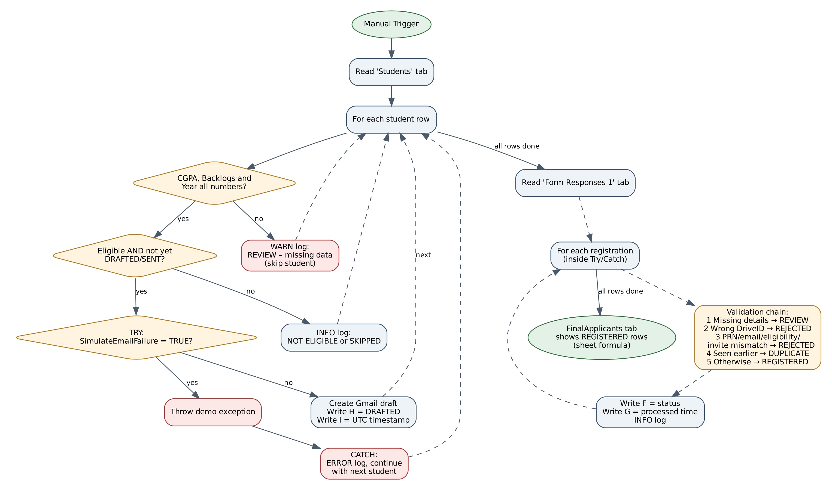
Figure 2: PlacementFlow workflow (Main.xaml)

6.1 Process Flow
The workflow runs in two phases, one after the other, every time it is started.
Phase 1: Eligibility and Invitations
1. Read Range loads all the rows from the "Students" tab into memory.
2. For Each Row loops through all the students and logs "Processing student: <name>"
3. Data check – in case CGPA, Backlogs or Graduation Year fields are not a number (e.g. blank), the robot logs a warning "REVIEW: Missing CGPA for student …" and skips to the next student
4. Eligibility check – student should have CGPA ≥ 7, 0 backlogs, graduation year 2027, branch CSE/IT/AIML, should not be labeled as DRAFTED or SENT. In case of ineligibility the robot logs "NOT ELIGIBLE" or "SKIPPED"
5. Invitation (in Try/Catch block) – in case the student is eligible the robot creates a draft email in Gmail with drive details and link to the form, labels the row with label DRAFTED and current UTC time in columns H and I respectively
6. In case of failure at step 5 the Catch block logs an error with student name and loop just moves on.
Phase 2 – Registration validation

1. Read Range scans the “Form Responses 1” tab.

2. For each individual response (processed within the respective Try/Catch), a validation chain is run and the outcome written to column F, while the processing time is written to column G (the time is preserved for already processed responses).

3. The tab “FinalApplicants” uses a sheet formula to display the rows where the status is equal to REGISTERED.

6.2 Decision Logic
Eligibility rule used in the "If 1" activity:
CDbl(CurrentRow("CGPA").ToString()) >= 7 AndAlso
CInt(CurrentRow("Backlogs").ToString()) = 0 AndAlso
CInt(CurrentRow("GraduationYear").ToString()) = 2027 AndAlso
New String() {"CSE", "IT", "AIML"}.Contains(CurrentRow("Branch").ToString().Trim().ToUpper()) AndAlso
(Not New String() {"DRAFTED", "SENT"}.Contains(CurrentRow("InvitationStatus").ToString().Trim().ToUpper())
OrElse CurrentRow("SimulateEmailFailure").ToString().Trim().ToUpper() = "TRUE")

Registration validation chain used in "Write Cell 2" (checked top to bottom – the first rule that matches decides the status):
Order | Check | Status written
1 | PRN, Name or Email is blank | REVIEW: Missing registration details
2 | Drive ID is not PF-2027-001 | REJECTED: Unknown drive
3 | No student in the Students tab with the same PRN and same email who was invited (DRAFTED/SENT) and is eligible | REJECTED: Student, email or eligibility mismatch
4 | An earlier response has the same PRN, email and drive | DUPLICATE: Already registered
5 | All checks passed | REGISTERED

6.3 Exception Handling and Retry Strategy (summary)

The errors will be dealt with per individual student and registration. One error will never affect all the other records. The process of retrying is incorporated in the system design since the robot writes 'DRAFTED' once the draft is successfully created, and hence, the student who had his/her email unsuccessful will not be marked at all. All the details are found in Section 10.

7. Technology Stack
Layer | Technology | Why we used it
Automation platform | UiPath Studio Web + Automation Cloud (Orchestrator, cloud robot) | Industry-standard RPA tool; browser-based, so the whole team could build and run it without installing anything.
Language | VB.NET expressions inside UiPath (low-code) | Lets us write the eligibility and validation rules as short, readable formulas.
API / connectors | UiPath Integration Service – Google Sheets and Gmail connectors (Google REST APIs underneath) | Secure OAuth sign-in; no passwords or API keys inside the workflow.
Data store | Google Sheets (PlacementFlow_Data) | Familiar to placement staff; acts as a lightweight database and tracking log.
Email | Gmail (draft mode, HTML body) | Lets a human check invitations before they go out.
Data collection | Google Forms | Free, easy for students, and writes responses straight into the sheet.
Reporting | Google Sheets formula (FinalApplicants tab) | Live applicant list without extra code.
Monitoring | UiPath Orchestrator job logs (Info / Warn / Error) | Central place to see what the robot did on every run.

8. Implementation

8.1 Modules
Module | UiPath activities | Purpose
M1 – Data intake | Manual Trigger, Read Range (Students) | Start the job and load the student list.
M2 – Data quality check | If + Log Message (Warn) | Catch blank or non-numeric CGPA / backlogs / year.
M3 – Eligibility engine | If 1 + Log Message | Apply the four placement rules and the "already invited" check.
M4 – Invitation | Try Catch, Send Email (Save as draft), Write Cell ×2 | Create the Gmail draft and record DRAFTED + time.
M5 – Registration validator | Read Range (Form Responses 1), For Each Row, Try Catch, Write Cell ×2 | Give every response a status and time.
M6 – Reporting & logs | FinalApplicants formula, Log Message (Info/Warn/Error) | Final list and an audit trail of the run.

8.2 Data Design
Students tab: A PRN · B Name · C Email · D Branch · E CGPA · F Backlogs · G GraduationYear · H InvitationStatus · I Invitation timestamp · plus a SimulateEmailFailure column used only for testing.
Form Responses 1 tab: Timestamp, PRN, Name, Email, DriveID (from the form) · F Validation status · G ProcessedTime (written by the robot).
FinalApplicants tab: a FILTER formula that shows Form Responses rows whose status is "REGISTERED", for example =FILTER('Form Responses 1'!A2:G, 'Form Responses 1'!F2:F="REGISTERED").

8.3 Integration

• The integration between Google Sheets and Gmail is done through UiPath Integration Service connections (one for each service). In the workflow, the services are referenced by their connection IDs, which means that the workflow can easily point to another account by just changing the connection ID.

• The Gmail action uses Save as draft = True and a body consisting of an HTML document with the Drive ID, eligibility criteria, and Google form.

• The Google forms are connected to the same spreadsheet, meaning that the new registrations will show up in "Form Responses 1."

• The robot writes to specific cells by referencing the row number (row index + 2 since row 1 is the header).

8.4 Security

• No passwords coded in code – sign-in via OAuth with the use of Integration Service; connections are configured to be “Authenticate After Deployment,” allowing each user to authenticate using their own credentials.

• Password masking – there are no Private:* and *password* properties logged by the project.

• Human in the loop – drafts are used to create the invitations, which means that each email is approved by a human prior to sending.

• Less is more – only the fields required for the eligibility are saved; test data is fictitious.

• Access restrictions – the spreadsheet is accessible only to the placement team; the form gathers only the PRN, name, email and drive id.

8.5 Deployment Steps

1. Build the PlacementFlow_Data Google Spreadsheet with the three sheets and the column names described above.

2. Build the Google Form (PRN, Name, Email, DriveID) and connect its results to the spreadsheet.

3. In the UiPath Automation Cloud, open Studio Web and load the placement flow solution PlacementFlow.uis.zip.

4. Create the Google Sheets and Gmail connections in the Integration Service.

5. Set the destinations for both "Read Range" actions and all "Write Cell" actions to be your spreadsheet.

6. Publish – a process named "RPA Workflow" is automatically created in the Orchestrator folder.

7. Start the process from Orchestrator (or Studio Web) and verify its output in Gmail draft folder, the spreadsheet and the job log.

A step-by-step instruction is attached in the Documentation folder (Setup and Run Guide).

9. Test Cases
We tested the robot with a dummy student list and dummy form responses designed to hit every rule and every error path. The table uses the template format.
Test ID | Scenario | Expected Output | Actual Output | Status
TC-01 | Eligible student, not yet invited – CGPA 8.2, Backlogs 0, Year 2027, Branch AIML, InvitationStatus blank | Gmail draft created; H = DRAFTED; I = UTC timestamp; log "ELIGIBLE" | Draft created in Gmail; sheet updated with DRAFTED and timestamp | Pass
TC-02 | CGPA below cut-off – CGPA 6.8, other fields valid | No draft; log "NOT ELIGIBLE" | No draft; "NOT ELIGIBLE" logged | Pass
TC-03 | Student has an active backlog – Backlogs 1, other fields valid | No draft; log "NOT ELIGIBLE" | No draft; "NOT ELIGIBLE" logged | Pass
TC-04 | Branch not allowed – Branch MECH, other fields valid | No draft; log "NOT ELIGIBLE" | No draft; "NOT ELIGIBLE" logged | Pass
TC-05 | Wrong graduation year – GraduationYear 2026, other fields valid | No draft; log "NOT ELIGIBLE" | No draft; "NOT ELIGIBLE" logged | Pass
TC-06 | Missing data (Exception 1) – CGPA cell left blank | WARN log "REVIEW: Missing CGPA…"; student skipped; run continues | Warning logged; remaining students processed | Pass
TC-07 | Re-run on an already invited student – InvitationStatus = DRAFTED | No second draft; log "SKIPPED: Invitation already processed" | Skipped; no duplicate email draft | Pass
TC-08 | Simulated Gmail failure (Exception 2) – SimulateEmailFailure = TRUE | Exception thrown and caught; ERROR log "INVITATION WORKFLOW ERROR: DEMO ONLY…"; next students and Phase 2 still run | Error caught and logged; registration processing completed | Pass
TC-09 | Valid registration – Invited eligible student submits correct PRN, email, DriveID PF-2027-001 | F = REGISTERED; G = processed time; row appears in FinalApplicants | REGISTERED – Aarav Shah and Arjun Nair shown in FinalApplicants | Pass
TC-10 | Duplicate registration – Same student submits the form a second time | Second row F = "DUPLICATE: Already registered" | Duplicate flagged; not added to FinalApplicants | Pass
TC-11 | Wrong details in form – Correct PRN but different email | F = "REJECTED: Student, email or eligibility mismatch" | Rejected with mismatch status | Pass
TC-12 | Unknown drive – DriveID entered as PF-2027-999 | F = "REJECTED: Unknown drive" | Rejected with unknown-drive status | Pass
TC-13 | Incomplete form response – Email left blank | F = "REVIEW: Missing registration details" | Flagged for review | Pass
TC-14 | Registration without an invitation – Ineligible / uninvited student submits the form | F = "REJECTED: Student, email or eligibility mismatch" | Rejected; not in FinalApplicants | Pass
TC-15 | Messy input formatting – Branch typed " aiml ", email in capitals | Treated as AIML / same email (spaces and case ignored) | Matched correctly | Pass

10. Exception Handling
We separate problems into business exceptions (the data is wrong, but the system is working) and system exceptions (a service or connection fails). Both are handled without stopping the whole run.
# | Exception | Type | How it is detected | What the robot does | How to recover
E1 | Missing / non-numeric CGPA, backlogs or year | Business | IsNumeric check before the eligibility rule | Logs WARN "REVIEW: Missing CGPA for student …", skips only that student | Officer fills the data; next run processes the student
E2 | Gmail failure while creating the draft (demonstrated with SimulateEmailFailure = TRUE) | System | Try/Catch around Send Email + Write Cell | Logs ERROR "INVITATION WORKFLOW ERROR … Student: <name>", continues with next student and Phase 2 | Status is not written, so the next run retries automatically
E3 | Sheet write fails during registration processing | System | Try/Catch around each registration | Logs ERROR "REGISTRATION PROCESSING FAILED: PRN …" | Re-run; record is processed again
E4 | Incomplete form response | Business | Blank PRN / name / email | Status "REVIEW: Missing registration details" | Officer contacts student
E5 | Unknown drive ID | Business | Drive ID ≠ PF-2027-001 | Status "REJECTED: Unknown drive" | Student resubmits with correct ID
E6 | Wrong email / not invited / not eligible | Business | Cross-check with Students tab | Status "REJECTED: … mismatch" | Not added to final list
E7 | Duplicate registration | Business | Earlier row with same PRN + email + drive | Status "DUPLICATE: Already registered" | Only the first entry counts

Recovery and Retry

• Re-Runnable (Idempotent): DRAFTED status is added only when there is success in the draft and no action for already drafted rows. Re-running the robot will not cause duplicates; instead, only failures will be retried.

• Isolation per record: every student and every registration has its own scope of error.

• Error handling testing: the SimulateEmailFailure column allows simulating a failure by raising an actual exception to test the Catch statement without breaking Gmail, and only rows with the value “TRUE” will be retried in every run as a real failure row should.

• Precise error message: all error messages have information about the student or PRN that causes errors and what should be checked.

11. Performance Evaluation

11.1 Execution Time
The workflow was tested in UiPath Automation Cloud using the prepared student records and registration responses. The demonstration uses two runs: the first creates invitation drafts and records their statuses; the second reloads those statuses and validates registrations. Execution time varies with cloud startup and Google service response times.
The number of cloud calls the robot makes is easy to predict:

The frequency of cloud queries made by the robot is predictable as follows:

• 2 queries per run (Students sheet and Form Responses sheet).

• 3 queries per invited user (1 Gmail draft query + 2 mobile queries); no queries for uninvited users.

• 2 queries per registration (status and time).

11.2 Reliability

• All 15 tests gave the expected results (refer to Section 9).

• If there is an error in one of the records, the process is not stopped (try/catch per record).

• Reloading is not a problem: there is no risk of double invitation, and failed objects will be retried.

• The rules are applied the same way each time: without any “tired human” errors, and spaces/uppercase are irrelevant.

11.3 Scalability

For a list of the size of a class (dozens or hundreds of students), the existing approach will be quite efficient. For a list that represents all college students, the primary drawback is that the robot writes cells one by one, and Google imposes minute-by-minute limits on the number of API calls. In this case, it is necessary to use Write Range to update the status for multiple cells at once, move the driving logic from the code to the configuration spreadsheet, and launch the task periodically or based on submissions from the form.

12. Results

12.1 Outputs
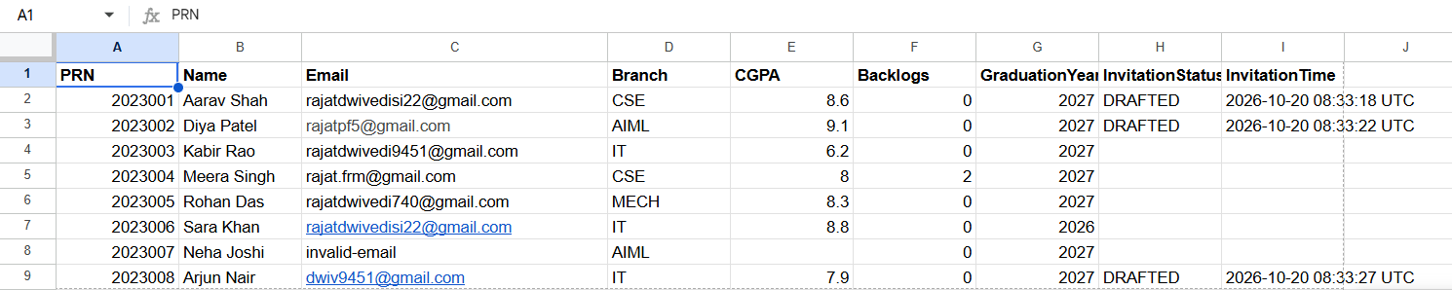
Figure 3. Students after a successful invitation run. Aarav, Diya and Arjun have DRAFTED statuses and UTC timestamps.

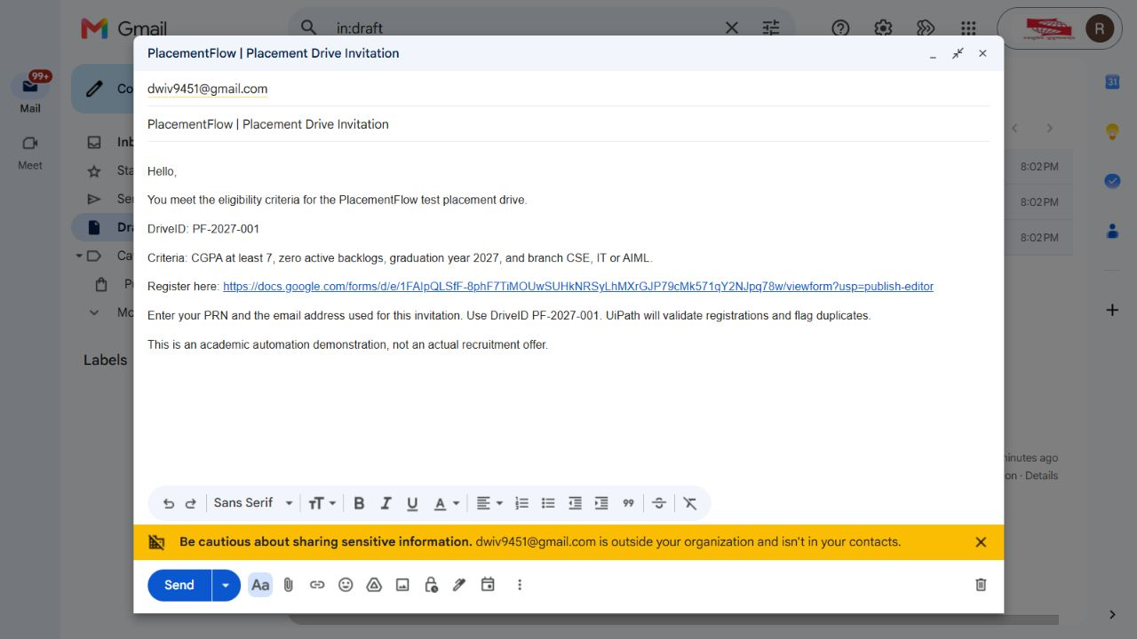
Figure 4. Generated Gmail invitation draft with the drive ID, eligibility criteria and registration link. The message has not been sent.

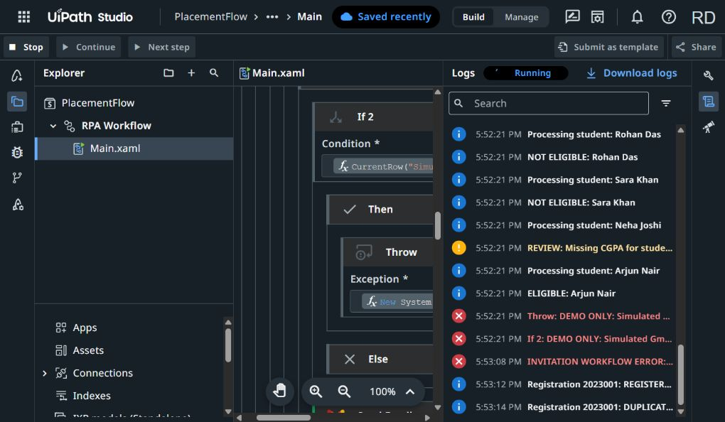
Figure 5. UiPath Studio Web debug logs showing the missing-CGPA warning and controlled Gmail-failure simulation. The catch logs the error and registration processing continues.

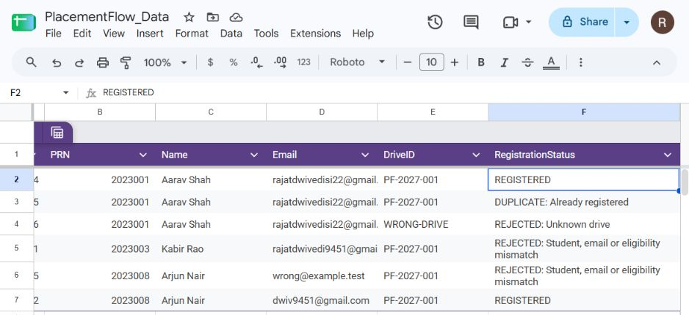
Figure 6. Registration results from the prepared test submissions. Valid entries are REGISTERED; the duplicate, unknown drive, ineligible student and email mismatch are flagged.

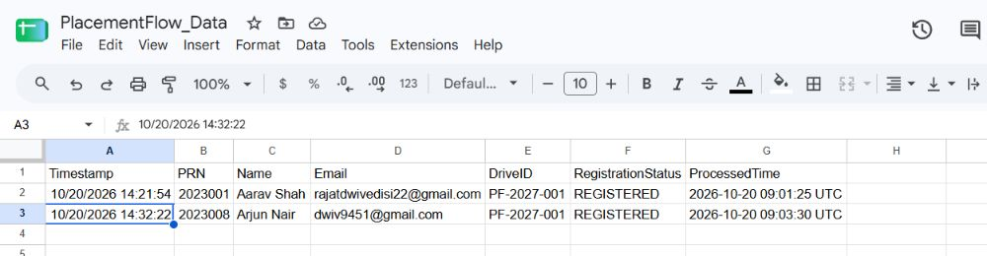
Figure 7. FinalApplicants after registration processing. The live filter displays Aarav Shah and Arjun Nair once each.

12.2 Observations

• Only those fulfilling all four conditions were sent a draft invitation letter, and all other students were recorded with reasons.

• A student who had no value in his CGPA field generated a warning and was skipped, while all other students' records were processed.

• The simulated Gmail problem was detected, recorded along with the student's name, and the processing of registration continued.

• The re-run of the robot skipped the already invited students and did not create any duplicate emails.

• The duplicate submission, incorrect email address, and drive ID not found were marked in the status field.

• The FinalApplicants sheet showed the accurate list of accepted students, which was Aarav Shah and Arjun Nair.

13. Innovation and Future Enhancements

13.1 What makes it different

• Closed loop: the majority of basic bots just send emails. PlacementFlow also verifies the reply (registration) against the original invite list, ensuring that only those who have been invited and qualified make it to the final list.

• Re-run safe: since the robot takes into account the status + timestamp of each user, the robot can be executed as many times as necessary without spamming users.

• Human-in-the-loop: the email drafts are created to ensure the final control stays with the officer.

• Automated fault testing: the SimulateEmailFailure switch allows anyone to test the fault tolerance, without affecting the live system.

• Business vs. system errors: invalid data errors are business errors and are logged for manual fixes, while the technical errors are retried.

• Zero additional costs: this entire solution is made using only software the college has (Google Workspace) plus the free tier of UiPath.

13.2 Future Enhancements

1. Drives configuration sheet – each row will represent each company with individual CGPA, branches, backlogs, year, and form link so that any future drive will not require any coding.

2. Real-time triggers – initiate registration check automatically after the form submission (Integration Service trigger/Apps Script) or scheduled trigger.

3. RunLog sheet/dashboard – log every run with counts (reads, eligible, drafted, warnings, errors) of the same for the placement officer.

4. Retries – wrap the Google Sheets/Gmail calls inside a retry scope in case of temporary network issues.

5. Batch writes – update the sheet in one go in case of large number of students.

6. Status email to students – inform students about the status of their registration or issues if there were any.

7. AI assistance – personalize invitations or generate a short summary of candidates for the company.

8. ERP Integration – extract the student data straight from the college ERP and not from the sheet.

14. Conclusion

This case demonstrates that an ordinary process in a real-life university can be automated end-to-end with low-code tools. The robot retrieves the data about the students, applies the placement logic, generates invitation drafts, verifies registration, and creates an application list free from missing data and service failures. It is safe to run several times, logs all decisions made, and delegates the final decision to send invitations to the human.

Key learnings:

• How to design an RPA process in UiPath Studio Web and integrate it into cloud applications via Integration Service.

• Why the principle of idempotency (not performing the same action twice) is important in real-life automation.

• How to distinguish business exceptions from system ones and how to continue a process when a particular record causes a problem.

• How to perform testing of an automation systematically with predefined scenarios and intentional failures.

• Team collaboration on a cloud automation project.

15. References
1. UiPath Documentation – Studio Web User Guide. https://docs.uipath.com/studio-web
2. UiPath Documentation – Integration Service: Google Sheets and Gmail connectors. https://docs.uipath.com/integration-service
3. UiPath Documentation – Orchestrator: Jobs and Logs. https://docs.uipath.com/orchestrator
4. Google Docs Editors Help – FILTER function. https://support.google.com/docs/answer/3093197
5. Google Forms Help – Choose where to save form responses. https://support.google.com/docs/answer/2917686

16. Annexure

A. Submitted Files
File / folder | Contents
Project_Report.pdf | This report
Demo_Video.mp4 | 5-minute demonstration of the complete working system
Workflow/ | PlacementFlow.uis.zip (UiPath solution export), Main.xaml, project.json, Workflow_Explanation.docx
Documentation/ | Setup and Run Guide, Sheet and Form Design, Test Plan and Test Cases, Architecture and Design Decisions
Repository_Link.txt | Link to the project repository

B. Repository Link
https://github.com/rajatwhosebrowsing/PlacementFlow-_RPA

C. Missing-data check (If activity)
Not IsNumeric(CurrentRow("CGPA").ToString()) OrElse
Not IsNumeric(CurrentRow("Backlogs").ToString()) OrElse
Not IsNumeric(CurrentRow("GraduationYear").ToString())

D. Registration validation chain (simplified)
1. PRN, Name or Email blank?
-> "REVIEW: Missing registration details"
2. DriveID is not "PF-2027-001"?
-> "REJECTED: Unknown drive"
3. No Students row where PRN matches AND Email matches (any case)
AND InvitationStatus is DRAFTED/SENT AND CGPA is 7-10
AND Backlogs = 0 AND GraduationYear = 2027
AND Branch is CSE / IT / AIML?
-> "REJECTED: Student, email or eligibility mismatch"
4. An EARLIER response has the same PRN + Email + DriveID?
-> "DUPLICATE: Already registered"
5. Otherwise
-> "REGISTERED"

E. Invitation email (as configured)
Subject: PlacementFlow | Placement Drive Invitation
Body: Hello, You meet the eligibility criteria for the PlacementFlow test placement drive. DriveID: PF-2027-001. Criteria: CGPA at least 7, zero active backlogs, graduation year 2027, and branch CSE, IT or AIML. Register here: https://docs.google.com/forms/d/e/1FAIpQLSfF-8phF7TiMOUwSUHkNRSyLhMXrGJP79cMk571qY2NJpq78w/viewform. Enter your PRN and the email address used for this invitation. Use DriveID PF-2027-001. UiPath will validate registrations and flag duplicates. This is an academic automation demonstration, not an actual recruitment offer.

F. Known limitations
- The drive rules and Drive ID are written inside the workflow, so a new drive needs a small edit (future: configuration sheet).
- The warning text always says "Missing CGPA" even when the blank field is Backlogs or Graduation Year.
- A student invited and registering within the same run is checked against the student list loaded at the start of that run; in practice students register after the invite, so this is handled on the next run.
- The job is started manually in this version.

G. Additional screenshots
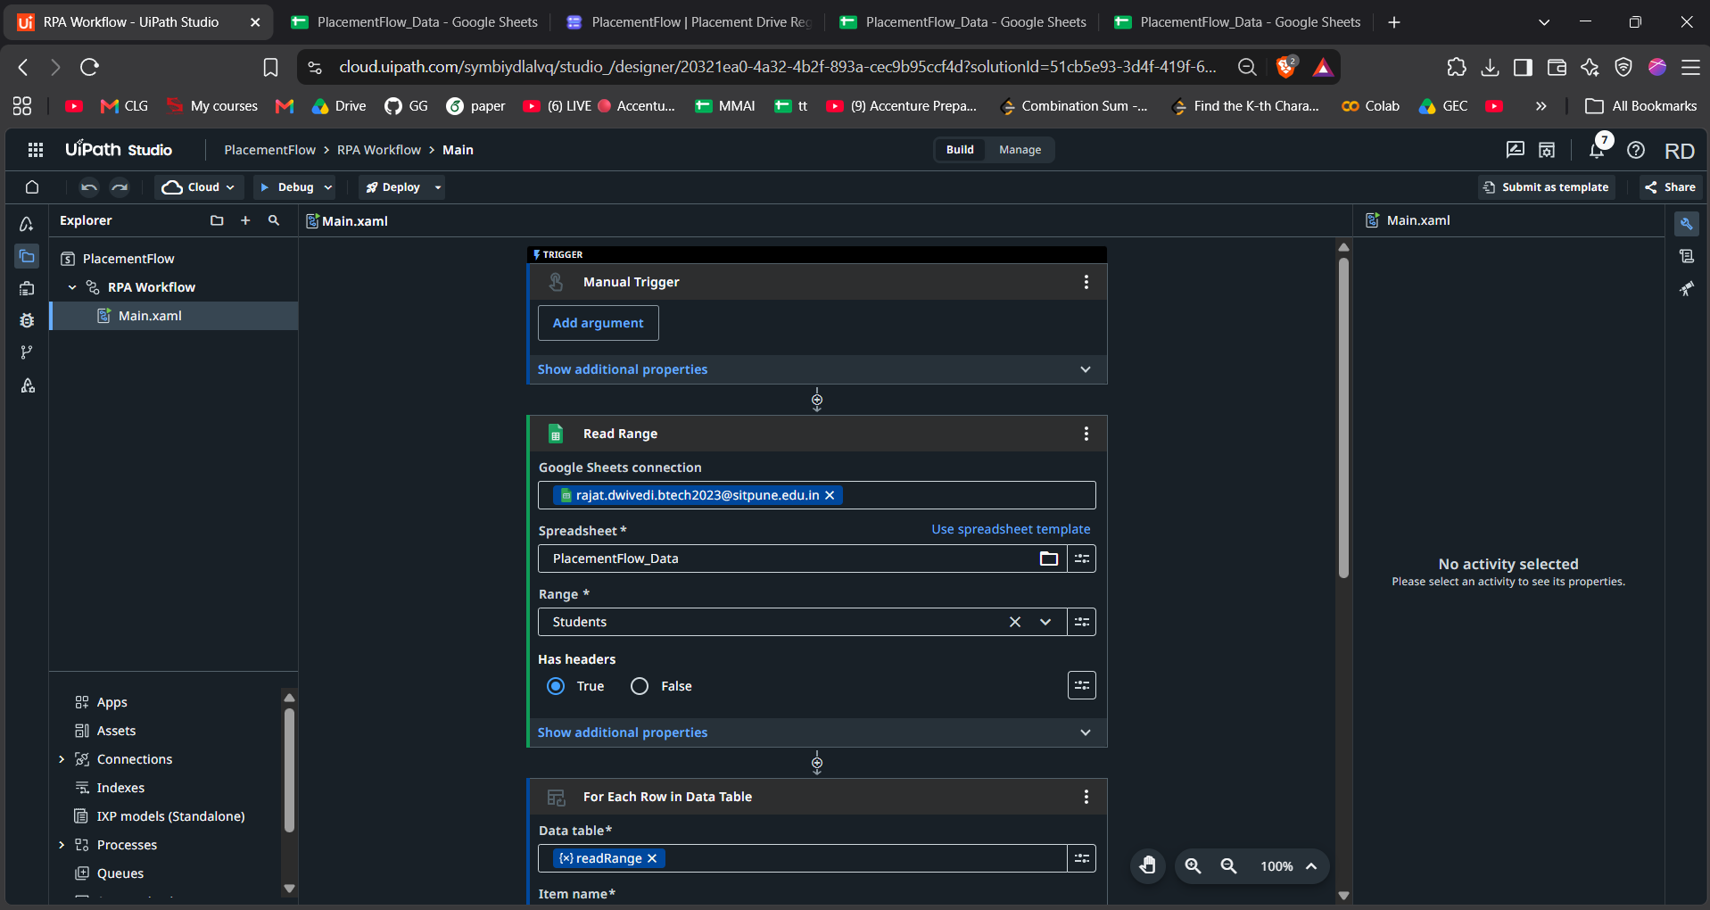
Figure 8. UiPath Studio Web designer showing Main.xaml, the manual trigger, student Read Range and row-processing loop.

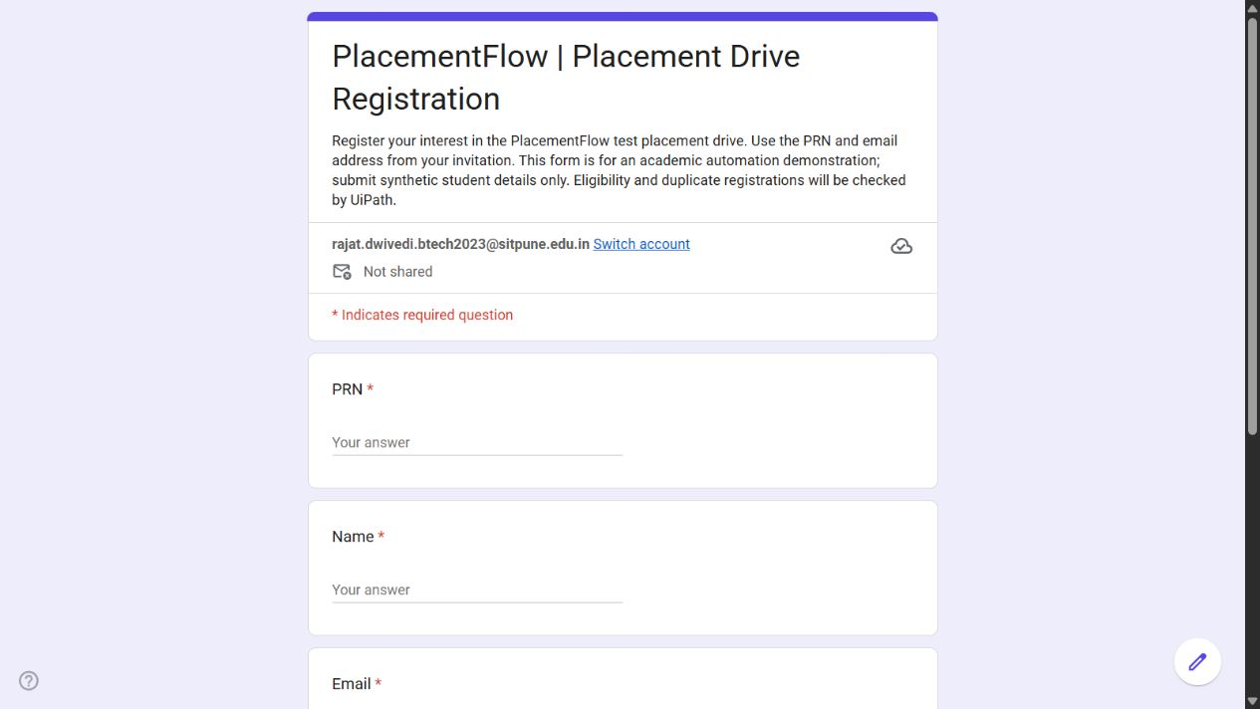
Figure 9. Published student registration form. The workflow checks submitted details against the student and invitation records.

