

NATIONAL UNIVERSITY OF MODERN LANGUAGES
Lab no 3
NAME: Raja Umer Shahzad
ROLL NO: FL23803
PROGAM: BSSE (6th Semester)
COURSE: Mobile Application Development
SUBMITTED TO: Mr. Muhammed Arif

Screen shots:
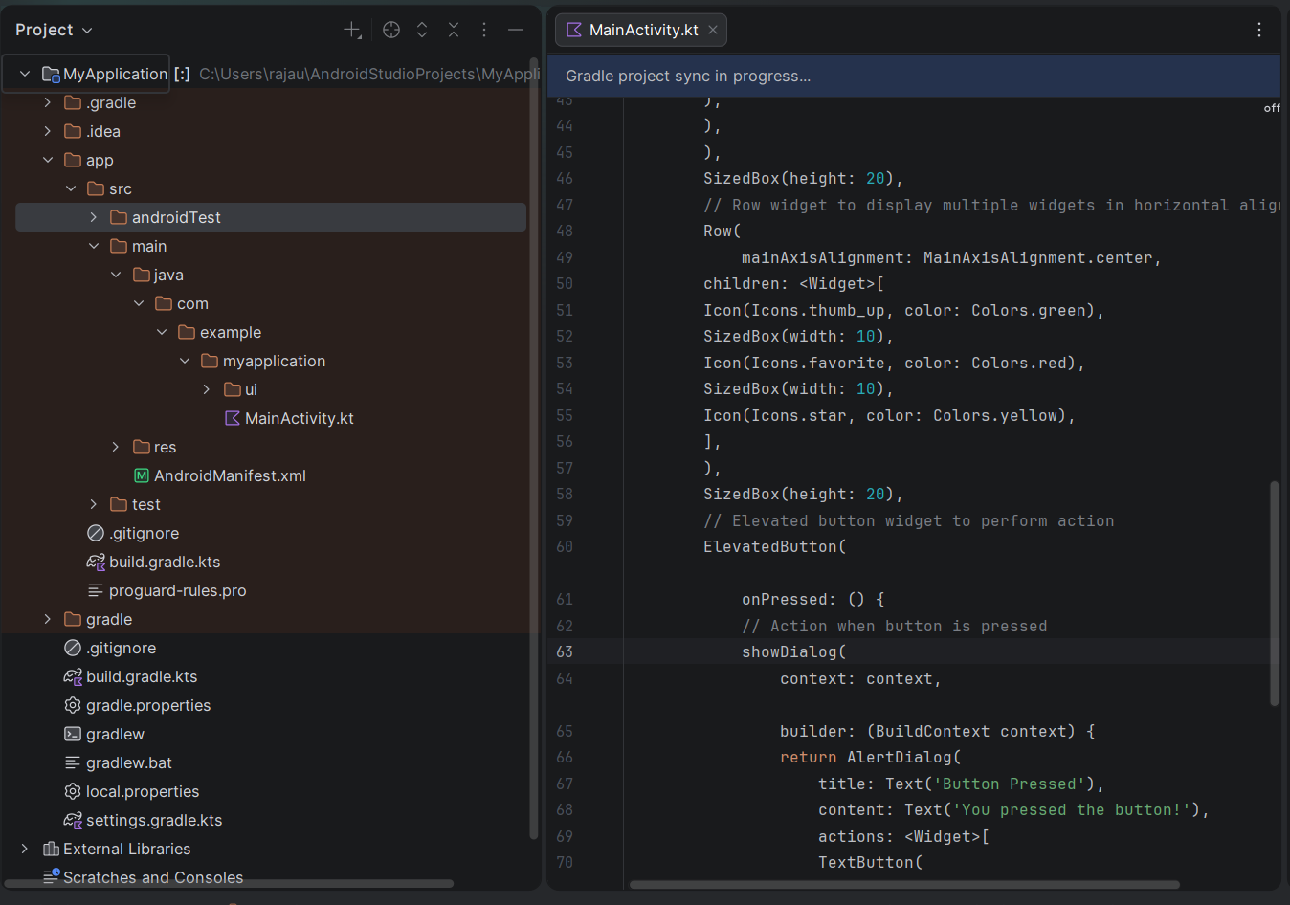

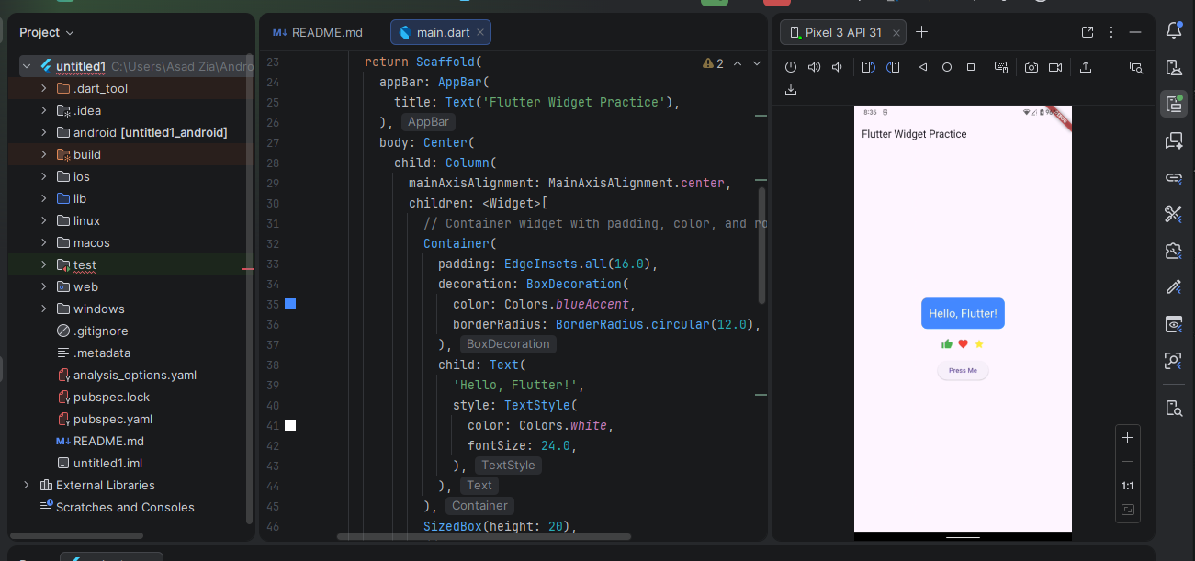

Explanation:
- MyApp: The main app widget that runs the application.
- HomePage: A widget with a scaffold containing a Column, displaying various widgets.
- Widgets:
  - Container: Used for decoration (color, padding, border radius) and text display.
  - Row: Displays multiple icons in a horizontal layout.
  - ElevatedButton: A button that shows an alert dialog when pressed.

