

NATIONAL UNIVERSITY OF MODERN LANGUAGES
Lab no 4

NAME: Raja Umer Shahzad
ROLL NO: FL23803
PROGRAM: BSSE (6th Semester)
COURSE: AI Lab
SUBMITTED TO: Ms Amna Sajid

List Data Structure :
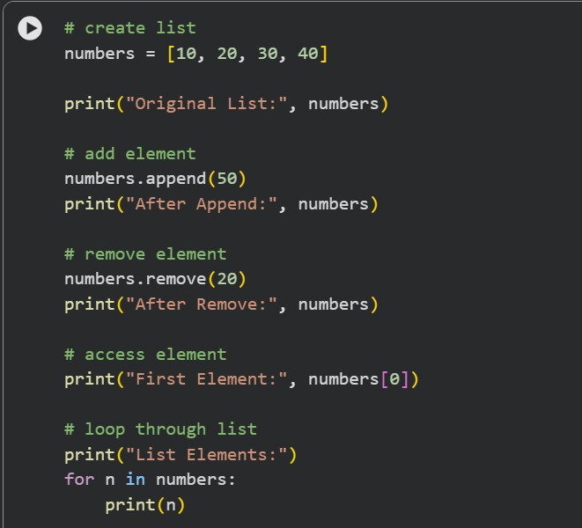

Output :
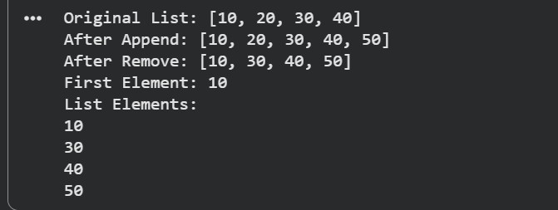
Output :



Stack (Last In First Out) :
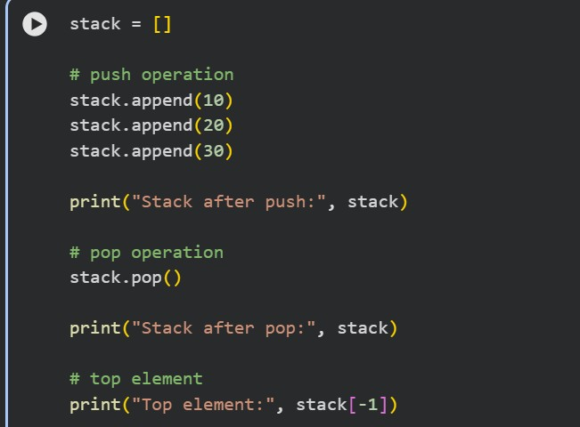
Output :

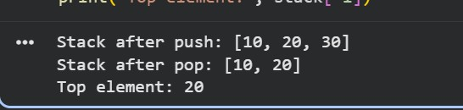

Queue (First In First Out ) :

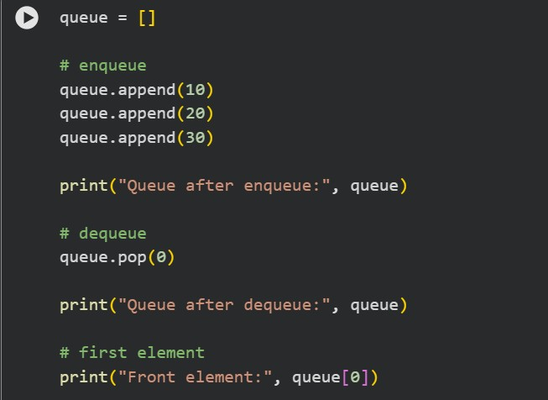

Output :
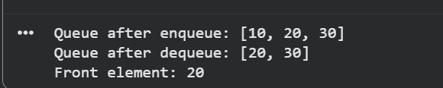

Linked List
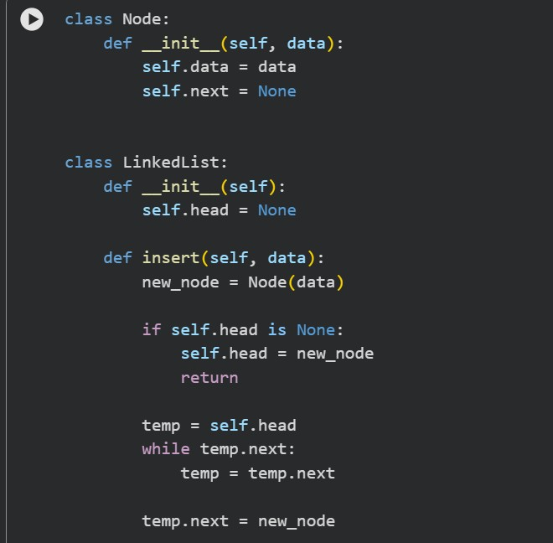

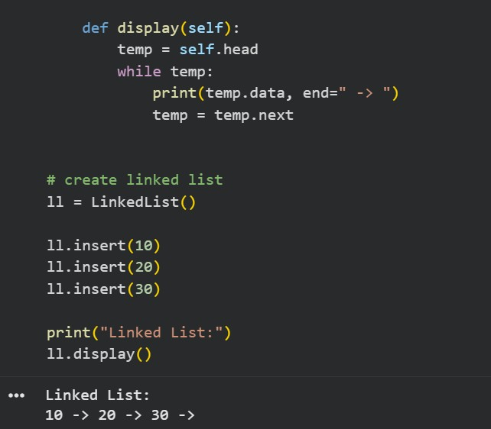
Binary Tree :
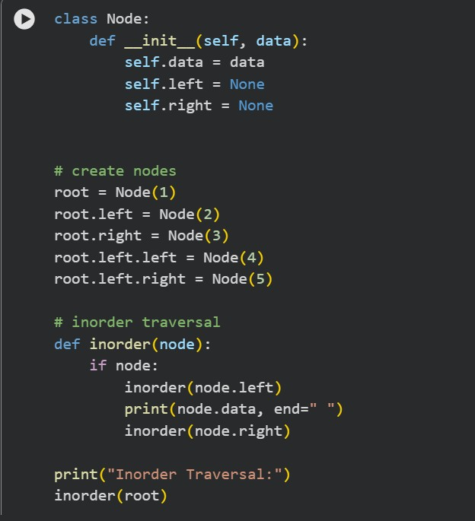

Output :
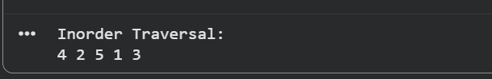
Graph:
