

NATIONAL UNIVERSITY OF MODERN LANGUAGES
Lab no 1

NAME: Raja Umer Shahzad
ROLL NO: FL23803
PROGRAM: BSSE (6th Semester)
COURSE: Software Quality Engineering Lab
SUBMITTED TO: Ms Rubab mushtaq

Screenshots(https://www.Youtube.com)
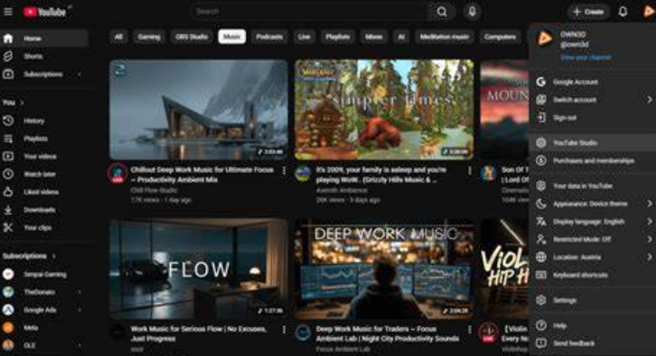

QA Report – Usability Evaluation Using Nielsen’s Heuristics

1. Target Application
The target application selected for usability evaluation is YouTube. It is a popular video-sharing platform where users can watch, upload, like, comment, and share videos.
YouTube is used by millions of users around the world for entertainment, education, and news. The application is available on both web and mobile platforms and provides features like video recommendations, subscriptions, playlists, and live streaming.
The purpose of this evaluation is to analyze the usability of YouTube using Nielsen’s 10 Usability Heuristics and identify possible usability issues.

2. Review Application Design
The design of YouTube focuses on simplicity and easy navigation.
The homepage shows recommended videos based on user interests. The top navigation bar includes search functionality, notifications, and profile options. The sidebar contains options like Home, Shorts, Subscriptions, and Library.
The video watching page contains the video player, video title, description, like/dislike buttons, comments section, and recommended videos.
Overall, the interface is user-friendly, but some usability issues can still be identified.

3. Apply Nielsen’s Heuristics
Below are some usability issues identified using Nielsen’s heuristics.

Issue 1 – Visibility of System Status
Observed Issue:
Sometimes when a video is loading, the buffering icon is small and not very noticeable. Users may feel confused if the video is not playing.
Page/Screen:
Video Player Screen
Severity:
Medium
Suggested Improvement:
YouTube should display a clearer loading message such as “Video is loading…” along with a more visible progress indicator.

Issue 2 – Match Between System and Real World
Observed Issue:
Some technical terms in settings such as “Restricted Mode” or “Data Saver” are not clearly explained for new users.
Page/Screen:
Settings Page
Severity:
Low
Suggested Improvement:
Add short explanations or tooltips that explain the purpose of these features in simple language.

Issue 3 – User Control and Freedom
Observed Issue:
When users accidentally tap on a video, there is no quick undo option to return to the previous video state.
Page/Screen:
Home Page / Video Player
Severity:
Medium
Suggested Improvement:
Provide an undo option or quick back button to allow users to return to the previous video quickly.

Issue 4 – Consistency and Standards
Observed Issue:
The placement of some icons like Share, Download, and Clip may change depending on screen size or device.
Page/Screen:
Video Player Screen
Severity:
Low
Suggested Improvement:
Maintain consistent icon placement across devices so users can easily locate them.

Issue 5 – Error Prevention
Observed Issue:
Users may accidentally delete a comment without confirmation.
Page/Screen:
Comments Section
Severity:
High
Suggested Improvement:
Add a confirmation message such as “Are you sure you want to delete this comment?”

4. Document Usability Issues (Summary Table)
Heuristic | Issue | Screen | Severity | Suggested Improvement
Visibility of System Status | Video buffering not clear | Video Player | Medium | Show clearer loading indicator
Match with Real World | Technical terms confusing | Settings | Low | Add explanations
User Control | No undo option | Video Player | Medium | Add undo/back option
Consistency | Icons change position | Video Player | Low | Keep icon placement consistent
Error Prevention | Comment deletion without confirmation | Comments | High | Add confirmation message

5. Recommendations for Improvement
Based on the usability evaluation, the following recommendations are suggested:
- Improve system feedback during video loading.
- Provide clear explanations for technical settings.
- Add undo options for accidental actions.
- Maintain consistent interface design across devices.
- Implement confirmation messages to prevent accidental errors.
These improvements can help enhance the overall usability and user experience of the application.

Screenshots and Annotated Comments
Students should include screenshots of the application screens where usability issues occur. Each screenshot should highlight the issue using arrows or notes.
Example:
- Screenshot of video buffering screen
- Screenshot of settings page
- Screenshot of comments deletion option

