

NATIONAL UNIVERSITY OF MODERN LANGUAGES
Lab no 3

NAME: Raja Umer Shahzad
ROLL NO: FL23803
PROGRAM: BSSE (6th Semester)
COURSE: AI Lab
SUBMITTED TO: Ms Amna Sajid

Task 1:
Code for DFS :
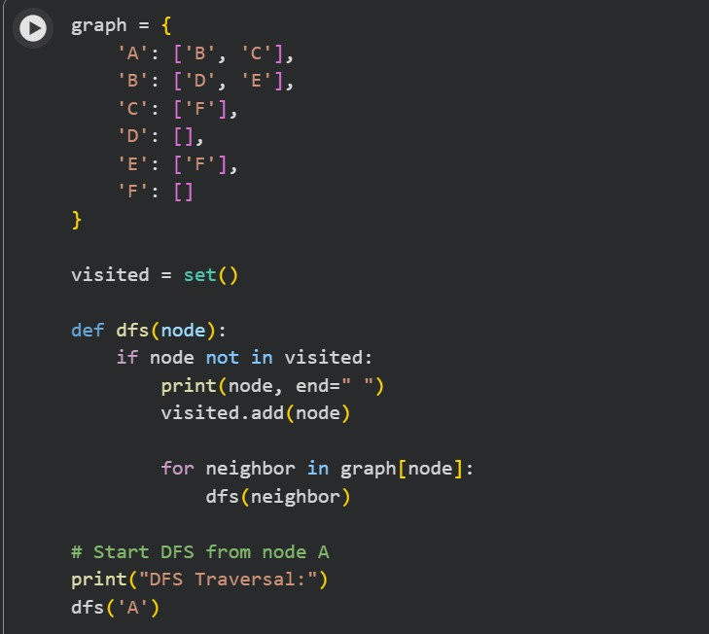
Output :



Code for BFS :
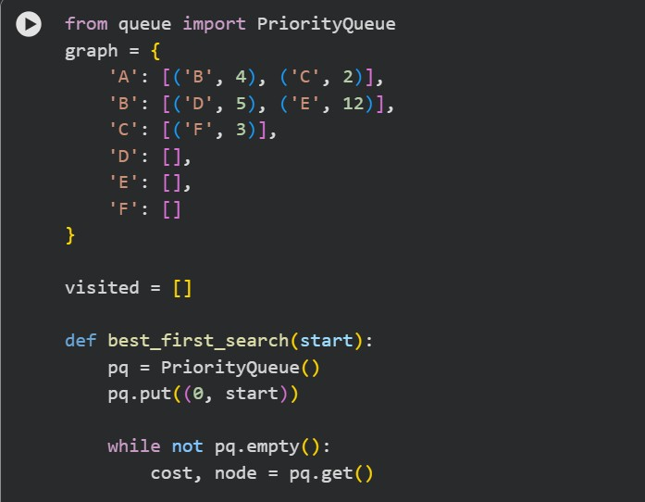
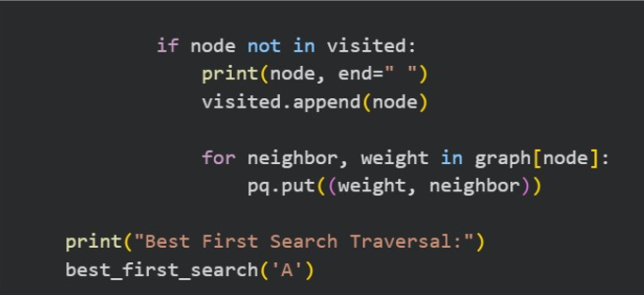
Output :
