
USER INTERFACE DESIGN (23CSE113)
LAB MANUAL
Submitted by
Name | R Raghavendra
Roll no | AV.SC.U4CSE25236
Year/Sem/Section | 1stYear/Sem-2/CSE-C
Credits | 03
Submitted to
Name | Dr. Raj Kumar Batchu
Designation | Asst. Professor (SI. Grade)
Department | School of Computing

INDEX
S.NO | TITLE | PAGE NO | REMARKS
1. | WEEK 1:  a)Installation of vs code  b)Understanding basic of HTML Structure  c)Understanding basic HTML tags | 3-12
2. | WEEK 2:  a)Making of Timetable using basic HTML elements  b)Syllabus page | 13-22
3. | WEEK 3 :  - A college wants to collect student details through an online admission form. Design a registration form using only HTML tags (no CSS) with proper labels, table alignment , background colour , and borders.  - A company wants to design a webpage that displays two different forms side by side using iframes . One Iframes should display a Login Form and the other should display a Registration Forms . | 23-30
4. | 4.A. A college wants to collect student details through an online admission form. Design a registration form using only HTML tags (no CSS) with proper labels, table alignment, background color, and borders.  B. A company wants to design a webpage that displays two different forms side by side using iframes. One iframe should display a Login Form and the other should display a Registration Form. | 31-41
5. | A. Creating a card layout using <div> t ag consider three cards and a button using html and CSS  B. Navigation using iframe (mini website) upon clicking each buttons the details about that button should be display on the same page  C. Design amrita login page by showing different campus on home page upon clicking on each campus the details about each campus should be display on the same page use html and css to design a stylish webpage | 41-66
6 | Design a responsive e-commerce application using the grid layout. This application should contain different categories of products such as electronics, clothing, home-appliances, books. Based on the category we select corresponding products should be displayed on the sidebar. | 66-73

WEEK 1:
a) AIM: To Download and Install VS-Code.
Step1: Open web browser and click on vs-code.
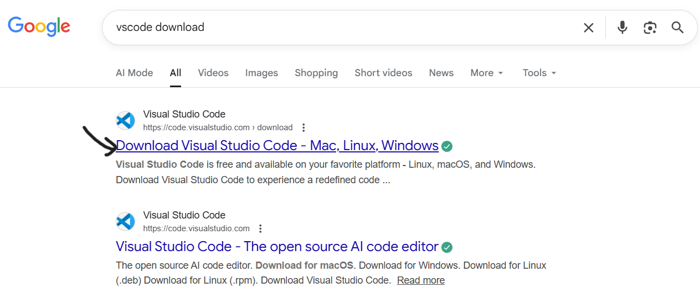
Step2: Click on the Download for windows.
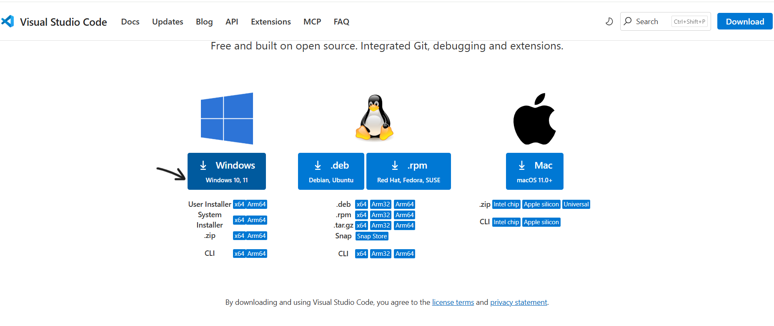
Step3: Click the Download button.
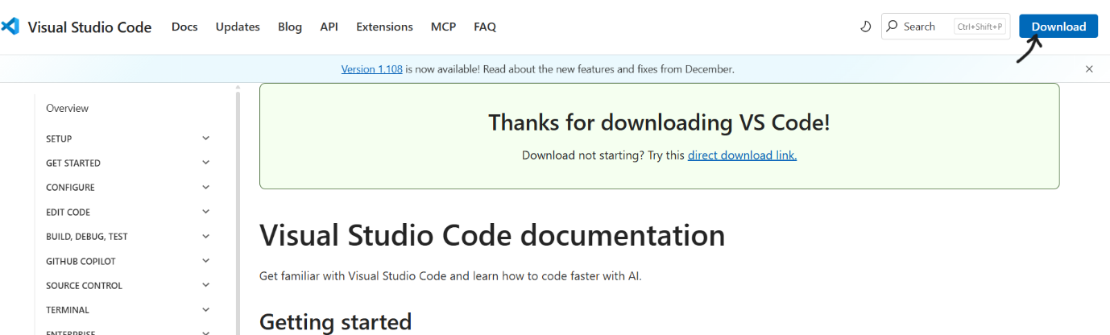

Step4: Click I accept the agreement and click next.
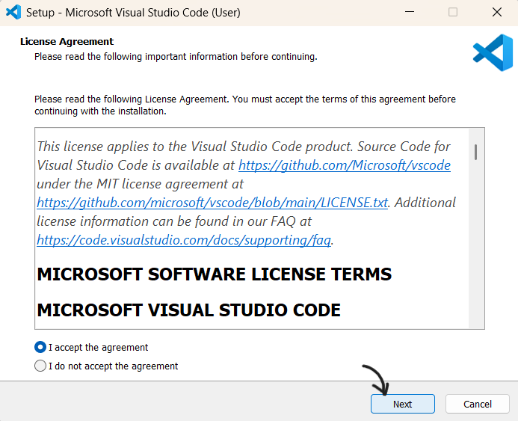

Step5: Click on add to path, create a desktop icon and click on next.
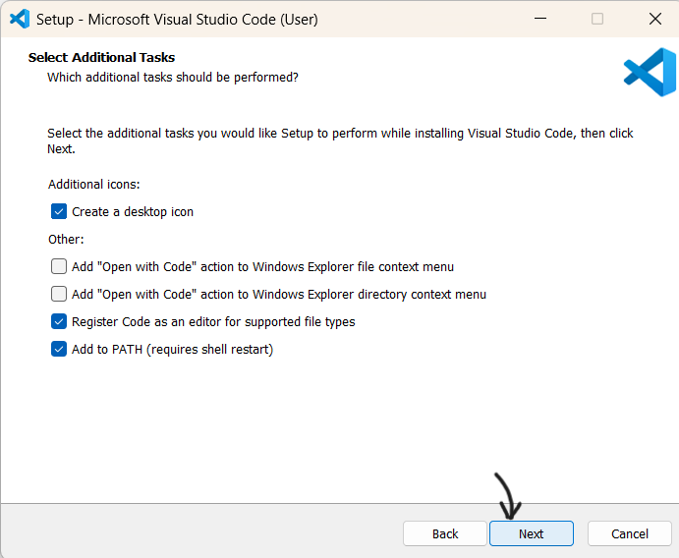

Step6: Click on Install vs-code.
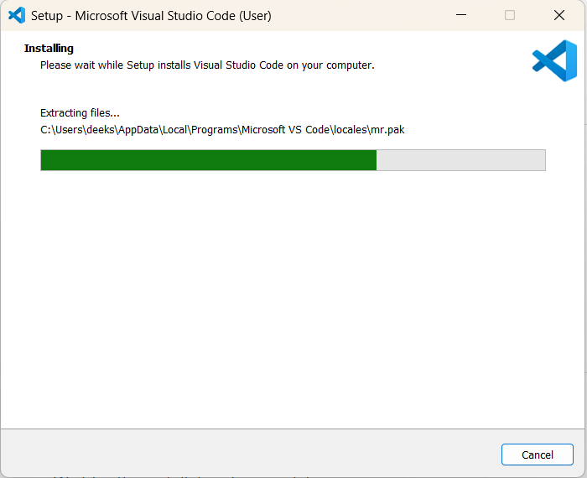

Step7: Click finish.
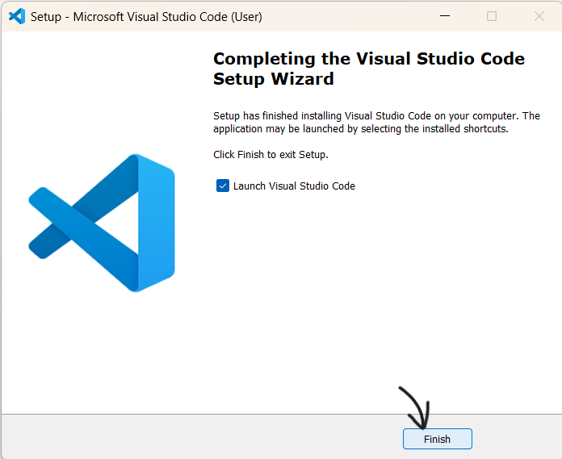

Output: VS-Code is Downloaded and Installed successfully.
b) AIM: Creating basic HTML page .

PROGRAM :
<!DOCTYPEhtml>
<html>
<head>
<title>First Web Page</title>
<head>
<body>
<h1>Happy to learn html</h1>
<p>This is my first sample code</p>
</body>
</html>

OUTPUT :
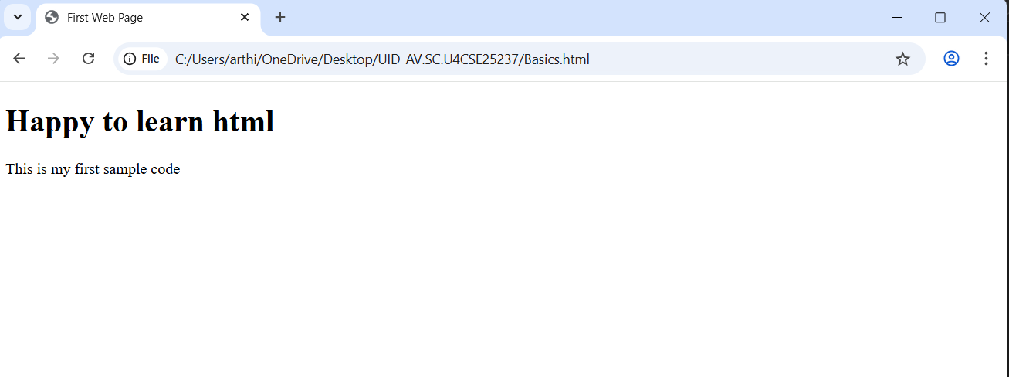
EXPLANATION :
This is basic html web page .There are mainly 4 important elements in every code they are <!DOCTYPEhtml>,<html>, <head>,</body>.

c) AIM: Basic html tags.
1)Heading Tag
PROGRAM :
<!DOCTYPEhtml>
<html>
<head>
<title>STUDENT DETAILS</title>
<head>
<body>
<h1>my details</h1>
<p>name:raghavendra</p>
<p>class:cse, c section</p>
<h2>personal details</h2>
<p>i live a dayscholar</p>
</body>
</head>
OUTPUT :

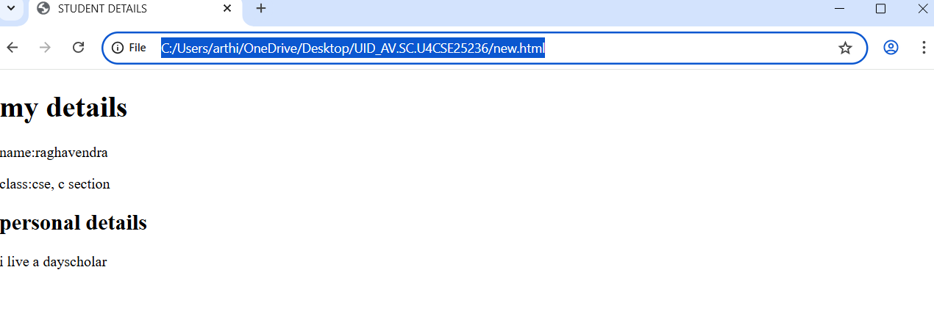
EXPLANATION :
Here we will kearn how to write headings in html web page.Here we can observe the size difference between h1 and h2.
2)Link Tag
PROGRAM :

<!DOCTYPE html>
<html>
<body>
<h2>HTML LINK</h2>
<p>This is link to open amrita university site:</p>
<a href="https://www.amrita.edu">this is the link of AMRITA University</a>
<p ABOUT YOURSELF <br> MY NAME IS RAGHAVENDRA<br> SECTION : CSE C <br> ROLL NO : AV.SC.U4CSE25236 </P>
</body>
</html>
OUTPUT :
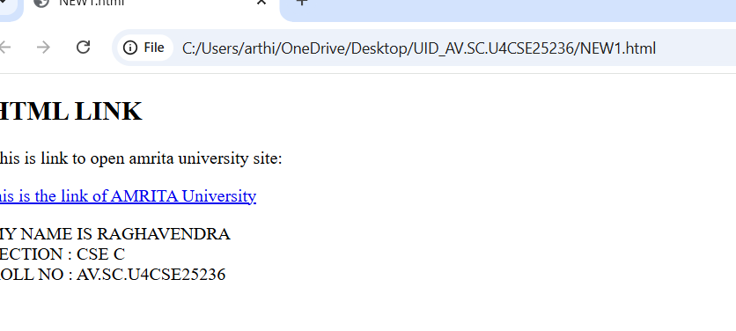
EXPLANATION:
Web page opens when we click on the link.

3)Adding image links
PROGRAM :
<!DOCTYPE html>
<html>
<head>
<title>Image,length and width attributes</title>
</head>
<body>
<h2>HTML IMAGE LINK</h2>

<img src="https://www.amrita.edu/branding/" alt="https://www.amrita.edu" width="104" height="142">
<p ABOUT YOURSELF <br> MY NAME IS RAGHAVENDRA <br> SECTION : CSE C <br> ROLL NO : AV.SC.U4CSE25236 </P>
</body>
</html>
OUTPUT :
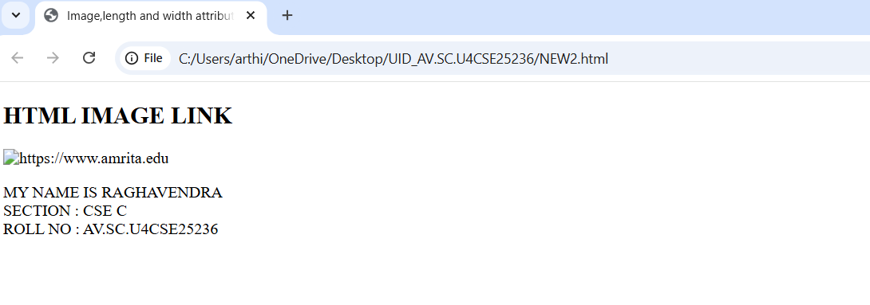
EXPLANATION:
Image logo is appeared here. When we click on the logo, image will appear .

4) Break Tags
PROGRAM :
<!DOCTYPE html>
<html>
<head>
<title >here we can print a single statement in different line by using break statement break </title>
<body>
<P>GECKS ARE A GROUP OF USUALLY SMALL,USUALLY NOCTURNAL LIZARDS<br> ARE FOUND ON EVERY CONTINENT EXCEPT ANTARTICA.</P>
<p ABOUT YOURSELF <br> MY NAME IS RAGHAVENDRA<br> SECTION : CSE C <br> ROLL NO : AV.SC.U4CSE25236 </P>
</body>
</html>
OUTPUT :
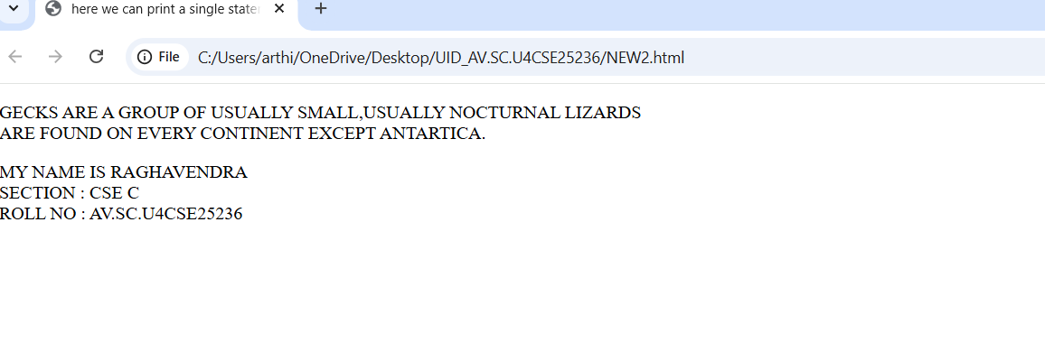

EXPLANATION:
When we insert br in between paragraph and then it prints from the next line in output.

5)Style Tags
PROGRAM :
<!DOCTYPE html>
<html>
<head>

</head>
<body>
<h2 style="color: blueviolet;">HTML LINK</h2>

<p style="color:red;">this is a red paragraph</p>
<p>ABOUT YOURSELF <br> MY NAME IS RAGHAVENDRA <br> SECTION : CSE C <br> ROLL NO : AV.SC.U4CSE25236 </P>

</body>
</html>
OUTPUT :
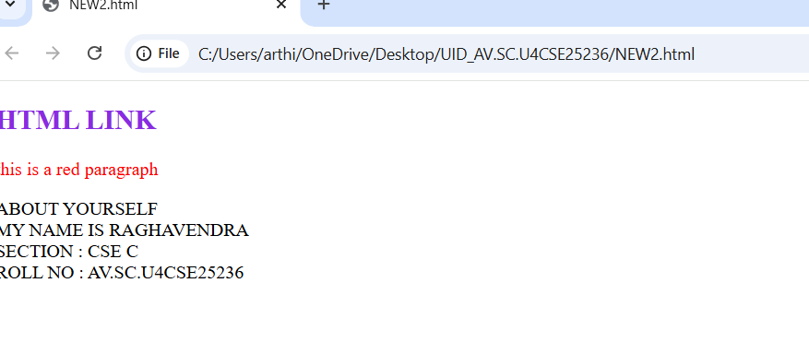

EXPLANATION:
With the help of this this we can modify the text according to our requirement. For example by using colour tag we can change the text colour .

WEEK 2:
AIM :
a)Making of Timetable using basic HTML elements
b)Syllabus page
PROGRAM :
<!DOCTYPE html>
<html>
<body>
<table border="2px">
<caption style="text-align: center; background-color: yellow;" border="2px" >MASTER TIME TABLE CSE 2-SEMESTER C-SECTION</caption>
<tr style="text-align: center;">
<td colspan="4">Dept. CSE</td>
<td rowspan="3" colspan="8">Class Room Venue: 512</td>
</tr>
<tr style="text-align: center;">
<td colspan="4"> Class: B. Tech. CSE-C</td>
</tr>
<tr style="text-align: center;">
<td colspan="4">Semester-II</td>
</tr>
<tr style="text-align: center;">
<td colspan="4">Class Advisors: <br>
1. Name: Mr. Budati Jaya Lakshminarayana<br>
Email : bj_lakshminarayana@av.amrita.edu<br>
Mobile Number :+91-7989795768
</td>
<td colspan="8" >2. Name: Dr. Arun Kumar S<br>
< Email : s_arunkumar@av.amrita.edu<br>
Mobile Number : +91-8940857202
</td>
</tr>
<tr style="text-align: center;">
<td rowspan="2">Time/ Day</td>
<td>Slot 1 </td>
<td>Slot 2</td>
<td rowspan="2">10.35am-
10.45am</td>
<td>Slot 3</td>
<td>Slot 4</td>
<td>Slot 5</td>
<td rowspan="2">01.15pm
-02.05pm</td>
<td>Slot 6</td>
<td rowspan="2">01.15pm
-02.05pm</td>
<td>Slot 7</td>
<td>Slot 8</td>
</tr>
<tr style="text-align: center;">
<td>08.55-09.45am</td>
<td> 09.45-10.35am</td>
<td>10.45-11.35am</td>
<td> 11.35am-12.25pm</td>
<td> 12.25am-01.15pm</td>
<td> 02.10-03.00pm</td>
<td> 03.10-04.00pm</td>
<td> 04.00-04.50pm</td>
</tr>
<tr style="text-align: center;">
<td>Monday</td>
<td colspan="2">23MAT116 Discrete Mathematics_lab2</td>
<td style="background-color: yellow;writing-mode: sideways-lr;" rowspan="5">Short Break</td>
<td> 23PHY115 Modern Physics</td>
<td>23CSE111Object Oriented Programming</td>
<td>Library</td>
<td style="background-color: yellow;writing-mode: sideways-lr;" rowspan="5">Lunch Break</td>
<td>Library</td>
<td style="background-color: yellow;writing-mode: sideways-lr;" rowspan="5">Short Break</td>
<td colspan="2">Library/Sports</td>
</tr>
<tr style="text-align: center;">
<td>Tuesday</td>
<td colspan="2">23CSE113 User Interface Design LAB(BYOD)</td>
<td> 23MAT117 Linear Algebra</td>
<td>23MAT116 Discrete Mathematics</td>
<td> COUNSELLING</td>
<td>Library</td>
<td colspan="2">22ADM111 Glimpses of Glorious India</td>
</tr>
<tr style="text-align: center;">
<td>Wednesday</td>
<td>23PHY115 Modern Physics</td>
<td>23CSE113 User Interface Design</td>
<td colspan="2">23MAT117 Linear Algebra_LAB(BYOD)</td>
<td>COUNSELLING</td>
<td>Library</td>
<td colspan="2">Library/Sports</td>
</tr>
<tr style="text-align: center;">
<td>Thursday</td>
<td>23CSE111Object Oriented Programming</td>
<td>23MAT116 Discrete Mathematics</td>
<td colspan="2">23CSE111Object Oriented Programming _Lab2</td>
<td>23MAT117 Linear Algebra</td>
<td>23MEE115 Manufacturing Practice LAB</td>
<td colspan="2">23MEE115 Manufacturing Practice LAB</td>
</tr>
<tr style="text-align: center;">
<td>Friday</td>
<td>23CSE111Object Oriented Programming</td>
<td>23MAT116 Discrete Mathematics</td>
<td>23PHY115 Modern Physics(T)</td>
<td>23CSE113 User Interface Design</td>
<td>23MAT117 Linear Algebra</td>
<td>22ADM111Glimpses of Glorious India(P)</td>
<td colspan="2">Library/Sports</td>
</tr>
</table>
<br>
<hr>
<br>
<table border="2px" style="border-collapse: collapse;margin: auto;" class="center" height="300" width="850" >
<tr style="text-align: center;">
<td>Course Code</td>
<td width="200px">Course Name</td>
<td width="50px"> </td>
<td width="70px">L-T-P</td>
<td width="70px">Credits</td>
<td width="200px">Faculty Name</td>
<td width="50px"></td>
<td width="200px">Assisting Faculty</td>
</tr>
<tr>
<td>23MAT116</td>
<td>Discrete Mathematics</td>
<td> </td>
<td style="text-align: center;"> 3-0-2</td>
<td style="text-align: center;">4</td>
<td> Dr.Srivivasa Rao Thota</td>
<td></td>
<td></td>
</tr>
<tr>
<td>23MAT117</td>
<td>Linear Algebra</td>
<td> </td>
<td style="text-align: center;"> 3-0-2 </td>
<td style="text-align: center;">4</td>
<td> Mr.Sapavat Bixapathi</td>
<td></td>
<td></td>
</tr>
<tr>
<td>23CSE111</td>
<td>Object Oriented Programming</td>
<td> </td>
<td style="text-align: center;">3-0-2</td>
<td style="text-align: center;">4</td>
<td>Dr.Satya Rajendra Singh R</td>
<td></td>
<td>Dr. Balaji TK</td>
</tr>
<tr><td>23PHY115</td>
<td>Modern Physics</td>
<td> </td>
<td style="text-align: center;">2-1-0</td>
<td style="text-align: center;">3</td>
<td>Dr.Soumya</td>
<td></td>
<td></td>
</tr>
<tr>
<td>23CSE113</td>
<td>User Interface Design</td>
<td> </td>
<td style="text-align: center;"> 2-0-2</td>
<td style="text-align: center;">3</td>
<td> Dr.Rajkumar Batchu</td>
<td></td>
<td>Mr. Barge Bharadwaj</td>
</tr>
<tr>
<td>23MEE115</td>
<td>Manufacturing Practice </td>
<td> </td>
<td style="text-align: center;">0-0-3</td>
<td style="text-align: center;">1</td>
<td>Dr. Sathies S</td>
<td></td>
<td></td>
</tr>
<tr>
<td>22ADM111</td>
<td>Glimpses of Glorious India</td>
<td> </td>
<td style="text-align: center;">2-0-1</td>
<td style="text-align: center;">2</td>
<td>Dr. Siva Panuganti</td>
<td></td>
<td></td>
</tr>
<tr>
<td></td>
<td style="text-align: center;">Total (15L + 1Tut +12P =28 hrs)</td>
<td cellpadding="10"></td>
<td style="text-align: center;">15-1-12</td>
<td style="text-align: center;">21</td>
<td></td>
<td></td>
<td></td>
</tr>
</table>
<br>
<br>
<br>
<hr>
<br>
<br>
<br>
<h1 style="text-align: center;background-color: yellow;" ><b> <strong> SYLLABUS (SEM - 2) </strong></b></h1>
<p><b>1.Discrete Mathematics (23MAT116)</b></p>
<img src="Discrete mathematics.jpeg" alt="Syllabus" width="1300" height="450">
<p><b>2.Linear Algebra (23MAT117)</b></p>
<img src="LINEAR ALGEBRA.jpeg" alt="Syllabus" width="1250" height="450">
<p><b>3.Object Oriented Programming (23CSE111)</b></p>
<img src="OOP.jpeg" alt="Syllabus" width="1250" height="500">
<p><b>4.Modern Physic (23PHY115)</b></p>
<img src="MORDERN PHYSICS.jpeg" alt="Syllabus" width="1350" height="650">
<p><b>5.User Interface Design (23CSE113)</b></p>
<img src="HTML.jpeg" alt="Syllabus" width="1350" height="600">
<p><b>6.Manufacturing Practice (23MEE115)</b></p>
<img src="MANUFACTURING UNIT DESIGN.jpeg" alt="Syllabus" width="1350" height="550">
<p><b>7.Glimpses of Glorious India (22ADM111)</b></p>
<img src="GGI.jpeg" alt="Syllabus" width="1209" height="200">
<br>
<br>
<hr>
<br>
<br>
<p style="text-align: justify;"> ABOUT YOURSELF <br> MY NAME IS RAGHAVENDRA <br> SECTION : CSE C <br> ROLL NO : AV.SC.U4CSE25236 </P>
</body>
</html>
OUTPUT:

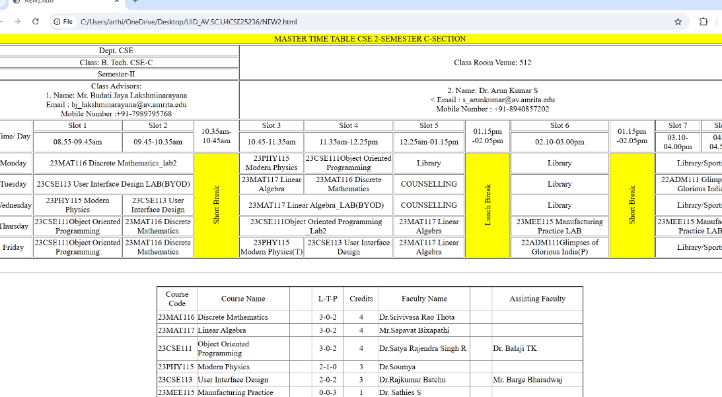

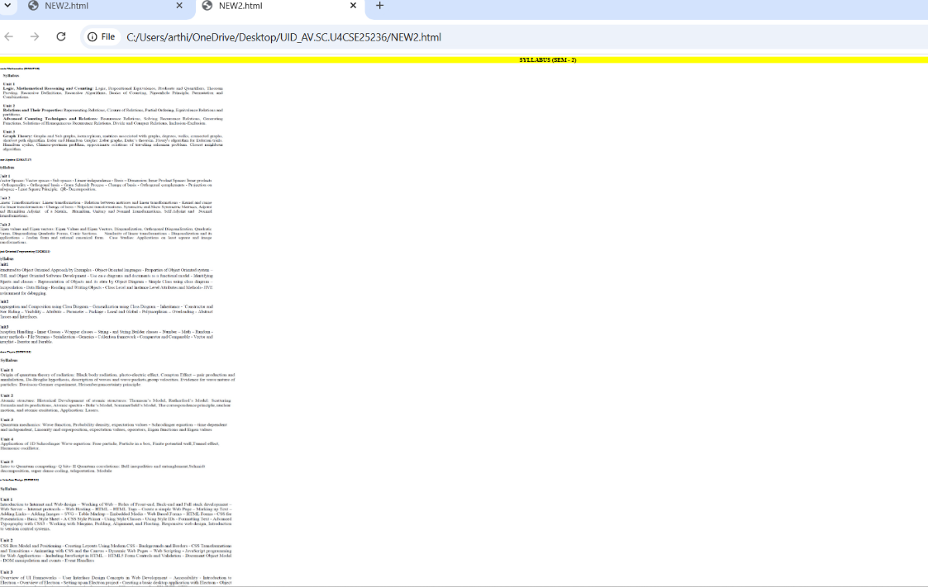

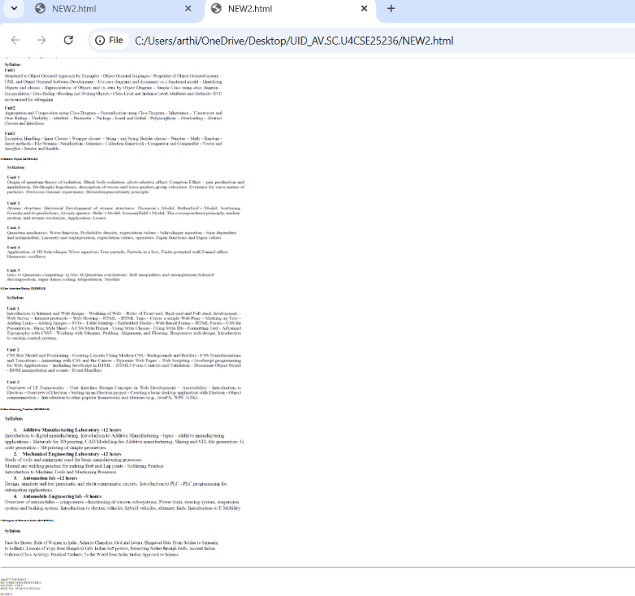

WEEK 3 :
- AIM : A college wants to collect student details through an online admission form. Design a registration form using only HTML tags (no CSS) with proper labels, table alignment , background colour , and borders.
PROGRAME :
<!DOCTYPE html>
<html>
<body style="background-color: lavender;">
<table width="420" style="border-width: 3px;background-color: white; border-collapse: collapse;"border="1" align="center">
<caption style="text-align: center;"><b>College Admission Registration</b></caption>
<br>
<tr>
<td cellpadding="10">
<label for="fname">Full Name:</label>
</td>
<td cellpadding="5" >
<input type="text" id="fname" name="fname">
</td>
</tr>
<tr>
<td>
<label for="mail">Email:</label>
</td>
<td>
<input type="text" id="mail" name="mail">
</td>
</tr>
<tr>
<td>
<label for="phone number">Phone Number:</label>
</td>
<td>
<input type="text" id="phone number" name="phone number" >
</td>
</tr>
<tr>
<td>
<label for="Gender">Gender:</label>
</td>
<td>
<input type="radio" id="gender" name="Male" >
<label for="gender">Female</label>
<input type="radio" id="gender" name="Male">
<label for="gender">Male</label>
<input type="radio" id="gender" name="Others">
<label for="gender">Others</label>
</td>
</tr>
<tr>
<td>
<label for="course">Course Applying For:</label>
</td>
<td>
<select id="course" name="course" >
<option value="BTECH">BTECH</option>
<option value="PHARMACY">PHARMACY</option>
<option value="ARTS">ARTS</option>
<option value="LAW">LAW</option>
<option value="MBA">MBA</option>
</select>
</td>
</tr>
<tr>
<td><label for="HOBBIES">Hobbies:</label></td>
<td>
<input type="checkbox" id="HOBBIES" name="HOBBIES">
<label for="HOBBIES">Sports</label>
<input type="checkbox" id="M" name="M">
<label for="m">Music</label>
<input type="checkbox" id="R" name="R">
<label for="R">Reading</label>
</td>
</tr>
<tr>
<td><label for="date">Date of Birth:</label></td>
<td><input type="date" id="date"></td>
</tr>
<tr>
<td>
<label for="file">Uplode Certificates:</label>
</td>
<td><input type="file"></td>
</tr>
<tr>
<td><label>Address:</label></td>
<td>
<textarea name="message" rows="10" cols="10"></textarea>
</td>
</tr>
<tr><td colspan="2" style="text-align: center;"><input type="submit"><input type="reset"></td></tr>
</table>
<br> <br><br>
<p style="text-align: justify;"> ABOUT YOURSELF <br> MY NAME IS RAGHAVENDRA <br> SECTION : CSE C <br> ROLL NO : AV.SC.U4CSE25236 </P>
</body>
</html>

OUTPUT :
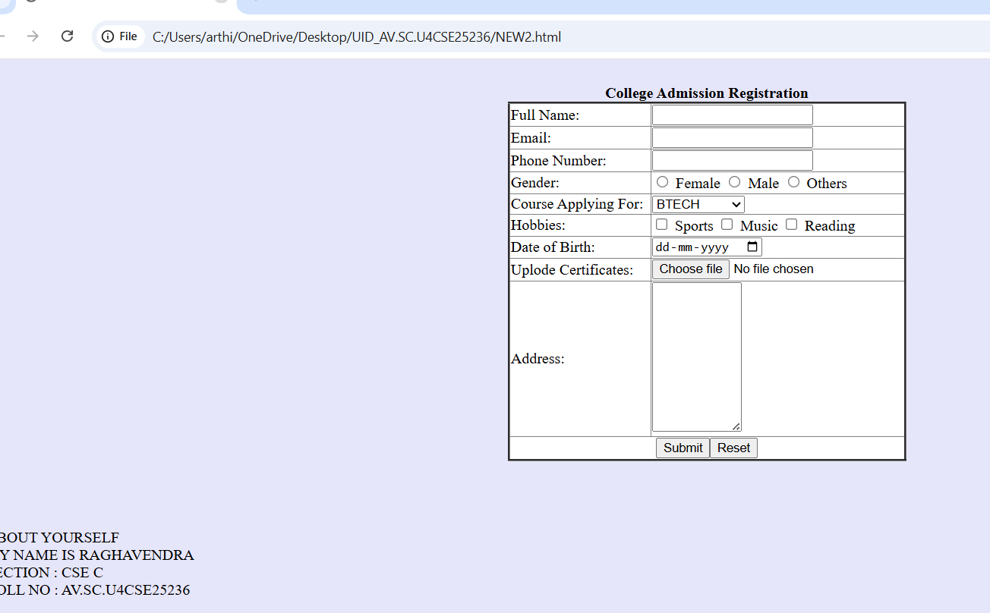

b) AIM :A company wants to design a webpage that displays two different forms side by side using iframes . One Iframes should display a Login Form and the other should display a Registration Forms .
PROGRAME :
PART 1:
<!DOCTYPE html>
<html >
<body>
<h3 style="text-align: center;">User Login</h3>
<table border="2px" align="center" style="border-collapse: collapse;background-color: white;">
<tr>
<td>
<label for="name">User Name :</label>
</td>
<td>
<input type="text" id="name" name="name"><br>
</td>
</tr>
<tr>
<td>
<label for="pass">Password :</label>
</td>
<td>
<input type="text" id="pass" name="pass">
</td>
</tr>
<tr>
<td colspan="2" style="text-align: center;"><input type="submit" value="Login"></td>
</tr>
</table>
</body>
</html>
PART 2 :
<!DOCTYPE html>
<html>
<body>
<h3 style="text-align:center;">User Registration</h3>
<table border="2px" style="border-collapse: collapse;background-color: white;" align="center">
<tr>
<td>
<label>Full Name:</label>
</td>
<td>
<input type="text">
</td>
</tr>
<tr>
<td>
<label>Email:</label>
</td>
<td>
<input type="email">
</td>
</tr>
<tr>
<td>
<label>Phone:</label>
</td>
<td>
<input type="text">
</td>
</tr>
<tr>
<td>
<label>Password:</label>
</td>
<td>
<input type="password">
</td>
</tr>
<tr>
<td style="text-align: center;" colspan="2">
<button type="submit">Register</button>
<button type="reset">Reset</button>
</td>
</tr>
</table>
</body>
</html>
PART 3 :
<!DOCTYPE html>
<html>
<body style="background-color: palevioletred;">
<h2 style="text-align: center;">Two Forms Displayed Using Iframes</h2>
<table style="margin: 0 auto;" cellspacing="40">
<tr>
<td><iframe src="p1.html" title="User Login" style="display: flex;float: left; background-color: white;" width="400" height="300" frameborder="1" ></iframe></td>
<td><iframe src="p2.html" title="User Registration" style="display: flex;float: right;background-color: white;" width="400" height="300" frameborder="1"></iframe></td>
</tr>
</table>
<br><br><br>
<p style="text-align: justify;"> ABOUT YOURSELF <br> MY NAME IS RAGHAVENDRA <br> SECTION : CSE C <br> ROLL NO : AV.SC.U4CSE25236 </P>
</body>
</html>

OUTPUT :
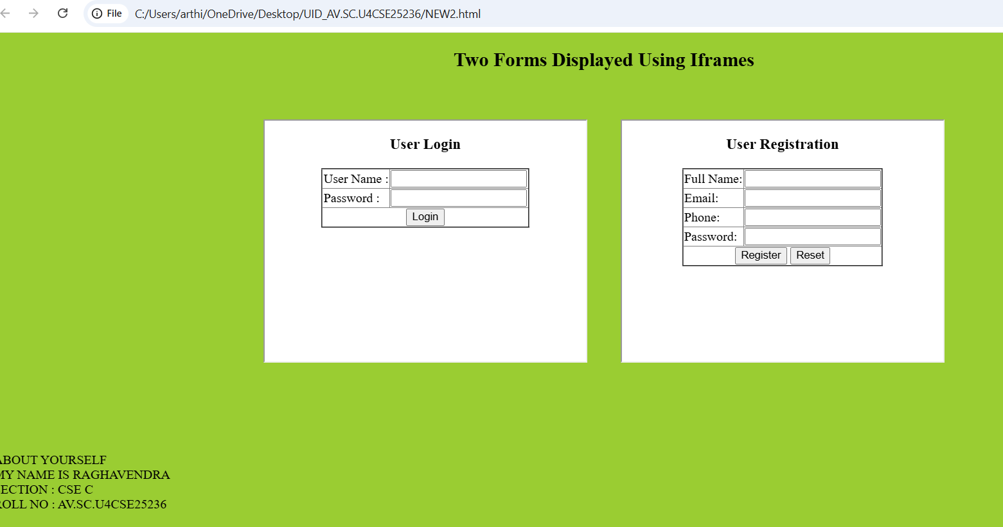

WEEK-4:A. Aim: To collect student details through a structured HTML form with proper labels and table layout.
Code:
<!DOCTYPE html>
<html>
UID-CSE25236
<body>
<p>P.Akhil</p>
<h1 align="center">HTML Forms</h1>
<table border="1" cellpadding="10" cellspacing="0" align="center">
<tr>
<th>Full Name</th>
<td><input type="text" name="fname"></td>
</tr>
<tr>
<th>Email</th>
<td><input type="email" name="email"></td>
</tr>
<tr>
<th>Phone Number</th>
<td><input type="tel" name="phone"></td>
</tr>
<tr>
<th>Gender</th>
<td>
<input type="radio" name="gender" value="male"> Male
<input type="radio" name="gender" value="female"> Female
<input type="radio" name="gender" value="other"> Other
</td>
</tr>
<tr>
<th>Course Applying for?</th>
<td>
<select name="course">
<option value="bt">BTech</option>
<option value="bba">BBA</option>
<option value="mbbs">MBBS</option>
</select>
</td>
</tr>
<tr>
<th>Hobbies</th>
<td>
<input type="checkbox" name="hobby" value="sports"> Sports
<input type="checkbox" name="hobby" value="music"> Music
<input type="checkbox" name="hobby" value="reading"> Reading
</td>
</tr>
<tr>
<th>Date of Birth</th>
<td><input type="date" name="dob"></td>
</tr>
<tr>
<th>Upload Certificate</th>
<td><input type="file" name="certi"></td>
</tr>
<tr>
<th>Address</th>
<td><textarea name="address" rows="4" cols="50"></textarea></td>
</tr>
<tr>
<td colspan="2" align="center"><input type="submit" value="Submit"><input type="reset" value="Reset"></td>
</tr>
</table>
</body>

Output:
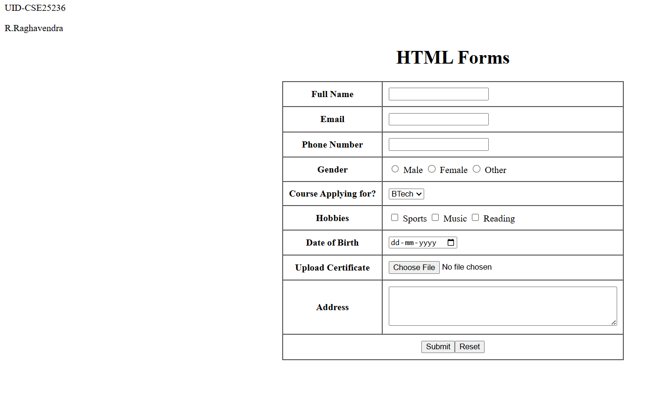

Explanation of the tags:

- <input type="text">: Creates a single-line text box for basic input like names.
- <input type="email">: Makes a text field that expects and validates email format.
- <input type="tel">: Input field designed for telephone numbers.
- <input type="radio">: Lets users pick one option from a group (like gender).
- <select>: Creates a dropdown menu with predefined choices.
- <option>: Individual items inside a dropdown/select menu.
- <input type="checkbox">: Lets users select multiple options (like hobbies).
- <input type="date">: Opens a calendar picker for selecting dates.
- <input type="file">: Button to upload and select files from computer.
- <textarea>: Multi-line text input box for longer content like addresses.
- <input type="submit">: Button that sends form data when clicked.
- <input type="reset">: Button that clears all form fields.
- colspan="2": Makes one cell stretch across two columns in the table.

4.B. Aim: To create a webpage showing Login and Registration forms side-by-side using iframes for easy embedding.
Code:

LOGIN.HTML
<!DOCTYPE html>
<html>
<head>
<title>Login Form</title>
</head>
<body style="background-color: antiquewhite; font-family: Arial; text-align: center;">

<div class="box">
<h3>User Login</h3>

<form >
<table style="text-align: center;" align="center" cellpadding="10" cellspacing="0" border="1">
<tr>
<td>Username:</td>
<td><input type="text" name="username"></td>
</tr>
<tr></tr>
<td>Password:</td>
<td><input type="password" name="password"></td>
</tr>
<tr>
<td colspan="2" align="center"><button type="submit">Login</button></td>
</tr>
</table>
</form>
</div>

</body>
</html>

Register.html
<!DOCTYPE html>
<html>
<head>
<title>Registration Form</title>
</head>
<body style="background-color: antiquewhite; font-family: Arial; text-align: center;">

<div class="box">
<h3>User Registration</h3>

<form>
<table style="text-align: center;" align="center" cellpadding="10" cellspacing="0" border="1">
<tr>
<th>Field</th>
<th>Input</th>
</tr>
<tr>
<td>Full Name:</td>
<td><input type="text" name="fullname"></td>
</tr>
<tr>
<td>Email:</td>
<td><input type="email" name="email"></td>
</tr>
<tr>
<td>Phone Number:</td>
<td><input type="tel" name="phone"></td>
</tr>
<tr>
<td>Password:</td>
<td><input type="password" name="password"></td>
</tr>
<tr>
<td colspan="2" align="center"><button type="submit">Register</button> <button type="reset">Reset</button></td>
</tr>
</table>
</form>
</div>

</body>
</html>

Main:
<!DOCTYPE html>
<html>
UID-CSE25236
<head>
<title>Two Forms Using Iframes</title>
<style>
body {
font-family: Arial, sans-serif;
background-color: #f2f2f2;
text-align: center;
}

h2 {
margin-top: 20px;
}

.container {
display: flex;
justify-content: center;
gap: 40px;
margin-top: 30px;
}

iframe {
width: 350px;
height: 400px;
border: 2px solid #555;
background-color: #fff;
}
</style>
</head>
<body>

<h2>Two Forms Displayed Using Iframes</h2>

<div class="container">
<iframe src="login.html" name="loginFrame"></iframe>
<iframe src="register.html" name="registerFrame"></iframe>
</div>

</body>
</html>
OUTPUT:
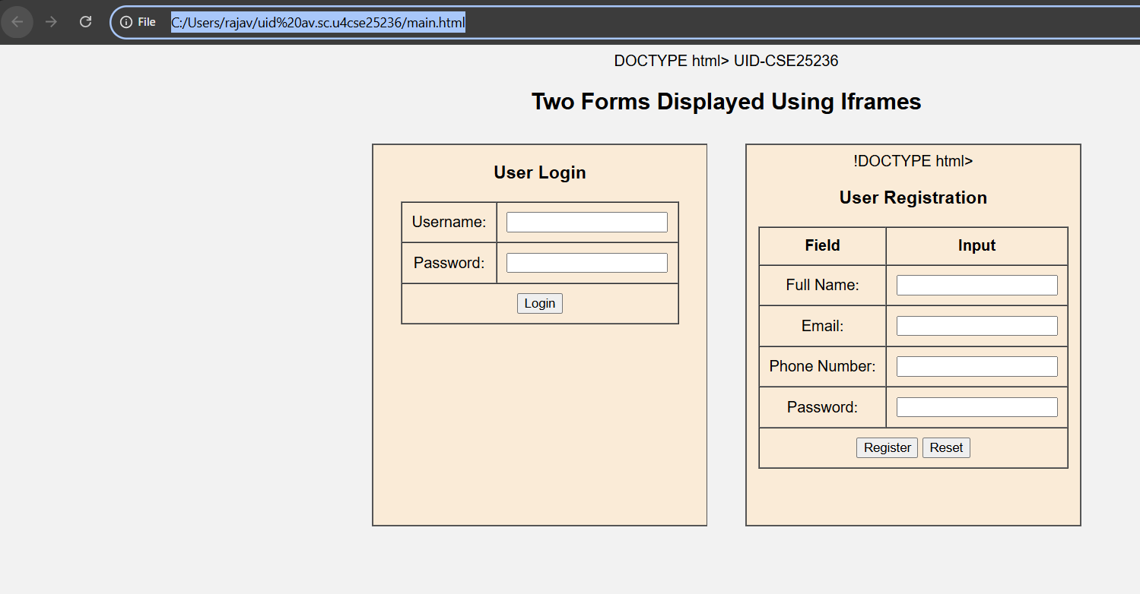

Explanation of the tags:

- <iframe>: Embeds another HTML page (like login.html) inside the current webpage as a frame.
- <div class="box">: Groups content together and applies CSS styling through the class name.
- <button type="submit">: Styled clickable button that submits form data (looks better than basic input).
- <th>: Makes table headers bold and centered (used in registration form headers).
- style="": Inline CSS that styles elements directly (background-color, font-family, text-align).
- .container: CSS class using flex layout to position two iframes side by side.
- display: flex: CSS property that arranges items horizontally in a row.
- justify-content: center: CSS centers the flex items (iframes) horizontally.
- gap: 40px: CSS adds space between the two side-by-side iframes.

WEEK-5.A. Aim: To create a card layout using <div> tag consider three cards and a button using HTML and CSS
CODE:
<!DOCTYPE html>
<html>
<head>
<title>Famous Scientists</title>

<style>
body{
font-family: Arial;
background:#0f172a;
text-align:center;
}

h1{
background:#3fd9a5;
padding:20px;
color:white;
}

.container{
display:flex;
flex-wrap:wrap;
justify-content:center;
gap:20px;
padding:30px;
}

.card{
background:white;
color:black;
width:260px;
padding:20px;
border-radius:12px;
box-shadow:0 5px 15px gray;
}

.hero-img{
width:150px;
height:200px;
object-fit:cover;
border-radius:8px;
}

button{
padding:8px 16px;
border:none;
background:#3fd9a5;
color:white;
border-radius:6px;
cursor:pointer;
}

button:hover{
background:black;
}
</style>
</head>

<body>

<h1>Famous Scientists</h1>

<div class="container">

<div class="card">
<img class="hero-img" src="einstein.jpg" alt="Albert Einstein">
<h3>Albert Einstein</h3>
<p>Theory of Relativity</p>
<button>Know More</button>
</div>

<div class="card">
<img class="hero-img" src="newton.jpg" alt="Isaac Newton">
<h3>Isaac Newton</h3>
<p>Law of Gravity</p>
<button>Know More</button>
</div>

<div class="card">
<img class="hero-img" src="tesla.jpg" alt="Nikola Tesla">
<h3>Nikola Tesla</h3>
<p>Electrical Engineer & Inventor</p>
<button>Know More</button>
</div>

</div>

</body>
</html>

OUTPUT:
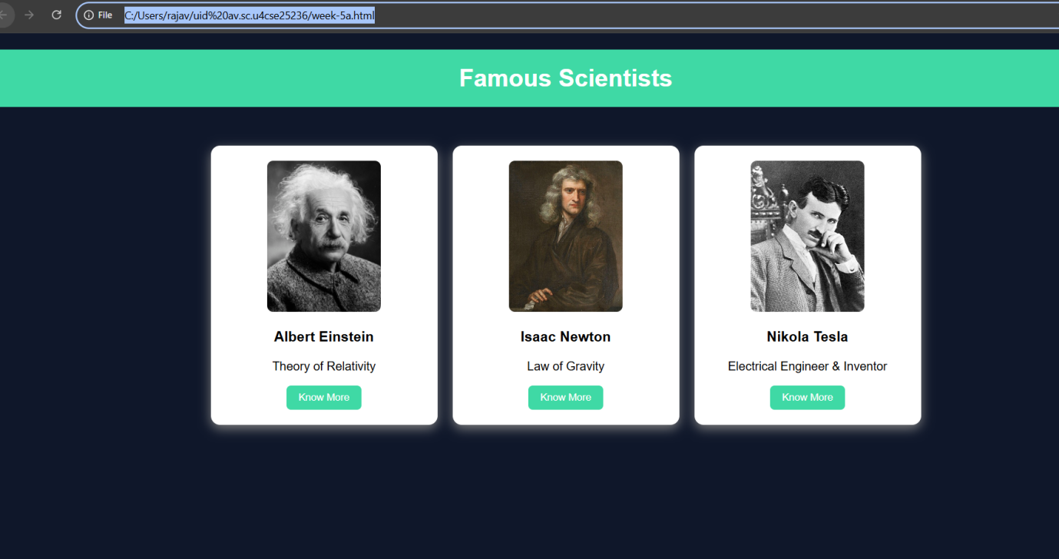

Explanation of the tags:
- .container { ... }: CSS class that uses flexbox to position cards side by side with spacing.
- display: flex: Lays out card items in a flexible row/line.
- flex-wrap: wrap: Allows cards to move to next line on smaller screens.
- justify-content: center: Centers all cards horizontally in the container.
- gap: 20px: Adds consistent space between each card.
- .card { ... }: Styles individual card boxes with size, shadow, rounded corners.
- border-radius: 12px: Rounds card corners for modern look.
- box-shadow: 0 5px 15px gray: Creates drop shadow to make cards appear lifted.
- .hero-img { ... }: Styles images inside cards with fixed dimensions.
- object-fit: cover: Crops images to fill container without distortion.
- button:hover { ... }: Changes button appearance when mouse hovers over it.

5.B. Aim: Navigation using iframe (mini website) upon clicking each buttons the details about that button should be display on the same page
Code:
Main File:
UID-AV.SC.U4CSE25236
<!DOCTYPE html>
<html>
<head>
<title>Famous Indian Leaders</title>

<style>
body{
margin:0;
font-family:Arial;
background-color:lightgray;
}

.menu{
background:#1e3a8a;
padding:15px;
text-align:center;
}

.menu a{
color:white;
margin:0 15px;
text-decoration:none;
background:black;
padding:10px 15px;
}

iframe{
width:100%;
height:450px;
border:none;
}
</style>
</head>

<body>

<h1 style="text-align:center;background:#1e3a8a;color:white;padding:20px;">
Famous Indian Personalities
</h1>

<div class="menu">

<a href="kalam.html" target="frame">APJ Abdul Kalam</a>

<a href="vivekananda.html" target="frame">Swami Vivekananda</a>

<a href="gandhi.html" target="frame">Mahatma Gandhi</a>

</div>

<iframe name="frame"></iframe>

</body>
</html>
KALAM.html:
<!DOCTYPE html>
<html>
<head>

<style>
body{font-family:Arial;text-align:center;}

.box{
border:2px solid black;
padding:20px;
display:inline-block;
}

h2{color:#1e3a8a;}
</style>

</head>

<body>

<div class="box">

<h2>Dr APJ Abdul Kalam</h2>

<p>Born: 15 October 1931</p>
<p>Known as the Missile Man of India</p>
<p>11th President of India</p>

<img src="kalam.jpg" width="200">

</div>

</body>
</html>
VIVEKANANDA.html:
<!DOCTYPE html>
<html>
<head>

<style>
body{font-family:Arial;text-align:center;}

.box{
border:2px solid black;
padding:20px;
display:inline-block;
}

h2{color:#b45309;}
</style>

</head>

<body>

<div class="box">

<h2>Swami Vivekananda</h2>

<p>Born: 12 January 1863</p>
<p>Indian Hindu monk and philosopher</p>
<p>Famous for Chicago speech in 1893</p>

<img src="vivekananda.jpg" width="200">

</div>

</body>
</html>

GANDHI.html:
<!DOCTYPE html>
<html>
<head>

<style>
body{font-family:Arial;text-align:center;}

.box{
border:2px solid black;
padding:20px;
display:inline-block;
}

h2{color:green;}
</style>

</head>

<body>

<div class="box">

<h2>Mahatma Gandhi</h2>

<p>Born: 2 October 1869</p>
<p>Leader of Indian Independence Movement</p>
<p>Follower of non-violence</p>

<img src="gandhi.jpg" width="200">

</div>

</body>
</html>

OUTPUT:
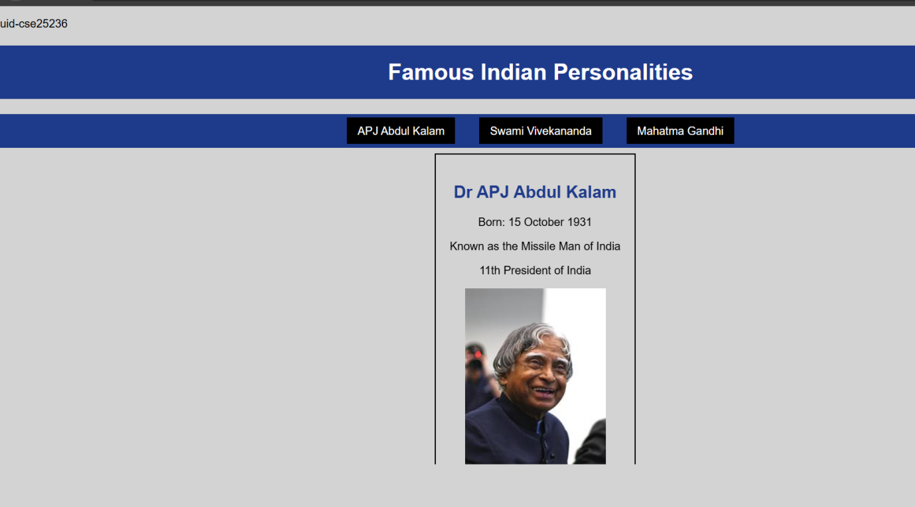

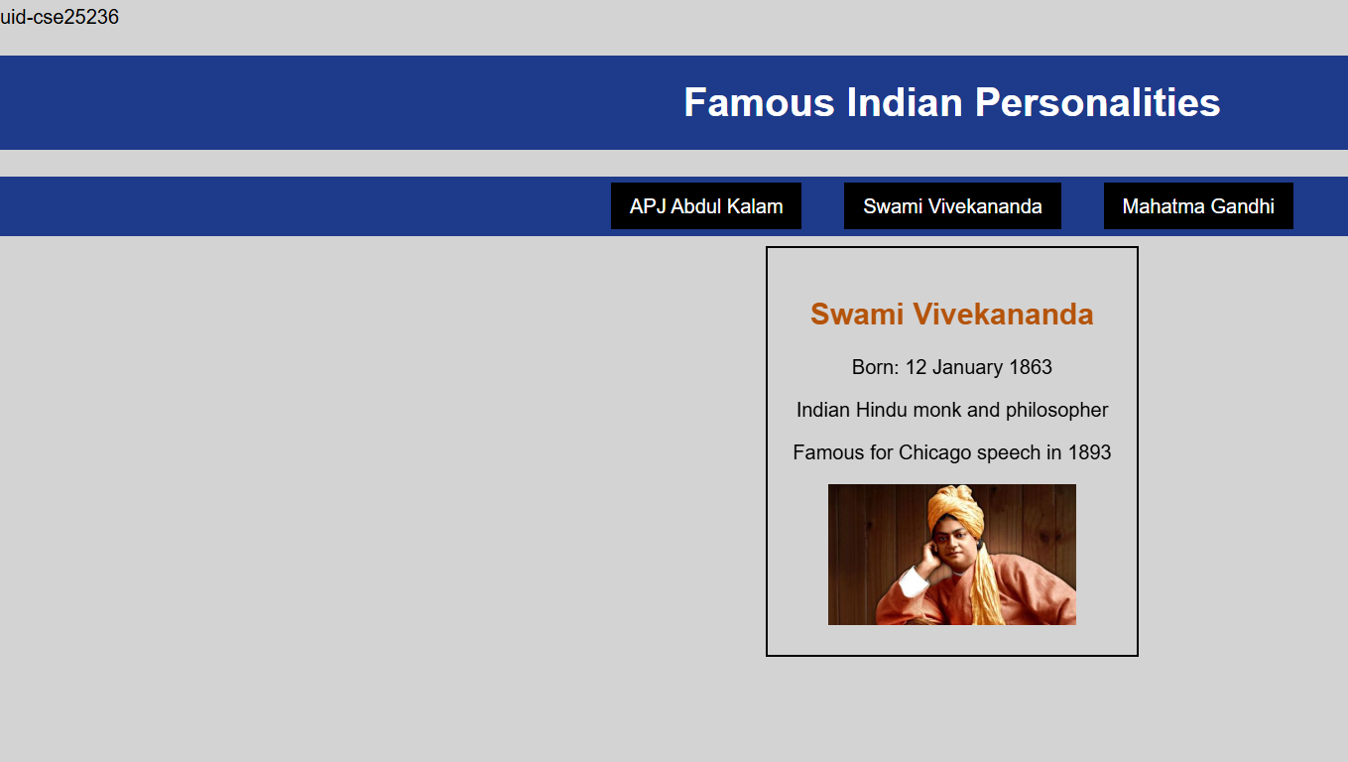

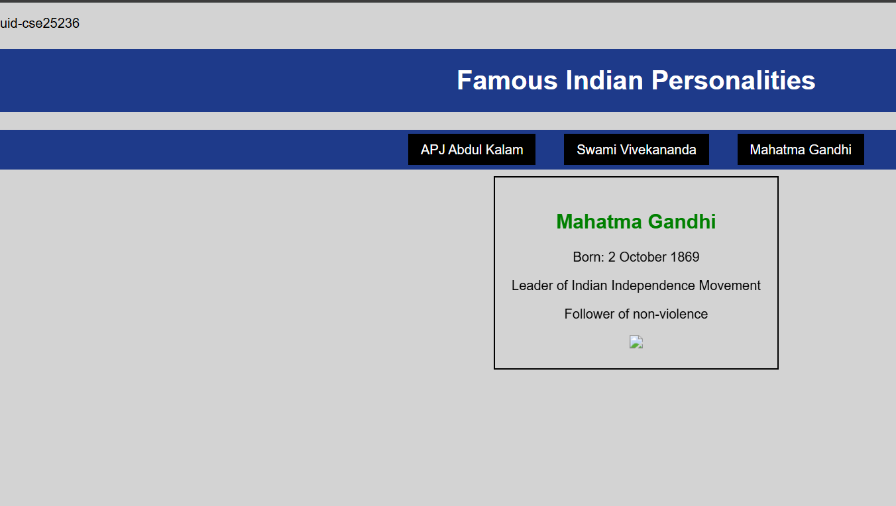

Explanation of the tags:
- iframe { ... }: Styles embedded frame (full width, 400px height, no border).
- target="frame": Loads linked pages inside specific iframe by name.
- name="frame": Names iframe so menu links can target it.
- .menu a { ... }: Styles navigation links (spacing, no underline, black background).
- margin:0 15px: Horizontal spacing between menu links.
- text-decoration:none: Removes underline from clickable links.
- .box { ... }: Styles sub-page content box (border, padding, inline-block).
- display:inline-block: Box fits content width, sits in line.

WEEK-5.C:
Main File:
UID-AV.SC.U4CSE25236
<!DOCTYPE html>
<html>
<head>
<title>Amrita Vishwa Vidyapeetham</title>
<style>
body {
margin: 0;
font-family: Arial;
background: rgb(50, 50, 100);
}
header {
background: #ff4444;
color: #fff;
text-align: center;
padding: 20px;
font-size: 36px;
}
nav {
background: #0066cc;
text-align: center;
padding: 10px;
}
nav a {
color: #ffff00;
margin: 12px;
text-decoration: none;
font-weight: bold;
padding: 5px;
}
nav a:hover {
background: #fff;
color: #0066cc;
border-radius: 5px;
}
main {
display: flex;
padding: 20px;
}
.login {
width: 350px;
background: #ffaa00;
padding: 15px;
border-radius: 10px;
color: white;
}
.login input[type="email"],
.login input[type="password"] {
width: 90%;
padding: 6px;
margin: 6px 0;
}
.remember {
display: flex;
align-items: center;
gap: 6px;
margin: 8px 0;
}
iframe {
flex: 1;
margin-left: 20px;
height: 520px;
border: none;
background: #aaffff;
border-radius: 10px;
}
</style>
</head>
<body>
<header>AMRITA VISHWA VIDHYAPEETAM</header>

<nav>
<a href="amaravati.html" target="campus">AMARAVATI</a>
<a href="amritapuri.html" target="campus">AMRITAPURI</a>
<a href="bengaluru.html" target="campus">BENGALURU</a>
<a href="chennai.html" target="campus">CHENNAI</a>
<a href="coimbatore.html" target="campus">COIMBATORE</a>
<a href="faridabad.html" target="campus">FARIDABAD</a>
<a href="kochi.html" target="campus">KOCHI</a>
<a href="mysuru.html" target="campus">MYSURU</a>
</nav>

<main>
<div class="login">
<h2>Login</h2>
Email: <input type="email">
Password: <input type="password">
<div class="remember">
<input type="checkbox">
<label>Save me</label>
</div>
<input type="button" value="Login" style="width:100%;padding:6px;">
<br><br>
<a href="#">Forgot Password?</a><br>
No account? <a href="#">Register</a>
</div>

<iframe name="campus" src="amaravati.html"></iframe>
</main>
</body>
</html>

amaravati.html:
<!DOCTYPE html>
<html>
<head>
<title>Amaravati Campus</title>
</head>
<body style="font-family:Arial;text-align:center;padding:30px;">
<h1 style="color:#ff4444;">Amaravati Campus</h1>
<p>
Amrita Amaravati campus is located near the Krishna River in Andhra Pradesh.
It provides modern classrooms, research labs, and excellent hostel facilities.
</p>
<p>
Popular Courses: CSE, AI, Data Science<br>
Facilities: Library, Smart Classrooms, Hostel<br>
Focus: Innovation and Research
</p>
<img src="Amaravati.jpg" width="450" alt="Amaravati Campus">
</body>
</html>

amritapuri.html:
<!DOCTYPE html>
<html>
<head>
<title>Amritapuri Campus</title>
</head>
<body style="font-family:Arial;text-align:center;padding:30px;">
<h1 style="color:#ff4444;">Amritapuri Campus</h1>
<p>
Amritapuri campus in Kerala is the main campus of Amrita University,
located near the Arabian Sea with a peaceful academic atmosphere.
</p>
<p>
Popular Courses: Engineering, Arts, Sciences<br>
Facilities: Research Labs, Beach Campus, Hostel<br>
Focus: Academic Excellence with Values
</p>
<img src="amritapuri.webp" width="450" alt="Amritapuri Campus">
</body>
</html>

bengaluru.html:
<!DOCTYPE html>
<html>
<head>
<title>Bengaluru Campus</title>
</head>
<body style="font-family:Arial;text-align:center;padding:30px;">
<h1 style="color:#ff4444;">Bengaluru Campus</h1>
<p>
Located in India's tech hub, Bengaluru campus offers advanced engineering programs
with strong industry connections.
</p>
<p>
Popular Courses: Robotics, CSE, ECE<br>
Facilities: Coding Labs, Innovation Centres<br>
Focus: Industry Collaboration
</p>
<img src="bengaluru.webp" width="450" alt="Bengaluru Campus">
</body>
</html>

Chennai.html:
<!DOCTYPE html>
<html>
<head>
<title>Chennai Campus</title>
</head>
<body style="font-family:Arial;text-align:center;padding:30px;">
<h1 style="color:#ff4444;">Chennai Campus</h1>
<p>
Chennai campus provides top-quality computing and management education
with modern infrastructure and placement support.
</p>
<p>
Popular Courses: IT, MBA, Electronics<br>
Facilities: Digital Library, Placement Cell<br>
Focus: Career Development
</p>
<img src="chennai.webp" width="450" alt="Chennai Campus">
</body>
</html>

Coimbatore.html:
<!DOCTYPE html>
<html>
<head>
<title>Coimbatore Campus</title>
</head>
<body style="font-family:Arial;text-align:center;padding:30px;">
<h1 style="color:#ff4444;">Coimbatore Campus</h1>
<p>
Coimbatore campus is well known for its engineering excellence and
research-oriented education.
</p>
<p>
Popular Courses: Mechanical, Civil, CSE<br>
Facilities: Workshops, Labs, Hostel<br>
Focus: Core Engineering Skills
</p>
<img src="coimbatore.webp" width="450" alt="Coimbatore Campus">
</body>
</html>

Faridabad.html:
<!DOCTYPE html>
<html>
<head>
<title>Faridabad Campus</title>
</head>
<body style="font-family:Arial;text-align:center;padding:30px;">
<h1 style="color:#ff4444;">Faridabad Campus</h1>
<p>
Faridabad campus focuses on medical and healthcare education with
advanced hospital training facilities.
</p>
<p>
Popular Courses: Medical, Nursing, Allied Health<br>
Facilities: Teaching Hospital, Labs<br>
Focus: Healthcare Research
</p>
<img src="faridabad.webp" width="450" alt="Faridabad Campus">
</body>
</html>

Kochi.html:
<!DOCTYPE html>
<html>
<head>
<title>Kochi Campus</title>
</head>
<body style="font-family:Arial;text-align:center;padding:30px;">
<h1 style="color:#ff4444;">Kochi Campus</h1>
<p>
Kochi campus offers programs in business, commerce, and applied sciences
with modern facilities.
</p>
<p>
Popular Courses: MBA, Commerce, Finance<br>
Facilities: Seminar Halls, Library<br>
Focus: Industry Training
</p>
<img src="kochi.webp" width="450" alt="Kochi Campus">
</body>
</html>

Mysuru.html:
<!DOCTYPE html>
<html>
<head>
<title>Mysuru Campus</title>
</head>
<body style="font-family:Arial;text-align:center;padding:30px;">
<h1 style="color:#ff4444;">Mysuru Campus</h1>
<p>
Mysuru campus is known for its peaceful environment, green campus,
and quality education.
</p>
<p>
Popular Courses: Arts, Sciences, Engineering<br>
Facilities: Hostel, Library, Sports Complex<br>
Focus: Calm Learning Atmosphere
</p>
<img src="mysuru.webp" width="450" alt="Mysuru Campus">
</body>
</html>

Output:
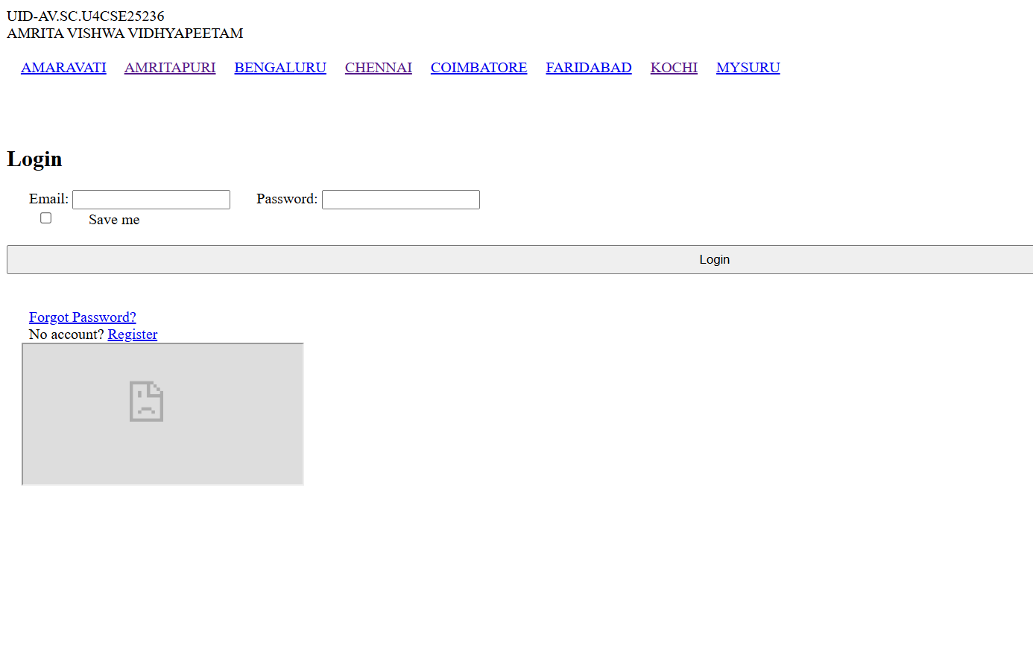

Explanation of the tags:
- header: Groups main title bar with bold styling (bright red background, large font).
- nav: Creates navigation bar with campus links (brighter blue background, centered).
- nav a:hover: Changes link appearance on mouseover (white background, blue text, rounded).
- main {display: flex}: Places login form and iframe side by side horizontally.
- .login: Styles login box (orange background, rounded corners, white text).
- .remember {display: flex}: Aligns checkbox and "Save me" label in a horizontal row.
- align-items: center: Vertically centers checkbox with its label.
- gap: 6px: Adds small space between checkbox and label.
- iframe {flex: 1}: Makes iframe take remaining width beside login box.
- target="campus": Loads campus pages inside specific iframe named "campus".
- name="campus": Names iframe so nav links target it specifically.

WEEK-6:
Design a responsive e-commerce application using the grid layout. This application should contain different categories of products such as electronics, clothing, home-appliances, books. Based on the category we select corresponding products should be displayed on the sidebar.

```html
<!DOCTYPE html>
<html>
<head>
<title>My E-Commerce Store</title>

<style>
body{
margin:0;
font-family:Arial;
background:linear-gradient(120deg,#00c6ff,#0072ff);
}
/* Main container */
.container{
display:grid;
grid-template-rows:80px 80px 1fr 60px;
height:100vh;
}
/* Header */
.header{
background:linear-gradient(90deg,#ff512f,#dd2476);
color:white;
text-align:center;
line-height:80px;
font-size:30px;
letter-spacing:2px;
}
/* Sale banner */
.sale{
background:linear-gradient(90deg,#ff0000,#ff9900);
color:white;
text-align:center;
line-height:80px;
font-size:24px;
font-weight:bold;
}
/* Layout */
.main{
display:grid;
grid-template-columns:1fr 3fr;
}
/* Sidebar */
.categories{
background:#1abc9c;
padding:20px;
}
.categories h3{
color:white;
}
.categories label{
display:block;
background:#8e44ad;
color:white;
padding:12px;
margin-bottom:12px;
border-radius:8px;
cursor:pointer;
transition:0.3s;
}
.categories label:hover{
background:#ff6b6b;
transform:scale(1.05);
}
/* Hide radio buttons */
input[type="radio"]{
display:none;
}
/* Product grid */
.products{
display:grid;
grid-template-columns:repeat(3,1fr);
gap:20px;
padding:20px;
background:#111;
}
/* Product cards */
.product{
background:linear-gradient(145deg,#ff7675,#e17055);
padding:12px;
text-align:center;
border-radius:10px;
box-shadow:0 5px 15px rgba(0,0,0,0.5);
transition:0.3s;
}
.product:hover{
transform:scale(1.05);
}
.product img{
width:100%;
height:200px;
object-fit:cover;
border-radius:6px;
}
.price{
color:#00ff9d;
font-weight:bold;
font-size:18px;
}/* Buttons */

button{
margin:6px;
padding:10px 16px;
border:none;
border-radius:6px;
cursor:pointer;
font-weight:bold;
transition:0.3s;
}
/* Cart button */
.cart{
background:linear-gradient(90deg,#36d1dc,#5b86e5);
color:white;
}
/* Buy button */
.buy{
background:linear-gradient(90deg,#00b09b,#96c93d);
color:white;
}
/* Blink animation */
@keyframes blink{
0%{opacity:1;}
50%{opacity:0.3;}
100%{opacity:1;}
}
/* Hover effect */
button:hover{
animation:blink 0.6s infinite;
transform:scale(1.1);
box-shadow:0 0 10px white;
}
/* Footer */
.footer{
background:#111;
color:white;
text-align:center;
line-height:60px;
font-size:18px;
}
/* FILTER SYSTEM */
/* Hide all products */
.product{
display:none;
}
/* Show all */
#all:checked ~ .main .products .product{
display:block;
}
/* Mobiles */
#mobile:checked ~ .main .products .mobile{
display:block;
}
/* Laptops */
#laptop:checked ~ .main .products .laptop{
display:block;
}
/* Accessories */
#accessory:checked ~ .main .products .accessory{
display:block;
}/* Watches */
#watch:checked ~ .main .products .watch{
display:block;
}
</style>
</head>
<body>
<div class="container">
<div class="header">My E-Commerce Store</div>
<div class="sale">🔥 Big Sale 50% OFF 🔥</div>
<input type="radio" name="cat" id="all" checked>
<input type="radio" name="cat" id="mobile">
<input type="radio" name="cat" id="laptop">
<input type="radio" name="cat" id="accessory">
<input type="radio" name="cat" id="watch">
<div class="main">
<div class="categories">
<h3>Categories</h3>
<label for="all">All</label>
<label for="mobile">Mobiles</label>
<label for="laptop">Laptops</label>
<label for="accessory">Accessories</label>
<label for="watch">Watches</label>
</div>
<div class="products">
<div class="product mobile">
<img src="https://images.unsplash.com/photo-1511707171634-5f897ff02aa9">
<h4>Mobile Phone</h4>
<p class="price">₹15999</p>
<p>Latest smartphone</p>
<button class="cart">Add to Cart</button>
<button class="buy">Buy Now</button>
</div>
<div class="product laptop">
<img src="https://images.unsplash.com/photo-1517336714731-489689fd1ca8">
<h4>Laptop</h4>
<p class="price">₹55999</p>
<p>Powerful laptop</p>
<button class="cart">Add to Cart</button>
<button class="buy">Buy Now</button>
</div>
<div class="product accessory">
<img src="https://tse2.mm.bing.net/th/id/OIP.JA8YTHyXaMNDHgjabg-7EAHaIO?pid=Api&P=0&h=180">
<h4>Headphones</h4>
<p class="price">₹1999</p>
<p>High quality sound</p>
<button class="cart">Add to Cart</button>
<button class="buy">Buy Now</button>
</div>
<div class="product watch">
<img src="https://tse1.mm.bing.net/th/id/OIP.G3TohTx6QtMkIfSKP6g3OgHaEK?pid=Api&P=0&h=180">
<h4>Smart Watch</h4>
<p class="price">₹2999</p>
<p>Fitness tracking watch</p>
<button class="cart">Add to Cart</button>
<button class="buy">Buy Now</button>
</div>
</div>
</div>
<div class="footer">© Copyrights Reserved 2026</div>
</div>
</body>
</html>```

OUTPUT:
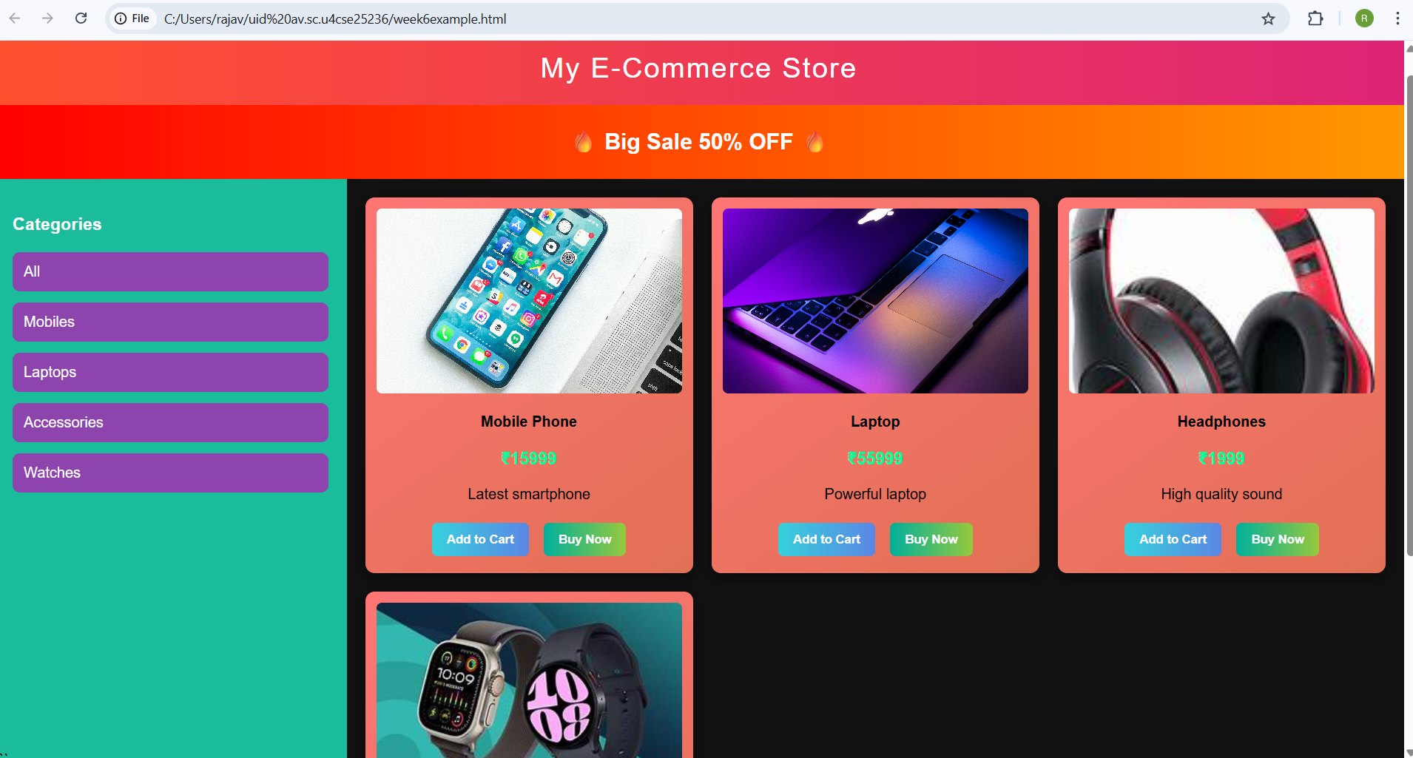

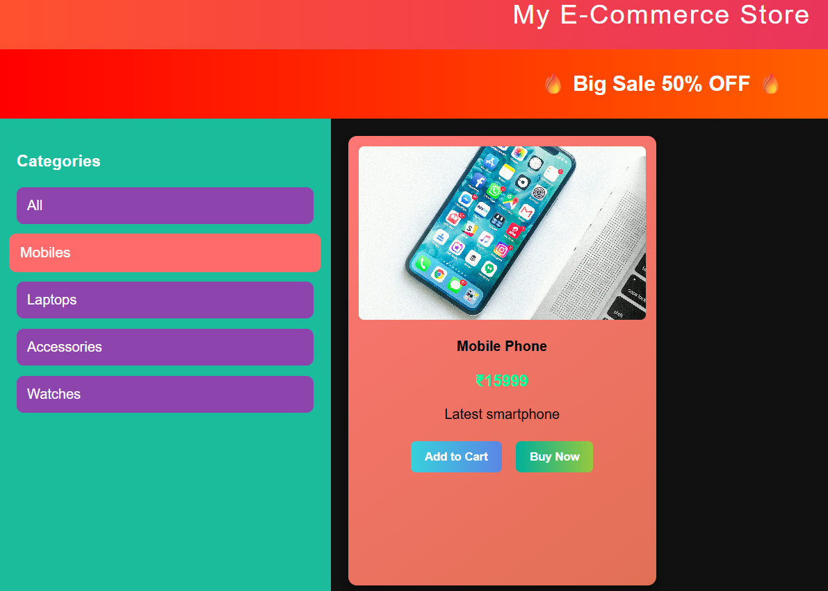

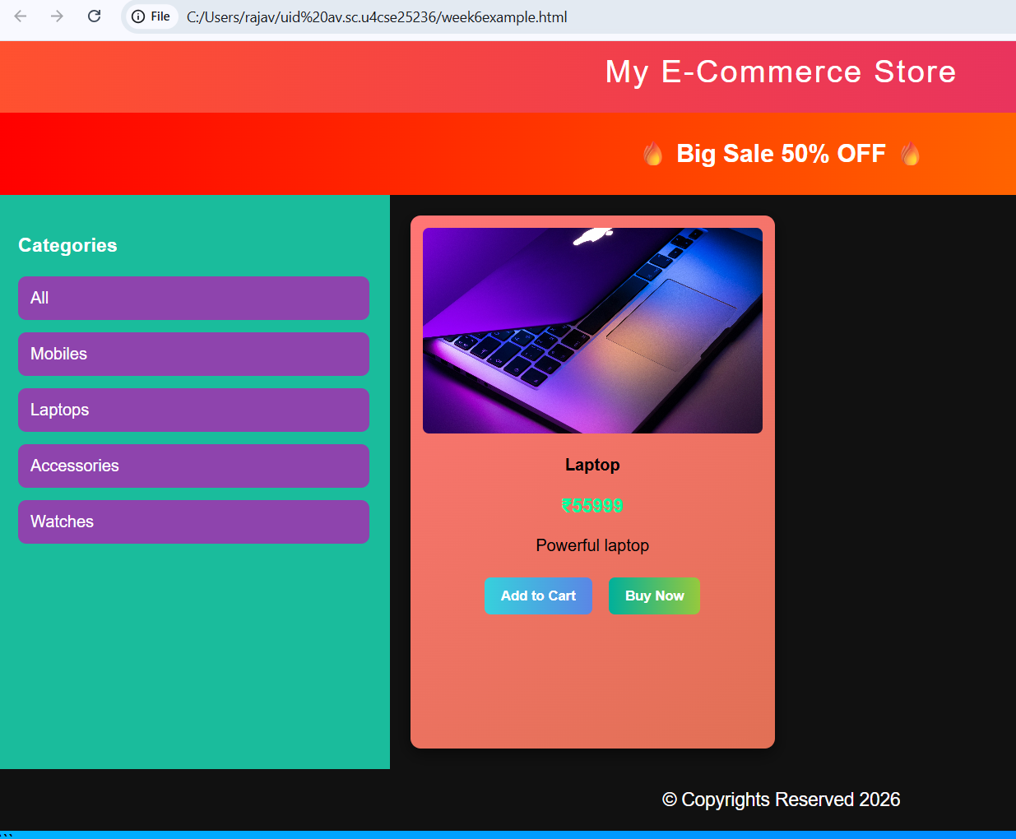

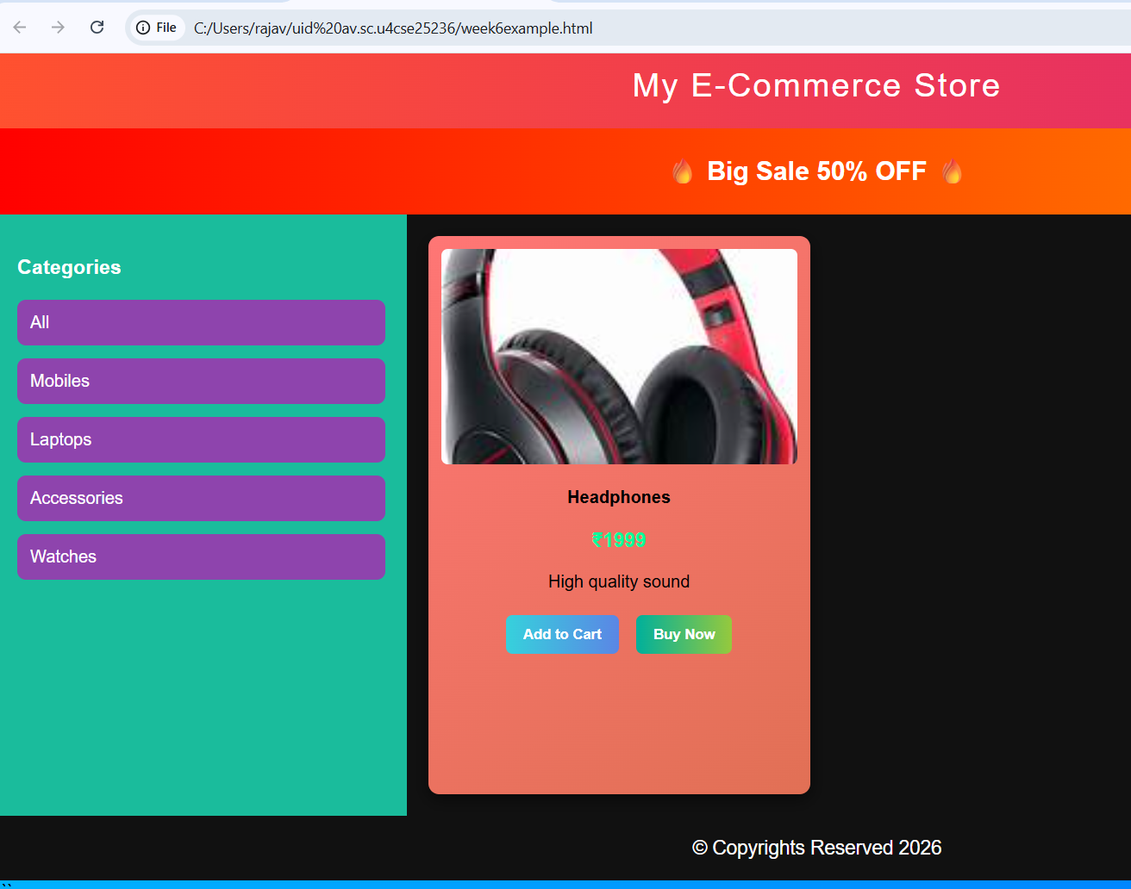

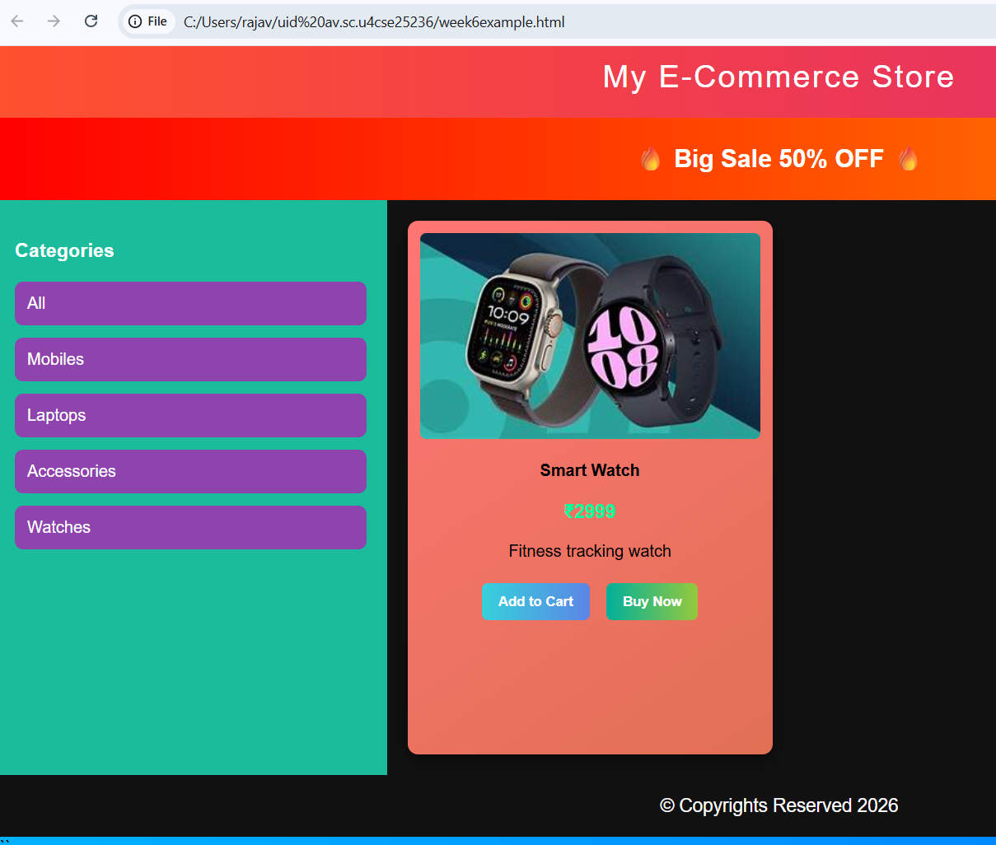

EXPLANATION OF TAGS:
- margin – Controls the outer space around an element.
- padding – Controls the inner space between the content and the border of an element.
- font-family – Specifies the font style used for text.
- background – Sets the background color or gradient of an element.
- background: linear-gradient() – Creates a gradient background with multiple colors.
- color – Defines the text color.
- display – Specifies how an element is displayed (block, grid, none, etc.).
- grid – Used to create grid-based layouts for arranging elements in rows and columns.
- grid-template-rows – Defines the number and size of rows in a grid layout.
- grid-template-columns – Defines the number and size of columns in a grid layout.
- gap – Sets the spacing between grid items.
- height – Defines the height of an element.
- width – Defines the width of an element.
- text-align – Aligns text horizontally (left, center, right).
- line-height – Controls the vertical spacing between lines of text.
- font-size – Defines the size of the text.
- font-weight – Controls the thickness of text (bold, normal).
- letter-spacing – Adjusts the spacing between characters in text.
- border – Creates a border around an element.
- border-radius – Rounds the corners of an element.
- cursor – Changes the mouse pointer style when hovering over an element.
- transition – Adds smooth animation effects when properties change.
- transform – Applies visual transformations like scaling or rotating elements.
- box-shadow – Adds shadow effects around elements.
- object-fit – Controls how images fit within their container.
- animation – Applies animation effects to elements.
- @keyframes – Defines the steps of a CSS animation.
- :hover – Applies styles when the user moves the cursor over an element.
- :checked – Targets input elements that are currently selected.
- ~ (general sibling selector) – Selects elements that share the same parent and come after another element.

