ALU Verification Plan

VERIFICATION DOCUMENT- ALU

S.NO | CONTENTS | PAGE NUMBER
1 | Chapter -1 | 3 -6
2 | Chapter-2 | 7
3
4
5
6
7
8
9
10

CHAPTER 1 – DESIGN OVERVIEW

1.0 ALU:-

The Arithmetic Logic Unit (ALU) is a fundamental combinational circuit that performs essential arithmetic and logical operations within a digital system. In this design, the ALU is implemented using Verilog, a hardware description language widely used for modelling digital systems.
Why is ALU important:-
- Every calculation your computer does goes through the ALU
- Without ALU, computers cannot do math or make decisions
- It works very fast - millions of operations per second

1.1 Advantages of ALU:-

- Does math problems like add, subtract, multiply, divide.
- Used to make logical decisions like AND, OR, NOT.
- Used to compares numbers which is bigger, smaller, or equal.
- It is fast accurate and occupies less space inside processor.

1.2 Disadvantages of ALU:-

1.No Memory
- Cannot remember previous calculations.
2.speed limit
Cannot work faster than the processor allows.
3.Supports only specific bit widths such as 32-bit and 64-bit; larger data sizes are truncated during processing..
4.Power consumption increases rapidly during high-complex calculations

1.3 Use cases of ALU:-
The ALU is a core component in digital systems and processors. Key use cases include:
1.Microprocessors and Microcontrollers – Executes arithmetic and logic instructions (e.g., add, subtract, AND, OR).
2.DSPs (Digital Signal Processors) – Used for filtering, FFT, and signal transformations.
3.Embedded Systems – Performs calculations for automation and control logic.
4.Cryptographic Units – Handles bitwise and modular arithmetic for encryption algorithms.
5.AI Accelerators / SIMD Units – ALU arrays process matrix/vector operations efficiently.

1.4 Project Overview of ALU:-

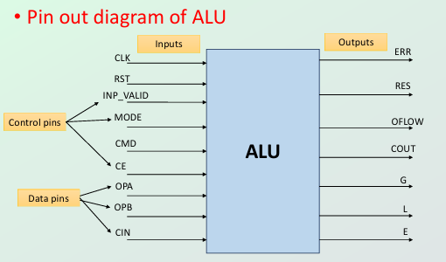

1.This project implements a parameterized ALU in Verilog that supports a variety of operations including arithmetic, logical, comparison, and bitwise shift/rotation. The ALU design is tested using a SystemVerilog testbench with functional coverage and assertions.

2.This pin-out diagram provides a structural overview of how the ALU interfaces with external components. The design features clearly categorized inputs and outputs to enable smooth data flow and operation control. Control pins manage the operation mode and synchronization,while data pins provide the operands required for computation. The outputs reflect the results of the operations along with relevant status indicators such as comparison and error flags.

3.By structuring the ALU in this way, the design ensures modularity, reusability, and ease of integration into larger digital systems such as CPUs and signal processors.

1.5 Design Features:-

• Arithmetic
Addition ,subtraction ,Comparision ,Increment,Decrement,Multiplication
• Logic
AND,NAND,OR,NOR, XOR,XNOR, NOT
• Others
Rotate right/left , Shift right/left

1.7 Design diagram with interface signals:-

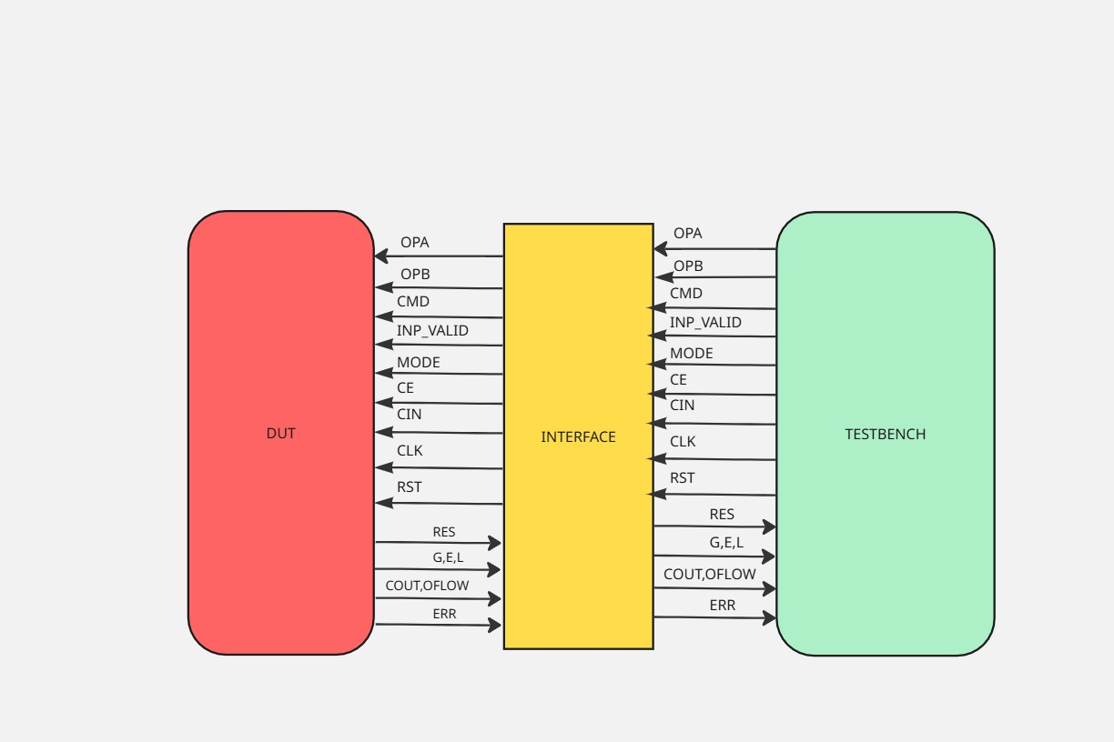

CHAPTER 2 - Verification Architecture

2.1 Verification Architecture :-

