Wi-Fi module 1

- In which OSL layer the Wi-Fi standard/protocol fits.

Wi-Fi (802.11) works in Physical Layer (Layer 1) and Data Link Layer (Layer 2 : MAC + LLC)

- Can you share the Wi-Fi devices that you are using day to day life, share that device's wireless capability/properties after connecting to network. Match your device to corresponding Wi-Fi Generations based on properties
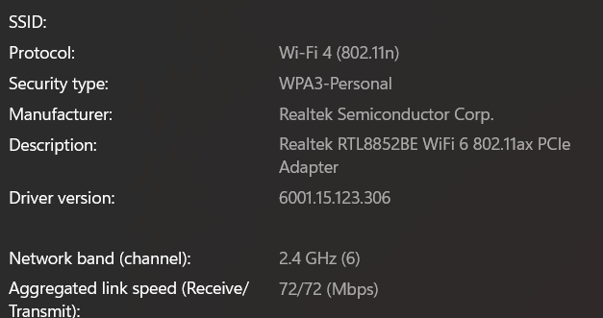

- What is BSS and ESS?

BSS (Basic Service Set)
One AP + connected devices
ESS (Extended Service Set)
Multiple APs connected via wired network acting as one network

- What are the basic functionalities of Wi-Fi Accesspoint
- Wireless portal
- Connectivity
- Coverage
- Medium access
- Security
- QoS
- Mobility
- Virtual networks

- Difference between Bridge mode and Repeater mode

 | Bridge Mode | Repeater Mode
Purpose | Connect 2 networks | Extend Wi-Fi range
Connection | AP to AP (wired/wireless link) | AP to AP (wireless only)
Use case | Building-to-building | Home signal extension

- What are the differences between 802.11a and 802.11b.

 | 802.11a | 802.11b
Frequency | 5 GHz | 2.4 GHz
Speed | 54 Mbps | 11 Mbps
Range | Lower | Higher
Interference | Less | More

- Configure your modem/hotspot to operate only in 2.4Ghz and connect your laptop/Wi-Fi device and capture the capability/properties in your Wi-Fi device. Repeat the same in 5Ghz and tabulate all the differences you observed during this
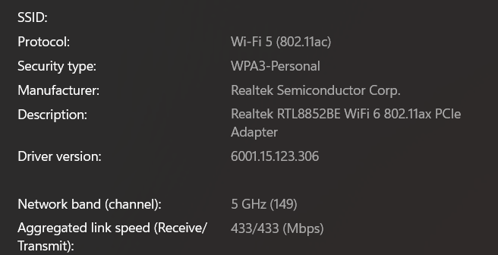


5 Ghz

2.4 Ghz

 | 2.4 GHz | 5 GHz
Range | High | Low
Speed | Lower(72 Mbps) | Higher(433 Mbps)
Interference | High | Low
Channels | Few(6) | More(149)

- What is the difference between IEEE and WFA

IEEE : Creates standards ,Defines protocols
WFA (Wi-Fi Alliance) : Certifies devices ,Ensures interoperability

- List down the type of Wi-Fi internet connectivity backhaul, share your home/college's wireless internet connectivity backhaul name and its properties

- Fiber
- Satellite
- MoCA
- Cellular
- Powerline
Home wireless internet connectivity backhaul
Backhaul Type: Cellular (4G LTE)
Properties:
- Moderate speed (10–50 Mbps)
- Higher latency (~30–80 ms)
- Signal dependent performance
- Portable connectivity

- List down the Wi-Fi topologies and use cases of each one.
- Infrastructure : Home/office Wi-Fi
- Mesh : Large areas, cities
- Bridge : Building connectivity
- Repeater : Range extension
- Ad-hoc : Device-to-device
- Hotspot : Mobile sharing

