Wi-Fi Module 2
1. Brief about SplitMAC architecture and how it improves the AP's performance
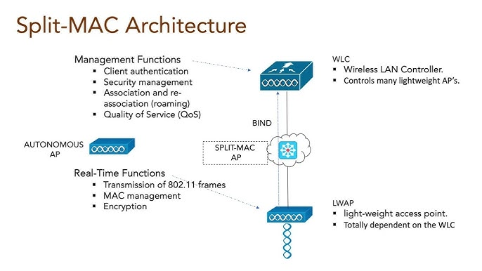

Lower MAC functions are done by the AP.
APs perform functions such as client association, sending out beacons/probes, encrypting data, sounding, MU-MIMO/OFDMA, aggregation, ACKs

Upper MAC functions are moved and centralized into the controller
Functions such as RRM, QoS Management, Load balancing, traffic shaping/policing, mobility, authentication/security etc. are handled by the controller.

Performance improvement through splitMAC
- AP handles only time-critical tasks and heavy tasks moved to controller
- AP hardware becomes cheaper
- Faster roaming (controller controls handoff)
- Better RF management (RRM)

2. Describe about CAPWAP , explain the flow between AP and Controller
The WLC and the APs uses a protocol called CAPWAP (Control and Provisioning of Wireless Access Points) to communicate with each other.
Connection Process
- AP gets IP (DHCP)
- AP discovers WLC
- AP sends join request
- WLC authenticates AP
- CAPWAP tunnels created
Data flow
STA → AP → CAPWAP → WLC → Network → Internet

3. Where this CAPWAP fits in OSI model , what are the two tunnels in CAPWAP and its purpose
CAPWAP operates at Layer 3 (UDP-based)
Two tunnels are established in CAPWAP:
• Control Tunnel for all the control/management of the APs. All traffic on this tunnel is fully encrypted.
• Data Tunnel for all the Data from/to APs pass through the controller

4. Whats the difference between Lightweight APs and Cloud-based APs
Lightweight AP | Cloud AP
On-prem WLC | Controller on Cloud
Data traffic goes via WLC | Data traffic goes directly to internet
Centralized control(local) | Centralized control (cloud)
Needs WLC | Needs internet

5. How the CAPWAP tunnel is maintained between AP and controller
- Uses keepalive, echo request/response messages
- AP periodically checks WLC availability
- If no response then tunnel drops and AP tries to rejoin controller

6.Whats the difference between Sniffer and monitor mode, use case for each mode
Sniffer Mode : Packet capture  - Captures raw wireless frames  - Sends to WLC (or tools like Wireshark)  - Used for debugging issues  Use case:  - Troubleshooting connectivity issues  - Analyzing packet-level problems  - Protocol debugging | Monitor Mode :Network monitoring & security  - Scans environment continuously  - Detects Rogue APs ,interference  - Sends analytics/alerts to WLC  Use case:  - Security monitoring  - Rogue AP detection  - Network health analysis

7.If WLC deployed in WAN, which AP mode is best for local network and how?
FlexConnect mode
- Works like LWAP normally
- If WAN/WLC fails then acts like autonomous AP

8. What are challenges if deploying autonomous APs (more than 50) in large network like university
- Manual config per AP
- No central management
- Difficult firmware updates
- Poor roaming
- VLAN scaling issues
- Large broadcast domains
- RF interference

9. What happens on wireless client connected to Lightweight AP in local mode if WLC goes down.
- Clients lose connectivity
- No new associations
- Existing sessions drop

