**Functional Specification**

**&**

**Planning report**

**(NAsa or SpaceX website)**

**(Project Exam1)**

**Assignment Week-1**

**(Combined Report)**

**Prepared by:**

**Raja waqas ahmed**

**Table of Contents**

1. functional specification document 3

a. Introduction: 3

i. Key requirements 3

b. Requirements Document 4

c. Usage scenario document 5

d. Functional specs summary 6

2. Project planning document 6

a. Introduction: 6

b. RESEARCH AND ANALYSIS: 6

*i. Team Chart: 6*

*ii. ANALYSIS 7*

*iii. SKETCHES – SCANNED IDEA DEVELOPMENT AND DIGITAL SKETCHES 7*

c. WORK PROCESS 8

*i. STYLE/GENRE 8*

d. Budget Detail: 9

e. Collaborative Communication tool: 9

*i. SLACK: 9*

*ii. DropBox Tool (File Sharing): 10*

*iii. GitHub for (Development Code): 10*

*iv. Formal Email Conversation: 10*

f. Follow Up With the Client: 10

g. Project Summary: 10

3. Appendices: 11

A. Gantt chart 11

# functional specification document

# Introduction:

This document represent the requirement gathering and analysis process, as well as basic design of the website and mobile app.

The general key requirements given by the business owner is represented below as a vision/scope document:

Build a microsite for SpaceX or NASA with the focus on space technology.

A microsite is a branded, self-contained site, usually on its own domain, with a single purpose and a limited number of pages. The purpose can be promotional or editorial, and be may linked to a specific event or period of time.

# Key requirements

* Create a microsite for SpaceX/NASA to raise awareness about space program activity around the world. The site should appeal to a specific target audience and provide links to more information, live feeds of launches, and so forth.
* The site should include a minimum of (4) pages, be responsive, and function well on a variety of platforms.
* The site should employ Javascript/JSON API for dynamic data and construction and styling of HTML/CSS. While a calendar is not mandatory, some kind of schedule or timeline information is recommended.
* A contact form with both HTML5 and Javascript validation is required.
* The site should be well designed and easy to use, and conform to WCAG standards.

# Requirements Document

Then I tried to make a Requirements Document based on the key requirements given above. In this document, I have tried to make and differentiate business, users, operational and system requirements.

|  |
| --- |
| User Requirement:   * Dynamic Website. * Recent launch information * Events schedule * User Friendly Site. * User can easily create/edit profile. * Easy access to Search Engine. * Products to sell related to Clothing, books, Videos, lectures. * Payment Methods easily available. * Receive newsletter, promotions and offers. * Wishlist for the customers for SpaceX related products. * Customers must create an online account for space related item purchases. * Entertainment section for users about SpaceX and NASA.   Business Requirement:   * Science and Technology awareness program information. * Online education material about Space and NASA * Payment methods to be catered for (PayPal, Visa, Master bank transfer, cash on delivery). * Site must also be easily updated if new products are made available. * Contact details to be listed on site. * 24/7 chat line available to all customers. * Email notification to customers   Operational and system Requirement:   * Database management system. * Login management system. * Events scheduling system * Delivery or parcel tracking system. |

# Usage scenario document

Based on the vision and scope document, and the redefined detailed requirements in the requirements document, I have tried to create usage scenario document for the key functions of the business. Here are those usage scenarios:

|  |
| --- |
| Usage Scenarios  Scenario no 1 (Space launching events schedule).   * User Open the websites. * Check the schedule of events. * Get events details, photos, videos and other reading material * Register for events (if needed) * Payee by visa, MasterCard etc. (if needed).   Scenario no 2 (Shopping related products).   * User Open the websites. * Select the product(s). * Put in wishlist. (if needed) * Do Payment.   Scenario No 3 (Making profile/account).   * Click on Sigin button. * Put the personal data. * Complete the profile.   Scenario No 4 (Track Orders).   * Click the Track Order button. * Check where the order reached by entering tracking number. * Check when to receive package. |

# Functional specs summary

In the functional specification document, key business requirements are analysed to be divided in the user, business, and operational system requirements. Usage scenarios are also defined in this document.

# Project planning document

# Introduction:

A microsite needs to be developed for SpaceX/NASA. It provides infromation about the launches and one can explore the informational material about the space and related equipment in the form of educational programs, videos, images, lecures, seminars etc.

# RESEARCH AND ANALYSIS:

# Team Chart:

# ANALYSIS

The main task is to focus the key end-users of the website. To make such decisions for the design, color scheme and theme of the website, we need to do research on the following:

1. To focus the end users and their purpose of visiting website
2. To research on the thinking of the people and their age-group
3. Develop the taste of the people.
4. The main issues is to how to attract the people.
5. Focus on schedule of launching events and other side events.
6. Main focus on Graphical desinging of the website (images, videos, theme, color pallete) that attracts the people attention.
7. Side products for sale on the website, for examples, printed clothes, books, videos, lectures, toys, DVDs etc.
8. Choice of color scheme and theme for the website is challanging.

# SKETCHES – SCANNED IDEA DEVELOPMENT AND DIGITAL SKETCHES

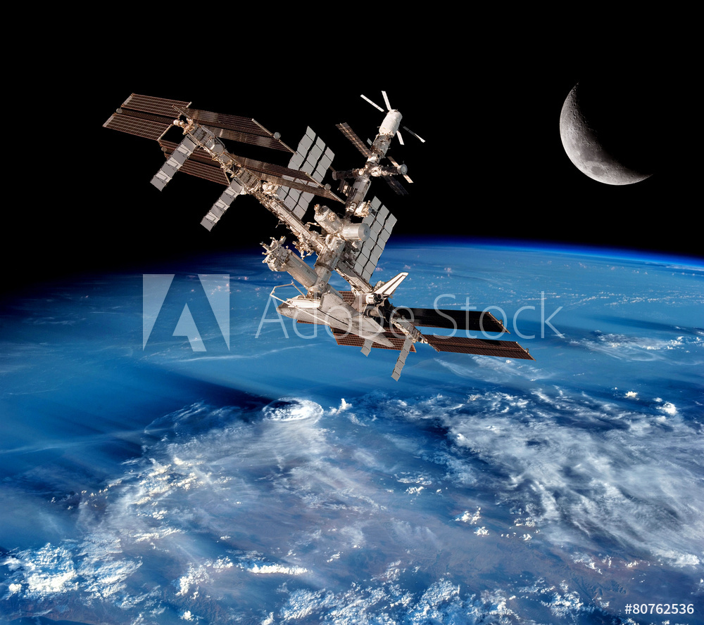 

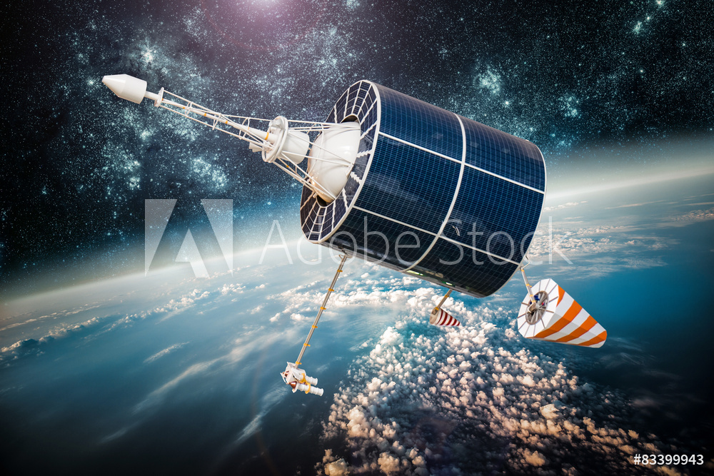 

# WORK PROCESS

Here we write about the process and choices we have made to finish the product.

# STYLE/GENRE

By designing the website first we design the style tile for website and to keep in mind we are building a website for Space company. The following steps to make the website style tile,

# Header section:

In the header section we have the logo and the company name with big size fonts and style which shows the title of the website.

# Main Navigation Menu:

We make the navigation menu for users to navigate the website easily for example, Home, Menu, Launches, Events, Products, Explore More, Contact us and About us.

# Color Palette:

In this section we will show the color scheme of our website. Which color is for background, fonts, headings, buttons etc. color palette or theme is very important part of the website because this section needs creativity if your color does not attract the eye of customer so most chances are they skip your website and get bore easily. The color scheme and content should be designed in a way that it keeps the active engagement of the users.

# Typography:

In the typography section we chose the font family for website. Which means font style, size etc., secondly we have to use font that can be easily read on mobile or other devices.

# Icons style:

In this section we design buttons for website, also we design the button according to the website requirement.



# Footer Section:

In the footer we write the copyright statement for the company and also gives the social media links or other links. It can also represent the contact us form.

# Budget Detail:

Use a range of prices to determine overall budget for the project. Whether stated or not, most projects are based on time and materials and should be determined accordingly. Listing the ‘assumptions’ about the project, including details about back-end or programming functions is also important for this point.

# Collaborative Communication tool:

We will use the Slack tool for communication with team members during the whole the project. Also this tool is used for meetings with Clients and other persons related to the project.

# SLACK:

Slack is more populær for some of its unique and developed features. It is mobile friendly as well. Some of the key features of this collaborative communication tool are group projects, video conferencing calling, excellent interface, on-desk notifications, and drag-and-drop files. It can be integrated with the Google Docs and Dropbox. It enables you to send direct messages to a private person, or groups and to start conversation.

# DropBox Tool (File Sharing):

This tool will be used during the project for file sharing.

# GitHub for (Development Code):

Github will be used to share the code and related documentation.

# Formal Email Conversation:

We will use Microsoft Outlook for the formal conversation with team members and Customer or Business Development Persons.

# Follow Up With the Client:

Calling or sending an email to confirm the receipt of a proposal is standard policy. Follow up in a gracious manner, and make sure to get a date by which the client promises to make their final decision. Ask if there are any questions they have regarding the proposal. Once you call, do not call again or bother the client until after the date of the final decision. If for some reason you do not get the project, you are entitled to a call or email from the client letting you know as quickly as possible, and take the opportunity to find out what the deciding factors were (budget, availability, expertise, existing relationship, etc.)

# Project Summary:

In the last few years, the space market has experienced increasing competition. The industry has to supply high quality information for a larger variety of customers, and better informational material with recent updates.

The structure tells the user which design decisions need to be made and when to make them. The tools support the decision making process. The structure is generally applicable, the set of tools makes the design method specifically suitable for the design of website.

The website design method consists of different phases which is describe under in details. The first phase is to gather as much information as possible from the business owner and create the specification document. Second, create a GANTT CHART for project in which we plan all the project tasks and milestones and the related resource persons. Then to create a Style Tiles for the website. Base don the research and analysis performed during initial stages of the project, make the usage scenarios and divide the requirements for various sprints to deliver gradually using Scrum methodology. Take frequent feedback from the business owner and implement the required/desired changes, and test the website before deployment. Finally handover all the code and documentation to the business owner.

# Appendices:

