**Board Game Roll’s UP**

**(Report writing)**

**(semester Project 2)**

**Prepared by:**

**Raja waqas ahmed**

**Executive summary:**

This document represent the full report about the planning, design and development of Online board game. In the following section, I discuss the development lifecycle and procedures followed for the game development.

First of all the project planning was performed, which involved doing research on existing websites, brainstorming, content planning and assigning timeline to the individual task for the whole development lifecycle.

In the second phase, the design is created that involved, designing the logo, color palette, navigation menu, body texture/pattern and buttons styles according to the unified theme of the website.

In the next phase, HTML / CSS and Javascript development was done according to the content identified in the project planning and the design defined in the designing phase. Testing phase and development phase were done in parallel. The bugs identified during the development and testing were solved in this phase. All content on the web page was checked for proper functional links, running of game and being responsive for cross platforms.

# introduction:

## Game statement:

This board game has ten players, all players have there information including image the user has to select two players to play the game out of 10 mentioned players. Ten players’ data is fetched from the API provided.

## Project objectives

The aim of this website is to give a free platform to online users to play the game and entertain themselves or with partner.

## Project scope

The scope of the project is to design and develop the board game for community. Board games targeting children and their parents as a main audience.

## Goals

The main goal is to create a board game for the comunity of kids and their parents. From which they can entertain each others and enjoy the time together.

## Assumptions and Constraints

It is assumed that the content (API’s ) are provided for the website. 1 pc and 1 mobile device is used during the development and testing phase.

# Planning:

This is the first step in which we take the initial start to do a brainstorming and research about the existing board game . We make a plan on how we move step by step within the project. Abstract level illustration of project development life cycle is presented as follows:

|  |  |  |  |  |  |
| --- | --- | --- | --- | --- | --- |
|  | **W1** | **W2** | **W3** | **W4** | **W5** |
| *PLANNING* |  |  |  |  |  |
| *DESIGNING* |  |  |  |  |  |
| *DEVELOPNENT* |  |  |  |  |  |
| *TESTING* |  |  |  |  |  |
| *FINALISATION/ DELIVERY* |  |  |  |  |  |
| *PROJECT MANAGEMENT* |  |  |  |  |  |

# Designing

## Color Scheme / Pallets:

According to the nature of content, that is game design, I have chosen following colors based on human emotions color psychology. Which represent different types of emotions and nature of users. My main colors are Red and Yellow.

|  |  |  |  |
| --- | --- | --- | --- |
| Red: #d8212f; | Blue: #30b1f2; | Black: #000; | Grey: #9fa09f; |
| Orange: #f95e08; | Green: #8bc53f; | White: #fff; | Yellow: #edff00; |

## 3D-Logo Design:

The logo is designed in Adobe Photoshop. Since it is a Dice Roll Board Game the logo is designed as 3D dice and user can easily understand the type of game. The logo is left alligned in navigation menu and white and black color is chosen to give orignal look.

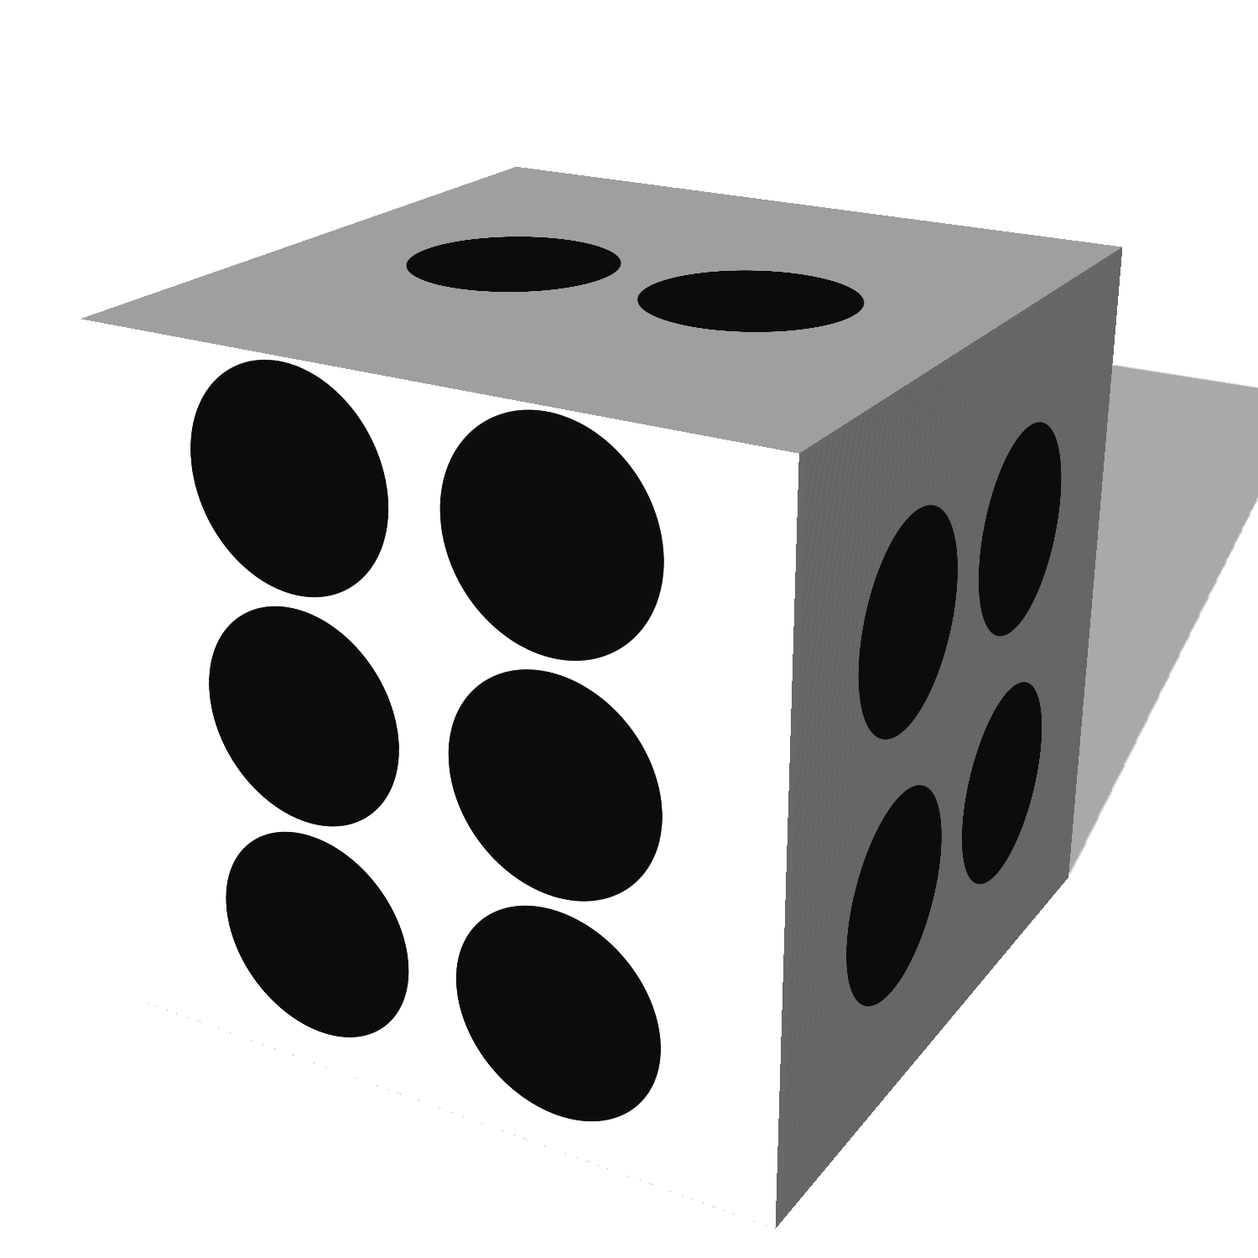

## Name of Game / Site Heading:

The Name of board game is **Roll’s Up,** it represents rolling a dice and moving up in the game. It gives the positive feeling to win, that is the main reason to chosse the that name.



## Icons Design:

All the icons are designed according to the game nature, and designed in Adobe Illustrator. Following are the icons used in the game,

* NavBar – Search Icon.
* Character Icons.
* Token Icons.
* Dice Icon.
* Canvas Game Icon.
  1. Snake for traps
  2. Castle for winner position
* Social media Icons.

## NavBar – Search Icon:

Searc icon is made to search any kind of things for example player with name etc.



## Card - Character Icons.

there are 10 different characters in the game so for separation from each other we made one icon to represent the character and differnet colors given to character. To make easy for user to choose and remember the character.



## Token Icons.

After choosing character, a token will issued to the player and for that token we made a icon to show the token of user. We have designed this token in two colors to different the players. Chosen colors for tokens are blue and yellow, for player1 and player2, respectively.



## Dice Icon.

Dice icon is used as a button in the game for generating the random number and redrawing the token on the canvas.



## Canvas Game Icon.

In the game canvas two different icons are used which are as follows:

Macintosh H  D:Users:iffat:Documents:Adobe:Front_end_development:Semester_project1:rollup:image:win_castle.pngMacintosh H  D:Users:iffat:Documents:Adobe:Front_end_development:Semester_project1:rollup:image:snake_icon.png

Snake icon on canvas is a trap when user token reaches on the snake, the token moves 3 steps backward because of the snake trap.

Castle icon is a wining or finish icon when the token reaches on castle it means the user has won the game.

## Footer – Social media Icons.

There are social media icons using in the footer section on which user can rate the game on social media like facebook twiter.

 

## Typography:

I have chosen two fonts for this website which are as follows:

* + Srisakdi, cursive.
  + Roboto, san-serif.

I chose the above fonts to give a easy to read and matching/creative look to website. I choose Srisakdi as a contrasting font which gives good and catchy looks to tagline. For headings I have used Roboto Black to emphasize bit more, and Roboto medium as a general text font.

## Texture:

On the background of HTML page, game texture is used to give a better, strong look. Therefore on the forground light colors are used.



## Buttons:

Rounded shape buttons are used in the game to make looks better in the game. Buttons have white colors and on hover we change the color of buttons. When the cursor is on the button the background color of the button is change in to white and text is red so it glows the button.

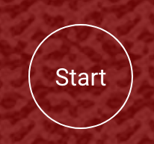 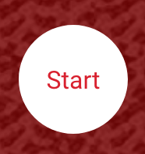

## Arrows Sign:

Arrows sign is used for indicating which user has the turn at the moment. The arrows signs are in white color in the game. There are two arrows, one for each player. On player’s turn the arrow appears next to dice and it gets hide for the second player.

 

# Design sketches:

Following wireframes are designed for the board game.

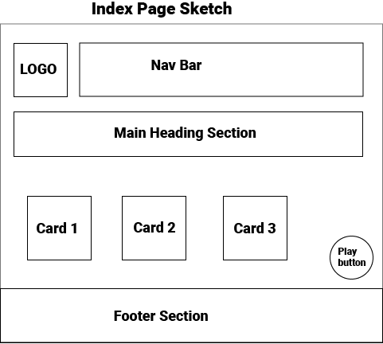

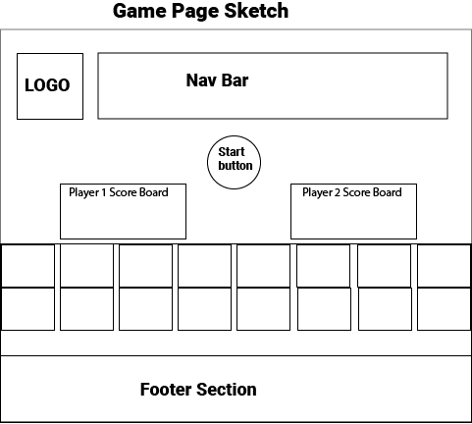

# Development of the Game:

The game is developed using Javascript, Bootstrap 4, HTML and SCSS. Bootstrap provides efficient way of using grid layouts as well as nice looking navigation bar, cards and buttons. Therefore, I have chosen Bootstrap 4.1.7 version, which is the latest one to use for this project.

## Fetch Players data from json api:

According to the assignment, we are suppose to use following URL to fetch data and use it players’ characters.

<https://anapioficeandfire.com/api/characters>

I have used this query to fetch page number 12 and used data from 16 to 26th record of fetched JSON array.

<https://anapioficeandfire.com/api/characters?pageSize=50&page=12>

This choice solely personal, because the data fetched on these JSON items seem more complete and readable.

## Cards:

Once the data of players is fetched from the provided API, I draw Bootstrap 4’s cards. Since, we are suppose of display details of 10 characters, therefore I have created 10 cards dynamically with the help of Javascript. The information I chose to display in the card is:

* The name of player
* Character image
* Gender of player
* Title of the player

These are the information of GAMES OF THRONES characters. Formating of card is done into three parts card-header, card-body, card-footer according to standard Bootstrap card structure.

In the card-header section there is the name of the player and in the card-body section character icon is used for different colors to sepearte the players from each other. In the card footer section there is a check box which means you have to choose the character and click on the check box. Maxium to players have to be chosen not more than that. When two checkboxes are checked, all the remaining checkboxes get disabled so that a user cannot choose more than 2 players. However, we allow user to deselect either of the players, and then all the checkboxes get enable again so that the user is able to select/choose any other player. If the user chooses none or 1 player and clicks on play button at the bottom of the page, an alert is generated to choose 2 players to start the game.

## GameBoard:

After choosing two players and clicking play button at the bottom of the page, the user will have the new content on the same page where the user needs to click a start button to load the game canvas and initialize the scorebaord. On the scoreboard, the selected players’ name are shown as player1 and player2. Player1 is assigned blue token and player2 is assigned yellow token.

To grab the attention and focus of the user on where to click and who has the turn to play, I have used different font color and an arrow. The player who has current turn will be highlighted in terms of white colorured text and an arrow pointing towards rolling the dice, and the player who is waiting for his/her turn will not be able to click his/her dice, and the scoreboard details are dimmed as gray colour. Similarly, when the turn changes for other player, the formatting gets switched and arrow gets hide for a waiting player, and arrow gets visible for the player who has turn at the moment.

## Game CANVAS:

First the canvas is initialized with the background design, that includes, 50 square boxes, digitis in each box, 5 traps with snake images, and a castle as a winning position. The two tokens, one for each player, are also initiazed when the canvas is initialized.

When the player clicks on dice icon, a random number is generated using Javascript built-in function and the total score is calculated accordingly. Based on the total score, current x/y-axis location of the token, it gets redraw on the canvas with new score value and new x/y-location. If the new score reaches the location of the trap(snake), then the token is forced to move 3 steps backward, as per the instructions provided in the assignment.

When either of the token reaches castle, that is crossing a total score of 49, it get a notification of win, the game ends and the page is redirected to home page.

## Final Congrats Page:

Finally, when either of the player wins, the page is redirected to final page where there is a simple button to get the surprise. If the player clicks the button labeled as ”Check Surprise”, the fireworks starts in the background. I have followed the instruction on the tutorial mentioned here [6]. And for this task, I have used built-in fireworks library provided at the following [6] tutorial.

## github code repo:

The code is maintained and kept updated on github. To find the source, please use following URL.

<https://github.com/rajawaqasahmed/boardgame>

# Testing and delivery:

I have performed unit testing in parallel with development of modules. Once all the individual components are designed, developed, and tested, I started integrating those modules with the main projects.

For example, I developed separated home page and a game canvas page. And tested the game play as an individual module, and fetching data from API was done separately and tested serately. Howeve, in the end, these individual tested moduled were integrated, and then integration testing was performed.

# Conclusion:

In conclusion, I would like say that throughout this semester, whatever material I have studied and learnt, I have tried my best to show it in this project with possible examples. Focusing on starting a project with propoer project plan, and then designing and development, as well as testing. Canvas programming is a great fun. I am excited to make more games with different types of user interactions.

# References

1. Adobe Photoshop, available on, <https://www.adobe.com/products/photoshop.html>
2. Adobe Illustrator, available on, <https://www.adobe.com/products/illustrator.html>
3. Bootstrap 4, available on <https://getbootstrap.com>
4. SCSS, available on <https://sass-lang.com/>
5. W3School, available on, <https://www.w3schools.com/>
6. Fireworks tutorial, available on, <https://www.jqueryscript.net/animation/jQuery-Plugin-To-Create-Canvas-Based-Fireworks.html>