**Steps to run this application in localhost**:

1. Create Repos folder in C: drive
2. Clone the project inside the Repos folder

Link: https://github.com/rajawatSwati/ContactApp.git

1. Open the ContactApp.sln in Visual Studio 2017 or above and Build the solution
2. Create new database ‘ContactDatabase’ and create new table ‘Contacts’ in the database

For table creation script refer “dbo.Contacts.sql” file.

1. Update the connection string in UnityConfig.cs file

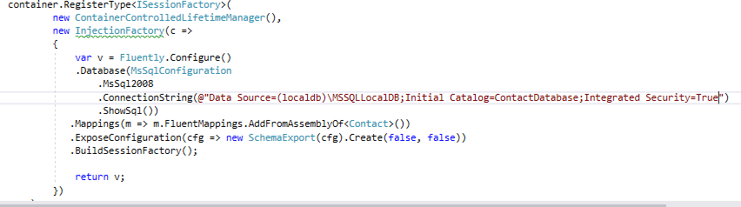

1. Run the Api.App in the local host and copy the url and update it in Web.config file

at path ..\ContactWebApp\Web.config

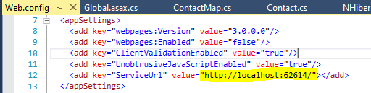

1. Do below setting for Startup project, Apply the changes and click ok

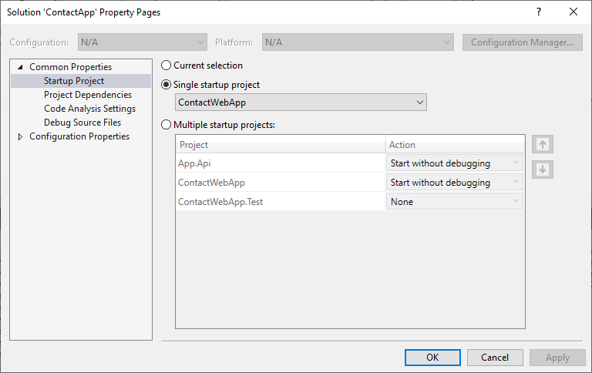

**Below page will be launched in the browser:**

