THEORY

Machine Learning
Machine learning allows computers to learn new tasks without being expressly programmed to perform them. It is a branch of artificial intelligence based on the idea that systems can learn from data, identify patterns and make decisions with minimal human intervention, and thus finds widespread applications in fields such as NLP, Image Recognition, Recommendation algorithms, etc. Amongst other NLP applications, by training machine learning models with examples of emotions in text,machines can even automatically learn how to detect sentiment without human input, and ML and AI-related techniques are thus very useful for performing Sport Prediction as well, that we aim to perform in this Project.
Machine Learning can review large volumes of data and discover specific trends and patterns that would not be apparent to humans. For instance, for an e-commerce website like Amazon, it serves to understand the purchase behaviours of users to help cater to the relevant products.
Basic Principle
The process starts with feeding good quality data and then training our machines(computers) by building machine learning models using the data and different algorithms. The choice of algorithms depends on what type of data do we have and what kind of task we are trying to automate. When we feed the data to a model, the model starts “learning” and analyzes the patterns in the data. This learning can be of two different types, supervised and unsupervised.
Supervised learning algorithms are trained using labeled examples, such as an input where the desired output is known. For example, a piece of equipment could have data points labeled either “F” (failed) or “R” (runs). The learning algorithm receives a set of inputs along with the corresponding correct outputs, and the algorithm learns by comparing its actual output with correct outputs to find errors. It then modifies the model accordingly. Through methods like classification, regression, prediction and gradient boosting, supervised learning uses patterns to predict the values of the label on additional unlabeled data. Supervised learning is commonly used in applications where historical data predicts likely future events. For example, it can anticipate when credit card transactions are likely to be fraudulent or which insurance customer is likely to file a claim.
Unsupervised learning is used against data that has no historical labels. The system is not told the "right answer." The algorithm must figure out what is being shown. The goal is to explore the data and find some structure within. Unsupervised learning works well on transactional data. For example, it can identify segments of customers with similar attributes who can then be treated similarly in marketing campaigns. Or it can find the main attributes that separate customer segments from each other. Popular techniques include self-organizing maps, nearest-neighbor mapping, k-means clustering and singular value decomposition. These algorithms are also used to segment text topics, recommend items and identify data outliers.
In our project we are using supervised models. The data we are using consists of tweets by actual people and it covers a huge domain of emotions or opinions. It will be hard to make an unsupervised model in such a case. So instead, we use a labelled dataset which classify tweets as positive or negative and thus we have a supervised model.
Regression vs Classification
Machine learning algorithms can also be divided into two other categories, based on the labels or values predicted by the model. These are called classification algorithms and regression algorithms.
In machine learning, regression algorithms attempt to estimate the mapping function (f) from the input variables (x) to numerical or continuous output variables (y).
In this case, y is a real value, which can be an integer or a floating point value. Therefore, regression prediction problems are usually quantities or sizes.
For example, when provided with a dataset about houses, and you are asked to predict their prices, that is a regression task because price will be a continuous output.
On the other hand, classification algorithms attempt to estimate the mapping function (f) from the input variables (x) to discrete or categorical output variables (y).
In this case, y is a category that the mapping function predicts. If provided with a single or several input variables, a classification model will attempt to predict the value of a single or several conclusions.
For example, when provided with a dataset about houses, a classification algorithm can try to predict whether the prices for the houses “sell more or less than the recommended retail price.”
Here, the houses will be classified whether their prices fall into two discrete categories: above or below the said price.
Basics of Training
Training data and test data are two important concepts in machine learning. The observations in the training set form the experience that the algorithm uses to learn. In supervised learning problems, each observation consists of an observed output variable and one or more observed input variables. Training a model simply means learning (determining) good values for all the weights and the bias from labelled examples. In supervised learning, a machine learning algorithm builds a model by examining many examples and attempting to find a model that minimizes loss; this process is called empirical risk minimization.
In various algorithms,extra optimitization by making specific improvements is achieved. But the basic idea behind this is to minimize the loss.
Loss is the penalty for a bad prediction. That is, loss is a number indicating how bad the model's prediction was on a single example. If the model's prediction is perfect, the loss is zero; otherwise, the loss is greater. The goal of training a model is to find a set of weights and biases that have low loss, on average, across all examples.
Testing and performance metrics
A test dataset is a dataset that is independent of the training dataset, but that follows the same probability distribution as the training dataset. Test dataset is a dataset used to provide an unbiased evaluation of a final model fit on the training dataset. A test set is therefore a set of examples used only to assess the performance of a fully specified classifier. The test set is a set of observations used to evaluate the performance of the model using some performance metric.
It is important that no observations from the training set are included in the test set. If the test set does contain examples from the training set, it will be difficult to assess whether the algorithm has learned to generalize from the training set or has simply memorized it. A program that memorizes the training data by learning an overly complex model could predict the values of the response variable for the training set accurately, but will fail to predict the value of the response variable for new examples. Memorizing the training set is called over-fitting. A program that memorizes its observations may not perform its task well, as it could memorize relations and structures that are noise or coincidence. Balancing memorization and generalization, or over-fitting and under-fitting, is a problem common to many machine learning algorithms. Regularization may be applied to many models to reduce over-fitting.
Even though its earlier said,training loss minimization is the only thing that matters to the training algorithm, but for human interpretation and for practical application of the classifier, many other factors are to be considered because how it performs in real world data is very different from a possibly biased (and having other issues as well) data set that it has been trained on. The various metrics used for such evaluation are discussed below:

Confusion Matrix
It is the easiest way to measure the performance of a classification problem where the output can be of two or more type of classes. A confusion matrix is nothing but a table with two dimensions viz. “Actual” and “Predicted” and furthermore, both the dimensions have “True Positives (TP)”, “True Negatives (TN)”, “False Positives (FP)”, “False Negatives (FN)” .
Explanation of the terms associated with confusion matrix are as follows −
- True Positives (TP) − It is the case when both actual class & predicted class of data point is 1.
- True Negatives (TN) − It is the case when both actual class & predicted class of data point is 0.
- False Positives (FP) − It is the case when actual class of data point is 0 & predicted class of data point is 1.
- False Negatives (FN) − It is the case when actual class of data point is 1 & predicted class of data point is 0.
Classification Accuracy is most common performance metric for classification algorithms. It may be defined as the number of correct predictions made as a ratio of all predictions made.
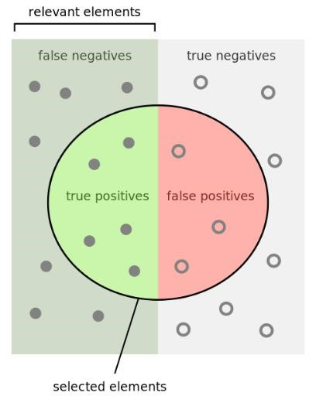
Fig:
Precision is the fraction of relevant instances among the retrieved instances
Recall or Sensitivity is the fraction of the total amount of relevant instances that were actually retrieved.
Specificity (also called the true negative rate) measures the proportion of actual negatives that are correctly identified as such.
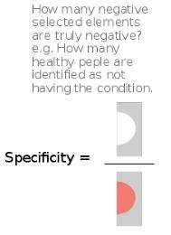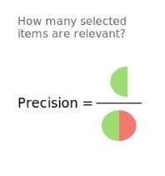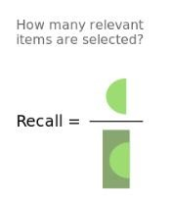
Fig.
F1 Score will give us the harmonic mean of precision and recall. Mathematically, F1 score is the weighted average of the precision and recall. The best value of F1 would be 1 and worst would be 0.

Learning Based Methods
Most learning based approaches use classification techniques to determine the polarity of the text. Usually, the learning used is supervised learning, and therefore, a training dataset is required. The most popular techniques used to perform learning based analysis are Logistics regression, Random forest classifier, Accuracy Cross validation. Feature selection is an important step in machine learning, because these features determine the results of the classifiers. Some of the features that are used for performing sentiment analysis are: term presence and frequency, Part of Speech (POS) tagging, negations encountered in the sentence and the list of opinion words/ phrases amongst other features. The classifiers that are used are:
- Random forest classifier: Random Forest classifier is a method used for regression and classification techniques. In the Random Forest Classifiers, to classify a new instance, there are number of trees in working randomly in a forest putting input vector down and duty of every tree is to give a class label or target variable as a vote for the class. And which node has highest votes will be chosen by Random Forest Classifier. As the name suggests, "Random Forest is a classifier that contains a number of decision trees on various subsets of the given dataset and takes the average to improve the predictive accuracy of that dataset." Instead of relying on one decision tree, the random forest takes the prediction from each tree and based on the majority votes of predictions, and it predicts the final output.
- Logistics regression : Logistic regression is a process of modeling the probability of a discrete outcome given an input variable. The most common logistic regression models a binary outcome; something that can take two values such as true/false, yes/no, and so on. Multinomial logistic regression can model scenarios where there are more than two possible discrete outcomes. Logistic regression is a useful analysis method for classification problems, where you are trying to determine if a new sample fits best into a category. As aspects of cyber security are classification problems, such as attack detection, logistic regression is a useful analytic technique..
- Cross validation Score: Cross-validation is a technique used to assess machine learning model and test its performance (or accuracy). It involves reserving a specific sample of a dataset on which the model isn't trained. Later on, the model is tested on this sample to evaluate it. Cross-validation is used to protect a model from overfitting, especially if the amount of data available is limited. It's also known as rotation estimation or out-of-sample testing and is mainly used in settings where the model's target is prediction.
- Accuracy Score: Accuracy is one metric for evaluating classification models. Informally, accuracy is the fraction of predictions our model got right. Formally, accuracy has the following definition:

Number of correct predictions
Accuracy=
Total number of predictions
For binary classification, accuracy can also be calculated in terms of positives and negatives as follows:

TP+TN
Accuracy=
TP+TN+FP+FN
Where TP = True Positives, TN = True Negatives, FP = False Positives, and FN = False Negatives.
- Average RMSE: The root-mean-square deviation (RMSD) or root-mean-square error (RMSE) is a frequently used measure of the differences between values (sample or population values) predicted by a model or an estimator and the values observed. The RMSE represents the square root of the second sample moment of the differences between predicted values and observed values or the quadratic mean of these differences. These deviations are called residuals when the calculations are performed over the data sample that was used for estimation and are called errors (or prediction errors) when computed out-of-sample. The RMSE serves to aggregate the magnitudes of the errors in predictions for various data points into a single measure of predictive power. RMSE is a measure of accuracy, to compare forecasting errors of different models for a particular dataset and not between datasets, as it is scale-dependent.
RMSE is always non-negative, and a value of 0 (almost never achieved in practice) would indicate a perfect fit to the data. In general, a lower RMSE is better than a higher one. However, comparisons across different types of data would be invalid because the measure is dependent on the scale of the numbers used.
RMSE is the square root of the average of squared errors. The effect of each error on RMSE is proportional to the size of the squared error; thus larger errors have a disproportionately large effect on RMSE. Consequently, RMSE is sensitive to outliers.

Mathmatical Calculation:-

- Logistic Regression Equation: The fundamental equation of generalized linear model is:
g(E(y)) = α + βx1 + γx2

Here, g() is the link function, E(y) is the expectation of target variable and α + βx1 + γx2 is the linear predictor ( α,β,γ to be predicted). The role of link function is to ‘link’ the expectation of y to linear predictor.
Let’s understand it further using an example:
We are provided a sample of 1000 customers. We need to predict the probability whether a customer will buy (y) a particular magazine or not. As you can see, we’ve a categorical outcome variable, we’ll use logistic regression.
To start with logistic regression, I’ll first write the simple linear regression equation with dependent variable enclosed in a link function:
g(y) = βo + β(Age) ---- (a)
Note: For ease of understanding, I’ve considered ‘Age’ as independent variable.
In logistic regression, we are only concerned about the probability of outcome dependent variable ( success or failure). As described above, g() is the link function. This function is established using two things: Probability of Success(p) and Probability of Failure(1-p). p should meet following criteria:
- It must always be positive (since p >= 0)
- It must always be less than equals to 1 (since p <= 1)
Now, we’ll simply satisfy these 2 conditions and get to the core of logistic regression. To establish link function, we’ll denote g() with ‘p’ initially and eventually end up deriving this function.
Since probability must always be positive, we’ll put the linear equation in exponential form. For any value of slope and dependent variable, exponent of this equation will never be negative.
p = exp(βo + β(Age)) = e^(βo + β(Age)) ------- (b)
To make the probability less than 1, we must divide p by a number greater than p. This can simply be done by:
p = exp(βo + β(Age)) / exp(βo + β(Age)) + 1 = e^(βo + β(Age)) / e^(βo + β(Age)) + 1 ----- (c)
Using (a), (b) and (c), we can redefine the probability as:
p = e^y/ 1 + e^y --- (d)
where p is the probability of success. This (d) is the Logit Function
If p is the probability of success, 1-p will be the probability of failure which can be written as:
q = 1 - p = 1 - (e^y/ 1 + e^y) --- (e)
where q is the probability of failure
On dividing, (d) / (e), we get,
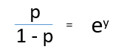
After taking log on both side, we get,
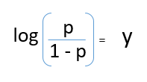
log(p/1-p) is the link function. Logarithmic transformation on the outcome variable allows us to model a non-linear association in a linear way.
After substituting value of y, we’ll get:
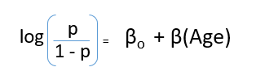
This is the equation used in Logistic Regression. Here (p/1-p) is the odd ratio. Whenever the log of odd ratio is found to be positive, the probability of success is always more than 50%. A typical logistic model plot is shown below. You can see probability never goes below 0 and above 1.
- Random forest classifier: Random Forest works in two-phase first is to create the random forest by combining N decision tree, and second is to make predictions for each tree created in the first phase.
The Working process can be explained in the below steps and diagram:
Step-1: Select random K data points from the training set.
Step-2: Build the decision trees associated with the selected data points (Subsets).
Step-3: Choose the number N for decision trees that you want to build.
Step-4: Repeat Step 1 & 2.
Step-5: For new data points, find the predictions of each decision tree, and assign the new data points to the category that wins the majority votes.
The working of the algorithm can be better understood by the below example:
Example: Suppose there is a dataset that contains multiple fruit images. So, this dataset is given to the Random forest classifier. The dataset is divided into subsets and given to each decision tree. During the training phase, each decision tree produces a prediction result, and when a new data point occurs, then based on the majority of results, the Random Forest classifier predicts the final decision. Consider the below image:
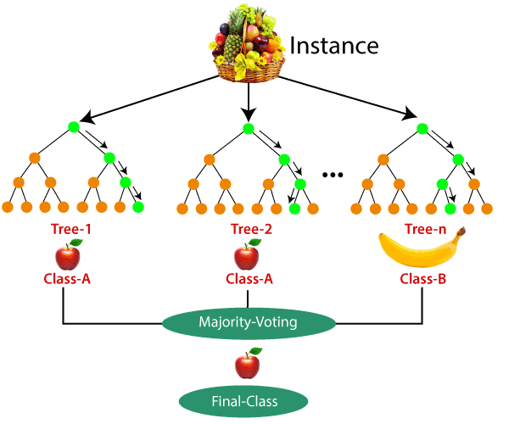

- Cross Validation: In this method, we split the data-set into k number of subsets(known as folds) then we perform training on the all the subsets but leave one(k-1) subset for the evaluation of the trained model. In this method, we iterate k times with a different subset reserved for testing purpose each time.
Example:-The diagram below shows an example of the training subsets and evaluation subsets generated in k-fold cross-validation. Here, we have total 25 instances. In first iteration we use the first 20 percent of data for evaluation, and the remaining 80 percent for training([1-5] testing and [5-25] training) while in the second iteration we use the second subset of 20 percent for evaluation, and the remaining three subsets of the data for training([5-10] testing and [1-5 and 10-25] training), and so on.

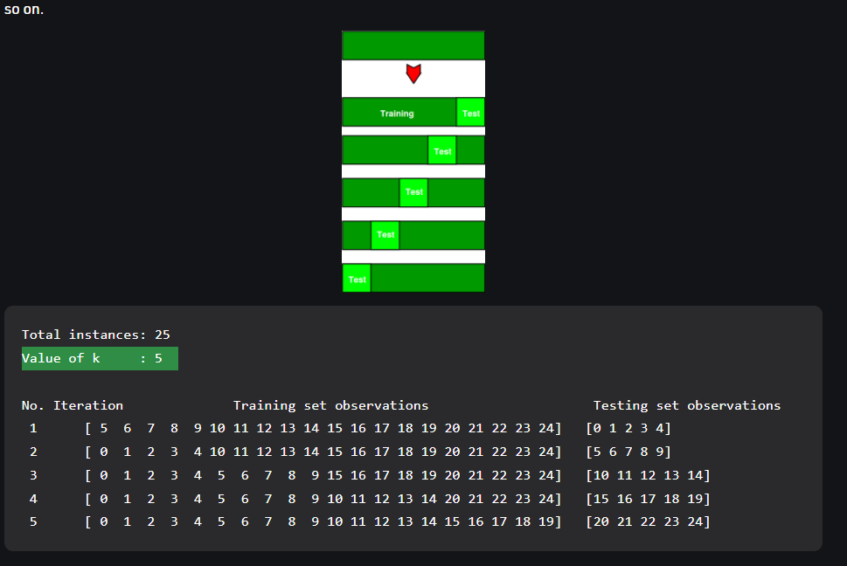
- Root Mean Square Error (RMSE): is the standard deviation of the residuals (prediction errors).

The formula is:- 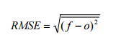

Where:
- f = forecasts (expected values or unknown results),
- o = observed values (known results).
The bar above the squared differences is the mean (similar to x̄). The same formula can be written with the following, slightly different, notation (Barnston, 1992):

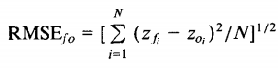

Where:
- Σ = summation (“add up”)
- (z_{fi} – Z_{oi})² = differences, squared
- N = sample size.
You can use whichever formula you feel most comfortable with, as they both do the same thing. If you don’t like formulas, you can find the RMSE by:
- Squaring the residuals.
- Finding the average of the residuals.
- Taking the square root of the result.
That said, this can be a lot of calculation, depending on how large your data set it. A shortcut to finding the root mean square error is:
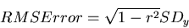

Where SD_{y} is the standard deviation of Y.

Sport Prediction:-
In cricket, particularly the twenty20 format is most watched and loved by the people, where no one can guess who will win the match until the last ball of the last over. In India, The Indian Premier League (IPL) started in 2008 and now it is the most popular T20 league in the world. So we decided to develop a machine learning model for predicting the outcome of its matches. Winning in a Cricket Match depends on many key factors like a home ground advantage, past performances on that ground, records at the same venue, the overall experience of the players, record with a particular opposition, and the overall current form of the team and also the individual player. This paper briefs about the key factors that affect the result of the cricket match and the regression model that best fits this data and gives the best predictions. Cricket, the mainstream and widely played sport across India which has the most noteworthy fan base. Indian Premier League follows 20-20 format which is very unpredictable. IPL match predictor is a ML based prediction approach where the data sets and previous stats are trained in all dimensions covering all important factors such as: Toss, Home Ground, Captains, Favorite Players, Opposition Battle, Previous Stats etc, with each factor having different strength with the help of KNIME Tool and with the added intelligence of Naive Bayes network and Eulers strength calculation formula.
After football, cricket is most loved and watched by many individuals in the world but in India cricket is the most loved sport. In the past few years, lots of research papers are published and lots of work is done which predicts the result of a cricket match by using the factors that affect the match outcome and they are using the supervised machine learning algorithms to predict the outcome of the match like Linear regression, support vector machines, logistic regression, decision tree, Bayes network, random forest. Cricket is one of the most well-liked sports in the world. Especially the Twenty20 format is very popular as it is a fast-paced form of the game that attracts the spectators at the ground and the viewers at home. The Indian Premier League (IPL) is a professional Twenty20 cricket league that is governed by the Board of Control for Cricket in India (BCCI). The Indian Premier League is conducted every year and participating teams represent a city in India. Various natural factors affect the game, the hype has given by the media, and a huge market like fantasy 11 and betting on sites has provided a lot of importance to the model. The rules of the game, the skill of the players, their form, and various other natural factors are very important in the prediction accuracy of the result of a cricket match. As the technology is growing and the apps like fantasy 11 and betting sites are getting popular the people going to use the predictions given by the machine learning model. The use of machine learning makes life easier in many aspects. To predict the outcome of a cricket match we are not going to rely on a single machine learning algorithm we are going to use all the machine learning algorithms. In machine learning, there are two types of learning supervised learning and unsupervised learning. In Unsupervised learning, the data is not properly labelled so the machine has to sort the data according to patterns, combinations without any training given. But in supervised learning, the data is labelled with the proper classification so the machine can easily analyze it and produce the correct result. For our application, the unsupervised learning models are not of any use because the data of cricket matches are properly labelled. So we are going to use the supervised learning models. In Supervised learning, there are again two types are classification and regression. Classification is used to classify among categories like red or blue and Regression is used when the output is a real number like rupees or height. In our model, we are going to use regression because the outcome will be the winning percentage and it is of type number. Our main objective is to find the key factors that affect the match outcome and select the best machine learning model that best fits this data and gives the best results. Some works already have been published in this area of predicting the outcome of a cricket match. In some paper, only a few key factors are taken for prediction so the accuracy is less. Whereas in some paper the machine learning model is not appropriate. So it is important to take all the key factors that can affect the match outcome and as well as to select the best model for training and testing the data. This will increase the prediction accuracy drastically.

