


Texas College of Management & IT Bachelor of Information Technology (BIT)

The effects of smartphone addiction on learning

Submitted By:
Name: Govinda Kumar Rajbanshi
LCID: LC00017001924
Semester: 6th Sem
Section: A

Submitted To:
Instructor Name: Shankar Prasad Gaire
Course: Research Methodology (BIT 356)
Date of Submission: 26th July, 2025

Texas College of Management & IT, Kathmandu

The effects of smartphone addiction on learning

Table of Contents
Abstract 3
Introduction 3
Conceptualization of smartphone addiction 4
Review of the research of smartphone addiction on learning 6
Purpose of the meta-analysis 7
Method 7
Inclusion/exclusion criteria 7
Data sources and search strategies 8
Outcomes of the search strategy 8
Result 10
Discussion 16
Conclusion 19
Reference 19

Abstract
There is a plenty of research on college students' smartphone use. Numerous research have looked at the connections between academic success and cell phone use, however the results of many of these studies have been conflicting. Therefore, this meta-analysis's main objective was to thoroughly summarize the body of studies in order to look into how smartphone addiction affects learning. In their analysis, the authors incorporated 44 studies (45 effects), resulting in a sample size of N = 147,943 college students from 16 different countries. The findings demonstrate that students' learning and general academic performance are adversely affected by smartphone addiction (Q (43) = 711.87%, p <.001, r = -0.12). Additionally, research indicates that using a phone while studying has a detrimental effect on learning and academic performance. The findings also imply that there is a detrimental influence on the cognitive and skill sets required for pupils to succeed academically and learn. The findings' implications are examined, and suggestions for additional study are outlined.

Introduction
The widespread use of cellphones in our culture has led to serious worldwide problems, including addiction and excessive use. Numerous research have looked at the connections between mobile phone use and academic performance, however the results of many of these studies have been conflicting. The majority of these research have used students' self-reported course grades to examine the relationship between problematic smartphone use and academic achievement. Because course grades don't necessarily reflect learning outcomes, this study focuses on student learning. Therefore, determining whether smartphone use in the classroom has an impact on students' learning is one of the objectives of this meta-analysis.

Both the advantages and disadvantages of smartphones have been the subject of research on smartphone use. Researchers have looked into the negative effects of excessive smartphone use, such as poor sleep quality (Brunborg, Mentzoni, Model, Myrseth, & Demirci, Akgönül, & Akpinar, 2015; Yang, Fu, Liao, & Li, 2020), inattention on a daily basis (Marty-Dugas, Ralph, Oakman, & Smilek, 2018), attention deficit and academic procrastination (Im & Jang, 2017; Yang, Asbury, & Griffiths, 2018), deterioration of interpersonal relationships (Seo, Park, Kim, & Park, 2016), and poor academic performance (Baert et al., 2020; Grant; Lust, & Chamberlain, 2019; Kate, Wu, Coryn, 2018; Kim, Min, Ahn, An, & Lee, 2019; Lin, Liu, Fan, Tuunainen, & Deng, 2021; Samaha & Hawi, 2016).
According to Geser (2004), using a cell phone can improve communication between people and systems and promote social interactions. Utilizing cellphones to monitor patient health data and convey health messages to modify lifestyle choices has improved patient care and health promotion initiatives (Blake, 2008; Fjeldsoe, Marshall, & Miller, 2009).

Notwithstanding the negative effects of smartphone use, some studies have looked at the educational advantages of smartphone use for self-regulated learning (Sha, Looi, Chen, & Zhang, 2012), classroom engagement (Wang, Shen, Novak, & Pan, 2009), personalized instruction (Steel, 2012), mobile learning (Traxler, 2009), and second language acquisition (Thornton & Houser, 2005). These research' conclusions emphasized the educational advantages of smartphone use, including closing the digital divide, finishing assignments, peer collaboration, rapid information accessibility, and vocabulary development. These advantages led to a dependence on smartphone use for tasks pertaining to education. College students' ongoing reliance on cellphones has been facilitated by these affordances.

The increased use of smartphones worldwide has resulted in a growing reliance on them due to their built-in features and portability. Because smartphones have so many features, including entertainment, social media, online shopping, agenda tracking, online gaming, online banking, chatting, online entertainment, and the ability to finish homework, some people—especially the younger generation—prefer them to laptops and personal computers (Cha & Seo, 2018; Nayak, 2018). Because of this, young adults have been using smartphones consistently over time, and as a result, most of them struggle to limit their use (Bianchi & Phillips, 2005). Examining the connections between smartphone addiction and students' learning is essential, especially since smartphone addiction is common among college students.

Many studies have investigated educational outcomes of smartphone addiction, and there have been inconsistencies in research findings. Hence, this study contributes to the literature on smartphone addiction in two ways: (1) examine the landscape of literature on the negative impact of smartphone addiction on students' learning and overall academic performance; (2) reconcile the mixed findings in the literature regarding the effects of smartphone addiction on students’ academic performance.

Conceptualization of smartphone addiction

Due to the proliferation of smartphone use, researchers have attempted to operationalize smartphone addiction in terms of smartphone overuse (Lee, 2017), excessive smartphone use (Chen, Liang, Mai, Zhong, & Qu, 2016), compulsive mobile phone usage (Kim & Byrne, 2011), mobile phone addiction (Eduardo et al., 2012), heavy smartphone use (Lee, 2014), problematic mobile phone usage (Billieux, Van der Linden, d’Acremont, Ceschi, & Zermatten, 2007; Rozgonjuk, Saal, & That, 2018), and mobile phone dependence (Wang, Wang, Li, Dong & Chi, 2013). Thus, the conceptualization of smartphone addiction has generated intense debates among researchers.
Given this, many scholars have attempted to define smartphone addiction in the context of behavioral addiction. Sussman and Sussman (2011) explored the definition of addiction under five elements: (a) engagement in the behavior to achieve appetitive effects, (b) preoccupation, (c) temporary satiation, (d) loss of control, and (e) negative consequences. They justified this definition by stating that anyone can experience each element in part(s), combined with one or more of others or a case where an individual possesses the five characteristics of addiction. Shambare, Rugimbana, and Zhowa (2012) examined six types of behavior: habitual, mandatory, voluntary, dependent, compulsive, and addictive. However, their study found support for only three: dependency, habitual, and addictive behavior. The findings explain a condition where smartphone use has fulfilled a deep need (dependency, habitual, and addictive behavior) to the extent that the individual has difficulty conducting basic activities of daily life without the concurrent use of a smartphone. For example, some people find it difficult to sleep through the night without checking social media sites multiple times.
In a similar vein, Griffiths (2005) operationalized behavioral addictions as any activity that includes the six essential elements of addiction: conflict, relapse, salience, mood modulation, tolerance, and withdrawal symptoms. According to Griffiths, an addiction is defined as any activity that meets any of these six requirements. Additionally, eleven criteria for substance-related and addictive disorders were listed in the Diagnostic and Statistical Manual of Mental Disorders (DSM-5). These criteria included withdrawal, tolerance, hazardous use, repeated attempts to control or quit, use-related physical or psychological problems, given-up activities, and craving (American Psychiatric Association (APA), 2013). To be diagnosed with a substance use disorder, a person must fulfill two or more of the DSM-5 criteria within a 12-month period.
In addition, Griffiths (1999, 2000) relates technological addictions as a type of behavioral addiction and defines the term as “non-chemical (behavioral) addictions that involve human-machine interaction.” The present study is based on the definition Griffiths proposed by categorizing this form of addiction as a subset of behavioral addiction and relating it to human-machine interaction. By doing so, we can place a distinction between chemical addiction and non-chemical addiction. Chemical addiction (substance use) involves digestion of a chemical or liquid substance, and non-chemical (behavioral) addiction arises when a person cannot resist a behavior despite experiencing a psychological need in the short term, leading to a harmful consequence in the long run.
To date, this conceptualization of smartphone addiction as a behavioral addiction is supported only by an exploratory study that heavily relies on self-report instruments (Billieux, J., Maurage, P., Lopez-Fernandez, O., Kuss, D. J., & Griffiths, M. D, 2015). The present research took account of this divergence in the conceptualization of smartphone addiction. In addition, the present meta-analysis seeks to comprehensively synthesize existing research on smartphone addiction and its effects on learning.
The secondary goal of this meta-analysis is to suggest an integrated model for understanding smartphone addiction because it is a complex topic. By incorporating the criteria of behavioral addiction using Griffiths (2005), Shambare et al. (2012), and the DSM-5 criteria of substance-related and addictive disorder (American Psychiatric Association, 2013), this meta-analysis defines smartphone addiction within the contextual framework of behavioral addiction. Accordingly, we define smartphone addiction in this meta-analysis as a state in which using a smartphone has satisfied a deep need (dependence, habitual, and addictive behavior). to the degree that the person finds it difficult to carry out everyday tasks without using a smartphone at the same time, which leads to neglect of other facets of their lives. Consequently, the inclusion of studies in the meta-analysis was impacted by this conceptualization.
According to how smartphone addiction is conceptualized, a person has a behavioral addiction to smartphone use if they exhibit any of the six elements of addiction: salience, mood alteration, tolerance, withdrawal symptoms, conflict, and craving. Therefore, the selection criterion for this meta-analysis is based on the paradigm of behavioral addiction to smartphone use. Studies that didn't fit these requirements weren't included in the analysis.

Review of the research of smartphone addiction on learning
Smartphone addiction is defined as excessive use of smartphones in a difficult to control. Its influence affects other basic activities of daily life, leading to negative consequences (Park & Lee, 2012). Most of the literature that examines the relationship between problematic smartphone use and academic performance reports varying levels of negative consequences (Durak, 2018; Jacobsen & Forste, 2011; Kuznekoff & Titsworth, 2013; Li, Lepp, & Barkley, 2015; Longnecker, 2017; Mendoza, Pody, Lee, Kim, & McDonough, 2018; Olufadi, 2015; Rozgonjuk et al., 2018). Previous research suggests that excessive smartphone use in the classrooms can inhibit academic performance (Lepp, Barkley, and Karpinski (2014) found the negative effects of excessive smartphone use on students’ academic performance through decreased GPA scores.
Roberts, Yaya, and Manolis (2014) found that cell phone addiction can negatively influence academic performance as students' attention in class is disrupted because of cell phone use, and such disruption affects their studies outside of class. Excessive mobile phone use has been associated with distraction in the classroom (Bugeja, 2007; Campbell, 2006; Dietz & Henrich, 2014; Froese et al., 2012; Harman & Seto, 2011; Wei & Wang, 2010). These studies reveal that in-class texting produces significant negative effects on students’ academic performance.
Many studies have discussed smartphone addiction in terms of students' multitasking in the classroom and the effects of this multitasking on students' academic performance (Ellis, Daniels, & Jauregui, 2011; Jacobsen & Forste, 2011; Junco & Cotton, 2011). Findings on the consequences of multitasking with the smartphone on academic performance showed a negative relationship between students' problematic mobile phone use and academic performance. Junco and Cotton (2011, 2012) investigated the relationship between multitasking on phones and student academic performance among college students to account for the effects of multitasking on academic performance. This study showed that sending text messages and checking social media websites like Facebook while performing an academic task or doing homework interfered with completing their schoolwork and negatively impacted the participants’ overall GPA.
However, few studies have found any effects of smartphone addiction on students' academic performance (Dos, 2014; Lau, 2017). The positive effects of smartphone addiction on students’ academic performance may be associated with the shift in social practices that normalize excessive smartphone use. In addition, Tessier (2013) found that smartphone use as an education tool could enhance learning. When students are allowed to use their cell phones as a learning aid in class, it could increase academic performance and benefit educational settings.
In sum, smartphone addiction has generated mixed findings among researchers. Hence, the primary goal of this meta-analysis is to reconcile the inconsistencies in the literature regarding the size and direction of the effects of smartphone addiction on students’ academic performance.

Purpose of the meta-analysis
Research on smartphone addiction has generated mixed findings. Hence, this study aims to reconcile inconsistencies in the literature by conducting a comprehensive meta-analysis on the effects of smartphone addiction on learning. Therefore, this meta-analysis sought answers to the following research questions:
- How do past research on smartphone addiction and academic performance demonstrate the relationships between smartphone addiction and students' learning?
- What factors moderate the relationship between smartphone addiction and academic performance as demonstrated by past research?
- How do the relationships of smartphone addiction and students' learning vary with characteristics of research design and methodological features of past research?

Method
This meta-analysis was carried out in accordance with a recognized review protocol that directs the processes for gathering and combining research (Cooper, Hedges, & Valentine, 2009).

Inclusion/exclusion criteria
Following a preliminary examination of empirical studies and reviews, we developed selection criteria to examine the impact of smartphone addiction on students’ academic performance. To be included in this meta-analysis, studies must meet the following criteria:
- Examine smartphone addiction or mobile phone use about learning and academic performance. The study must fall within the scope of a smartphone, cell phone, or mobile phone use.
- Student academic performance was measured by constructs of learning performance such as GPA, test scores, SAT scores, GRE/GMAT scores, overall class scores. In addition, any cognitive tasks that measure learning outcomes are used as proxies.
- Studies must satisfy the conditions stated for the conceptualization of smartphone addiction within the framework or model of this meta-analysis, such as but not limited to problematic use, behavioral addiction, compulsive use (texting or smartphone use), excessive use, and multitasking in class.
- Studies must report sufficient and appropriate data to calculate effect sizes.
- Studies must be publicly available either online or in library archives. Studies that reported insufficient data for effect size calculations were excluded. Studies that measured computer, internet addiction, or laptop use were also excluded.

Data sources and search strategies
We conducted a thorough and methodical search on the following electronic databases: PsycINFO, Education Full Text, ERIC, PsycARTICLES, PubMed, Pro-Quest, Google Scholar, and Web of Science. We used the keywords smartphone∗ addict OR mobile phone∗ addiction OR mobile phone ∗ use AND academic performance∗ OR GPA∗ OR learning∗. Additionally, a manual search of previous evaluations of the literature on smartphone addiction was carried out by looking through their reference lists (Dietz & Henrich, 2014; Junco & Cotton, 2012; Lepp, Barkley, & Karpinski, 2015; Samaha & Hawi, 2016).

Outcomes of the search strategy
A total of 320 articles were obtained from the search procedure and entered into an extensive coding form. This meta-analysis adopted two screening phases to guide the inclusion/exclusion criteria. In the first phase of the screening, both the first and second authors independently screened the relevant sources, reviewed the title and keywords of these articles for possible inclusion, and strictly ensured the inclusion criteria were applied. We removed 39 duplicate articles from the study. Besides, studies that did not meet the selection criteria were excluded, resulting in 51 articles after the first phase. The full text of the articles was obtained and read by two researchers.
To further assess eligibility in accordance with the inclusion criteria, we created a coding sheet and independently examined the complete text of each of the 51 articles following inclusion. The data from the 44 papers that satisfied the second inclusion criterion were taken out and stored in Zotero. Eleven categorical moderators comprised the coding variables: (a) smartphone construct, (b) source, (c) region, (d) sampling group, (e) purpose of use, (f) GPA predictor, (h) test format, (i) research design, (j) test instrument, and (k) grade level. Incorporating study features into our coding forms, the moderator variables were developed beforehand. Our research questions and readings from the body of existing literature on smartphone addictions served as the basis for this process.
The authors held lengthy discussions to settle any disagreements and come to a consensus on the code in situations when a variable was not apparent. The flowchart of how studies were filtered during the search for relevant studies to be included in this meta-analysis is displayed in Fig. 1.

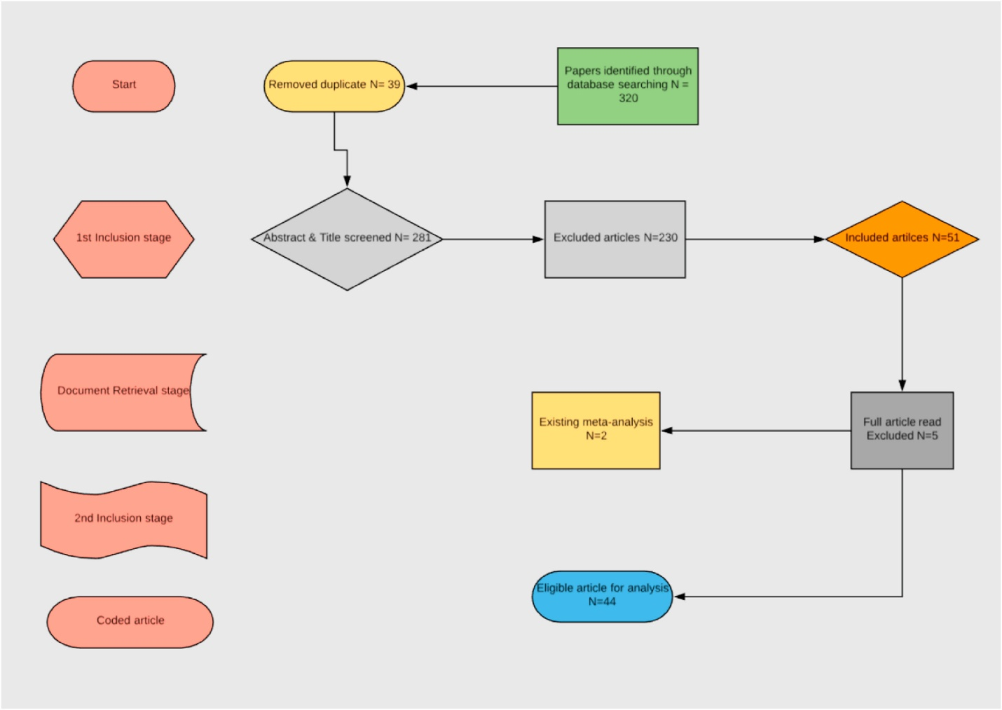
Fig:1. Flowchart for selection of studies.
Procedure for data analysis
The standard protocols for performing a meta-analysis were adhered to in this study (Adesope, Lavin, Thomson, & Ungerleider, 2010; Cooper & Hedges, 1994; Nesbit & Adesope, 2006). IBM SPSS version 24 for Windows and the Comprehensive Meta-Analysis software 2.2.048 (Borenstein, Hedges, Higgins, & Rothstein, 2009) were used to analyze the data. Coded variables were methodically organized in Excel prior to data entry into CMA and SPSS. We derived the Pearson Correlation Coefficient (r) for every outcome measure. Every effect size produced by studies that qualified was translated to the correlation coefficient (r).
The correlation coefficient was converted to the Fisher's Z scale in order to produce the summary effect size. Therefore, a thorough meta-analysis software was used to perform all analyses utilizing the transformed values. Because Pearson correlation makes it easier to see how strongly two variables are related, it was used to examine how smartphone addiction affected learning. Additionally, we looked at the effect sizes' normality distribution using SPSS. To investigate the normality distribution, the converted effect sizes were imported into SPSS.

Result
A total of 44 studies included (45 effect sizes) in the analysis consist of 147,943 students from 16 countries (e.g., Brazil, China, Italy, Lebanon, Nigeria, Turkey, United States). The distribution of effect sizes is displayed in Fig. 2. To give the presentation coherence, the moderator and overall results analyses were arranged and presented according to the study questions. There is a negative connection (r) between smartphone addiction and learning in every analysis that has been published. That is, kids' academic performance suffers as a result of smartphone addiction. Effect sizes (r), standard error (SE), 95% lower and upper confidence intervals, the number of participants (N) in each category, the number of findings (k), the results of a test of homogeneity (Q) and the corresponding degrees of freedom (df), and the percentage of variability that could be ascribed to true heterogeneity or between-studies variability (I²) are all included in the results tables.
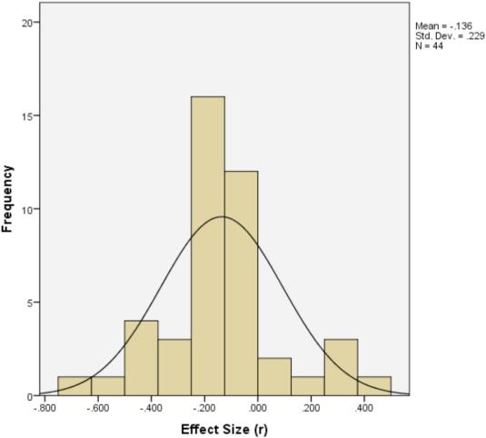

Fig. 2. Distribution of 45 independent effect sizes obtained from 44 studies (M ​= ​-0.14, SD ​= ​0.23).
How do past research on smartphone addiction and academic performance demonstrate the relationship?
Negative effect sizes in this meta-analysis suggest that smartphone addiction has a detrimental impact on academic achievement. An overall study of the relationship between the effects of smartphone addiction on academic performance and all statistically independent effect sizes is shown in Table 1. According to Table 1, the overall mean effect size under the random-effects model was statistically significant, suggesting that smartphone addiction has a detrimental impact on students' academic performance (r = -0.12, p <.001). In addition, the sample as a whole was diverse, with Q (43) = 711.87, p <.001, and I2 = 0.94. Ninety-four percent of the variability was attributable to genuine heterogeneity or between-studies variability. These findings suggest that 94% of the variance might be explained by study-level variables, with sampling error accounting for 6% of the variance.

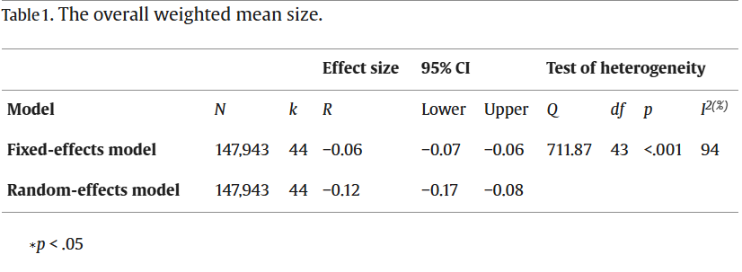
This result shows significant variability in the individual effect sizes that constitute the overall result. Hence, there is a need to conduct moderator analyses to investigate factors responsible for such variability in study characteristics.
What factors moderate the relationship between smartphone addiction and academic performance as demonstrated by past research?
To answer this research question, we examined the possible moderating effects of the following variables: (a) source, (b) region, (c) sampling group, (d) purpose of use, (e) GPA predictor, (f) smartphone construct, (g) test format, and (h) research design, (i) test instrument, and (j) grade level.
Overall, Table 2 shows that smartphone addiction was associated with statistically significant effect sizes. Under the fixed-effect model, there was a statistically significant difference between the weighted mean correlation of the dissertation (r ​= ​−0.26) and journal (r ​= ​−0.06). The between-levels difference was statistically significant, Q_{B} (1) ​= ​27.65, p ​< ​.001, and findings showed that studies from the dissertation produced a statistically significant negative effect that is different and lower than the effect produced with studies from the journal.

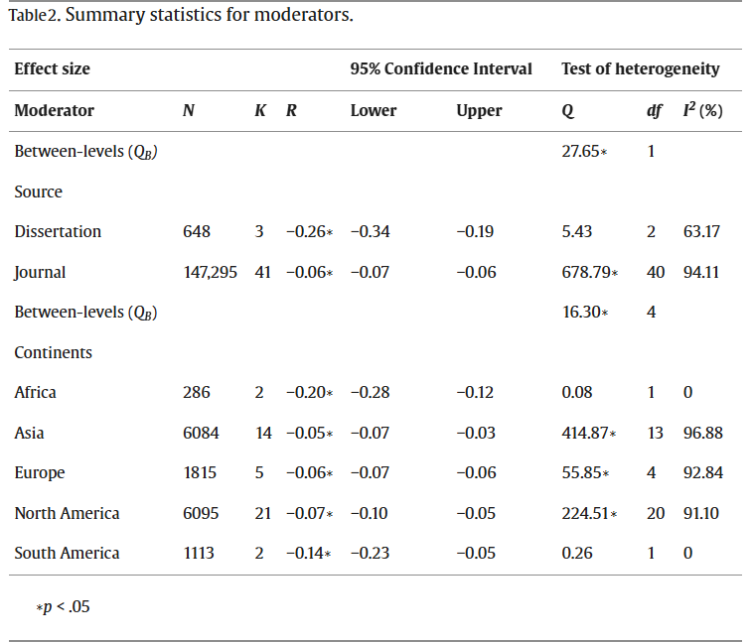
Additionally, smartphone use was linked to significant negative effects across all continents: Africa (r = -0.20), Asia (r = -0.05), Europe (r = -0.06), North America (r = -0.07), and South America (r = -0.14). The results demonstrated that research conducted in Africa produced a statistically significant negative effect that is distinct and lower than the effects produced with studies conducted in Asia, Europe, North America, and South America. The between-levels difference was statistically significant, with QB (4) = 16.30, p <.05.
Table 3 shows the results of the moderator analysis based on grade level. Under the fixed-effects model, the between-level was not statistically significant, Q_{B} (1) ​= ​1.01, p ​> ​.05, indicating no difference between the groups.

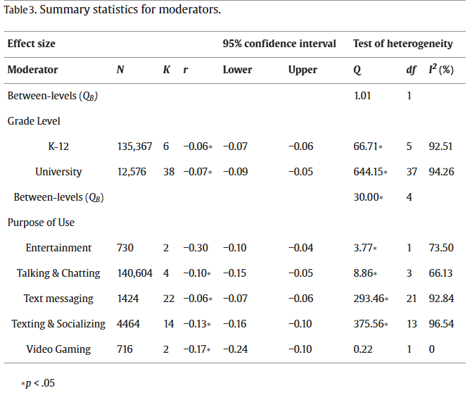
However, there were statistically significant effects regardless of grade level, university students (r ​= ​−0.07) and k-12 students (r ​= ​−0.06).
Table 3 also shows that the weighted mean of entertainment did not produce significant effects under a fixed-effects model. However, talking and chatting, text messaging, texting and socializing, and video gaming produced statistically deleterious effects. The results showed that video gaming induced a higher weighted mean effect (r ​= ​−0.17) than texting and socializing (r ​= ​−0.13), talking and chatting (r ​= ​−0.10), and text messaging (r ​= ​−0.06). The between-levels difference was statistically significant, Q_{B} (4) ​= ​30.00, p ​< ​.001, and findings showed that video gaming produced a statistically significant negative effect that is different and lower than the effects produced with texting and socializing, talking and chatting, and text messaging.
Table 4 demonstrates that smartphone use was linked to significant negative effects independent of GPA predictors. Time spent on smartphone activities (r = -0.10), excessive texting (r = -0.06), multitasking during class (r = -0.16), and excessive smartphone uses (r = -0.06). The between-levels difference was statistically significant, QB (3) ​= ​22.27, p ​> ​.001, indicating that the weighted effect sizes differed significantly between the group. Specifically, multitasking in class was associated with a significant deleterious effect that is significantly different from excessive texting and excessive phone use.

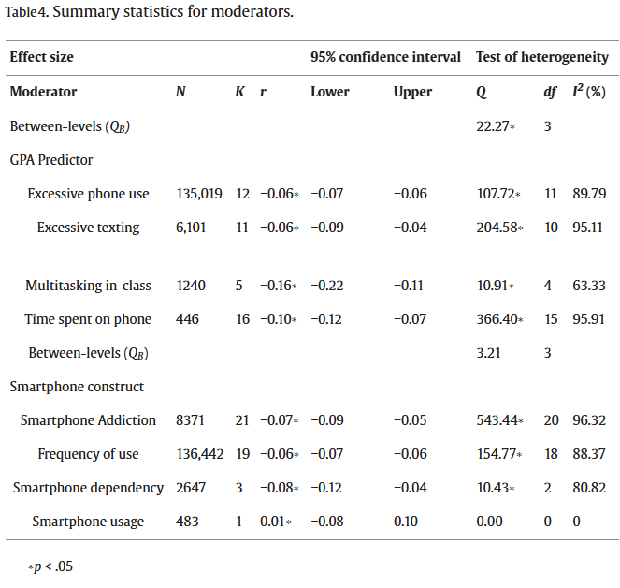
Table 4 also shows that the between-levels difference was not statistically significant, QB (3) ​= ​3.21, p ​> ​.05. There was no difference between the groups, according to the results. Nevertheless, irrespective of smartphone designs, statistically significant impacts were seen. There were statistically significant negative impacts from smartphone dependency (r = -0.07), smartphone addiction/problematic use (r = -0.06), and frequency of use (r = -0.06). Additionally, the weighed mean effects of smartphone use were positive and not statistically significant (r = 0.01; p >.05.
How do the impacts of smartphone addiction change depending on the methodological aspects of previous studies and the parameters of the research design?

Table 5 shows the pattern of effect sizes according to the methodological features of the studies included in this meta-analysis. The study was categorized according to research design, test formats, and test instruments. Under the fixed-effects model, regardless of test format, smartphone use was associated with significant deleterious effects with experiments (r ​= ​−0.03) and surveys (r ​= ​−0.06). However, the between-levels difference was not statistically significant (Q_{B} (1) ​= ​1.68, p ​> ​.05). The results indicate that there was no difference between the group.
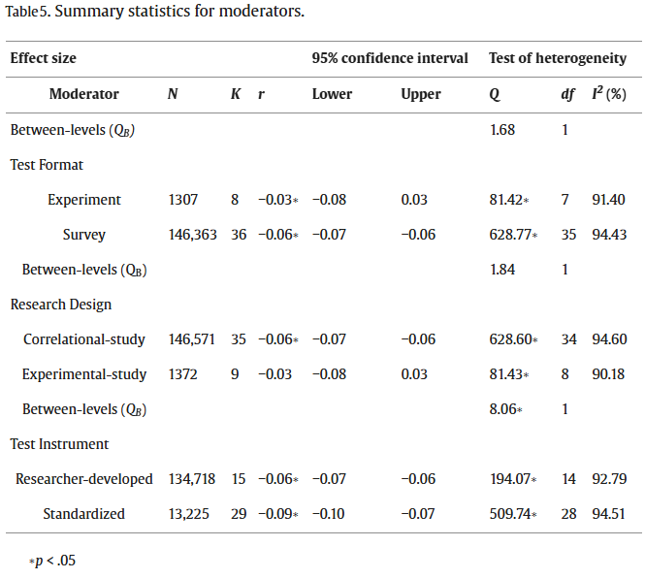
Table 5 also shows that, under the fixed-effects model, only the correlational study produced a statistically significant effect (r ​= ​−0.06). However, the between-levels difference was not statistically significant (Q_{B} (1) ​= ​1.84, p ​> ​.05).
Table 5 shows that regardless of the test instrument, smartphone use was associated with significant deleterious effects, standardized (r ​= ​−0.09) and researcher-developed instrument (r ​= ​−0.06). The between-levels difference was statistically significant, Q_{B} (1) ​= ​8.06, p ​< ​.05, and findings showed that standardized test produced a statistically significant negative effect that is different and lower than the effect produced with the researcher-developed test.
Publication bias
All studies in this meta-analysis that met the selection criteria excluding three studies from the dissertation were published in peer review journals, enhancing the potential for publication bias and restraining the possibility of examining the potential moderating effect of the source of the publication.
Two statistical tests were conducted using Comprehensive Meta-Analysis software to evaluate the potential for publication bias. First, a classic fail-safe N test was conducted to estimate the number of null effect studies that could be added to this meta-analysis before the result becomes invalid. Results showed that 2787 additional studies would be needed to invalidate the overall effect. Second, Egger's linear regression test (Egger, Smith, Schneider, & Minder, 1997) was used to thoroughly investigate the robustness of the classic fail-safe test by examining the unbiased effect sizes and standard errors.
Results of this test further corroborated the result of the fail-safe test, showing the absence of publication bias (p ​> ​.05). Researchers have affirmed that results from meta-analyses are valid and thus resistant to publication bias if the fail-safe N reaches the 5k + 10 limit (Carson, Schriessheim, & Kinicki, 1990; Rosenthal, 1979). Therefore, results from the two computed statistical tests indicate that publication bias does not pose a significant threat to the validity of this meta-analysis since both fail-safe N values are larger than 5k + 10 limit.
Besides, a test of normality was conducted, and the histogram showed a bell-curved shape. Thus, there was evidence of normality in the distribution. Also, no outliers in the study as the z values range from −2.67 to 2.48 (< ±3.3; Tabachnick et al., 2007).

Discussion
How do past research on smartphone addiction and academic performance demonstrate the relationships between smartphone addiction and students’ learning?
Examining how smartphone addiction affects learning and how much it is influenced by factors like (a) source, (b) continents, (c) grade level, (d) purpose of use, (e) smartphone construct, (f) GPA predictor, (g) test format, (h) research design, and (i) test instrument were the goals of this meta-analysis. The results show that learning is negatively impacted by smartphone addiction (r = -0.12). Several research have demonstrated a negative correlation between smartphone addiction and academic performance (Hawi & Samaha, 2016; Junco & Cotton, 2012; Lepp et al., 2014, 2015; Longnecker, 2017; Samaha & Hawi, 2016). The results of this meta-analysis are consistent with those findings. These findings suggest that addicts exhibit a lower capacity for learning.
The results point to two key areas for comprehending how smartphone addiction affects learning: (1) the more a student uses a phone during study sessions, the more detrimental the effect on learning and academic performance; and (2) the findings also imply that excessive and addictive phone use can impair cognitive and other skills that students need for learning and academic success. The current meta-analysis also shows that students may be suffering from smartphone addiction if they struggle to limit their use of smartphones. Implementing several cognitive-behavioral therapies, clinical interventions, and self-care techniques may be necessary to address this condition.

What factors moderate the relationship between smartphone addiction and academic performance as demonstrated by past research?
To identify the moderating factors between smartphone addiction and academic performance, moderator analysis was investigated. The findings indicate that smartphone addiction was statistically moderated by grade levels (K–12 vs. university students), continents (Africa, Asia, Europe, North Africa, and South America), and source (dissertation vs. journal). Additionally, there were statistically significant differences in the GPA predictors (excessive phone use, excessive texting, multitasking in class, and time spent on the phone) and the purpose of use (entertainment, talking & chatting, text messaging, texting & socializing). Nevertheless, there was no statistically significant difference in grades between levels. There is insufficient data to substantiate the idea that students' grade level mitigated the impact of smartphone addiction for this moderator variable. In other words, pupils of all grade levels experienced negative consequences from smartphone addiction.
In answer to the second research question, results showed that all six moderator variables (source, continent, purpose of use, GPA predictors, and smartphone constructs) produced statistically significant effects of smartphone addiction on learning, excluding grade level. For instance, all the constructs measuring the purpose of use as a moderator variable produced negative weighted mean effects on learning except entertainment. These results reveal that sending text messages, talking and chatting, multitasking in-class, and texting and socializing negatively affect students' academic performance. Findings from this meta-analysis align with results from several studies that found negative effects of text messages in the classroom (Dietz & Henrich, 2014; Harman & Sato, 2001; Kuznekoff & Titsworth, 2013; MacDonald, 2013), multitasking in-class (Jacobsen & Forste, 2011; Junco & Cotten, 2012), and socializing (Junco & Cotton, 2012; Lee, 2015; Kirschner & Karpinski, 2010; Rozgonjuk et al., 2018) on students’ academic performance. This result reveals that students need to maintain high levels of attention and self-regulation in their academic pursuits to achieve high academic excellence.
All of the constructs that measured GPA predictor as a moderator variable also demonstrated detrimental effects on academic performance and were statistically significant. Academic performance is predicted by excessive smartphone use, phone time, and excessive texting (Dos, 2014; Felisoni & Godoi, 2018; Junco & Cotton, 2012; King & Dong, 2017; Lepp et al., 2015). According to the findings, students who spend too much time on their phones, neglect their daily routines, use their smartphones excessively, or text excessively on their phones are more likely to see a drop in their GPA.
Given this, distraction has been found to have negative effects on academic performance (Burns & Lohenry, 2010; Junco & Cotton, 2012). In other words, past research found that the more a student excessively uses his/her phone, the greater the potential for an addiction he/she could experience, and the greater the potential for adverse effects on academic success.
How do the effects of smartphone addiction vary with characteristics of research design and methodological features of past research?
This meta-analysis also conducted moderator analysis to examine if the effects of smartphone addiction vary with characteristics of research design and methodological features of the research. The results showed that the test instruments (researcher developed and standardized test) yielded statistically significant differences between groups. This meta-analysis found that both instruments have good validity and reliability in moderating the effects of smartphone addiction on learning. However, the between-level for test format (experiment and survey) and research design (correlational study and experimental study) were not statistically significant. The variation in these results may be associated with the types of research designs in empirical studies.
Limitations and direction for future research
This meta-analysis has several limitations. First, the conceptualization of smartphone addiction was a difficult undertaking in this study. Due to the ubiquity of smartphone use and difficulty measuring differences between non-problematic use, problematic use, and addictive use, there is a need for psychometrics development of standardized tools to measure smartphone addiction.
Second, smartphone constitutes a new technology with significant socio-cultural impacts on daily living. Thus, there is limited availability of prior research to explore the effects of smartphone addiction on academic performance. This may have impacted the number of studies available for this meta-analysis. More research is needed to focus attention on the consequences and implications of smartphone use on students’ academic performance while providing intervention strategies to ameliorate the negative impacts experienced.
Despite these limitations, several recommendations can be made based on the findings of this meta-analysis. Findings suggest that if smartphone use could be controlled in school settings, it may significantly improve students’ academic performance. For instance, experimental studies included in this meta-analysis revealed that students who did not use smartphones in the classroom outperformed students that used their smartphone in the classroom (Dietz & Henrich, 2014; Froeze, 2012a, 2012b; Gingerich & Lineweaver, 2013; Mendoza, 2018a, 2018b).
Based on the findings of this meta-analysis, we recommend that educators consider adopting a policy that will help reduce students' use of smartphones in school settings. The present meta-analysis offers some practical suggestions for students, instructors, or educators. Instructors can include the smartphone rules in their syllabi and inform their students of the adverse effect of smartphone addiction on learning by drawing on this study's findings and extant literature. By so doing, students become aware of the potential negative consequences of their actions.
In addition, educators can provide good strategies by which people can learn through the use of smartphones. Healthy use of smartphones should be encouraged in all educational settings, including minimizing smartphone use because healthy use of smartphones adds to life while smartphone addictions take away from life (Griffiths, 2005).
Educators may carefully consider implementing a policy to reduce the number of hours spent on smartphones for elementary, middle, and high school students. This policy will help to discourage or minimize heavy use of smartphones, especially among elementary students. Specifically, it is recommended that infants under 1 year old should not be exposed to electronic screens. Children under five years old are to limit or eliminate screen use to 1 ​h per day of high-quality programming with their parents watching and helping the children understand what they are watching (World Health Organization, 2019). This recommendation will improve the children's mental health and well-being and help prevent health-related diseases that may occur later in life.
Future research should explore smartphone addiction, the resulting mental health concerns, and academic impacts with implications for teaching and learning practices and educational policy development.

Conclusion
The findings from this study advance understanding of the negative effects of smartphone addiction on learning. The results of this meta-analysis showed that smartphone addiction has negative effects on students’ academic performance. When students spend time on their phones to the extent of neglecting their practices of daily life, engaging in excessive smartphone use, or excessively texting on their phones, there is a tendency to develop behavioral addiction to smartphone use, thereby experiencing a decline in academic performance. Given this, active engagement in exercising control and minimal smartphone use may be beneficial for student learning and academic performance.
In sum, based on the results of this meta-analysis, we suggest that education policies, teacher training, cognitive-behavioral interventions, the development of specific teaching and learning practices that address harm reduction and addiction in smartphone use could help students maximize study time and enhance learning effectively.

Conflict of interest statement
We maintain that none of the authors of this paper have a financial obligation or personal relationship with any person(s) or organizations that could inappropriately influence/bias the content of the paper. We do not receive funding from any person(s) or organization to carry out this research.
Given this, we specifically state that “No Competing interests are at stake and there is No Conflict of Interest” with any person(s) or organizations that could inappropriately influence/bias the content of the paper.

Reference
Adesope, O. O., Lavin, T., Thompson, T., & Ungerleider, C. (2010). A systematic review and meta-analysis of the cognitive correlates of bilingualism. Review of Educational Research, 80(2), 207–245. https://doi.org/10.3102/0034654310368803
American Psychiatric Association. (2013). Diagnostic and statistical manual of mental disorders (DSM-5) (5th ed.). Washington, DC: American Psychiatric Association Publishing. https://doi.org/10.1007/s11019-013-9529-6
Baert, S., Vujic, S., Amez, S., Claeskens, M., Daman, T., Maeckelberghe, A., & De Marez, L. (2020). Smartphone use and academic performance: Correlation or causal relationship? Kyklos, 73(1), 22–46. Bianchi, A., & Phillips, J. G. (2005). Psychological predictors of problem mobile phone use. CyberPsychology and Behavior, 8(1), 39–51. https://doi.org/10.1089/ cpb.2005.8.39
Billieux, J., Maurage, P., Lopez-Fernandez, O., Kuss, D. J., & Griffiths, M. D. (2015). Can disordered mobile phone use be considered a behavioral addiction? An update on current evidence and a comprehensive model for future research. Current Addiction Reports, 2(2), 156–162. https://doi.org/10.1007/s40429-015-0054-y
Billieux, J., Van der Linden, M., d'Acremont, M., Ceschi, G., & Zermatten, A. (2007). Does impulsivity relate to perceived dependence on and actual use of the mobile phone? Applied Cognitive Psychology, 21(4), 527–537. https://doi.org/10.1002/acp.1289
Blake, H. (2008). Innovation in practice: Mobile phone technology in patient care. British Journal of Community Nursing, 13(4), 160–165. https://doi.org/10.12968/
bjcn.2008.13.4.29024 Borenstein, M., Hedges, L. V., Higgins, J. P. T., & Rothstein, H. R. (2009). Introduction to meta-analysis. Chichester, England: Wiley. https://doi.org/10.1111/j.1751 5823.2009.00095.x
Brunborg, G. S., Mentzoni, R. A., Molde, H., Myrseth, H., Skouverøe, K. J. M., Bjorvatn, B., et al. (2011). The relationship between media use in the bedroom, sleep habits and symptoms of insomnia. Journal of Sleep Research, 20(4), 569–575. https://doi.org/10.1111/j.1365-2869.2011.00913.x
Bugeja, M. J. (2007). Distractions in the wireless classroom. The Chronicle of Higher Education, 53(21), C1–C4.
Burns, S. M., & Lohenry, K. (2010). Cellular phone use in class: Implications for teaching and learning a pilot study. College Student Journal, 44(3), 805–810. Campbell, S. W. (2006). Perceptions of mobile phones in college classrooms: Ringing, cheating, and classroom policies. Communication Education, 55(3), 280–294. https:// doi.org/10.1080/03634520600748573
Carson, K. P., Schriesheim, C. A., & Kinicki, A. J. (1990). The usefulness of the “fail-safe” statistic (N) in the meta-analysis. Educational and Psychological Measurement, 50, 233243. https://doi.org/10.1177/0013164490502001
Chen, J., Liang, Y., Mai, C., Zhong, X., & Qu, C. (2016). General deficit in inhibitory control of excessive smartphone users: Evidence from an event-related potential study. Frontiers in Psychology, 7, 511. https://doi.org/10.3389/fpsyg.2016.00511
Cooper, H. M., Hedges, L. V., & Valentine, J. (Eds.). (2009). The handbook of research synthesis and meta-analysis (2nd ed.). New York, NY: Russell Sage Foundation. Demirci, K., Akg€ onül, M., & Akpinar, A. (2015). Relationship of smartphone use severity with sleep quality, depression, and anxiety in university students. J. Behav. Addict, 4(2), 85–92. https://doi.org/10.1556/2006.4.2015.010 Dietz, S., & Henrich, C. (2014).
Texting as a distraction to learning in college students. Computers. In Human Behavior, 36, 163–167. https://doi.org/10.1016/ j.chb.2014.03.045 Dos, B. (2014).
The relationship between mobile phone use, metacognitive awareness and academic achievement. European Journal of Educational Research, 3(4), 192–200. https://doi.org/10.12973/eu-jer.3.4.192 Durak, H. Y. (2018).
Investigation of nomophobia and smartphone addiction predictors among adolescents in Turkey: Demographic variables and academic performance. The Social Science Journal, 56(4), 492–517. https://doi.org/10.1016/ j.soscij.2018.09.003
Eduardo, P. P., Teresa, M., Monje, R., Maria, J., Sanchez, R., & Leon, D. (2012). Mobile phone abuse or addiction. A review of the literature. Adicciones, 24(2).
Egger, M., Smith, G. D., Schneider, M., & Minder, C. (1997). Bias in meta-analysis detected by a simple graphical test. BMJ, 315(7109), 629–634. https://doi.org/ 10.1136/bmj.315.7109.629
Ellis, Y., Daniels, B., & Jauregui, A. (2011). The effect of multitasking on the grade performance of business students. Research in Higher Education Journal,1–10. Felisoni, D. D., & Godoi, A. S. (2018). Cell phone usage and academic performance: An experiment. Computers & Education, 117, 175–187.
Fjeldsoe, B. S., Marshall, A. L., & Miller, Y. D. (2009). Behavior change interventions delivered by mobile telephone short-message service. American Journal of Preventive Medicine, 36(2), 165–173. https://doi.org/10.1016/j.amepre.2008.09.040
Froese, A. D., Carpenter, C. N., Inman, D. A., Schooley, J. R., Barnes, R. B., Brecht, P. W., et al. (2012). Effects of classrooms cell phone use on expected and actual learning. College Student Journal, 46(2), 323–333. Geser, H. (2004). Towards A sociological theory of the mobile phone. Retrieved July12, 2005, (From). Grant, J. E., Lust, K., & Chamberlain, S. R. (2019). Problematic smartphone use associated with greater alcohol consumption, mental health issues, poorer academic performance, and impulsivity. Journal of behavioral addictions, 8(2), 335–342. https://doi.org/10.1556/2006.8.2019.32
Griffiths, M. D. (1999). Gambling technologies: Prospects for problem gambling. Journal of Gambling Studies, 15(3), 265–283. https://doi.org/10.1023/A:1023053630588
Griffiths, M. D. (2000). Internet addiction- time to be taken seriously? Addiction Research, 8, 413–418. https://doi.org/10.3109/16066350009005587
Griffiths, M. D. (2005). A ‘components’ model of addiction within a biopsychosocial framework. Journal of Substance Use, 10, 191–197. https://doi.org/10.1080/ 14659890500114359
Harman, B. A., & Seto, T. (2011). Cell phone use and grade point average among undergraduate university students. College Student Journal, 45(3), 544–550. Hawi, N. S., & Samaha, M. (2016). To excel or not to excel: Strong evidence on the adverse effect of smartphone addiction on academic performance. Computers & Education, 98,81–89. https://doi.org/10.1016/j.compedu.2016.03.007
Im, I. C., & Jang, K. (2017). The Convergence Influence of excessive smartphone use on attention deficit, learning environment, and academic procrastination in health college students. Journal of the Korea Convergence Society, 8(12), 129–137.
Jacobsen, W., & Forste, R. (2011). The wired generation: Academic and social outcomes of electronic media use among university students. Cyberpsychology, Behavior, and Social Networking, 14(5), 275–280. https://doi.org/10.1089/cyber.2010.0135
Junco, R., & Cotton, S. (2011). Perceived academic effects of instant messaging use. Computers & Education, 56, 370–378. https://doi.org/10.1016/
j.compedu.2010.08.020 Junco, R., & Cotton, S. (2012). No A 4 U: The relationship between multitasking and academic performance. Computers & Education, 59(2), 505–514. https://doi.org/ 10.1016/j.compedu.2011.12.023 Kim, S., & Byrne, S. (2011).
Conceptualizing personal web usage in work contexts: A preliminary framework. Computers in Human Behavior, 27, 2271–2283. https:// doi.org/10.1016/j.chb.2011.07.006
Kim, M. H., Min, S., Ahn, J. S., An, C., & Lee, J. (2019). Association between high adolescent smartphone use and academic impairment, conflicts with family members or friends, and suicide attempts. PloS One, 14(7), Article e0219831. https://doi.org/ 10.1371/journal.pone.0219831
King, R. C., & Dong, S. (2017). The impact of smartphone on young adults. The Business& Mangement Review, 8(4), 342. Kirschner, P. A., & Karpinski, A. C. (2010). Facebook and academic performance. Computers In Human Behavior, 26, 1237–1245. https://doi.org/10.1016/ j.chb.2010.03.024
Kuznekoff, J. H., & Titsworth, S. (2013). The impact of mobile phone usage on student learning. Communication Education, 62(3), 233–252. https://doi.org/10.1080/ 03634523.2013.767917
Lau, W. W. F. (2017). Effects of social media usage and social media multitasking on the academic performance of university students. Computers in Human Behavior, 68, 286–291. https://doi.org/10.1016/j.chb.2016.11.043 Lee, E. B. (2014).
Facebook use and texting among African American and Hispanic teenagers: An implication for academic performance. Journal of Black Studies, 45, 83–101. https://doi.org/10.1177/0021934713519819
Lee, J., Cho, B., Kim, Y., & Noh, J. (2015). Smartphone addiction in university students and its implication for learning. In G. Chen, V. Kinshuk, R. Huang, & S. C. Kong (Eds.) (p. 297). Heidelberg: Springer. https://doi.org/10.1007/978-3-662-44188-6_40.
Emerging issues in smart learning. Lee, H. K., Kim, J. H., Fava, M., Mischoulon, D., Park, J. H., Shim, E. J., et al. (2017). Development and validation study of the smartphone Overuse Screening questionnaire. Psychiatry Research, 257, 352–357. https://doi.org/10.1016/ j.psychres.2017.07.074 Lepp, A., Barkley, J. E., & Karpinski, A. C. (2014). The relationship between cell phone use, academic performance, anxiety, and satisfaction with life in college students. Computers in Human Behavior, 31(1), 343–350. https://doi.org/10.1016/ j.chb.2013.10.049
Lepp, A., Barkley, J. E., & Karpinski, A. C. (2015). The relationship cell phone use and academic performance in a sample of U.S. college students. SAGE open, 5(1), 1–9. https://doi.org/10.1177/2158244015573169
Li, J., Lepp, A., & Barkley, J. E. (2015). Locus of control and cell phone use: Implication for sleep quality, academic performance, and subjective well-being. Computers in Human Behavior, 52, 450–457. https://doi.org/10.1016/j.chb.2015.06.021
Lin, Y., Liu, Y., Fan, W., Tuunainen, V. K., & Deng, S. (2021). Revisiting the relationship between smartphone use and academic performance: A large-scale study. Computers in Human Behavior, 122, 106835. https://doi.org/10.1016/j.chb.2021.106835

