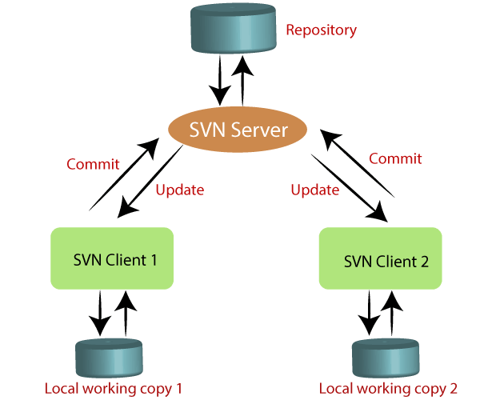

Microsoft – team center / Foundation

Svn – free – center

Gits – de-ceterialise

<https://git-scm.com/>

to install

<https://youtu.be/4xqVv2lTo40>