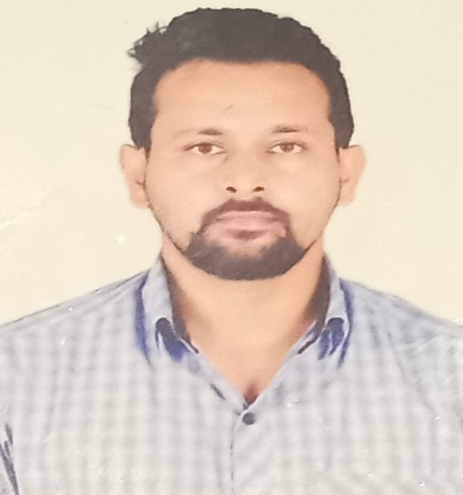

**Career Objective**

To seek a position that offers opportunity to explore my qualification, experience and skills in the area of Pharmacovigilance, in such organizations that provides a work environment that foster teamwork and allows independent responsibilities.

**Summary of Experience**

* Pharmacovigilance professional, with 5.4 years of industry experience in ICSR.
* Performed case management including duplicate check, seriousness, expectedness, data entry, narratives, follow up and QC.
* Proficient in using MedDRA and WHO drug dictionary.
* Performing quality check of adverse events, serious adverse events based on approved case processing metrics.
* Proficient in Microsoft Word, Excel and PowerPoint.
* Ability to work independently and also as a team player.
* Effective verbal and written communication skills and able to meet strict project deadlines and guidelines.

**Organization:** Qinecsa (Mysore). 21-Dec-2019 to present

**Designation:** Drug Safety Associate II

**Responsibilities**

* Perform QC review of all processed cases, prioritizing QC review of serious cases in safety database.
* Check all fields against source information.
* Error/discrepancy correction.
* Narrative consistency check in line with source information and structured fields.
* Provide quality feedback to team resources and maintaining quality metrics.
* Identify and resolve case issues, coordinate with client therapeutic teams/site for specific products or functional groups.
* Conduct Quality Awareness sessions and initiation.
* Assisting case processing team in case of high volume of cases to manage workload.
* Mentor and guide the new associates for processing of live cases.
* Conducting refresher trainings regarding updates in conventions and guidelines.
* Conducting monthly assessments for the entire team.
* Workflow handling and prioritization of cases as per the timelines.
* Train and mentor new team members as per the requirements of the project.
* Workflow mailbox handling and acknowledging client mails and prioritizing accordingly.

**Organization:** IQVIA (Bengaluru). 11-Dec-2017 to 29-Aug-2018

**Designation:** Safety Associate Trainee

**Responsibilities**

* Experienced in Sceptre database operations, excels in identifying and managing duplicate/invalid Individual Case Safety Reports (ICSR) in compliance with Standard Operating Procedures (SOPs).
* This professional demonstrates comprehensive knowledge of product quality complaints, labelling, and conducts causality assessments for adverse events, while also actively engaging in Quality Control for various case categories. With a strong focus on adherence to regulations and timelines, they skillfully review, triage, and process adverse event reports, ensuring thorough assessments of seriousness, validity, causality, and expectedness.

**Achievements and Recognition**

* I was promoted as a quality reviewer within 5 months from the date of production due to excellent quality and productivity.
* Received special recognition as the star performer for 4 times.
* I was selected for Meghalaya’s U-19 cricket team and have won numerous trophies and medals in cricket, carom and badminton.

**Academic Credentials**

* M.Pharm (Pharmaceutics) **-** Passed out in 2017 from PES College of Pharmacy, Bangalore-560050. Affiliated to Rajiv Gandhi University of Health Sciences, Karnataka.
* B.Pharm – Passed out in 2015 from Himalayan pharmacy institute, Majhitar, Rangpo, East Sikkim, 737136.
* D.Pharm – Passed out in 2012 from Himalayan pharmacy institute, Majhitar, Rangpo, East Sikkim, 737136.
* Intermediate Board of Examination – Passed out in 2010 with 52% at Don Bosco College, Tura, Meghalaya, 794001.
* Secondary School Certificate (SSC) - Secured 68 % at Embee Rose Bud School, Tura, Meghalaya, 794001.

**Personal Skills**

* Positive Attitude, Determined.
* Hard Working and Sincere.
* Patience, flexible and easily adopt into new environment and cultures.

**Declaration**

I hereby declare that the above information furnished is true to the best of my knowledge and belief.

Sibu Karmakar