<https://github.com/mirzaevinom/promise12_segmentation>

1. Rewrote the best performing model codes to latest TensorFlow framework (2.1) to predict the mask. This is done to
   1. Take advantage of latest features
2. Increased Network Layers and Changed hyperparameters
3. K-Fold Validation was performed and compared their dice coefficients to select the best Performing model
4. For 3-Fold – it took one week on 1080Ti  
     
   A picture containing clock

   Description automatically generated
5. Built a UI Application to test the model and show the inference as below
   1. To take in a 3D MRI Image and display multiple segmented images with Cancer and Non-Cancer region - Marked in Red and Yellow Respectively
   2. Lab assistants can help to validate the results
   3. Non-Cancer region or the Mask in Yellow is generated by resizing the predicted cancer region mask and superimposing it on the original MRI Image in a different color.
   4. It is challenging otherwise to manually segment masks of the cancer region which is present in different shapes and sizes
   5. Results – Dice Index

<https://github.com/tianbaochou/NasUnet>

1. Accuracy was 68% on Test data – Not Good enough

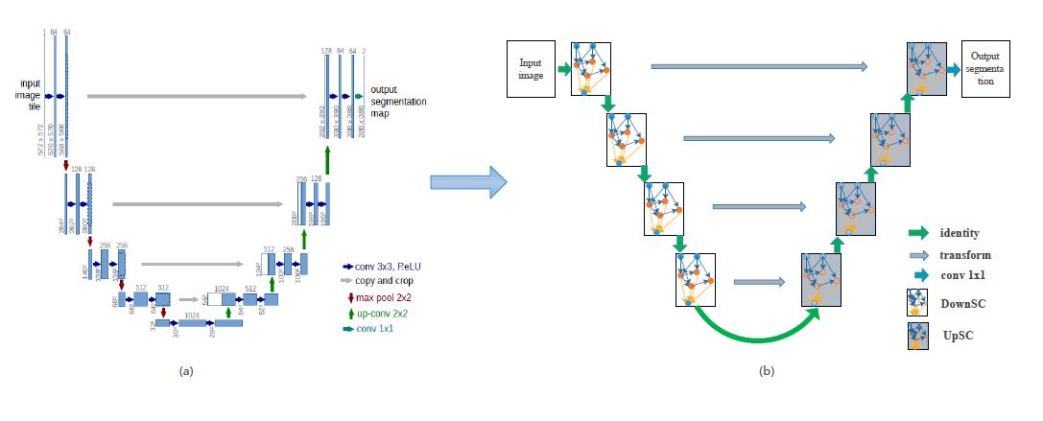

<https://github.com/Yeening/Attn-Unet-Prostate-Segmentation>

1. K-Fold Validation was performed and compared their dice coefficients to select the best Performing model. For 3 Fold – it took one week on 1080Ti
2. Not as good as 3D U Net with CNN & residual network
3. Results to be described  
     
   A close up of a logo

   Description automatically generated

<https://github.com/black0017/MICCAI-2019-Prostate-Cancer-segmentation-challenge>

1. Images – JPG as apposed to 3D MRI [Individual Slices]
2. Generate Labels – by voting
3. U-Net Architecture [Training time is quite high] and
4. Results to be described