Inter-subject Motor Imagery classification using Artificial Neural Networks

Bharat Nagaraju (A0178258N), Chan Su-Wen Philemon (A0110588E), and Vignesh Ram Andiappan Selvaraj (A0178215A)

*Abstract*—The use of artificial neural networks for electroencephalogram (EEG) signal classification, specifically for the case of motor imagery, has proliferated in recent years. This trend arose from the development of graphics processing units (GPUs) that enable faster computation time for neural networks to classify EEG signals. This study presents different methods of classifying EEG signals via shallow convolutional neural network (CNN), long short-term memory convolutional neural network and capsule network. The artificial neural networks were tested on the Grasp-and-Lift WAY-EEG-GAL Detection dataset and the results show that the Capsule Network, amongst all models tested achieved the highest accuracy of 97.58% and an AUC of 0.978 after 1 training epoch.

Keywords-EEG signal; CapsNet; CNN network; CNN-LSTM network; Motor Imagery;

# INTRODUCTION

**T**he capability to classify electroencephalogram (EEG) signals from motor imagery (MI) for brain-computer interfaces (BCI) is crucial for developing applications in helping Amyotrophic Lateral Sclerosis (ALS) patients express themselves or regain control [1]. With the advent of neural networks and better computing resources, the classification of EEG signals has become less dependent on trained human professionals [2]. Deep learning algorithms have demonstrated to supersede other machine learning methods in yielding high classification accuracies [3]. In these deep learning approaches, the EEG data is converted to an image (2-dimensional array input) where each EEG channel is represented as an pixel of an image [4,5].

In this study, a few deep learning methods such as convolutional neural network (CNN), long short-term memory (LSTM) and capsule network were used to classify motor imagery EEG data. The EEG data was obtained from WAY consortium’s Grasp-and-Lift EEG Detection Challenge hosted on Kaggle, an online platform for competitive data science. The Capsule network achieved an AUC of 0.978 after 1 training epoch. The winning solution reported a n AUC of 0.981 using recurrent neural network [6].

# Related work

Researchers have used non-deep learning approaches to classify motor imagery such as Filter Bank Common Spatial Pattern (FBCSP) and have been used as a standard for MI classification [7]. In this method, the EEG signal is separated into 9 bands, ranging from 4-40 Hz at frequency bands of 4Hz. The common spatial pattern (CSP) then determines best spatial filter to correlate the two datasets (one from each motor imagery class). The CSP algorithm works for only two classes of EEG signal (i.e. right- and left-hand motor imagery or right and idle motor imagery). A Naïve Bayesian Parzen Window (NBPW) classifier is then used to classify the EEG trial after application of spatial filters on the different frequency bands [7]. However, FBCSP methods can be superseded with deep learning approaches (e.g. CNN) [4].

In order to accommodate multiclass classification, deep learning approaches can be used. Elman recurrent neural networks (ERNNs) have been used to classify EEG signals able-bodied and subject with spinal cord injury to a classification accuracy of 93.3% [8]. An extension to the recurrent neural network is the long short-term memory (LSTM) networks which achieved classification accuracies of for BCI Competition IV Dataset and GigaDB dataset are 96.91% and 97.93% respectively [9] A separate study using LSTM with dropout and gated recurrent unit (GRU) achieved accuracies of 87.98% and 88.60% respectively [10].

Another study utilized a sequence of Morlet wavelet transform, fast Fourier transform and multilayer backpropagation neural network (MLNN) to classify left from right hand motor imagery with accuracy spanning 97.7% to 100% [11]. Apart from RNNs and MLNNs, convolutional neural networks (CNNs) are one of the most common deep learning techniques on applied 2-dimensional EEG data to classify EEG signals.

1-dimensional CNNs have been used to classify abnormal EEG signals with an accuracy of 78.71% [12]. CNN model with scaled exponential linear unit (SELU) had best mean accuracy of 92.73% while CNN(ReLU) and CNN(ELU) achieved a mean accuracy of 86.74% and 88.92% respectively [13]. When CNN model was compared with FBCSP, the accuracy of decoding was 2.8% better using CNN [14]. As such, this study used 1D CNNs as a baseline model from which other models are benchmarked against.

Apart from CNNs and RNNs, capsule network (CapsNet) has been tested on BCI competition IV dataset 2b yielded a mean accuracy of 78.44% across 9 subjects but has yet to be tested on the WAY-EEG-GAL dataset.

# About the data

There a total of 12 subjects, 10 series of trials for each subject and about 30 trials for each series. The number of trials varies for every series and the training set contains the first 8 series for each subject while the test set comprises 9th and 10th series.

For each grasp-and-lift action, the subject goes through the following 6 events:

### HandStart

### FirstDigitTouch

### BothStartLoadPhase

### LiftOff

### Replace

### BothReleased

These 6 events occur in sequence and within the training set, each subject and series combination have two files. The events file for the test set are not given as they must be predicted as part of the WAY-EEG-GAL dataset Kaggle Competition. The events file contain six label columns with each having a value of zero or one, depending on whether the corresponding event has occurred within ±150ms (±75frames).

The dataset is collected via the placement of electrodes on the subject’s scalp and is connected to a digital EEG amplifier such as the following:

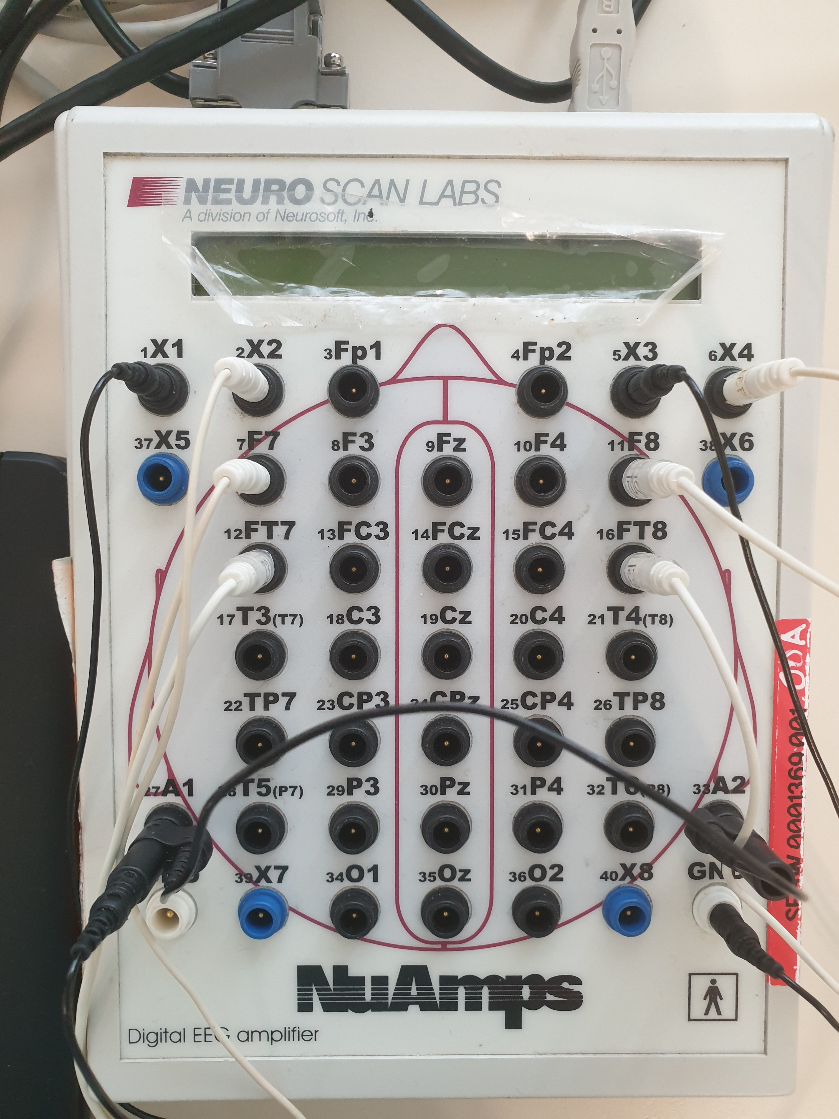

Fig. 1. Digital EEG amplifier showing position of electrodes on the scalp

The spatial relationship between the electrodes is captured in Figure 1. There are various challenges associated with collecting data. First, EEG patterns are inconsistent due to a varying level of subject’s awareness and mental state. Second, the placement of electrodes on the subject’s scalp may vary from day-to-day and person-to-person. Third, the proximity of electrodes on the person’s scalp may short circuit each other. Finally, signals of patients with neuro degenerative disorder or ALS may have brain signals that deteriorates over time or not accurately imagining the right movement hence resulting in misclassification of EEG signals.

# Methods

One of the datasets used for this study is the WAY-EEG-GAL dataset which consists of a total of 3,936 grasp and lift trials. In each trial, the subject was tasked to grasp a small object with two fingers (index fingers and thumb), lift the object up for a few seconds and lower the object back onto the surface.

This study experimented with various approaches to see which model works best on the EEG data. The approaches differ mainly in the machine learning algorithms used at different phases.

## Convolutional Neural Network Model

As part of this study, a shallow CNN architecture known as ShallowNet was developed that could decode raw EEG signals without hand-crafting the features. When the CNN parameters such as normalization and activation function varied, the classification performance of the CNN changed and was measured.

The architecture of the ShallowNet consists of two main blocks. The first block comprises temporal and spatial convolution layers. For the temporal convolution layer, a 3-dimensional kernel is used. In the second block, max pooling and classification using ReLU function, which prevented overfitting and noise, was implemented sequentially.

(1)

After doing several runs and optimization a 3-layer 1D CNN was decided as the number of layers for the model to be built. Max Pooling was used in the CNN model over average pooling for the following reason. First, max pooling extracts the key features such as edges from images, while average pooling smoothens out sharp edges. Hence max pooling is better at extracting good features. To further improve their performance, dropout is applied to the model. The model was then trained for about 5100 iterations beyond which no significant learning occurred. An architecture of the CNN model was implemented as follows.

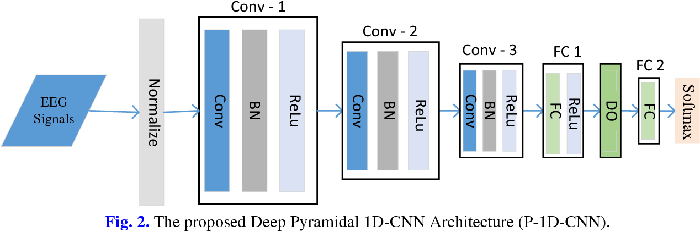

Fig. 2. 1D-CNN Architecture

## Long Short-Term Memory (LSTM)

Long Short-Term Memory Networks (LSTMs) are a special type of Recurrent Neural Network (RNN) that addresses the issue of short-term memory in RNNs. Long sequences can be hard to learn for standard RNN because it is trained through time-based backpropagation (BPTT) which results in the problem of vanishing gradients or exploding gradients. RNNs tend to ‘forget’ what it has learned in longer sequences and thus an LSTM is better suited for such cases. In LSTM, the gated cell is used to replace the RNN cell. The gates keep track of which information in memory must be remembered or forgotten. The key to LSTM is the state of the cell. The LSTM can add or remove information to the cell state via 3 gate types – forget, input and output gate.

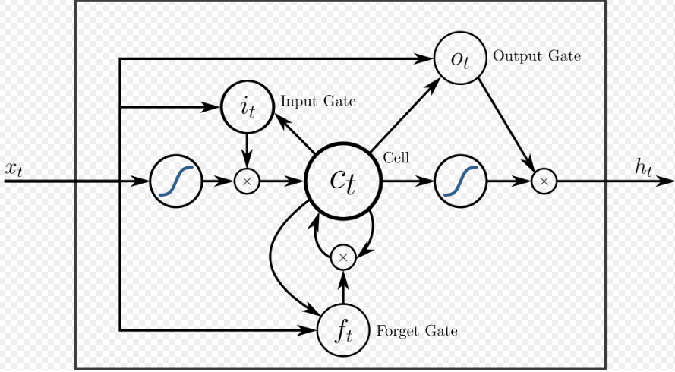

Fig. 3. LSTM Cell Diagram

First, input is passed into the forget gate along with information from the previous state, and the gate determines what information to keep or forget.

) (2)

First, the input gate decides which input value should be used to alter the memory. It takes in the previous hidden state and the current input into a sigmoid function in (2). At the same time, the hidden state and current input are passed into the tanh function.

) (3)

) (4)

Third, the output gate governs the next hidden state. The hidden state is used for predictions. The hidden state is combined with the current input and passed into a sigmoid function. Once the cell state is modified, it is passed into the tanh function. This is then multiplied with the sigmoid function’s output. The output is the new hidden and cell state.

) (5)

) (6)

## Long Short-Term Memory and CNN (CNN-LSTM)

Although CNN has great success in image classification and computer vision, it has some shortcomings. First, CNNs are not invariant to tilting or rotation. The models need to be retrained with the same samples in rotated positions for the model to perform better. Second, CNNs do not capture the core spatial relationships between image features. CNN can learn the features of an image but not the location of and relationship of the objects in the image. In EEG classification, the signals vary over time for each subject and vary from subject to subject. A model that can capture the temporal relationship between features will perform better than CNN model. The model that performs better than CNN is the long short-term memory (LSTM) model.

By considering the advantages of both the CNN and LSTM, the team decided to build a hybrid architecture consisting of two blocks. The CNN as the first block and the LSTM as the second block. The CNN block is used to deriving all important EEG image features. The LSTM block is used to capture the time series nature of the EEG data.

## Capsule Network

The final model that was experimented with is the hybrid CNN and Capsule network model. Before explaining the concept of a hybrid model, this paper aims to explain the concept behind capsule networks. Capsule networks solve the problem by introducing neuron groups that store spatial information. A capsule is a group of neurons where the activity vector acts as an instantiation parameter of a particular entity. The length of the output vector of the capsule is the probability that the entity, that constitutes the capsule, that exists in current input. The short vectors are reduced to near zero length and long vectors get reduced to length below 1.

(7)

In (7), the vector output is of capsule j and is the total input. For a capsule that is not in the first layer, the total input to is given by the following

(8)

And the vector is given by the following

(9)

In (8) and (9), are the prediction vectors from the capsules in the layer before. These values are calculated by multiplying the weight matrix by the output . To better illustrate the inputs and outputs in a capsule, a diagram is shown below.

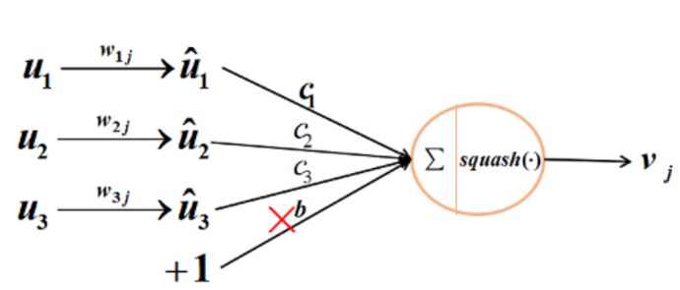

Fig. 4. Capsule Diagram

By considering the strengths of the capsule network in capturing spatial information, the study used a combination of CapsNet with CNN in a hybrid fashion. For the first block of the hybrid model, a 2D CNN is used which had a 3x3 kernel size with a stride of 2. The activation function was ReLU. The output of the CNN was passed to the primary CapsNet layer consisting of 256 channels with 6 capsules. In this primary capsule layer, the capsule layer has 4 convolutional kernels of size 3 x 3 with a stride of 2.

## Comparison of Model Complexity

The number of trainable parameters for the 3 models – CNN, CNN+LSTM and Capsule network are represented in the following table:

|  |  |
| --- | --- |
| Model | Parameters |
| CNN + CapsNet | 71,369,216 |
| 1D-CNN + LSTM | 49,408 for LSTM layer |
| 1D-CNN | 2,016,618 |

Table 1. Number of trainable parameters for each neural network model

In terms of model complexity, the Capsule Network has the greatest number of trainable parameters which means that it is the most computationally intensive model. Despite this, the network produces the best classification accuracy due to the network’s ability to capture the spatial relationship of EEG channels on the subject’s scalp.

# Results

Of all the models tested, the hybrid CNN and Capsule Network performed the best with 97.58% accuracy. The results from 4 deep learning models were tabulated as follows.

|  |  |
| --- | --- |
| Model | Accuracy |
| CNN + CapsNet | 97.58 |
| 1D-CNN + LSTM | 96.74 |
| 1D-CNN + LSTM (K-Fold CV) | 87.76 |
| 1D-CNN | 87.70 |

Table 2. Accuracy of each neural network model

The following are the Receiver Operating Characteristic (ROC) curves for an event type for each neural network model:

## CNN + CapsNet Sequence Model

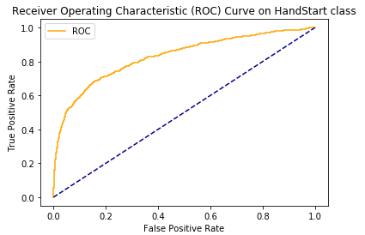

Fig. 5. ROC Curve of CNN + CapsNet Sequence Model

## 1D-CNN + LSTM Sequence Model

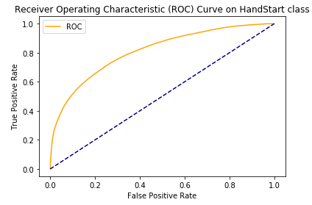

Fig. 6. ROC Curve of 1D-CNN + LSTM Sequence Model

## Base CNN Model

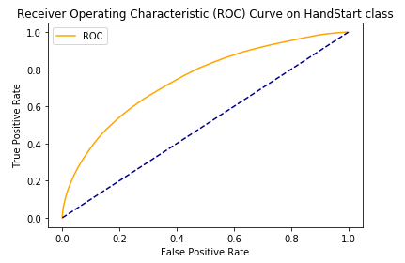

Fig. 7. ROC Curve of Base CNN Model

# conclusion

Based on the results of this study, one can build a robust Capsule network model for EEG signal classification. Using Pytorch multi-GPU, the training of neural networks can be parallelize leading to shorter training time. Since the network itself is more complex than a CNN model, the CapsNet model required at 32 Gb RAM and two NVIDIA 1080 Ti cards to train the network. The Global benchmark for this challenge is 0.983 AUC. However, the accuracy is not known. This study’s test accuracy of 97.58% has exceeded the accuracy achieved by other neural networks.

For other researches to reproduce the results from the models in this research, a dockerized Flask web application containing this research’s Pytorch model (e.g. CNN+LSTM model) was created which can be deployed and hosted on the public Cloud to enable scientists to upload their test data and test it against the model in this paper.

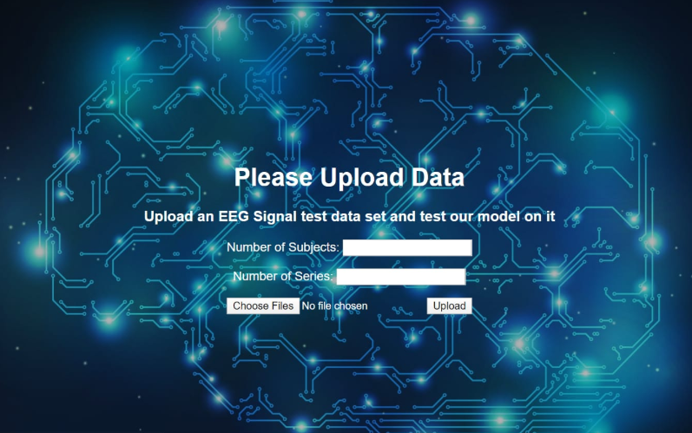

Fig. 8. Deployed Pytorch Model running behind Web User interface

Acknowledgment

The team of this research would like to thank Dr. Yang Tao, mentor from A*STAR Institute of Infocomm Research, for his guidance and patience in explaining the problem statement and research direction to us. The team would also like to thank our project mentor from National University of Singapore - Institute of Systems Science for is advice throughout the course of the project.

References

1. T. Yang, K. K. Ang, K. S. Phua, J. Yu, V. Toh, W. H. Ng, and R. Q. So, “EEG Channel Selection Based on Correlation Coefficient for Motor Imagery Classification: A Study on Healthy Subjects and ALS Patient,” *2018 40th Annual International Conference of the IEEE Engineering in Medicine and Biology Society (EMBC)*, 2018.
2. A. Craik, Y. He, and J. L. Contreras-Vidal, “Deep learning for electroencephalogram (EEG) classification tasks: a review,” *Journal of Neural Engineering*, vol. 16, no. 3, p. 031001, Sep. 2019.
3. Y. Zhao et al., "On the improvement of classifying EEG recordings using neural networks," 2017 IEEE International Conference on Big Data (Big Data), Boston, MA, 2017, pp. 1709-1711.doi: 10.1109/BigData.2017.8258112.
4. T. Yang, K. S. Phua, J. Yu, T. Selvaratnam, V. Toh, W. H. Ng, K. K. Ang, and R. Q. So, “Image-based Motor Imagery EEG Classification using Convolutional Neural Network,” *2019 IEEE EMBS International Conference on Biomedical & Health Informatics (BHI)*, 2019.
5. Tan C., Sun F., Zhang W., Chen J., Liu C., "Multimodal Classification with Deep Convolutional-Recurrent Neural Networks for Electroencephalography," in *International Conference on Neural Information Processing*, 2017, pp. 767-776: Springer.
6. A. Barachant, R. Cycon, “Pushing the limits of BCI accuracy: Winning solution of the Grasp & Lift EEG challenge,” *6th International Brain-Computer Interface Meeting,* May 2016.
7. T. Yang, K. K. Ang, K. S. Phua, J. Yu, V. Toh, W. H. Ng, and R. Q. So, “EEG Channel Selection Based on Correlation Coefficient for Motor Imagery Classification: A Study on Healthy Subjects and ALS Patient,” *2018 40th Annual International Conference of the IEEE Engineering in Medicine and Biology Society (EMBC)*, 2018.
8. E. M. Forney and C. W. Anderson, “Classification of EEG during imagined mental tasks by forecasting with Elman Recurrent Neural Networks,” *The 2011 International Joint Conference on Neural Networks*, 2011.
9. S. Kumar, A. Sharma, and T. Tsunoda, “Brain wave classification using long short-term memory network based OPTICAL predictor,” *Scientific Reports*, vol. 9, no. 1, 2019.
10. J. An and S. Cho, “Hand motion identification of grasp-and-lift task from electroencephalography recordings using recurrent neural networks,” *2016 International Conference on Big Data and Smart Computing (BigComp)*, 2016.
11. M. A. Hassan, A. F. Ali, and M. I. Eladawy, “Classification of the Imagination of the Left and Right Hand Movements using EEG,” *2008 Cairo International Biomedical Engineering Conference*, 2008.
12. Ö. Yıldırım, U. B. Baloglu, and U. R. Acharya, “A deep convolutional neural network model for automated identification of abnormal EEG signals,” *Neural Computing and Applications*, 2018.
13. J. Zhang, C. Yan, and X. Gong, “Deep convolutional neural network for decoding motor-imagery based brain computer interface,” *2017 IEEE International Conference on Signal Processing, Communications and Computing (ICSPCC)*, 2017.
14. S. Chua, Y. Tao, and R. Q. So, “Improved Decoding of EEG-Based Motor Imagery Using Convolutional Neural Network and Data Space Adaptation,” *2019 IEEE EMBS International Conference on Biomedical & Health Informatics (BHI)*, 2019.
15. K.-W. Ha and J.-W. Jeong, “Motor Imagery EEG Classification Using Capsule Networks,” *Sensors*, vol. 19, no. 13, p. 2854, 2019.
16. M. D. Luciw, E. Jarocka, and B. B. Edin, “Multi-channel EEG recordings during 3,936 grasp and lift trials with varying weight and friction,” *Scientific Data*, vol. 1, no. 1, 2014.
17. Kaggle Inc., “Grasp-and-Lift EEG Detection,” 2015. Available from: https://www.kaggle.com/c/grasp-and-lift-eeg detection/data [Accessed: 21 Apr 2019]
18. S. Sabour, N. Frost and G. E. Hinton, “Dynamic Routing between Capsules”, 2017. Available from: https://arxiv.org/pdf/1710.09829.pdf [Accessed: 7 Nov 2017]
19. M. Pechyonkin. “Understanding Hinton’s Capsule Networks”, 2017. Available from: https://pechyonkin.me/capsules-1/.
20. K.-W. Ha and J.-W. Jeong, “Motor Imagery EEG Classification Using Capsule Networks,” *Sensors*, vol. 19, no. 13, p. 2854, 2019.
21. Hortal, E.; Planelles, D.; Costa, A.; Iáñez, E.; Úbeda, A.; Azorín, J.M.; Fernández, E. Svm-based brain-machine interface for controlling a robot arm through four mental tasks. Neurocomputing 2015, 151, 116–121. [CrossRef]
22. Morganti, E.; Angelini, L.; Adami, A.; Lalanne, D.; Lorenzelli, L.; Mugellini, E. A smart watch with embedded sensors to recognize objects, grasps and forearm gestures. Proced. Eng. 2012, 41, 1169–1175. [CrossRef]
23. Black, D.; Unger, M.; Fischer, N.; Kikinis, R.; Hahn, H.; Neumuth, T.; Glaser, B. Auditory display as feedback for a novel eye-tracking system for sterile operating room interaction. Int. J. Comput. Assist. Radiol. Surg. 2018, 13, 37–45. [CrossRef]
24. Hwang, C.-E.; Lee, S.-H.; Jeong, J.-W. VisKit: Web-based interactive IoT management with deep visual object detection. J. Sens. Actuator Netw. 2019, 8, 12. [CrossRef]
25. Kim, J.-H.; Choi, S.-J.; Jeong, J.-W. Watch & Do: A smart iot interaction system with object detection and gaze estimation. IEEE Trans. Consum. Electron. 2019, 65, 195–204.
26. Baloglu, U.B.; Yildirim, Ö. Convolutional long-short term memory networks model for long duration EEG signal classifification. J. Mech. Med. Biol. 2019, 19, 1940005. [CrossRef]
27. Yıldırım, Ö.; Baloglu, U.B.; Acharya, U.R. A deep convolutional neural network model for automated identifification of abnormal EEG signals. Neural Comput. Appl. 2018, 1–12. [CrossRef]Sensors 2019, 19, 2854 19 of 20
28. Nicolas-Alonso, L.F.; Gomez-Gil, J. Brain computer interfaces, a review. Sensors 2012, 12, 1211–1279. [CrossRef]
29. Shih, J.J.; Krusienski, D.J.; Wolpaw, J.R. Brain-computer interfaces in medicine. Mayo Clin. Proc. 2012, 87, 268–279. [CrossRef]
30. Birbaumer, N.; Ghanayim, N.; Hinterberger, T.; Iversen, I.; Kotchoubey, B.; Kübler, A.; Perelmouter, J.;
31. Taub, E.; Flor, H. A spelling device for the paralysed. Nature 1999, 398, 297–298. [CrossRef]
32. Middendorf, M.; McMillan, G.; Calhoun, G.; Jones, K.S. Brain-computer interfaces based on the steady-state visual-evoked response. IEEE Trans. Rehabil. Eng. 2000, 8, 211–214. [CrossRef] [PubMed]
33. Müller-Putz, G.R.; Scherer, R.; Neuper, C.; Pfurtscheller, G. Steady-state somatosensory evoked potentials: Suitable brain signals for 8 brain-computer interfaces? IEEE Trans. Neural Syst. Rehabil. Eng. 2006, 14, 30–37. [CrossRef] [PubMed]
34. Pfurtscheller, G.; Lopes Da Silva, F.H. Event-related EEG/MEG synchronization and desynchronization: Basic principles. Clin. Neurophysiol. 1999, 110, 1842–1857. [CrossRef]
35. Pfurtscheller, G.; Neuper, C.; Flotzinger, D.; Pregenzer, M. EEG-based discrimination between imagination of right and left hand movement. Electroencephalogr. Clin. Neurophysiol. 1997, 103, 642–651. [CrossRef]
36. Müller-Gerking, J.; Pfurtscheller, G.; Flyvbjerg, H. Designing optimal spatial fifilters for single-trial EEG classifification in a movement task. Clin. Neurophysiol. 1999, 110, 787–798. [CrossRef]
37. Ramoser, H.; Müller-Gerking, J.; Pfurtscheller, G. Optimal spatial fifiltering of single trial EEG during imagined hand movement. IEEE Trans. Rehabil. Eng. 2000, 8, 441–446. [CrossRef] [PubMed]
38. Ang, K.K.; Chin, Z.Y.; Zhang, H.; Guan, C. Filter Bank Common Spatial Pattern (FBCSP) in Brain-Computer Interface. In Proceedings of the IEEE International Joint Conference on Neural Networks, Hong Kong, China, 1–8 June 2008; pp. 2391–2398.
39. Lotte, F.; Bougrain, L.; Cichocki, A.; Clerc, M.; Congedo, M.; Rakotomamonjy, A.; Yger, F. A review of classifification algorithms for eeg-based brain-computer interfaces: A 10 year update. J. Neural Eng. 2018, 15, 031005. [CrossRef] [PubMed]
40. Krizhevsky, A.; Sutskever, I.; Hinton, G.E. Imagenet Classifification with Deep Convolutional Neural Networks. In Proceedings of the 25th International Conference on Neural Information Processing Systems (NIPS), Lake Tahoe, NV, USA, 3–8 December 2012; pp. 1097–1105.
41. Tabar, Y.R.; Halici, U. A novel deep learning approach for classifification of EEG motor imagery signals. J. Neural Eng. 2017, 14, 016003. [CrossRef] [PubMed]
42. Thomas, J.; Maszczyk, T.; Sinha, N.; Kluge, T.; Dauwels, J. Deep Learning-Based Classifification for Brain-Computer Interfaces. In Proceedings of the 2017 IEEE International Conference on Systems, Man, and Cybernetics, Banffff, AB, Canada, 5–8 October 2017; pp. 234–239.
43. Kumar, S.; Sharma, A.; Mamun, K.; Tsunoda, T. A Deep Learning Approach for Motor Imagery EEG Signal Classifification. In Proceedings of the Asia-Pacifific World Congress on Computer Science and Engineering (APWC), Nadi, Fiji, 5–6 December 2016; pp. 34–39.
44. Zhang, J.; Yan, C.; Gong, X. Deep Convolutional Neural Network for Decoding Motor Imagery Based Brain Computer Interface. In Proceedings of the 2017 IEEE International Conference on Signal Processing, Communications and Computing (ICSPCC), Xiamen, China, 22–25 October 2017; pp. 1–5.
45. Schirrmeister, R.T.; Springenberg, J.T.; Fiederer, L.D.J.; Glasstetter, M.; Eggensperger, K.; Tangermann, M.; Hutter, F.; Burgard, W.; Ball, T. Deep learning with convolutional neural networks for EEG decoding and visualization. Hum. Br. Mapp. 2017, 38, 5391–5420. [CrossRef] [PubMed]
46. Sabour, S.; Frosst, N.; Hinton, G.E. Dynamic Routing Between Capsules. In Proceedings of the 31th International Conference on Neural Information Processing Systems (NIPS), Long Beach, CA, USA, 4–9 December 2017; pp. 3856–3866.
47. Leeb, R.; Lee, F.; Keinrath, C.; Scherer, R.; Bischof, H.; Pfurtscheller, G. Brain-computer communication: Motivation, aim, and impact of exploring a virtual apartment. IEEE Trans. Neural Syst. Rehabil. Eng. 2007, 15, 473–482. [CrossRef] [PubMed]
48. Pedregosa, F.; Varoquaux, G.; Gramfort, A.; Michel, V.; Thirion, B.; Grisel, O.; Blondel, M.; Prettenhofer, P.; Weiss, R.; Dubourg, V.; et al. Scikit-learn: Machine Learning in Python. J. Mach. Learn. Res. 2011, 12, 2825–2830.
49. Ang, K.K.; Chin, Z.Y.; Wang, C.; Guan, C.; Zhang, H. Filter bank common spatial pattern algorithm on BCI competition iv datasets 2a and 2b. Front. Neurosci. 2012, 6, 39. [CrossRef] [PubMed]Sensors 2019, 19, 2854 20 of 20
50. Ang, K.K.; Quek, C. Rough Set-based Neuro-Fuzzy System. In Proceedings of the 2006 IEEE International Joint Conference on Neural Network Proceedings, Vancouve