<https://www.analyticsvidhya.com/blog/2016/03/tutorial-powerful-packages-imputing-missing-values/>

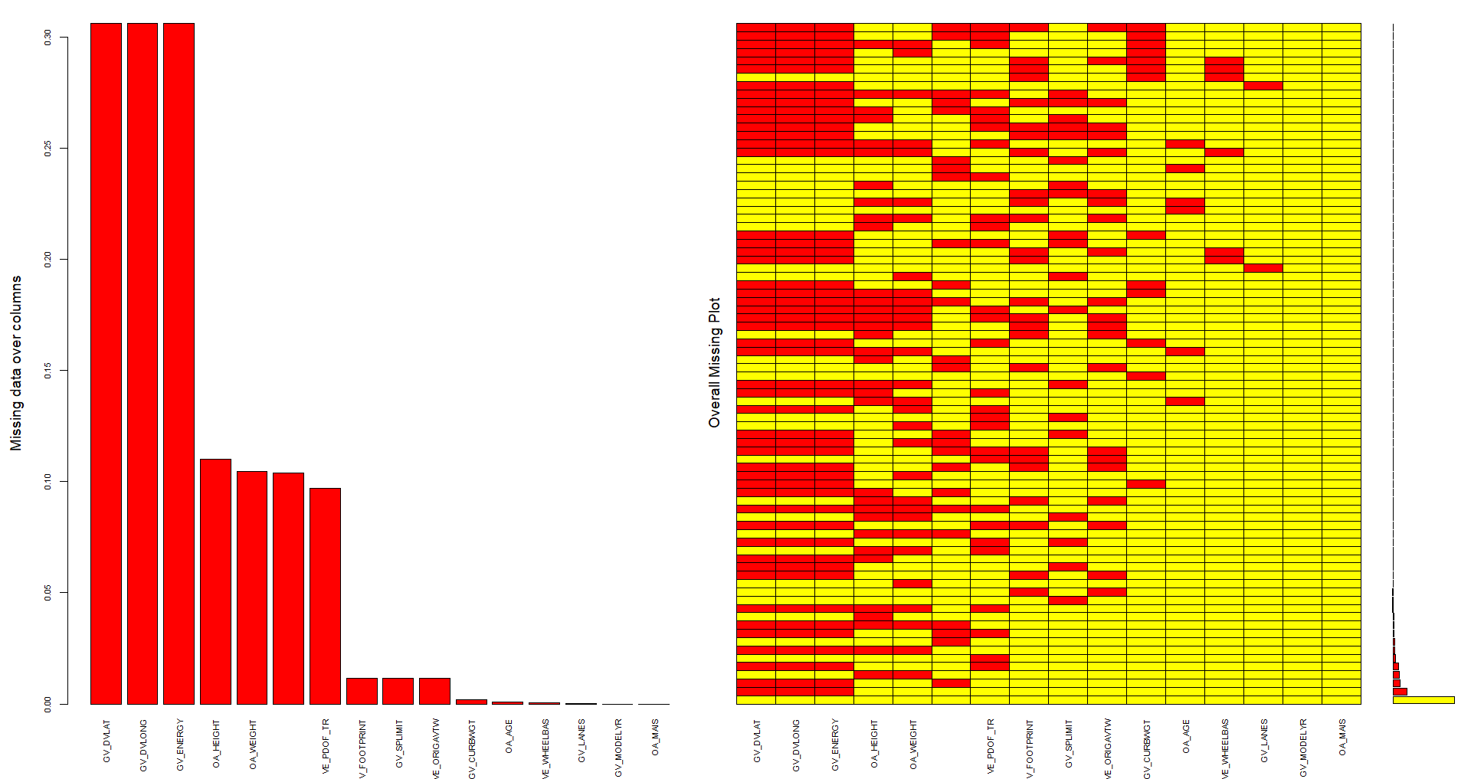

Missing values are as above. Cleaned by removing missing values in Target variable and removed categorical variables. Converted Continuous variables into discrete by using binning technique as per below. Followed by TAN and Naïve Bayes model. Followed K-Fold Cross validation. K=5 since target variable has 5 categories. **(ET: should be 7 categories. See Workshop pdf)**

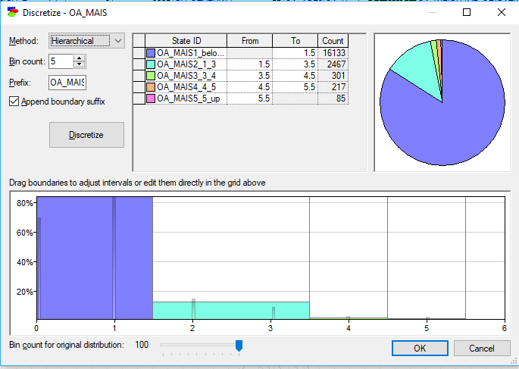

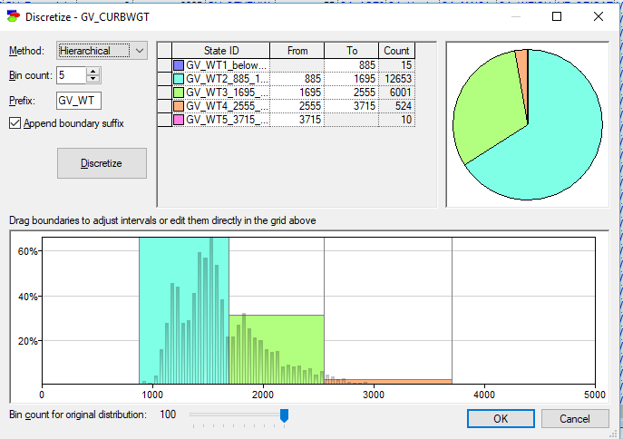

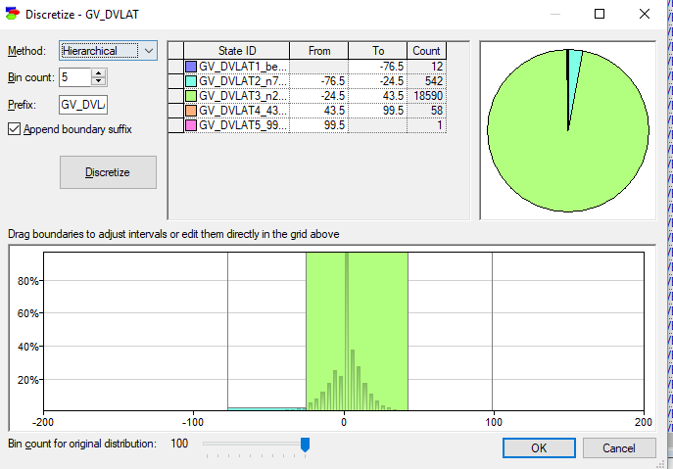

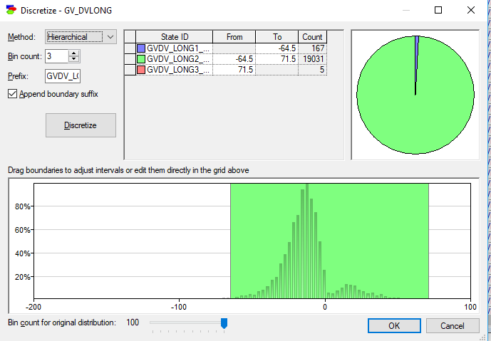

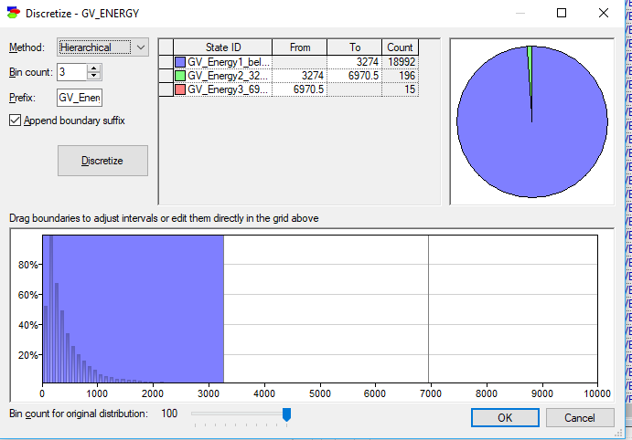

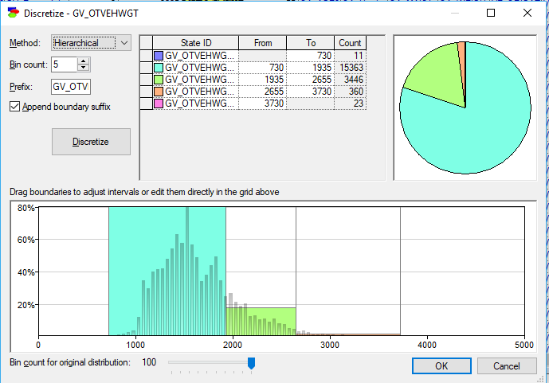

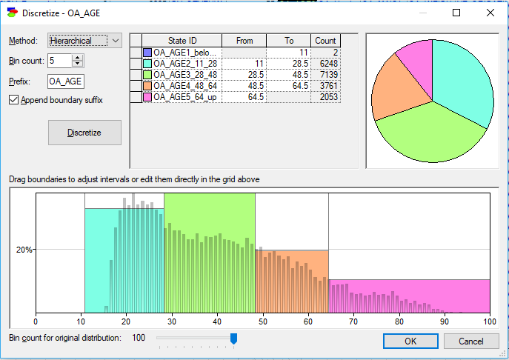

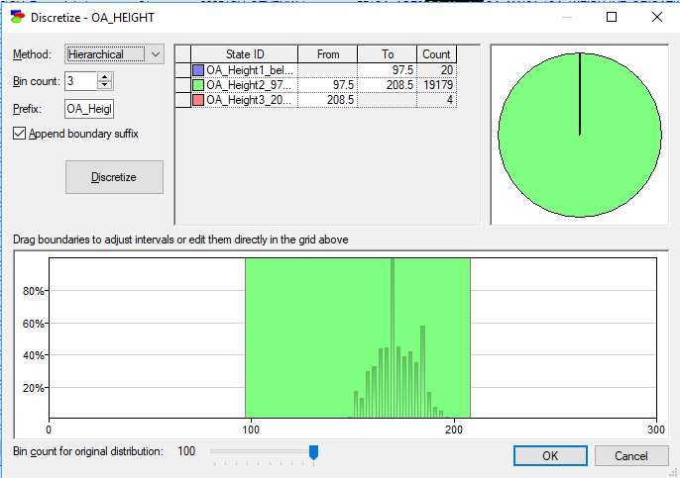

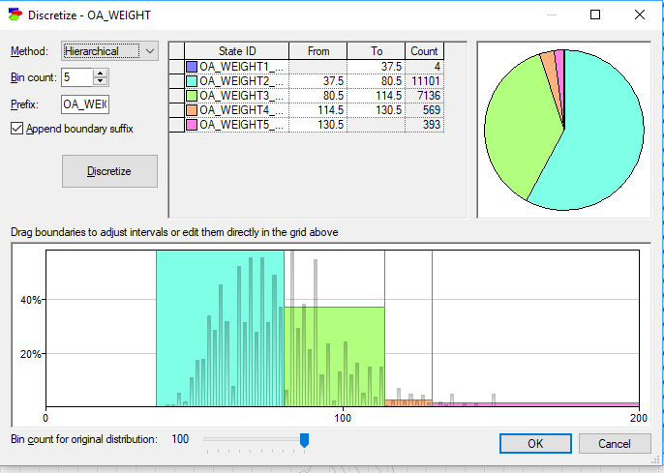

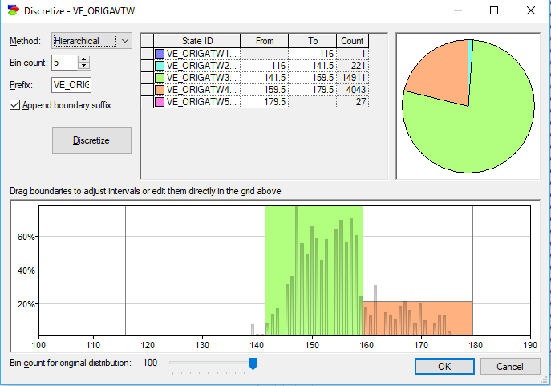

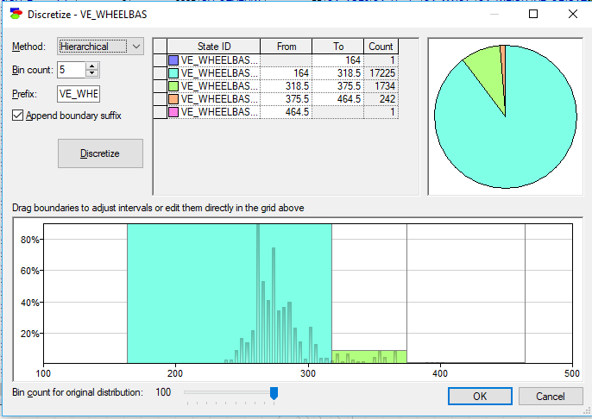

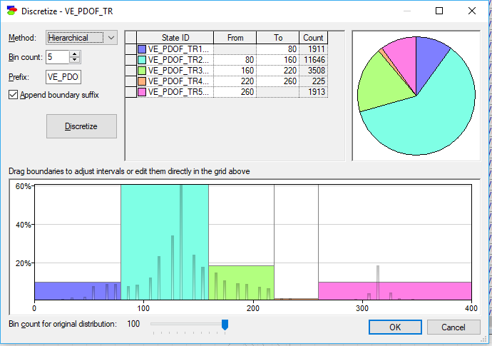

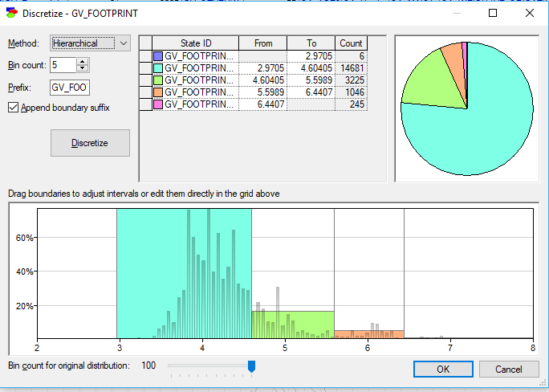

Tree Augmented Network

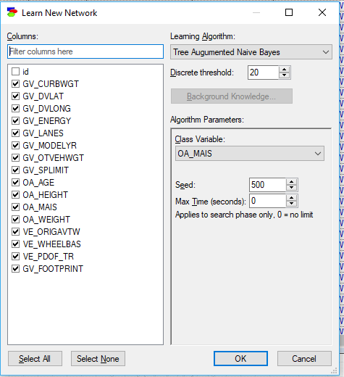

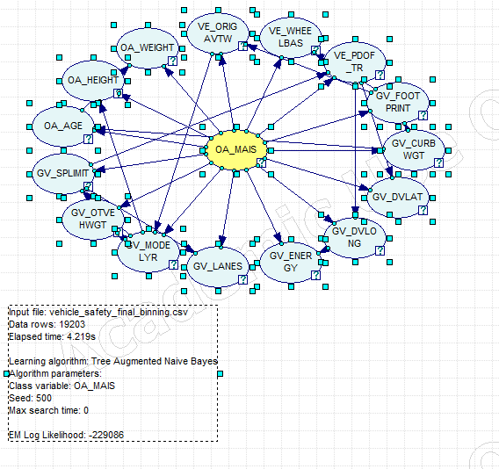

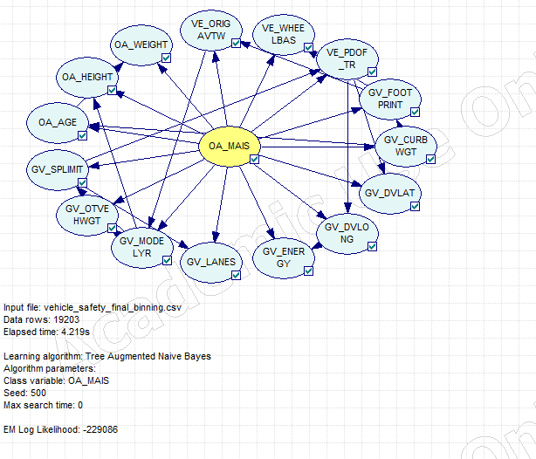

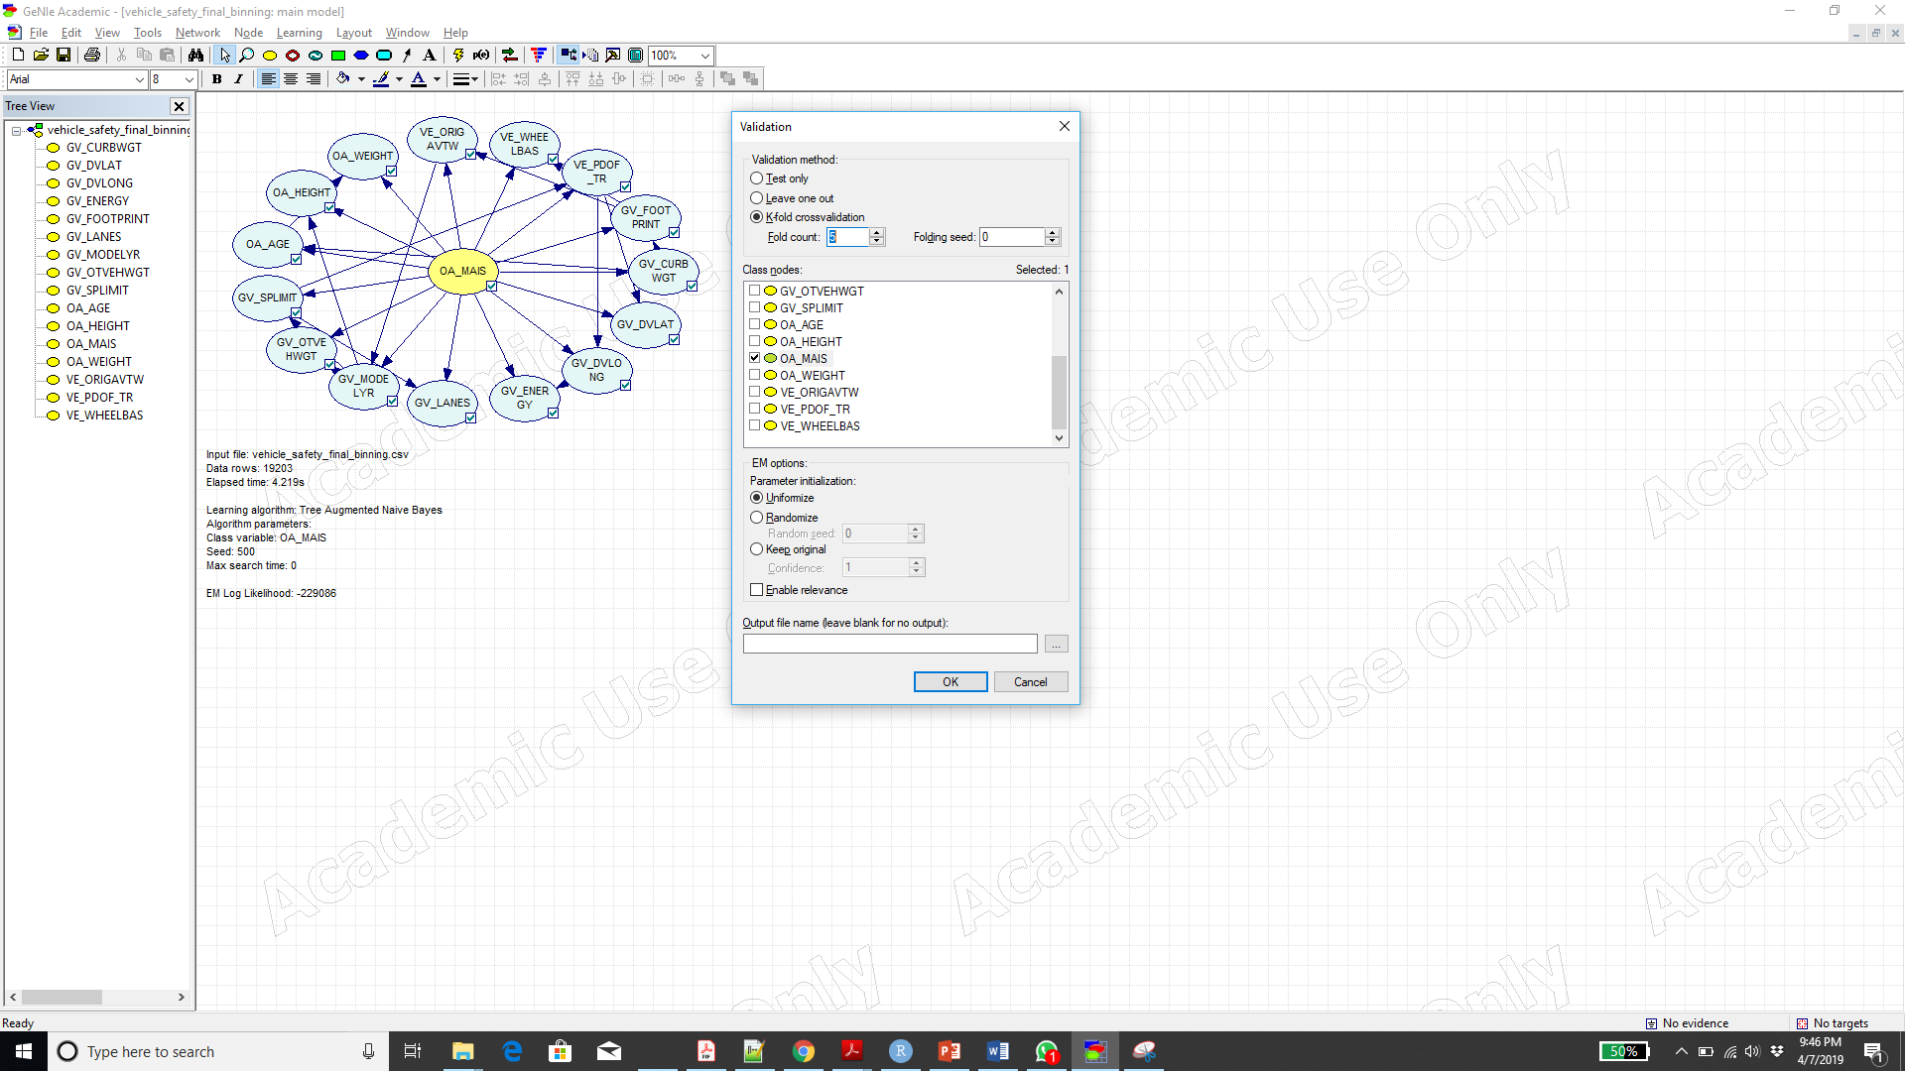

OA_MAIS = 0.839244 (16116/19203)

OA_MAIS1_below_1 = 0.992066 (16005/16133)

OA_MAIS2_1_3 = 0.0360762 (89/2467)

OA_MAIS3_3_4 = 0.00996678 (3/301)

OA_MAIS4_4_5 = 0.0506912 (11/217)

OA_MAIS5_5_up = 0.0941176 (8/85)

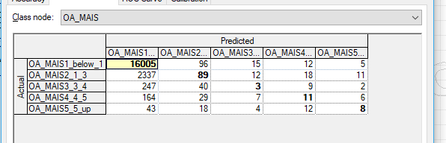

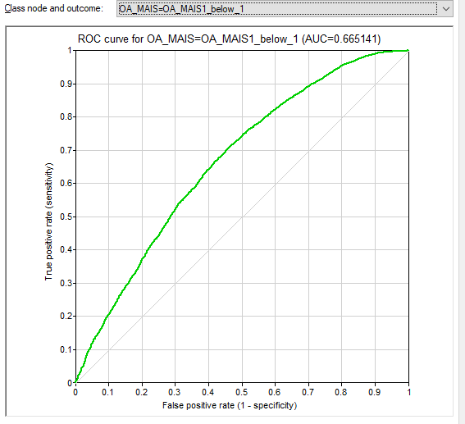

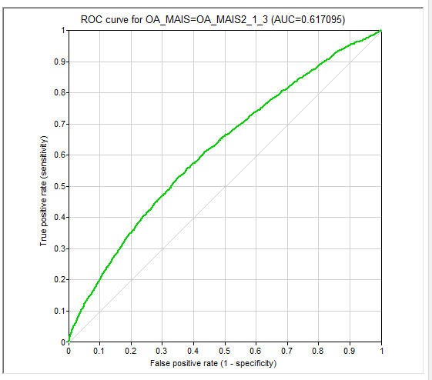

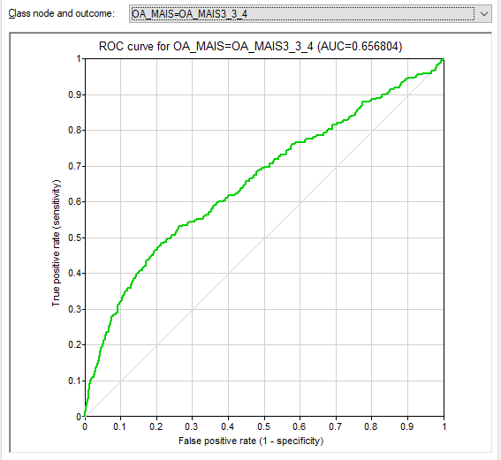

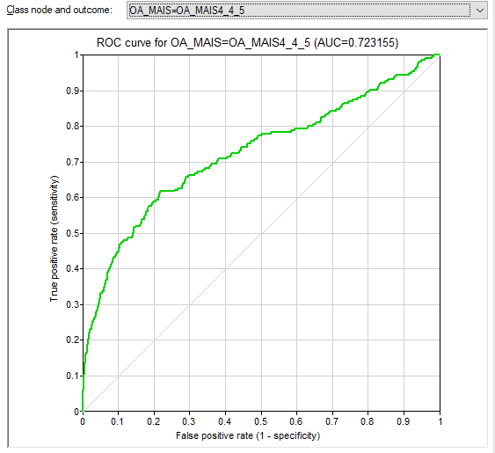

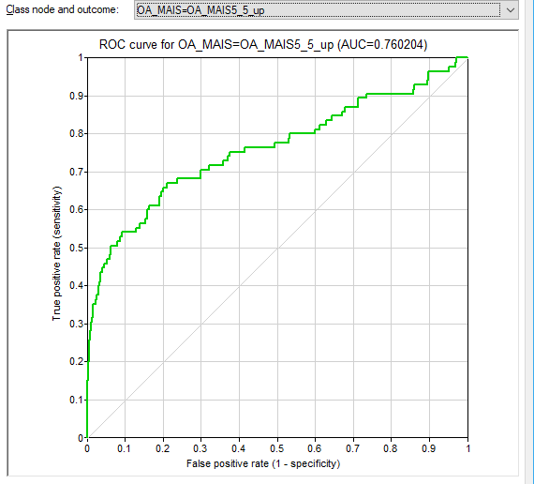

Naïve Bayes:

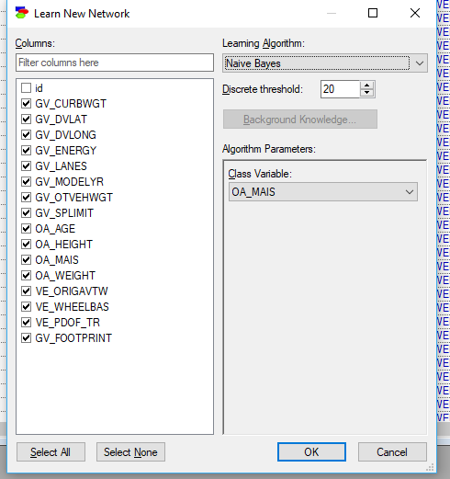

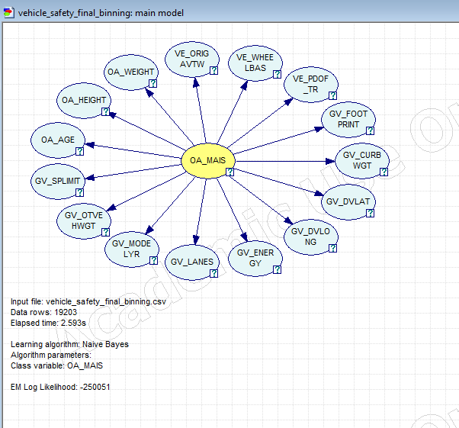

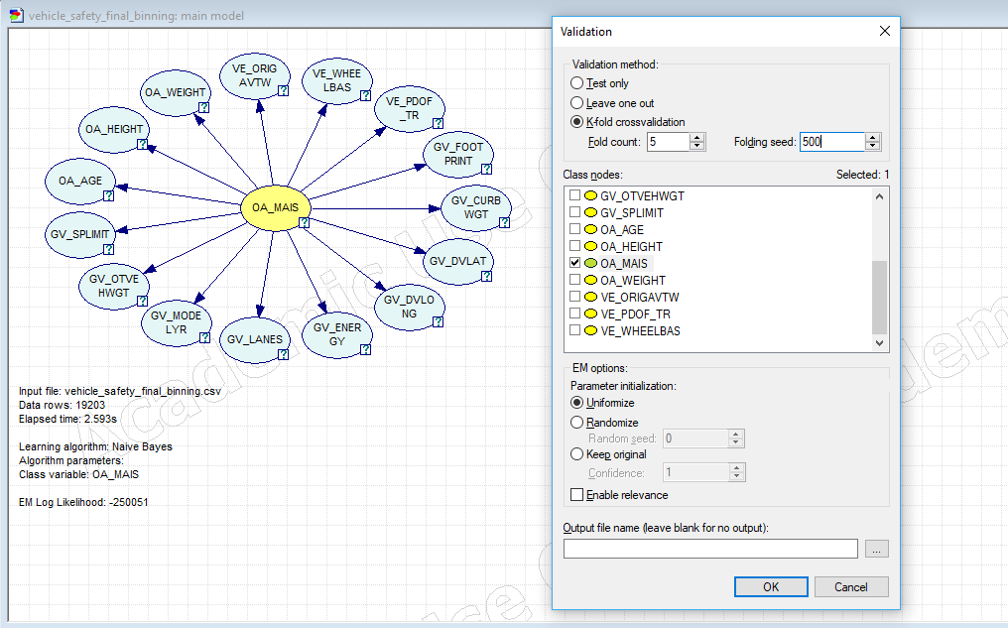

OA_MAIS = 0.840858 (16147/19203)

OA_MAIS1_below_1 = 0.995103 (16054/16133)

OA_MAIS2_1_3 = 0.0218889 (54/2467)

OA_MAIS3_3_4 = 0.00996678 (3/301)

OA_MAIS4_4_5 = 0.0737327 (16/217)

OA_MAIS5_5_up = 0.235294 (20/85)

