Windows Registry Change Monitoring System
Author: Raj Bharti

1. Executive Summary
Objective The primary objective of this project is to develop a Host-Based Intrusion Detection System (HIDS) capable of monitoring critical Windows Registry keys. The system aims to detect unauthorized changes to "Autostart" locations, which are frequently exploited by malware to establish persistence.
Scope
- Target Environment: Windows 10/11 Operating System.
- Key Monitoring: HKEY_CURRENT_USER\Software\Microsoft\Windows\CurrentVersion\Run and HKEY_LOCAL_MACHINE equivalents.
- Deliverables: A Python-based monitoring toolkit, integrity log analysis, and architectural documentation.
Tools & Technologies
- Language: Python 3.x (winreg, logging, time libraries).
- Platform: Windows Registry Editor (regedit).
- Methodology: Baseline comparison (Integrity Checking).
2. Technical Background
2.1 The Windows Registry The Registry is a hierarchical database used by Windows to store low-level settings for the operating system and applications. It is structured into "Hives," "Keys," and "Values."
2.2 The Threat: Persistence Mechanisms Adversaries use specific Registry keys (known as ASEPs - Auto-Start Extensibility Points) to launch malicious code automatically upon system boot.
- Risk: If a modification to a "Run" key goes unnoticed, malware can survive reboots and evade standard antivirus scanning.
- Solution: Continuous monitoring of these keys to alert administrators immediately upon modification.
3. Implementation & Testing
3.1 Establishing the Baseline
Figure 1: Initial baseline scan of HKEY_CURRENT_USER Run keys.
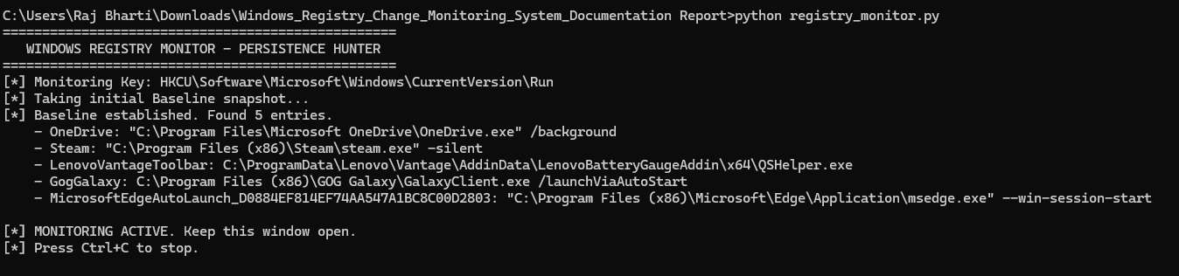

3.2 Detecting Unauthorized Changes
Figure 2: Real-time detection of unauthorized registry modification.

4. Architecture & Logic Flow