Threat Intelligence Aggregator
Author: Raj Bharti

1. Executive Summary
Objective The goal of this project is to develop an automated Threat Intelligence (TI) Aggregator. The system is designed to fetch, normalize, and export Indicators of Compromise (IOCs) from multiple open-source feeds, enabling organizations to proactively block known threats.
Scope
- Data Sources: Public threat feeds (e.g., URLHaus, AlienVault OTX, or Blocklist.de).
- IOC Types: Malicious IP Addresses, Phishing URLs, and File Hashes (MD5/SHA256).
- Output: Standardized "Blocklists" (CSV/TXT) ready for firewall or SIEM integration.
Tools & Technologies
- Language: Python 3.x (requests, pandas, re libraries).
- Environment: Windows 10/11 or Kali Linux.
- Format: CSV and JSON for structured data export.

2. Technical Background
2.1 What is Threat Intelligence? Threat Intelligence involves collecting data about emerging threats to prevent cyberattacks. Instead of waiting to be attacked, organizations download lists of "known bad" actors to block them in advance.
2.2 Indicators of Compromise (IOCs)
- IP Addresses: Computers used by hackers.
- URLs: Fake login pages or malware download sites.
- Hashes: Digital fingerprints of known viruses/ransomware.

3. Implementation & Testing
3.1 Aggregation Module Output
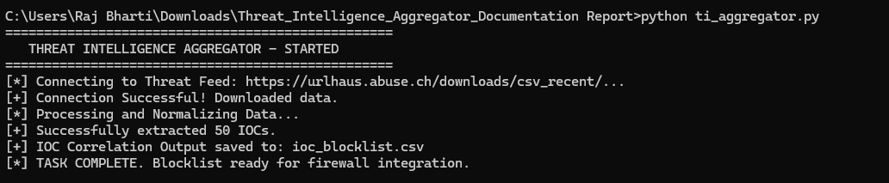
3.2 Generated Blocklists (CSV/TXT)
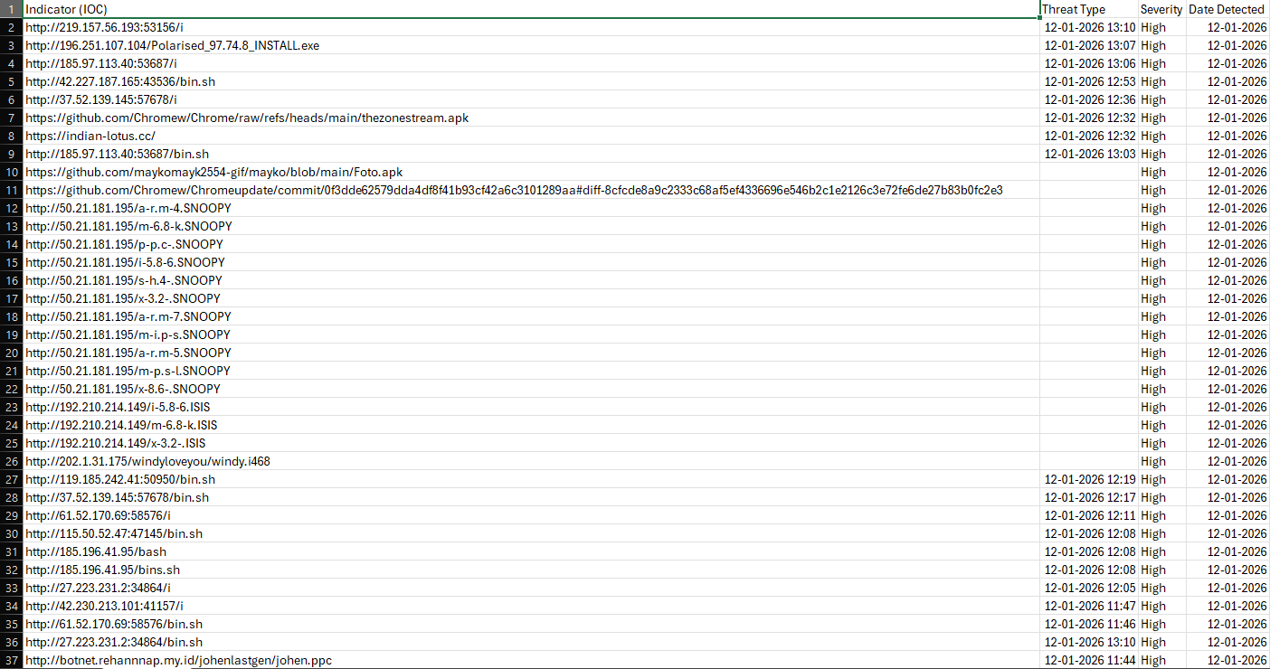
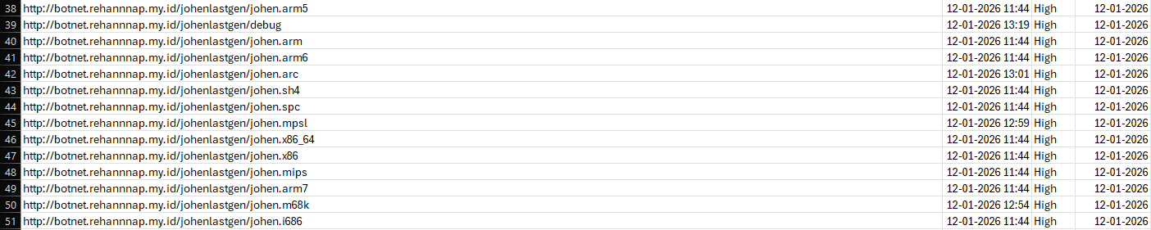

4. Architecture & Data Flow