Secure File Transfer Monitoring System
Project Type: Endpoint Security & Data Loss Prevention (DLP)
Author: Raj Bharti

1. Executive Summary In the modern threat landscape, data exfiltration and unauthorized file tampering are top risks for organizations. This project implements a Secure File Transfer Monitoring System designed to ensure data confidentiality and integrity. The system provides real-time auditing of file movements, detects unauthorized handling of sensitive data (Data Loss Prevention - DLP), and verifies file integrity using SHA-256 hashing.
2. Project Objectives The primary goals of this implementation were to:
- Log all file system activities (creation, modification, deletion) to create a forensic audit trail.
- Enforce Data Loss Prevention (DLP) policies by flagging filenames containing sensitive keywords (e.g., "secret", "password").
- Verify File Integrity using cryptographic hashing (SHA-256) to detect unauthorized tampering or malware injection.
- Alert on Policy Violations in real-time to facilitate immediate Incident Response.
3. Technical Architecture The system was built using Python to leverage its robust system interaction libraries.
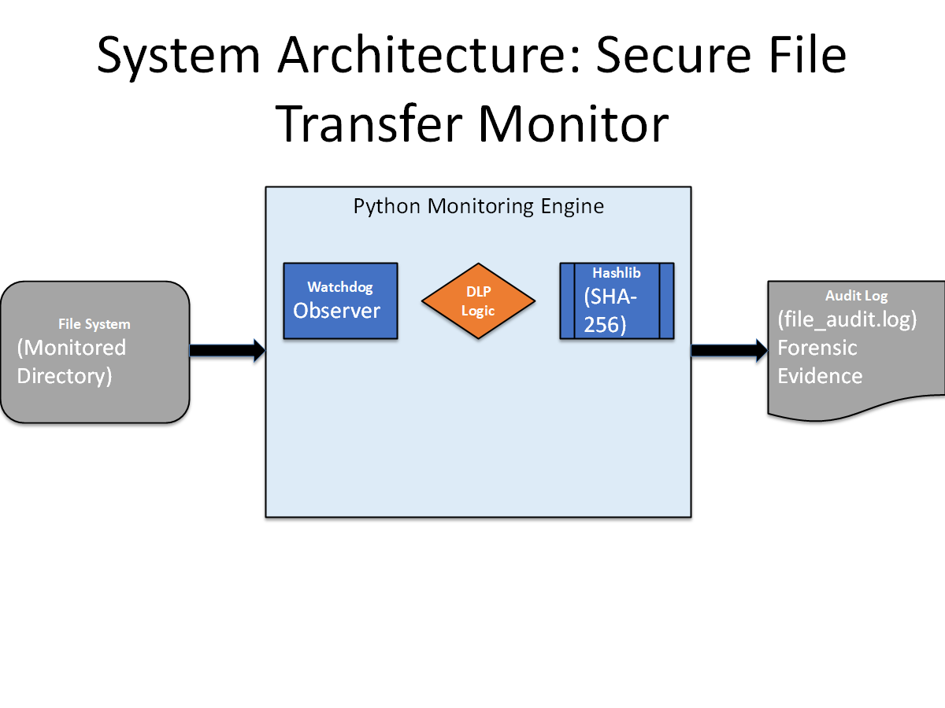
Figure 1: System Architecture Diagram showing the flow of data from the File System through the Python Monitoring Engine to the Audit Log.
- Core Engine: watchdog library for real-time file system event monitoring.
- Integrity Module: hashlib for generating SHA-256 digital signatures (hashes) of files.
- Logging Module: Python's logging framework to generate timestamped, immutable audit logs.
4. Methodology & Workflow The system operates on a continuous monitoring loop:
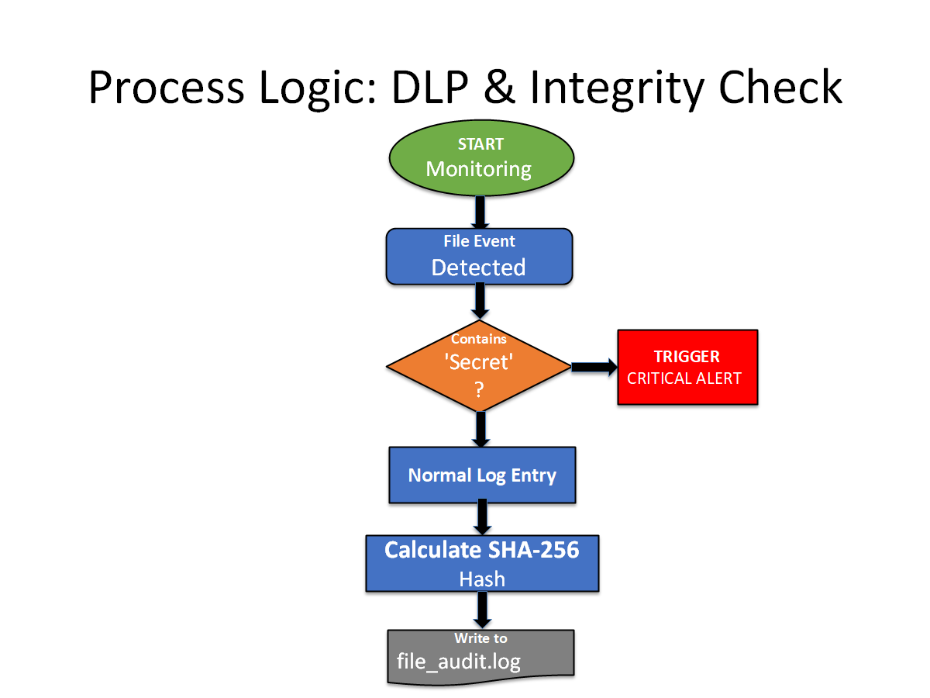
- Monitor: The Observer thread watches the target directory for OS-level events.
- Classify: When an event occurs, the system classifies it (Create, Modify, Delete, Move).
- DLP Scan: The filename is checked against a "Watchlist" of sensitive keywords (SENSITIVE_KEYWORDS).
- Integrity Check: If the file exists, a SHA-256 hash is calculated to freeze its state.
- Alert & Log:
  - Normal Events: Logged as INFO with the file hash.
  - Violations: Logged as WARNING with a "CRITICAL POLICY VIOLATION" alert.
- Results & Evidence:
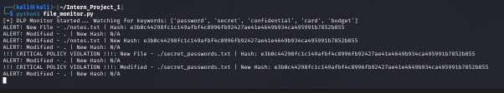
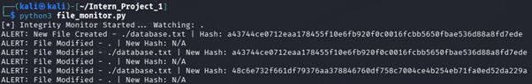
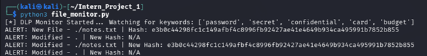
5. Monitoring Logs & Evidence:
Figure 1: Real-Time Threat Detection. The system successfully flagged 'secret_passwords.txt' as a Critical Policy Violation.
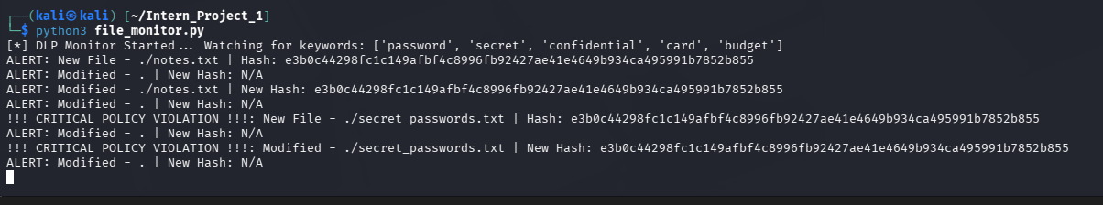
Figure 2: Forensic Audit Log. A permanent record of all file events, including timestamps and SHA-256 hashes, stored in 'file_audit.log'.
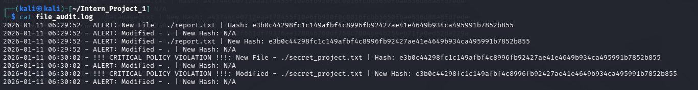
5.1. Integrity Verification: File Integrity Verification. The system automatically calculates a SHA-256 hash for every file event. In this example, the file secret_project.txt was assigned the unique digital fingerprint:
e3b0c44298fc1c149afbf4c8996fb92427ae41e4649b934ca495991b7852b855.
This hash serves as cryptographic proof of the file's content at that specific timestamp.

6. Conclusion This project successfully demonstrated the implementation of a host-based DLP and FIM (File Integrity Monitoring) control. It mitigates the risk of insider threats and data leakage by providing visibility and immediate alerts on unauthorized data handling.

Deliverable 6: Final Presentation (PPT)
Create a 5-Slide PowerPoint. Here is the text for each slide:
Slide 1: Title Slide
- Title: Secure File Transfer Monitoring & DLP System
- Subtitle: Project 1 - Endpoint Security Implementation
- Name: Raj Bharti
Slide 2: The Problem (Risk Context)
- Risks: Data Exfiltration, Insider Threats, Unauthorized Tampering.
- The Gap: Standard file systems do not log who moved a file or if it contains sensitive data.
- Goal: Build a "Security Camera" for the file system.
Slide 3: The Solution (Technical Approach)
- Language: Python (Watchdog + Hashlib).
- Key Features:
  - Real-time Monitoring: Detects creation, deletion, and movement instantly.
  - FIM (File Integrity Monitoring): Uses SHA-256 hashes to detect content changes.
  - DLP (Data Loss Prevention): Scans filenames for "Confidential" or "Secret" keywords.
Slide 4: Implementation Evidence (Demo)
- Caption: System automatically flagging a sensitive file ("secret_passwords.txt").
Slide 5: Conclusion & Learning Outcomes
- Demonstrated practical implementation of Control Monitoring.
- Mitigated Data Leakage risks through automated auditing.
- Gained experience in Forensic Logging and Integrity Verification .

