USB Device Control Monitoring Framework Documentation Report
Author: Raj Bharti

1. Executive Summary
- Objective: To implement a host-based security control that detects and restricts unauthorized USB storage devices to prevent data exfiltration and malware introduction.
- Scope: Endpoint monitoring, real-time alerting, and automated blocking logic.
2. Technical Implementation
- Language: Python
- Key Libraries: pyudev (Linux Device Management), os, time.
- Environment: Kali Linux.
- The system is designed as a user-space driver that interacts with the Linux Kernel's udev subsystem. It listens for hardware events in real-time and enforces a strict "Default Deny" policy.
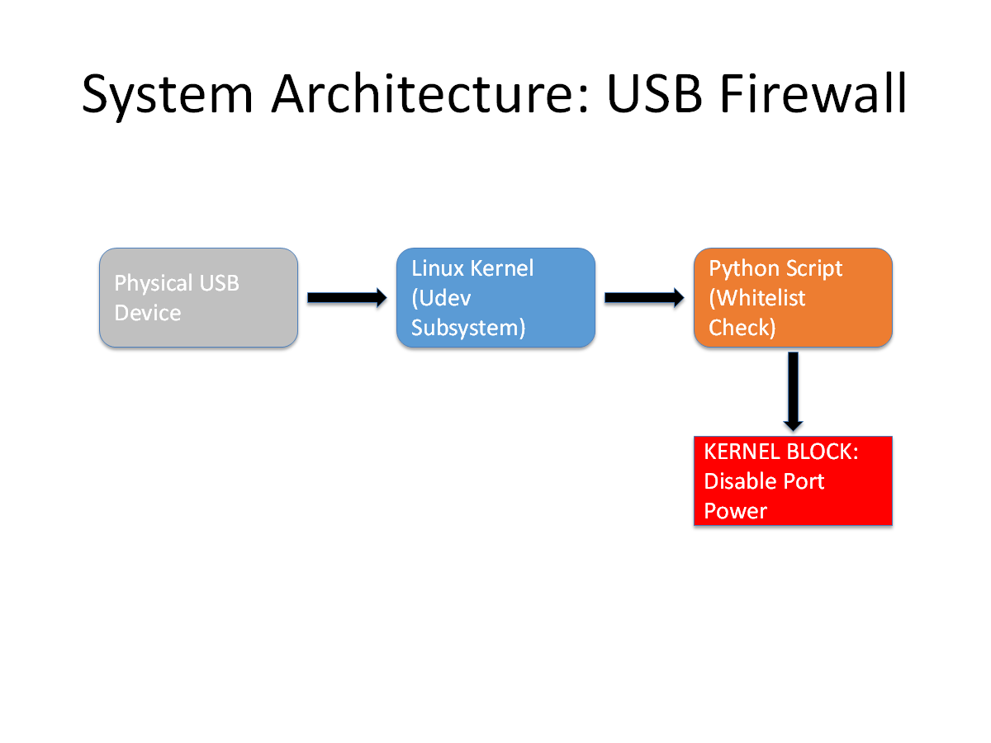
3. Implementation Steps & Evidence
3.1. Environment Setup & Tool Installation
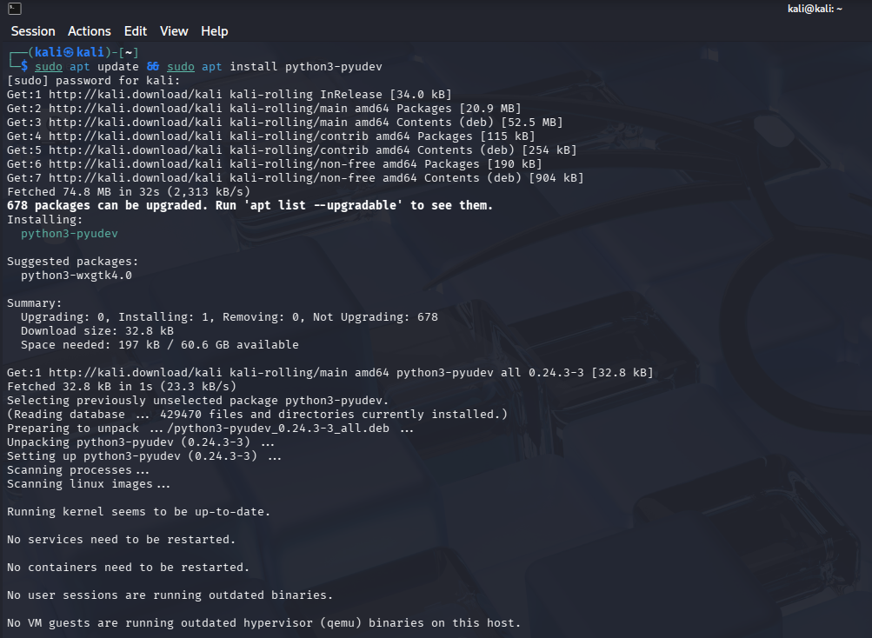

3.2. Detection Logic (The "Listener")
The script initializes a netlink socket monitor to capture kernel signals. Upon detecting an add event from the USB subsystem, it extracts the device's Vendor ID, Model, and Serial Number.

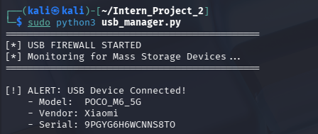
3.3. Blocking Logic (The "Firewall")
The core security control involves comparing the device's Serial Number against a pre-defined USB_WHITELIST.
- Trusted: If the serial matches, the device is logged and allowed to mount.
- Untrusted: If no match is found, the system immediately writes 0 to the device's /sys/bus/usb/.../authorized file, electrically disabling the data port.
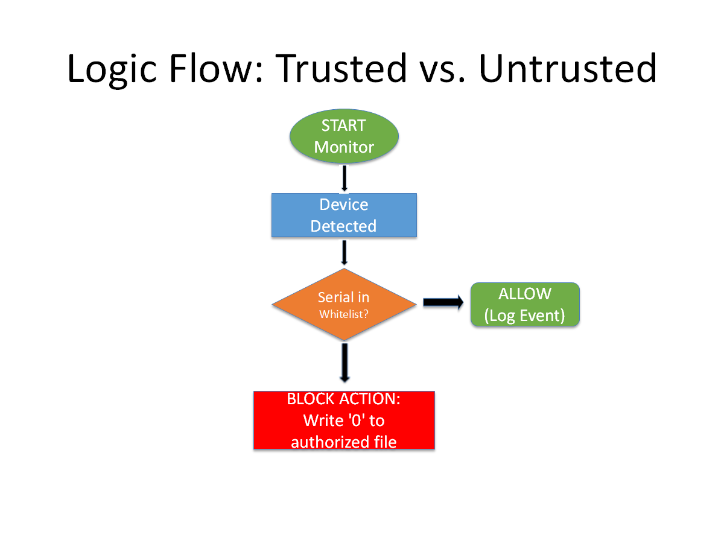
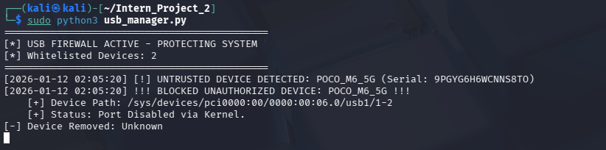

Section 3.4: Whitelist Verification
To verify operational usability, a known device (Serial ending in ...8TO) was added to the whitelist. The system successfully validated the serial number and permitted the connection.

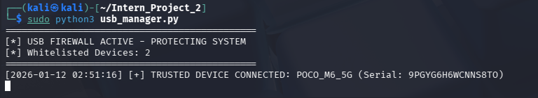

Section 4: Conclusion
This project successfully demonstrated a host-based "USB Firewall" capable of preventing unauthorized peripherals from interacting with the operating system. By leveraging kernel-level authorization controls, the system mitigates risks associated with BadUSB attacks and physical data exfiltration.

Appendix A: Project Source Code

import pyudev
import time
import sys
import os

# ==============================================================================
# PROJECT 2: USB DEVICE CONTROL TOOLKIT
# AUTHOR: [Your Name]
# PURPOSE: Detects USB Mass Storage devices and enforces a Whitelist policy.
# ==============================================================================

# --- CONFIGURATION ---
# REPLACE with your actual device Serial Number found during testing.
USB_WHITELIST = ["9PGYG6H6WCNNS8TO", "ANOTHER_TRUSTED_SERIAL"]

def log_event(message):
"""
Logs events to both the terminal and a local log file for auditing.
"""
timestamp = time.strftime("%Y-%m-%d %H:%M:%S")
formatted_msg = f"[{timestamp}] {message}"

print(formatted_msg)

# Append to log file (Deliverable 3 Evidence)
with open("usb_security.log", "a") as f:
f.write(formatted_msg + "\n")

def block_device(device):
"""
Disables the USB device by writing '0' to the kernel 'authorized' interface.
This effectively cuts power/data to the specific USB port.
"""
try:
# The 'authorized' file controls if the OS allows the device to communicate
auth_path = os.path.join(device.sys_path, 'authorized')

if os.path.exists(auth_path):
with open(auth_path, 'w') as f:
f.write('0') # 0 = Disabled, 1 = Enabled

log_event(f"!!! ACTION TAKEN: BLOCKED UNAUTHORIZED DEVICE: {device.get('ID_MODEL')} !!!")
print(f" [+] Path: {device.sys_path}")
print(" [+] Status: Port Disabled via Kernel.")
else:
log_event(f"[-] Warning: Could not find 'authorized' control file for {device.get('ID_MODEL')}")

except Exception as e:
log_event(f"[!] Error attempting to block: {str(e)}")

def monitor_usb():
"""
Main loop that listens for Kernel Udev events.
"""
context = pyudev.Context()
monitor = pyudev.Monitor.from_netlink(context)

# Filter only for 'usb' subsystem events
monitor.filter_by(subsystem='usb')

print("=============================================")
print("[*] USB FIREWALL ACTIVE - PROTECTING SYSTEM")
print(f"[*] Whitelisted Devices: {len(USB_WHITELIST)}")
print("=============================================")

# Continuous listening loop
for device in iter(monitor.poll, None):
if device.action == 'add':
# Wait briefly for attributes to initialize
time.sleep(1)

# --- INPUT SANITIZATION ---
# Get the raw serial and remove any hidden non-alphanumeric characters
# This fixes issues with hidden null bytes or spacing
raw_serial = device.get('ID_SERIAL_SHORT', 'Unknown')
serial = ''.join(char for char in str(raw_serial) if char.isalnum())
model = device.get('ID_MODEL', 'Unknown')

# Ignore internal USB hubs/interfaces, focus on the device itself
if device.device_type == 'usb_interface':
continue

# --- DECISION ENGINE ---
if serial in USB_WHITELIST:
log_event(f"[+] ALLOWED: Trusted Device Connected - {model} (Serial: {serial})")
else:
log_event(f"[!] ALERT: Untrusted Device Detected - {model} (Serial: {serial})")
block_device(device)

elif device.action == 'remove':
model = device.get('ID_MODEL', 'Unknown')
print(f"[-] Device Removed: {model}")

if __name__ == "__main__":
# Script must be run as Root to access /sys/ files for blocking
if os.geteuid() != 0:
print("[-] ERROR: This script requires ROOT privileges.")
print(" Run with: sudo python3 usb_manager.py")
sys.exit(1)

try:
monitor_usb()
except KeyboardInterrupt:
print("\n[*] Stopping USB Firewall...")
sys.exit()

