Advanced Executive Program in Cybersecurity
Virtual Internship Project Problem Statement



Network Security Consultant

Problem Statement:
You are working as a network security consultant for El Banco Bank. Your primary responsibility is to secure the bank's assets by designing, integrating, and implementing complex network architecture solutions after reviewing the network security.
You should be able to troubleshoot very complex network issues spanning various types of technologies.

Background of the problem statement:
El Banco Bank is one of the fastest-growing banks in Europe with more than 1200 branches across the country and manages €200 billion in assets.
Handling millions of dollars of banking transactions per day, its customers hugely depend upon the security of their banking data. The recent surge in cyber-attacks and data breaches has become a significant issue for every organization.

Expected Deliverables:
TASK 1:
As a network security consultant, you have to review tickets raised by users due to digital certificate issues. To help them resolve these issues, you need to understand the organization's certificate information. Identify the likely issue and the possible solution for the following tickets:
Ticket 1:
Date: 10/11/2021
Submitted by: Bob Wood (Pen tester)
I am trying to browse this website using an IP address, but my browser displays a certificate error. What should I do?
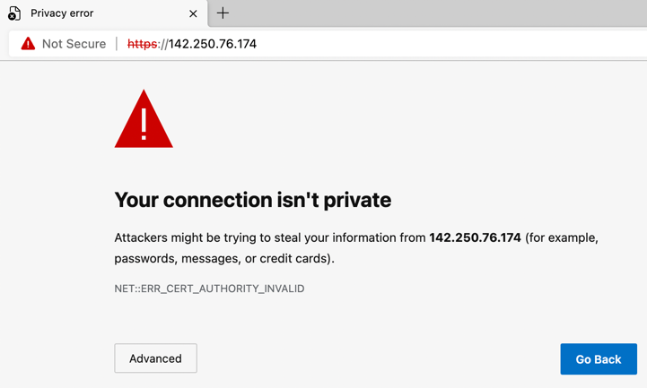
The Solution for Ticket 1: Use FQDN (Fully Qualified Domain Name) instead of IP address.

Ticket 2:
Date: 1/10/2021
Submitted By: Sheila Shaz (System Administrator)
I am trying to browse this website, but my browser displays an error that the certificate is expired. We have just renewed the certificate, and I am certain that the certificate will only expire in June 2022. What could be the reason for this error?
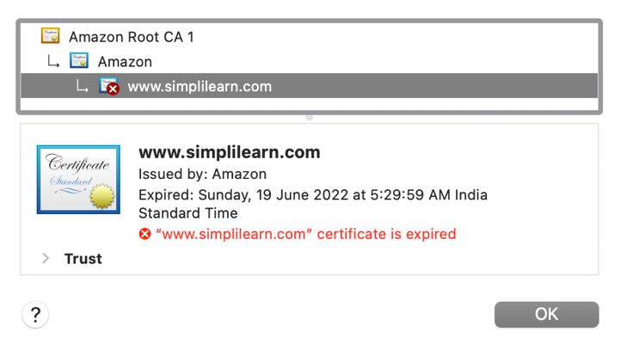
The Solution for Ticket 2: Check NTP (Network Time Protocol) to see if it is working properly and whether there are any errors that are being showed by that. If yes then fix it, as time is different, it’s future time.

Ticket 3:
Date: 2/12/2021
Submitted By: James Clay (Software Developer)
I am trying to browse this website, but my browser displays an error that the root certificate is not trusted. Is this issue client related?
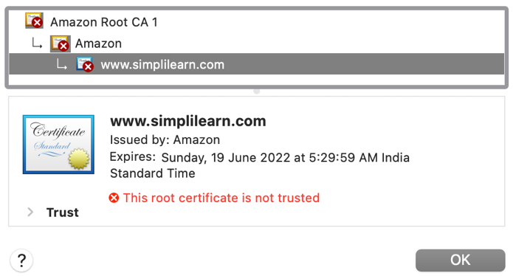
Client Machine Root Certificates
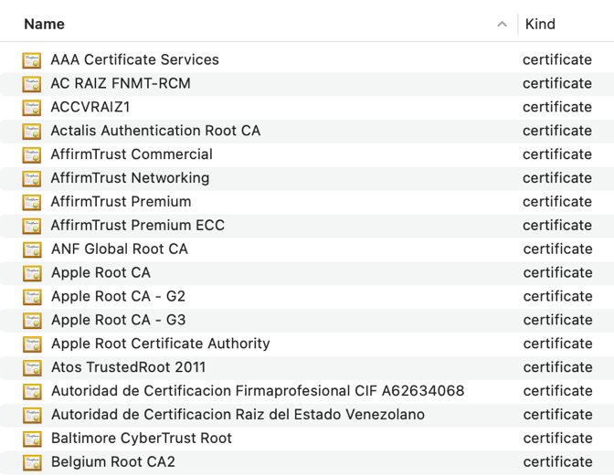

The Solution for Ticket 3: Check the certificate manager, update it and ensure that all known and approved route certificate authorities are installed in your certificate manager.

TASK 2:
You are reviewing the inbound rules of a VM in the cloud. The VM is used to host the bank’s website. For additional security, a valid digital certificate has been configured.
The cloud administrator is authorized to access the VM using RDP and SSH connections, but access should only be allowed from the authorized system with a fixed public IP (18.66.78.112).
Add the appropriate Inbound rules in the given format.
Type | Protocol | Port Range | Source
HTTPS | TCP | 443 | 0.0.0.0/0
RDP | TCP | 3389 | 18.66.78.112/32
SSH | TCP | 22 | 18.66.78.112/32

Note:
- Use 0.0.0.0/0 to indicate anywhere (IPv4).
- Subnet mask /32 indicates only one host whereas /0 indicates all the hosts in the network.

TASK 3:
As a network security consultant, you are designing the VPN connectivity requirements so that users working remotely from home can access the corporate network. The business has provided the following connectivity requirements:
VPN Connection 1:
This VPN will be used by software developers working on Ubuntu 20.04 from home to connect only to the main software repository server in the enterprise network. Use an open-source VPN protocol that is designed for speed. Configure all the network traffic to go through the enterprise network.
VPN Connection 2:
This VPN will be used by remote users working on Windows 10 from home to connect to the enterprise network. Use a Microsoft proprietary VPN protocol for ease of configuration. Users should be able to watch Netflix directly without connecting through the enterprise network, which would otherwise block this kind of traffic.
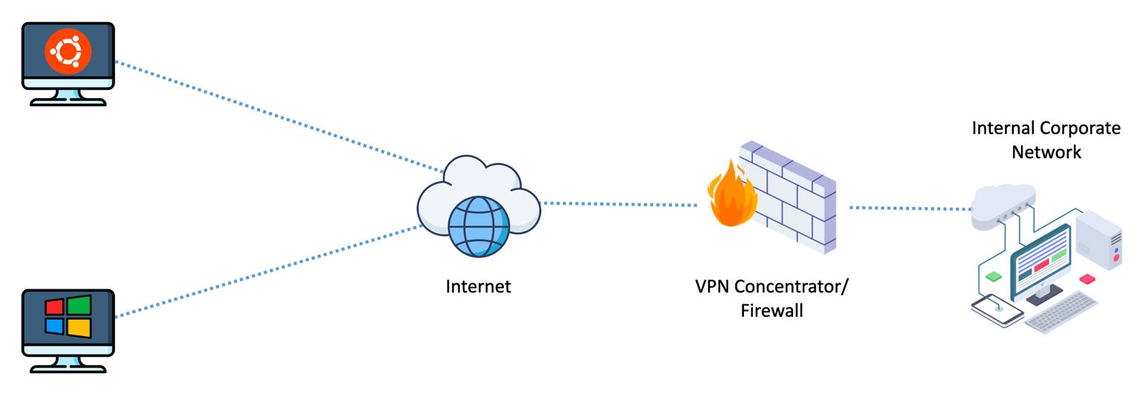
For these VPN connections, you will need to perform the following:
- Determine the VPN types, VPN protocols, and the tunnel methods
- Select the Firewall ports to allow
- Both VPN connections must support strong 256-bit encryption and use the SSL/TLS for key exchange.

Here is the breakdown for both VPN connections type, protocols and the tunnel methods.
User/OS | VPN Type | Protocol | Tunnel | Port
Ubuntu | Host to Host | OpenVPN | Full | UDP 1194
Windows 10 | Host to Site | SSTP | Split | TCP 443

