**How to work with Azure Function**

1. **Install Azure CLI using Node NPM package manager**

* **Goto** [**https://nodejs.org**](https://nodejs.org) **download and install latest version of nodejs**
* **Goto terminal and type:** npm install -g azure-cli

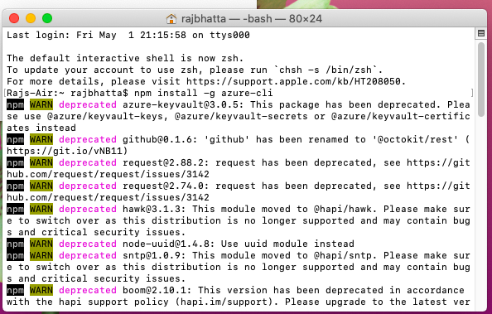

* **Once installation is completed, use terminal and type azure**

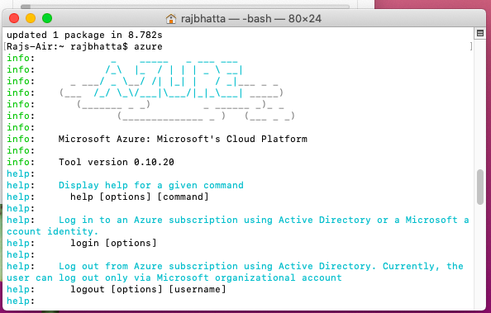

1. **Work with Azure Service Portal Now (I’m using Azure Service provided for student)**

* **Goto Azure Service Portal**

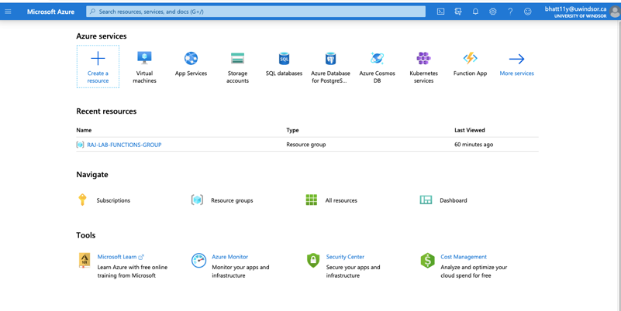

* **Create Resource Group (Type Resource Group on search bar)**

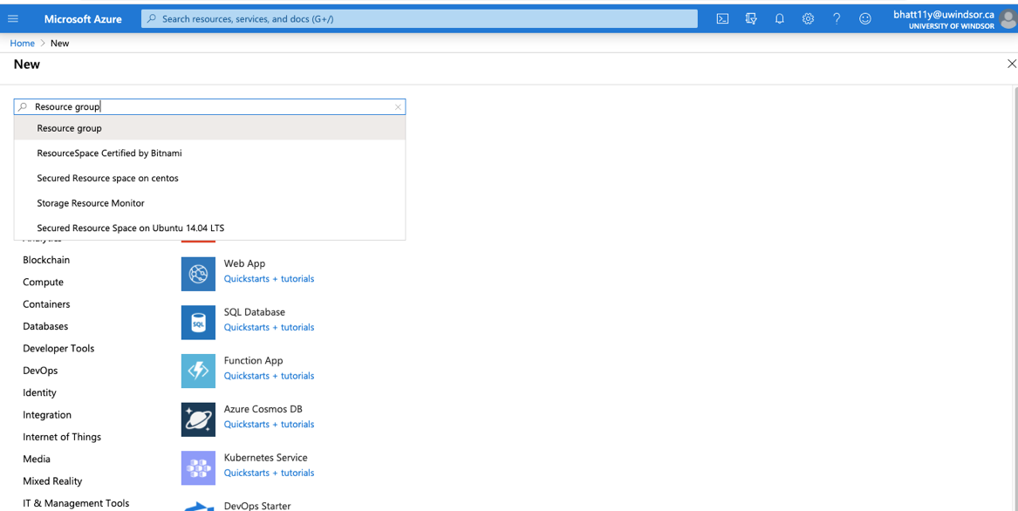

* **Select resource group from dropdown and click create button**

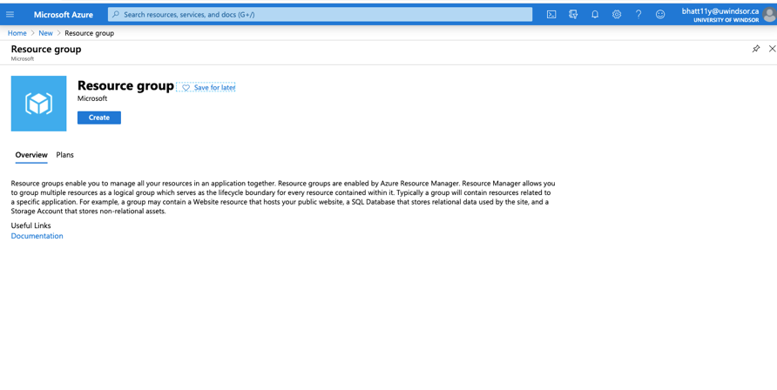

* **Provide proper name and select region where you want to create your resource group**

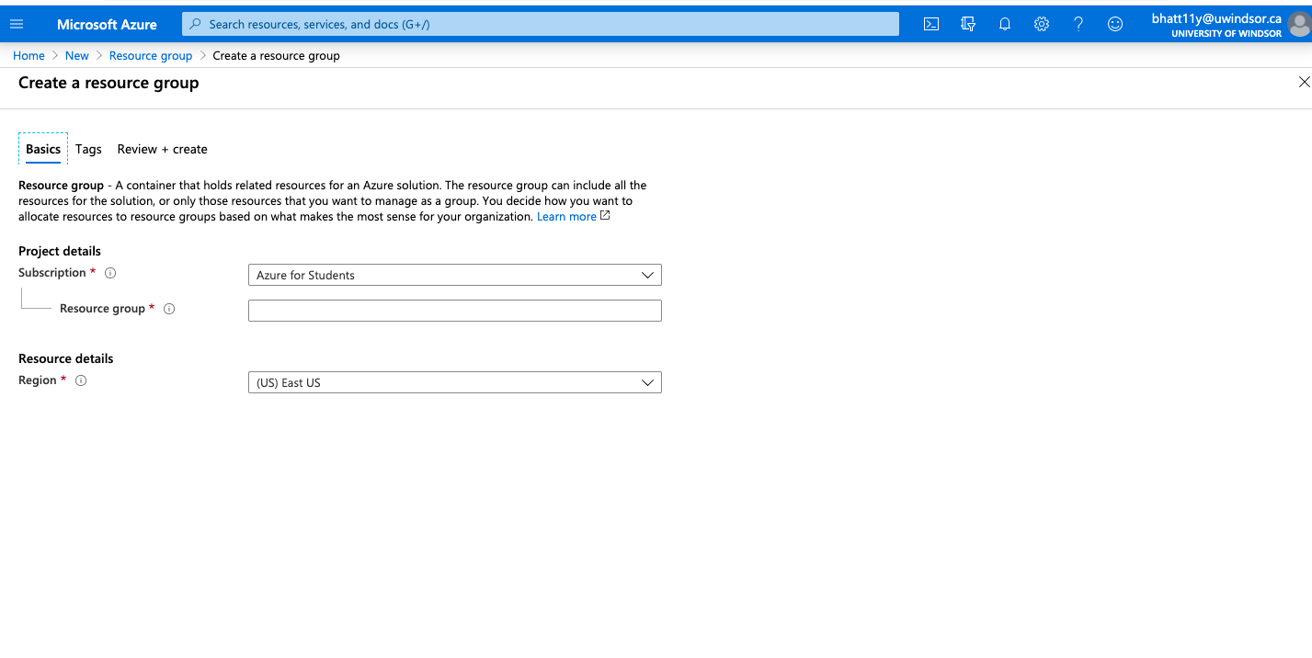

1. **Create HttpTrigger Function**

* **Goto Azure service portal home and search Function App**

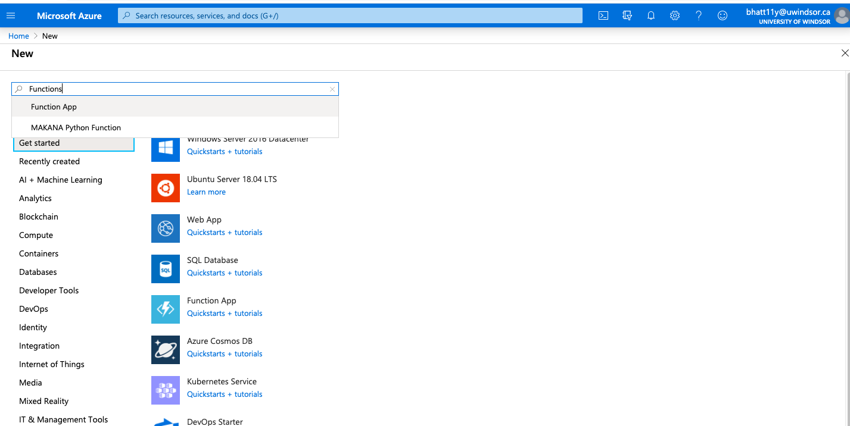

* **Select Function App from dropdown and click on Create**

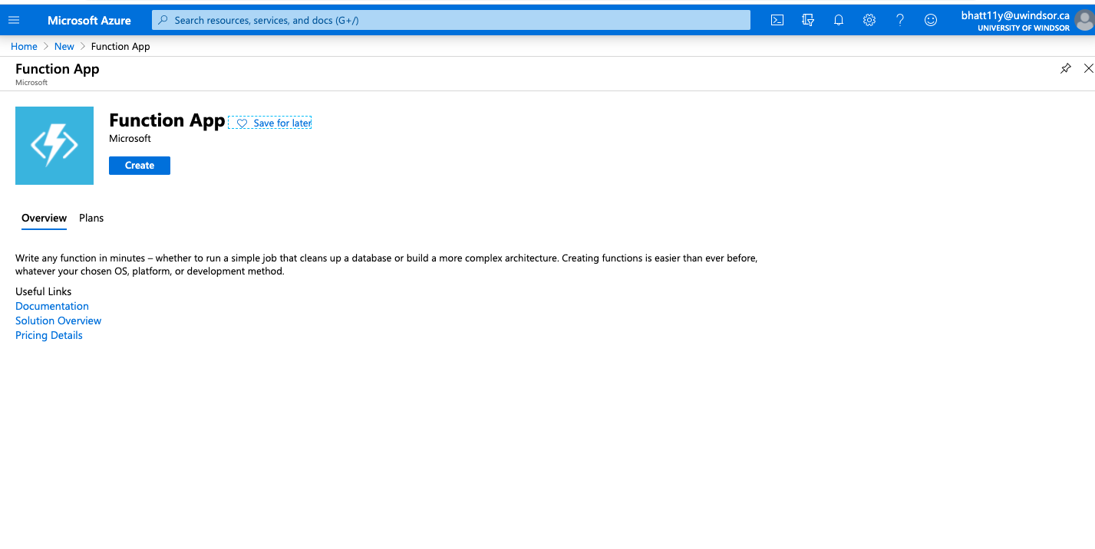

* **Provide Proper Function App name along with proper language version (In my case I had already created function app name)**

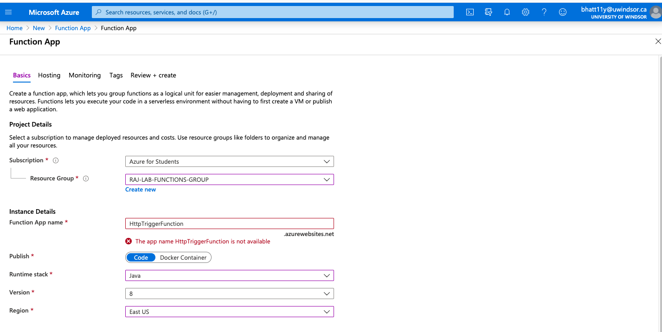

* **Now Goto Home -> Resource Group -> Select created resource group -> then you can see created Function App inside it as shown below:**

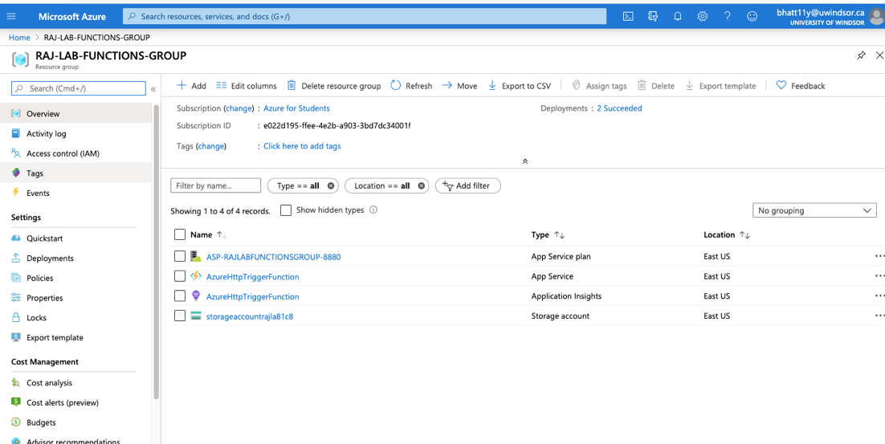

1. **Create function inside Function App**

* **Click on Function app that we created**

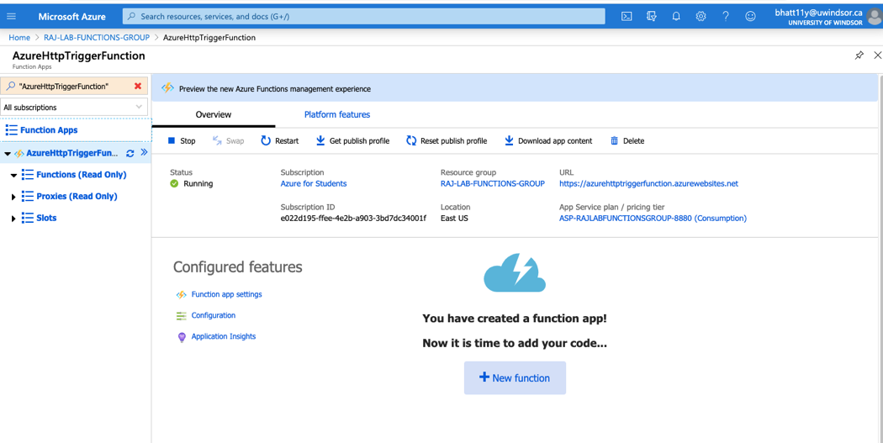

* **Click on New Function**

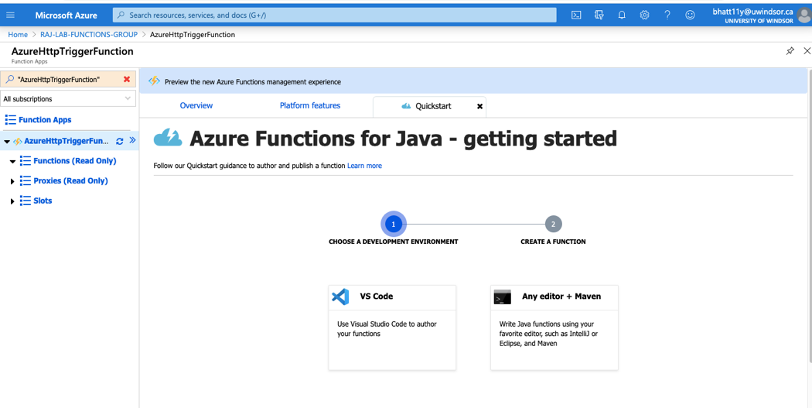

* **Select Any editor+Maven**

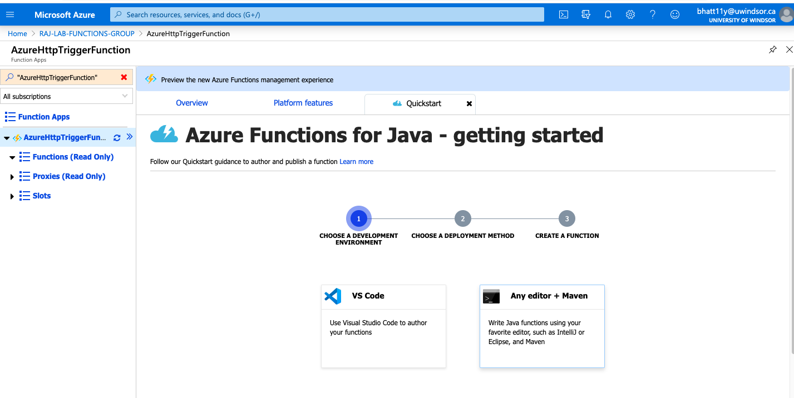

* **Direct publish using Maven**

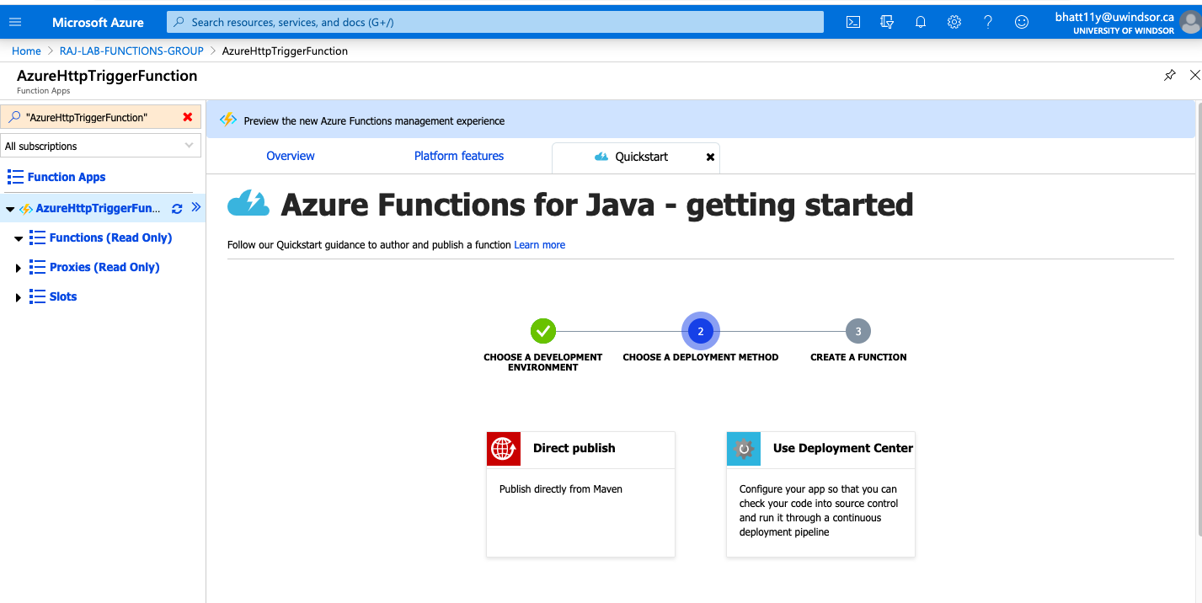

* **Work with the provided command on your terminal.**

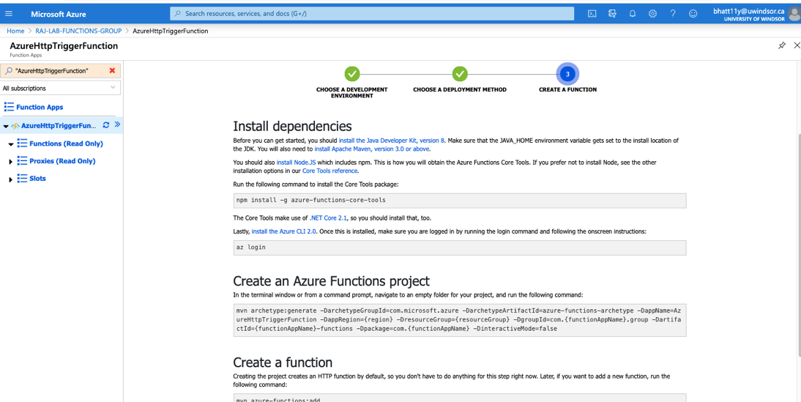

1. **Working with Azure CLI for Azure verification**

* **Goto terminal and type azure login**

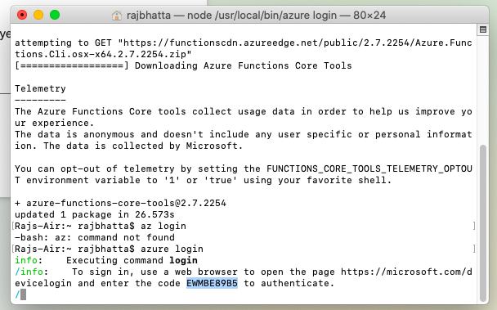

* **Copy the link and open in browser then enter code as shown below**

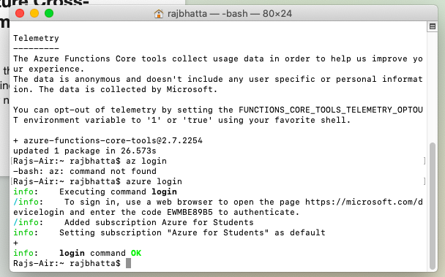

* **Then your browser will have**

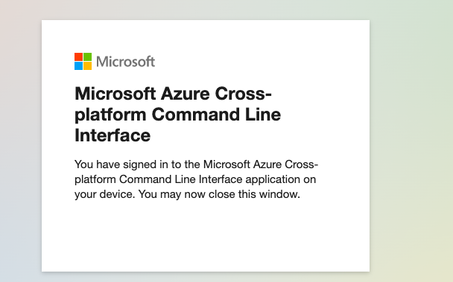

1. **Create Azure Trigger Function for development using Eclipse and Maven**

* **Create new Maven project**

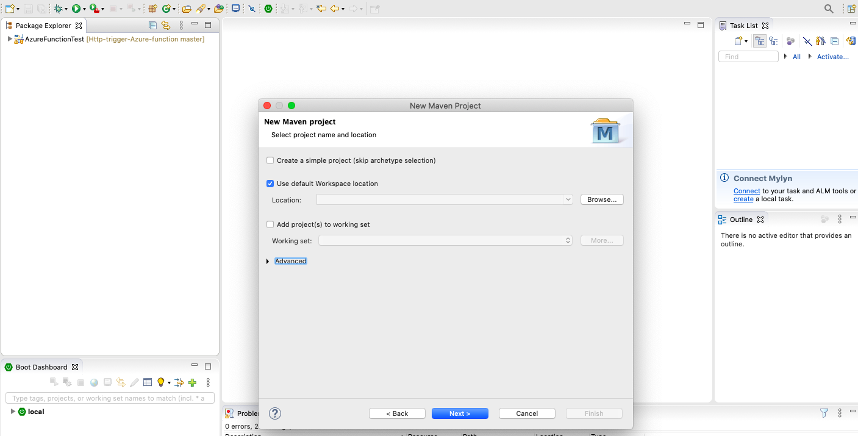

* **Click on next**

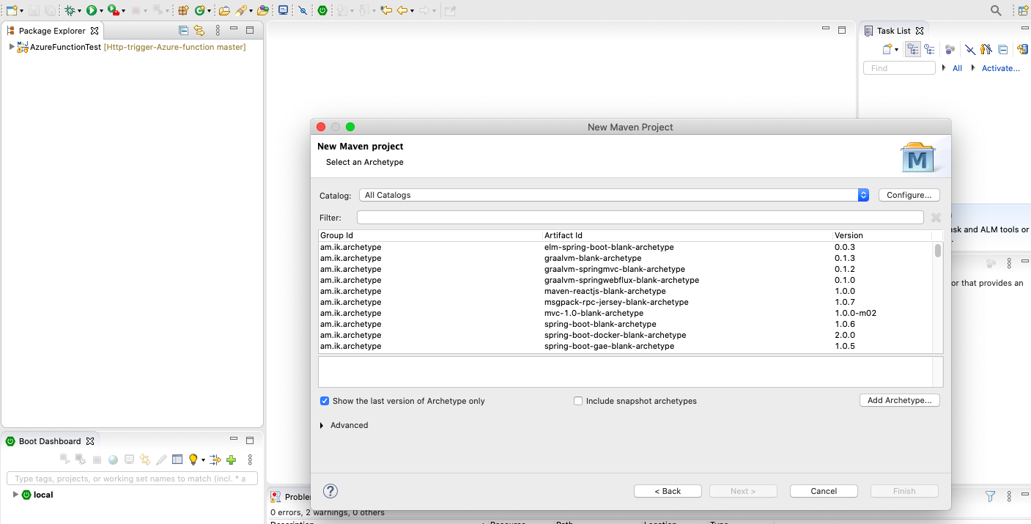

* **Click on add Archtype**

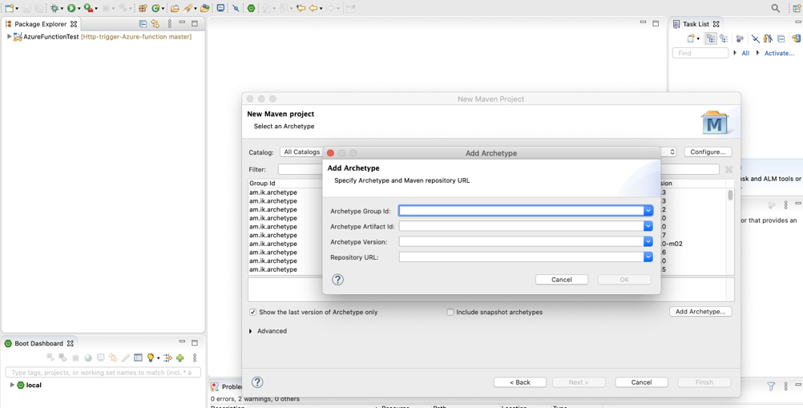

**Note: Maven repo for latest Azure function archtype:** <https://mvnrepository.com/artifact/com.microsoft.azure/azure-functions-archetype>

* **Provide archtype as shown below:**

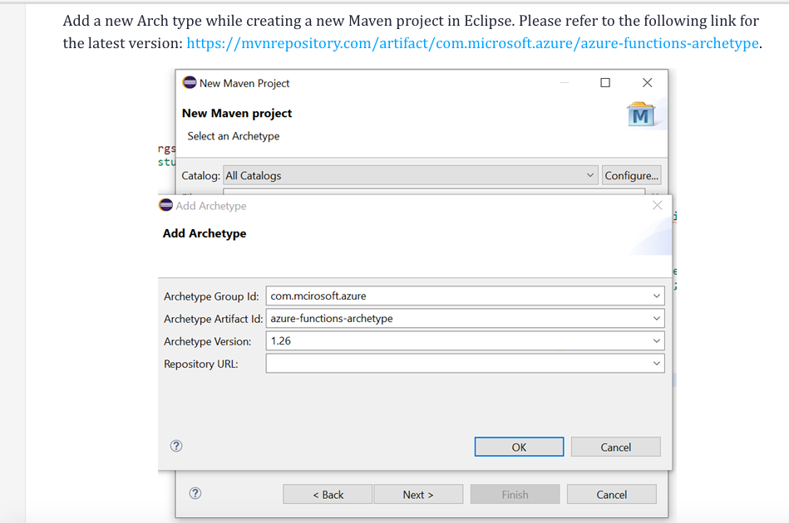

* **Search Azure function**

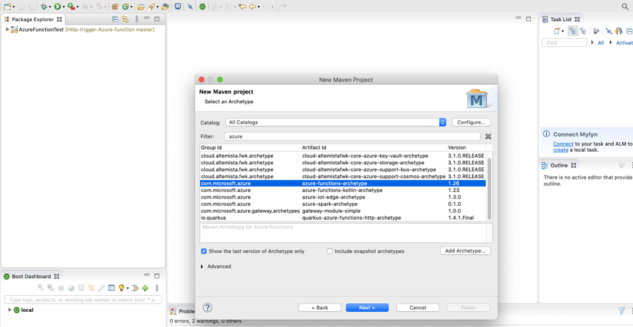

* **Fillup groupId and archtype**

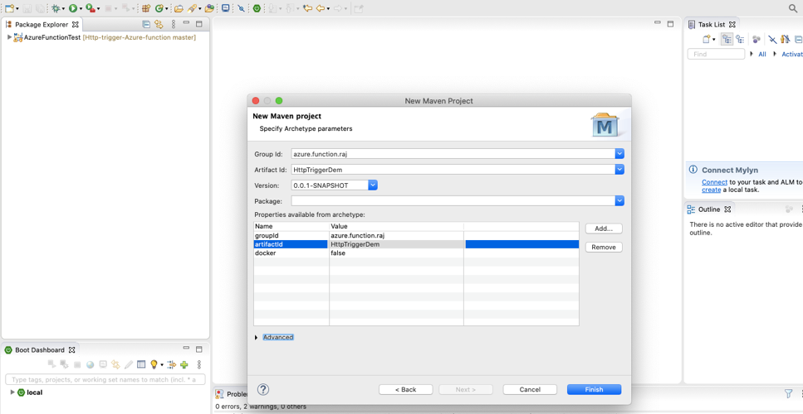

1. **Update resource group, function app and region inside POM.XML**

<?xml version=*"1.0"* encoding=*"UTF-8"* ?>

<project xmlns=*"http://maven.apache.org/POM/4.0.0"* xmlns:xsi=*"http://www.w3.org/2001/XMLSchema-instance"* xsi:schemaLocation=*"http://maven.apache.org/POM/4.0.0 http://maven.apache.org/xsd/maven-4.0.0.xsd"*>

<modelVersion>4.0.0</modelVersion>

<groupId>com.raj</groupId>

<artifactId>AzureFunctionTest</artifactId>

<version>0.0.1-SNAPSHOT</version>

<packaging>jar</packaging>

<name>Azure Java Functions</name>

<properties>

<project.build.sourceEncoding>UTF-8</project.build.sourceEncoding>

<maven.compiler.source>1.8</maven.compiler.source>

<maven.compiler.target>1.8</maven.compiler.target>

<azure.functions.maven.plugin.version>1.4.1</azure.functions.maven.plugin.version>

<azure.functions.java.library.version>1.3.1</azure.functions.java.library.version>

**<functionResourceGroup>RAJ-LAB-FUNCTIONS-GROUP</functionResourceGroup>**

**<functionAppName>AzureHttpTriggerFunction</functionAppName>**

**<functionAppRegion>westus</functionAppRegion>**

<stagingDirectory>${project.build.directory}/azure-functions/${functionAppName}</stagingDirectory>

</properties>

<repositories>

<repository>

<id>maven.snapshots</id>

<name>Maven Central Snapshot Repository</name>

<url>https://oss.sonatype.org/content/repositories/snapshots/</url>

<releases>

<enabled>false</enabled>

</releases>

<snapshots>

<enabled>true</enabled>

</snapshots>

</repository>

</repositories>

<pluginRepositories>

<pluginRepository>

<id>maven.snapshots</id>

<name>Maven Central Snapshot Repository</name>

<url>https://oss.sonatype.org/content/repositories/snapshots/</url>

<releases>

<enabled>false</enabled>

</releases>

<snapshots>

<enabled>true</enabled>

</snapshots>

</pluginRepository>

</pluginRepositories>

<dependencyManagement>

<dependencies>

<dependency>

<groupId>org.junit.jupiter</groupId>

<artifactId>junit-jupiter</artifactId>

<version>5.4.2</version>

</dependency>

<dependency>

<groupId>org.mockito</groupId>

<artifactId>mockito-core</artifactId>

<version>2.23.4</version>

</dependency>

<dependency>

<groupId>com.microsoft.azure.functions</groupId>

<artifactId>azure-functions-java-library</artifactId>

<version>${azure.functions.java.library.version}</version>

</dependency>

</dependencies>

</dependencyManagement>

<dependencies>

<dependency>

<groupId>com.microsoft.azure.functions</groupId>

<artifactId>azure-functions-java-library</artifactId>

</dependency>

<!-- Test -->

<dependency>

<groupId>org.junit.jupiter</groupId>

<artifactId>junit-jupiter</artifactId>

<scope>test</scope>

</dependency>

<dependency>

<groupId>org.mockito</groupId>

<artifactId>mockito-core</artifactId>

<scope>test</scope>

</dependency>

</dependencies>

<build>

<pluginManagement>

<plugins>

<plugin>

<groupId>com.microsoft.azure</groupId>

<artifactId>azure-functions-maven-plugin</artifactId>

<version>${azure.functions.maven.plugin.version}</version>

</plugin>

<plugin>

<groupId>org.apache.maven.plugins</groupId>

<artifactId>maven-resources-plugin</artifactId>

<version>3.1.0</version>

</plugin>

<plugin>

<groupId>org.apache.maven.plugins</groupId>

<artifactId>maven-dependency-plugin</artifactId>

<version>3.1.1</version>

</plugin>

<plugin>

<groupId>org.apache.maven.plugins</groupId>

<artifactId>maven-clean-plugin</artifactId>

<version>3.1.0</version>

</plugin>

</plugins>

</pluginManagement>

<plugins>

<plugin>

<groupId>com.microsoft.azure</groupId>

<artifactId>azure-functions-maven-plugin</artifactId>

<configuration>

**<resourceGroup>${functionResourceGroup}</resourceGroup>**

**<appName>${functionAppName}</appName>**

**<region>${functionAppRegion}</region>**

<appSettings>

<!-- Run Azure Function from package file by default -->

<property>

<name>WEBSITE_RUN_FROM_PACKAGE</name>

<value>1</value>

</property>

<property>

<name>FUNCTIONS_EXTENSION_VERSION</name>

<value>~2</value>

</property>

</appSettings>

</configuration>

<executions>

<execution>

<id>package-functions</id>

<goals>

<goal>package</goal>

</goals>

</execution>

</executions>

</plugin>

<plugin>

<groupId>org.apache.maven.plugins</groupId>

<artifactId>maven-resources-plugin</artifactId>

<executions>

<execution>

<id>copy-resources</id>

<phase>package</phase>

<goals>

<goal>copy-resources</goal>

</goals>

<configuration>

<overwrite>true</overwrite>

<outputDirectory>${stagingDirectory}</outputDirectory>

<resources>

<resource>

<directory>${project.basedir}</directory>

<includes>

<include>host.json</include>

<include>local.settings.json</include>

</includes>

</resource>

</resources>

</configuration>

</execution>

</executions>

</plugin>

<plugin>

<groupId>org.apache.maven.plugins</groupId>

<artifactId>maven-dependency-plugin</artifactId>

<executions>

<execution>

<id>copy-dependencies</id>

<phase>prepare-package</phase>

<goals>

<goal>copy-dependencies</goal>

</goals>

<configuration>

<outputDirectory>${stagingDirectory}/lib</outputDirectory>

<overWriteReleases>false</overWriteReleases>

<overWriteSnapshots>false</overWriteSnapshots>

<overWriteIfNewer>true</overWriteIfNewer>

<includeScope>runtime</includeScope>

<excludeArtifactIds>azure-functions-java-library</excludeArtifactIds>

</configuration>

</execution>

</executions>

</plugin>

<!--Remove obj folder generated by .NET SDK in maven clean-->

<plugin>

<artifactId>maven-clean-plugin</artifactId>

<version>3.1.0</version>

<configuration>

<filesets>

<fileset>

<directory>obj</directory>

</fileset>

</filesets>

</configuration>

</plugin>

</plugins>

</build>

</project>

1. **Running Azure function locally**

* Go inside project folder and type **mvn package**
* Then **mvn azure-functions:run** to run the Azure function

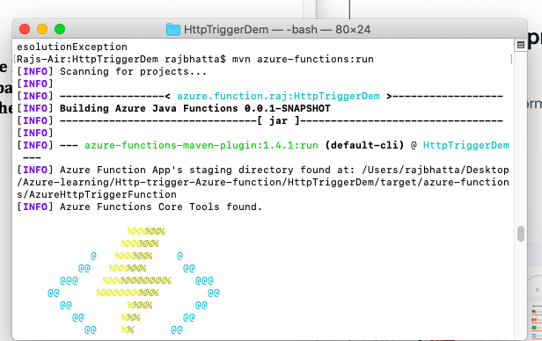

* **Goto web browser and type:** <http://0.0.0.0:7071/>

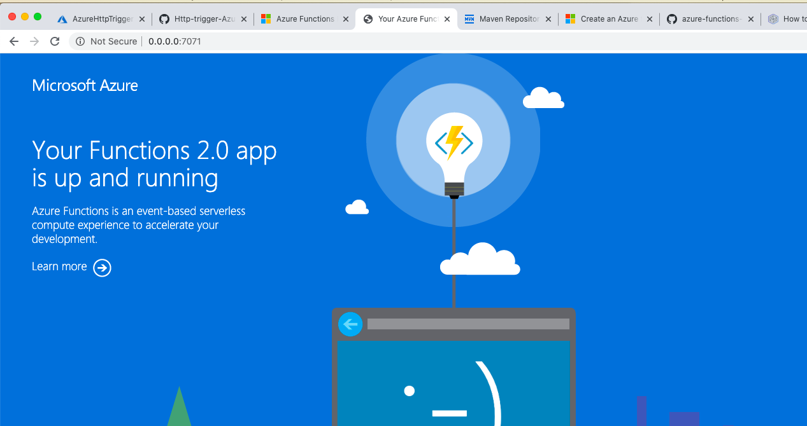

1. **Deploying Azure Function**

* Type Azure login to CLI and validate the login
* Then type: **mvn install package azure-functions:deploy**

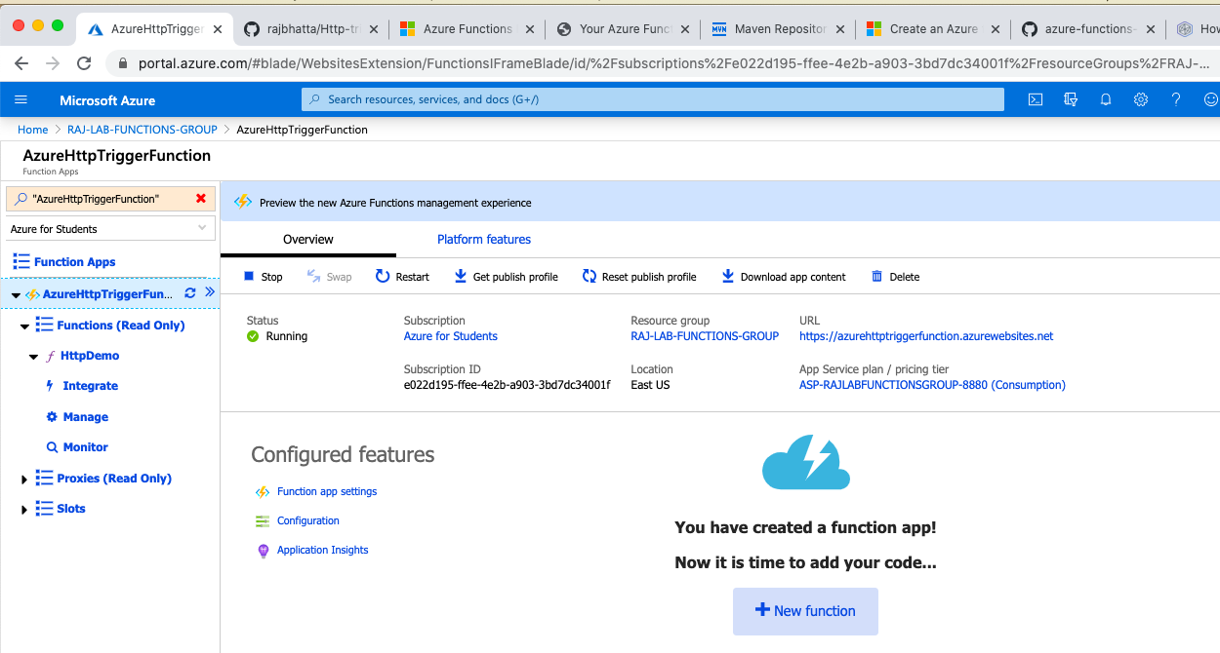

**Note: Http Demo is the function that we created along with above specified steps. Now, you can utilize this function to handle HttpGet and HttpPost**

**Note: Step to create Azure function in IntelliJ is provided here**

<https://docs.microsoft.com/en-us/azure/azure-functions/functions-create-maven-intellij>