**Ansible Terms:**

* **Controller Machine**: The machine where Ansible is installed, responsible for running the provisioning on the servers you are managing.
* **Inventory**: An initialization file that contains information about the servers you are managing.
* **Playbook**: The entry point for Ansible provisioning, where the automation is defined through tasks using YAML format.
* **Task**: A block that defines a single procedure to be executed, e.g. Install a package.
* **Module**: A module typically abstracts a system task, like dealing with packages or creating and changing files. Ansible has a multitude of built-in modules, but you can also create custom ones.
* **Role**: A pre-defined way for organizing playbooks and other files in order to facilitate sharing and reusing portions of a provisioning.
* **Play**: A provisioning executed from start to finish is called a play*.*In simple words, execution of a playbook is called a play.
* **Facts**: Global variables containing information about the system, like network interfaces or operating system.
* **Handlers**: Used to trigger service status changes, like restarting or stopping a service.

Ansible is a helpful tool that allows you to create groups of machines, describe how these machines should be configured or what actions should be taken on them. Ansible issues all commands from a central location to perform these tasks.

No other client software is installed on the node machines. It uses SSH to connect to the nodes. Ansible only needs to be installed on the control machine (the machine from which you will be running commands) which can even be your laptop. It is a simple solution to a complicated problem.

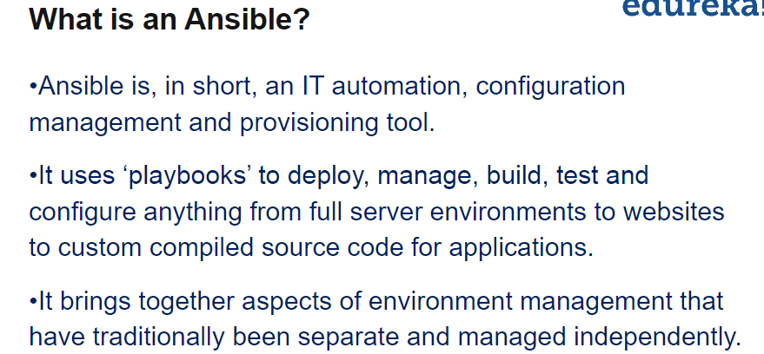

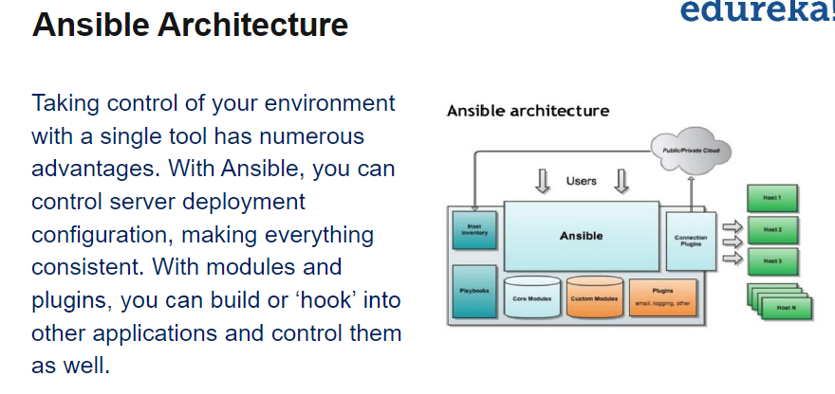

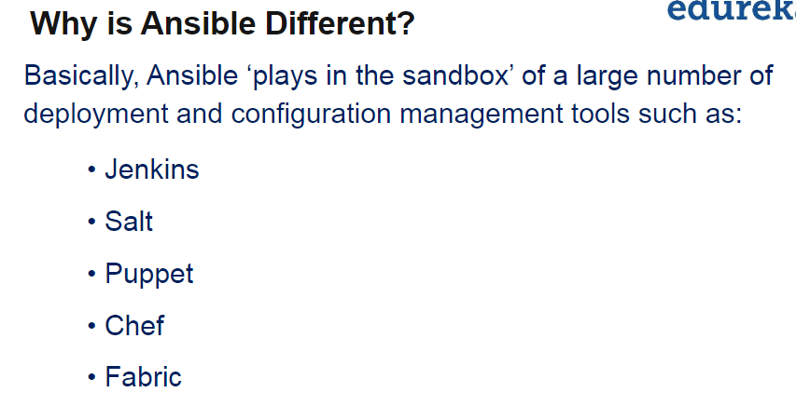

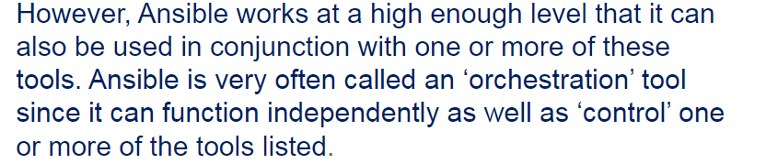

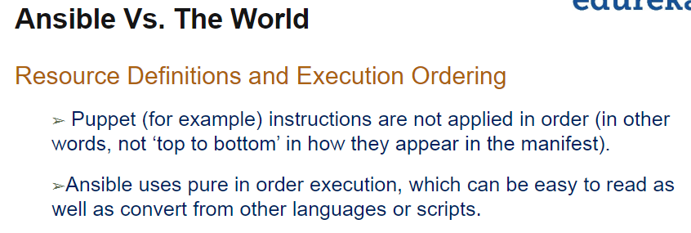

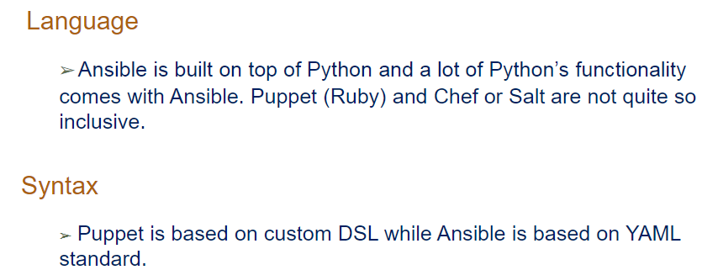

**Module 2**

**Setting up Ansible and AWS**

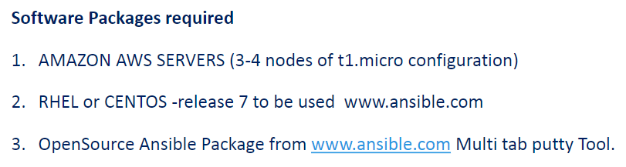

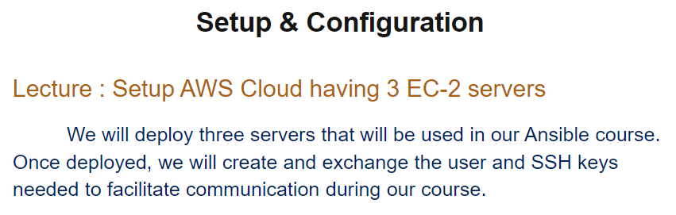

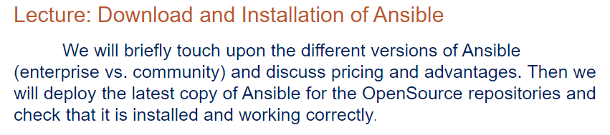

* **Rename machines to master and node1,node2,node3**
* **Add userdata test in all machines**
* **Vi /etc/ssh/ssh_config**

Set PasswordAuthentication yes

Set PermitRootLogin yes

* systemctl restart sshd (in all machines)
* Now check login without key, only with password of test user
* Now communicate between all nodes and master using ssh communication by sharing ad copying keys to all nodes(use private as we working internally)
* First give sudo permission to “test” user (**vi /etc/sudoers.d)**
* 
* Switch to test
* Ssh-keygen and shared keys using ssh-copy-id command
* 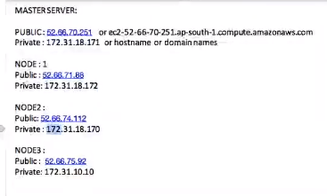

Do for all nodes and master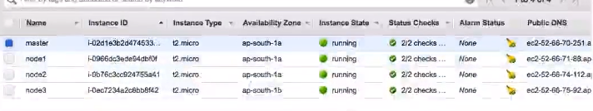

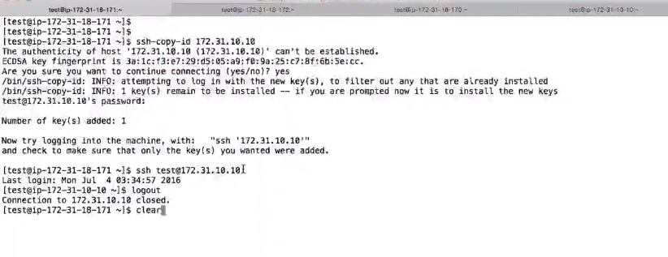

Note: Ansible required without password based authentication

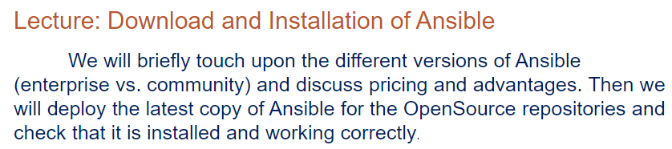

Need to install ansible now

<https://www.ansible.com/>

Try Tower Free

Before installing Ansible,

You need to have EPEL release installed to each nodes (extra pakage repository for RHEL 7) using wget

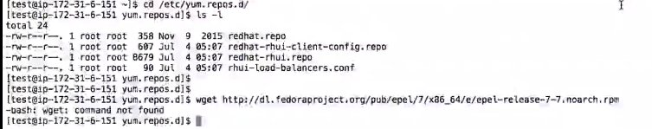

Yum install wget

/etc/yum.repos.d

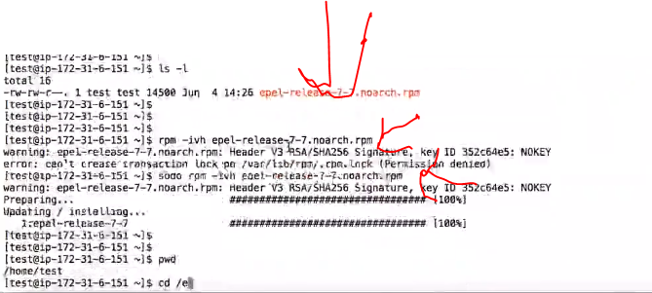

Sudo yum update (master and nodes)

Now install anisible using

**Sudo yum install ansible -y (on each machines)**

**(it will install python dependencies)**

**Ansible –version**

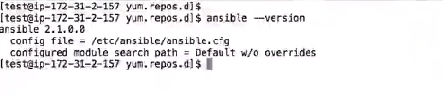

**Make sure config file exist on all the machines**

Enable logging /ansible.cfg and enable logging

Download free ansible from **fedora ansible**

**Module 3**

**Configuring Ansible**

