**Nginx vs Apache**

Apache server single request at a time



Whereas ngnix serves asynchronously means a single nginx process serve concurrently

So all dynamic connect serve by different process (php) and reverse proxy via nginx to the client

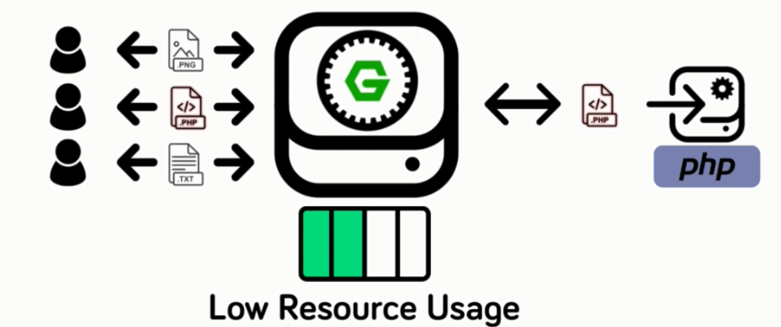



Ngnix serve static content/request without server side languages

-------------------------------------------------------------------------------------------------------



**Configuration Approach**

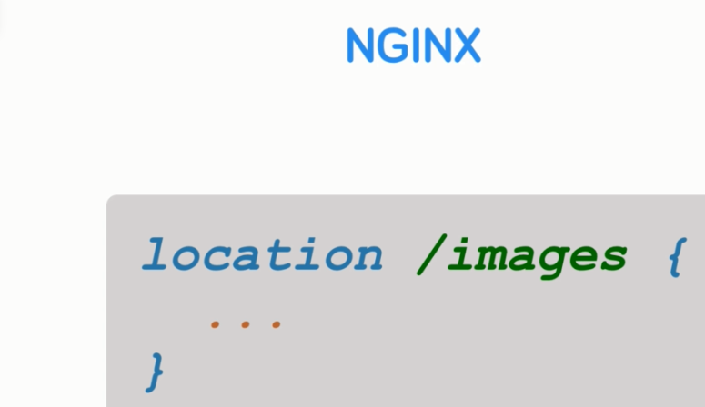

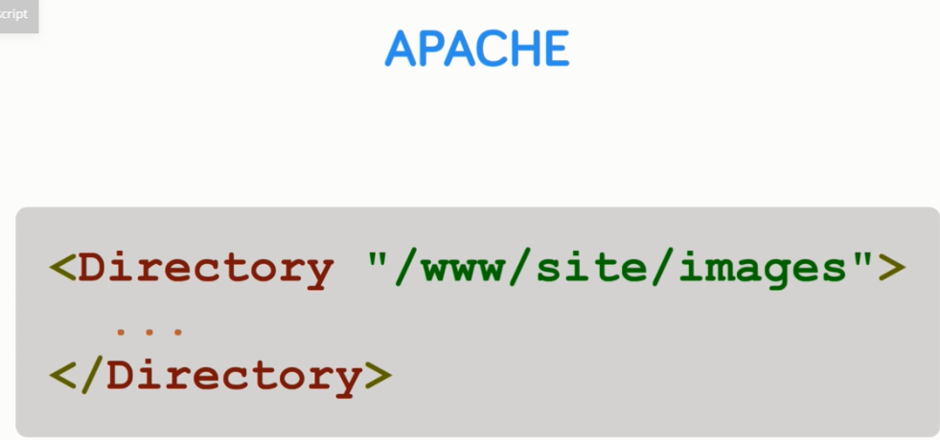



Section 2

Installing with a Package manager

And the first installation method will cover is via the operating systems built in backage manager.





apt-get update

apt-get add nginx

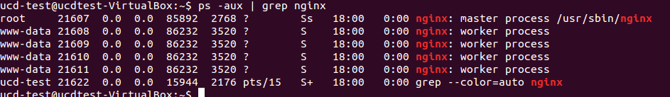

Ifconfig

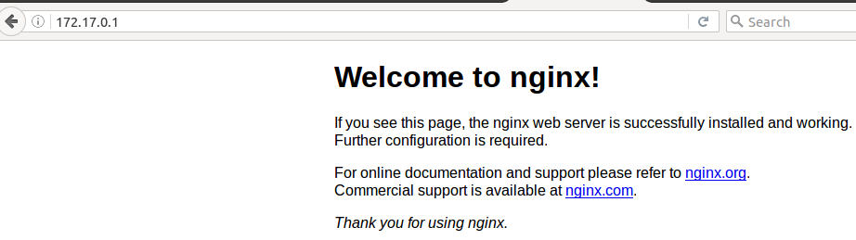

Config file are in /etc/config

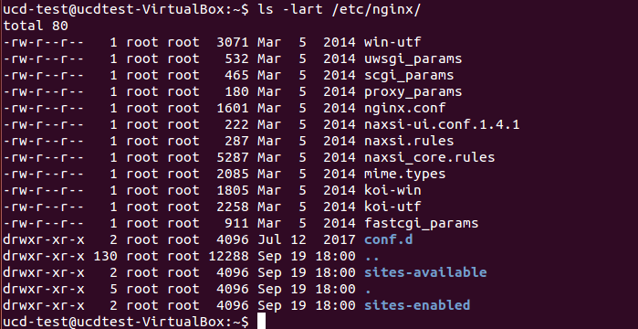

Similarly for centos use. YUM command

Lect 3, Section 2

