**Schools Performance Analysis:**

Analyzed performance on the Top and bottom performing schools based on the below data considerations:

* Local government Vs Independent schools:
* Average Budget spent on performance improvements.
* School Type & School Size

**Local government Vs private schools**:

There are total 15 schools with **39710** students in the area with overall passing rate:72.81% (Maths Passing percentage: 86.08% and Reading passing percentage:84.3%)

**Local Government Area Summary**



**School Summary:**

Students who passed with more than 50% or more in Maths and Reading scores are summarized with overall passing percentage below:

## 

## Top Performing Schools (By % Overall Passing):

Amont the top 5 performing schools with the highest overall passing rates, 3 are independent schools and 2 are government schools.

Griffin High school is at the top with an overall passing rate of 81.34%:

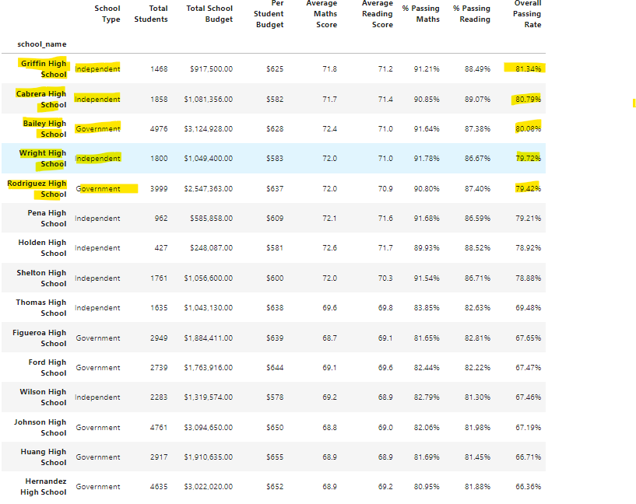

## Bottom Performing Schools (By % Overall Passing)

Though Government schools are among the Top 5 performing schools, there are some Government schools which are among Bottom 5 performing schools:

From the Bottom 5 performing schools, 4 are Government schools and 1 is independent school.

## Maths Scores by Year:

Bailey school (Government)students are topping on Maths & Reading scores.

## Reading Score by Year

## 

## Scores by School Spending:

## Schools with a spending range per student( $585-$630) has the highest passing percentage of 79.96%, but still some schools are not performing though the spending range is more than 630$ per student, need to consider the other factors per student.

## Scores by School Size:

## Looks like schools with smaller size (less than 1000 students) are top performing when comparing to schools with more than 1000 students.

## Scores by School Type:

## Based on the stats below, looks like independent schools are top performing with overall passing percentage 76.22% when compared to local government schools in the area.

## Conclusion:

Though the overall passing percentage are varying across the different parameters such as Budget spent per student, school size, Maths & Reading scores and the top 5 performing schools in the area.

Overall Independent schools are in better position compared to Local government schools which government has to take measures on the quality of education by recruiting knowledgeable teachers.