Task #3: Data profiling

The task is to perform data profiling for the dataset. Expected output of the task is:

### 1. brief description of how you checked the data. If needed screenshot(s), code/query

### snippets, excel formulas can be added and explained.

Answer: perform data profiling task, I have used power BI’s Power Query Editor (Used Get data 🡪 Text/CSV) and PostgreSQL database (Used Pentaho ETL tool to pull data).

Csv file categories:

Power BI tool:

Data type of all the columns look correct (marked red) and data validation results are also looking ok.

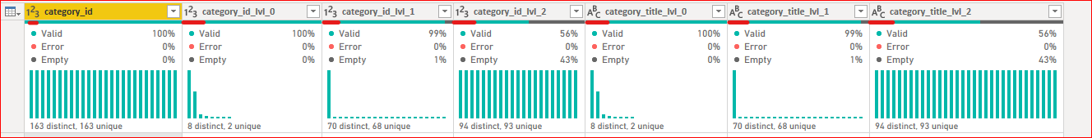

Check data quality on column level:

category_id: data type is integer.

Total number of column count is 163 and all are distinct. Zero empty rows, min value is 101 and 806. Please see in below picture:

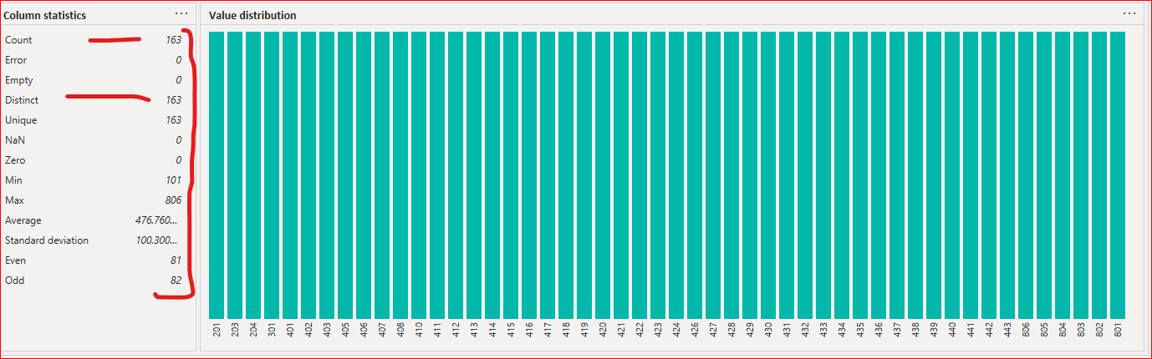

category_id_lvl_0: data type is integer.

Total number of column count is 163 and Zero empty rows, min value is 100 and 800. Please see in below picture:

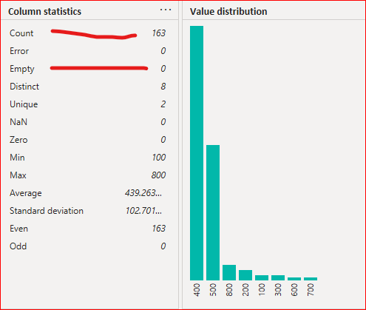

category_id_lvl_1 : data type is integer.

Total number of column count is 163 and 2 empty rows, min value is 101 and 806. Please see in below picture:

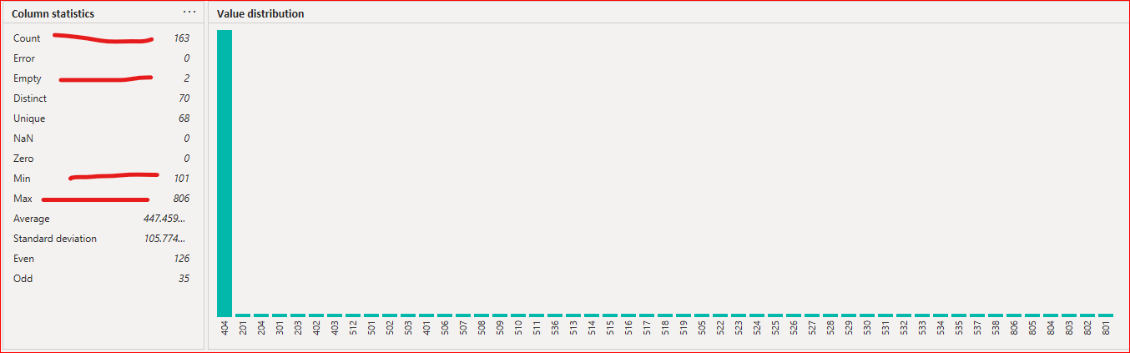

category_id_lvl_2 : data type is integer.

Total number of column count is 163 and 70 empty rows, min value is 405 and 497. Please see in below picture:

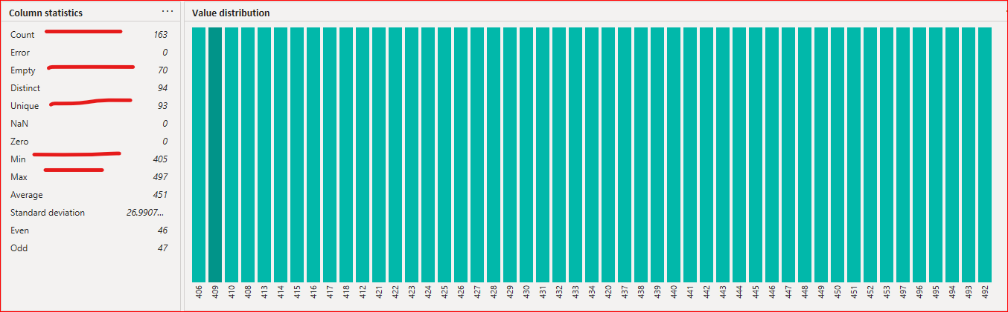

category_title_lvl_0: data type is string.

This column data statistics are matching with column category_id_lvl_0.

Please see in data below picture:

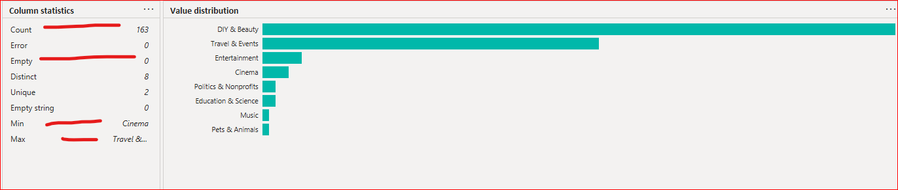

category_title_lvl_1 : data type is string.

This column data statistics are matching with column category_id_lvl_1.

Please see in data below picture:

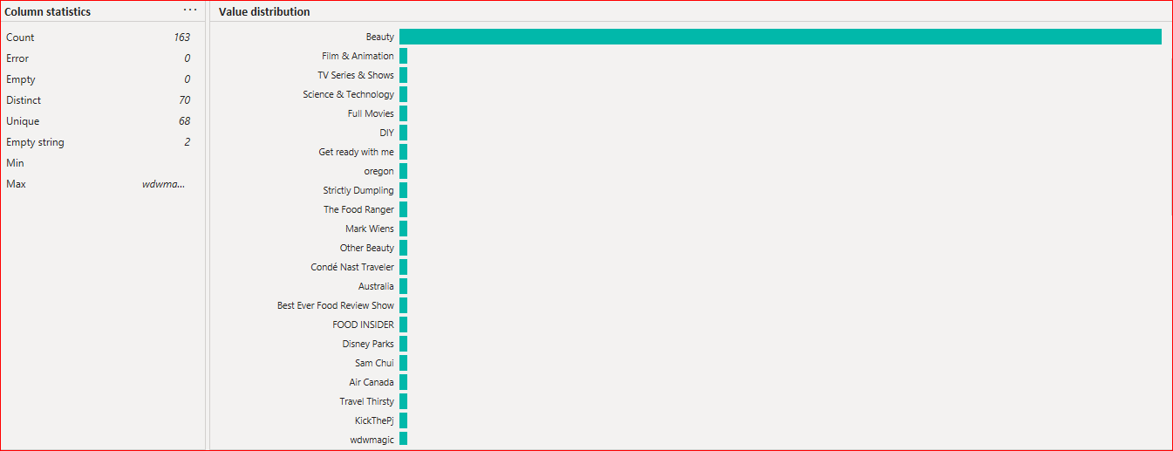

category_title_lvl_2 : data type is string.

This column data statistics are matching with column category_id_lvl_2.

Please see in data below picture:

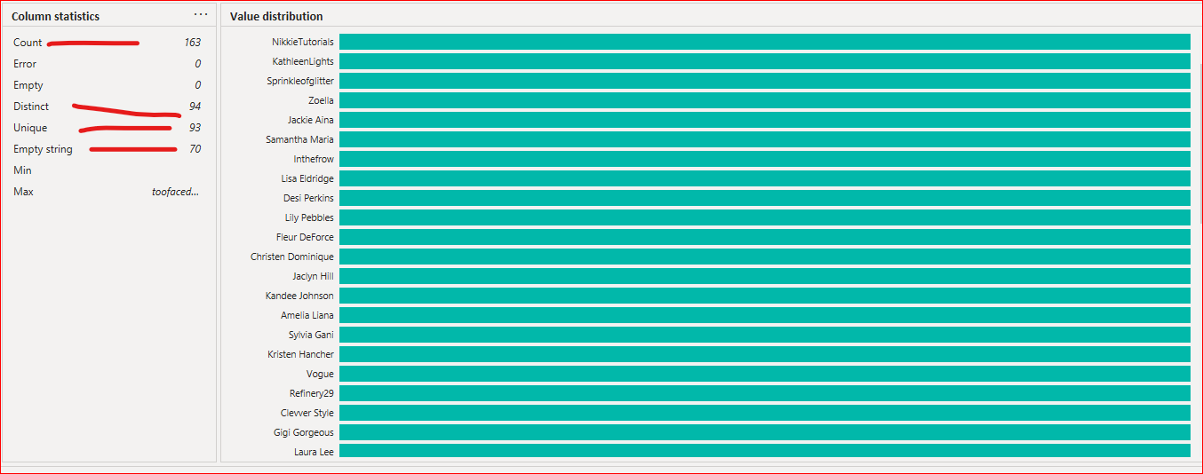

Check data via SQL queries

I have created test table in PostgreSQL database.

Create table query:

1. This distinct count based on category_id is 163 rows and our result is matching with Power BI result. Therefore, we can use column category_id as a primary key in table.

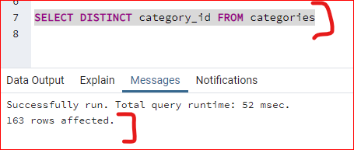

1. Number of rows count are matching one to one. For example , column category_title_lvl_2 has 93 rows same as category_id_lvl_2. Therefore, data is not missing in any columns.

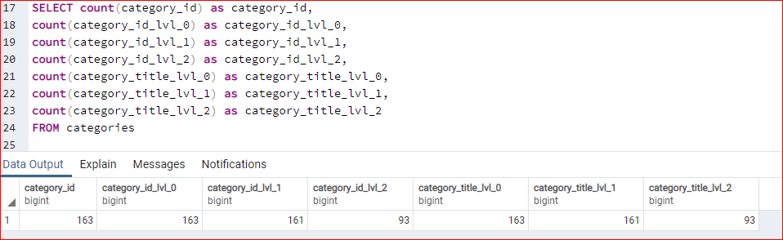

1. Categories are assigned as per the description.

‘Categories are assigned based on a tree-based structure. It has three-level depth, where the

highest level - named lvl_0 - can have lvl_1 sub-category, and lvl_1 level can have lvl_2

sub-category. Each transaction is described with at least one level and, at most, three level granularity; and the final category for each transaction is always assigned to the lowest possible

level.

’

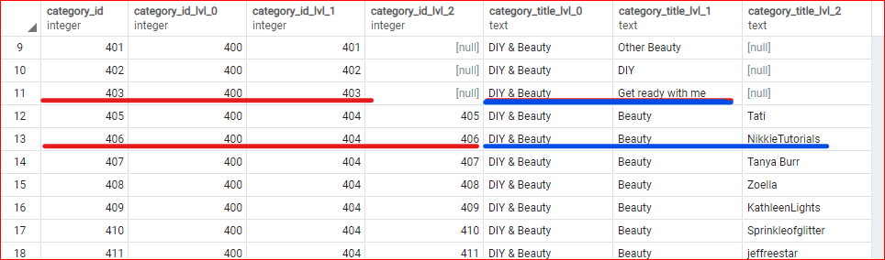

Csv file GB_videos:

Power BI tool:

First column has error correct (marked red) and column trending_date has a string data type but it should be date. However, other columns have correct data types and no Error found.

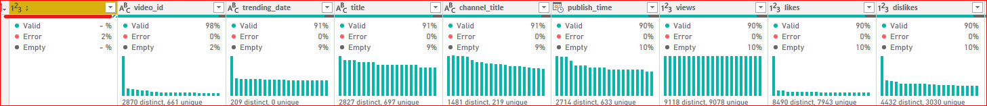

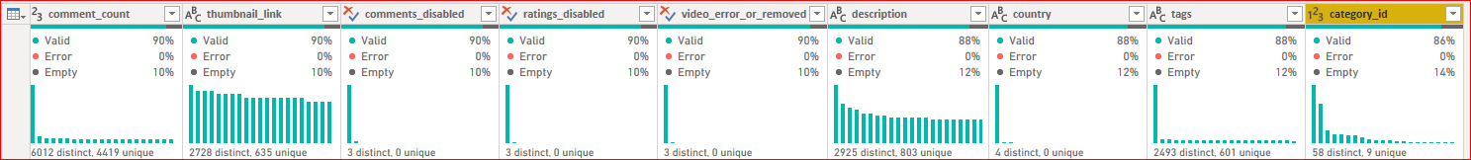

Individual column profile:

video_id: data type is string and there are issues with data quality. Video_id is word or special characters.

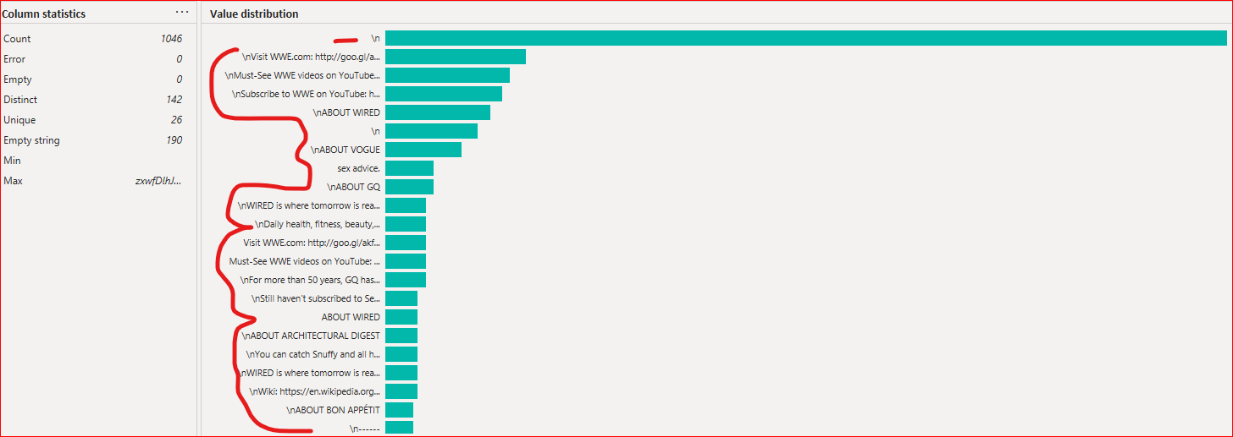

String length in video_id. Please see data in below picture:

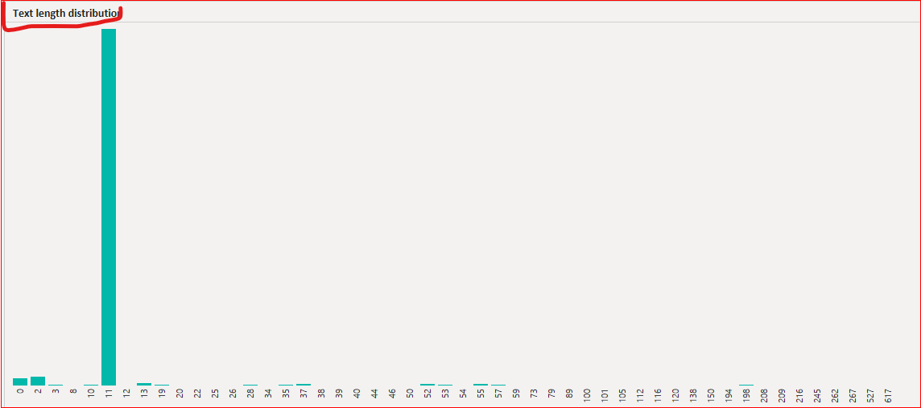

trending_date:

Date type is a string but it should be date. Word and date are in one column. Therefore, data are not correct in this column.

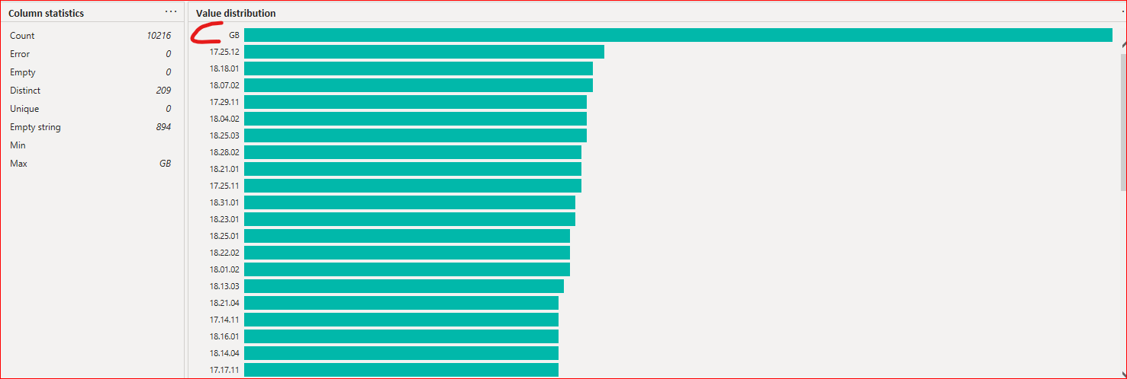

Title:

Data type is string and there are issues with data quality.

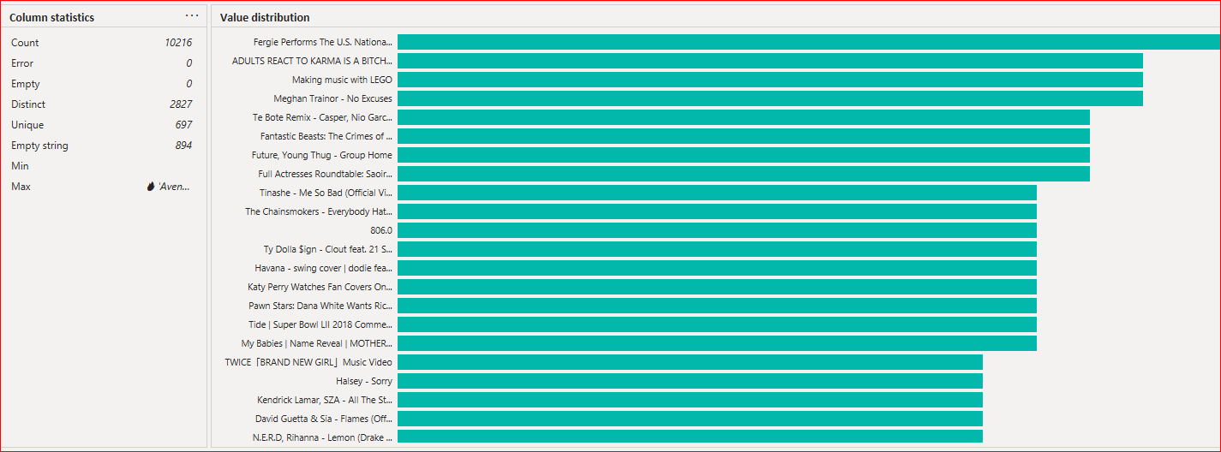

channel_title:

Data type is string and there are issues with data quality.

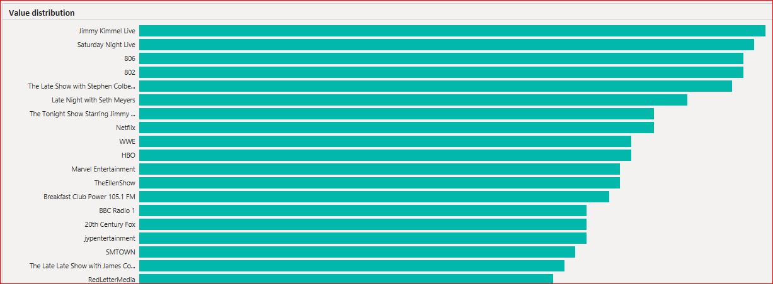

publish_time:

Data type is datetime and we have data from 2007 till 2018. It will help us to create calendar table in Power BI.

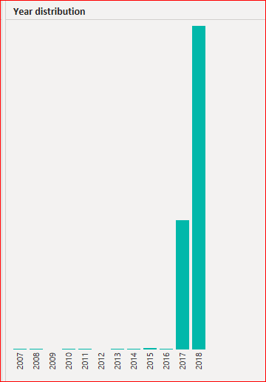

Views:

Data type is integer and have null values

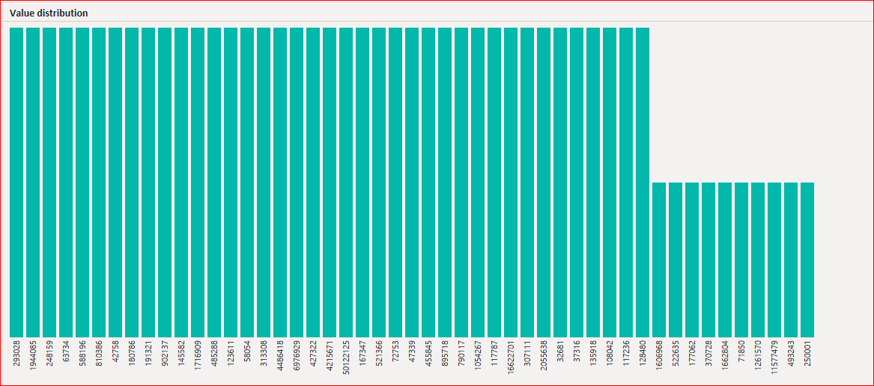

Likes:

Data type is integer and have null values

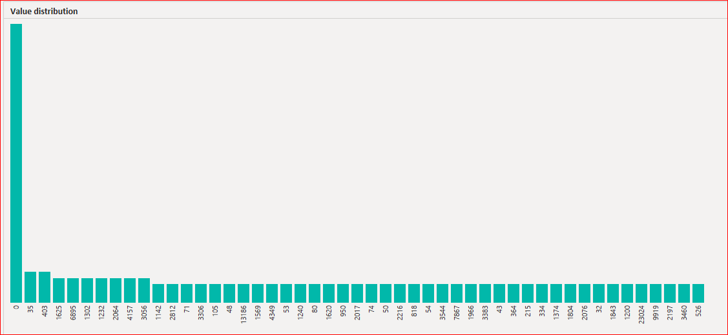

Dislikes:

Data type is integer and have null values

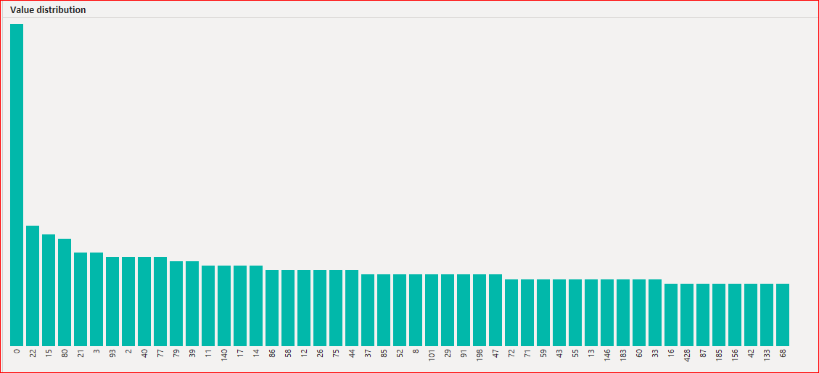

comment_count:

Data type is integer and have null values

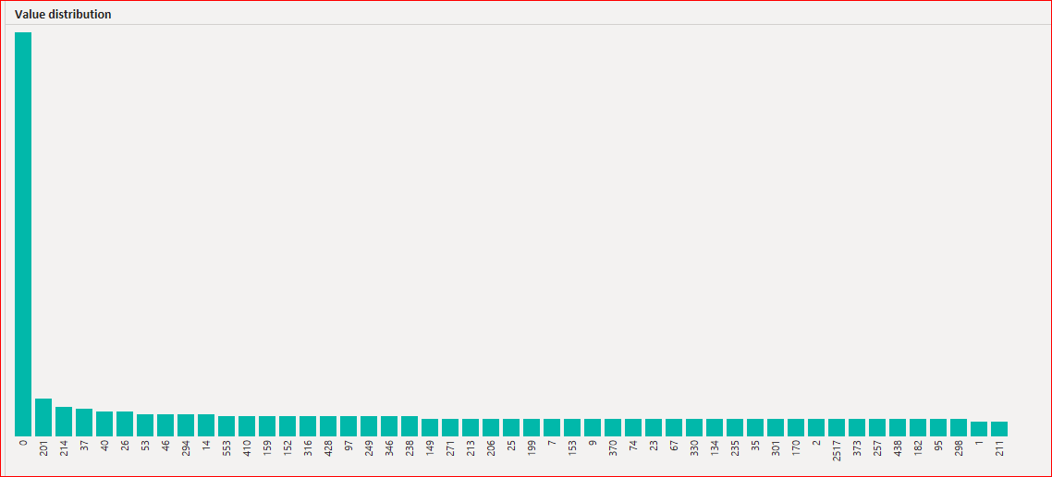

thumbnail_link:

Data type is string and have null values

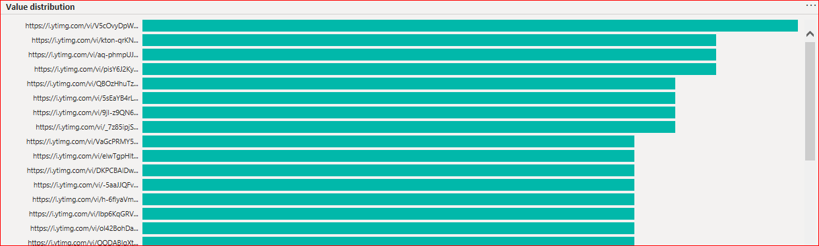

comments_disabled:

Data type is boolean and have null values

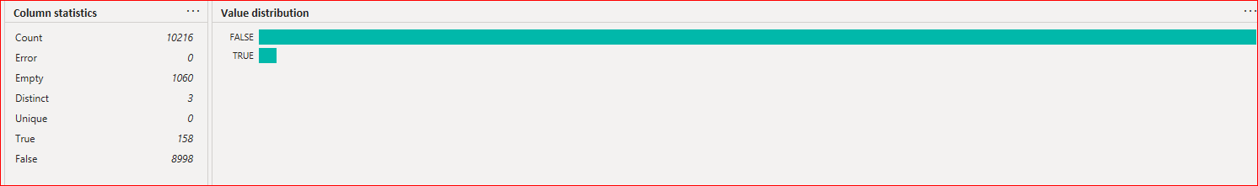

ratings_disabled:

Data type is boolean and have null values

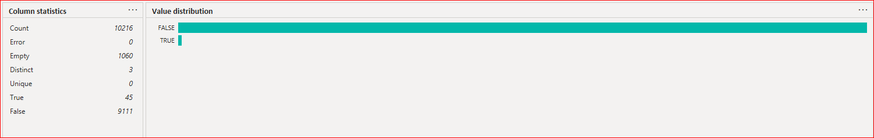

video_error_or_removed:

Data type is boolean and have null values

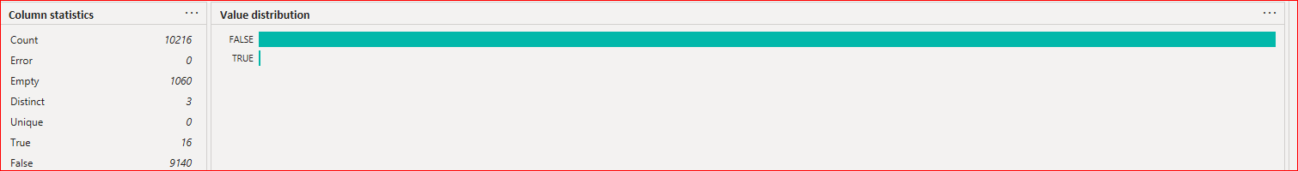

Description:

Data type is string and have null values

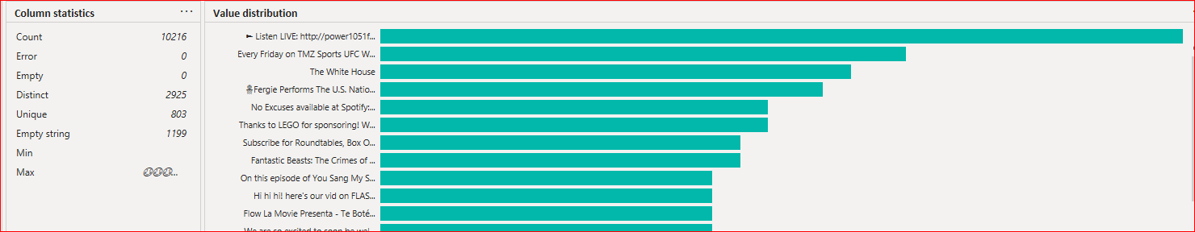

Country:

Data type is string and have null values

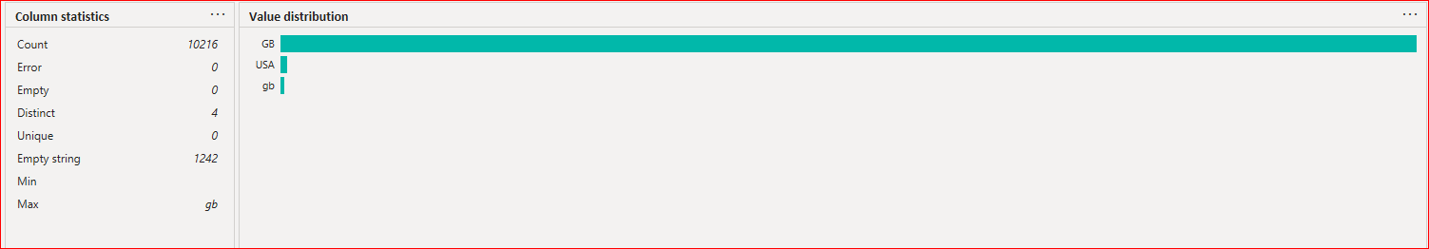

Tags:

Data type is string and have null values

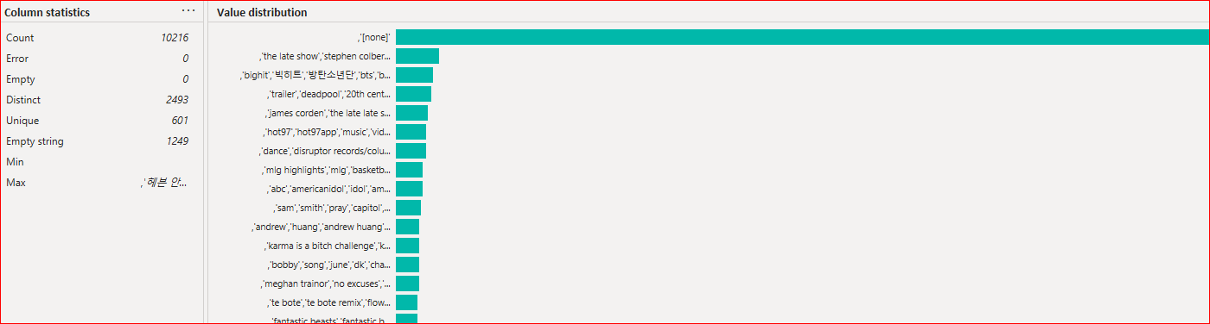

category_id:

Data type is integer and have null values

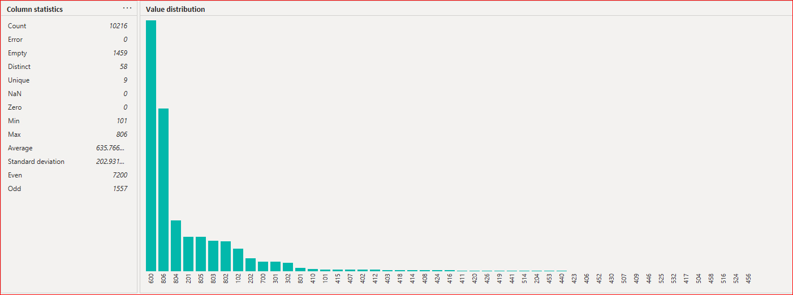

### 2. brief description of non-trivial data quality issues you noticed if any;

Table categories data quality issue:

I have not seen any major data quality issue in Table categories. There are Letter Case issues like capital letters, small letters in column category_title_lvl_1 and column category_title_lvl_2. Please see in below screenshots:

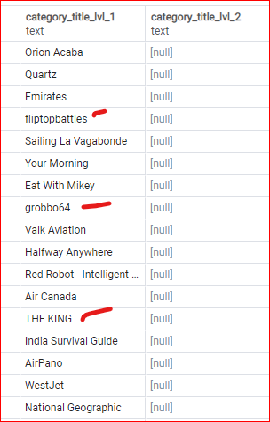

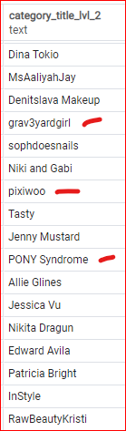

Table GB_videos data quality issue:

video_id:

Here are the following data issues:

Full length sentences, website urls, null values and duplicate ids.

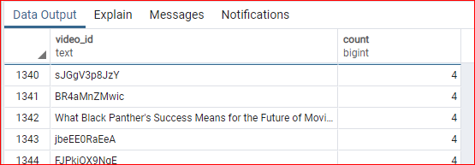

trending_date:

Here are the following data issues:

Date format, null values and word.

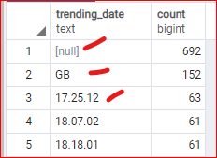

publish_time:

Here are the following data issues:

Date format and null values.

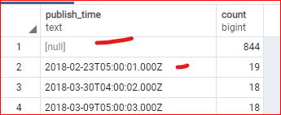

Country:

Here are the following data issues:

GB is in small and capital letter and null values.

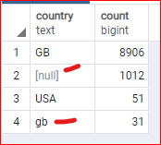

category_id

null values.

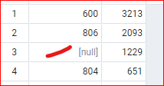

### 3. brief description of non-trivial improvements in data processing you would suggest if

### any;

Table categories:

INITCAP() function to convert a string to a new string that capitalizes the first letter of every word. All other letters will be lowercase.

select

category_id,

category_id_lvl_0,

category_id_lvl_1,

category_id_lvl_2,

category_title_lvl_0,

INITCAP(category_title_lvl_1) as category_title_lvl_1,

INITCAP(category_title_lvl_2) as category_title_lvl_2

from categories

Result:

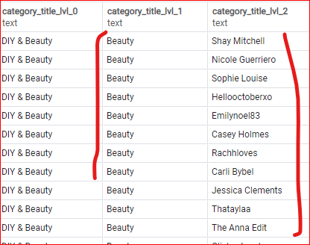

OR

In ETL process, you can fix this issue on the fly.

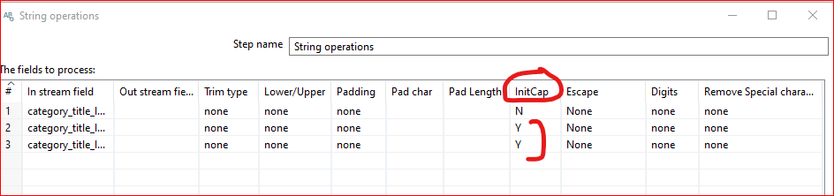

Table GB_videos:

There are the following data qualities issues will fix if we just gather data where category_id is not null.

We need to correct date format for two columns (trending_date and publish_time) and change GB value from small and capital letters in column Country. All this issues, we can fix in ETL process very easily.

Step 1:

Pull raw data in temp table and put assign data type as text.

Step 2:

* Gather data from temp table
* Perform data manipulation and cleaning task
* Insert clean data with the help of below SQL query in database .

select

video_id,

TO_DATE(CONCAT(substring(trending_date,1,2), '-', substring(trending_date,4,2), '-', substring(trending_date,7,2)),'yy-DD-MM') as trending_date,

title,

channel_title,

TO_DATE(CONCAT(substring(publish_time,1,4), '-', substring(publish_time,6,2), '-', substring(publish_time,9,2), ' ', substring(publish_time,12,8)),'yyyy-MM-dd hh24:mi:SS') as publish_time,

views,

likes,

dislikes,

comment_count,

thumbnail_link,

comments_disabled,

ratings_disabled,

video_error_or_removed,

description,

UPPER(country) as country,

tags,

category_id

from GB_videos

where category_id is not null

### 4.your final conclusion whether this data set is good enough for further analysis.

We can join table GB_videos and Categories with column category_id. This is data is good for further analysis task.

select

---columns from table GB_videos

gbv.video_id,

gbv.trending_date,

gbv.title,

gbv.channel_title,

gbv.publish_time,

gbv.views,

gbv.likes,

gbv.dislikes,

gbv.comment_count,

gbv.thumbnail_link,

gbv.comments_disabled,

gbv.ratings_disabled,

gbv.video_error_or_removed,

gbv.description,

UPPER(gbv.country) as country,

gbv.tags,

---columns from table categories

gbv.category_id,

ct.category_id_lvl_0,

ct.category_id_lvl_1,

ct.category_id_lvl_2,

ct.category_title_lvl_0,

ct.category_title_lvl_1,

ct.category_title_lvl_2

from GB_videos gbv

left join categories ct on gbv.category_id = ct.category_id

where gbv.category_id is not null

Note: I have attached file create_table_Task3.sql. In this file, you can find create table scripts for categories, GB_videos_temp and GB_videos.