**Objective Questions**

1. **What is total number of tables present in the data?**

**Ans.** The given data has **2** tables on two different sheets.

**Point of view: -** We can visually see it in given raw data workbook.

1. **What is the total no. of attributes present in the data?**

**Ans.** In given Data there are **22** attributes. **20** attributes in table from Raw data sheet and **2** in table of Country description sheet.

**Point of view: -** We can count it manually.

1. **How many categorical columns are there in the data? [Search about categorical and continuous data, and try to answer this question]**

**Ans.** There are 15 categorical columns in given data.

**Point of view: -** The column which gives you categories and has only finite value car called categorical columns. We can count it manually.

1. **The data consists of some inconsistent and missing values so ensure that the data used for further analysis is cleaned.**

**Ans.** Longitude and Latitude columns were deleted from the data. There were 9 blank cells in cuisine column which were replaced According to country code and highest occurring Cuisine.

**Point of view:** - Longitude and latitude cannot be replaced by mean of mode because they define specific place or location and we don’t need it for getting insights so I deleted it. The blank cells in Cuisine were replace by Mexican because Mexican cuisine is most occurring cuisine in that country.

1. **Using the LookUp functions, fill up the countries in the original data using the country code.**

**Ans.** The VLOOKUP formula used for fetching country names is

**=VLOOKUP(Reference cell,'country description'!$A$2:$B$16,Index Number)**

**Point of View: -** We need country named in original data so I added new Column in Raw data sheet and fetched the country names using above given formula.

1. **Create a table to represent the number of restaurants opened in each country.**

**Ans.** I have created a Pivot table to show the number of restaurants in each country.

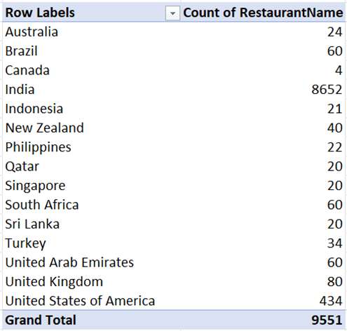

1. **Also, the management wants to look at the number of restaurants opened each year, so provide them with something here.**

**Ans.** I have created a pivot table to show number of restaurants opened each year.

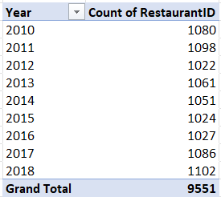

1. **What is the total number of restaurants in India in the price range of 4?**

**Ans.** The total number of Restaurants in India with price range of 4 is **388.**

**Point of view: -** I got to that answer using COUNTIFS function

**=COUNTIFS($U:$U,"India",$O:$O,4)**

1. **What is the average number of voters for the restaurants in each country according to the data?**

**Ans.** The Average number of voters for restaurants in each country is represented as below

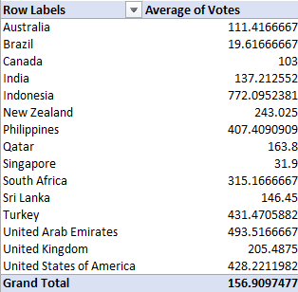

1. **Calculate the average rating for all the restaurants that have price_range < 4 and provide online delivery. Use only the “IF” function, Logical Operators, ad Aggregation functions to solve this problem. [Note: Don’t use Conditional aggregation in this question.]**

**Ans.** The average rating for all the restaurants that have price_range < 4 and provide online delivery is **3.27381151**

**Point of view: -** AVERAGEIFS function was used which is given below

**=AVERAGE(IF(('Raw Data'!O2:O9552<4)*('Raw Data'!L2:L9552="Yes"),'Raw Data'!S2:S9552))**

1. **Using Conditional formatting highlight the rows of restaurants that are located in the countries or cities that you’ve suggested to the management for opening new restaurants.**

**Ans.** Rows of restaurants that are located in the countries or cities that you’ve suggested to the management for opening new restaurants are highlighted with orange colour.

**Point of view: -** You can see it in Excel sheet that the rows are been highlighted on the basic of country and cities.

1. **Create a new customized price column that consists of the abbreviation/symbol of the currency along with the Average_cost_for_two values. [Use string operations to do this task]**

**Ans.** New customized price column that consists of the abbreviation/symbol of the currency along with the Average_cost_for_two value was created using text to column and concate function

**Point of view: -** At first, I used Text to column to extract the symbol of currency from the existing column currency and then used the concate function in Newly created column to get it together. The function used is given below

**=CONCAT(J2,"",Q2)**

1. **How can you create an array formula in Excel or Google Sheets to count the number of restaurants listed that do not offer online delivery, are in the lowest price range, and have an average cost for two people less than or equal to 250 Indian Rupees?**

**Ans.** An array formula in Excel to count the number of restaurants listed that do not offer online delivery, are in the lowest price range, and have an average cost for two people less than or equal to 250 is 1685 .

**=SUM(COUNTIFS('Raw Data'!O2:$O$9552,"1",'Raw Data'!L2:$L$9552,"No",'Raw Data'!X2:$X$9552,"<=250"))**

**Subjective Question**

1. **Suggest a few countries where the team can open newer restaurants with lesser competition. Which visualization/technique will you use here to justify the suggestions?**

**Ans.** After studying the data I came on conclusion that to open the Restaurant minimum three to four parameters should be taken under consideration.

I suggest that the countries where the Company should open the Restaurants are

1. New Zealand.
2. Philippines.
3. Turkey.

**Insights and Approach: -**

1. **New Zealand -** The total number of restaurants present in this country is 40. No online food delivery is provided in any of these restaurants. The Average rating of all the restaurants is 4.34. The overall price range for this country is 1-4. The growth in number of restaurants is seen after 2016.
2. **Philippines -** The total number of restaurants present in this country is 22. No online food delivery is provided in any of these restaurants. The Average rating of all the restaurants is 4.42. The overall price range for this country is 2-4. The growth in number of restaurants is seen after 2016.
3. **Turkey -** The total number of restaurants present in this country is 34. No online food delivery is provided in any of these restaurants. The Average rating of all the restaurants is 4.3. The overall price range for this country is 2-4. The growth in number of restaurants is seen after 2017.

**Reference: -**

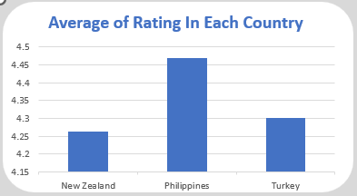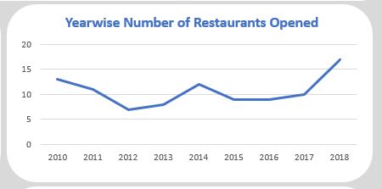

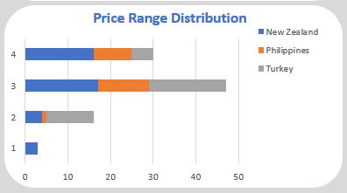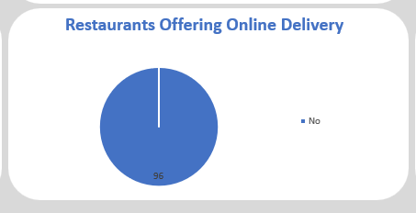

1. **Come up with the names of States and cities in the suggested countries suitable for opening restaurants.**

**Ans.** After studiying the data I came up with tis names of cities where company should open restaurants.

1. Auckland.
2. Pasay city.
3. Taguig city.
4. ÛÁstanbul.

**Insight and Approach: -**

1. There is no growth in number of restaurants last few years. Even there is good rating for the present restaurants. Opening restaurant and porviding online food delivery
2. In above cities the number of restaurant is less compared to other cities in that country. There is wide range of cuisine compared to restaurant in that country which will help to attract various catogeries of customers.

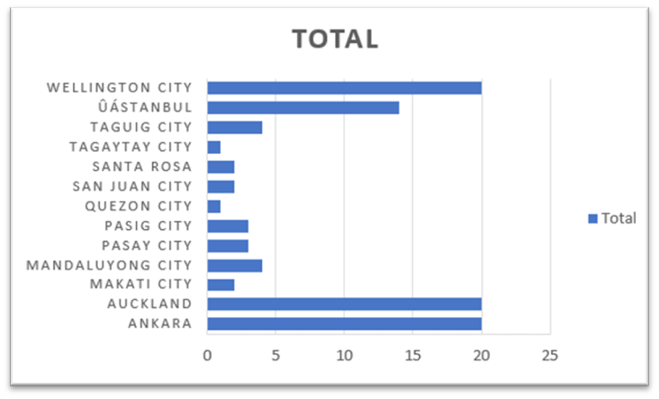

1. **According to the countries you suggested, what is the current quality regarding ratings for restaurants that are open there?**

**Ans.** The current quality regaurding rating in the New Zealand, Philippines and Turkey is good. The average rating in all three countries is above 4.

**Approach and insight: -**

1. The average rating In all three countries is above 4. Wecan see by the map given below that average rating of New Zealand is 4.26, for Philippines it 4.46 and for Turkey it is 4.3.
2. The average rating country wise also good as you can see it in below mentioned table.

**Reference: -**

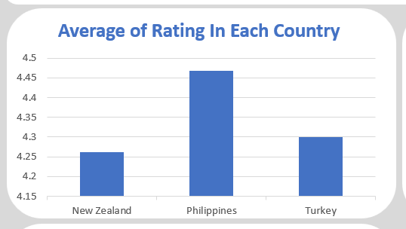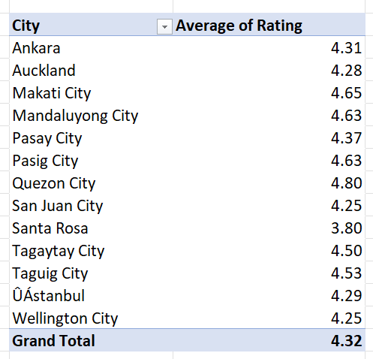

1. **Also, what is the current expenditure on food in the suggested countries, so we can keep our financial expenditure in control?**

**Ans.** Theaverage cost for two is affordable amount in each individual country. The prices are given in currencies of individual country.

**Approach and insights: -**

The pivot table was created to find average cost for 2 in each country and the filter was applied to the pivot table which gave the average cost of two for the countries I selected

**Reference: -**

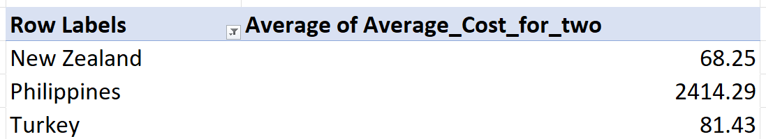

1. **Come up with the names of restaurants from the recommended states that are our biggest competitors and also those that are rated in lower brackets, i.e.1-2 or 2-3**

**Ans.** The restaurants given table shows the Restaurants that are the competitors to our business in the country and Cities. These are the restaurants whose Rating is between 4.5 to 5 and has average price range in all 1 to 4 range.

**Reference: -**

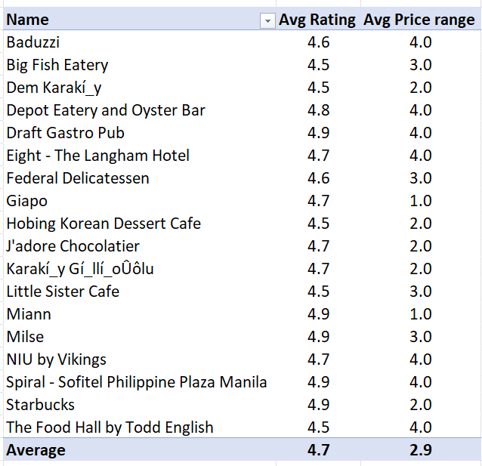

There is only one hotel which comes is rated in bracket of 1-3 that is **De Fontein Belgian Beer Café** whose rating is 2.3.

1. **Which cuisines should we focus on in the newer restaurants to get better feedback? Does the choice of cuisines affect the restaurant ratings?**

**Ans.** There are various cuisines in the all three countries but the cuisine on which we should focus should are the cuisine with Average rating from 4 - 5 in last 5 years

The price range for this cuisine is between 2 – 4 and are popular in the countries and the cities I have selected

Yes, Choice of cuisine Affects the restaurants rating as people prefer the cuisine which is regular for them and that are familiar with in their daily appetite.

**Reference: -**

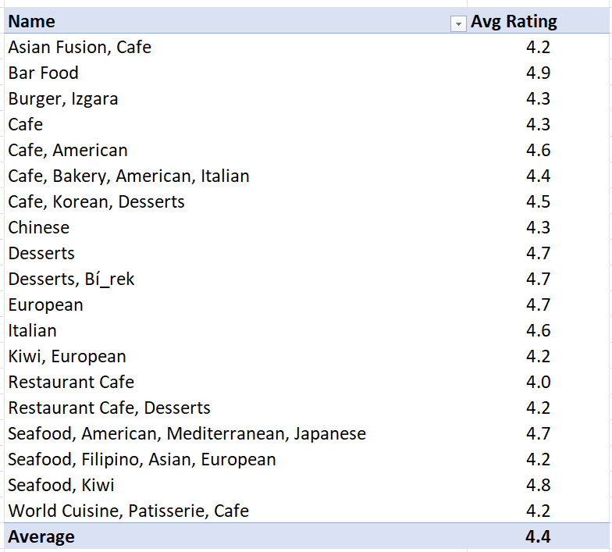

1. **According to our current data, should we go for online delivery and table booking? Does that affect the customer’s ratings?**

**Ans.** In the selected countries Online delivery’s is not provided which means we will be first to be in that criteria and it will definitely affect the rating. It will increase the rating if we provide good service.

Table booking is provided an all-selected countries but only in few restaurants so we can enter in that category also for other restaurants.

**Reference: -**

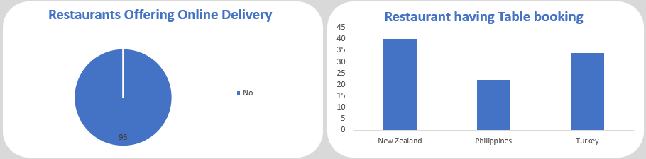

1. **Should the team keep the rate of cuisines higher? Will that affect the feedback? According to our data are the rates of cuisines and ratings, correlated?**

**Ans.** Price do not affect the rating as you can see in give below chart that even if the price is high the rating is still good above 4.5. If the service provided is good then it won’t affect the rating.

**Reference: -** 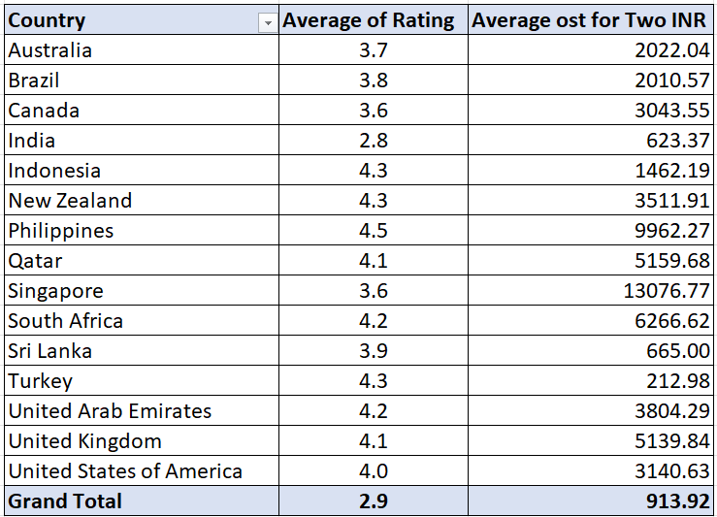

1. **What is the distribution of the number of restaurants of different price ranges in all the countries?**

**Ans.** A) So according to price range distribution of number of restaurants varies with respect to that country.

B) Most of countries has all 4price range but some countries have only 2 or 3 price range.

C) As India has the highest number of restaurants but by ratio has a smaller number of restaurants in price range 4 where the countries like Qatar, Singapore, South Africa has higher number of restaurants by ratio with price range of 4.

D) Most of the countries don’t even have a single restaurant with price range of 1.

E) Most countries are having restaurants with price range of 3 in majority.

F) Below is the chart that displays the number of restaurants but in ratio which is easy to understand for determining the price range.

1. **Explain your approach in brief for suggesting countries/cities in order to open new restaurants, if the objective and subjective questions would have not been given to assist you.**

**Ans.** My general approach for opening new restaurant will focus on 4 things

1. **Cuisine** – The cuisine which I will select will be Familiar and Favorable to the Locality where I am planning to open the restaurant.
2. **Price range** – I will always go with medium and higher price like upper bracket of price range. I will consider the lower price if and only if it has high demand.
3. **Competition & High Demand** - I will generally prefer the area with low competition and higher demand. Places like Hospitals, School & Colleges and working areas.
4. **Service** – I will ensure that we provide the best service in that area where we are working