WOXSEN UNIVERSITY
B.Tech Artificial Intelligence and Machine Learning | Database Management Systems
HackerRank Profile
Name | Student ID | Platform / username | Profile link
B. Deekshan Raj (Bangla Deekshan Raj) | 25WU0102037 | HackerRank / deekshan_b_2029 | hackerrank.com/profile/deekshan_b_2029

1. Profile login screenshot
HackerRank profile, logged in as Bangla Deekshan Raj (@deekshan_b_2029). The badge shown is Problem Solving.
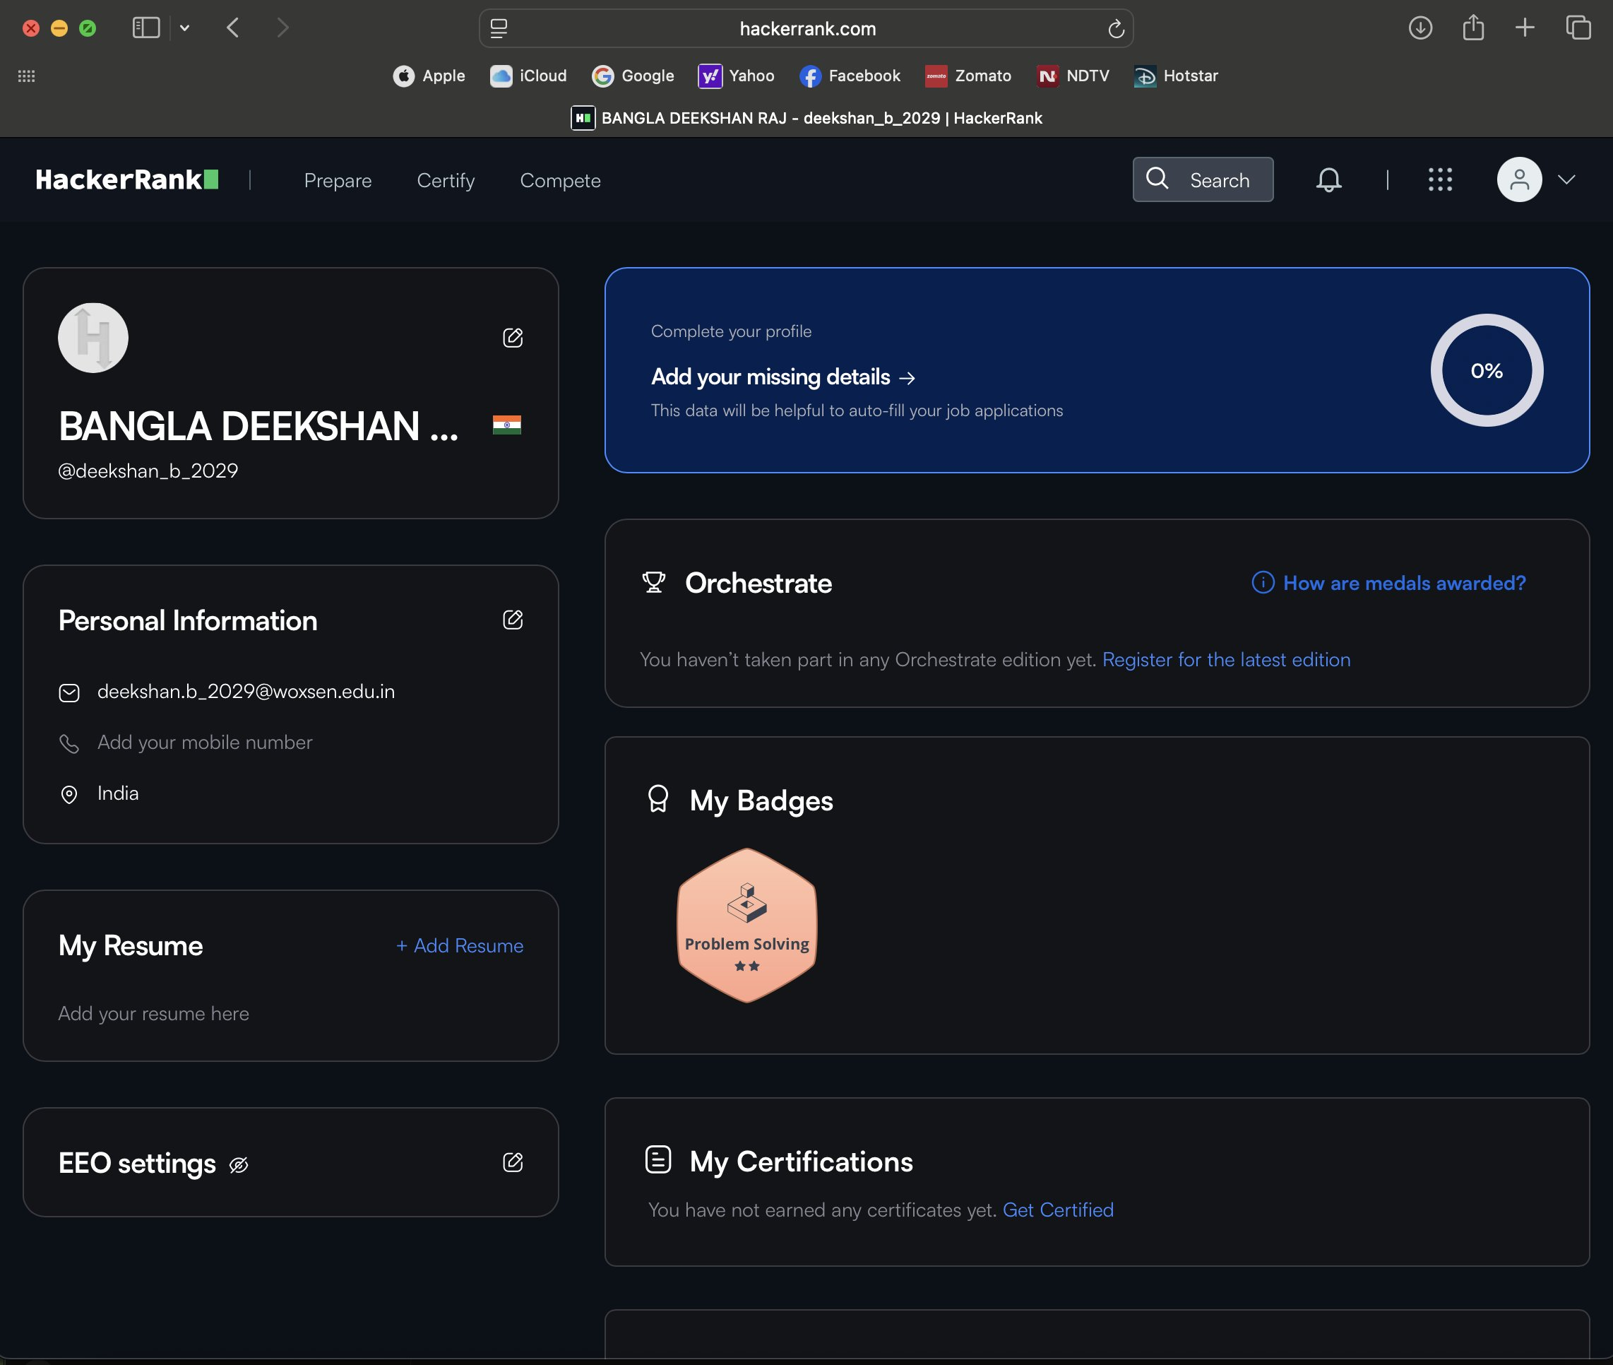

2. Submissions list (page 1)
Page 1 of the submissions list: nine problems Accepted, plus one earlier Wrong Answer attempt on Database Normalization #1 - 1NF that was later solved.
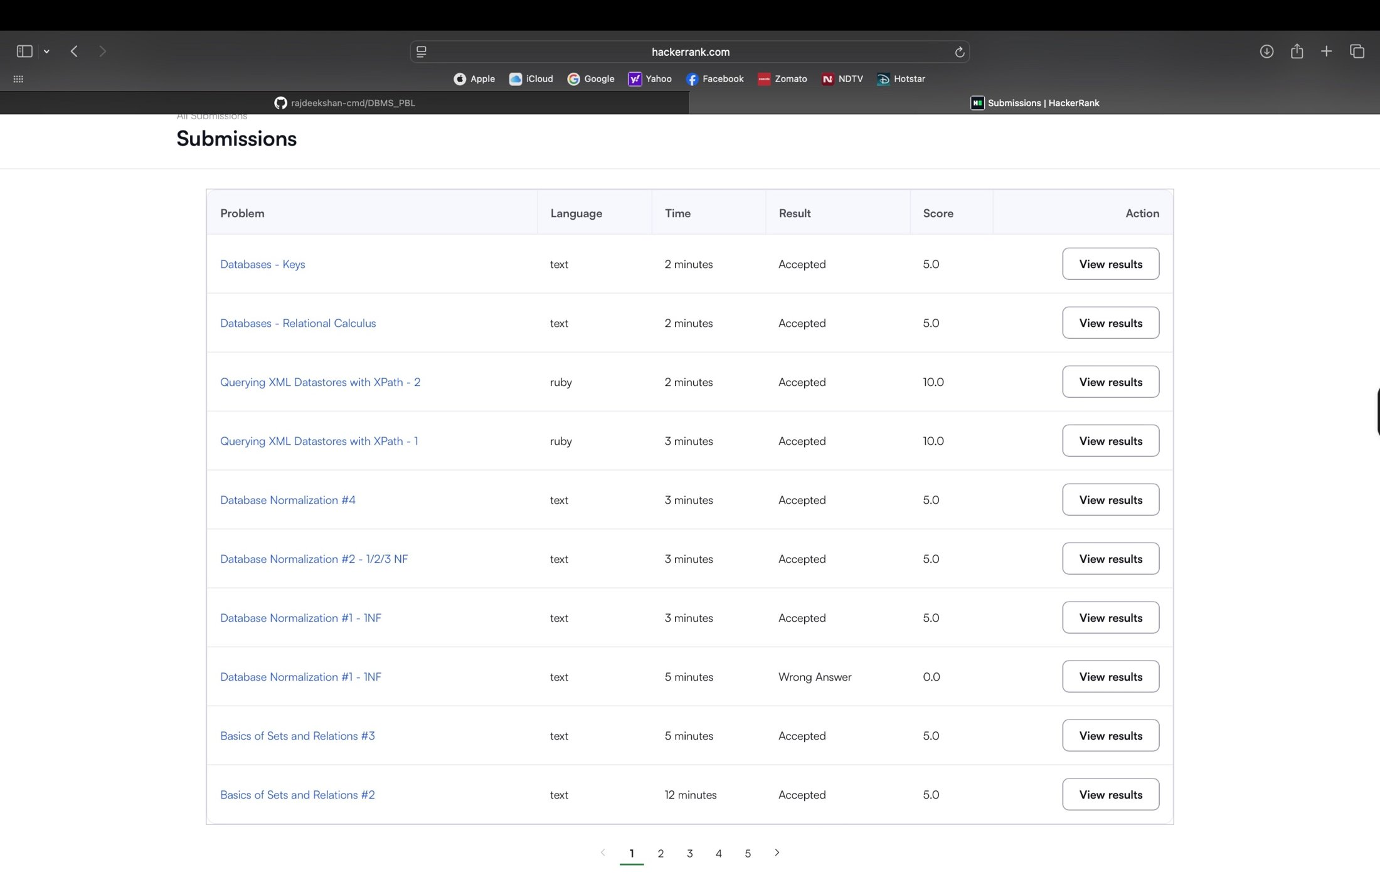
Earlier attempt: Basics of Sets and Relations #2 was first a Wrong Answer, then Accepted on the next attempt (shown in section 4).
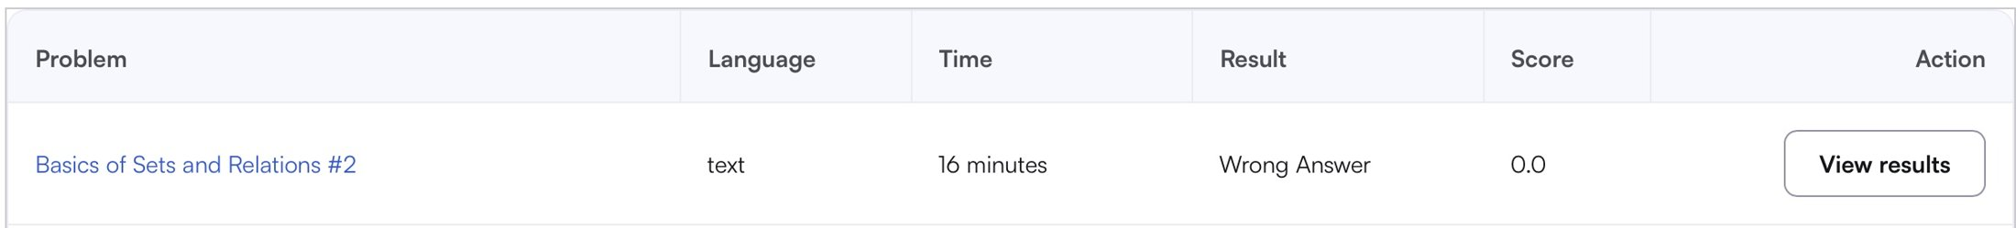

3. Problems solved (9)
All nine problems below show Result: Accepted in the submissions list. Score is the points awarded by HackerRank (total 55.0).
No. | Problem name | Topic | Language | Result | Score
1 | Basics of Sets and Relations #2 | Relational Algebra | Plain Text | Accepted | 5.0
2 | Basics of Sets and Relations #3 | Relational Algebra | Plain Text | Accepted | 5.0
3 | Database Normalization #1 - 1NF | Database Normalization | Plain Text | Accepted | 5.0
4 | Database Normalization #2 - 1/2/3 NF | Database Normalization | Plain Text | Accepted | 5.0
5 | Database Normalization #4 | Database Normalization | Plain Text | Accepted | 5.0
6 | Querying XML Datastores with XPath - 1 | NoSQL - XML, MapReduce | Ruby | Accepted | 10.0
7 | Querying XML Datastores with XPath - 2 | NoSQL - XML, MapReduce | Ruby | Accepted | 10.0
8 | Databases - Relational Calculus | Set and Algebra | Plain Text | Accepted | 5.0
9 | Databases - Keys | Set and Algebra | Plain Text | Accepted | 5.0

4. Submission screenshots
Each screenshot shows the problem page with Status: Accepted and the test case result.
3.1 Basics of Sets and Relations #2
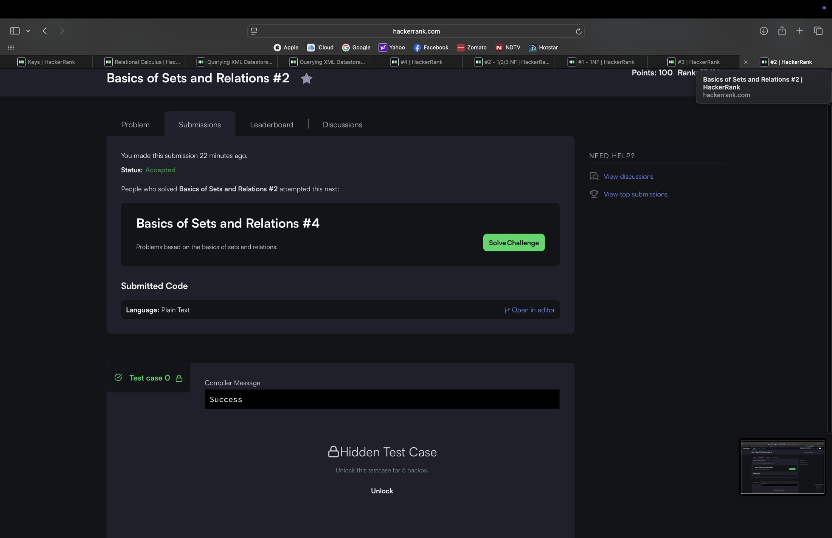
3.2 Basics of Sets and Relations #3
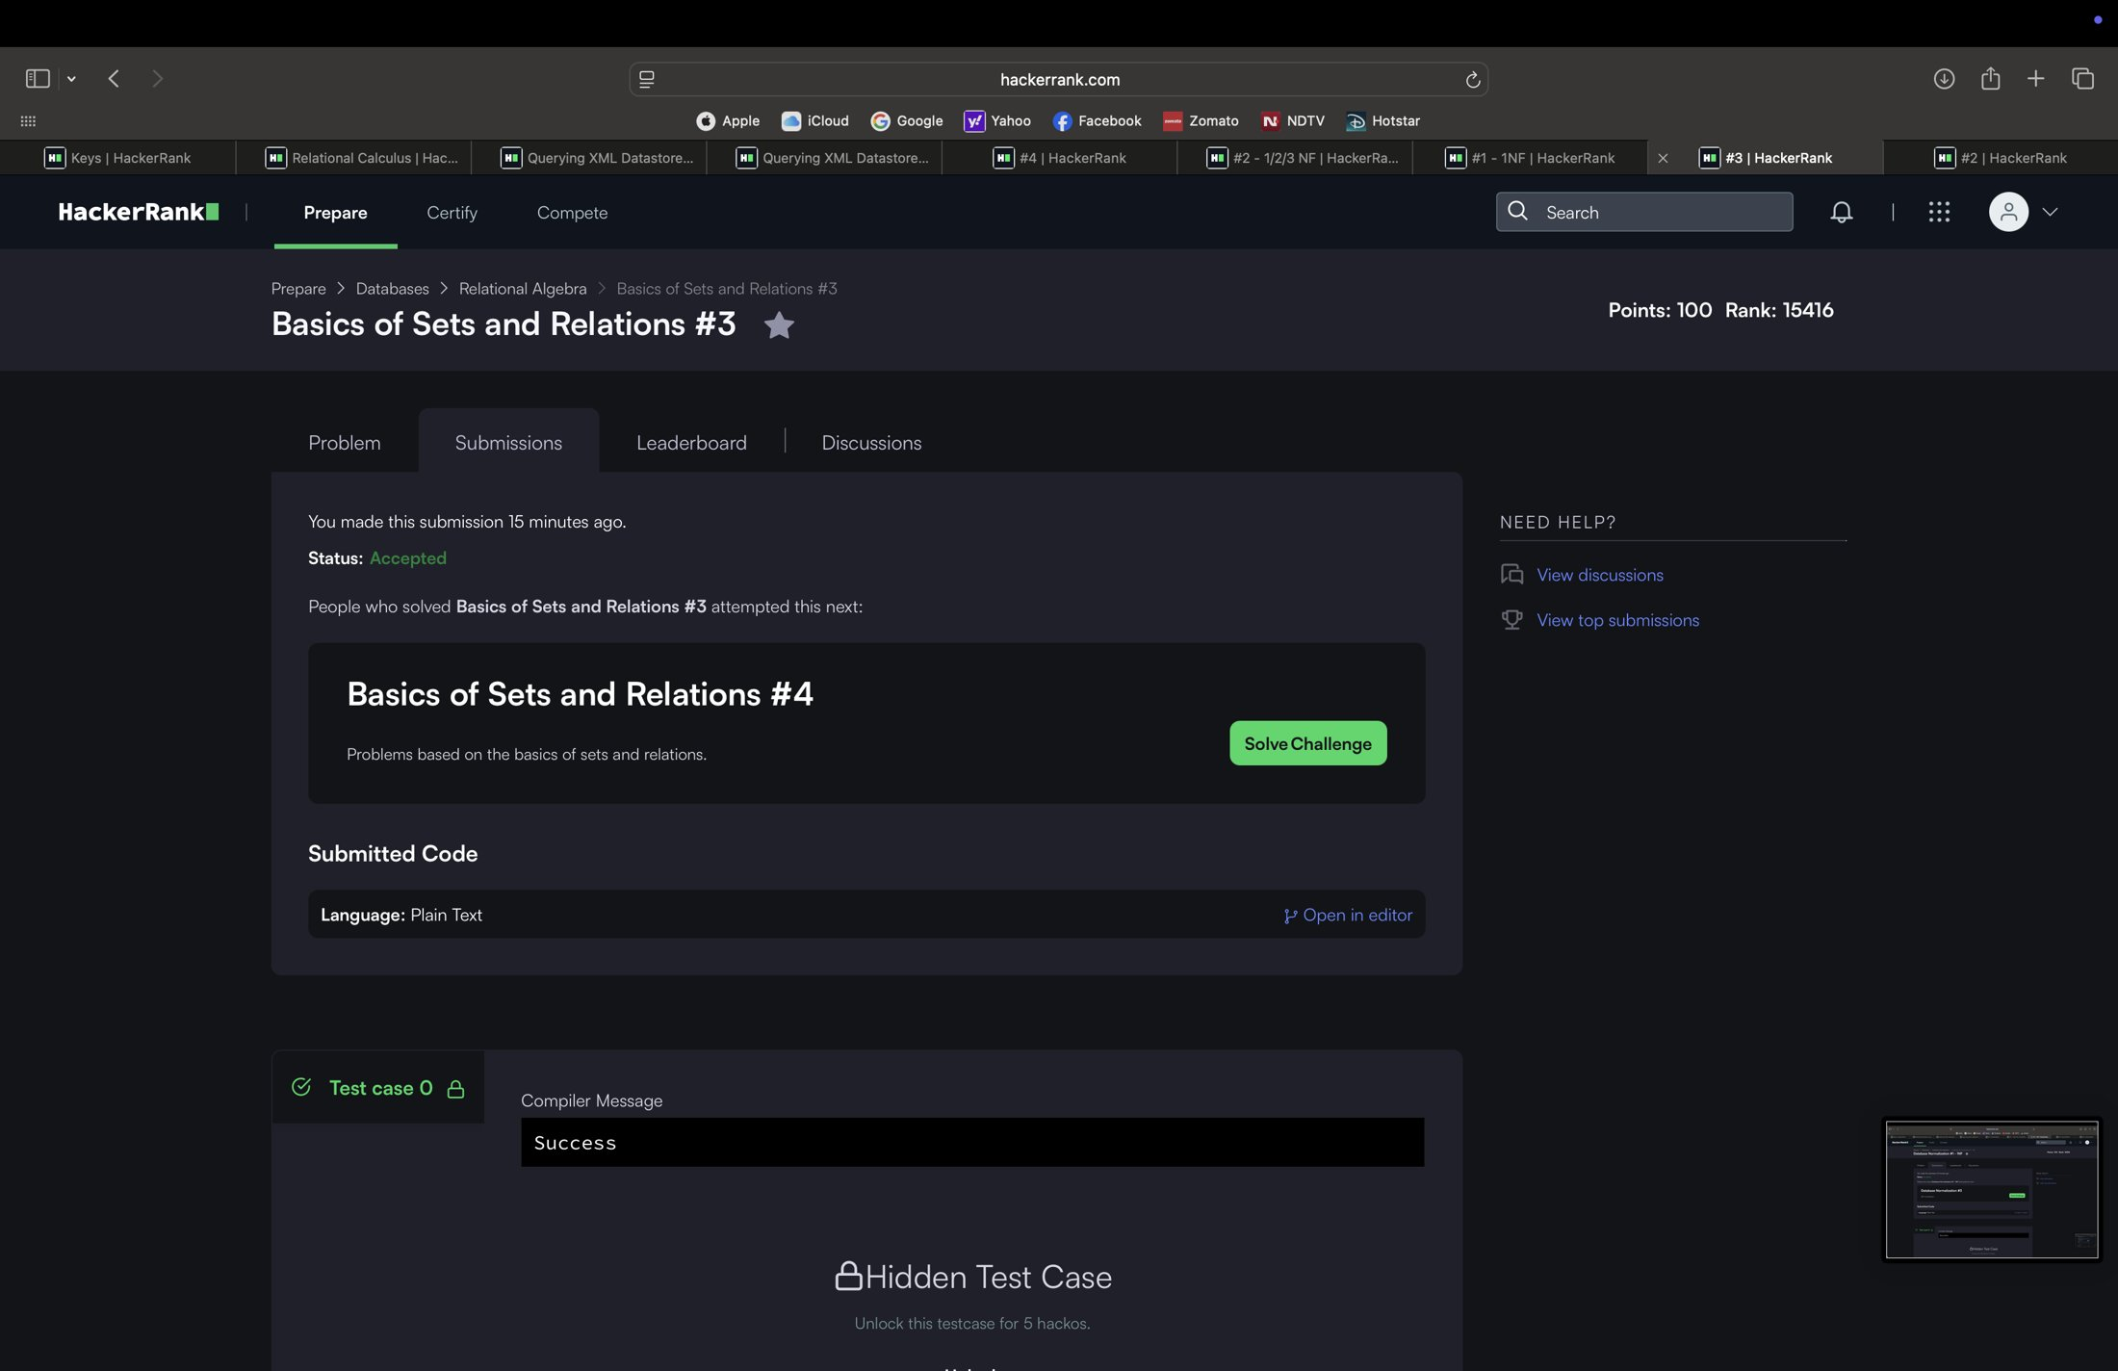
3.3 Database Normalization #1 - 1NF
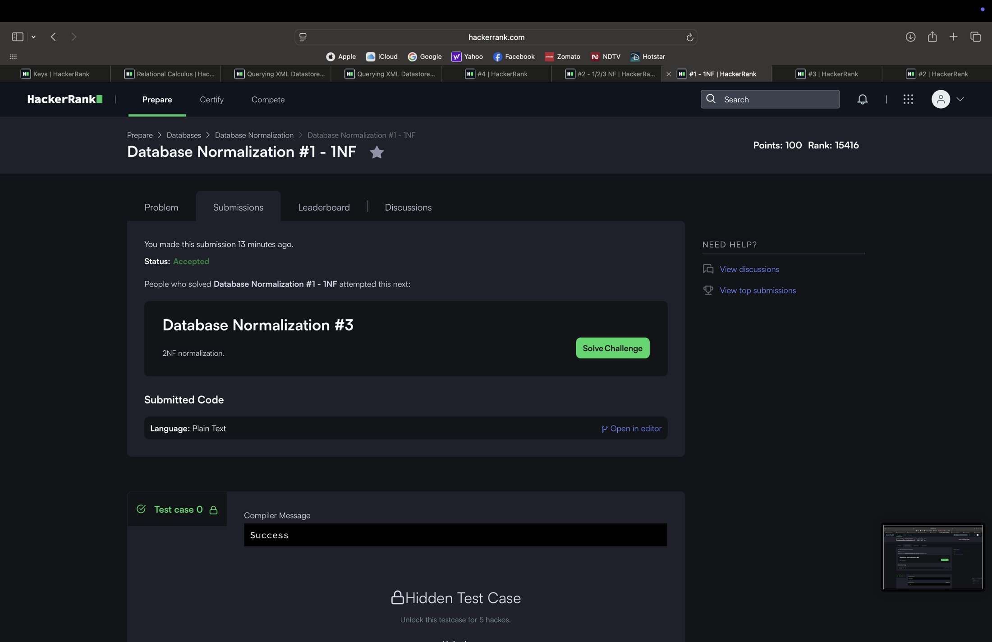
3.4 Database Normalization #2 - 1/2/3 NF
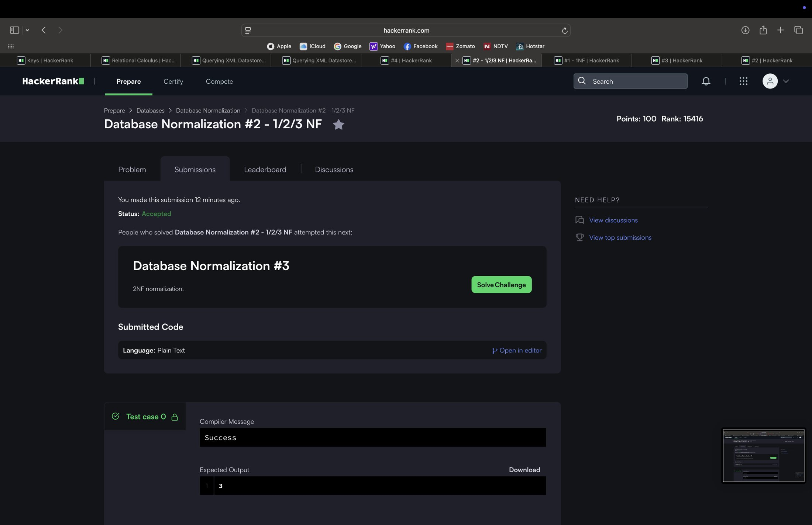
3.5 Database Normalization #4
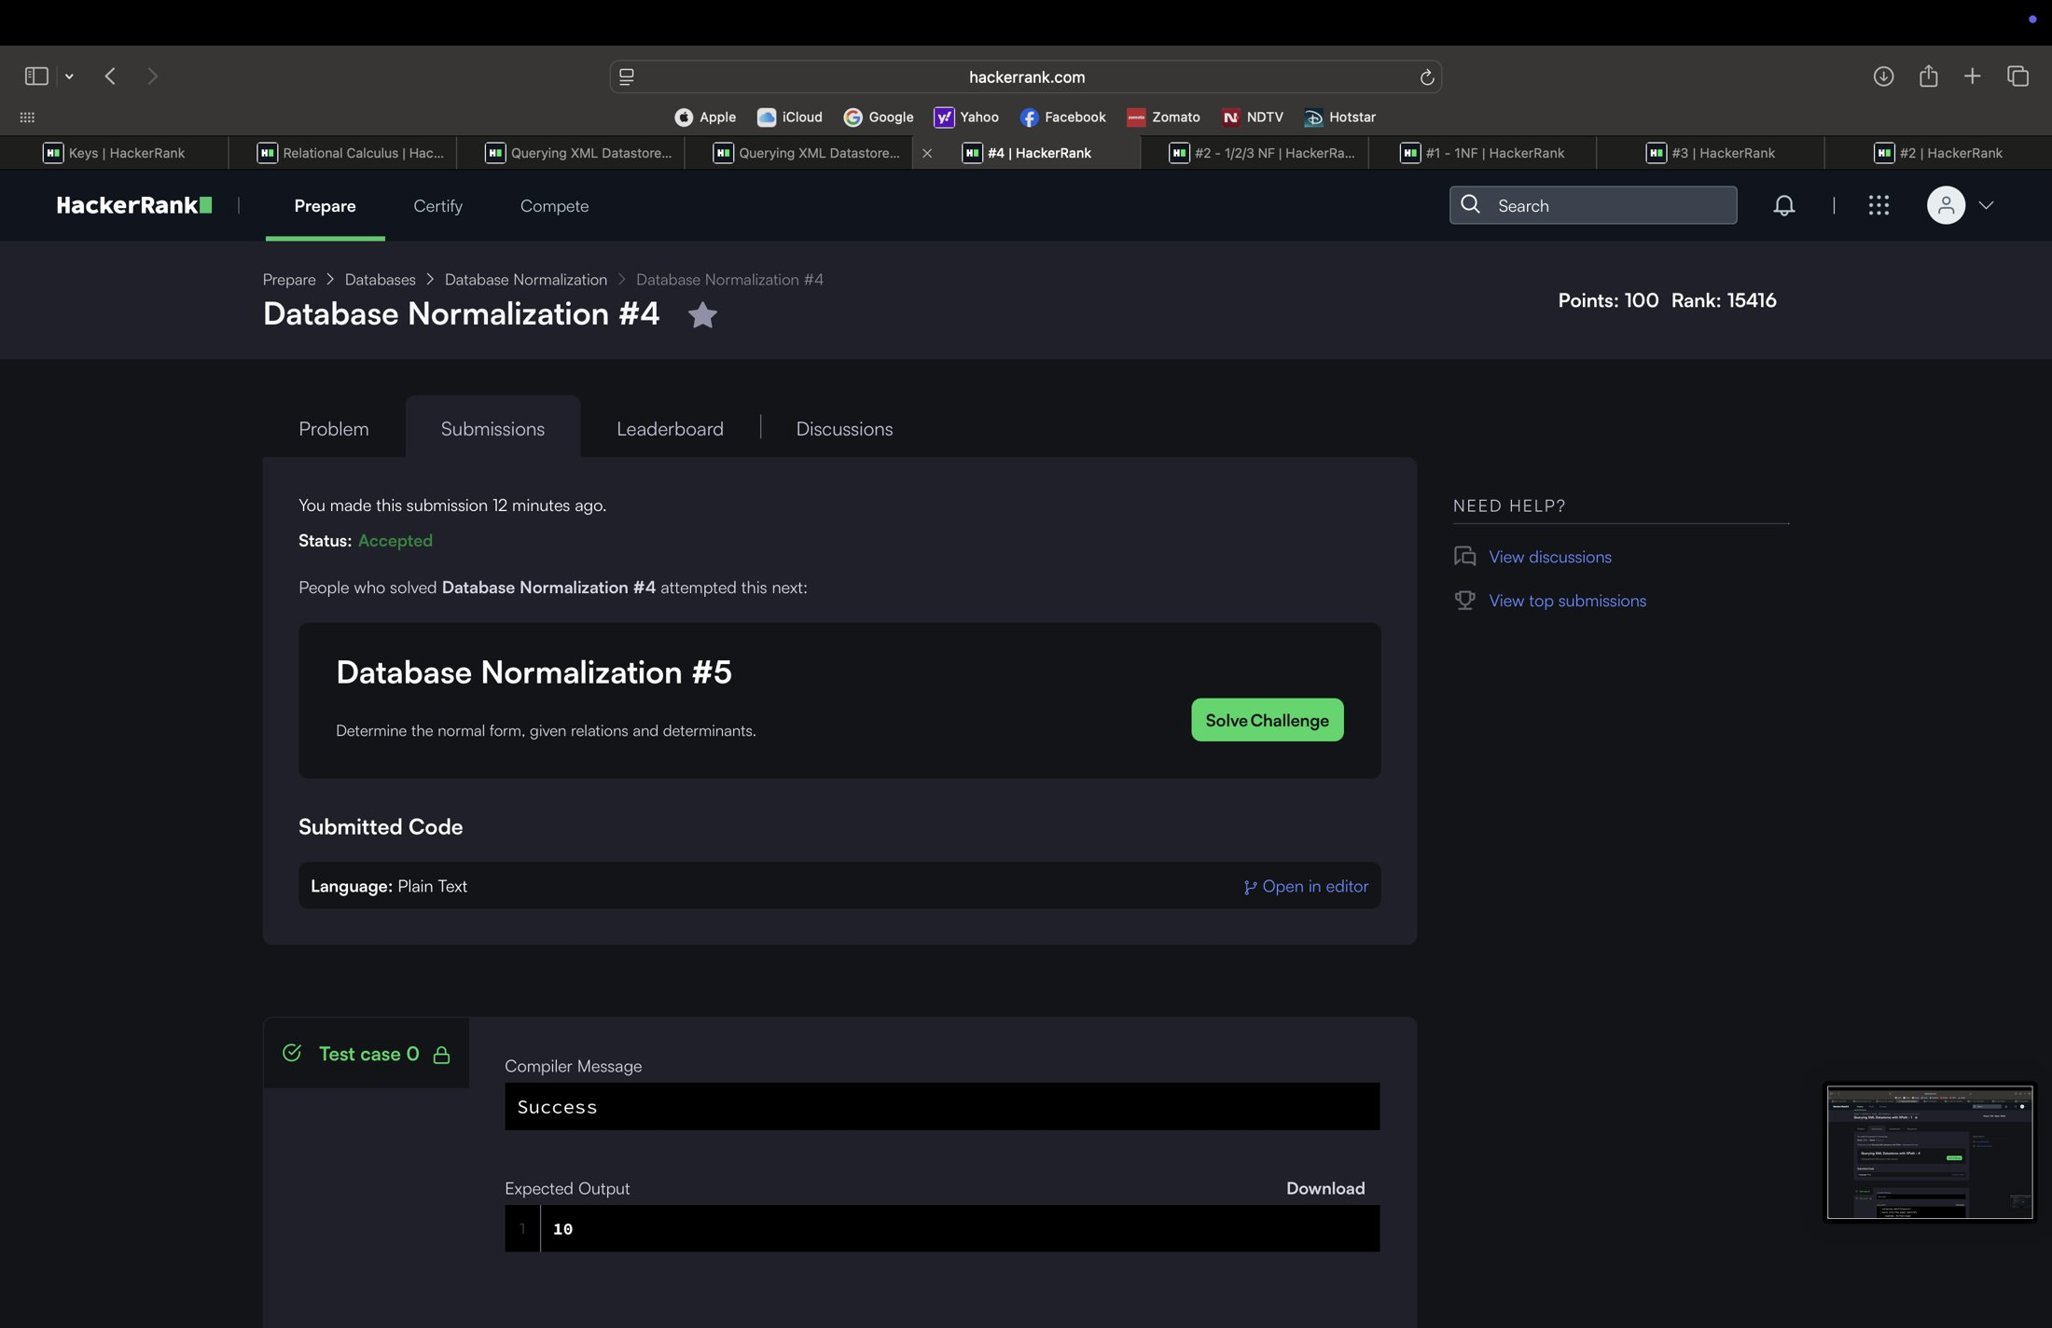
3.6 Querying XML Datastores with XPath - 1
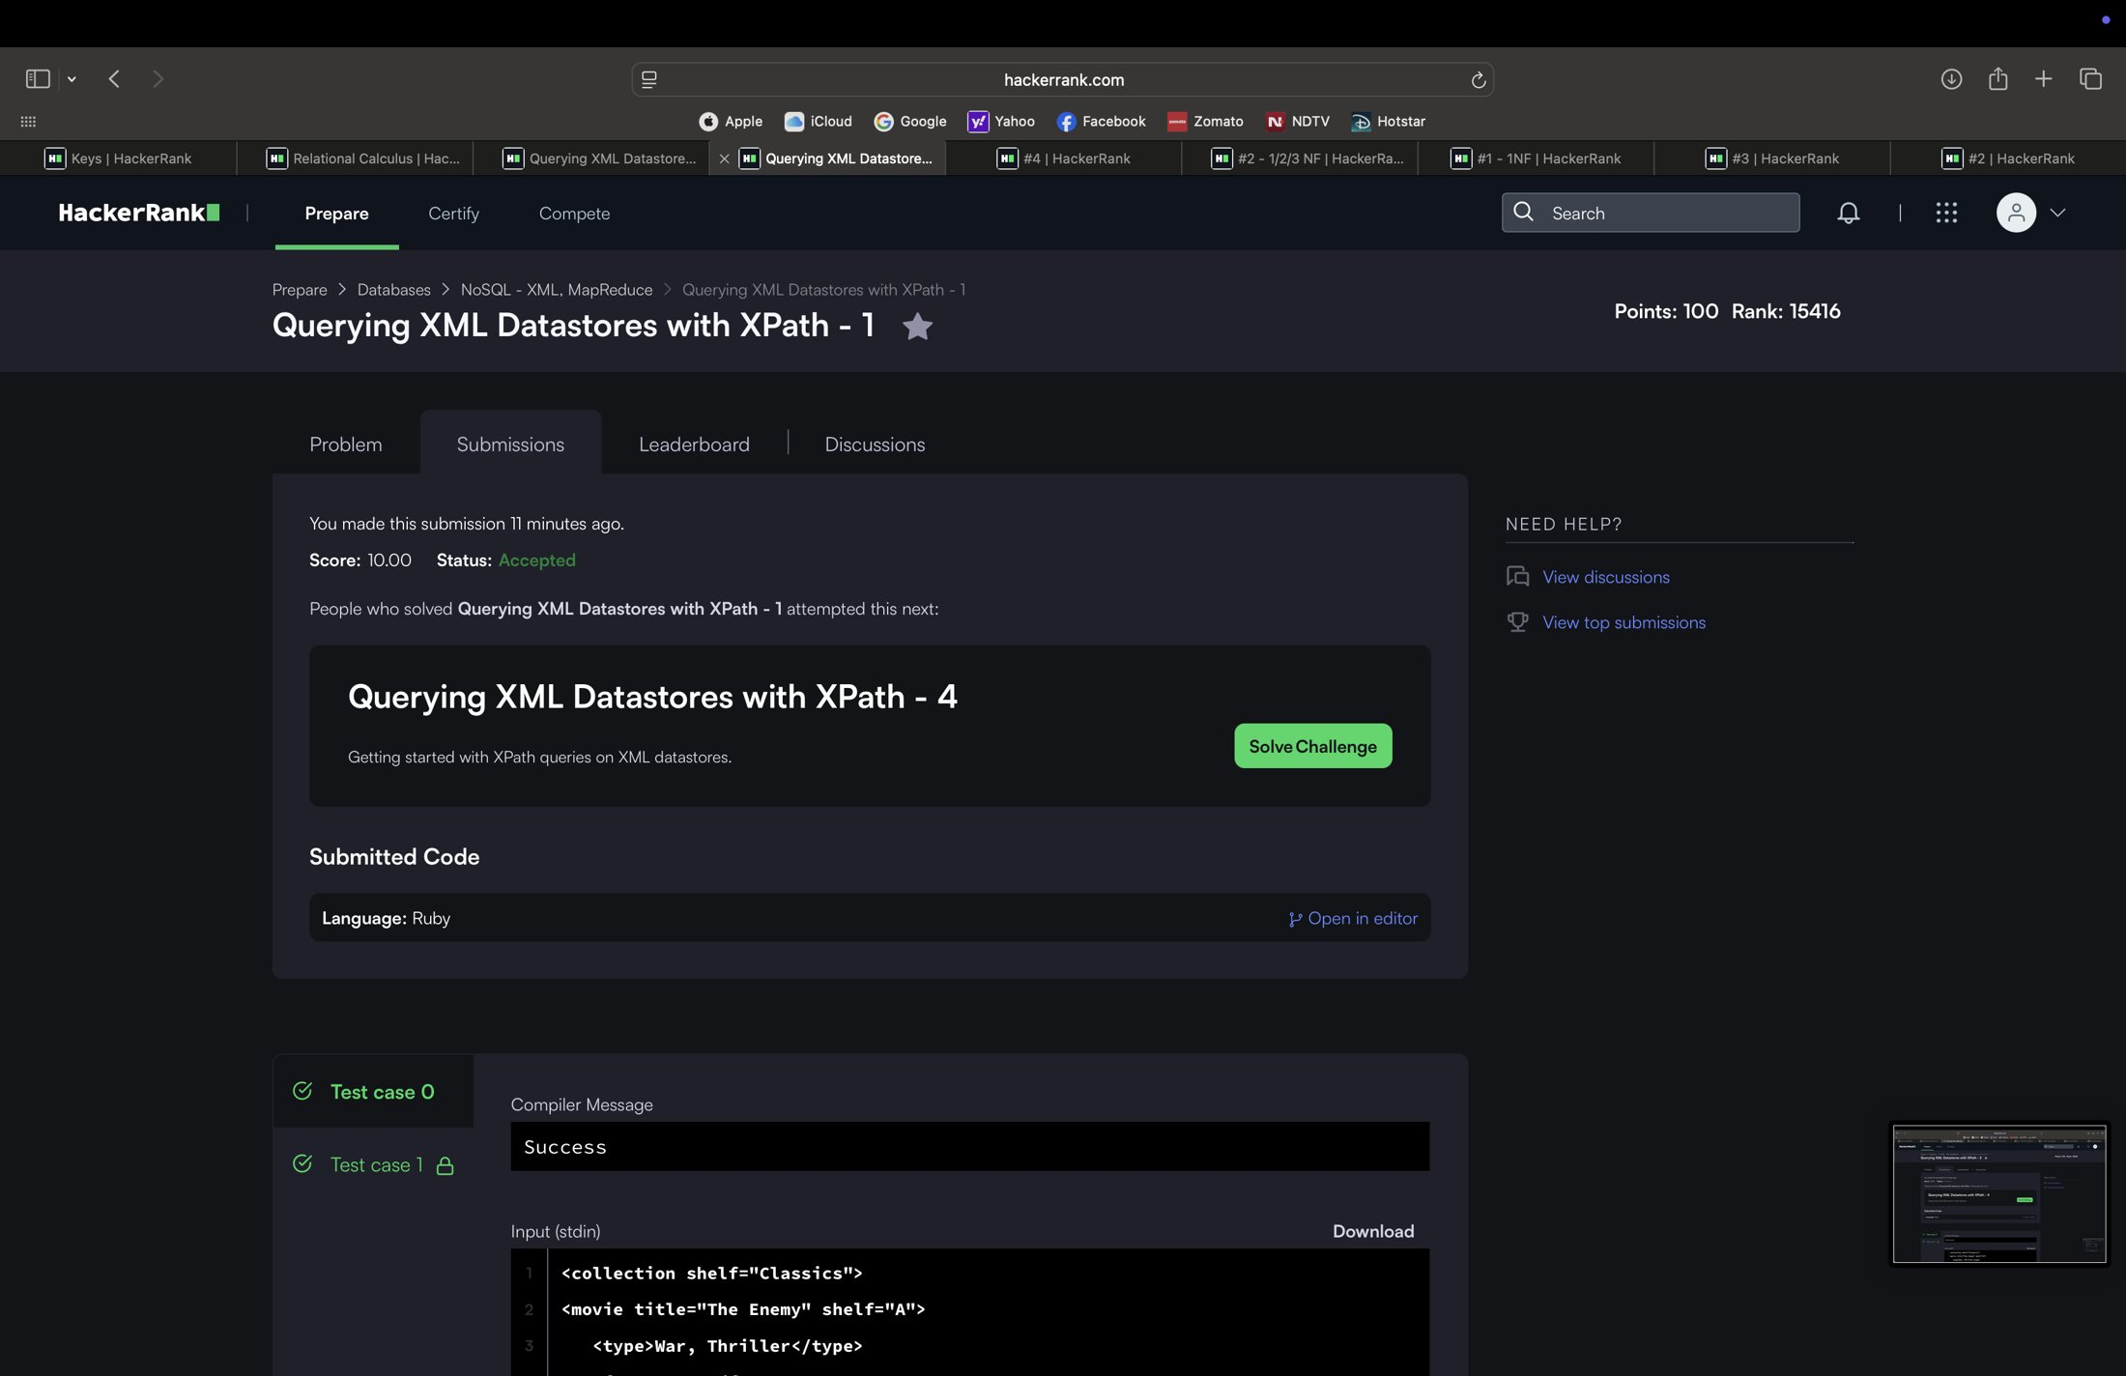
3.7 Querying XML Datastores with XPath - 2
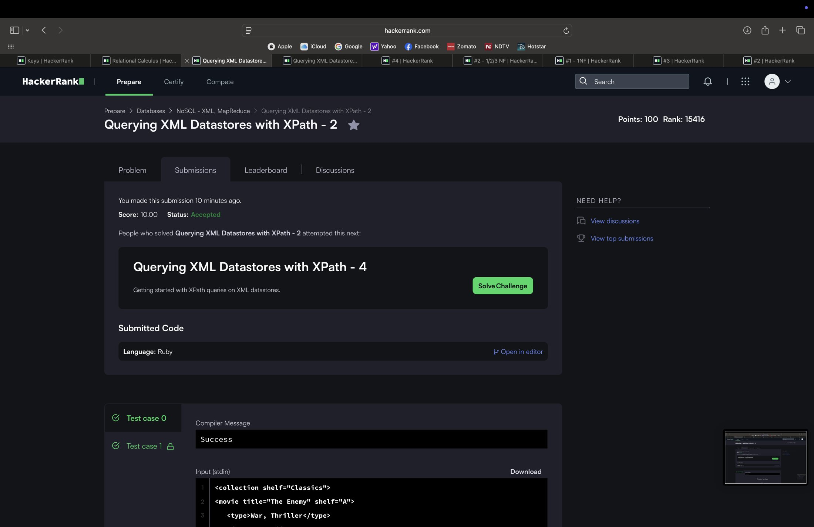
3.8 Databases - Relational Calculus
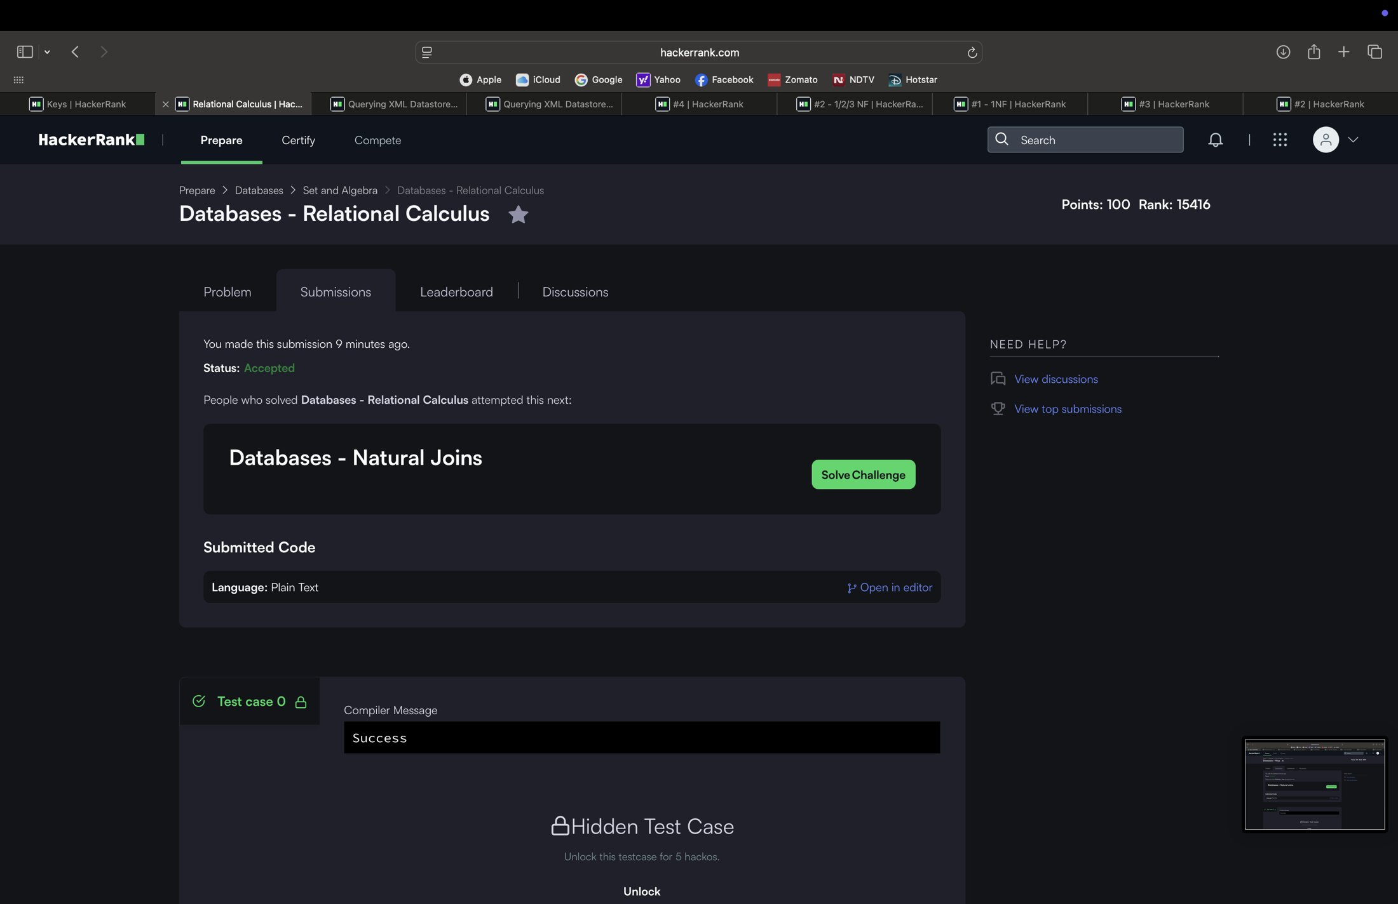
3.9 Databases - Keys
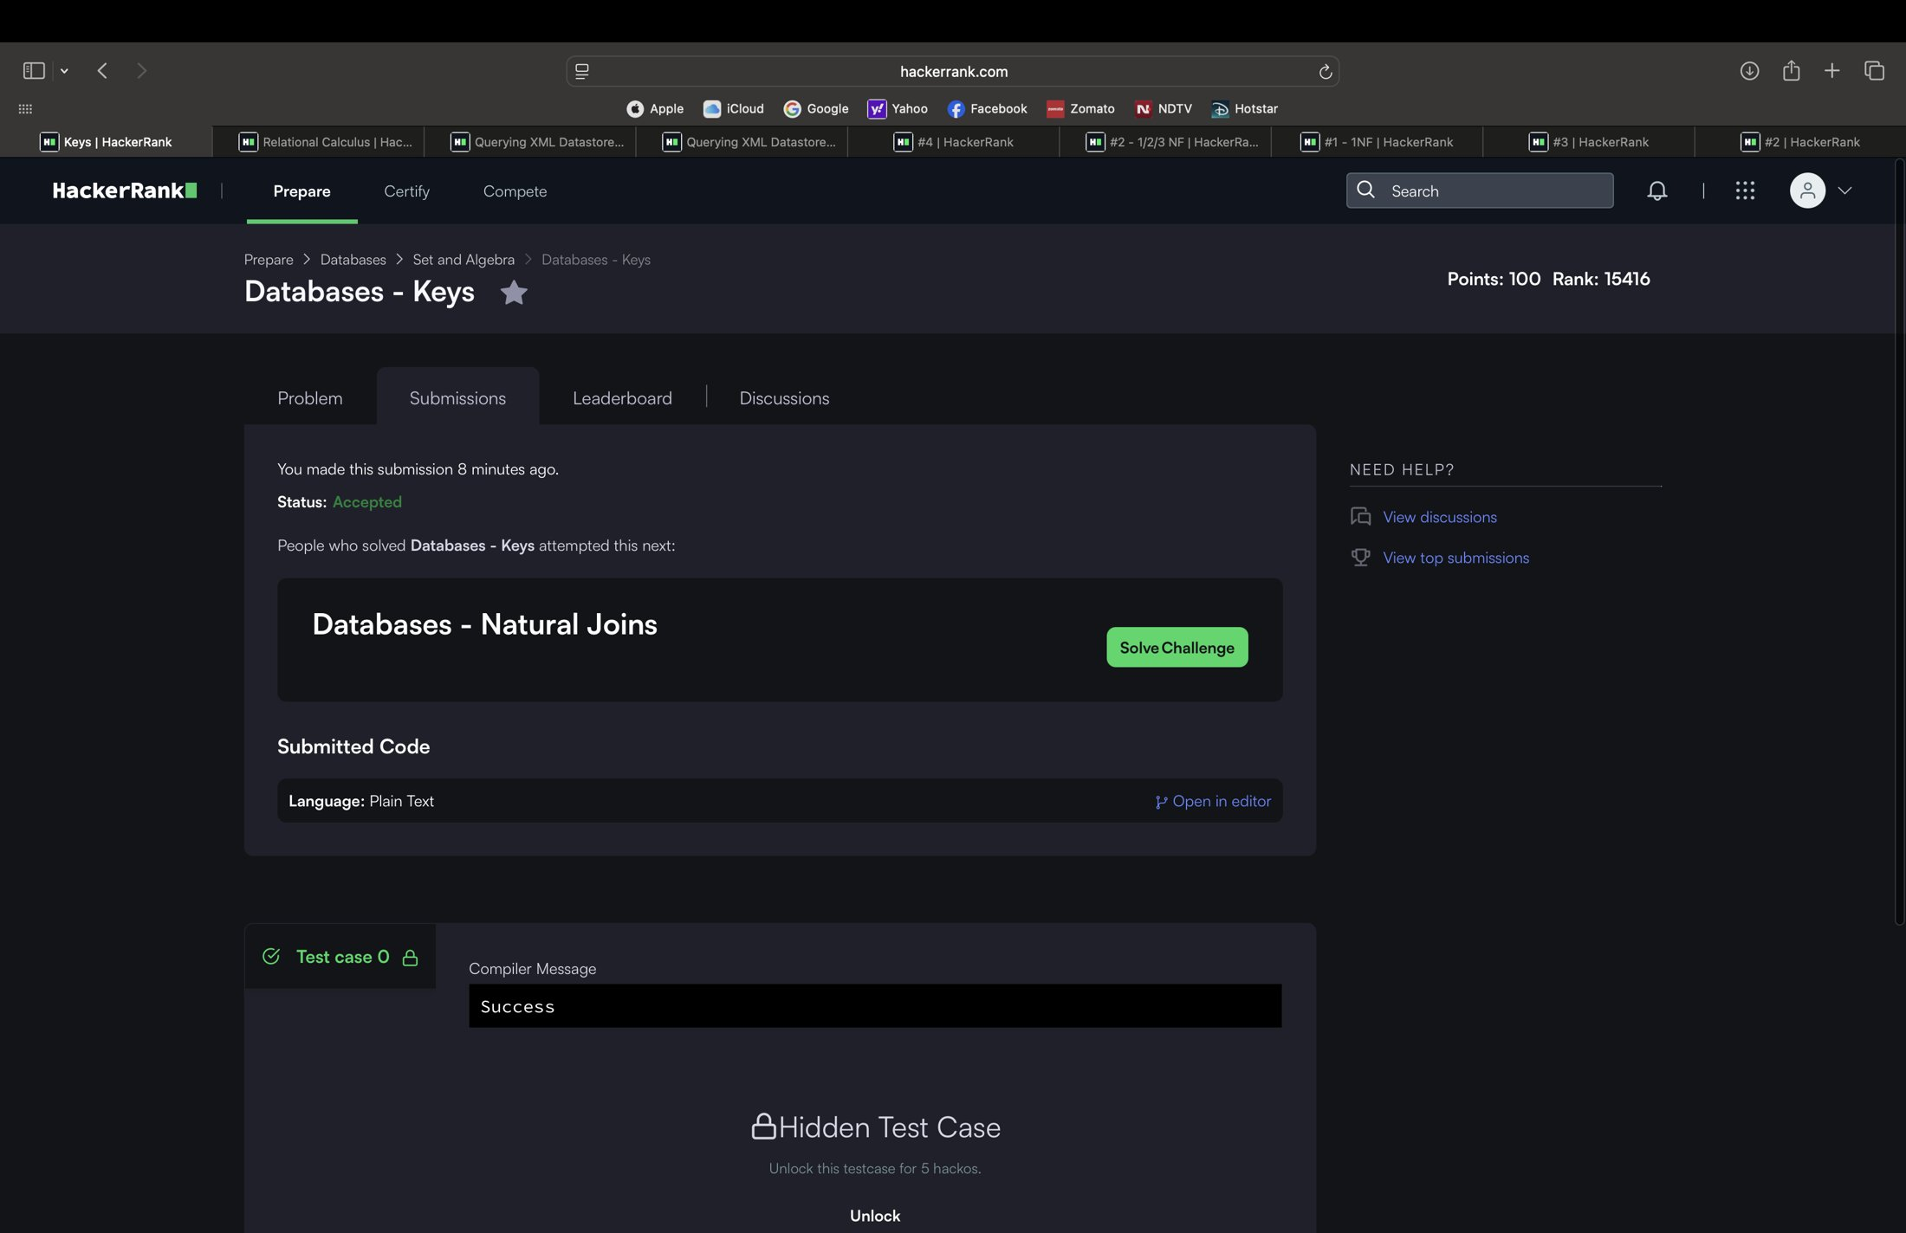

5. Badges and certificates
Badge earned: Problem Solving (2 stars). No HackerRank certificate has been earned yet.

