WOXSEN UNIVERSITY
B.Tech Artificial Intelligence and Machine Learning | Design and Analysis of Algorithms
LeetCode Profile
Name | Student ID | Platform / username | Profile link
B. Deekshan Raj | 25WU0102037 | LeetCode / DEEKSHANRAJ | leetcode.com/u/DEEKSHANRAJ

1. Profile login screenshot
LeetCode profile of DEEKSHANRAJ: 20 problems solved (14 Easy, 5 Medium, 1 Hard), in C++ and MySQL.
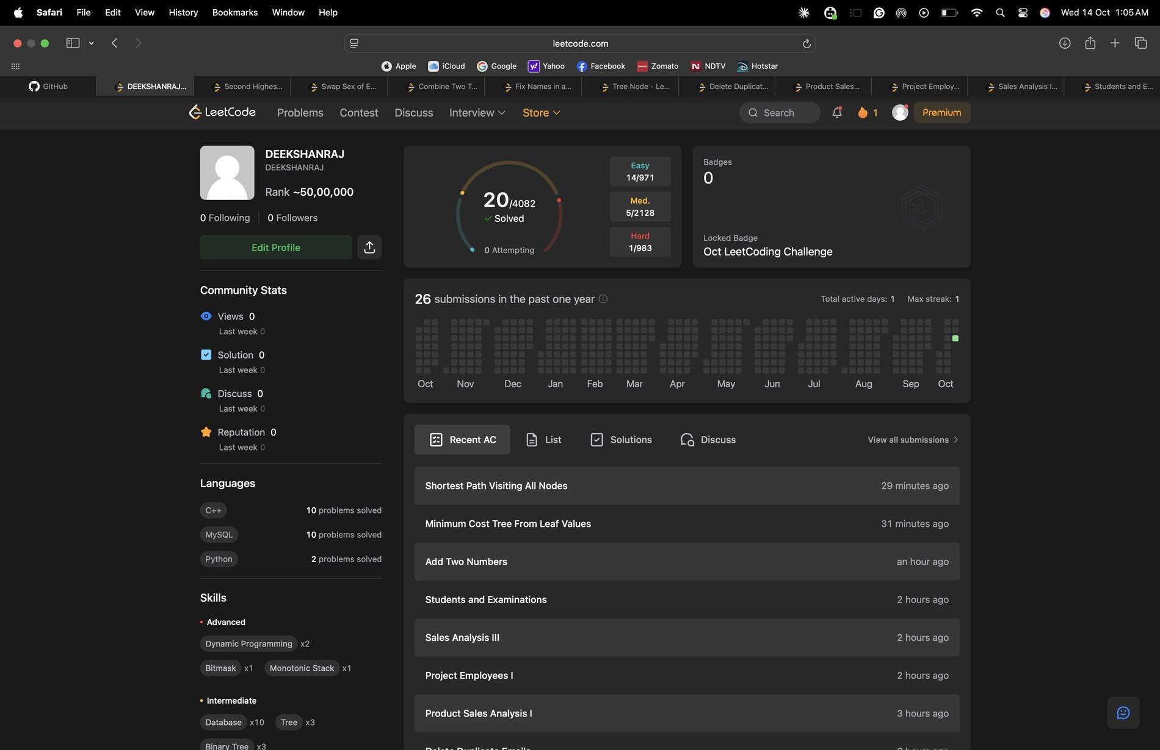
Practice history of the logged-in account DEEKSHANRAJ, showing the accepted submissions.
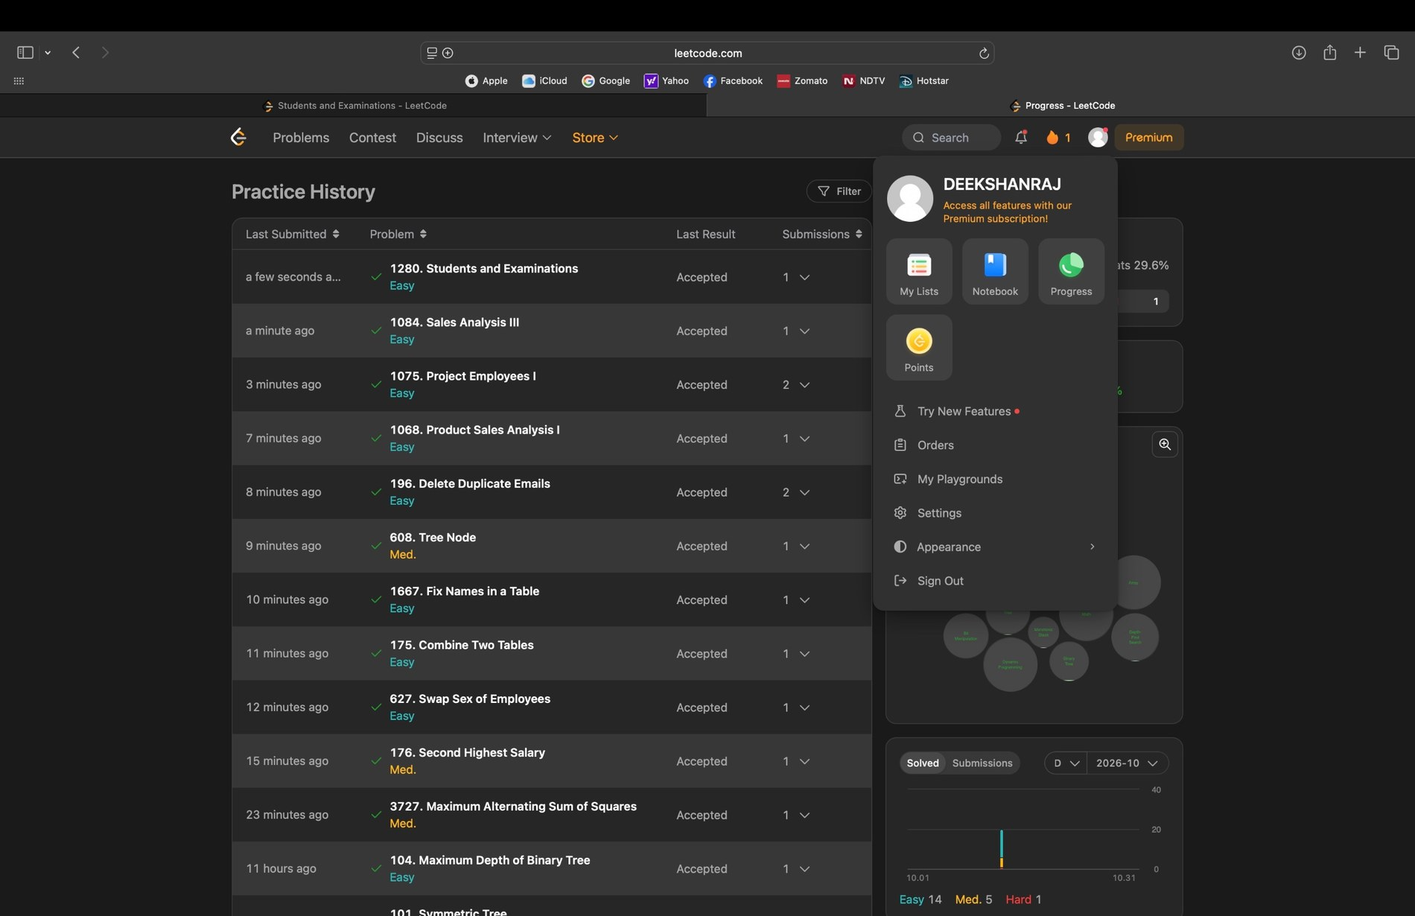

2. Problems solved (10)
Every problem below shows Accepted on LeetCode. Each screenshot is in section 3, in the same order.
No. | Problem name | Difficulty | Topic / technique | Language
1 | Second Highest Salary | Medium | Subquery / LIMIT-OFFSET | MySQL
2 | Swap Sex of Employees | Easy | UPDATE with CASE | MySQL
3 | Combine Two Tables | Easy | LEFT JOIN | MySQL
4 | Fix Names in a Table | Easy | String functions | MySQL
5 | Tree Node | Medium | CASE / subquery | MySQL
6 | Delete Duplicate Emails | Easy | Self join DELETE | MySQL
7 | Product Sales Analysis I | Easy | JOIN | MySQL
8 | Project Employees I | Easy | JOIN / GROUP BY / AVG | MySQL
9 | Sales Analysis III | Easy | JOIN / GROUP BY / HAVING | MySQL
10 | Students and Examinations | Easy | CROSS JOIN / LEFT JOIN / GROUP BY | MySQL

3. Accepted submission screenshots
1. Second Highest Salary (Medium) - Accepted
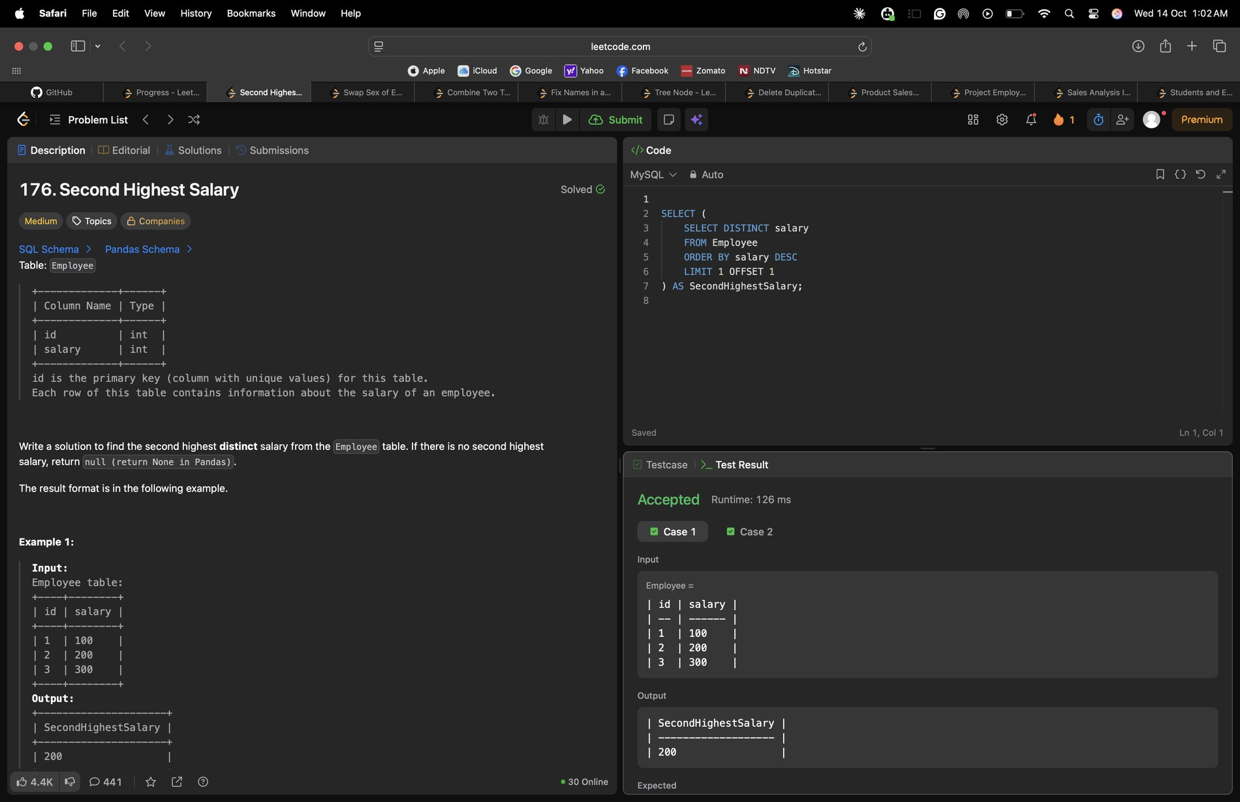
2. Swap Sex of Employees (Easy) - Accepted
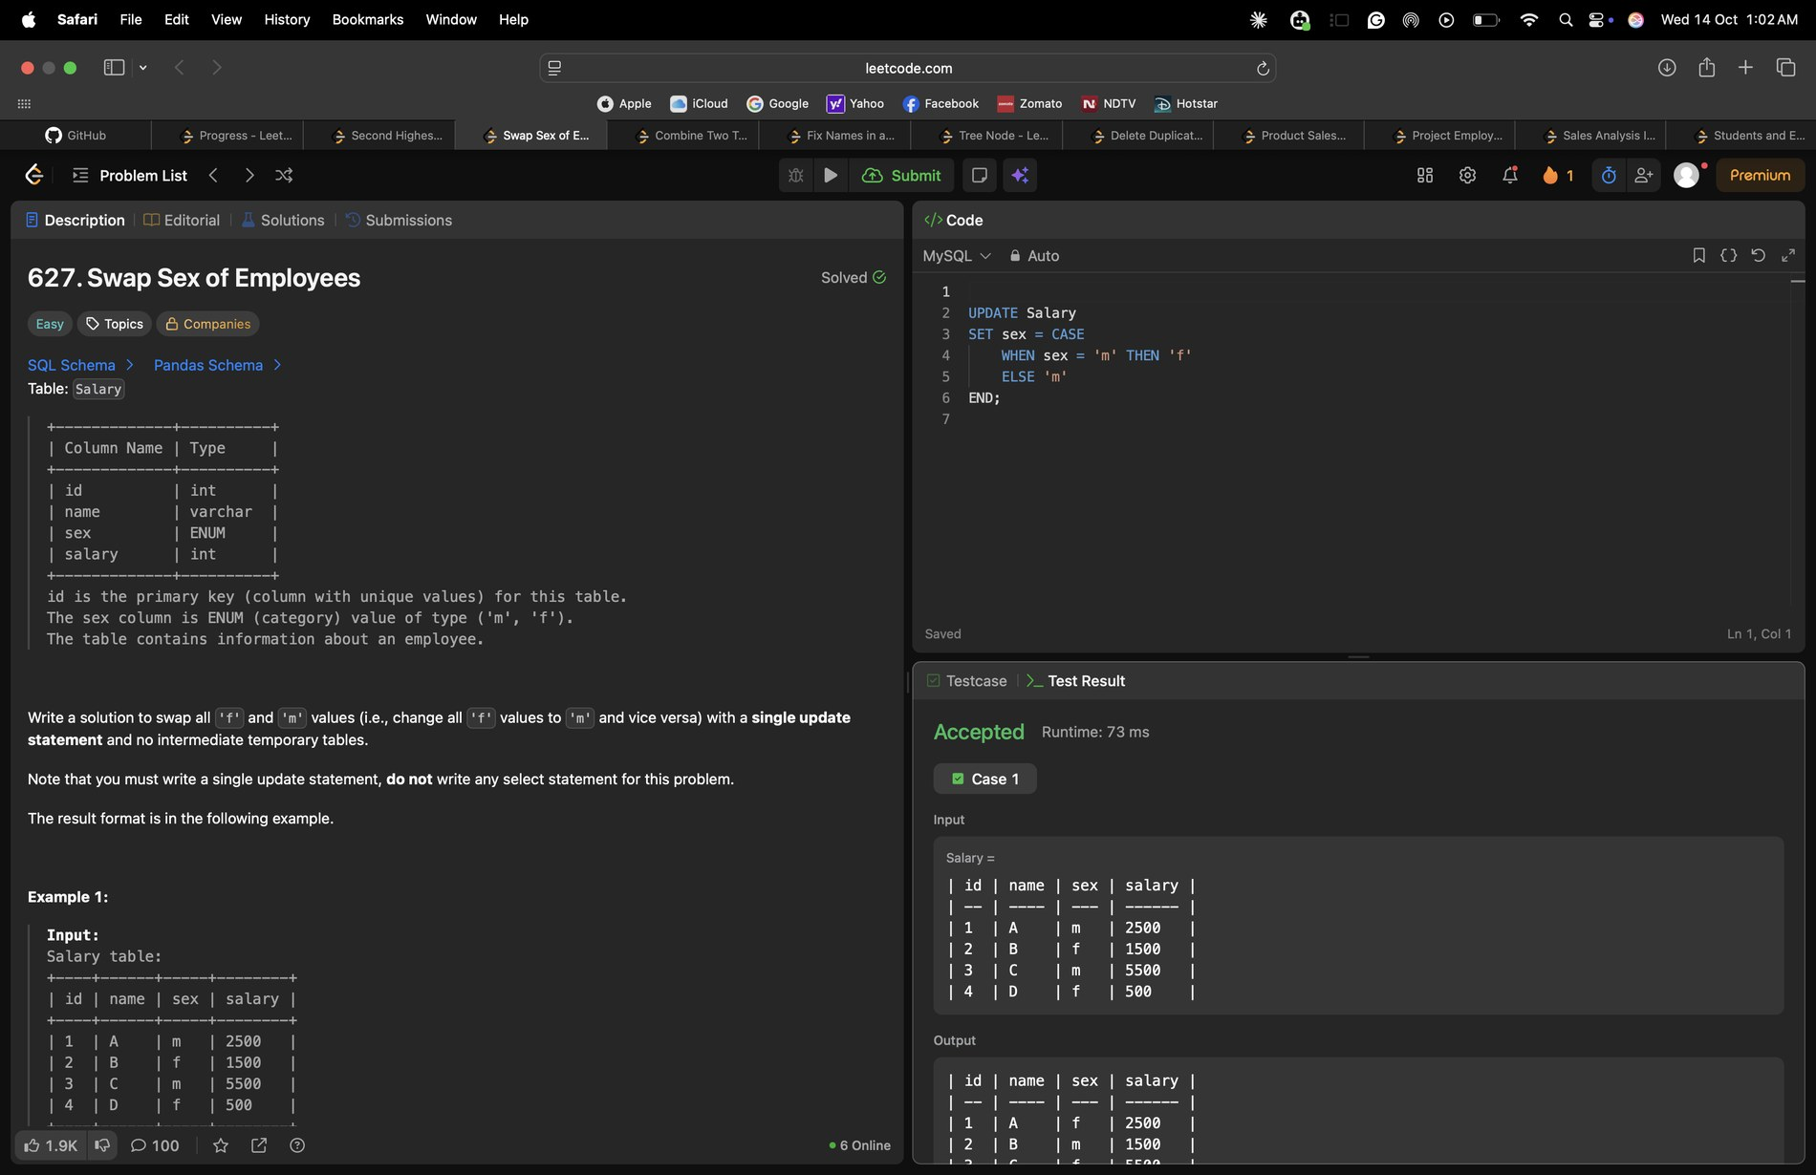
3. Combine Two Tables (Easy) - Accepted
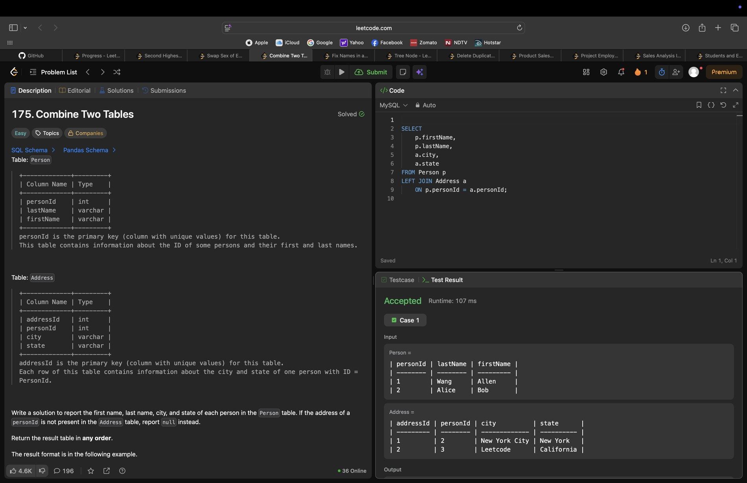
4. Fix Names in a Table (Easy) - Accepted
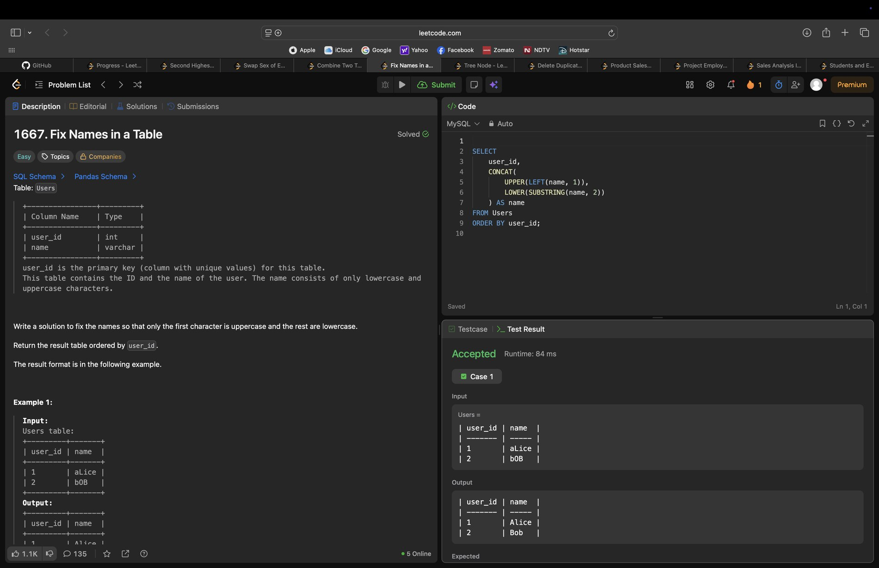
5. Tree Node (Medium) - Accepted
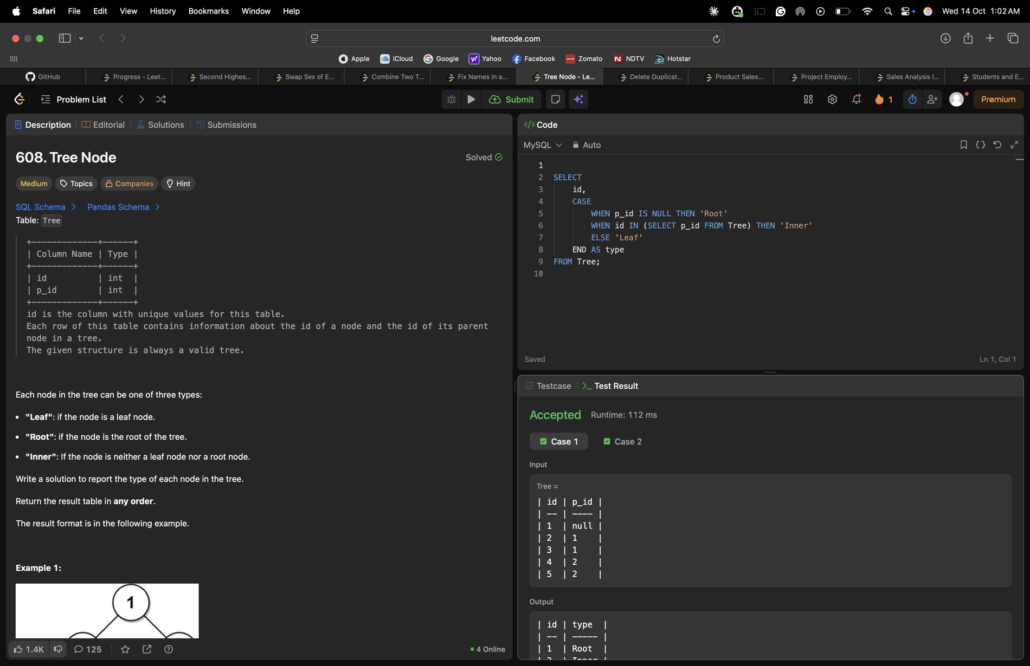
6. Delete Duplicate Emails (Easy) - Accepted
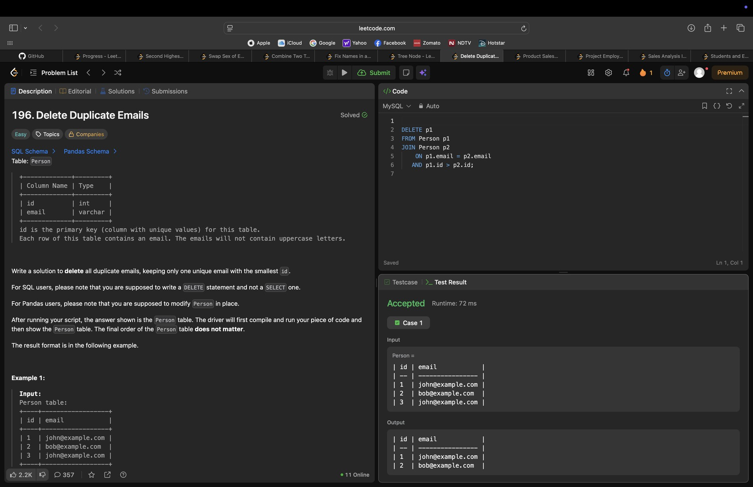
7. Product Sales Analysis I (Easy) - Accepted
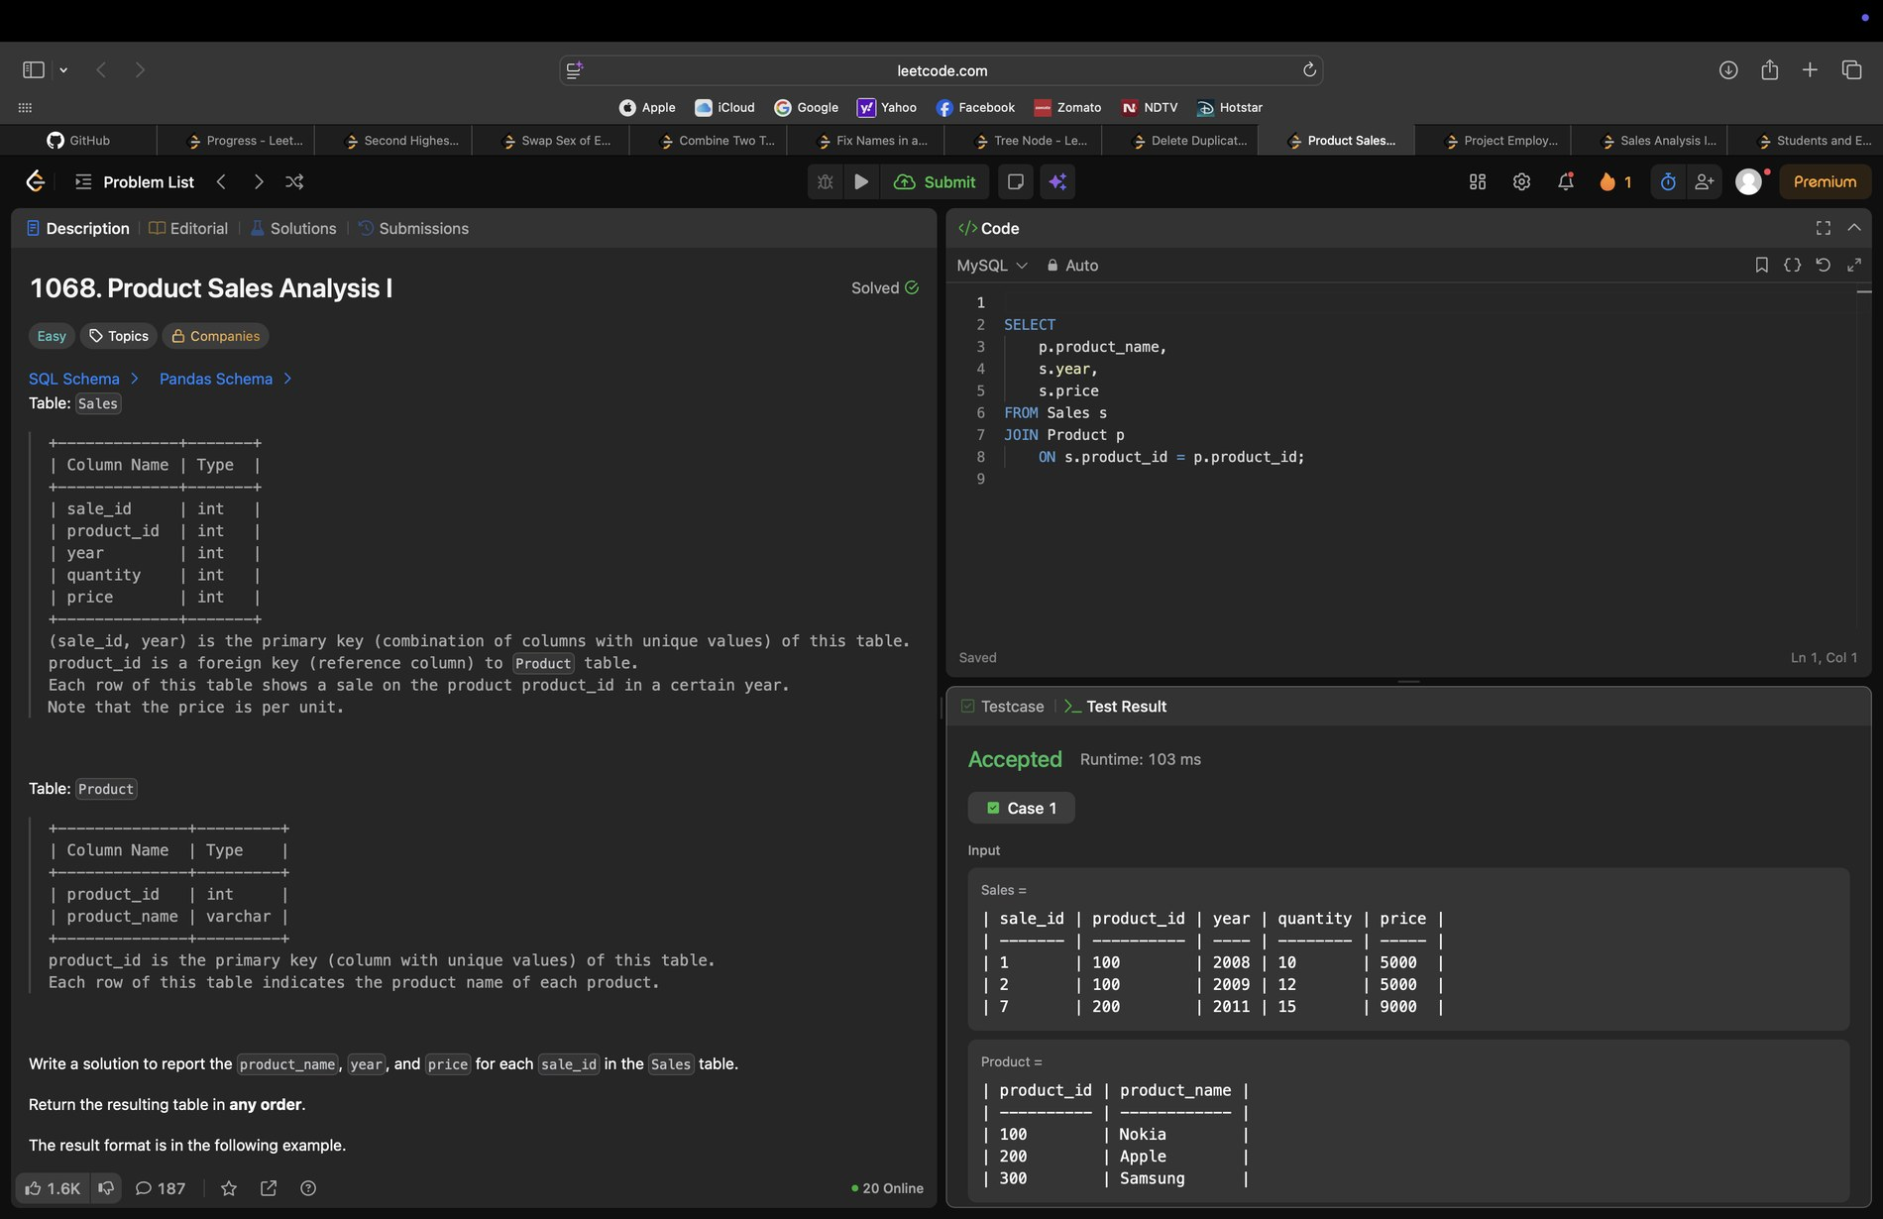
8. Project Employees I (Easy) - Accepted
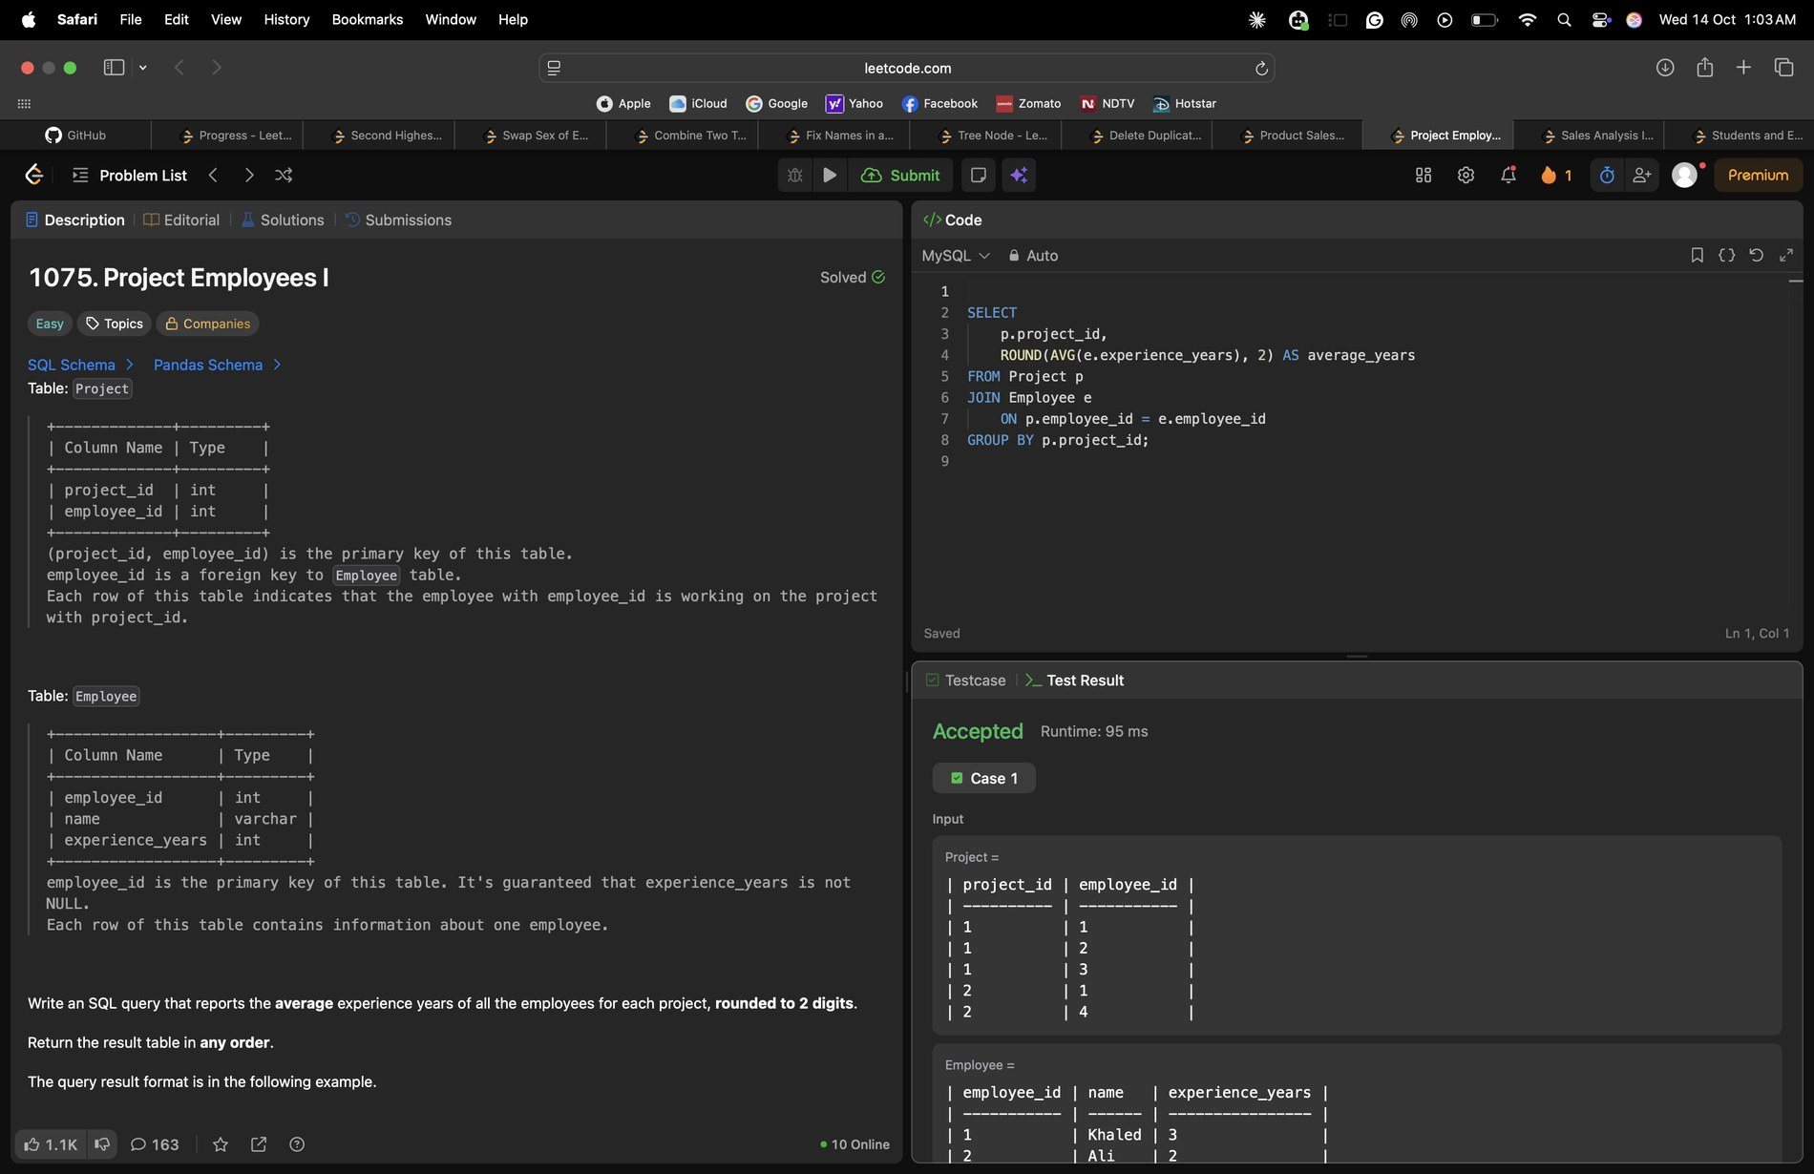
9. Sales Analysis III (Easy) - Accepted
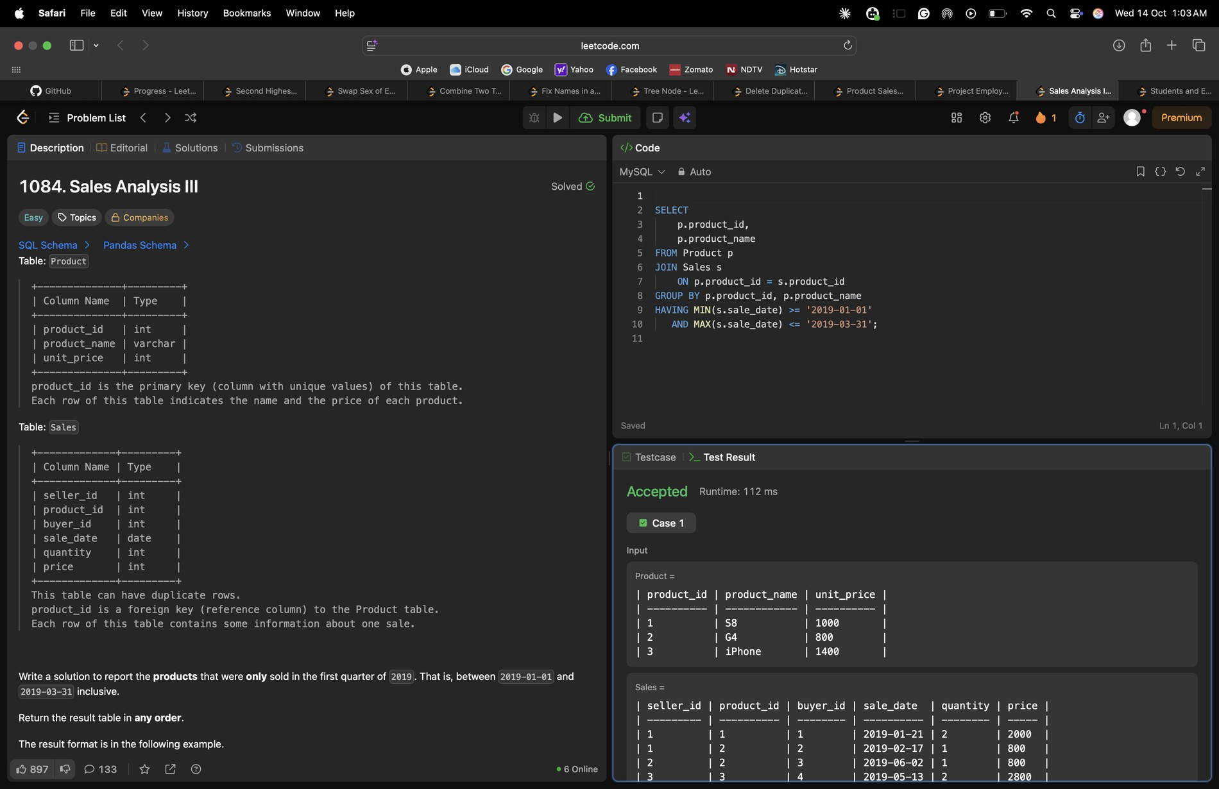
10. Students and Examinations (Easy) - Accepted
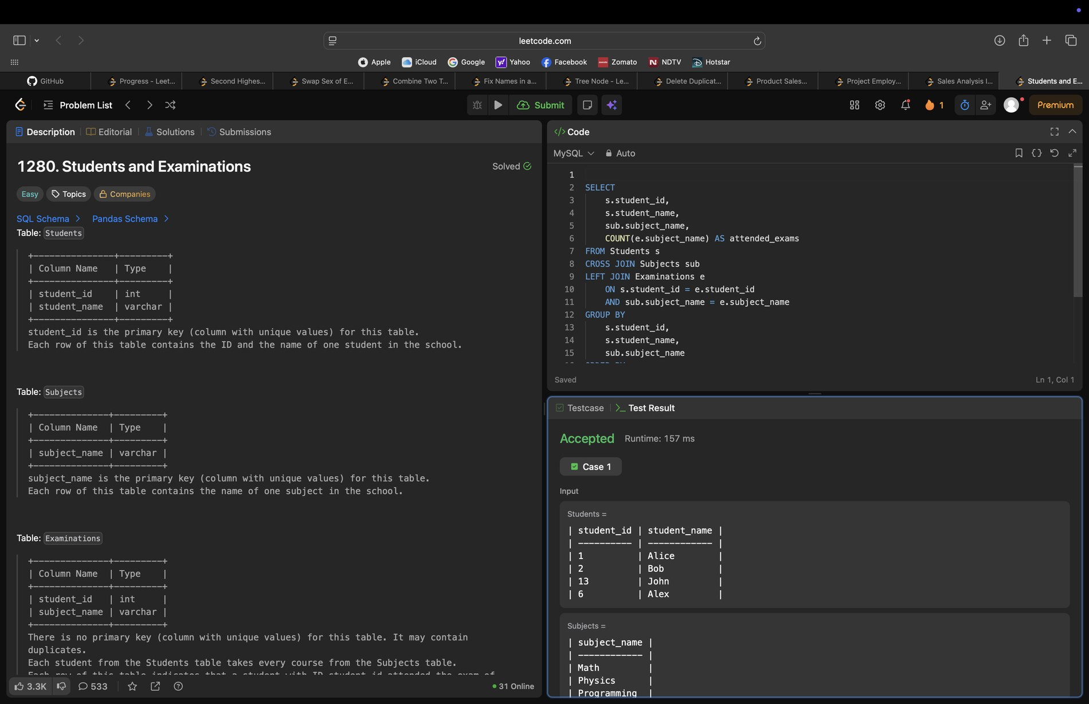

4. Certificates
No LeetCode certificate or badge earned yet.

