RAJDEEP ACHARYA

**Senior Software Engineer**

[**rajdeep777acharya@gmail.com**](mailto:rajdeep777acharya@gmail.com) **+91-9663970562** **linkedin.com/in/rajdeep-acharya/** [**github.com/rajdeep-acharya**](https://github.com/rajdeep-acharya)

**PROFFESIONAL SUMMARY**

**9 years of experience** in software design, development, integration, maintenance of various client-server web applications**.**

# EXPERIENCE

### *Nagravision India Pvt. Ltd* @ Bangalore, India

**Senior Software Engineer** - July 2019 – Present

## Developing **cloud-based microservices** using **Java 8** and **Spring Boot**

## Coordinating with technical architects to create **high-level design** and **low-level design** using **UML diagrams**.

## **Mentoring** junior members in the team.

## Writing **docker** based **containerizied integration tests** and **unit tests** using JUnit, Mockito, WireMock, Hamcrest.

## Actively doing **pair-programming** for **code reviews** and technical challenges.

## **Software Engineer** - October 2014 – June 2019

## Designing and coding webservices, domain and database components using **service-oriented architecture.**

## Working by **Agile Scrum** framework. Responsibilities include interaction with business team in story grooming, estimations, defining acceptance criterias, definition of done.

## **Bug-fixing** and tracking issues using **JIRA**, version control in **GitLab**

### *Cognizant Technologies Solutions* @ Coimbatore, India

**Programmer Analyst** - July 2003 – October 2014

### Developing, maintaining software using Java 6 and MySQL

### Tracking issues via HP ALM

# PROJECTS

### Business Enabling Interface

BEI provides interfaces and administration to provide integration of online services to customers to implement value added business solutions.

* Authentication - Basic, JWT, OAuth2
* Authorization - Permission (Allow method/action per service). Contract (parking facility rights for customers) Auditing. Usage Metrics (evaluating hits, transactions, orders).

### Tech stack used

* Routing - Used Nethix OSS Zuul for upstream/downstream proxy
* Proxy - HA-Proxy (TCP/HTTP Load Balancer/Reverse Proxy), Squid (Caching proxy)
* Increased fault tolerance between web components by implementing Circuit-Breaker Pattern using Hystrix. Introduced multiple Hystrix Circuits with reliable fallback mechanism during downtime.

# STRENGTHS

# 

# SOFTSKILLS

# 

# PROFESSIONAL SKILLS

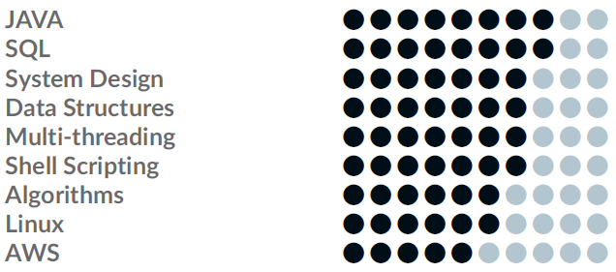

* Load Balancing - used Nethix Ribbon library. Used Weighted Response Time rule for improving time efficiency
  + Implemented PingService for Alive check.
  + Implemented LoadBalancerStats for publishing Active-servers, total requests, connection history (hrst, successive, last)
* Dynamic Property hle management - Archiaus
* Health monitor - Implemented RESTFul API similar to Spring Boot actuators to monitor - DB Datasources, Thread pools(active, peak threads, queue size, rejected pool)
* Improved robustness by implementing health monitor RESTFul API using Spring Boot actuators to monitor datasources, thread pools, active threads, peak threads, rejected threads.

### SSP

### SSP provides the Sales platform to SKIDATA with cloud solution stack. SSP serves as a 24x7 SaaS realized as a platform for web-based consumer portal and connected as a sales channel on-top-of DTA. It comes with a pre-deployed set of ready-to-use portals. Different services serve different purpose i.e. Order service to place the order, Payment service for payments, Catalog for elastic search.

### Tech stack used

### Spring, Spring boot, Spring data JPA, REST webservices,

### Microservices architecture, RabbitMQ, Docker, Rancher, PostgreSQL.

### MAXXO

### MAXXO is part of SKIDATA ONLINE™ cloud solution stack. The MAXXO-Microsite is a highly customizable web application developed for selling tickets online. It comes with a pre-deployed set of ready-to-use microsites. Additional feature is a unified interface for payment service providers supported by a sub-component SDPay.

### Tech stack used

### Java/J2EE, EJB 3.0, Oracle, Wildfly, REST and SOAP WebServices, Maven.

# EDUCATION

## B.E. in Computer Science and Engineering

### Birla Institute of Technology, Mesra

August 2009 – June 2013 @ Ranchi, Jharkhand

# PROFESSIONAL TRAINING

## B.E. in Computer Science and Engineering

### Birla Institute of Technology, Mesra

August 2009 – June 2013 @ Ranchi, Jharkhand

# ACHIEVEMENTS