**Natasha**

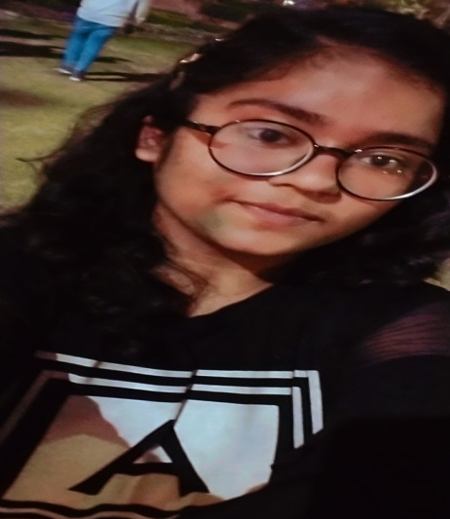

**Education**

**PR PUBLIC SCHOOL**

[**https://prpublicschool.com/**](https://prpublicschool.com/)

**Research Interests**