Game Design Document

Fill up the Following document

1. Write the title of your project.

The Pirates Saga.

1. What is the goal of the game?

The goal of the game is to reach the finish line (The main land) by overcoming various enemies a.k.a. The pirates.

1. Write a brief story of your game?

Brock has to reach the main land as he managed to escaped from a pirate ship on the sea but the evil birds and the Pirates are planning to stop him.

1. Which are the playing characters of this game?

* Playing characters are the ones which respond to the user based on the input from the user
* Cars, monkeys, dinos, wizards etc, are the playing characters in the game.

|  |  |  |
| --- | --- | --- |
| Number | Character Name | What can this character do? |
| 1 | Brock | Run |
| 2 |  |  |
| 3 |  |  |
| 4 |  |  |
| 5 |  |  |
| 6 |  |  |
| 7 |  |  |
| 8 |  |  |

1. Which are the Non Playing Characters of this game?

* Non Playing characters are the ones which don't have an action or a behaviour when the user interacts with the game.
* Hurdles, stones, bananas, coins, etc are non playing characters in the game.

|  |  |  |
| --- | --- | --- |
| Number | Character Name | What can this character do? |
| 1 | Pirates | Shoot guns or maybe kill Brock |
| 2 | Evil Birds | Stop Brock from reaching the main land. |
| 3 |  |  |
| 4 |  |  |
| 5 |  |  |
| 6 |  |  |
| 7 |  |  |
| 8 |  |  |

Draw your imagination of this game. What does this game look like?

* Draw the game either on your computer or on paper,
* Add images of scenes of the game to show each of the playing and non-playing characters at least once.

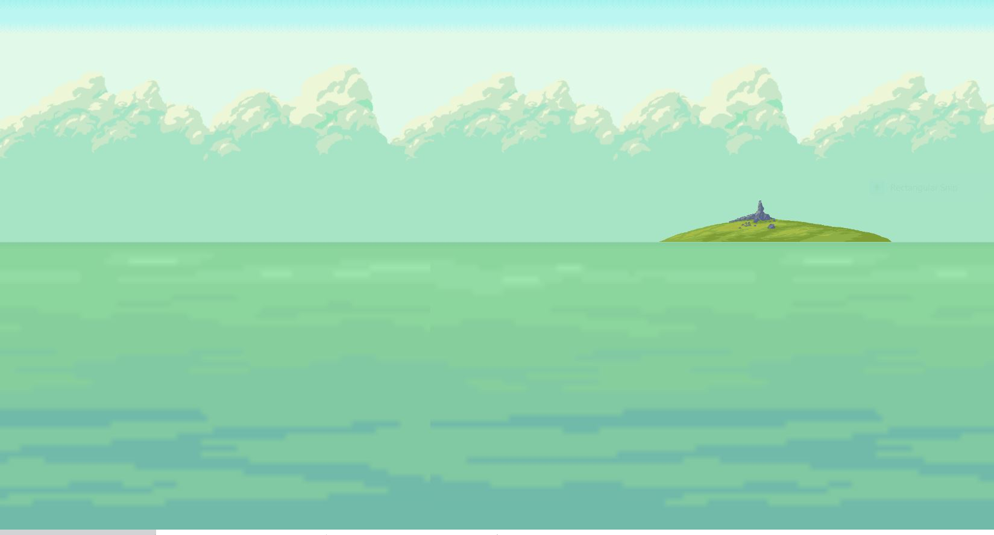

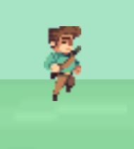

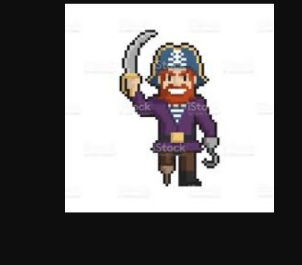

How do you plan to make your game engaging?

By adding Power ups.