GAME LIBRARY MANAGER

Linux Shell Scripting Project Report
Project: L76 – Game Library Manager
Student: Rajdeep Kanzariya
Roll No.: C14 Division: H
Enrollment No.: 24004501210130

Environment: Ubuntu Linux / Bash
Project Folder: ~/linux_project/gamelib

Introduction and Objectives
Game Library Manager is a menu-driven Linux shell scripting application designed to manage a user's video game collection.
It stores game details such as title, platform, genre, hours played and completion status.

Objectives
Develop a menu-driven Bash application.
Add and manage game records.
Filter games by platform or genre.
Calculate total hours played.
Calculate game completion percentage.
Display the top five most played games.
Create compressed backups.
Maintain an activity log.
Generate weekly reports using Cron scheduling.

Project Folder Structure
gamelib/
├── main.sh
├── README.md
├── lib/
│ └── functions.sh
├── data/
│ └── games.csv
├── reports/
├── backups/
└── logs/
└── activity.log
main.sh provides the main menu. functions.sh contains the feature functions. The
data directory stores game records, reports stores generated summaries, backups stores compressed backups, and logs records program activities.

Feature 1: Add a Game
The user can enter the following information:
Game Title
Platform
Genre
Hours Played
Status
The program validates the input and saves the new game record in games.csv .
Screenshot: Feature 1 – Add a Game
[Insert actual Ubuntu terminal screenshot here]
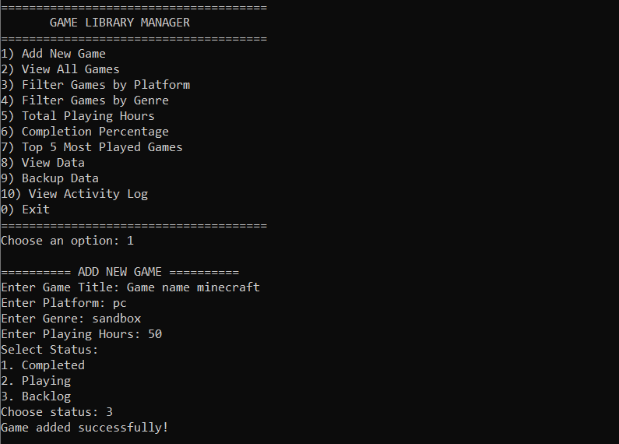

Feature 2: Filter Games by Platform or Genre
Users can search their game collection using a platform or genre.
The program searches the CSV file without considering uppercase or lowercase differences and displays matching records.
Screenshot: Feature 2 – Filter Games
[Insert actual Ubuntu terminal screenshot here]
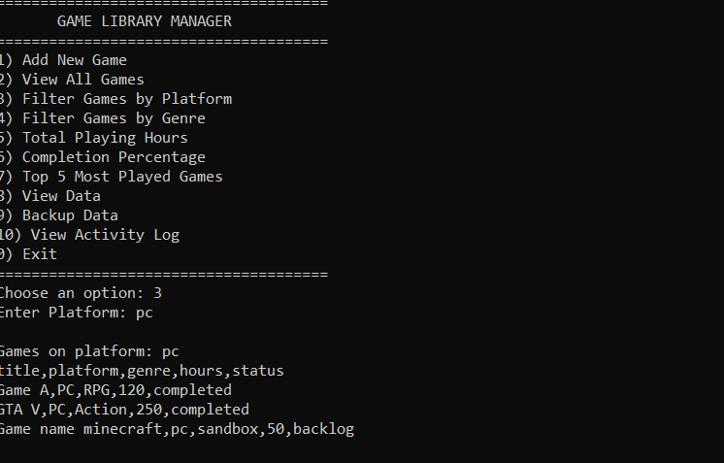
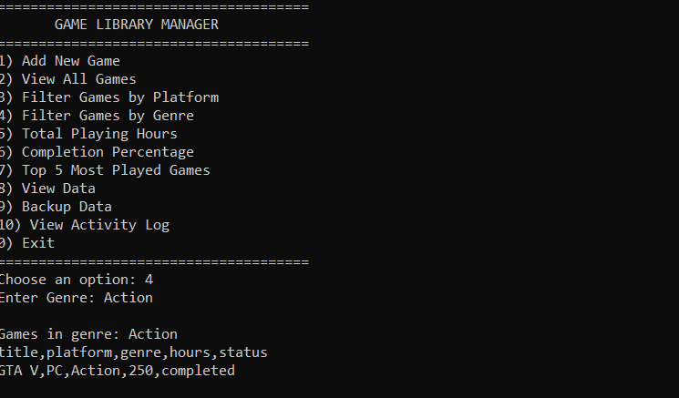

Feature 3: Show Total Hours Played
This feature uses the awk command to calculate the total hours played across all games.
The program skips the CSV header and adds the hours from each game record.
Screenshot: Feature 3 – Total Hours Played
[Insert actual Ubuntu terminal screenshot here]
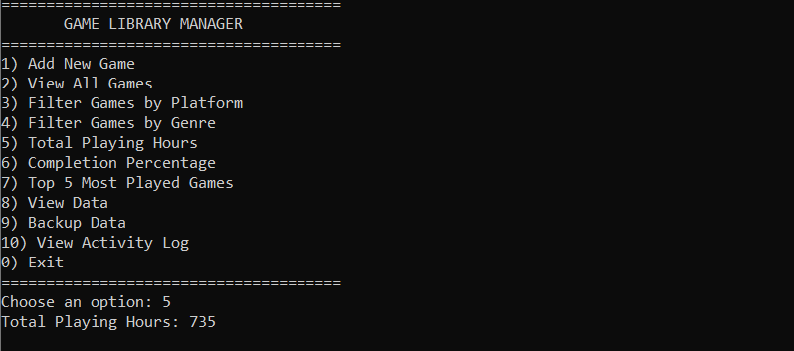

Feature 4: Show Completion Percentage
This feature calculates the percentage of completed games.
Formula:
Completion Percentage = (Completed Games / Total Games) × 100
The program displays the number of completed games and the completion percentage.
Screenshot: Feature 4 – Completion Percentage
[Insert actual Ubuntu terminal screenshot here]
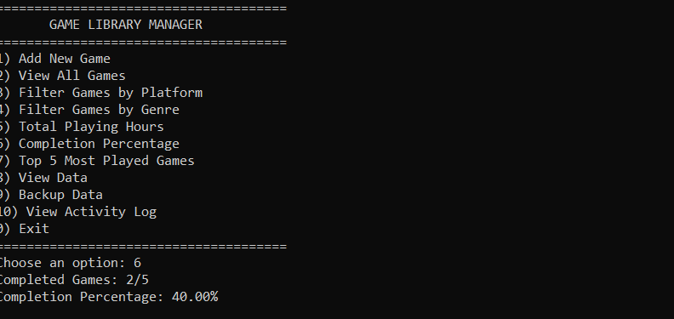

Feature 5: Top 5 Most Played Games
This feature sorts game records according to hours played and displays the five games with the highest playing time.
Linux commands such as sort , tail and head are used.
Screenshot: Feature 5 – Top 5 Most Played Games
[Insert actual Ubuntu terminal screenshot here]
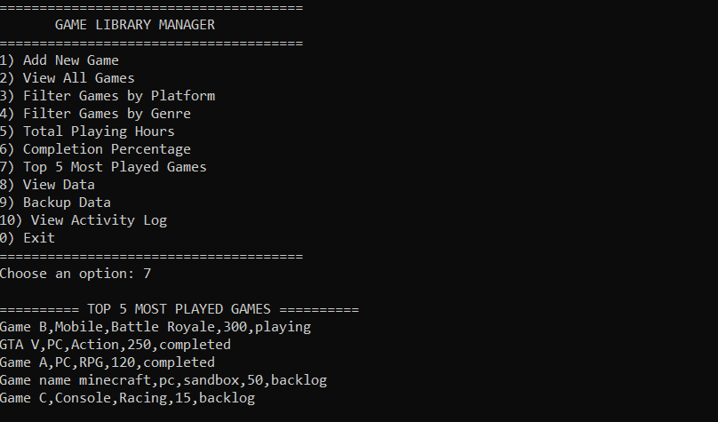

View Data and Backup
The View Data option displays the game records stored in data/games.csv .
The Backup option creates a compressed .tar.gz archive of the data directory using the Linux tar command.
Screenshot: View Data and Backup
[Insert actual Ubuntu terminal screenshot here]
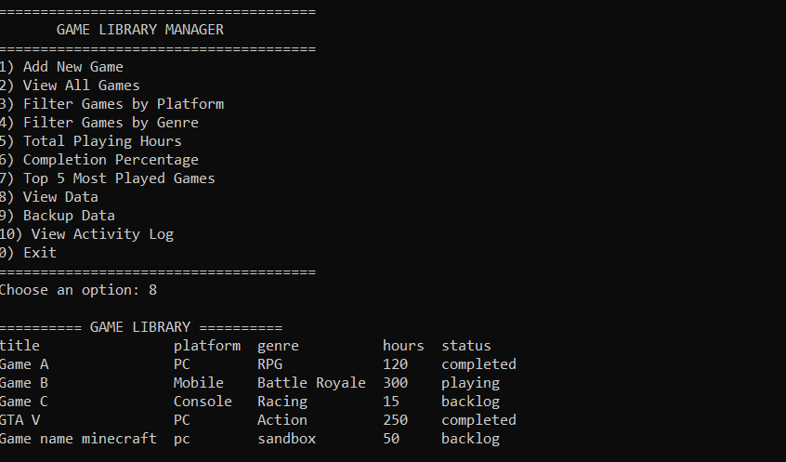
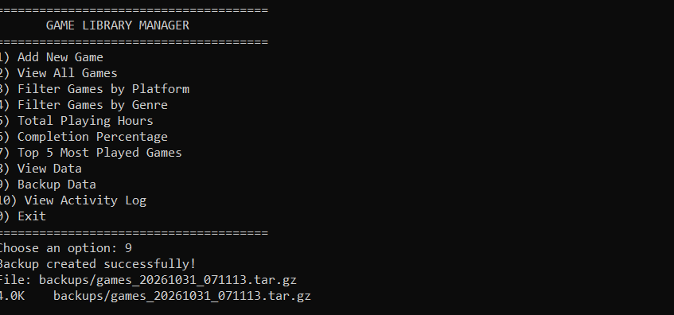

Activity Log and Input Validation
The activity log records important application activities, including:
Adding a new game.
Viewing game statistics.
Filtering game records.
Creating backups.
Generating weekly reports.
Input validation checks that required fields are not empty, hours are numeric, and game status is valid.
Screenshot: Activity Log
[Insert actual Ubuntu terminal screenshot here]
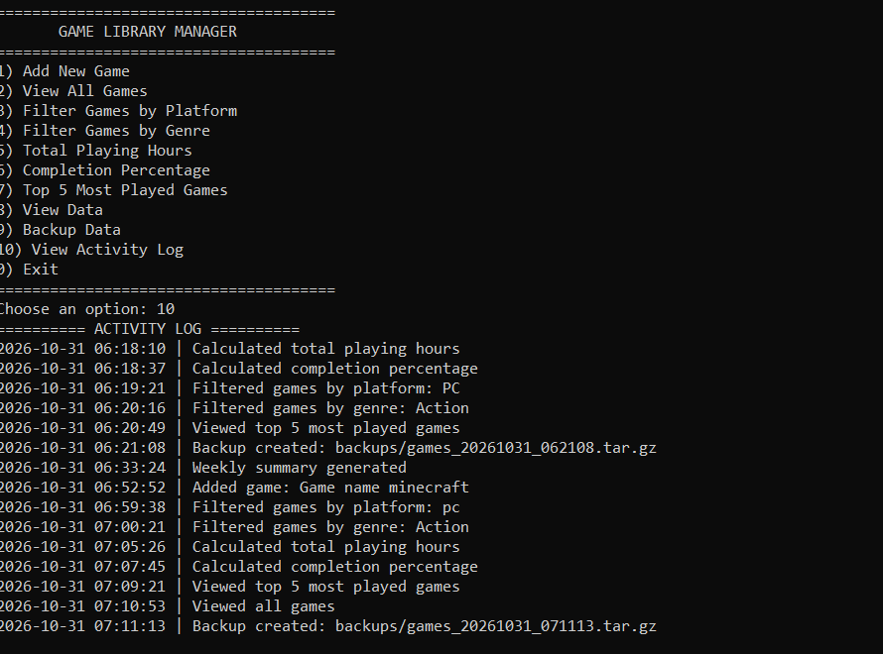

Cron Task and Weekly Report
The project is designed to generate a weekly game library summary every Sunday at 8:00 PM.
Cron expression:
0 20 * * 0
The scheduled task executes:
./main.sh --cron
The generated report is saved in the reports/ directory.
Screenshot: Cron Configuration and Generated Report
[Insert actual screenshots after testing Cron here]
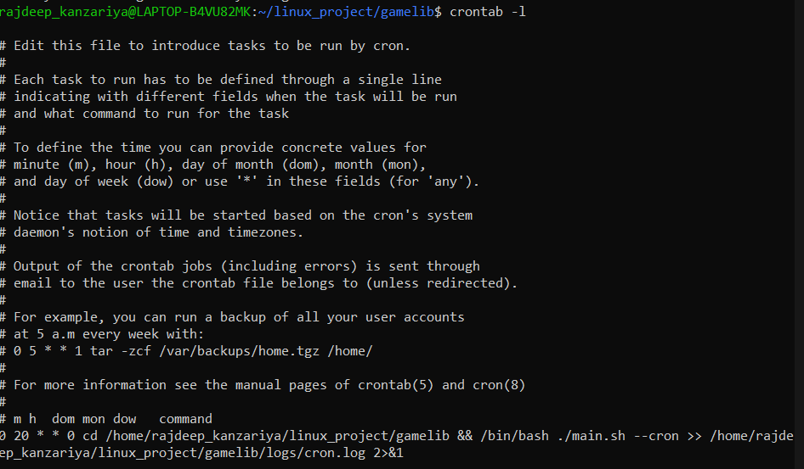
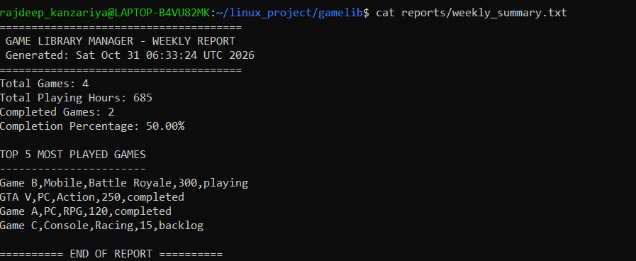

What I Learned
Through this project, I practised Bash scripting, functions, loops, conditional statements, case statements and input validation.
I learned how to manage CSV files, calculate statistics using awk , filter and sort records, create compressed backups using tar , maintain activity logs and schedule automated tasks using Cron.

Conclusion
Game Library Manager demonstrates how Linux shell scripting can be used to develop a practical menu-driven application.
The project provides features for managing game records, filtering information, calculating statistics, creating backups and generating scheduled reports.
It helped me improve my understanding of Ubuntu Linux, Bash scripting and Linux command-line utilities.

