Jenkins

<https://www.jenkins.io/download/>

* Download Jenkins
* Install Jenkins
* Configure Jenkins
* Create Selenium Scripts
* Create batch file
* Execute Jenkins Jobs

Download the stable .war file from URL

Go to cmd

Java-jar war

e4c7978e2f0a46f98ee72a43e7471a2c

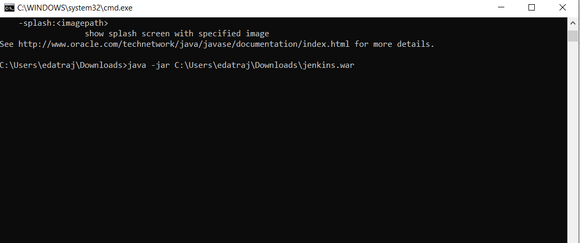

Open New Java Project

Add Selenium Jar

Check Jenkins after

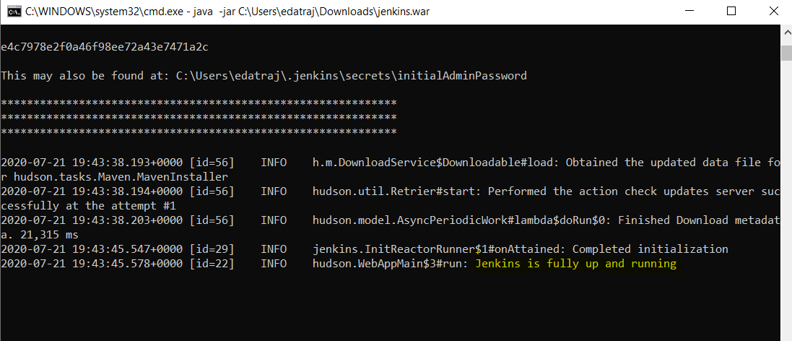

Localhost:8080

In browser

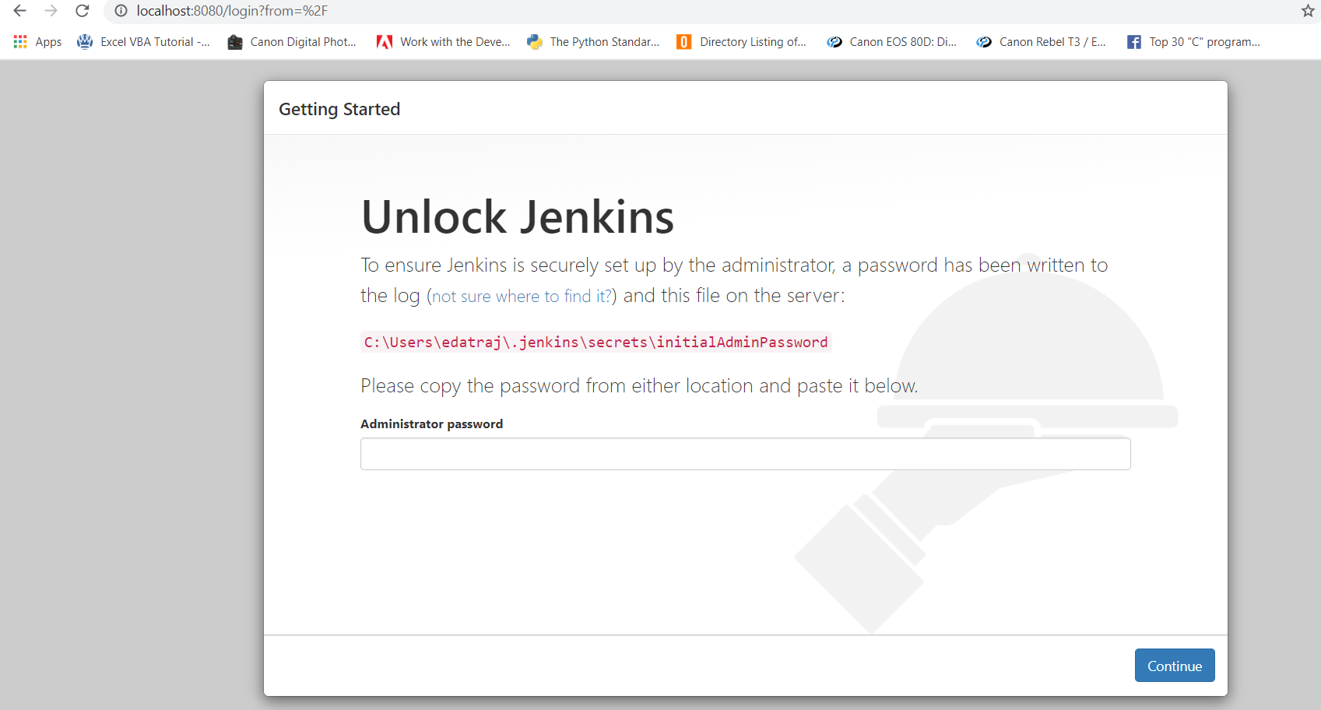

Now paste the Passkey!

e4c7978e2f0a46f98ee72a43e7471a2c

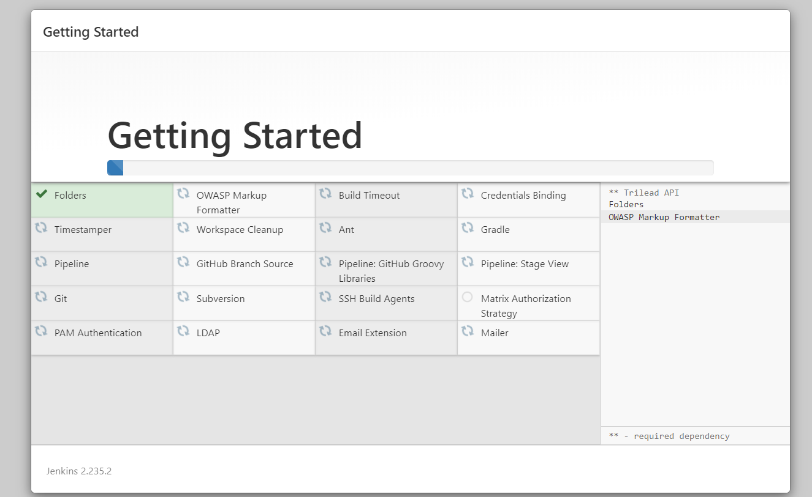

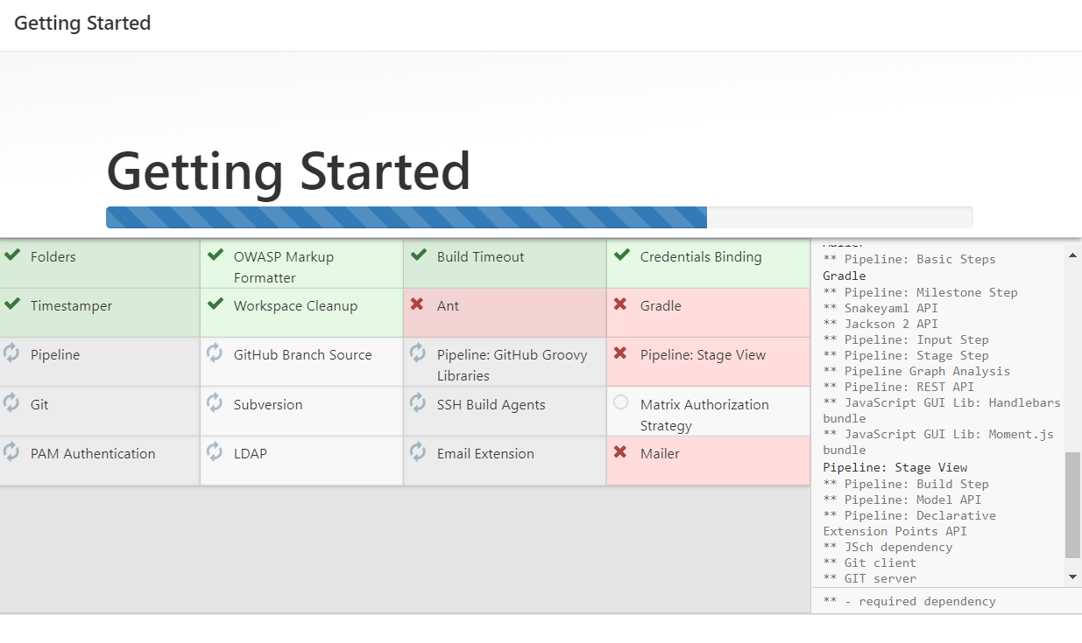

Set admin user and password

Admin P@$$w0rd

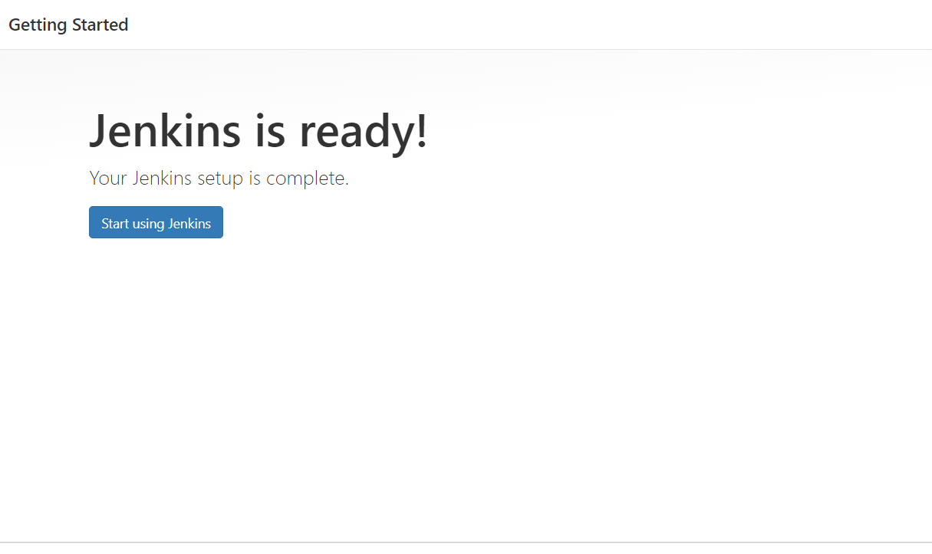

Jenkins is ready!

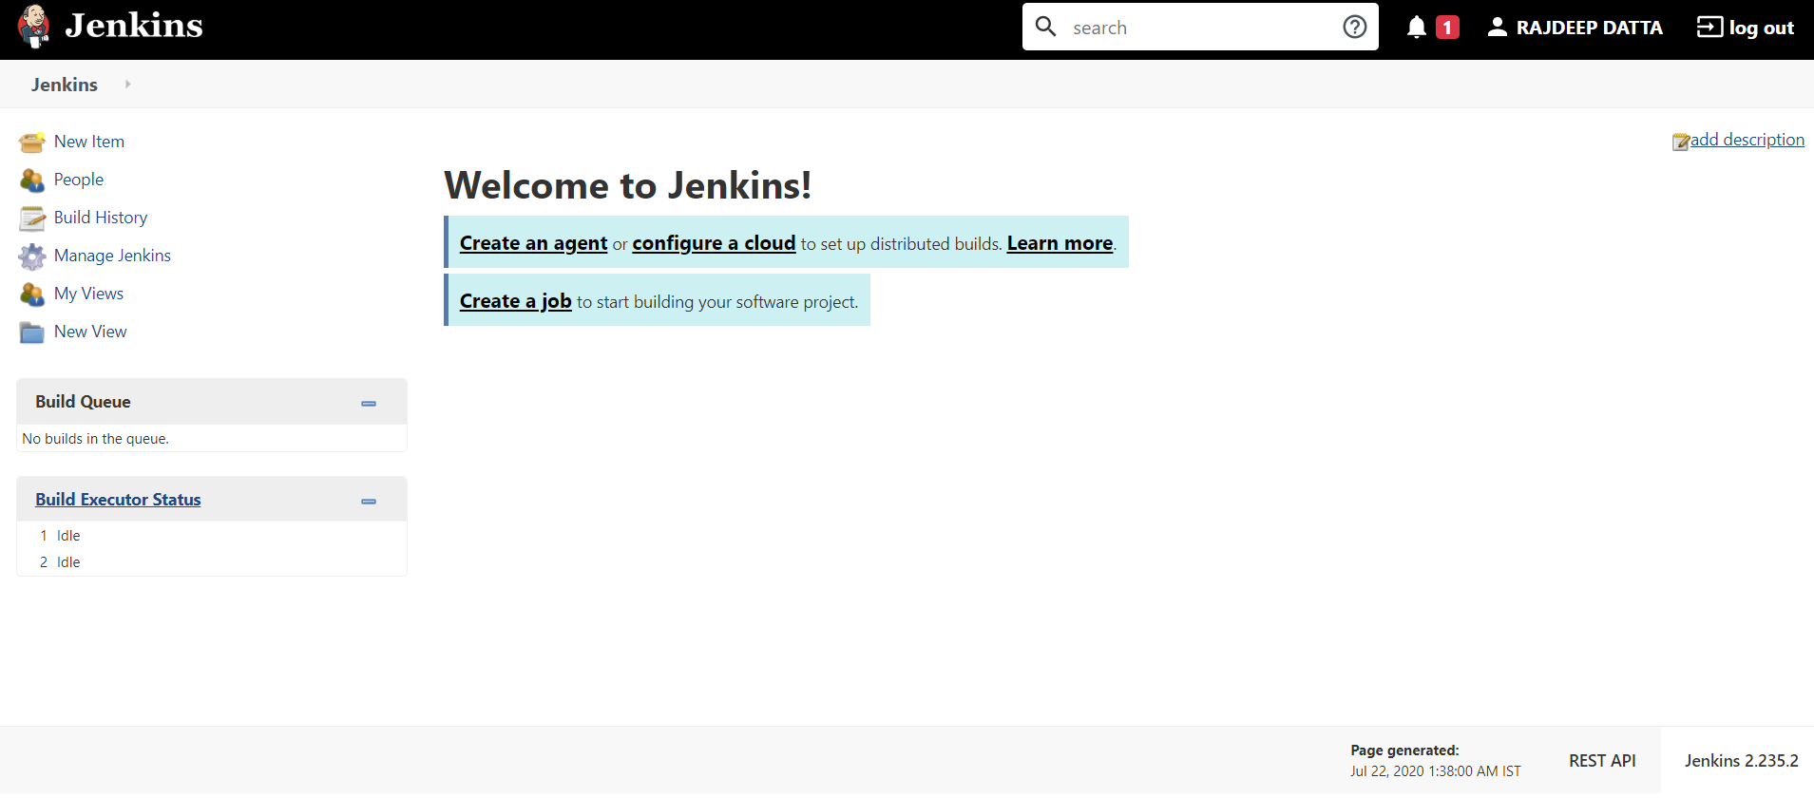

Create multiple people if you want

Create New Item

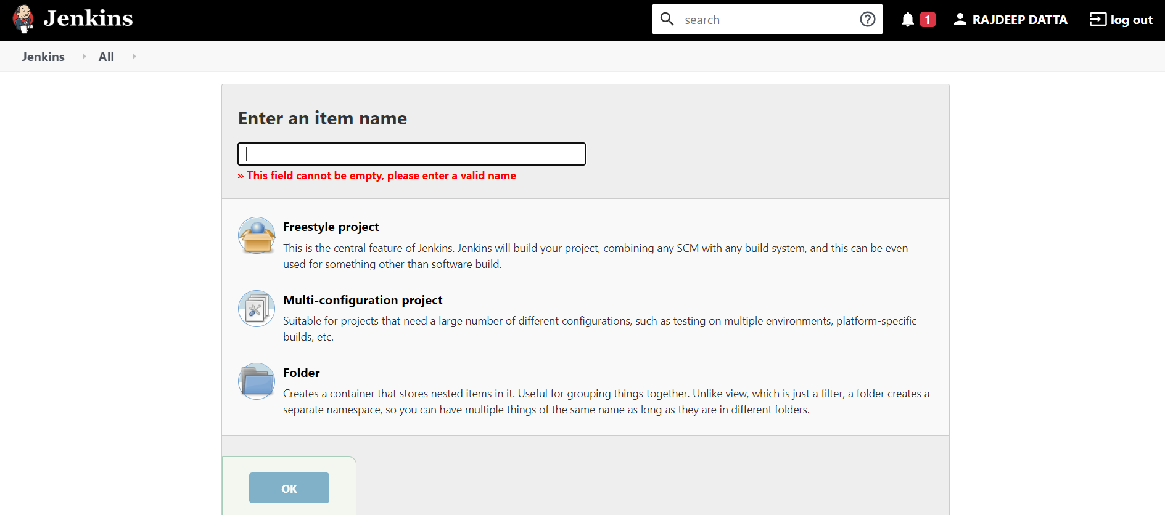

Adding Maven

Manage Jenkins

Available

