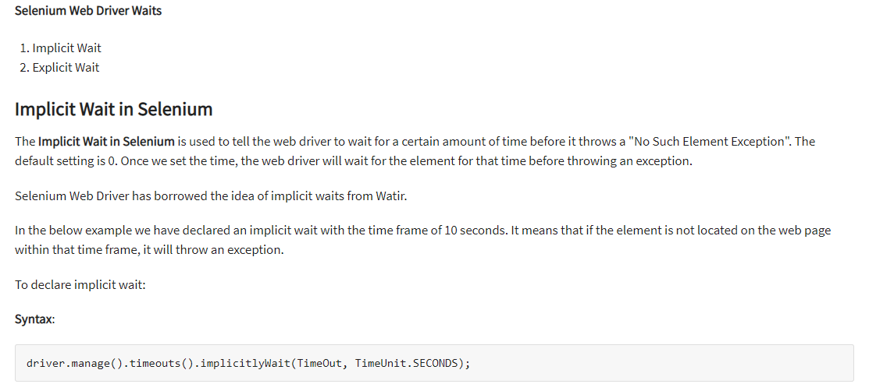

driver.manage().timeouts().implicitlyWait(10,TimeUnit.SECONDS) ;

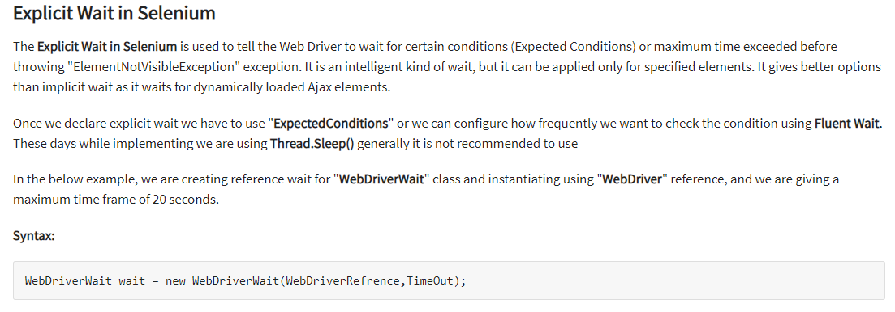

WebDriverWait wait = new WebDriverWait(WebDriverRefrence,TimeOut);

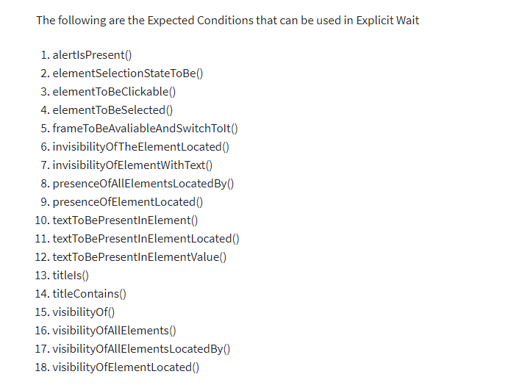

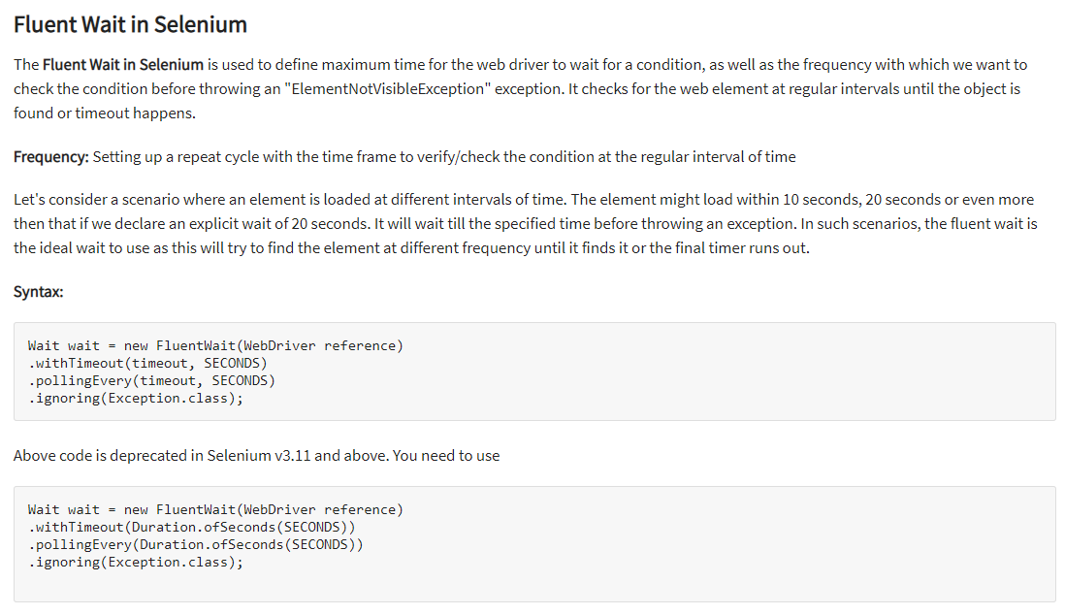

Wait wait = new FluentWait(WebDriver reference)

.withTimeout(Duration.ofSeconds(SECONDS))

.pollingEvery(Duration.ofSeconds(SECONDS))

.ignoring(Exception.class);

CODE FOR FLUENT

// launch Chrome and redirect it to the Base URL

driver.get("http://demo.guru99.com/test/guru99home/" );

//Maximizes the browser window

driver.manage().window().maximize() ;

//get the actual value of the title

aTitle = driver.getTitle();

//compare the actual title with the expected title

if (aTitle.contentEquals(eTitle))

{

System.out.println( "Test Passed") ;

}

else {

System.out.println( "Test Failed" );

}

Wait<WebDriver> wait = new FluentWait<WebDriver>(driver)

.withTimeout(30, TimeUnit.SECONDS)

.pollingEvery(5, TimeUnit.SECONDS)

.ignoring(NoSuchElementException.class);

WebElement clickseleniumlink = wait.until(new Function<WebDriver, WebElement>(){

public WebElement apply(WebDriver driver ) {

return driver.findElement(By.xpath("/html/body/div[1]/section/div[2]/div/div[1]/div/div[1]/div/div/div/div[2]/div[2]/div/div/div/div/div[1]/div/div/a/i"));

}

});

//click on the selenium link

clickseleniumlink.click();

//close~ browser

driver.close() ;