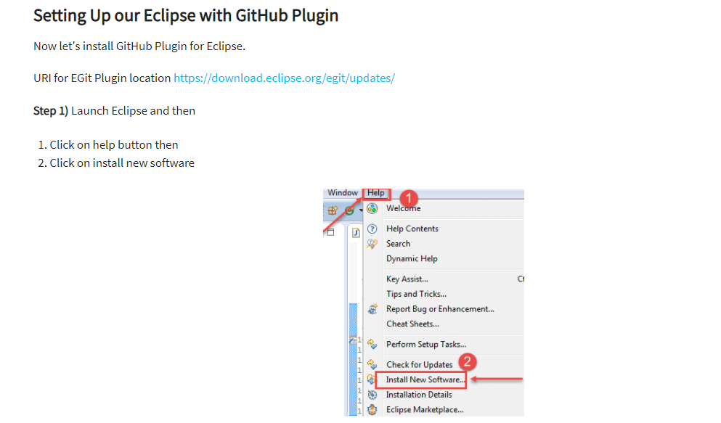

<https://download.eclipse.org/egit/updates/>

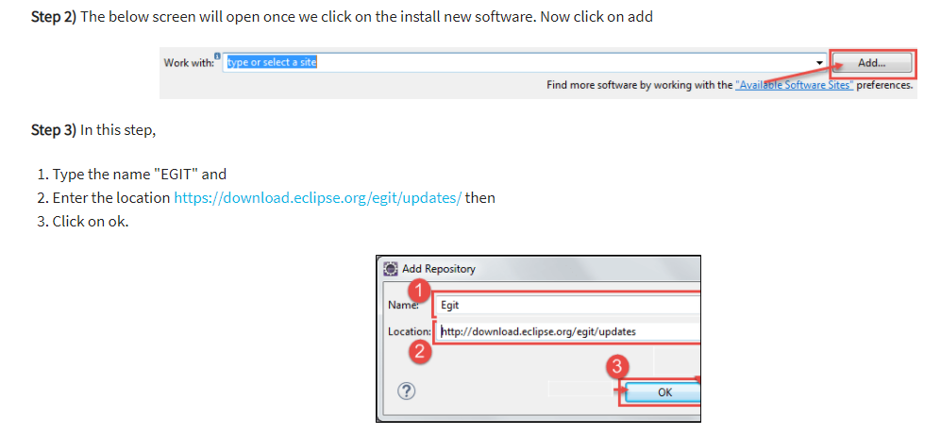

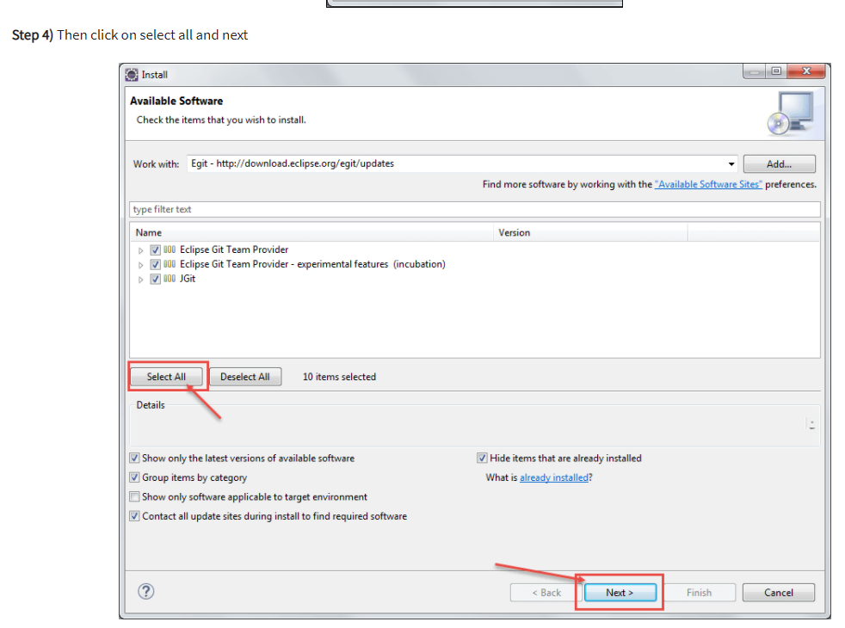

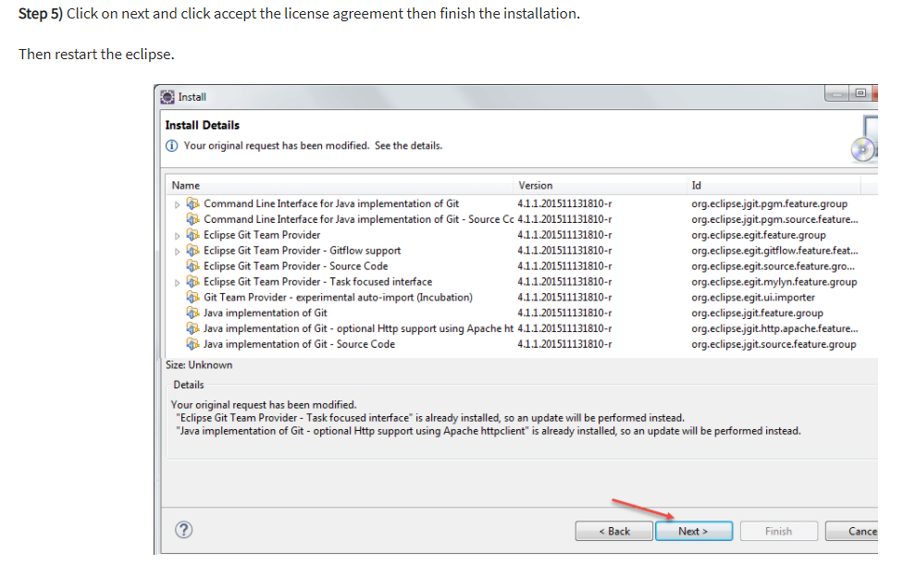

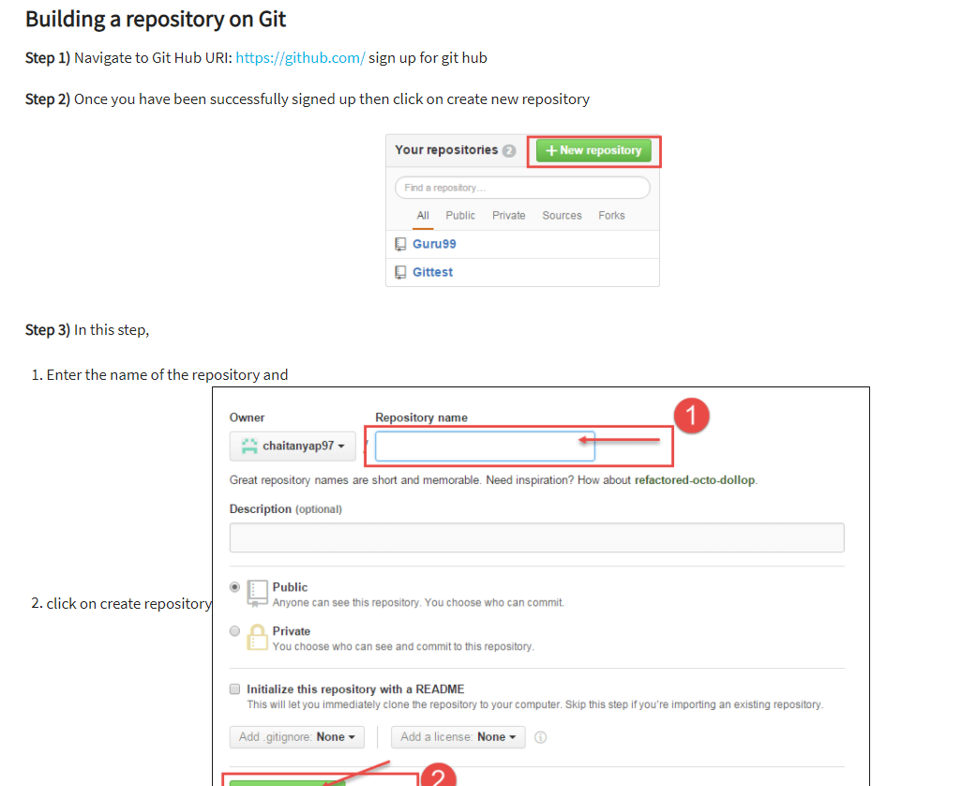

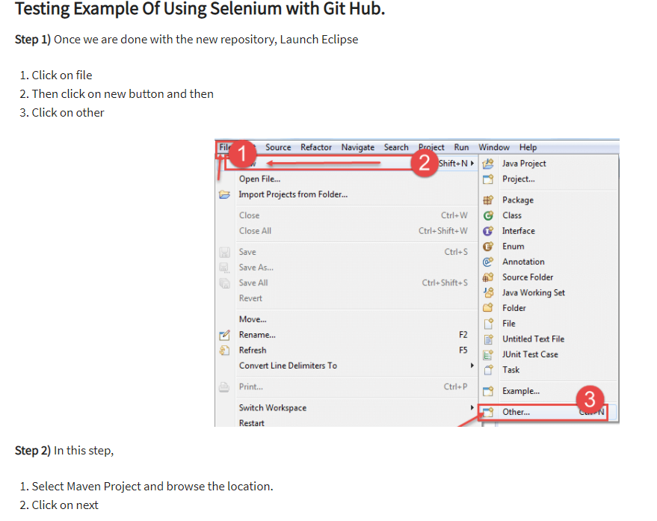

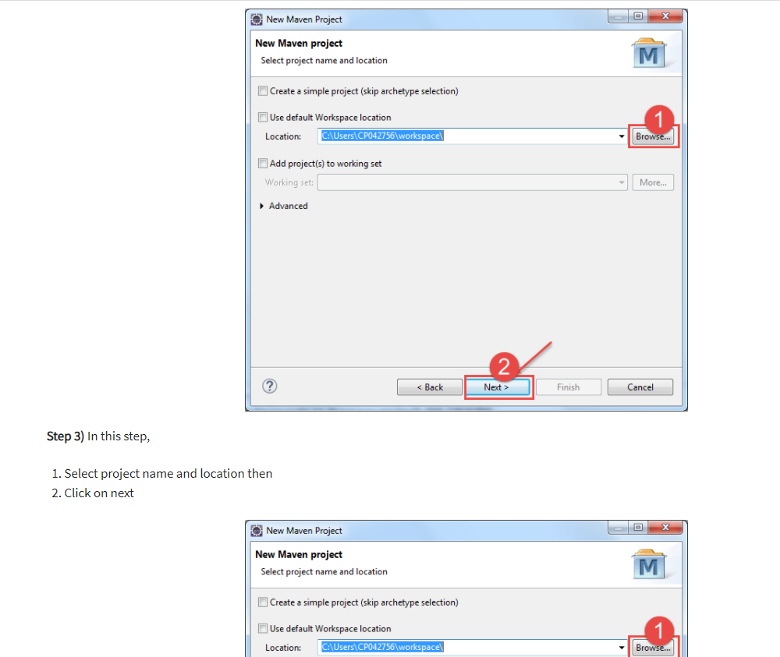

**Advantages:**

* GitLab Continuous Integration (CI), Continuous Delivery (CD) is an integral part of GitLab and is free as an offering from GitLab.com
* The learning curve is pretty flat whereas the topics are all covered in detail in the quick start guides
* GitLab Continuous Integration/Continuous Delivery offers the same experience as GitLab which are familiar, easy to use and all beautiful.
* Tests run distributed on separate machines, which can be added at any point in time – scalability of the machines
* Each of the builds can be split into multiple jobs which can run in parallel on multiple machines to provide faster results
* Continuous Delivery is achieved in multiple stages, environments and can be done in manual deployments.
* Both the CI and CD features are included in both the open-source GitLab Community Edition and also in the proprietary Enterprise Edition.
* Most of the useful projects are either on Git or on GitHub.
* You could share your code, documentation, presentations in a very easy manner.
* This is the best place for all the programmers with both public and private repositories to work with.
* There are a varied number of integrations that can be done along with GitHub, which makes it appealing amongst the programmers
* It provides one of the cleanest and the best UIs to navigate with all its useful features as assigning issues, pulls requests, labels, and milestones.
* The whole system is simple but very useful
* Creation of projects, documentation and almost everything that relates to your projects at one place
* One of the best ways to clean up or reorganize all the present issues is done along with the Milestones feature.
* There is a provision for anyone to host, review the code or to manage the projects
* It gives you the collaboration when working on open source projects where you can work alongside developers from various other nationalities.