Assignment 8

Rajdeep Pinge 201401103

Aditya Joglekar 201401086

Till now we have been studying everything in inertial reference frame since newton’s laws of motion only apply in inertial reference frame. But in real world a lot of things are happening in non-inertial reference frame. The motion in non-inertial reference frame in not easy to visualize and hence we have taken this opportunity to study the motion of particle in non-inertial reference frame with a strong simulation tool like matlab which would help us in understanding some of the complex problems conveniently.

We have taken two basic problems each of which contains a lot of cases and sub-problems. We have chosen such problems which relate with the course as well as with what we have done in earlier assignments.

Problem 1: This is a simple simulation of motion of a ball in an elevator frame. Here we are going to simulate how the ball will move when it is released by the person standing in the elevator and how will it appear to the person.

The extension of this problem would be to simulate the motion when the ball is thrown vertically upwards or vertically downwards with varying initial conditions.

This leads us to our second problem of throwing a ball (projectile) from a moving vehicle.

Problem 2: Here we will be simulating the situation in which a projectile is thrown from a moving vehicle in such a manner that the person throwing the projectile covers enough distance to catch back the projectile from the vehicle. This problem has a lot of cases to consider like the effect of wind and changing conditions like theta and initial velocity.

Problem 3: Another interesting problem is we have a pendulum attached to the roof of a moving vehicle. We will simulate how the equilibrium position of the pendulum changes with the acceleration of the vehicle.

Q1. Simulating motion of a ball in elevator frame of reference. Here first we will take the case when ball is just released with no initial velocity and then build on it with giving some initial velocity and observing the motion. This will lead us to our 2nd problem.

Assumptions: Elevator moving with constant acceleration. Initial velocity = 0

The ball is released from the elevator at t = 0 and is at a location y = 0 w.r.t elevator.

We are standing in the elevator and observing the movement of ball w.r.t elevator reference frame.

MATLAB Code:

% This is a programme to simulate the motion of a ball in elevator

% reference frame

clear;

close all;

%define the basic parameters

mass = 1; %mass of the ball

g = -9.8 ; %gravitational acceleration, convetion, the downward direction is negative.

a_elevator = -5; %acceleration of the elevator

% effective acceleration acting on the ball

global g_eff;

g_eff = g - a_elevator;

total_time = 10;

tstart = 0;

tfinal = total_time;

dt = total_time/100;

y_init = 0; % assuming the vertical direction is y direction

v_init = 20;

% values to be given to ode solver

u0=zeros(2,1);

u0(1) = y_init; % initial position

u0(2) = v_init; % initial velocity

% ode solver

options = odeset('RelTol',1e-8);

[t,u] = ode45(@elevator_ode, [tstart:dt:tfinal], u0, options);

% store the solution

y = u(:, 1);

vy = u(:, 2);

% plot the position vs. time

plot(t, y)

title('Position wrt to the elevator frame vs. Time')

xlabel('time (sec)');

ylabel('position of ball in y-direction (m)');

% generating quiver plot

x = zeros(length(y), 1); %since 1 dimensional motion

vx = zeros(length(y), 1);

figure

quiver(x, y, vx, vy)

title('quiver plot')

xlabel('x');

ylabel('y');

Ode Solver:

function F = elevator_ode(t,u)

% In our case we will use:

% u(1) -> y

% u(2) -> vy

% declare the globals so its value set in the main script can be used here

global g_eff;

% make the column vector F

F = zeros(length(u), 1);

% dx/dt = v

F(1) = u(2);

% dv/dt = acceleration

F(2) = g_eff;

Acceleration of elevator = 9.8 m/s2 in downward direction.

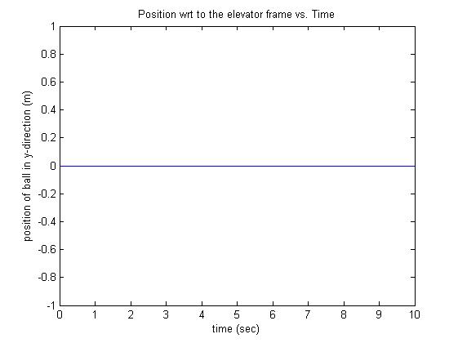

When the ball is released, it is in free fall condition. So ball experiences downwards acceleration = 9.8 m/s2 i.e. gravity. Now since the elevator is also moving downwards with acceleration 9.8 m/s2 downwards, the ball appears stationary from elevator.

Acceleration of elevator = 5 m/s2 in downward direction.

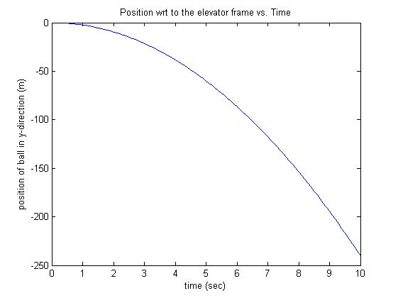

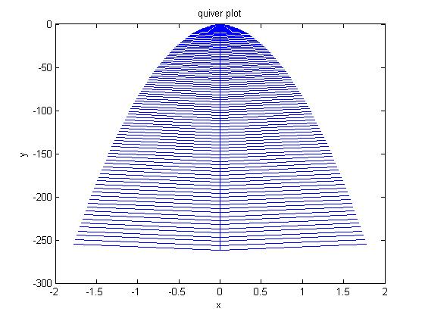

Here the elevator moving downwards with acceleration less than gravitational acceleration. Hence the ball will appear to move downwards but relatively slowly than at stationary.

Acceleration of elevator = 5 m/s2 in upward direction.

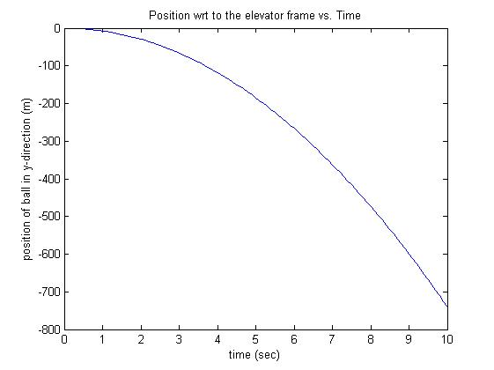

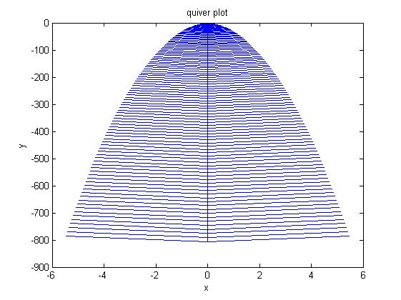

Here the elevator is moving upwards while the ball is moving downwards so from elevator the ball will appear moving downwards with acceleration more than gravity and hence cover larger distance with increasing velocity.

This can be verified by the graphs of above two cases.

Acceleration of elevator = 15 m/s2 in downward direction.

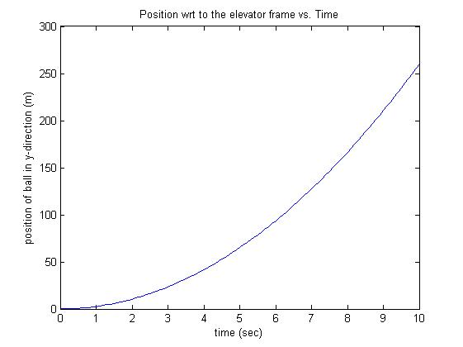

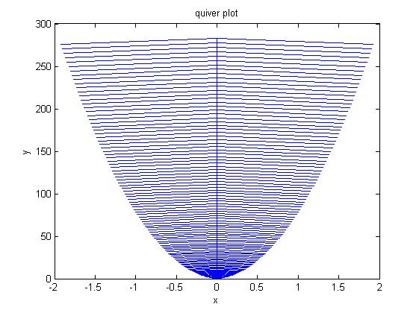

Here the elevator is moving downwards extremely fast with an acceleration of 15m/s2 which is more than gravitational acceleration. Hence the downward velocity of elevator is increasing faster than the ball. Therefore, although ball is also falling along with elevator, in the reference frame of elevator, the ball appears going upwards and its velocity increasing gradually.

Now let us consider situations in which initial velocity is non-zero.

Acceleration of elevator = 15 m/s2 in downward direction. Initial velocity of ball = 20m/s downward direction

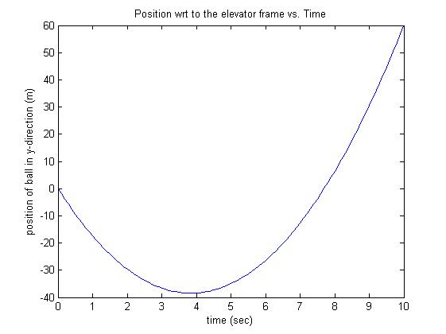

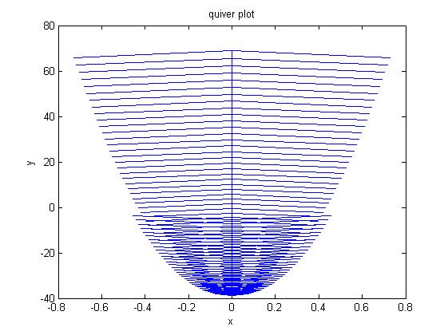

This gives a more clarity about how the motion of the ball appears from elevator when acceleration is more than gravity.

Acceleration of elevator = 5 m/s2 in downward direction. Initial velocity of ball = 20m/s upward direction

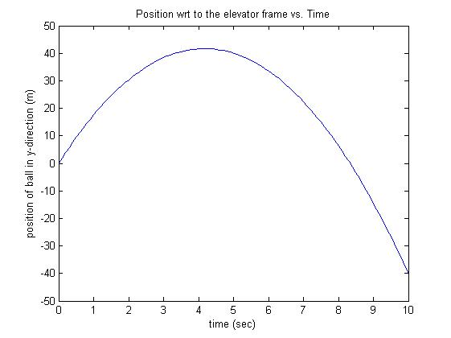

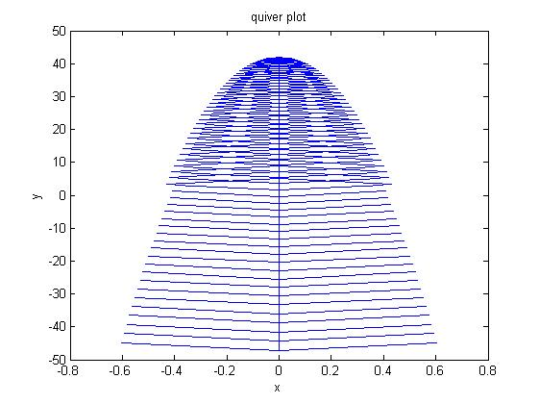

This represents a more realistic situation to observe where elevator is going down and the person in the elevator throws the ball straight upwards with constant velocity. And the ball goes up to a certain height and then enters free fall. Since the elevator moves slower than gravity the ball starts catching up the elevator.

We will also observe the motion of ball in x-y plane

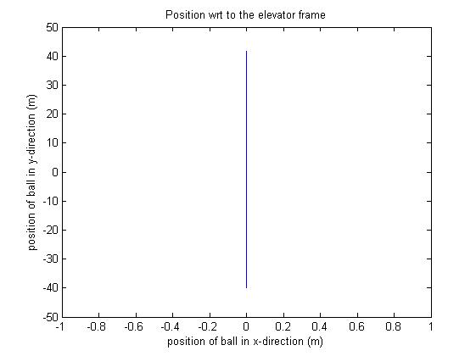

The motion is as expected from the above plots since there is no motion in x-direction while in y direction due to initial velocity, the ball moves upwards, with decreasing velocity, then comes to rest and then starts moving downwards under gravity. W.r.t elevator it comes down since acceleration of elevator is less than acceleration of ball i.e gravitational acceleration.

With this scenario we move on to our next problem of throwing a projectile from a moving vehicle in such a manner than we can catch it again.

Q2.  **Catch the ball. Investigating motion of a projectile in the frame of reference of an accelerating vehicle.**

We are in a vehicle at rest. We throw a ball in the air. The car accelererates along a flat rode. The acceleration is constant. The question for a given velocity at which we throw the ball, what should the angle be such that we will be able to catch the ball. In other words what should the angle be so that coordinates of the car and the ball when the ball returns close to the ground almost match. Take a practical situation in which we will be able to catch the ball it is within say 0.5m from us.

Initially, the vehicle is at rest. Decide a velocity for the ball. Now, the purpose of our assignment is to study relative motion of our standard particle motion in non inertial frame of references and to understand the notion of pseudo forces required to make Newton's laws of motion valid in these situations. So instead of using the ground frame we will use the frame of reference of the accelerating vehicle itself. So, we fix our x and y coordinate systems ( pointing rightwards and upwards respectively ). Note that the vehicle will be always be at rest in its own reference frame. While we would need to use relative velocity for the projectile. Also, more importantly, in noninertial frame of references there is a 'pseudo' force acting on the object which arises out of the acceleration of the frame of reference itself. Here as the vehicle is accelerating rightwards at a constant rate, the pseudoforce acting on the particle will be directed along the negative x direction and its magnitude will be mass*acceleration_of_the_vehicle.

So now the fdb of the object will be as follows. There will be weight acting in the downward direction (as usual) but along with it there will be the extra pseudo force along the negative x direciton. Hence in the frame of reference of the vehicle, the projectile's trajectorry will have a different nature it will not the same as that in the ground frame.

Now that we have defined the setup, it is time to tackle the actual problem. We need to find the angle for which there exists a point at which the vehicle and the projectile are at the same instant in time. That is when we will be able to catch the ball. It might be difficult to work out this problem analytically. But, using our ODE solver we can get a very simple solution. First of all, recognize that as we are analysing in the vehicle frame of reference there is no need to study the motion of the vehicle (it is at rest!). We want to find out the appropriate angle. So we must loop through angles 1 to 90 degrees. For each iteration, we compute the trajectory of the projectile in the vehicle frame using the ode solver. Then we check if there exists a point in time where the distance (using distance formula) between the projectile and the vehicle is decreasing below 0.5. We take care to consider only those points where the projectile is in the descending part of its trejectory.

We we do find such a point, we check if the coordinates make sense. We plot several graphs to visualize what is going on and to verify if the calculations made are correct.

MATLAB Code:

clear;

close all;

%state the parameters

g = 9.8;

thetadeg = 7;

theta = thetadeg*pi/180;

init_vel = 10;

tstart = 0;

tfinal = 10;

dt = 0.1;

global drag;

drag=10;

global m;

m = 1; %mass of projectile

%we will need two ode's one for the projectile and one for the vehicle.

global acce_vehicle; %acceleration of the vehicle.;

global const;

acce_vehicle =10;

const = g;

%find the point of catching or impact.

%now we define the ode for the vehicle.

u1=zeros(2,1);

u1(1)=0; % initial position of vehicle in x

u1(2)=0; % init vel of pos in x

% set the solve options

options = odeset('RelTol',1e-8);

%[t,u]=ode45(@rhs,[tstart,tfinal],u0,options);

[tv, uv] = ode45(@ode_vehicle,[tstart:dt:tfinal],u1);

%hold on;

x_vehi = uv(:, 1);

v_vehi = uv(:, 2);

y_vehi = zeros(1, length(x_vehi));

%plot(x_vehi,y_vehi);

for thetadeg=1:90

theta = thetadeg*pi/180;

ux = init_vel * cos(theta);

uy = init_vel * sin(theta);

% set the initial conditions in the y0 column vector

u0=zeros(4,1);

u0x(1)=0; % initial position of the projectile

u0(2)=0;

u0(3)=ux; % initial velocity of the pendulum

u0(4)=uy;

% set the solve options

options=odeset('RelTol',1e-8);

%[t,u]=ode45(@rhs,[tstart,tfinal],u0,options);

[t,u]=ode45(@ode_projectile,[tstart:dt:tfinal],u0);

%extracting data from the ode solver output

x_pos = u(:, 1);

y_pos = u(:, 2);

%plot(x_pos,y_pos)

%hold on

%plot(t,x_pos)

%plot(t,y_pos)

vx_vel = u(:, 3);

vy_vel = u(:, 4);

%plot(x_pos,y_pos); %plot of the projectile relative to the vehicle.

%title('Trajectory of the projectile as seen in the reference frame of the vehicle');

%xlabel('x');

%ylabel('y');

for loop=1:length(x_pos)

distance=sqrt((x_pos(loop)-x_vehi(loop))^2+ ((y_pos(loop)-y_vehi(loop)))^2);

if vy_vel(loop)<0 && distance<0.5

impact=x_vehi(loop)

check=x_pos(loop)

check1=y_pos(loop)

timeofimpact=t(loop)

angleneeded=thetadeg

figure

plot(t,x_vehi)

xlabel('time')

ylabel('vehicle x position')

title('vehicle movement')

figure

plot(t,x_pos)

xlabel('time')

ylabel('projectile x position')

title('projectile x movement')

figure

plot(x_pos, x_vehi)

xlabel('projectile x position')

ylabel('vehicle x position')

title('comparison movement')

figure

plot(x_pos,y_pos);

xlabel('projectile x position')

ylabel('projectile y position')

title('trajectory of the particle in the with respect to the vehicle')

figure

plot(x_pos,vx_vel);

xlabel('projectile x position')

ylabel('projectile x velocity')

title('phase space plot of the projectile with reference to the vehicle')

break

end

end

end

ODE solvers

For projectile:

function F = ode_projectile(t,u)

% In our case we will use:

% u(1) -> x

% u(2) -> y

% u(3) -> vx

% u(4) -> vy

% declare the globals so its value

% set in the main script can be used here

global const

global acce_vehicle;

global drag;

global m;

% make the column output vector F filled with zeros, so that it is

% initialized to same direction as our input col vec

F = zeros(length(u), 1);

if (u(2)<0) %proj under the ground doesn't make sense.

return;

end

% dx/dt=v

F(1) = u(3);

F(2) = u(4);

vel_mag=sqrt(u(3)^2+u(4)^2);

F(3) =-acce_vehicle-(drag*vel_mag*u(3)/m); %should be -g

F(4) = -const-(drag*vel_mag*u(4)/m);

For vehicle

function F=ode_vehicle(t,u)

%global acce_vehicle;

% make the column vector F filled with zeros

F=zeros(length(u),1);

% so the equation dx/dt=v means that F(1)=u(2)

F(1)=u(2);

% so the equation dv/dt=-....

F(2)=0;

A sample run of the program. Suppose the initial velocity is 10 m/s second then we get the following results.

Vehicles x coordinate = 0 m

projectile x coodinate = -0.2093 m

projectile's y coordinate= 0.3023 m

time of impact = 1.8000 s

angleneeded = 64 degrees.

The plots for this situation are as follows.

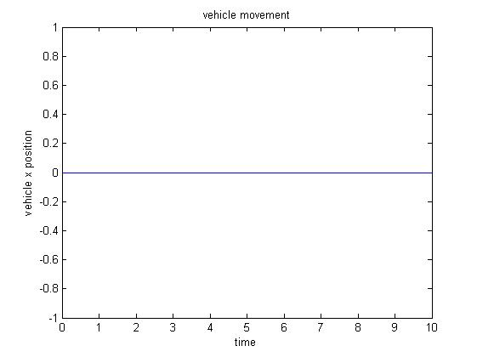The vehicle is not moving in its own frame of reference.

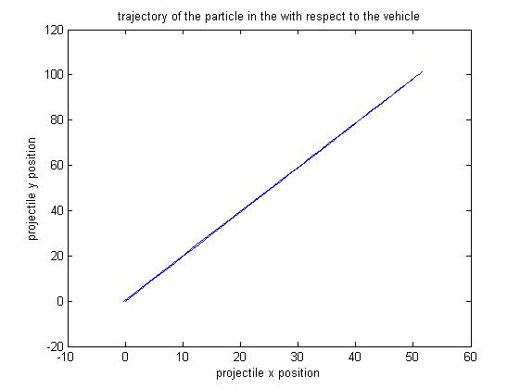

Notice that the this trajectory is similar to a projectile but it is streched in the frame of reference of the vehicle. Thus a person in the car will more or less see the projectile nature but the percepiton of motion is distorted because of the person's motion.

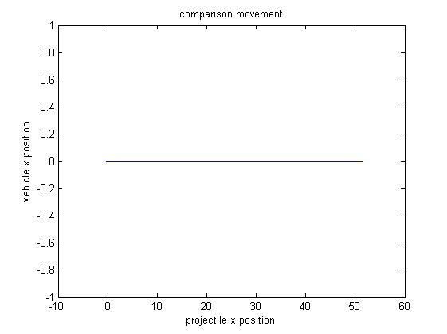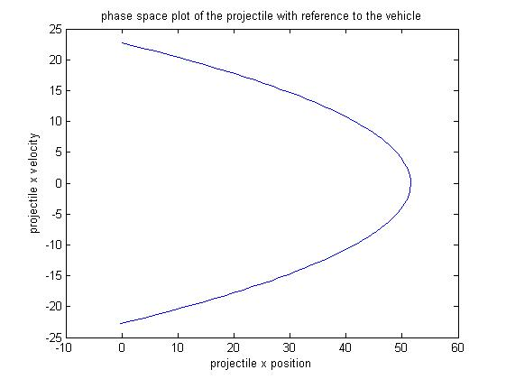The projectile in this frame of reference beings at origin and must come back to the origin if we are to catch it. We get this phase space as expected.

Plots for higher velocity of the car, v= 100 m/s

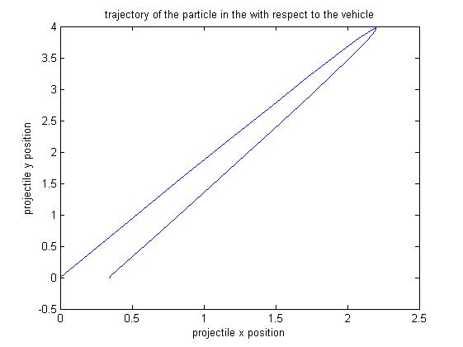

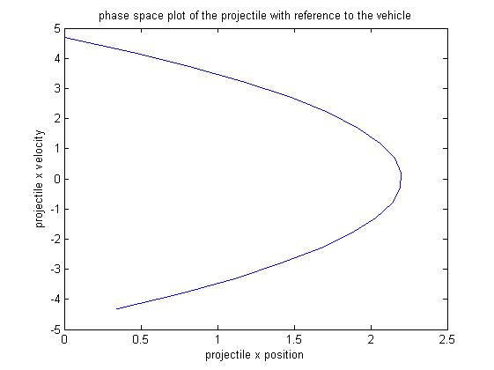

For yet higher velocitiy, this time v=100 m/s,

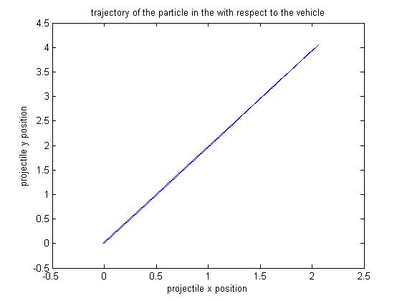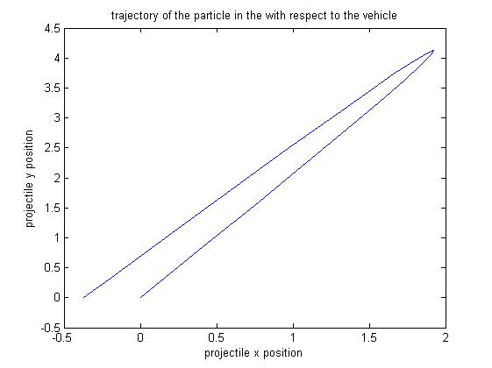

Interestingly if, we make the car accelerate leftwards and throw the ball rightwards we expect not to get any solutions. However, the code generates trivial solutions for instance giving angles of 1 degree. Which means that the projectile was so low that it fell inside the car. This however is a trivial answer. But it shows that the code is general enough to handle negative acceleration as well.

Next, we include the drag effect of wind as discussed in class. For the same situation as given in the first example we now get the following plots.

impact =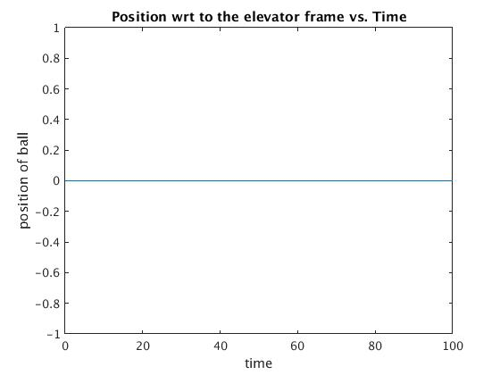 0

projectile position=

0.2177

vehicle position=

7.6427e-004

timeofimpact =

0.1000

angleneeded =

7

Interestingly, in presense of drag the angles for impact decrease. This makes sense it means that earlier for these low angles the projectile was moving way too ahead of the vehicle for us to catch it and hence we were forced to throw the ball at greater angles. But when we include drag the motion of the projectile is inhibited and this allows the car to catch it even when thrown at lower angles.

Q3. Pendulum experiences pseudo force.

It is important to consider the pseudo force ie the apparent force which manifests because of the acceleration of the frame itself if we wish to apply Newtons laws of motion in such non inertial frames. If we don't then we can't account for the seen state of the system because no physical force ie a force which has some tangible physical origin is acting on the system.

To illustrate this consider the following situation. Imagine a pendulum tied to a thread in train. Initially, the train is at rest and hence as expected the tension in the thread balances out the pendulum's weight and we have a static equilibrium. Now what happens when say the train starts accelerating in the rightward direction? We observe, that the pendulum makes a certain angle with the vertical. The angle is constant if the acceleration of the train is too. It is as if something is pushing the pendulum in the direction against the acceleration of the train. But, where is this force coming from? The answer is that the force perceived is not because of an external agent but because of the acceleration of the train itself. That is why the angle was consant when the acceleration was constant.

The rule states that to use Newton's laws of motion in such a noninertial frame, add a force with magnitude equal to m*acceleration whose direction is opposite to that of the acceleration.

Then, we can derive the equilibrium equations in the usual manner.

MATLAB Code:

clear;

close all;

%anaytically the relation between the angle made with horizontal and

%acceleration can be derived.

%plot of the angle obtained with values of acceleration in the horizontal

%direction.

nObs=1000;

g=9.8;

theta=zeros(1,nObs);

for ax=1:nObs

%plot theta in degrees.

theta(ax)=atan(ax/g);

theta(ax)=theta(ax)*180/pi; %convert to degrees.

end

plot(1:nObs,theta)

title('Angle made with the vertical against acceleration of the frame');

xlabel('acceleration');

ylabel('angle in degrees');

Since there is a direct relation between acceleration and theta, we decided to plot this relation. Initially, we expected to see a monotonic increase in the angle as acceration increases. However, this is not the case! Let us have a look at 3 cases how various ranges of the acceleration.

Plot for range 1 to 10

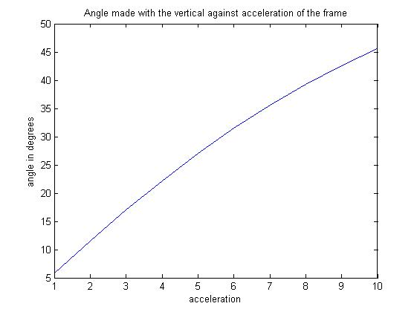

Plot for range 1 to 100

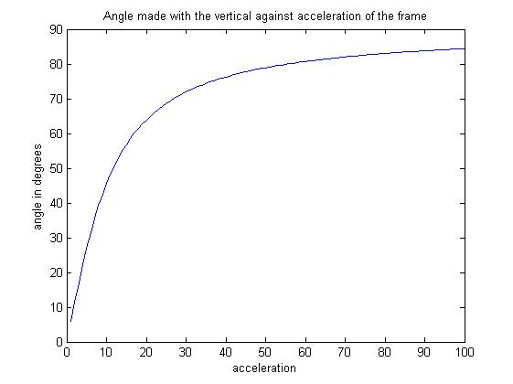

Plot for range 1 to 1000

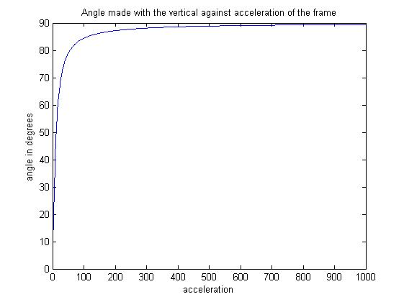

Clearly, we can make the following observations.

1. For smaller accelration the relation is almost linear and monotonically increasing.
2. So, we would expect this behaviour to continue. However, we notice that as the acceleration starts to increase the angle starts tending to pi/2. However, it can never seem to reach pi/2. What is the reason for this?
3. We can explain this using two approaches. The first being mathematical. We know that tan(theta)= acceleration/g. So for theta pi/2 we would need infinite acceleration. In other words as the acceleration starts blowing up, the angle will tend to pi/2.

Also, if we suppose that the angle is 90 and that the pendulum is in equilibrium. Then, we get a contradiction as Tension and the pseudo force would cancel out but the weight would be unbalanced and the object could not have been in equilibruim. Hence, we see that pi/2 is the upper bound as far as the angle is concerened.